Trapezium Mill
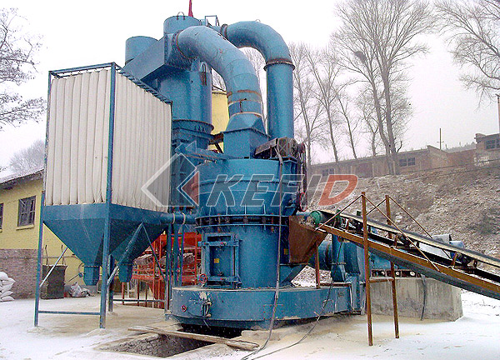
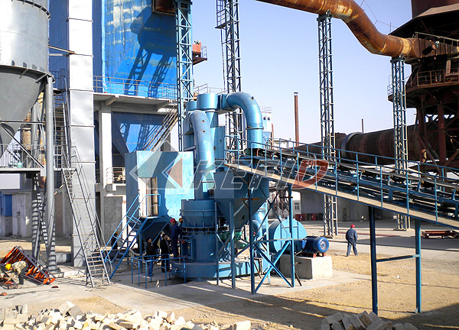
The trapezium mill is innovated and developed based on many years hard research, designed and improved according to using and suggesting of mill users, on basis of high roller mill, which is a new, efficient, energy saving super fine powder making machine for customers abroad. Trapezium working table, flexible connection, linked pressure boost of rollers are the pated technologies, which has set up the most advance level in the world for the super pressure trapezium mill.
The super pressure trapezium mill is mainly used in metallurgy, construction materials, chemicals, ores, highway construction, hydroelectricity, fire resistant materials, steel industries to process powder. Those materials such as quartz, feldspar, calcite, talc, barite, fluorite, rare earth, the marble, ceramic, bauxite, iron ore, copper, iron oxide red, zircon sand, slag, cement clinker, activated carbon, dolomite, , granite, garnet, iron oxide yellow, fertilizer, compound fertilizer, fly ash, coal, Ling U.S. sand, chromium oxide green, gold, red mud, clay, kaolin, coke, coal gangue, porcelain clay, kyanite , fluorspar, bentonite, stone, shale, basalt, gypsum, graphite, silicon carbide, thermal insulation materials with mohs hardness below 9.3 and humidity below 6%, and non-flammable and non-explosive ore materials are suitable for processing.
The trapezium mill mainly consists of mainframe, speed reducer, high density classifier, blower, bag filter, piping, elevator, hopper, vibrating feeder, crusher, cyclone, motor, etc.
Main Features:
Compared with the traditional grinding mill,the Super Pressure Trapezium Grinding Mill has below advantages:
1. The trapezium roller and grinding ring improve the grinding efficiency greatly. The roller and grinding ring are designed in inverted trapezium with different diameter, which reduce the slip velocity of materials between roller and grinding ring, extend grinding time, and improve the grinding efficiency.
2. With high efficient balanced adding pressure springs.Adopting the advantages of Raymond Mill and High Pressure Suspension Mill, Super Pressure Trapezium Grinder has longer service life. The roller assembly has been linked by the pulling pole and the levelled springs, with the radial force yeilding, which avoids the bulk material entering into the grinding chamber to wear down the principal axis and the the bearings, thus the service life will be longer.
3. Using flexible connection to connect main frame and powder concentrator, so the damping spring and airproof belt can reduce the vibration and noise, and avoid the resonance as well.
4. There is high desity and high precision impeller.
5. There is high-efficiency and energy-saving centrifugal induced draft fan.
6. With the impeller adjusting device brings more convenience. The clearance between housing and powder concentrator's blade front end also effects the fineness of the final product. The patent technology enables adjust the clearance more convenience.
Technical Parameter:

Mm to inch conversion: 25.4millimeters=1 inch
Mm to mesh conversion: 25.4mm=1in.
The humidity and hardness of raw materail will affect the fineness and capacity.

Item\Model | TGM100 | TGM130 | TGM160
Roller piece | 4 | 5 | 6
Roller Diameter×Height(mm) | Ф320×200 | Ф410×240 | Ф440×270
Ring Inner Diameter×Height(mm) | Ф980×200 | Ф1280×240 | Ф1600×270
Speed Of Main frame (r/min) | 130 | 103 | 82
Max. Input Size (mm) | ＜25 | ＜30 | ＜35
Product Size (mm) | 1.6～0.045  fineness can reach to 0.038 | 1.6～0.045  fineness can reach to 0.038 | 1.6～0.045  fineness can reach to 0.038
Capacity (t/h) | 3～8 | 6～15 | 9～22
Overall Dimension (mm) | 9910×5365×8310 | 7910×7000×9645 | 12550×5700×8355
Weight (t) | 16 | 26.1 | 35

Note:
1. Based upon limestone-grinding with 80% pass-through;
2. The final technical data are subject to the operation manual along with the machine.
Table 2
Name | Item | Unit | Specifications & Technical Data
Name | Item | Unit | TGM100 |  | TGM130 | TGM160
Motor for main frame | Model |  | Y225M-4 |  | Y280M-4 | Y135M1-4
Motor for main frame | Power | kW | 45 |  | 90 | 132
Motor for main frame | Rev. | rpm | 1480 |  | 1480 | 1480
Motor for separator | Model |  | YCT200-4A |  | YCT200-4B | YCT225-4A
Motor for separator | Power | kW | 5.5 |  | 7.5 | 11
Motor for separator | Rev | rpm | 125～1250 |  | 125～1250 | 125～1250
Motor for Elevator | Model |  | Y100L-4 |  | Y100L2-4 | Y112M-4
Motor for Elevator | Power | kW | 3 |  | 3 | 4
Motor for Elevator | Rev | rpm | 1420 |  | 1420 | 1420
Motor for Blower | Model |  | Y225M-4 |  | Y280M-4 | Y135M1-4
Motor for Blower | Power | kW | 45 |  | 90 | 132
Motor for Blower | REV | rpm | 1480 |  | 1480 | 1480
Motor for Jaw Crusher | Model | PE | 200×350 | 250×400 | 250×400 | 250×750
Motor for Jaw Crusher | Model | PE | Y160M-6 | Y180L-6 | Y180L-6 | Y200M-6
Motor for Jaw Crusher | Power | KW | 7.5 | 15 | 15 | 22
Motor for Jaw Crusher | REV | rpm | 970 |  | 970 | 970
Electro-Magnetic Vibrating Feeder | Model |  | GZ2F |  | GZ2F | GZ3F
Electro-Magnetic Vibrating Feeder | Power | W | 150 |  | 150 | 200

Note: The final technical data are subject to the operation manual along with the machine.

