VM - Vertical Grinding Mill
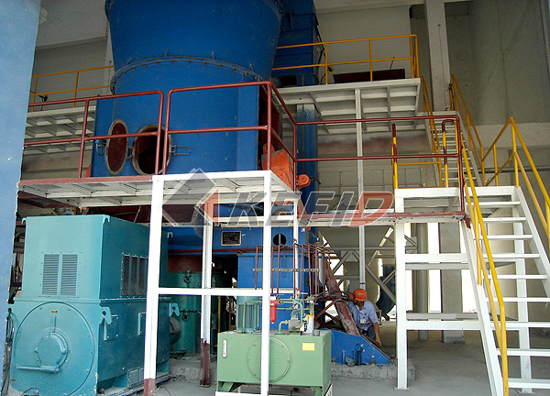
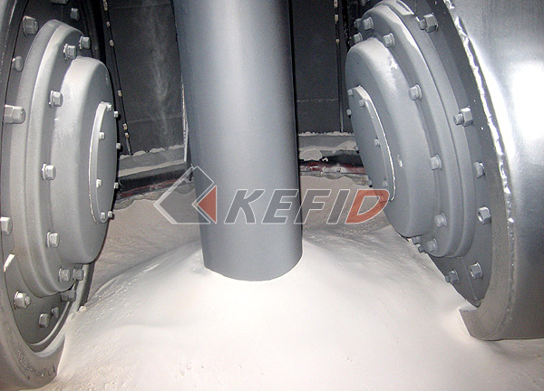
Vertical mill is a large grinding equipment based on years concentrated design and development by introducing advanced european technology and years design and manufacturing experience and market demand of Kefid to solve the problem of low production capacity and high power consumption of traditional grinding mills. Vertical mills have adopted reasonable and reliable structure design acting in concert with advanced process which is integrated by drying, grinding, powder seperating and elevating, which is able to meet clients’ need well with internationally advanced technological and economical indexes and can be adopted in cement, hydroelectric construction, metallurgy, chemical, and non-metal ore grinding, especially in large scale grinding or various ores of lump and grain shape into powder.
Main Features:
1. Low operation cost
(1) High grinding efficiency. Vertical mills grind material through grinding between grinding rollers and material bed with 40%-50% less power consumption comparing with ball mill, which will be more obvious while moisture is increasing.
(2) Less metal wear. Liner and rollers are made of special material which enables longer life, less operation cost and higher utilization.
(3) Outer loop device is equipped to reduce power consumption further.
(4) Larger feed material size which can be 5% of roller diameter, generally ranges from 40 to 100mm. And by using medium and large models, there will be no need to use secondary crushing system.
2. Lower Construction Cost
(1) Simple process. Land occupation and construction area can be 50% less comparing with ball mill system reducing construction cost by about 70%.
(2) Vertical mill is an integration of crushing, drying, grinding, separating and conveying, which is simple in system,compact in distribution and can be distributed in open air, which will cause less construction expense.
3. Simple and stable operation:
(1) Automatic control system is equipped to enable long distance control and is simple in operation.
(2) Special device to avoid direct contact of rollers and disc liner has been equipped to avoid fragmentation severe vibration.
4. Powerful drying ability. Vertical mills adopts air stream in material conveying. During grinding of material with higher moisture, wind temperature can be controlled so as to prepair final products to meet moisture requirements, which is up to 12% to 15% in vertical mill, which can only be 3-4% in drying ball mill.
5. Stable prodcts quality and even products shape. Material will stay only a short period in the mill making inspection and controll of product grain size and chemical composition easier and quality of products more stable.
6. Easy in maitenance. Maitenance can be completed by maintaining oil cylinder, turning moving arms, rollers, liner quickly.
7. Environmental friendly and low in power consumption. There will be light vibration, small noise, small amount dust, clean operating environment, which can meet environment protection requirement well.
Technical Parameter:

Contents|Data\Model |  | LM130K | LM150K | LM170K | LM190K | LM220K | LM240K
Disc Dia. (mm) |  | 1300 | 1500 | 1700 | 1900 | 2200 | 2400
Capacity (t/h) |  | 10~30 | 13~40 | 18~57 | 23~72 | 36~114 | 41~128
Output fineness | micron | 170~45 | 170~45 | 170~45 | 170~45 | 170~45 | 170~45
Output fineness | mesh | 80~325 | 80~325 | 80~325 | 80~325 | 80~325 | 80~325
Product moisture |  | ≤1% | ≤1% | ≤1% | ≤1% | ≤1% | ≤1%
Max.input size (mm) |  | <38 | <40 | <42 | <45 | <50 | <55
Best input moistrure |  | <4% | <4% | <4% | <4% | <4% | <4%
input moistrure(drying required) |  | <15% | <15% | <15% | <15% | <15% | <15%
Inlet air temperature (℃) |  | <350 | <350 | <350 | <350 | <350 | <350
Outlet air temperature (℃) |  | 70~95 | 70~95 | 70~95 | 70~95 | 70~95 | 70~95
Main mill power (KW) |  | 185~220 | 250~280 | 355~400 | 450~500 | 710~800 | 800~900
Dimension | Lmm | 3500 | 4200 | 4700 | 8500 | 10200 | 11700
Dimension | Wmm | 3400 | 3900 | 4500 | 5600 | 6700 | 7700
Dimension | Gmm | 5800 | 7100 | 8300 | 8800 | 10600 | 12200
Weight (t) |  | 48 | 75 | 90 | 100 | 125 | 160

Notes:
1. Material should be with hardness less than 7 in Mohs.
2. Hot air is only necessary if outlet moisture is required to be less than inlet moisture.
3.When grinding mateiral that is difficult to grind, please use the largest power.

Coal Mill:
Contents|Data\Model |  | LM130M | LM150M | LM170M | LM190M | LM220M | LM240M
Disc Dia. (mm) |  | 1300 | 1500 | 1700 | 1900 | 2200 | 2400
Capacity (t/h) |  | 10~15 | 16~22 | 20~28 | 26~35 | 35~45 | 40~50
fineness (R0.08) |  | <15% | <15% | <15% | <15% | <15% | <15%
Coal powder moisture |  | <1% | <1% | <1% | <1% | <1% | <1%
Max.input size (mm) |  | <38 | <40 | <42 | <45 | <50 | <55
input moistrure |  | <15% | <15% | <15% | <15% | <15% | <15%
Inlet air temperature (℃) |  | <350 | <350 | <350 | <350 | <350 | <350
Outlet air temperature (℃) |  | 75~95 | 75~95 | 75~95 | 75~95 | 75~95 | 75~95
Hardgrove index of raw coal (HGI) |  | >55 | >55 | >55 | >55 | >55 | >55
Main mill power (KW) |  | 185 | 250 | 315 | 400 | 500 | 560
Dimension | Lmm | 3500 | 4200 | 4700 | 8500 | 10200 | 11700
Dimension | Wmm | 3400 | 3900 | 4500 | 5600 | 6700 | 7700
Dimension | Hmm | 5800 | 7100 | 8300 | 8800 | 10600 | 12200
Weight (t) |  | 46 | 75 | 94 | 100 | 122 | 157
Note: Any change of LM Series Vertical Mill technical data shall not be advised additionally.

