Vibrating Feeder
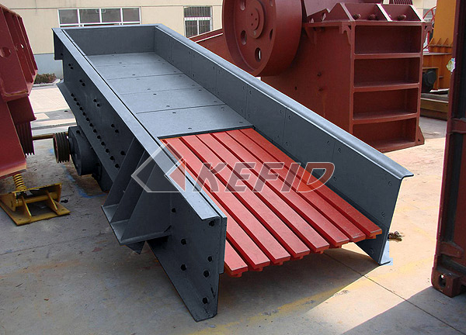
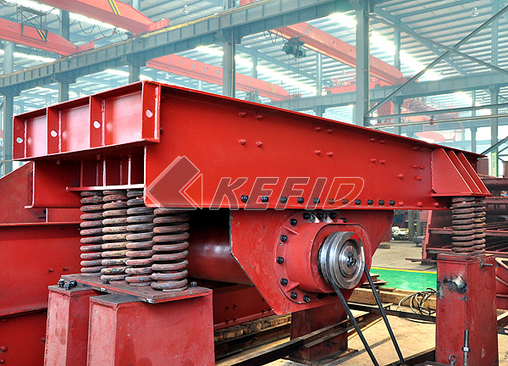
Vibrating Feeder is a kind of linear direction feeding equipment. It features smooth vibrating, reliable operation, long service life and being suitable for feeding. They are widely used in mining, building-material, silicate and chemical industry in the crushing and screening plants.
Main Features:
1. stable and long span life
2. easy to adjust
3. reliable operation.
4. easy maintenance.
Vibrating Feeder Operating principle :
Vibrating feeder consists of vibrating frame, spring, vibrator, motor vibrating device and motor. The vibrator is made of two fixed eccentric shafts whose gears are jogged. When installation, the two gears must be jogged according to the sign. Through drive of the motor, the two eccentric shafts start rotating to produce a linear huge power which forces the feeder to vibrate. Through the vibration, The materials will slip and sling on the funnel, moving forward, when the materials pass the screening part, smaller parts will fall down, avoiding the further crushing, so screening purpose can be reached.
Technical Parameter:
Mm to inch conversion: 25.4millimeters=1 inch

Model | Max. feeding  size(mm) | Handling  capacity(t/h) | Power (kW) | Dip angle(º) | Weight(kg)
GZG70-4 | 200 | 120-170 | 2X0.5 | ~10 | 389
GZG100-4 | 300 | 270-380 | 2X1.1 | ~10 | 762
GZD240X70 | 400 | 30-80 | 2x1.5 | ~10 | 3000
GZD300×85 | 450 | 80-120 | 2x3.7 | ~9 | 3900
ZSW380×96 | 500 | 120-210 | 11 | 0 | 4200
ZSW420×110 | 650 | 180-400 | 15 | 0 | 4800
ZSW490×110 | 650 | 250-480 | 15 | 0 | 5300
ZSW490×130 | 750 | 300-550 | 22 | 0 | 6700
ZSW600×130 | 750 | 400-800 | 30 | 0 | 7800
ZSW600×150 | 800 | 500-850 | 30 | 0 | 8800

Note: Any change of Vibrating Feeder technical data shall not be advised additionally.

