Vibrating Screen
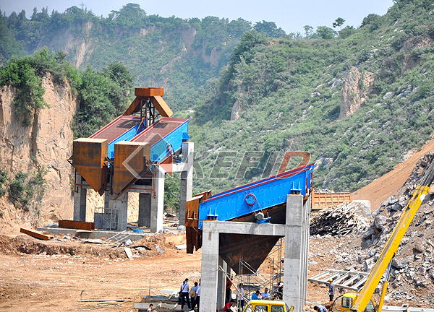
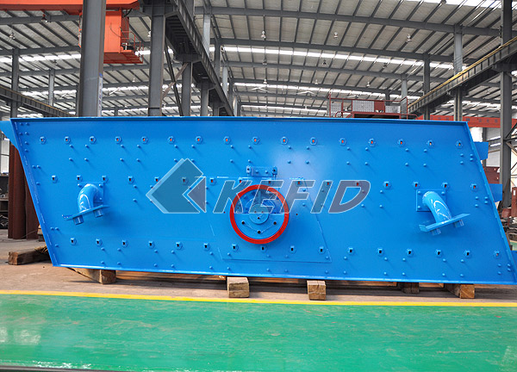
Vibrating Screen is a new type screener with the cycle-vibrating, multilayer and high efficiency. It adopts the eccentric shaft vibration exciter and partial block to adjust the amplitude. It features with credible structure, strong exciting force, high screening efficiency, low vibrating noise, convenient maintenance, safe operation.
Vibrating Screen is specialized for the quarries, and is widely used in industries, such as the mine, building materials, traffic, energy and chemistry. It has to use the water flush when dealing the high moisture materials with the small mesh.
Main Features:
Vibrating Screen features long flowing line, many screening specifications, strong violent vibration force, high screening efficiency, small vibrating noises, firm and durable construction, convenient maintenance and safe operation.
Working Principle
Vibrating screen moves round. It has multi-layers and is of high efficiency. The eccentric shaft vibration exciter and partial block help to adjust amplitude. The material drops down along the long line. In screen grading, the material is separated mechanically on screen plates. Rolling bearings in vibrating screens are stressed by high, mostly shock-type loads. Moreover, the bearings, while rotating about their own axis, perform a circular, elliptical or linear vibrating motion. This results in high radial accelerations which additionally stress the bearings, and especially the cages, considerably. The operating speeds are usually very high. As a result, the bearing temperatures are up to 20 to 30 degrees Kelvin higher than in normal applications. In addition, considerable misalignments between the bearing locations and considerable shaft deflections have to be accommodated.
Technical Parameter:
1. Parameters of machine body
Name | Unite | Specifications and technical parameters
Quantity of roller | pcs | 4
Diameter of roller×height | mm | Ф410×210
Diameter of grinding ring×height | mm | Ф1300×210
Rotating speed of machine body | Rev/min | 103
Max feeding size | mm | <30
Grain size of powder | mm | 0.074—0.038
Production capacity | t/h | 4－13
Total weight of machine body | t | 18
2. System power
Name | Item | Unite | Specifications, technical data
Main motor | Model |  | Y280S-4
Main motor | Power | Kw | 75
Main motor | Rotational speed | Rev/min | 1480
Motor of classifier | Model |  | Y160L-4
Motor of classifier | Power | Kw | 15
Motor of classifier | Rotational speed | Rev/min | 1460(frequency control)
Motor of elevator | Model |  | Y100L2-4
Motor of elevator | Power | Rev/min | 3
Motor of elevator | Rotational speed | Rev/min | 1430
Motor of draught fan | Model |  | Y280M-4
Motor of draught fan | Power | Kw | 90
Motor of draught fan | Rotational speed | Rev/min | 1480
Motor of jaw crusher | Jaw crusher model |  | PE 250×400
Motor of jaw crusher | Motor model |  | Y180L-6
Motor of jaw crusher | Motor power | Kw | 15
Motor of jaw crusher | Motor rotational speed | Rev/min | 970
Vibration feeder | Model |  | GZ3F
Vibration feeder | power | W | 200

