Wheel sand washing machine
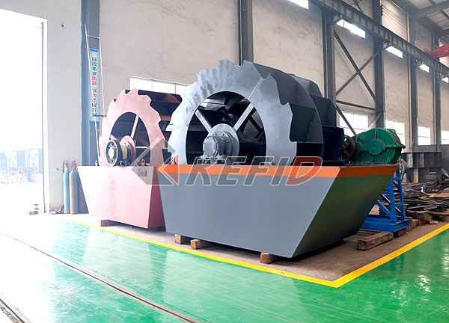
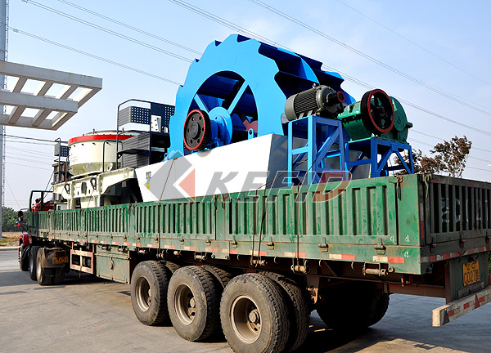
This machine is the wheel type for washing and selecting the artificial sand (including the natural sand), It used to clean and separate the dirt and the impurity from the sand and improve the sand quality. It adopts the novel seal structure, weir plate can be charged, the stable driven device, which ensures the best effect on the cleanout and dewatering and usually matched with sand making machine in the production line.
This series of sand washing machine is fixed of 15 degree tilt, the triangular weir surrounds the bottom of the tank and forms a sedimentation tank, the screw head immerges into the tank, the motor drove by the reducer drives the screw head do consecutive motion, the clean water inflows the tank from the porous plate of the bottom. This device has three functions of cleanout, dewatering and classification.
The sand washing machine is widely used in the construction site, quarries, concrete dam building site of hydropower station, concrete precast plant, oil well filling and other fields. It owns the features of high cleanness, suitable structure, high capacity, low power consumption, and less sand loss in the washing procedure, especially its transmission device separated from the sand and water, which lengthens its usage life compared to the normal style and is the best choice for making a upgrade in the washing industry.
Main Features:
1. The simple structure, stable performance, high cleanness, less sand lose in the washing procedure, especially the transmission device separates from the water and sand, which lengthens the usage life compared to the normal style.
2. Suitable structure, novel seal structure, total seal oil bath gear, the weir plate can be charged, which ensures this series product effective, durable, good effect on the cleanness and dewatering and the even final product.
3. High capacity, low power consumption, water saving, low pollution, easy to maintain. Technical Parameter:
Model | Wheel Size (mm) | Max feed size (mm) | Power (kW) | Weight (t) | Capacity (t/h) | Overall dimension (mm)
XSD2610 | Φ2600×1000 | 10 | 5.5 | 2.7 | 20-50 | 3255×1982×2690
XSD2816 | Φ2800×1600 | 10 | 11 | 3 | 30-60 | 3540×3000×2880
XSD3016 | Φ3000×1600 | 10 | 15 | 3.3 | 50-100 | 3845×3000×3080

Note: Any change of Sand Washing Machine technical data shall not be advised additionally.

