

Subclassing Useing VB5's Built in Features (Addressof) No. 1

***Note*****************************************************************
Before beginning this , the assumed idea is that you have a firm
understanding of Visual Basic and the Window 32 bit API. There are many
other API calls that are used in the samples that I do not provide support for.
It is assumed that you know how to look up API Declarations and implement
them also. If you are not a intermediate to advanced Visual Basic programmer
then you may have great difficulty understanding this.
**************************************************************************

Up until VB5 , there was no built in feature to help us to change the behavior of
our programs. We would have to obtain 3rd party controls ( such as Desawares's
SpyWorks ). Well ,with version 5 of Visual Basic , the ability to intercept windows
messages was now built in , now closeing the gap between VB and C++. Although
the support for intercepting messages still doesn't support cross tasking ( subclassing
other applications windows) , we are still able to intercept messages within our own forms
which gives us the ability to customize our programs like never before. This is the magical
call that gives us this ability.....

__________________________________________________________________________

' This would go in your module

Declare Function CallWindowProc Lib "user32" Alias "CallWindowProcA" _
(ByVal lpPrevWndFunc As Long, ByVal hWnd As Long, ByVal MSG As Long, _
ByVal wParam As Long, ByVal lParam As Long) As Long

Declare Function SetWindowLong Lib "user32" Alias "SetWindowLongA" (ByVal hWnd As Long, ByVal nIndex As Long, ByVal dwNewLong As Long) As Long

'Contsants

Public Const GWL_WNDPROC = (-4)

__________________________________________________________________________

Whats possible with this call?...basiacally anything!

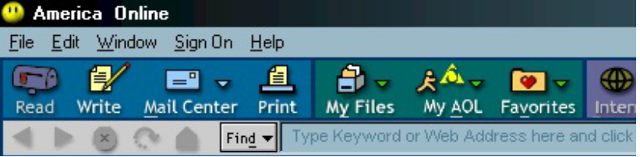
Achieve with AddressOf and assisted by Desaware's SpyWorks

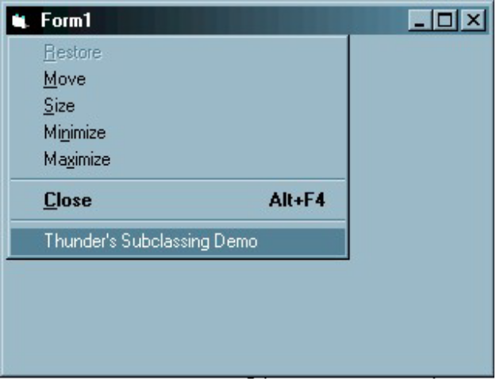
Subclassed System Menu and Gradient Title- NO 3rd Party Controls Straight Code!
____________________________________________________________________________________

And it doesnt stop there... The ability to change things like default context menus
and makeing controls act like YOU want them to is closer than you think.

Lets look at what these calls do!

Lets start simple , we will append our own menu to the system menu:

__________________________________________________________________________

Public Function SysMenu(frm As Form)

Dim SysMenu As Long, lRet As Long

'Lets Find where we want to put the menu....

SysMenu = GetSystemMenu(FormName.hWnd, 0&)

' We found the place , now lets add a entry
Ret = AppendMenu(SysMenu, MF_SEPARATOR, 0&, vbNullString)
Ret = AppendMenu(SysMenu, MF_STRING, SYS_ABOUT, "About...")
' We just added the entry , and added a ID to the new entry

'Show the form to redraw the menu and subclass the form
FormName.Show
lProcOld = SetWindowLong(FormName.hWnd, GWL_WNDPROC, AddressOf MenuHandle)
End Function
__________________________________________________________________________

Public Function MenuHandle(ByVal hWnd As Long, ByVal iMsg As Long, ByVal wParam As Long, ByVal lParam As Long) As Long

'Lets set up out message

If iMsg = WM_SYSCOMMAND Then

' If the message going to windows is the system menu being clicked then....

If wParam = SYS_ABOUT Then

'Check to see if our item was also clicked... If it is then do a message box

MsgBox "About . . .", vbInformation, "Message was found!"

'End our function

Exit Function

End If

'Hook the window once again

MenuHandle = CallWindowProc(lProcOld, hWnd, iMsg, wParam, lParam)

End Function
__________________________________________________________________________

IMPORTANT!!!!!!

When subclassing it is VERY important you hand control back over to windows BEFORE
you unload your project or form, if you don't you could GPF , lock up , or maybe even have
little elfs pop on your screen ( well maybe not that last one). So in this case we will hand back
control when we unload the form......

__________________________________________________________________________

Sub Form(?)_UNLOAD (Cancel as Integer)

SetWindowLong Me.hWnd, GWL_WNDPROC, lProcOld
'Hand messages back to windows

End Sub

__________________________________________________________________________

This was a quick BUT powerful example of AddressOf . You can even apply this to
popup menus for controls and add menu selection to the default pop-ups. Next help
file on Subclassing I will tackle the "Mysterious" Gradient Title Bar, which we will need
no controls , or stupid vb hack tricks such as useing a picturebox etc.. it will redraw your forms
titlebar gradient.

About me:

I have been programming for 2 years in visual basic , javascript , and c.g.i . I now work as
a web programmer. I do not program AOL addons , well at least
aol "hacker" type addons. Please do not emai me asking question about AOL vb programming ,
there are tons of other places to ask those questions. All other questions and contributions are
welcome! I wrote this because it seems that there is little written about AddressOf in vb5 even
though vb5 is more than a year old. Plus I'm really bored =P

email: brokengroove@usa.net
AIM : ThunderIM
__________________________________________________________________________

This file is © PNG (Programmers News Group)
-Members-
Fuddoko , Maz , Benzene , Numaric , Kanae , Thunder

All code is public domain and is property of its respective owner... Blah Blah

