Roundcube plugin – undoEmail

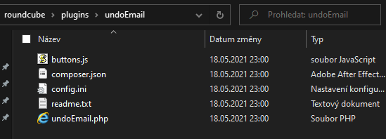To get undoEmail plugin for Roundcube running, you need to set up a few things. After you have a folder with files containing a source code you must create a folder ‘UndoEmail’ in C:\xampp\htdocs\roundcubemail\plugins where you can copy a source code.

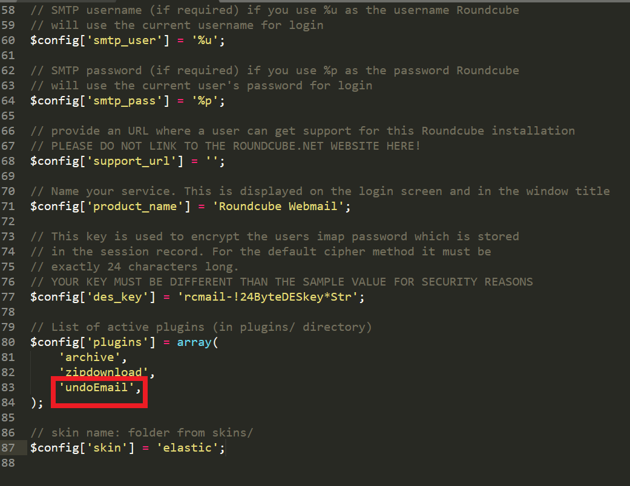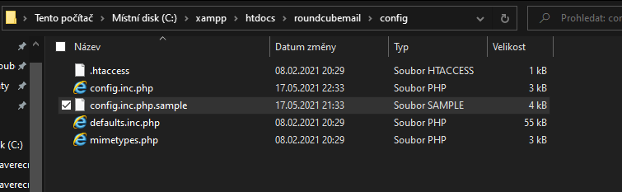After creating a destination for undoEmail.php and other files, you should edit config.inc.php. Path to this file is C:\xampp\htdocs\roundcubemail\config\config.inc.php. Open it with a text editor and edit the array that holds information about names of plugins. Fill in the exact name ‘undoEmail’.

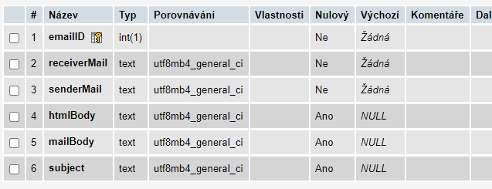You will also need to create a database with unsent emails called ‘emails’ with a table called ‘unsentEmails’ with defined columns.

|  |
| --- |
| create table unsentemails |
|  | ( |
|  | emailID int auto_increment, primary key |
|  |  |
|  | receiverMail text not null, |
|  | senderMail text not null, |
|  | htmlBody text null, |
|  | mailBody text null, |
|  | subject text null |
|  | ); |

Use the database name, etc. that you have created, in the roundcube configuration.

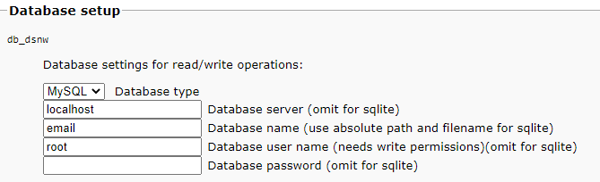

On your server, navigate yourself through and create a new user. Then set @localhost.com in ‘identities’.

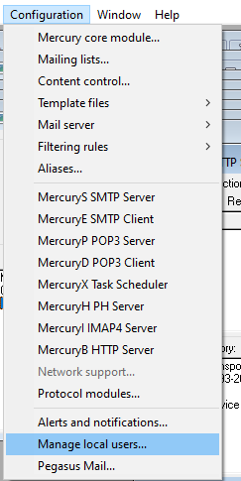

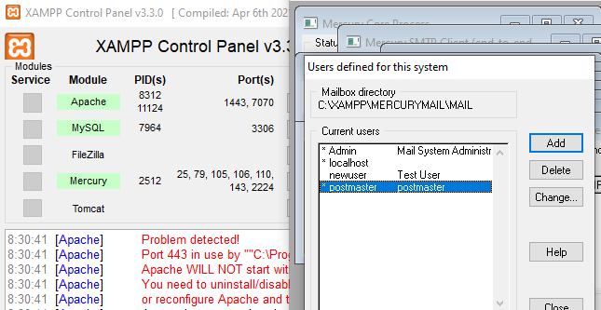

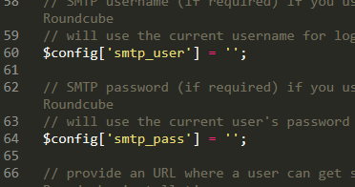You may get an error with authentication. You should clear information in fields smtp_pass and smtp_user. Leave these empty to fix this error.