Roundcube plugin – undoEmail

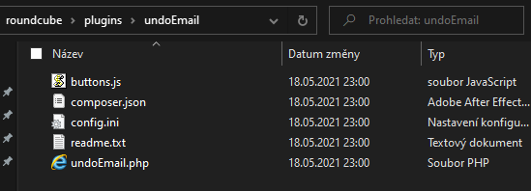For the roundcube plugin to work, create a folder named undoEmail in the Roundcube plugins folder, place all contents of the undoEmail repository into it.

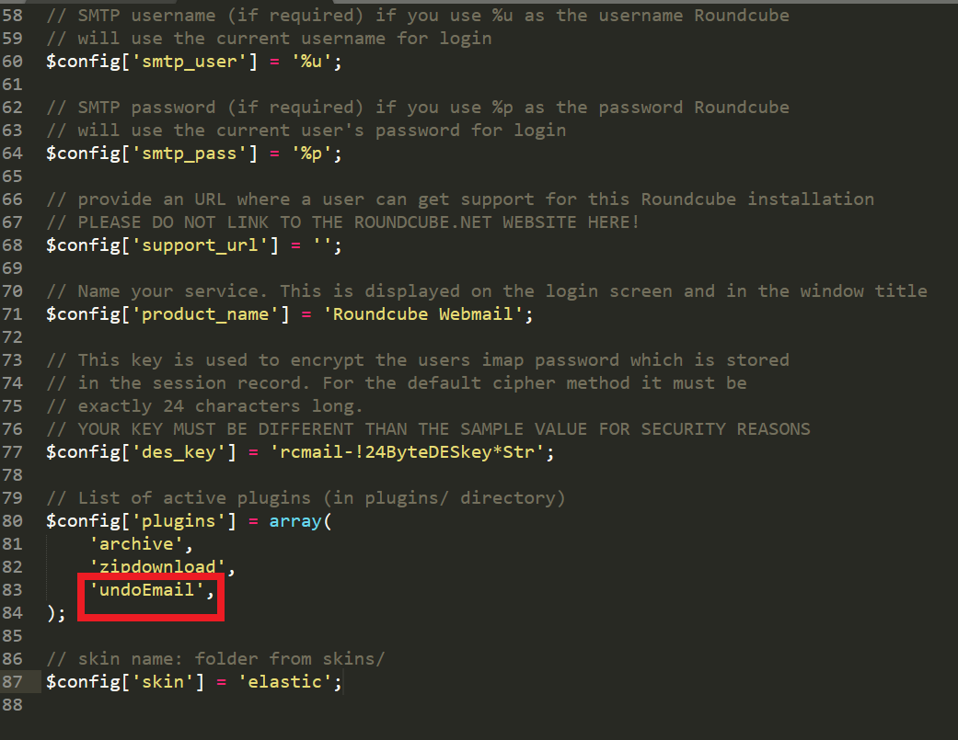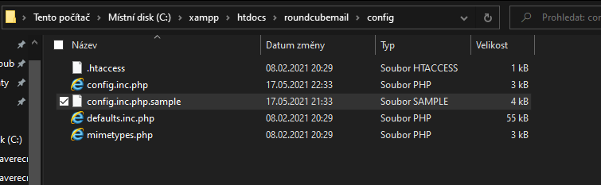After creating the folder, you must modify the configuration in **config.inc.php**. Find the plugins array and add undoEmail into it.

Create a table named unsentEmails in your roundcube database.

Table definition: create table unsentemails

(

emailID int auto_increment

primary key,

receiverMail text not null,

senderMail text not null,

htmlBody text null,

mailBody text null,

subject text null

);

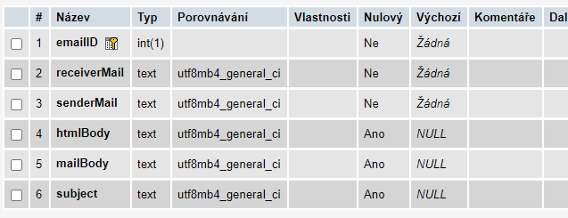

**^ Outdated ^**

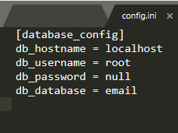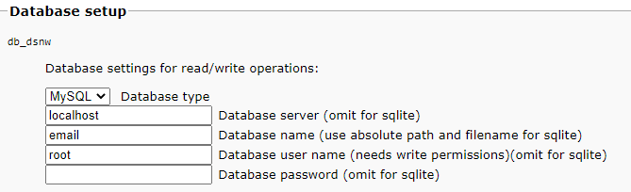Use **config.ini** to configure the plugin.