》products表
1.列出价格大于30元的产品,并按价格升序排列
select productname, unitprice from products
where unitprice > 30 order by unitprice asc
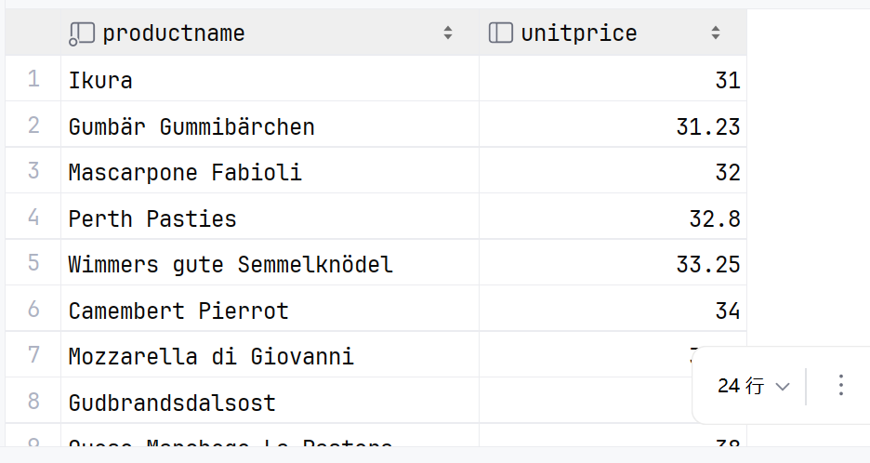
2.找出供不应求的产品（存货量小于定购量）
select productname, unitsinstock, unitsonorder from products
where unitsinstock < unitsonorder
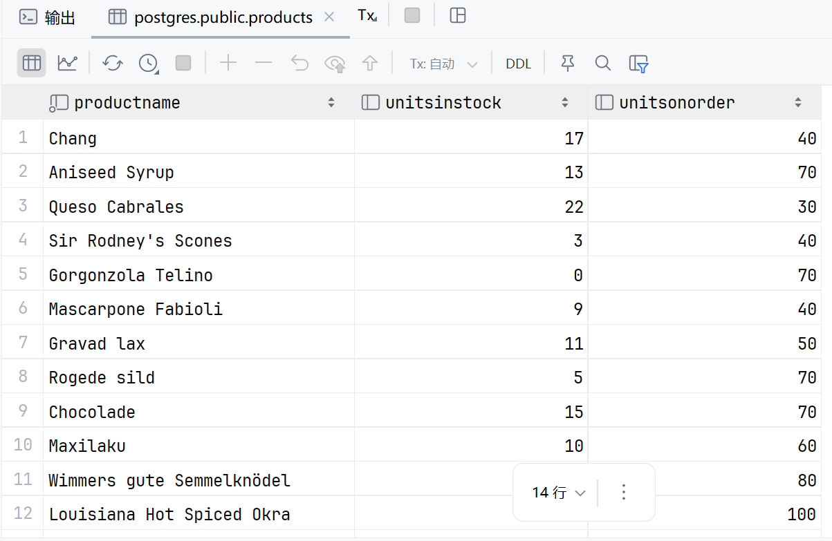
3.找出以广口瓶（jars）包装提供产品的产品名称
select productname,quantityperunit from products
where quantityperunit like '%jars%'
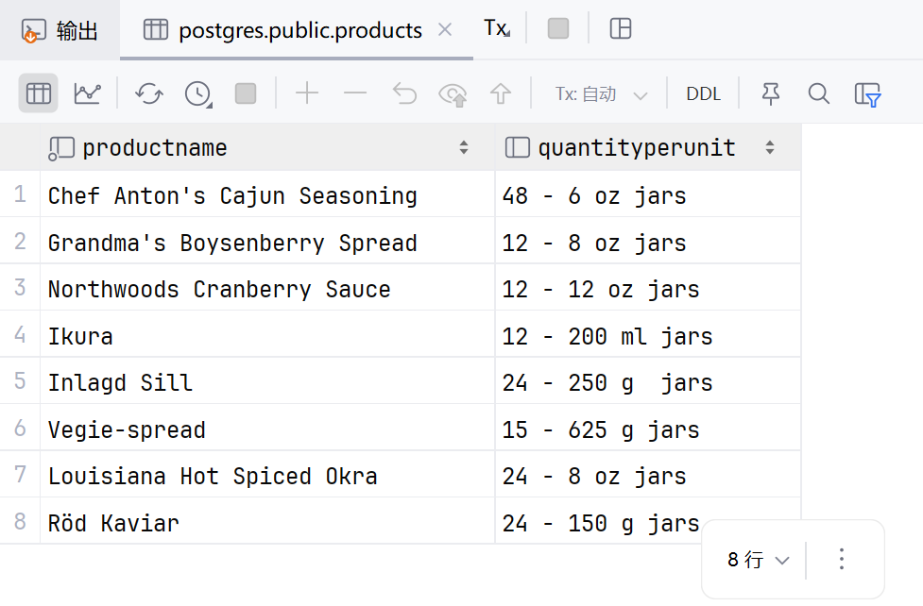
4.假设货币的单位是美元，将单价和货币符号放在一列显示，单价取整（不要四舍五入）
select productname, unitprice, concat(floor(unitprice),'$') as price from products;
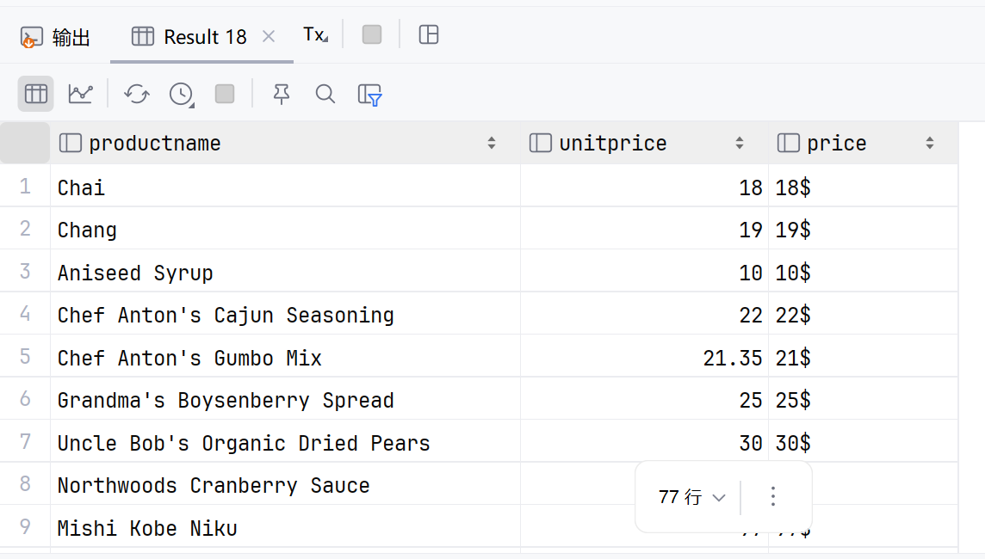
5.列出产品打九折后的价格，保留到小数点后一位
select productname, round(cast(unitprice as decimal) * 0.9,1) as discountprice, unitprice from products;
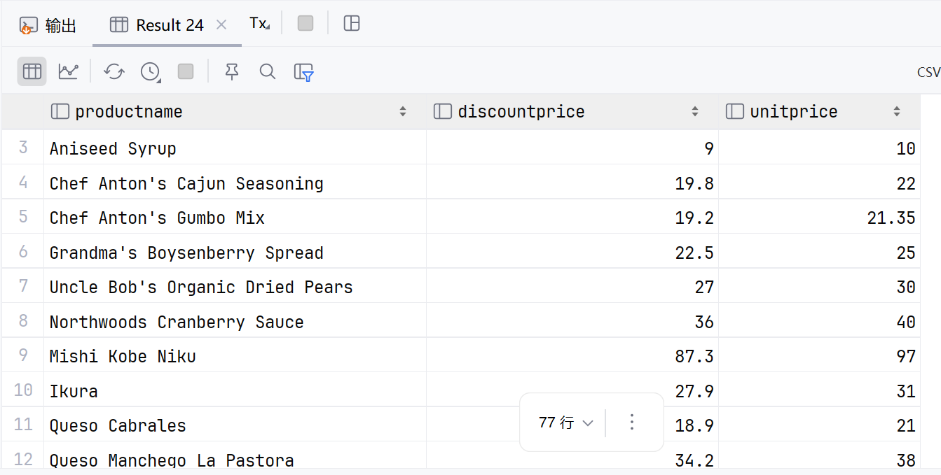
6.按供货商统计商品的平均单价，保留到小数点后一位
select supplierid, round(avg(cast(unitprice as decimal)),1) as averageprice from products group by supplierid;
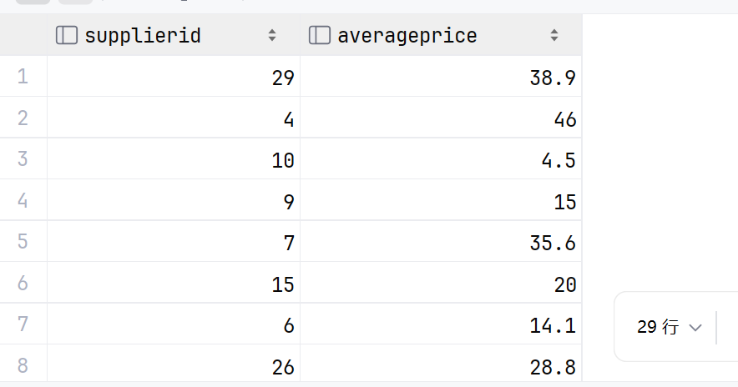
》employees表
- 按国籍统计雇员的人数，并按人数降序排列
select country, count(*) as numberofemployees from employees
group by country order by numberofemployees desc;
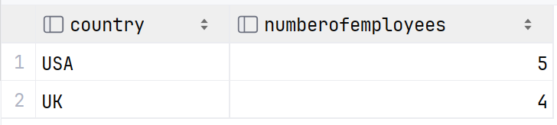
- 找出个人简介（notes）中包含单词“university”（不区分大小写）的雇员
select concat(firstname,' ',lastname) as employee, notes from employees
where lower(notes) like '%university%';
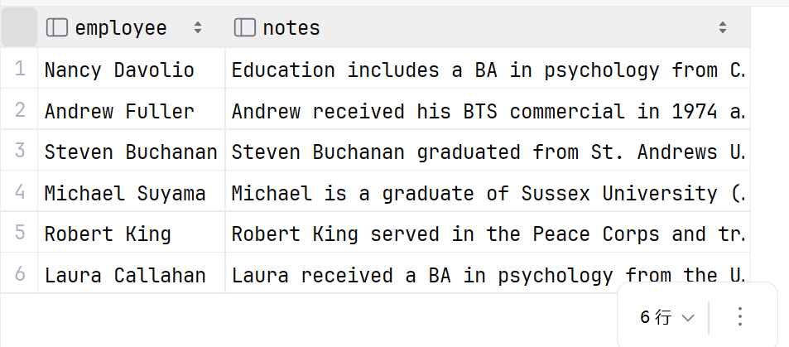
- 找出1993年9月11日以后雇用的员工
select concat(firstname,' ',lastname) as employee, hiredate from employees where date(hiredate) > '1993-09-11' order by hiredate desc;
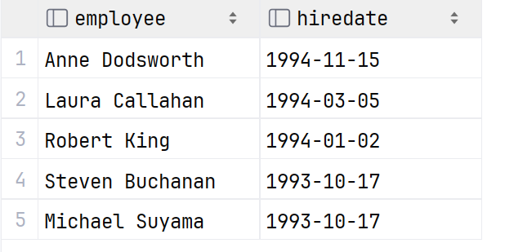

- 哪些雇员是在1952年2月17号～1963年7月2号之间出生的
select concat(firstname,' ',lastname) as employee, birthdate from employees where date(birthdate) < '1963-07-02' and date(birthdate) > '1952-02-17' order by birthdate desc;
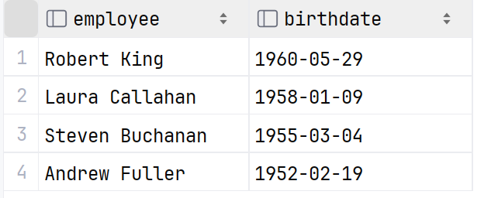
- 公司的员工来自多少个不同的城市
select count(distinct city) as numberofcities from employees;
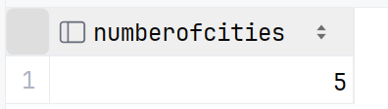
- 按城市统计雇员的个数
select city, count(*) as numberofemployees from employees group by city order by numberofemployees desc;
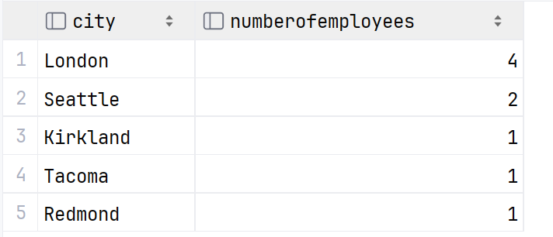
- 显示以下三列：firstname，birthdate，年龄，按年龄排序
select firstname, birthdate, age(birthdate) as days from employees
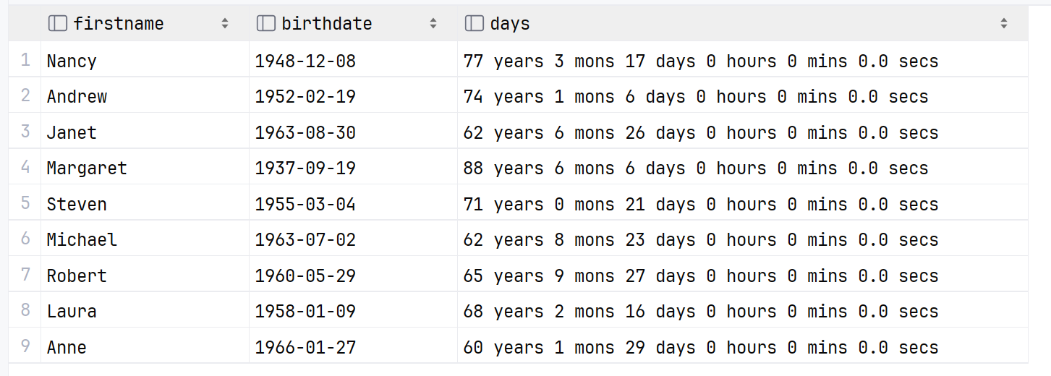
- 将字段photopath中'http://'后的字符串提取出来，在旁边一列显示该字符串的长度
select photopath, substring(photopath, 8) as extracted, length(substring(photopath, 8)) as length from employees
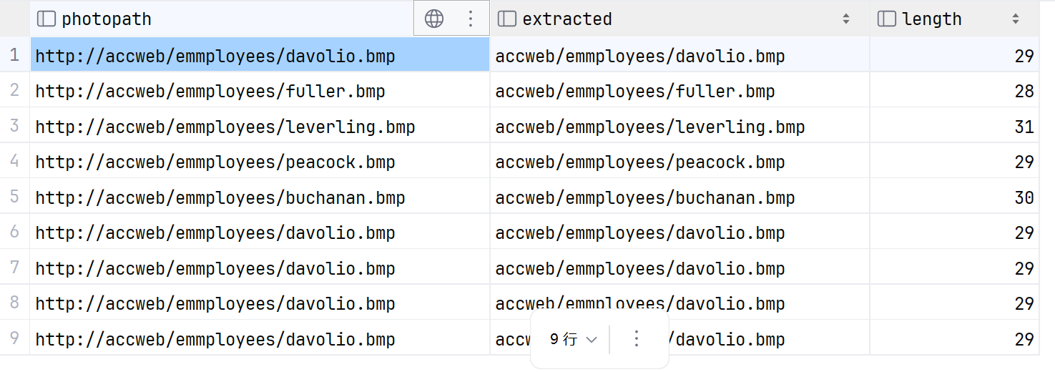
》suppliers表
- 找出firstname叫Michael的供货商的头衔和联系电话
select contactname, contacttitle, phone from suppliers where contactname like 'Michael%';
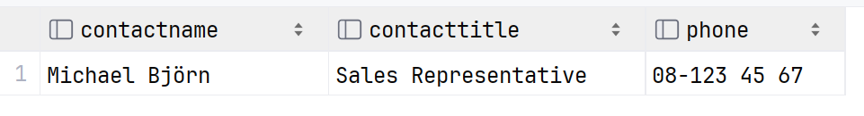
- 找出头衔是“Marketing Manager”并且提供了传真号的供货商
select contactname, contacttitle, fax from suppliers where contacttitle = 'Marketing Manager' and fax is not null;
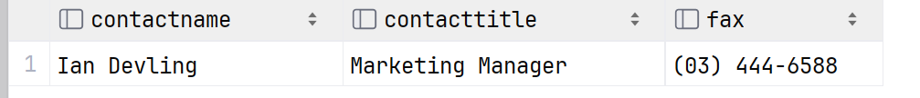
- 有多少供货商提供了region信息
select count(supplierid) as numberfsuppliers from suppliers where region is not null;
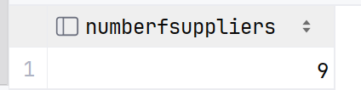
- 有多少供货商没有提供region信息
select count(supplierid) as numberfsuppliers from suppliers where region is null;
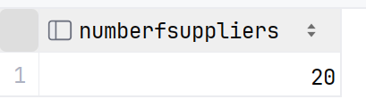
5.根据公司名的长短对供货商进行排序，降序排列，只显示长度超过20的记录
select companyname, contactname, length(companyname) as companylength from suppliers where length(companyname) > 20 order by companylength desc;

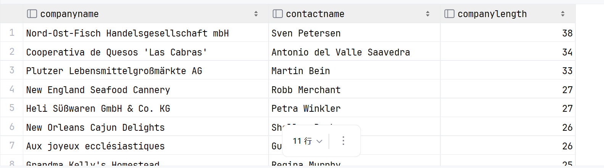
6.将国家和联系人姓名放在一起显示，中间用12个'.'隔开
select country || repeat('.',12) || contactname as contact from suppliers;
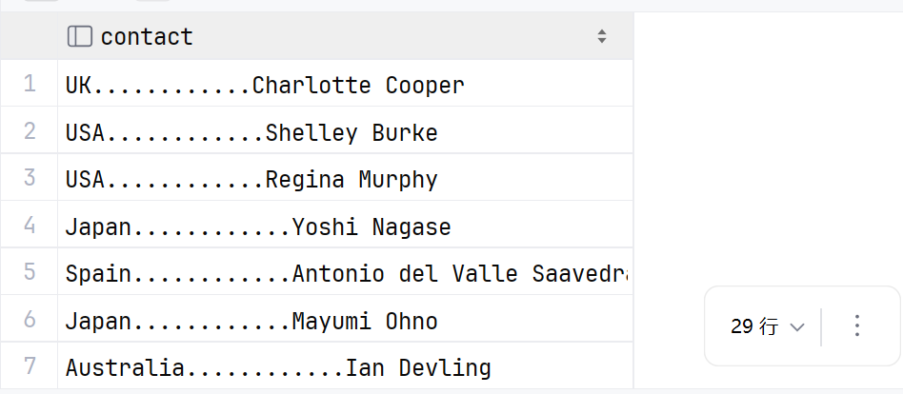
7.列出电话号码，将'('替换成'['，')'替换成']'
select phone, translate(phone,'()','[]') as newphone from suppliers;
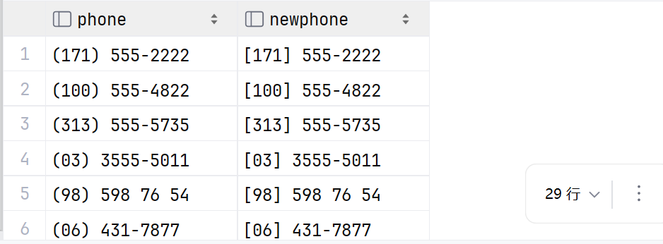
》customers表
- 找出位于布宜诺斯艾利斯的客户
select companyname, contactname, city from customers where city = 'Buenos Aires';
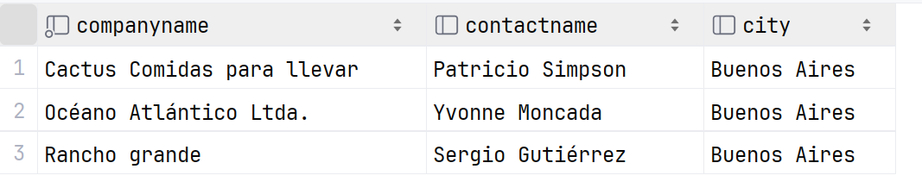
- 找出联系人名字以’r’结尾且第2或第3个字母是’i’的记录
select contactname from customers where contactname like '%r' and (contactname like '_i%' or contactname like '__i%')
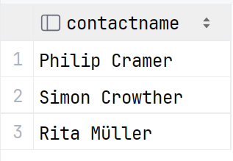
- 找出电话号码后四位包含数字“39”的记录（用两种方法）
select phone from customers where right(phone,4) like '%39%';
select phone from customers where substring(phone, length(phone)-3) like '%39%';

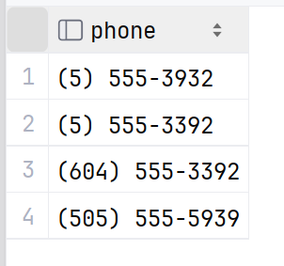
- 将联系人的名和姓提取出来分两列显示
select split_part(contactname,' ',1) as firstname, split_part(contactname,' ',-1) as lastname from customers;
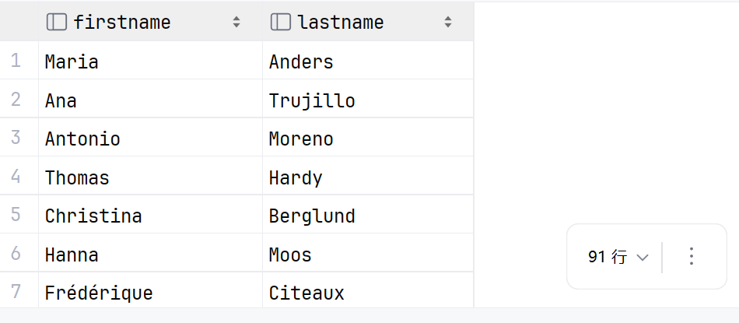
- 找出同名（可以不同姓）的联系人
select distinct c1.contactname from customers c1
join customers c2 on split_part(c1.contactname,' ',1) = split_part(c2.contactname,' ',1)
where c1.customerid <> c2.customerid order by c1.contactname;
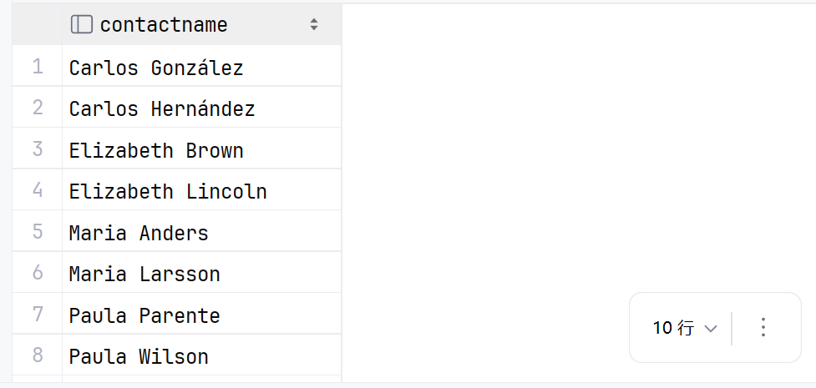
6.北风公司决定挑选一位幸运客户，请从客户表中随机选取一条记录
select * from customers order by random() limit 1;
》order_details表
1.假设货币的单位是美元，显示换算成人民币后的单价（汇率网上查），取整数，数字后显示汉字“元”
select round(unitprice * 6.89) || '元' as pricecny from order_details;
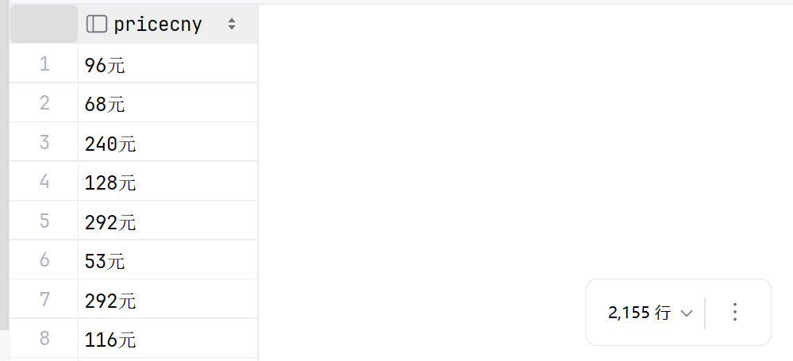
》orders表
- 提取定购日期（orderdate）中的年
select orderdate, extract(year from orderdate) as year from orders;
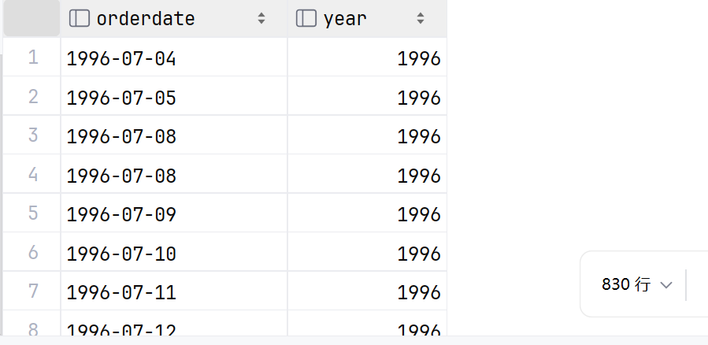
2.根据定购日期是星期几对订单分组，统计定单的个数，按星期几排序；结果绘制成饼图。
select to_char(orderdate, 'TMDay') AS weekday_name, count(*) as numberoforders from orders group by weekday_name,extract(dow from orderdate) order by extract(dow from orderdate);
（在Pycharm里面，运行结果可以直接切换成图表视图，选择饼图即可。）
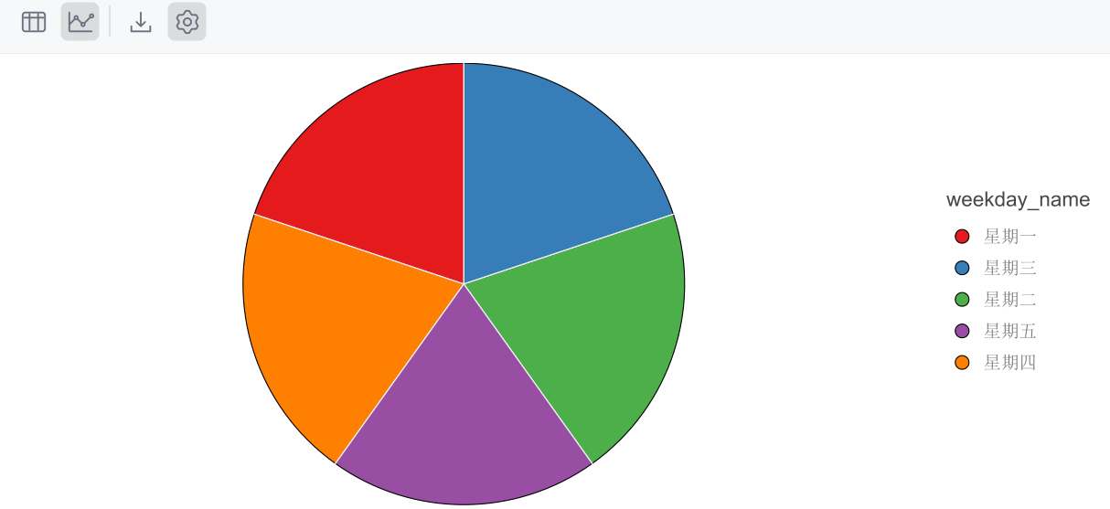
访问https://hub.arcgis.com/datasets/esri::world-cities/about
下载shapefile格式的数据并在QGIS中加载，加载OSM图层（背景）
- 找出名称中包含'an'的城市；
"CITY_NAME" ilike '%an%'
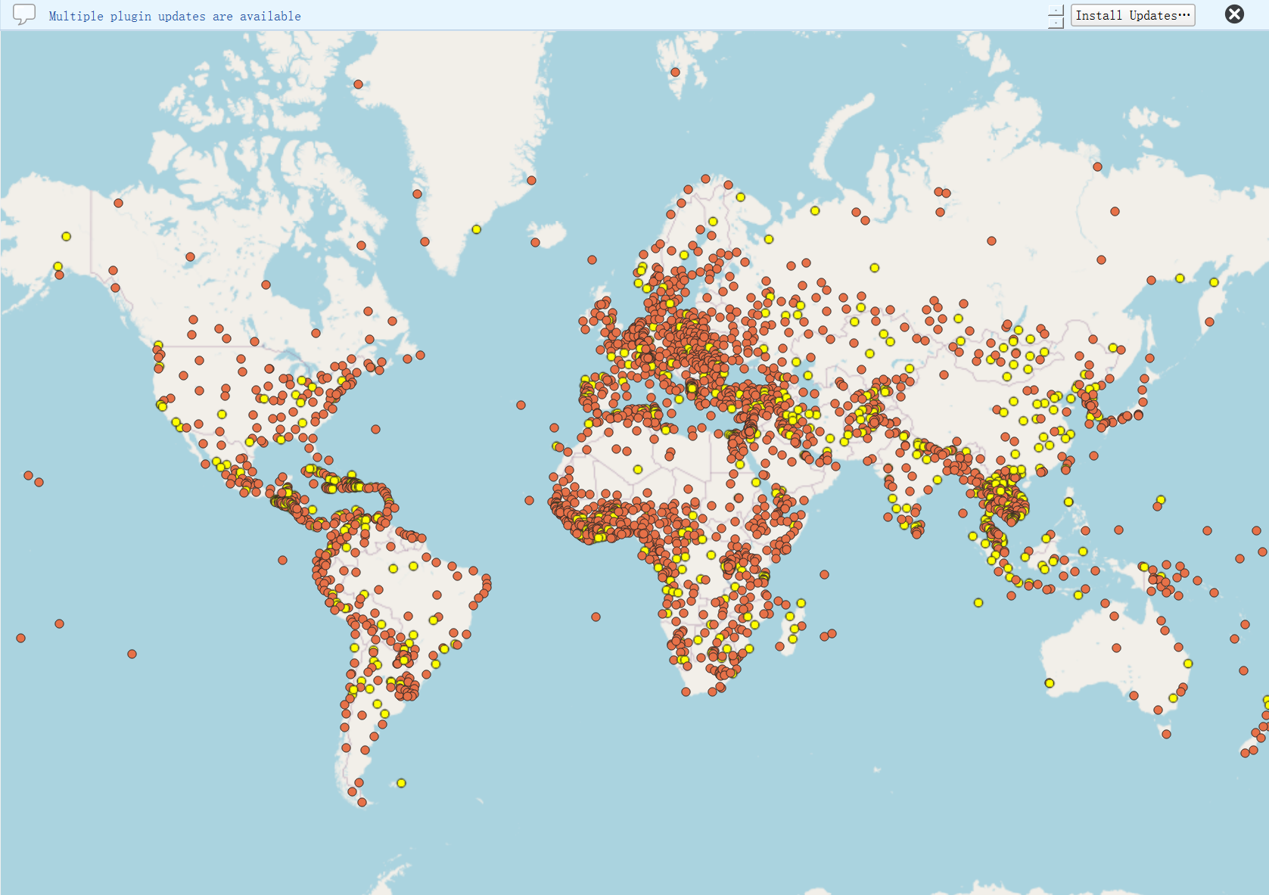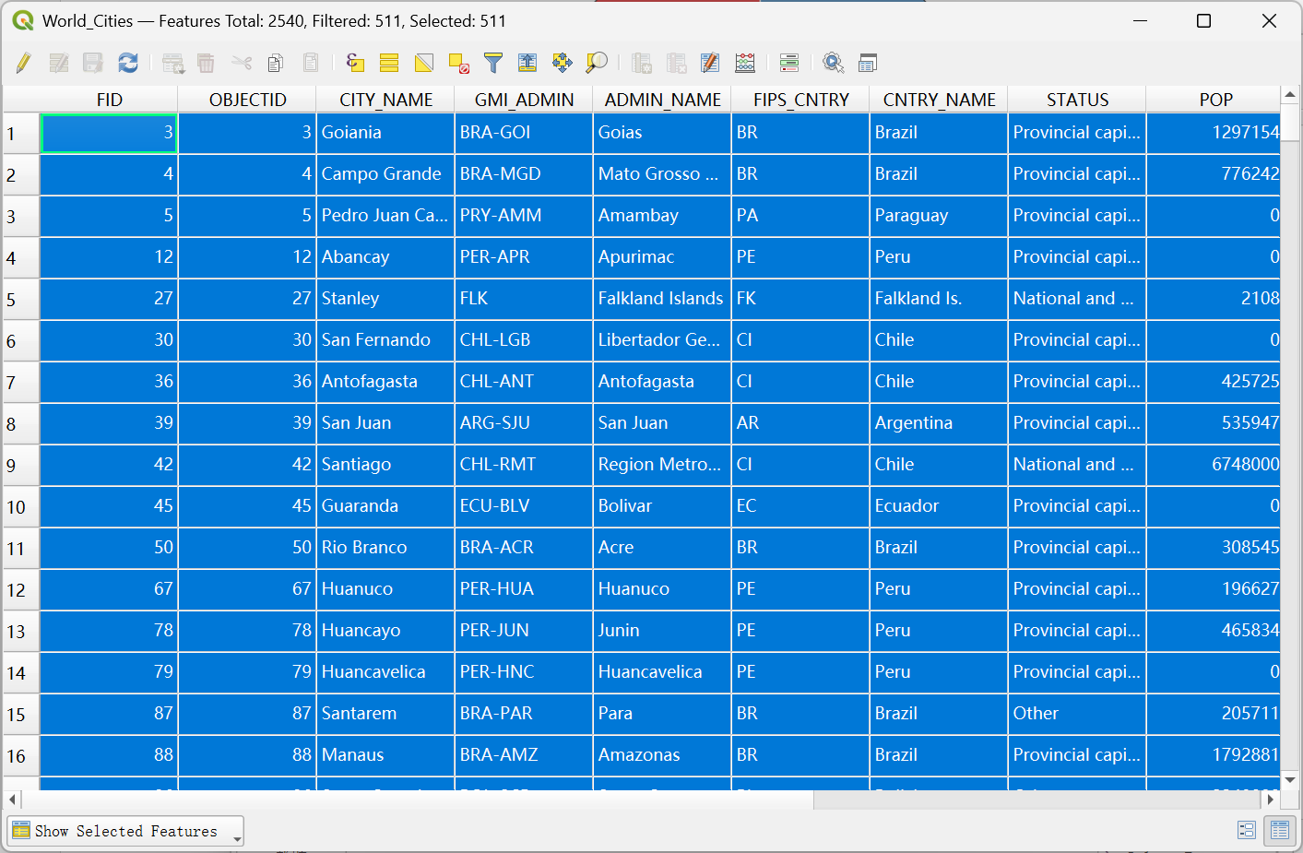

- 找出位于北半球又位于东半球，且人口(POP)大于一千万的城市；
$x > 0 and $y > 0 and "POP" > 10000000
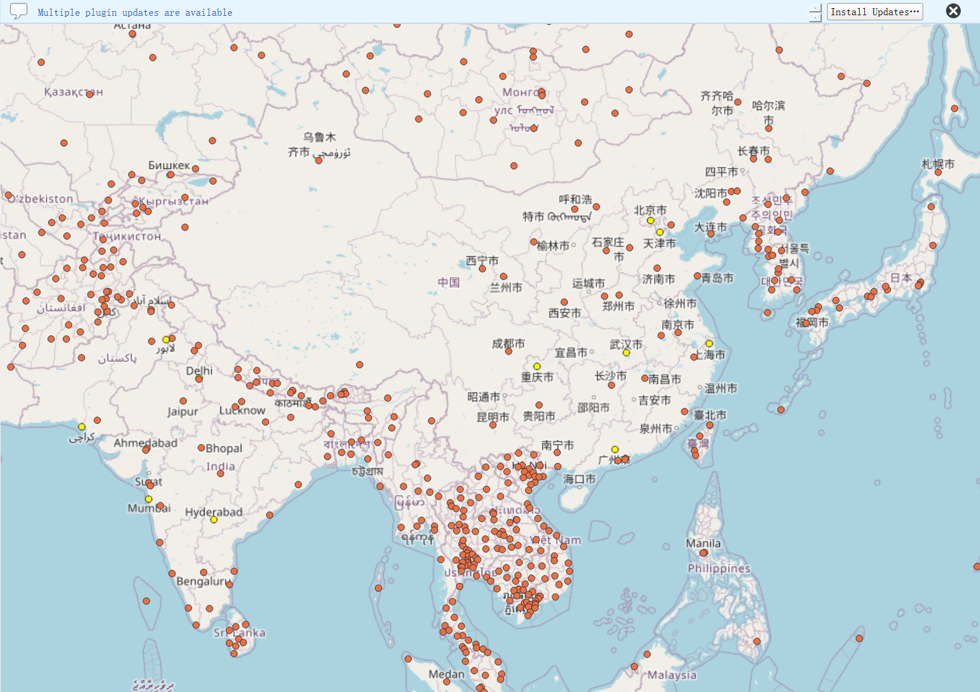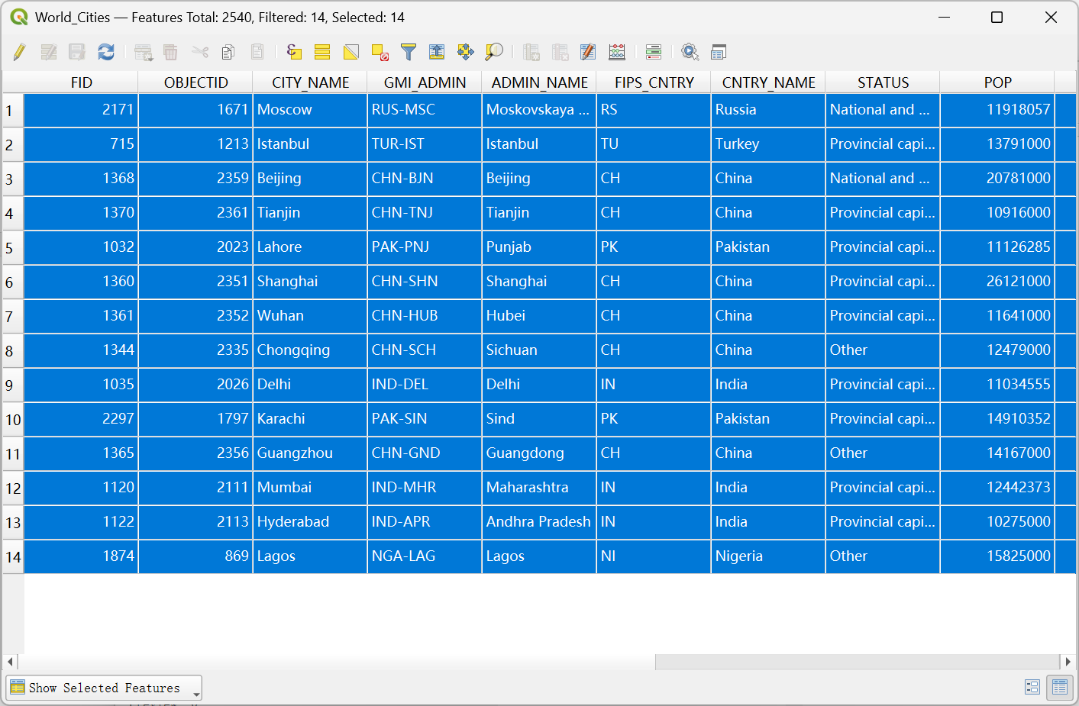
- 计算每个城市到赤道的最短球面距离（假设地球为正球体，半径6371公里）；
首先在属性表新建一列，命名“eq_dist”。
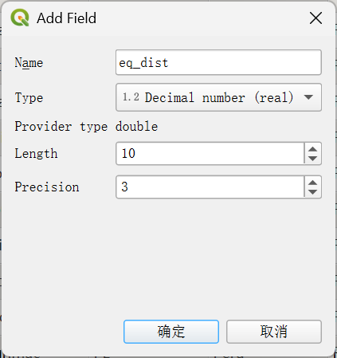
发现的World Cities图层在投影坐标系EPSG:3857下，所以需要对坐标进行转换，再使用弧长公式 $l=α×r$，最终公式为：
6371*abs(radians(y(transform($geometry,'EPSG:3857','EPSG:4326'))))，计算字段得到：
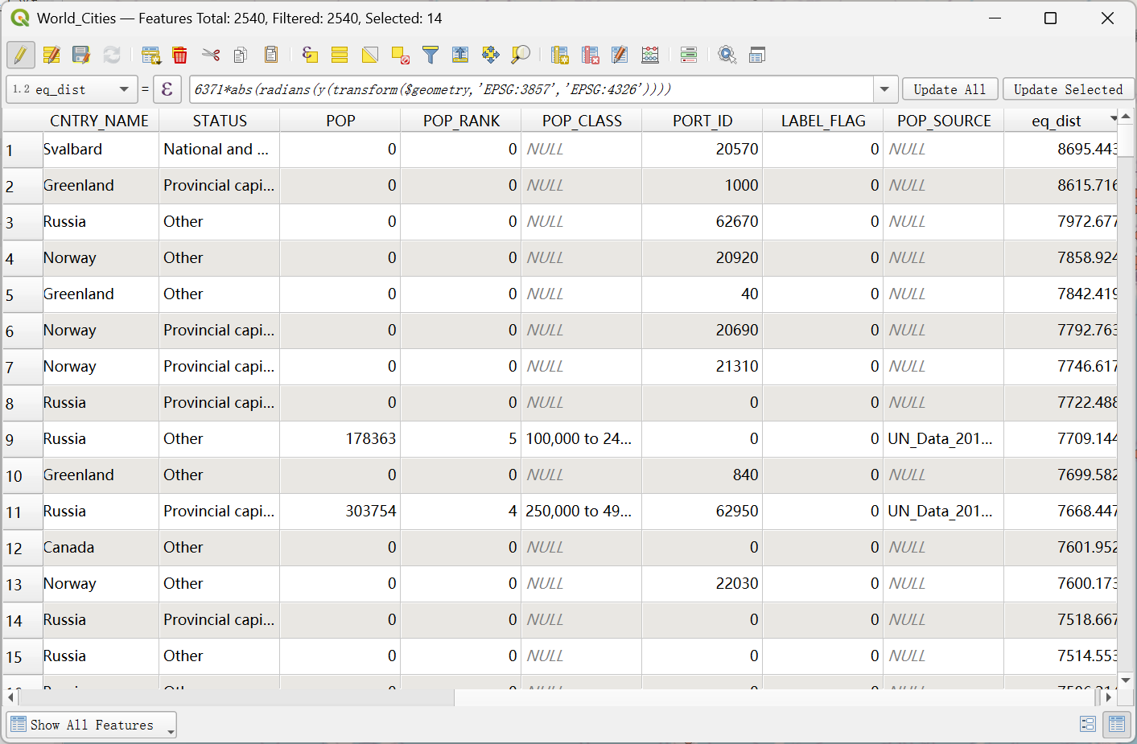
- 找出一年之中能被太阳直射且离上海市的距离不超过四千公里的城市。
和第三题一样，World Cities图层在投影坐标系EPSG:3857下，所以需要对坐标进行转换：
abs(y(transform($geometry,'EPSG:3857','EPSG:4326'))) <= 23.5
然后还要满足与上海的距离不超过4000 km (distance返回的单位为m，所以需要加三个0)，因此有：
distance($geometry, geometry(get_feature(@layer, 'CITY_NAME', 'Shanghai'))) <= 4000000
将这两个语句用and连接，运行后得到如下结果：
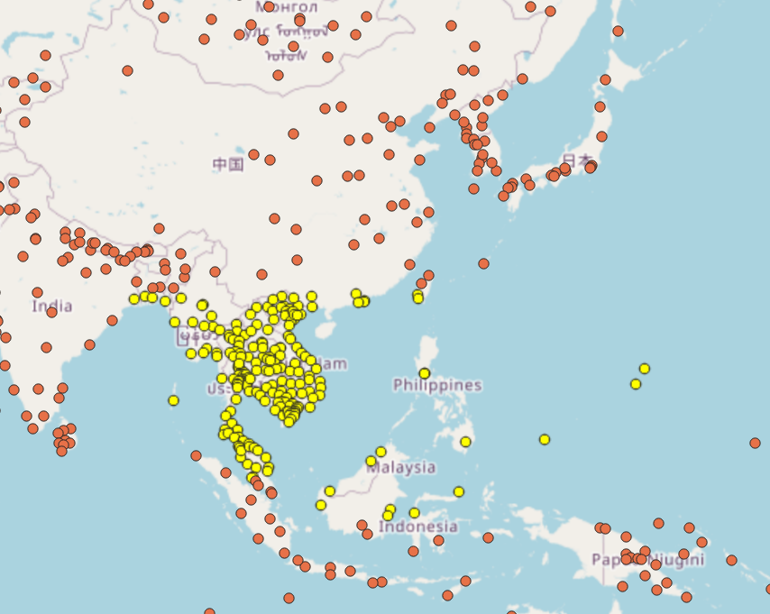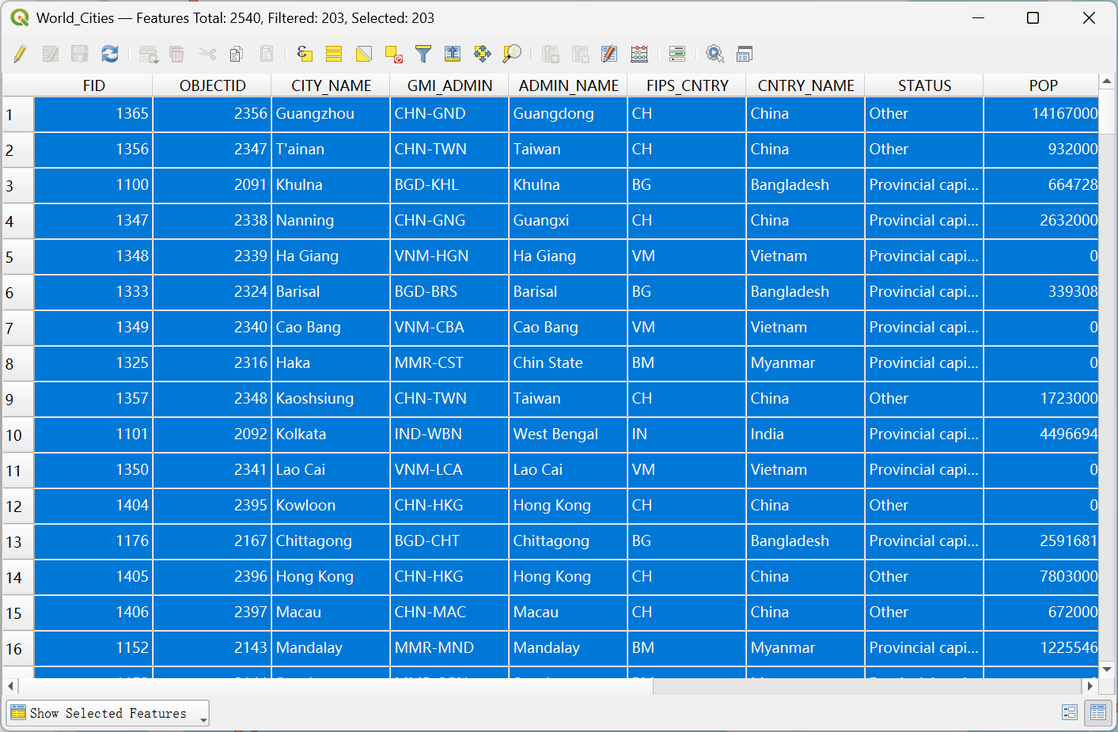
（3月26号24:00前提交）

