1.提供'Pâté chinois'的供货商来自哪一个国家和城市
select s.country, s.city from suppliers s join products p on s.supplierid = p.supplierid
where p.productname = 'Pâté chinois'
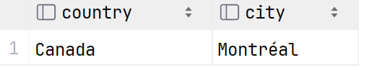
2.列出供货商公司名和主页，若主页为空值则显示‘无记录’
select companyname,
case when homepage is null then '无记录'
else homepage end as homepage from suppliers;
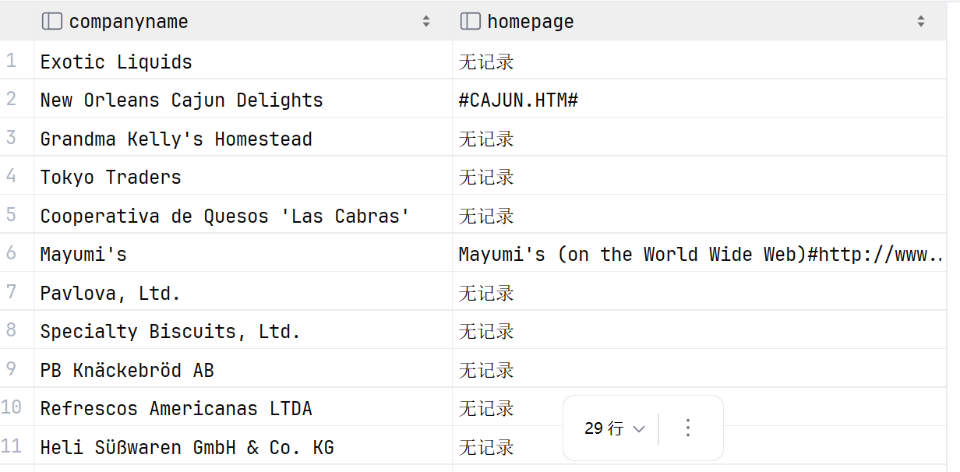
3.按订单号分组统计订单中产品的数目（按产品编号）
select orderid, count(productid) as product_count from order_details
group by orderid order by product_count desc;
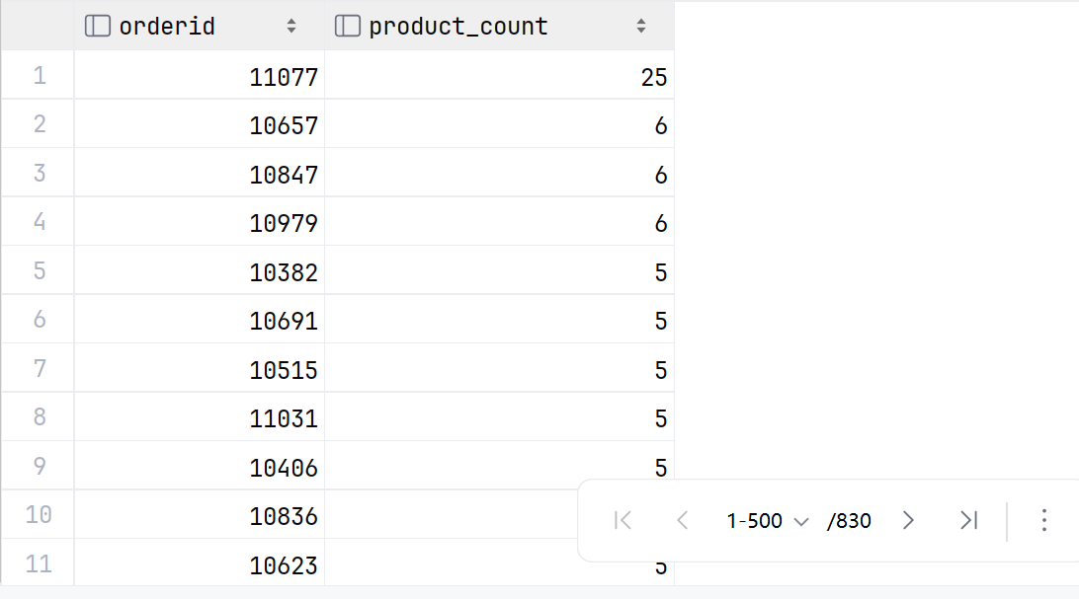
4.按订单号分组统计订单的金额（unitprice,quantity）
select orderid, round(sum(unitprice*quantity*(1-discount))::numeric, 2) as sum_price, sum(quantity) as sum_quantity from order_details group by orderid;
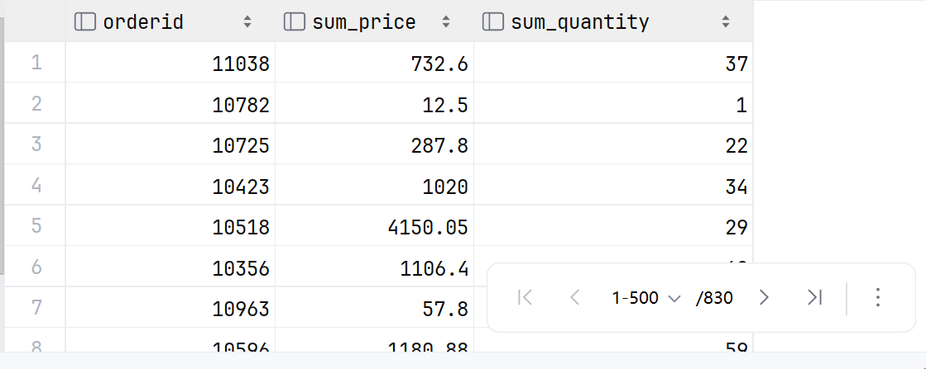
5.列出提供调味品的供货商公司名称
select distinct s.companyname from suppliers s
join products p on s.supplierid = p.supplierid
join categories c on p.categoryid = c.categoryid
where c.categoryname = 'Condiments';
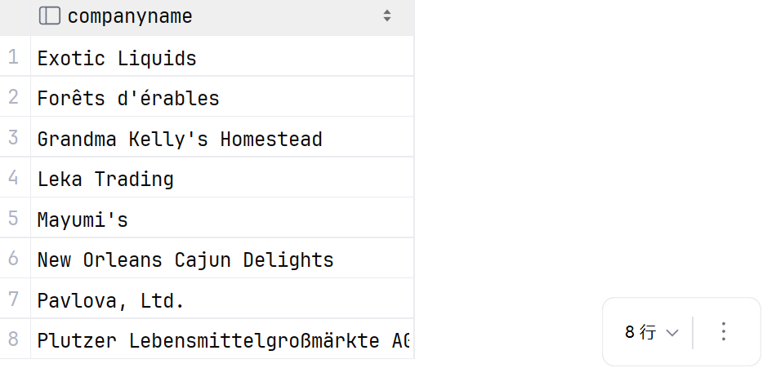
6.饮料类产品在产品表中的平均单价是多少
select avg(unitprice) as average_price from products p
join categories c on c.categoryid = p.categoryid
where c.categoryname = 'Beverages';
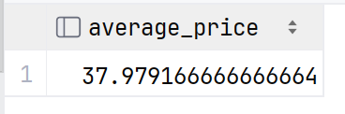

7.列出每一个产品的名称、与该产品同属一个类别且价格差异在10元以内的产品的个数
select p1.productname, count(p2.productid) as similar_price_count from products p1
join products p2 on p1.categoryid = p2.categoryid and p1.productid <> p2.productid
where abs(p1.unitprice - p2.unitprice) <=10 group by p1.productname order by similar_price_count desc;
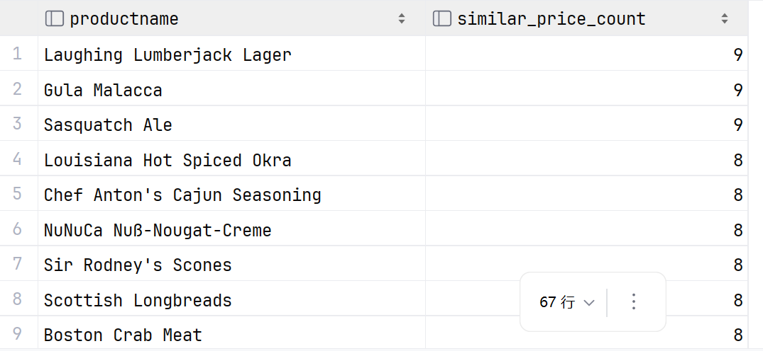
8.哪个国家的供货商们提供的产品类别最多
select s.country, count(distinct p.categoryid) from suppliers s join products p on s.supplierid = p.supplierid
group by s.country order by count(p.categoryid) desc limit 1;
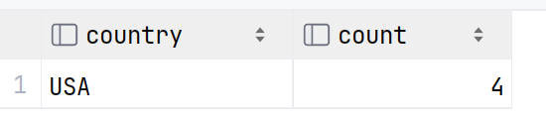
9.找出这样一个产品类别，提供该类别产品的供货商数量最多
select c.categoryname, count(distinct p.supplierid) as supplier_count from categories c
join products p on c.categoryid = p.categoryid
group by c.categoryname order by supplier_count desc limit 1;
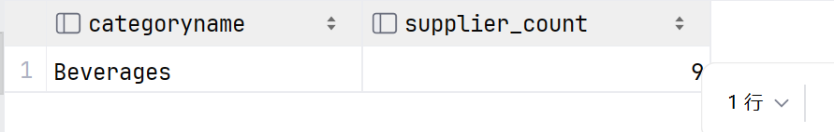
10.找出客户表中同名（可以不同姓）的联系人
select c1.contactname from customers c1
join customers c2 on c1.customerid <> c2.customerid and split_part(c1.contactname,' ',1) = split_part(c2.contactname,' ',1)
group by c1.contactname order by c1.contactname;
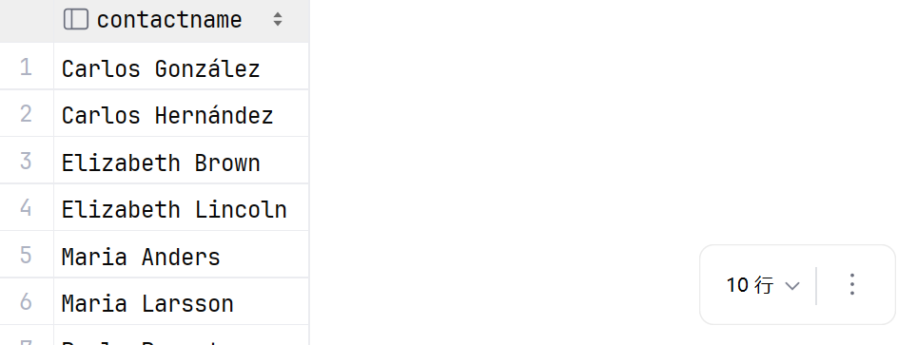
11.找出向Andrew Fuller汇报（reportsto）的员工
select e1.firstname || ' ' || e1.lastname as employee from employees e1
join employees e2 on e1.reportsto = e2.employeeid
where e2.firstname = 'Andrew' and e2.lastname = 'Fuller';
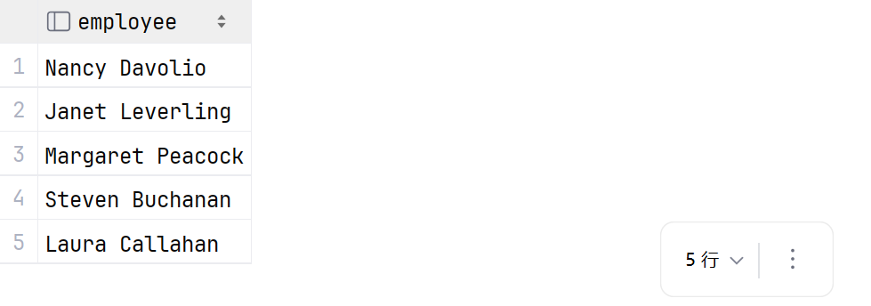
12.统计每个雇员入职以来一共过了多少天，按天数降序排列，同时显示雇员的firstname和年龄(只显示'年'),查看入职时间最长的雇员是否是年龄最大的
select current_date - hiredate as hire_days, firstname, extract(year from age(current_date, hiredate)) as age from employees
order by hire_days desc;
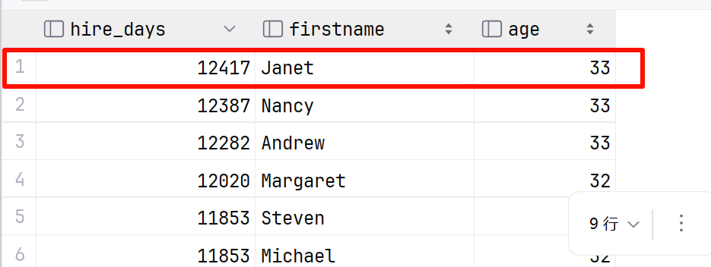
可以看到入职时间最长的雇员确实是年龄最大的。
13.统计每个雇员入职以来平均每天处理的订单数(保留到小数点后四位)，按数量降序排列
select e.firstname, e.lastname, round((count(o.orderid)::numeric/(current_date - e.hiredate)),4) as order_per_day from employees e
join orders o on e.employeeid = o.employeeid
group by e.employeeid, e.hiredate, e.firstname, e.lastname order by order_per_day desc;
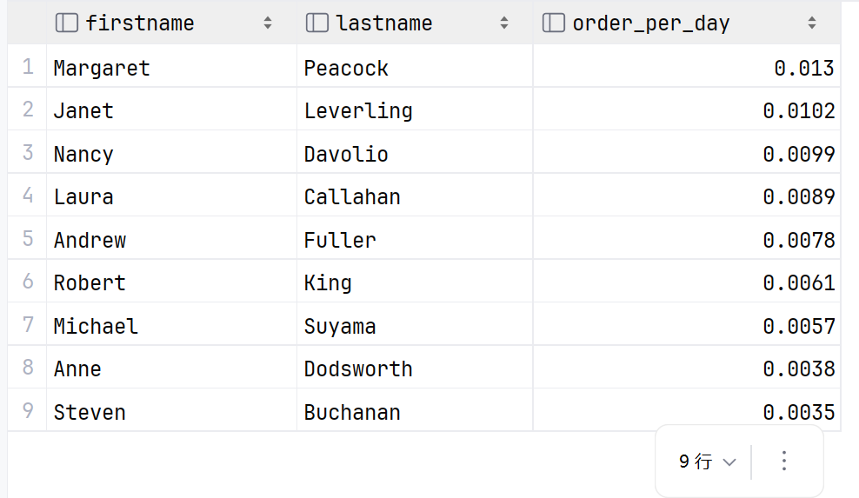
14.列出雇员的firstname以及比该雇员年轻的雇员的人数
select e1.firstname, count(e2.employeeid) as younger_employees from employees e1
join employees e2 on e2.birthdate > e1.birthdate
group by e1.firstname order by younger_employees desc;
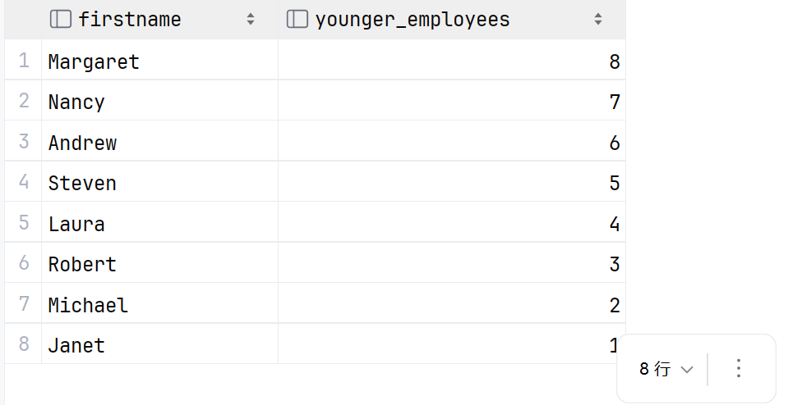
15.哪个国家的哪座城市同时驻有北风公司的雇员、客户公司和供货商公司(用两种方法)
select distinct s.country, s.city from suppliers s
join customers c on s.country = c.country and s.city = c.city
join employees e on s.country = e.country and s.city = e.city
group by s.country, s.city order by s.country, s.city;
select country, city from suppliers
intersect select country, city from customers
intersect select country, city from employees;
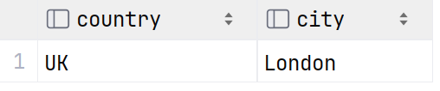
16.找出货运公司Speedy Express在1997-05-19至1998-02-19之间发往布宜诺斯艾利斯的产品名称以及收货客户的公司名与联系电话
select p.productname, c.companyname, c.phone from shippers s
join orders o on s.shipperid = o.shipvia
join customers c on o.customerid = c.customerid
join order_details od on o.orderid = od.orderid
join products p on od.productid = p.productid
where s.companyname = 'Speedy Express' and o.shipcity = 'Buenos Aires' and o.shippeddate between '1997-05-19' and '1998-02-19'
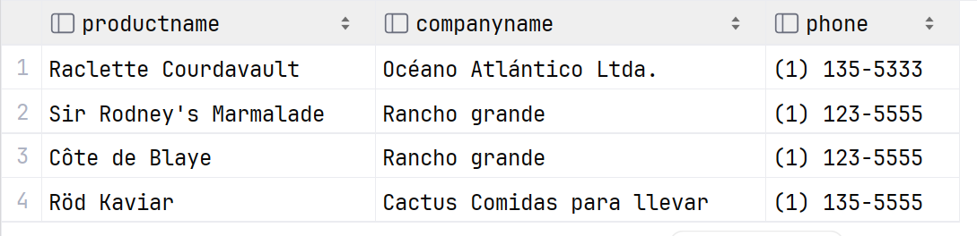
PHP
- 按照课件中的公式，写一个计算圆周率的函数
- <?php

- function calculatepi($n){
- $sum = 0;
- for($k=1; $k<=$n; $k++){
- $sum += 1/($k * $k);
- }
- $pi = sqrt(6 * $sum);
- return $pi;

- }
- $myPi = calculatepi(1000000);
- echo "计算出的pi值：" . $myPi;
- ?>

2.从上面选一道查询题，将查询结果显示在浏览器的页面中
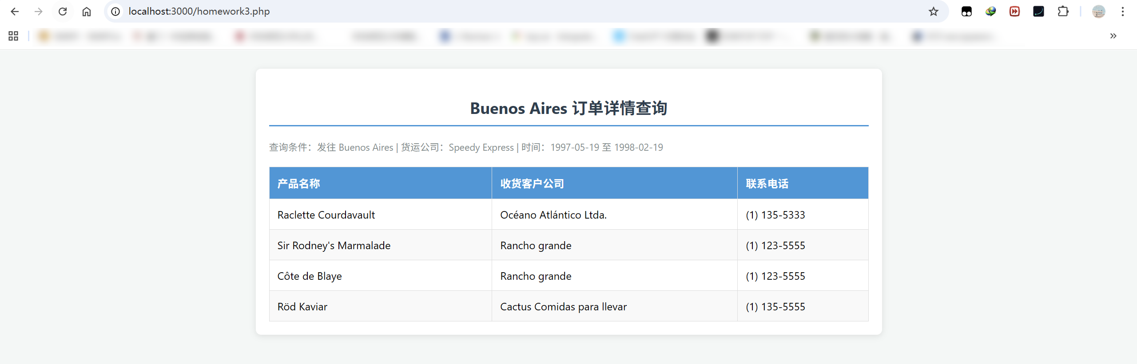
<?php
$host = "localhost";
$port = "5432";
$dbname = "postgres";
$user = "postgres";
$password = ❌️;
$conn_str = "host=$host port=$port dbname=$dbname user=$user password=$password";
$dbconn = pg_connect($conn_str);

$sql = "
SELECT
p.productname,
c.companyname,
c.phone
FROM shippers s
JOIN orders o ON s.shipperid = o.shipvia
JOIN customers c ON o.customerid = c.customerid
JOIN order_details od ON o.orderid = od.orderid
JOIN products p ON od.productid = p.productid
WHERE s.companyname = 'Speedy Express'
AND o.shipcity = 'Buenos Aires'
AND o.shippeddate BETWEEN '1997-05-19' AND '1998-02-19'
";
$result = pg_query($dbconn, $sql);
?>

<!DOCTYPE html>
<html lang="zh-CN">
<head>
<meta charset="UTF-8">
<title>Northwind 订单物流查询系统</title>
<style>
body { font-family: 'Segoe UI', Tahoma, Geneva, Verdana, sans-serif; background-color: #f4f7f6; padding: 20px; }
.container { max-width: 900px; margin: auto; background: white; padding: 20px; border-radius: 8px; box-shadow: 0 2px 10px rgba(0,0,0,0.1); }
h2 { color: #2c3e50; text-align: center; border-bottom: 2px solid #3498db; padding-bottom: 10px; }
table { border-collapse: collapse; width: 100%; margin-top: 20px; }
th, td { border: 1px solid #ddd; padding: 12px; text-align: left; }
th { background-color: #3498db; color: white; }
tr:nth-child(even) { background-color: #f9f9f9; }
tr:hover { background-color: #f1f1f1; }
.info { margin-bottom: 15px; font-size: 0.9em; color: #7f8c8d; }
</style>
</head>
<body>

<div class="container">
<h2>Buenos Aires 订单详情查询</h2>
<div class="info">
查询条件：发往 Buenos Aires | 货运公司：Speedy Express | 时间：1997-05-19 至 1998-02-19
</div>

<table>
<thead>
<tr>
<th>产品名称</th>
<th>收货客户公司</th>
<th>联系电话</th>
</tr>
</thead>
<tbody>
<?php
if (pg_num_rows($result) > 0) {
while ($row = pg_fetch_assoc($result)) {
echo "<tr>";
echo "<td>" . htmlspecialchars($row['productname']) . "</td>";
echo "<td>" . htmlspecialchars($row['companyname']) . "</td>";
echo "<td>" . htmlspecialchars($row['phone']) . "</td>";
echo "</tr>";
}
} else {
echo "<tr><td colspan='3' style='text-align:center;'>未找到符合条件的记录</td></tr>";
}
?>
</tbody>
</table>
</div>

</body>
</html>
<?php
pg_free_result($result);
pg_close($dbconn);
?>

（4月3号24:00前提交，文件名中加上姓名）

