Samuel Stall

COP3530

Section: 1087

10/17/17

HW5

*On my honor, I have neither given nor received unauthorized aid in doing this assignment*

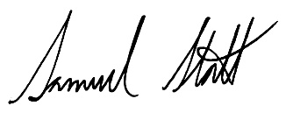

I learned how to process an array given the array begin address and end address, using a stack to evaluate each level of a tournament tree, and making packed array representation of a tournament tree. The most difficult part was converting the array addresses to an actual array, the easy part was constructing the levels of the tree and converting that into the final packed array. I believe the learning objectives was learning to construct a tournament tree in packed array representation and I think I achieved them with an efficient algorithm.

Samuel Stall

COP3530

10/17/17

HW5

1. Does the program compile without errors?

Yes.

1. Does the program compile without warnings?

Yes.

1. Does the program run without crashing?

Yes.

1. Describe how you tested the program.

I tested the program with two arrays, {50, 5, 3, 4, 20, 9, 100} and {60, 4, 1000, 251, 43, 56, 67, 67, 89, 1000}. Then printing out the returned array. I also tested the program with Valgrind to assure that all memory was properly deallocated.

1. Describe the ways in which the program does not meet assignment's specifications.

This program meets the assignment’s specifications.

1. Describe all known and suspected bugs.

If the array addresses that are passed are invalid, there is no check so unexpected behavior can occur.

1. Does the program run correctly?

Yes.

Program output: