Microsoft Dynamics
Customer Solution Case Study
 | 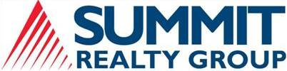 |  |   Real-Estate Leader Uses CRM to Empower Brokers and Enhance Client Services

Overview  Country or Region: United States  Industry: Professional services—Real estate  Customer Profile  Summit Realty Group, a member of the Cushman & Wakefield Alliance, provides commercial real-estate services to clients in the Indianapolis, Indiana, metropolitan area.  Business Situation  The company wanted to make its brokers more effective, make the business more manageable, and ensure delivery of consistently excellent client services.  Solution  Summit implemented Real Estate Advantage by Ascendix Technologies, a solution based on Microsoft Dynamics CRM, to replace cumbersome and outdated software tools.  Benefits  - Enable employees to work more effectively  - Manage business for best results  - Offer faster, more detailed customer service |  |  | “By using Real Estate Advantage, which is based on Microsoft Dynamics CRM, we’ve strengthened our ability to deliver outstanding service by freeing up brokers to spend more time securing the optimum tenants for our landlord clients and securing the optimum property or lease agreement for our tenant clients.”  Bill Ehret, President and CEO, Summit Realty Group
 |  |  | A leading provider of commercial real-estate services, Summit Realty Group wanted to provide the best possible service levels and simplify broker operations. An older customer relationship management system was cumbersome to use, poorly accepted, and not integrated with the company’s other business tools. It was hard to gauge business performance and not always possible to ensure completion of important tasks. Summit engaged with Microsoft Gold Certified Partner Ascendix Technologies to implement Real Estate Advantage, a solution based on Microsoft Dynamics CRM and optimized for real-estate services. Today, almost all of the company’s brokers use the highly intuitive, efficient solution to focus solely on helping clients. Managers can direct the business based on real-time information, and extensive automation helps ensure that the company acts on all business and service opportunities.
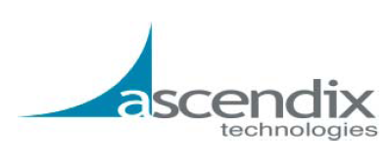 |  |  | 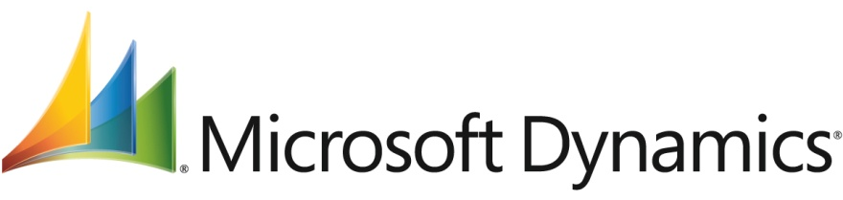

Situation
Summit Realty Group is a top-tier commercial real-estate firm based in Indianapolis, Indiana, and part of the Cushman & Wakefield Alliance. The company employs 39 people, including 24 real-estate brokers, to provide comprehensive services—such as leasing and management, site acquisition, market research, and marketing and design support—to its clients.
“For myself, I like being able to know exactly where we are at the end of each day in terms of our revenue goals so that I can direct the business in the right way.”
Bill Ehret, President and CEO,
Summit Realty Group

Looking to centralize account information and foster collaboration among its team members, Summit deployed a customer relationship management solution from REApplications. However, this system never lived up to its full potential because it did not synchronize with Microsoft Outlook, which was the application that brokers used to communicate with clients and prospects. Instead, to record information toward a project, brokers would have to log on to the customer relationship management solution, find the appropriate account, and then perform a copy-and-paste operation or key in that data. The customer relationship management solution also offered limited customization and reporting functionality, often forcing employees at Summit to create disconnected spreadsheets in Microsoft Excel to track broker performance or other account information.

“Today, email is the dominant communication platform,” says Bill Ehret, President and CEO of Summit Realty Group. “We need to track all communication associated with a transaction, but it was too large a burden for our brokers to constantly have to log on to the customer relationship management system to record activities. Because of this, our adoption rate was poor; less than half of our brokers were using the system.”
To obtain a unified, up-to-date view of its business, Summit realized it had to find a new customer relationship management solution that would dramatically lower the barrier to adoption for brokers. Company executives started researching solutions online and at trade shows and focused on solutions that were specific to the commercial real-estate industry and worked closely with Outlook.

Solution
Summit Realty Group discovered Microsoft Gold Certified Partner Ascendix Technologies’s Real Estate Advantage solution through online research and was intrigued by how it took advantage of the Outlook interface. “We called Ascendix Technologies to find out more about Real Estate Advantage and found that the solution fit our main requirement excellently, primarily because of its close integrations with Outlook,” says Ehret. “We also appreciated the flexibility of the technology in that it could link to other systems, such as the Cushman & Wakefield property database.”

The Real Estate Advantage solution from Ascendix Technologies is built on Microsoft Dynamics CRM to offer functionality tailored for the commercial real-estate industry. “A lot of firms we talk to think that getting all their client information on a single system is not possible,” says Wes Snow, President and CEO of Ascendix Technologies. “But because our solution is built into the Outlook interface and works with tasks and calendaring, it does a lot to break down barriers to sharing information. It’s a tool that has the potential to help shape your company culture.”

Strong Executive Support and
Focused Training
After Summit made the decision to implement Real Estate Advantage, Ascendix Technologies worked with a team of Summit employees, including senior management, to define the requirements for the new solution. “Ascendix Technologies made it clear that executive buy-in was crucial. We needed to clearly demonstrate our support for the new project for it to succeed,” says Ehret. “I took this to heart and tried to show our brokers, ‘I’m not going to ask you to do anything that I’m not also doing.’”

Ascendix Technologies helped Summit convert its historical data, configure the solution, and create dashboards for the company, team, and individual roles. When the time drew near for the solution to go live, Summit used its annual company retreat event to train everyone on the new system.

Automation to Simplify Business and Opportunity Management
Summit uses workflows in the new solution to automate tasks that previously depended on informal communication among the people responsible. For example, when a broker closes a deal and it is recorded in the system, an alert is automatically sent to accounting to create an invoice. Or, when clients sign an agreement with Summit to list their property, the system automatically sends a series of email messages to the appropriate people responsible for posting the property in listing services and creating marketing collateral. Real Estate Advantage tracks the completion of all these tasks.
Summit Realty Group provides commercial real-estate services to clients in the Indianapolis, Indiana, metropolitan area.

“When we sign a lease agreement and it is recorded in Real Estate Advantage, we receive reminders about an upcoming lease expiration 6 months and 11 months later,” says Ehret. “The solution automates reminders and tasks to help us not miss any opportunity.”

The new solution also helps Summit take a more disciplined approach to marketing. Whereas people in the marketing department previously had to compile segmented lists of customers in Excel, they can now automatically create updated lists by using Real Estate Advantage, which categorizes contacts by such criteria as industry, client type, and deal size.

“Previously, customer data was stored in separate applications,” says Susie Viehmann, Vice President of Marketing and Business Development at Summit. “Real Estate Advantage now serves as a central repository for information, saving time and eliminating confusion about what data is stored where.”

Efficient, Personalized Reporting for Executives and Clients
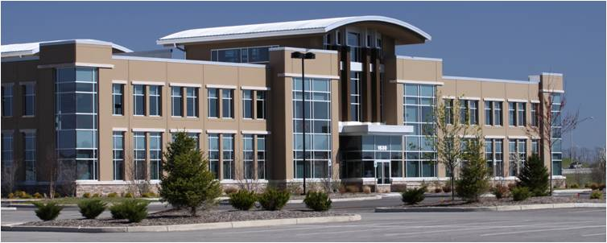
Brokers can quickly assess their performance through personal dashboards that show their individual goals, those of other brokers on the team, and up-to-date activity. Similarly, executives can get an overview of company performance by looking at the company scoreboard, which shows goals, current performance, historical performance, pending transactions, and other critical indicators.

“A tab in Real Estate Advantage called Executive Reports helps me gain insight into where our company has been historically and where we might be headed,” says Ehret. “I can compare sales volume month by month and year by year.”

Real Estate Advantage helps brokers prepare reports for clients who expect periodic reports on what Summit is doing to market and lease space in their buildings. Previously, pulling together the data for these reports consumed a significant amount of brokers’ time because they needed to comb through records in Outlook and spreadsheets in Excel. Now, because all Summit brokers enter information into a single, shared system, they can create accurate and comprehensive reports much faster than before.

The solution pulls together market data so that Summit employees can make informed decisions on behalf of tenants or landlords. “Real Estate Advantage brings together an abundance of market intelligence in one place,” says Viehmann. “When investigating a property, we can quickly see important details, such as the owner, management company, space available, average rental rate, and operating expenses. These details give us an edge when negotiating on behalf of our clients.”
“Less than half of our employees used the previous system’s key functions. Now, we have 90 percent of our brokers using all the core modules of Real Estate Advantage because the barrier to adoption is far lower.”
Bill Ehret, President and CEO,
Summit Realty Group

Benefits
Real Estate Advantage built on Microsoft Dynamics CRM equips Summit Realty Group with a single view of data and activity across its brokerage, marketing, accounting, and executive management groups. Everyone in the company now shares information for customers and properties, project management, marketing campaigns, and business performance and projections.

In addition, Summit has dramatically increased the adoption rate for its customer relationship management solution. Because people use the solution in the course of their daily work activities, the entire company shares accurate and up-to-date information.

“When we chose Real Estate Advantage, it was because it addressed our immediate and future needs,” says Ehret. “The underlying technology of Microsoft Dynamics CRM is flexible and can accommodate our future growth. The solution is of great value and will continue to be critical to our success for years to come.”

Enable Employees to Work More Effectively
Summit’s entire firm now uses the solution because it fits into their regular way of doing things. “Less than half of our employees used the previous system’s key functions,” says Ehret. “Now, we have 90 percent of our brokers using all the core modules of Real Estate Advantage because the barrier to adoption is far lower.”

Ehret points out that in the old system, users needed as many as five mouse clicks to enter transactional data in a separate system. Now, they can enter that same data in Real Estate Advantage with just one mouse click.

Manage Business for Best Results
Real Estate Advantage built on Microsoft Dynamics CRM provides Summit brokers and managers with the business insight they need to make better-informed decisions. Everyone has a shared view of deals that are in the pipeline and the progress of those transactions from early stages to closure. Managers can drill deeper into information to see activity according to industry type, size of the deal, or other measures.
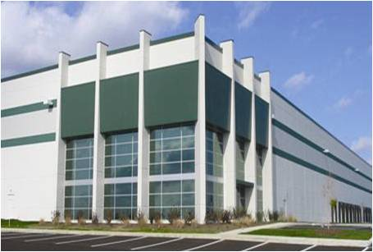
Real Estate Advantage helps brokers secure the best deals for their tenant or landlord clients.
“Our brokers now have greater visibility into where they are, relative to their revenue goals, and where they stand, relative to their team,” says Ehret. “This helps them work in a more goal-oriented manner. For myself, I like being able to know exactly where we are at the end of each day in terms of our revenue goals so that I can direct the business in the right way. Previously, we wouldn’t know how we were performing until the end of the month or quarter.”

Offer Faster, More Detailed
Customer Service
One of Summit’s core value propositions is specialized, personal service for clients. Says Ehret, “By using Real Estate Advantage, which is based on Microsoft Dynamics CRM, we’ve strengthened our ability to deliver outstanding service by freeing up brokers to spend more time securing the optimum tenants for our landlord clients and securing the optimum property or lease agreement for our tenant clients.” Brokers now have information at the ready, which enables them to spend less time preparing materials for clients. When preparing client reports, brokers simply select a few criteria, such as date range and client, and generate a report.

Summit can also manage properties more proactively with the new solution. The new solution automatically tracks project tasks and other key events, and helps to coordinate activity among different groups. “Real Estate Advantage helps us provide more consistent service to tenants and address issues before they become problems,” says Viehmann.

Additional Resources
- Learn about Microsoft Dynamics CRM for professional services organizations.
- Participate in Microsoft Dynamics CRM communities.
- Hear about other customers’ successes with Microsoft Dynamics CRM.

Microsoft Dynamics
Software and Services  - Microsoft Dynamics  - Microsoft Dynamics CRM | Partners  - Ascendix Technologies

This case study is for informational purposes only. MICROSOFT MAKES NO WARRANTIES, EXPRESS OR IMPLIED, IN THIS SUMMARY.

Document published June 2010

For More Information
For more information about Microsoft products and services, call the Microsoft Sales Information Center at (800) 426-9400. In Canada, call the Microsoft Canada Information Centre at (877) 568-2495. Customers in the United States and Canada who are deaf or hard-of-hearing can reach Microsoft text telephone (TTY/TDD) services at (800) 892-5234. Outside the 50 United States and Canada, please contact your local Microsoft subsidiary. To access information using the World Wide Web, go to:
www.microsoft.com

For more information about Summit Realty Group products and services, call (317) 713-2100 or visit the website at:
www.summitrealtygroup.com

For more information about Ascendix Technologies products and services, call (972) 889-8090 x280 or visit the website at:
www.ascendix.com
Microsoft Dynamics is a line of integrated, adaptable business management solutions that enables you and your people to make business decisions with greater confidence. Microsoft Dynamics works like familiar Microsoft software such as Microsoft Office, which means less of a learning curve for your people, so they can get up and running quickly and focus on what’s most important. And because it is from Microsoft, it easily works with the systems that your company already has implemented. By automating and streamlining financial, customer relationship, and supply chain processes, Microsoft Dynamics brings together people, processes, and technologies, increasing the productivity and effectiveness of your business, and helping you drive business success.

For more information about Microsoft Dynamics, go to:
www.microsoft.com/dynamics

