Artificial Evolution Phase 1 Summary Report
Academic-style technical summary of the system design and Experiments 1-31
Project directory: C:\artificial-evolution
Prepared on: 2026-05-10 16:28
Document type: technical report for academic reference

Abstract
This report summarizes Phase 1 of the Artificial Evolution project. The study asked whether efficient body plans and lineage-capable agent strategies could emerge under strict constraints of energy, danger, reproduction, and ecological unevenness. The implementation evolved from a simple body-comparison simulation into a layered system that included world zones, day/night, seasons, life stages, family support, nest construction, food storage, hunting, cooking, tool crafting, persistent roles, and trait-based behavioral specialization. The central result is that Experiment 31 produced 50 body types that both survived and produced mature offspring without lowering world difficulty. Final bodies recorded between 497 and 536 births and between 260 and 299 mature offspring.

Research Question and Objectives
The core research question was whether efficient survival structures could emerge naturally under environmental and energetic pressure. Phase 1 translated that question into three operational goals: to build a world harsh enough to make ecological trade-offs meaningful, to shift evaluation from individual survival to lineage survival, and to document each design and experimental change in a reproducible technical archive.

Core System Components
The world is a 100x100 grid divided into four ecological zones: Safe Low Food, Safe High Food, Danger High Food, and Danger Low Food, together with day/night vision loss and seasonal food shifts. Body design begins with a 100-point budget distributed across sensor, muscle, armor, and brain. Later work added continuous and hidden traits such as brain capacity, memory retention, planning focus, cooperation drive, parenting instinct, curiosity, fear, aggression, metabolism rate, and plant/meat efficiency. This made behaviorally distinct lineages possible even when morphology remained similar.

Experimental Progression Across Experiments 1-31
Experiments 1-18 established the ecological and behavioral baseline by adding memory, cooperation, life stages, parental care, multi-stage food, herd hunting, family identity, nests, storage, memory maps, tools, and persistent social roles. Despite this richness, the system still failed to cross the barrier created by child isolation and the absence of stable surplus. Experiments 19-26 focused on structural bottlenecks: path scoring was fixed, founders became adults, cooperative nest founding was enabled, high-brain cohorts spawned as local bands, and planned safe-site nest construction was allowed through cognition and labor. Experiment 26 produced the first lineage-capable body. Experiments 27-31 then expanded the search space through multi-seed search, scalable lineage search, and trait-space variants, culminating in 50 successful body types in Experiment 31.

Final Phase 1 Findings
Experiment 31 yielded 50 lineage-capable body types. Mean births per successful body were 516.5, mean mature offspring were 279.5, and mean achieved survivors were 50.0. The strongest pattern is that all successful bodies remained concentrated in a narrow morphology corridor: sensor=0, muscle=0, armor=1, brain=3. Diversity was therefore not initially morphological but trait-driven. Successful lineages split evenly into two dominant families, social_planner and nurturing_settler, with variants such as secure_reproducer, dense_storage, child_guard, and broad_memory further widening the viable trait space.

Academic Interpretation
Phase 1 suggests that this world rewards settlement-centered lineage strategies more strongly than maximal speed, strength, or vision. Brains become adaptive only when they create ecological structure: memory-guided routing, safe-site nesting, food storage, care for children, and coordinated use of tools and groups. The project therefore supports a nuanced answer to the research question: efficient survival structures do emerge naturally, but in this world they first appear as a narrow viability corridor and only later broaden through structured trait-space exploration around that corridor.

Key Milestones
Experiment | Focus | Qualified | Candidates | Interpretation
1 | Danger/food baseline | 0 | 188 | No lineage-capable body yet
9 | Cooked food + herd prey | 0 | 189 | Resource pressure intensified
19 | Path bug fix + matured-child metric | 0 | 189 | Lineage became measurable
26 | Planned safe-site nest construction | 1 | 189 | First lineage-capable body
27 | Multi-seed distinct-search | 1 | 2079 | Viability concentrated in one niche
30 | Trait-space variant expansion | 20 | 1528 | Diversity expansion began
31 | Massive lineage search | 50 | 1558 | Target reached

Representative Successful Bodies
Body | Profile | Births | Matured | Achieved
body_14 | nurturing_settler | 536 | 299 | 50
body_8 | social_planner | 497 | 260 | 50

Figures
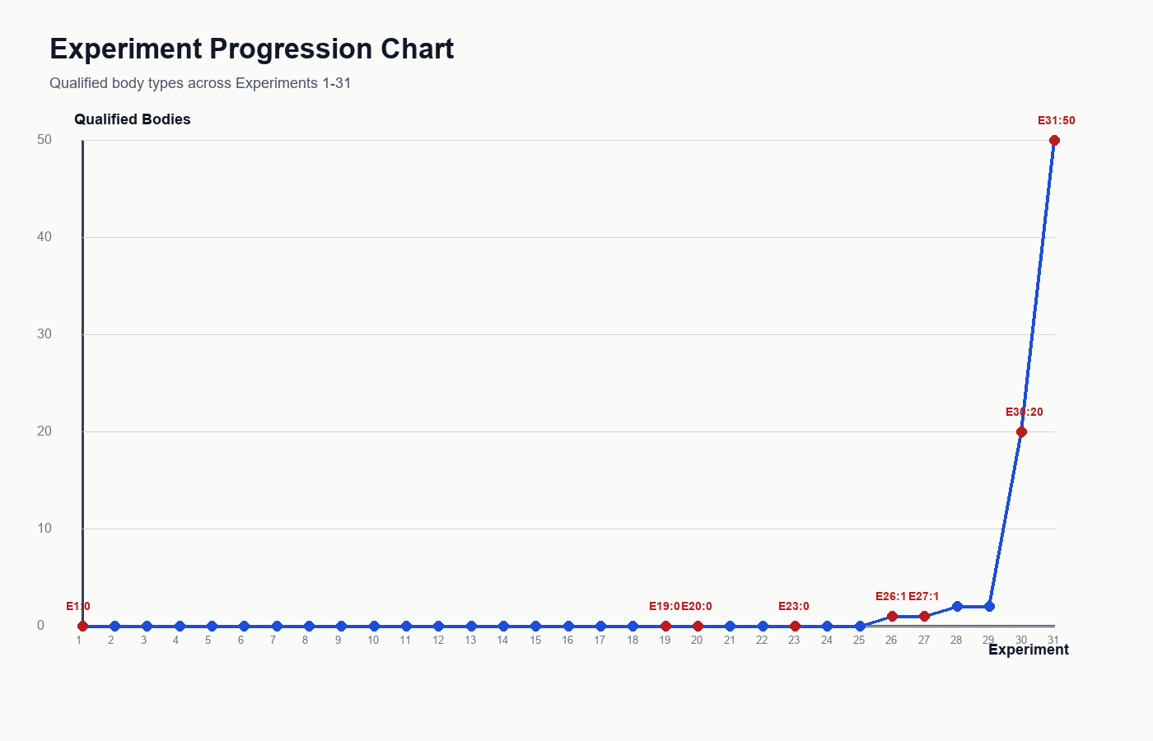
Figure 1. Experiment progression and breakthrough moments.
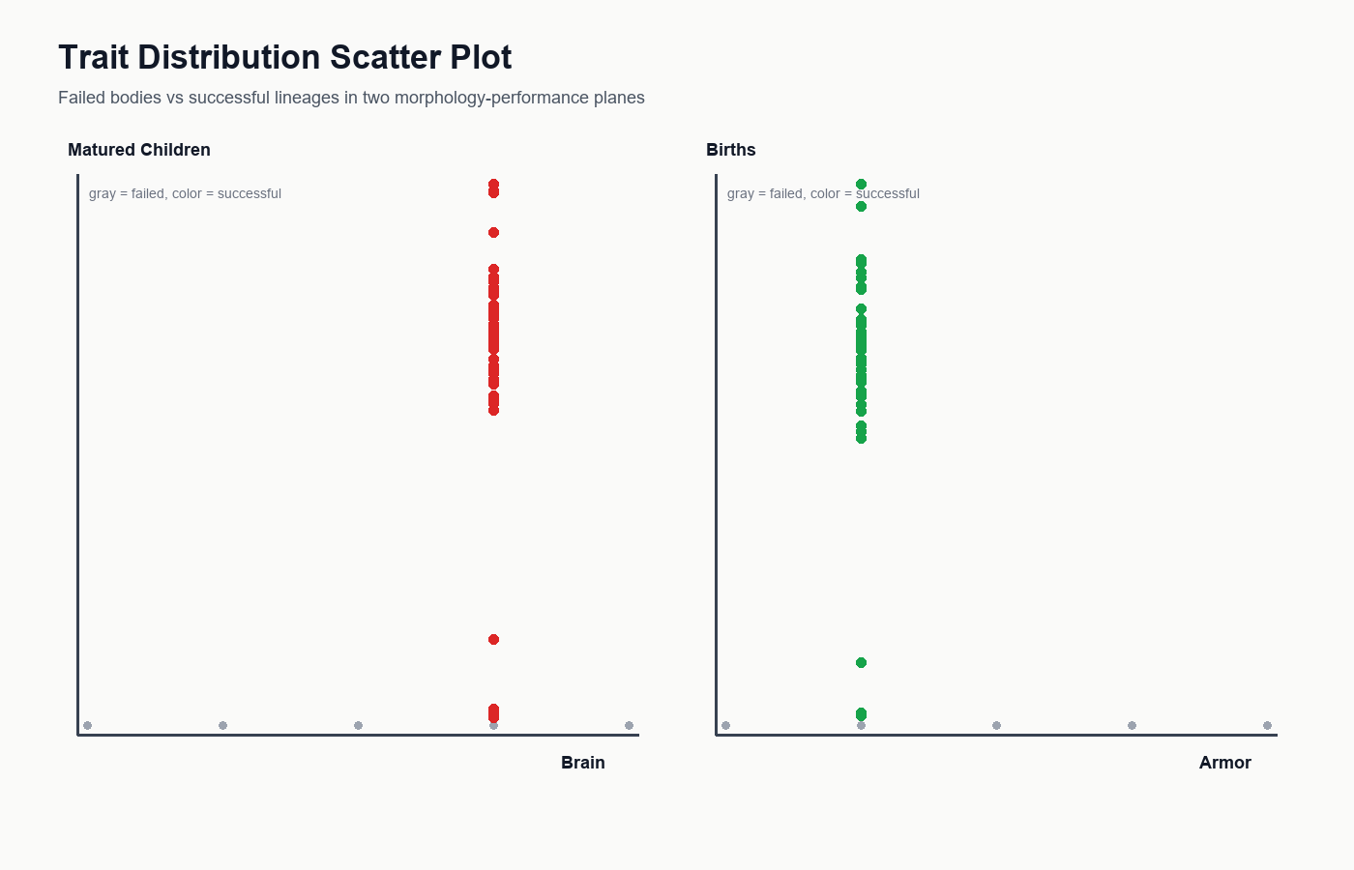
Figure 2. Trait-performance scatter showing the morphology corridor.
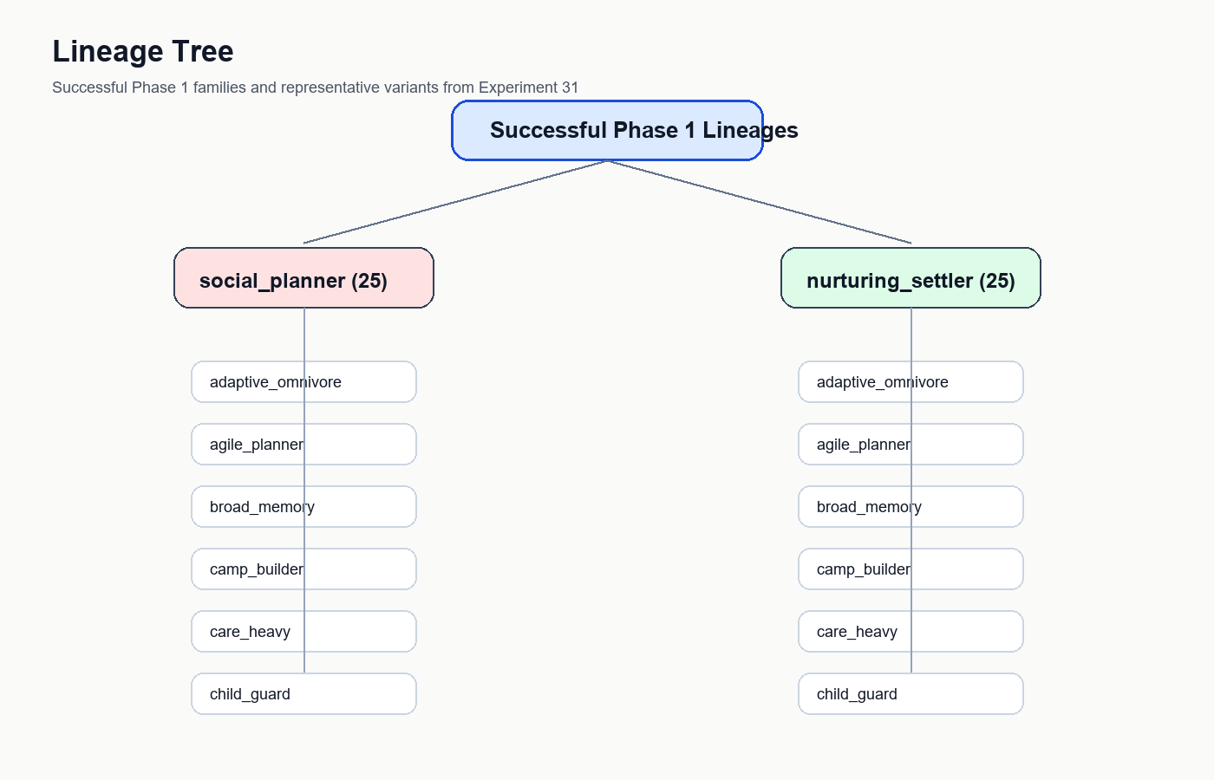
Figure 3. Successful lineage families and representative variants.
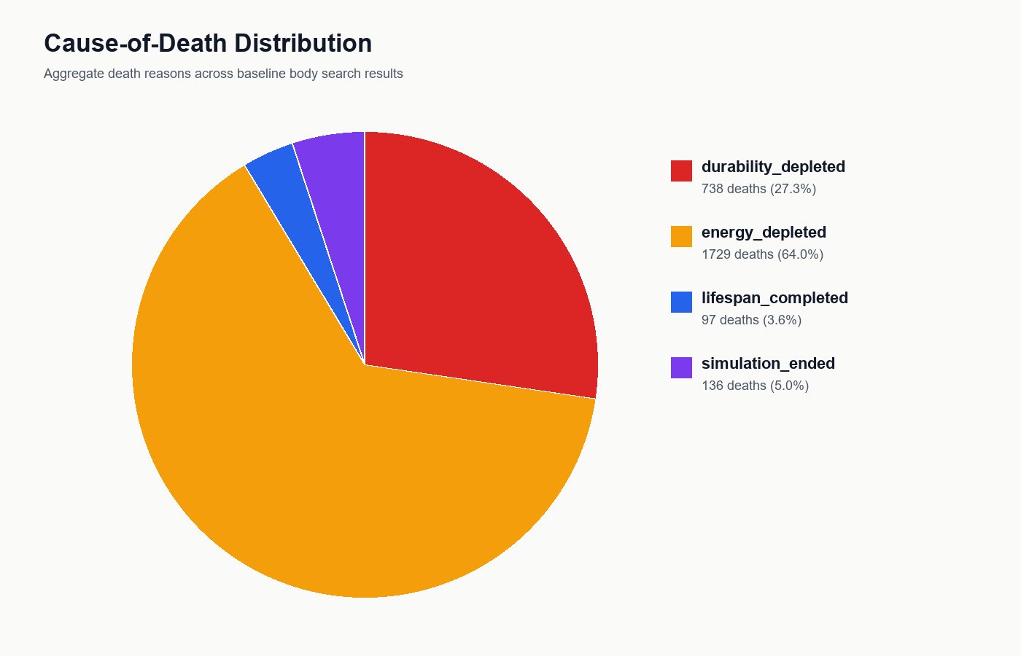
Figure 4. Aggregate cause-of-death distribution in the body search baseline.

Appendix Note
This split-language document omits the full appendix timeline for layout stability. The complete experiment-by-experiment archive remains available in data/experiment_history.json and data/experiments/experiment_001.md through experiment_031.md.

