Random RVE Generator User’s Manual
Written by Scott Stapleton
If you use this in a publication, please cite:
Husseini, J.F., Pineda, E.J., Stapleton, S.E., “Generation of artificial 2-D fiber reinforced composite microstructures with statistically equivalent features” Composite Part A: Applied Science and Manufacturing, Vol. 164, 2023. doi: 10.1016/j.compositesa.2022.107260
Stapleton, S. E., Appel, L., Simon, J-W., and Reese, S., “Representative Volume Element for Parallel Fiber Bundles: Model and Size Convergence,” Composites Part A, 2016. DOI: 10.1016/j.compositesa.2016.04.018

Input Files
General format: program is run via text input files. Output can be requested in the form of .csv files with fiber positions/radii only or a file of the generation process to be read by PlotFDEM (_all).

Sample Input File:
** FDEM RANDOM RVE GENERATOR
** Scott Stapleton
** University of Massachusetts Lowell
**________________________________________________________________
**
**THESE HAVE TO BE IN ORDER!
**
r 3 radius of fiber (um)
Vf 0.90 Fiber volume fraction
nRows 17 number of rows (total fibers is nRows^2)
nRep 1 number of repetitions of the RVE
**
**The rest of these are optional arguments: no order needed
**
MinSpacing 0.5
FPerSquare 7
Margin 0.61
ConDamp 0.8
GlobDamp 1.2
MaxSteps 8000
UndampedSteps 100
SaveFinalPositions True
SaveResults True
MultipleRadii 1/2/4/6, 40/30/15/15,
DoNotAllowOverlaps True
BoundaryTypes p/s
MinBoundarySpacing 0.2
**
** Separate option name and value with one tab. Use True/False for booleans.
**
*END

General Formatting Comments:
- ** = comment (ignored by program)
- Names of options and the value must be separated by a tab
- First set of inputs must be in order
- Second set of inputs are optional
- Must have *END

Required Variables (in Order)

Fiber Radius
This is the radius of the fiber. Normally this is in micrometers, but units can be whatever the user would like, as long as it’s consistent. If there are multiple radii or a radius distribution is used, this value is replaced, but something must be here, nonetheless.
r 3 radius of fiber (um)

Fiber Volume Fraction
Fiber volume fraction is the ratio of areas of fibers divided by the area of the RVE. For multiple radii, this is approximated rather than exact due to the random nature of fiber radius selection.
Vf 0.70 Fiber volume fraction

Number of Rows
This is the square root of the total number of fibers. The number of fibers is dictated this way because hexagonal packing was the first packing implemented, and for that packing the number of rows is a more relevant metric. Options can be chosen to make this the number of fibers instead (IsNRowsActualltNFibers)
nRows 17 number of rows (total fibers is nRows^2)

Number of Repetitions
This dictates how many RVEs will be generated with the same parameters.
nRep 1 number of repetitions of the RVE

Optional Variables (don’t need to be in order or even be specified)

Seeding Variables
During the seeding of fibers into the RVE, the RVE can be broken up into squares/cells. Then the fibers are evenly allocated to each square and placed randomly within the square. Breaking up the space into squares can affect the cluster size, but can also do a great deal to speed up relaxation, since fibers can be artificially spread out.

Fibers Per Square
This is in units of number of fibers. Similar to the nRows, the FPerSquare is actually the square root of the number of fibers that would be in each cell. So if I had nRows=10 (100 fibers total) and set FPerSquare=5, there would be 4 squares (cells) with 25 fibers in each cell. If FPerSquare is bigger than the nRows, there will just be one cell/square. One fiber per cell/square is the default.
FPerSquare 7
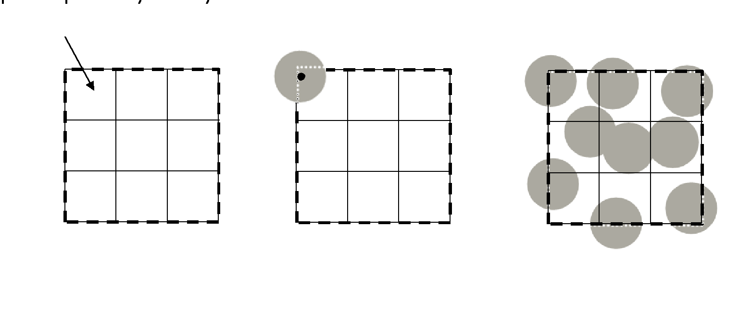

Margin
This is unitless, and the actual margin is margin*fiberRadius. When there are multiple radii, it is the maximum radius. When the margin is 1, then fibers from adjacent cells will not be touching each other during seeding. The margin can help to add kinetic energy to the system by crowding the fibers to the center of the square, so that they all push out of the center at high speeds. 0.75 is the default.
Margin 0.61
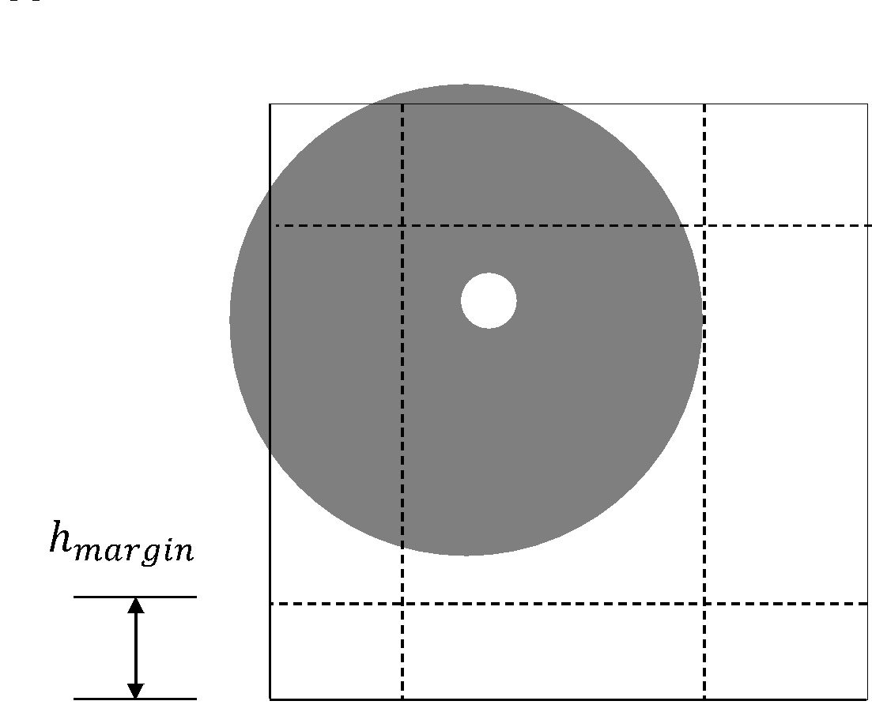

Multiple Radii
Using this option defines multiple radii and what percentage each radius should be represented by number. If I want to have 3 different radii with representing different % of the fibers, I could put in the input file:
MultipleRadii 1/2/4/6, 40/30/15/15,
Which would give me 40% fibers with a radius of 1, 30% with a radius of 2, 15% with a radius of 4, and 15% with a radius of 6. There is no check that the percentages add up to 100%, so this is your responsibility. Errors here will cause the last radius to be under or over-represented. A random number (0.0-1.0) is generated when a fiber is placed, and the radius of the fiber is based on where it falls within the percentages. For the example above, 0.0-0.4 would have r=1, 0.4-0.7 would have r=2, 0.7-0.85 would have r=4, and 0.85-1.0 would have r=6. Because this is a random process, the volume fraction ends up being slightly off, and the boundary is adjusted to fit it exactly. This may cause a few edge fibers to be slightly past the edge, so care should be taken, especially for smaller RVEs. The more fibers in the RVE, the more this will not be a problem. This option is not activated by default.

Simulation Variables

Minimum Spacing
This is in units of length (micrometers) and controls the spacing between the fibers. The default value is 0. For this, the fiber radius is increased by ½ of this value, the relaxation is run, then the fibers are shrunk again. If you want to avoid any fibers touching for use in a finite element program, then you should at least use a small value here since minor overlaps of fibers are common.
MinSpacing 0.5
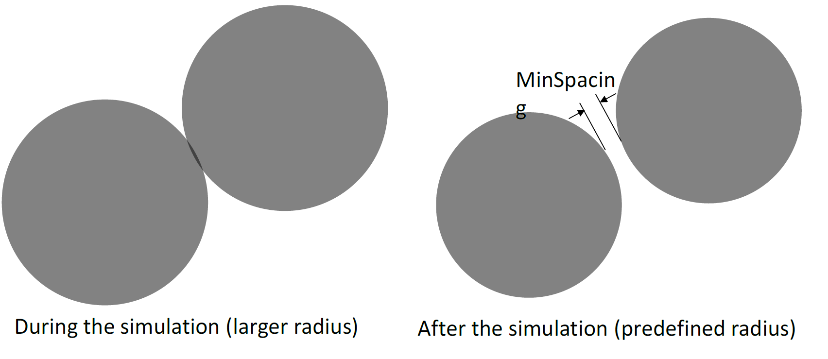

Contact Damping
This is the damping coefficient for the contact between fibers. When two fibers contact each other, there is a spring and a damper between them. This value slows down the relative speed of the two fibers. A value of 1 is critical damping, while >1 is overdamped and <1 is underdamped. This controls how much the fibers aggregate. If the contact damping is high, then fibers lose a lot of energy upon contact, and end up sticking together. In my experience, usually values of around 1.9 are the max you can set this to without instabilities. Typically, values over 0.75 all behave similarly. If this is set low, then one must increase the global damping to compensate. Default is 0.1
ConDamp 0.8

Global Damping
This is the damping coefficient for the movement of an individual fiber. This slows down the speed of a fiber. A value of 1 is critical damping, while >1 is overdamped and <1 is underdamped. Some global damping is almost always needed to keep the simulation from blowing up. I’ve found that values above 2.0 are in danger of becoming unstable. Global damping should be used with contact damping to help speed up the fiber settling. The default value is 1.0.
GlobDamp 1.2

Incremental Damping
This is Global Damping that increases with increasing time steps. This helps to keep the system from moving around indefinitely and settles the fibers. The global damping coefficient is calculated as 1.0 / IncrDamp * (i - nStepsWithoutDamping), where i is the number of time steps. This planes out when the global damping is reached. The default value is 0.001.
IncrDamp 0.0001

Maximum number of Time Steps
This control the maximum number of time steps that are allowed during relaxation. To make sure that the simulation settles and there are very few overlaps, this should be set to something very high, then you can look at the Pack_All file to see how many iterations were actually used for convergence. I usually set this to 8000 when running final runs, but set it low (1000) when I am experimenting or trying out a new input file. The default value is 3000.
MaxSteps 8000

Maximum Undamped Time Steps
The undamped steps are steps run with contact damping, but any global damping is not yet applied. Setting this to higher values may cause the fibers to move faster and separate out sooner, but too much and the system doesn’t slow down. The default value is 500.
UndampedSteps 100

Percent of Kinetic Energy Cutoff
This stops the simulation when the kinetic energy of the simulation falls below a % of the maximum kinetic energy. A higher value will stop the simulation early but may give more fiber overlaps. This or the Maximum number of time steps are the two parameters that end the simulation. The default value is 0.01.
perKECutoff 0.001

Using Number of Fibers Rather than defining rows
This makes nRows actually the number of fibers rather than the square root of the number of fibers. If this is true and nRows is set to 50, then there will be 50 fibers. The default value is False.
IsNRowsActuallyNFibers True

Aspect Ratio of RVE
This makes the RVE non-square. The aspect ratio is Height over Width, so 1.0 is square, >1.0 is higher than wider, and < 1.0 is wider than higher.
RVEHoverW 1.6

Percent of Kinetic Energy Cutoff
This makes nRows actually the number of fibers rather than the square root of the number of fibers. If this is true and nRows is set to 50, then there will be 50 fibers. The default value is False.
IsNRowsActuallyNFibers True

Do not allow overlaps
If this option is set to true, it will check for overlaps (contacts) at the end of the relaxation, and stop the fibers and re-run the analysis from the current position if there are overlaps. If you have a minSpacing, this just flags overlaps after the radius has been re-adjusted to the original radius. If there are still overlaps after re-running, an exception will be thrown. This is by default set to false, since many methods allow a slight overlap.
DoNotAllowOverlaps True

Boundary Types
Boundary types indicates what they y and z boundaries are. The x-boundary is always linear displacements. The y and z boundaries are periodic by default (p), but can be set to solid walls (s). Separated by a “/”
BoundaryTypes p/s

Minimum Boundary Spacing
This is an absolute number. If the boundary is solid, this will cause a buffer around the boundary by the amount indicated. During the generation phase, the boundary is brought in by the amount given, then corrected after relaxation.
MinBoundarySpacing 0.2

Output Variables

Save Results
This saves a .csv file named “nameOfInputFile_Pack_#Rep_All.csv”. This file saves the fiber positions, contacts, homogenized stress/strain, and boundaries at every X time steps (X = nMaxSteps/100). This can be used with PlotFDEM.exe, either in the “Fiber Only” or “Contact Force Plot” to watch the relaxation simulation. These are nice to have a good idea of the generation and seeding, but can often be large files. The fibers will be bigger than the final size if the minimum fiber spacing is non-zero. This file can be used in FDEM to load the packing rather than re-doing the packing. Default is False.
SaveResults True

Save Final Positions
This saves a .csv file named “nameOfInputFile_Pack_#Rep.csv”. This file saves the fiber positions and radius at the end of the relaxation simulation. This is the best for using the results elsewhere. Default is False.
SaveFinalPositions True

Save Final Positions Without Projections
This saves a .csv file named “nameOfInputFile_Pack_#Rep.csv”. This file saves the fiber positions and radius at the end of the relaxation simulation, but does not include the projected fibers. The projected fibers are what give the RVE their periodicity. I don’t remember what case I needed this for😊. Default is False.
SaveFinalPositionsWithoutProjections True

Save Vf Statistics
This saves the mean, IQR (Inter-quartile region) and kurtosis of the distribution of local fiber volume fractions in an output file. It goes in the same _Pack file as the others, and is placed at the end. Default is False.
SaveVfStatistics True

Save Connection Plot
This is only active when SaveVfStatistics is true, but it outputs a connection plot, which plots the triangulation using PlotFDEM. This is the triangulation used both for the volume fraction data, but also for the identification of fiber pairs when a matrix model is applied.
SaveConnectionPlot True

Programming Guidelines
Each class should be divided up into private properties, public, constructors, private methods, and public methods in this template:
#region Private Members
#endregion
#region Public Members
#endregion
#region Constructors
#endregion
#region Private Methods
#endregion
#region Public Methods
#endregion
All variables should be private, with public get/set properties which call on the private properties when needed.
Private variables generally lowercase, while public are uppercase with the same name. All methods are uppercase. Use CamelCase for all variables.

Running on Command Line
You can run RandomRVEGenerator from the commandline and pass in arguments. The arguments can be a file name (with full or relative path) or a directory (with full or relative path). If it’s a directory, it’ll try to run all .txt files in the directory. You can separate directories with a space. Like this:
“E:\Google Drive\IFAM\Projects\FDEM\Programs\FiberDEM_2D\fiberdem\bin\Debug\FiberDEM.exe” “E:\Google Drive\IFAM\Projects\FDEM\Programs\FiberDEM_2D\fiberdem\bin\Debug\Test\Dummy2” “E:\Google Drive\IFAM\Projects\FDEM\Programs\FiberDEM_2D\fiberdem\bin\Debug\Test\Dummy”
(I had to put the quotes around it because there is a space in Google Drive, and the computer doesn’t like it.)
I made it so that it starts each file on a separate thread up to the number of cores.

