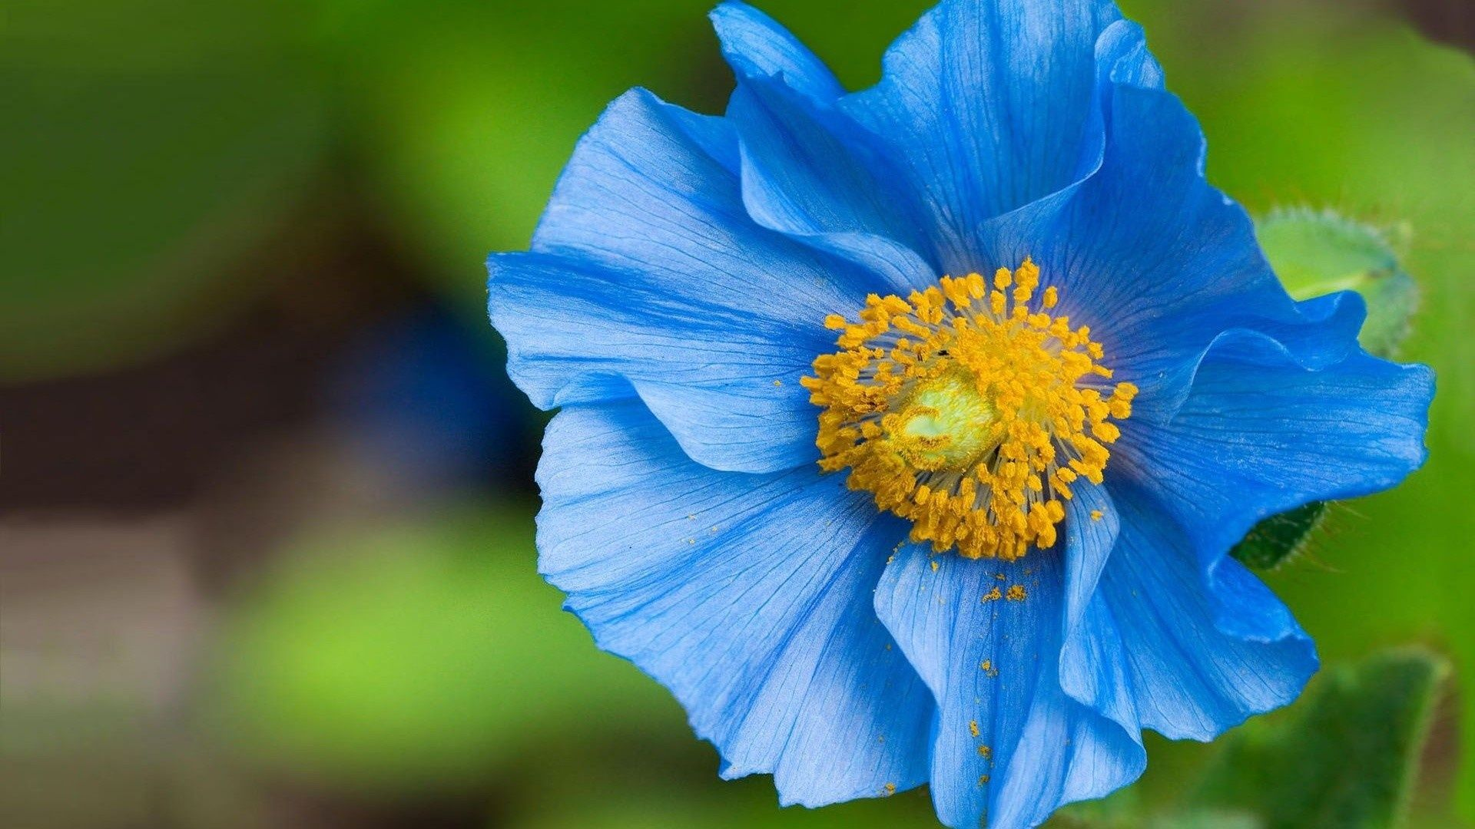

Original

Intermediate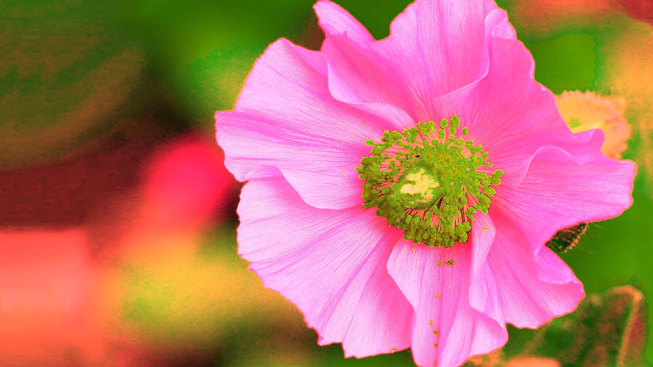

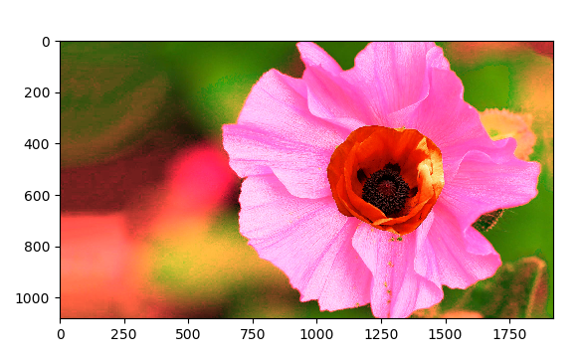Modified

Code

import PIL

import matplotlib.pyplot as plt

import os.path

from PIL import Image, ImageFilter

im = Image.open("C:\users\pngo\desktop\lowers.jpg")

# split the image into individual bands

source = im.split()

R, G, B = 0, 1, 2

# select regions where red is less than 100

mask = source[B].point(lambda i: i > 10 and 255)

# process the green band

out = source[B].point(lambda i: i * 4)

# paste the processed band back, but only where red was < 100

source[R].paste(out, None, mask)

# build a new multiband image

im = Image.merge(im.mode, source)

im.save("trial.jpg")

# Open the files in the same directory as the Python script

directory = os.path.dirname(os.path.abspath(__file__))

#student_file = os.path.join(directory, 'lowers.jpg')

student_file = os.path.join(directory, 'trial.jpg')

# Open and show the student image in a new Figure window

student_img = PIL.Image.open(student_file)

# Open, resize, and display the oriental poppy

poppy_file = os.path.join(directory, 'oriental_trans.png')

poppy_img = PIL.Image.open(poppy_file)

poppy_small = poppy_img.resize((470, 440)) #eye width and height measured in plt

# Paste poppy into center of flower and display

# Uses alpha from mask

student_img.paste(poppy_small, (1034, 325), mask=poppy_small)

# Display

fig3, axes3 = plt.subplots(1, 1)

axes3.imshow(student_img, interpolation='none')

fig3.show()