Reflect a Point

 1. In the toolbox, tap 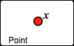. Then tap in the sketch, and *x* is placed!

2. Drag variable *x* around the screen.

3. Tap 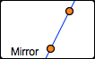. Tap or drag both glowing points.

4. Tap 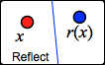. Attach the glowing *x* to the original *x*. The dependent variable is the *reflection* across line *j* of *x*. It’s called *rj*(*x*) for short.

**Q1** Make mirror *j* vertical, and then drag variable *x* up. Which way does *rj*(*x*) go? Draw a sketch to show what happened.

Drag independent variable *x* left. Which way does the dependent variable *rj*(*x*) go? Draw a sketch to show what happened.

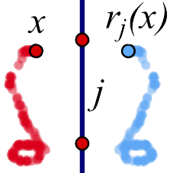 **Q2** Trace an interesting shape and describe it. How are the blue *rj*(*x*) traces similar to the red *x* traces, and how are they different? Include a drawing showing your shapes.

**Q3** Erase the tracing and do a new one. What happens when you drag *x* across the mirror? Describe the traced shapes, and include a drawing on your paper.

Match the Traces

 5. On page 2, contruct a segment. 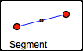



6. Construct *x* attached to the segment, **but not on the end points or midpoint.** Drag *x* to make sure it’s attached.

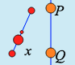

7. Construct a vertical mirror.

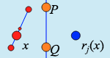 8. Tap . Attach the glowing *x* to the original *x*.

9. Tap 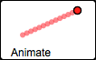 and attach the glowing *x* to the original *x*.

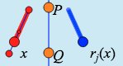

10. Notice the  button. Tap it. Then turn tracing on. The red traces show the *domain*. The blue traces show the *range*.

**Q4** Move the mirror and the segment, and use tracing to match the pictures below. In each box, draw a line to show where you put the mirror. Try to match all 5!

|  |  |  |  |  |
| --- | --- | --- | --- | --- |
|  |  |  |  |  |

**Q5** Describe the method(s) you used to place the mirrors. Did you develop new tricks as you did the five challenges?

Restrict the Independent Variable to a Polygon

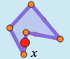 11. On page 3, tap 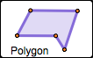 to make a polygon. Tap to place each glowing point.

12. Construct independent variable *x* on the polygon. Drag *x* to make sure it’s attached. (The polygon is now the domain.)

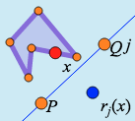 13. Construct a mirror. Then tap  and attach the glowing *x* to the original *x.*

14*.* Turn on tracing and drag or animate *x.* Adjust the polygon to make an interesting shape.

**Q6** Adjust your mirror so you can get *x* and *rj*(*x*) in the same place at the same time. A place like this is called a *fixed point* of the function. Adjust your polygon and mirror so there are two fixed points. Erase your traces and then animate. Draw a sketch below to show what you did.

**Q7** Adjust the domain (the polygon) so that on one side of the polygon the variables move in the same direction, and on another side they move in opposite directions. Draw a sketch to show how you did it.

Reflection Challenges

**Q8** On page 4, figure out where the mirror is that is reflecting the domain and range. How can you check your guess to be sure? Draw your solution below.

**Q9** On pages 5 and 6, there are two more find-the-hidden-mirror challenges. Solve them, and describe your methods. Draw a sketch for each solution. Which challenge was harder? Why?

**Q10** On page 7, find the mirror that reflects independent variable *x* to dependent variable *f*(*x*). Draw your solution below.

**1.** Describe one important thing you learned today about the reflection function family.

**2.** Describe one thing about the reflection function family that seems confusing to you.