Reflect a Point

1. Open geometricfunctions.org/links/reflection-family/ THEN go to page 2.

2. click 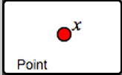 … once you click it and let go, it’s placed!

3. Drag the *x* around the screen.

4. Click 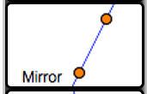. Drag the both glowing points until the “mirror” is vertical.

5. Click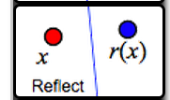 Drag the glowing x onto the original x. .

*rj*(*x*) is the dependent variable. It’s a reflection of x across the line.

**Q1** Drag point *x* up. Which way does *rj*(*x*) go?

Drag *x* left. Which way does *rj*(*x*) go?

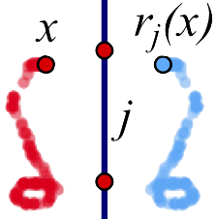

**Q2** Trace an interesting shape and describe it. How are they similar, and how are they different? Include a drawing showing your shapes.

**Q3** Erase the tracing and do a new one. What happens when you drag *x* across the mirror? Describe the traced shapes, and include a drawing on your paper.

Match the Traces

8. On page 3, click 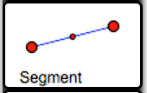 to contruct a segment.

9. Next, click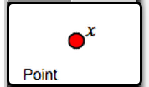 and attach it to the segment, **but not on the end points or midpoint.**

10. Click 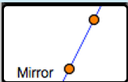, and click both glowing points to place the mirror vertically.

11. Click 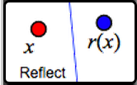 and drag the glowing x onto the original x.

12. Click 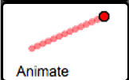 and drag the glowing x onto the original x again.

13. Animate your x by clicking  in the top right of the screen

**Q4:** Turn tracing on and try to match the pictures below by moving the mirror. The challenge is to match all 5!

|  |  |  |  |  |
| --- | --- | --- | --- | --- |
|  |  |  |  |  |

**Q5** Describe the method(s) you used to place the mirrors. Did you develop new tricks as you did the five challenges?

Restrict the Independent Variable to a Polygon

14. On page 4, click 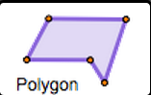, to make a polygon. (Click each glowing point once)

15. click  and place *x* on the polygon.

16. click  to place your mirror

17. click  and place the glowing x on the original x.

**18***.* Drag x or animate it to make interesting shapes.

**Q6** A *fixed point* of a function is where x and r(x) are in the same place at the same time. Can you move your mirror to create 2 fixed points? Draw a sketch on paper of what it looks like.

**Q7** The path that x traces is called the domain. Can you adjust the domain so that the variables will relate in the 3 way seen below at least once along a single path?

|  |  |  |
| --- | --- | --- |
| same | opposite | perpendicular |

**Q8** The path that r(x) travels is called the range. What is similar and what is different about the domain and range in this case?

Reflection Challenges

**Q9** On page 5, try to guess where the mirror is that is reflecting the domain and range.

Draw your solution, and use 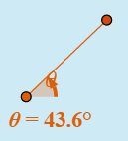 in the bottom corner to measure the angle of the mirror you used.

**Q10** On pages 6 and 7, there are two more find-the-hidden-mirror challenges. Solve them, and describe your methods. What makes one challenge harder than another?

**Q11** On page 8, find the mirror that reflects independent variable *x* to dependent variable *f*(*x*). mirror. Draw your solution, and use to measure the angle of the mirror you used.

**Q1** Make sure the mirror is vertical, and then drag point *x* up. Which way does *rj*(*x*) go?

Drag x left. Which way does *rj*(*x*) go?

**Q2** Describe the traced shapes. How are they similar, and how are they different? Consider position, size, angle, and anything else you think of. On your paper include a drawing showing your shapes.

**Q3** What happens when you drag *x* across the mirror? Describe the traced shapes, and include a drawing on your paper.

**Q4** Each picture below was made by animating point *x* with traces turned on. Arrange your segment and mirror so that animating *x* produces traces like the ones in the pictures. On each picture, draw a line to show where you decided to put the mirror.

|  |  |  |  |  |
| --- | --- | --- | --- | --- |
|  |  |  |  |  |

**Q5** Describe the method(s) you used to place the mirrors. Did you develop new methods, or figure out any tricks, as you did these five challenges?

**Q6** A *fixed point* of a function is a point where the independent and dependent variables meet. Arrange the domain (the polygon) and the mirror so your reflection function has two fixed points. Draw a sketch of the arrangement you used.

**Q7** Arrange the domain so that there’s one side that makes both variables move in the same direction, one side that makes them move in opposite directions, and one side that makes them move in directions that are perpendicular. Draw a sketch of the arrangement you used.

**Q8** How does the range compare to the domain? What features are similar, and what features are different? How do these features relate to the relative motions?

**Q9** On page 5, locate the mirror that reflects the red domain to the blue range. Draw your solution, and use the widget in the corner of the sketch to measure the angle of the mirror you used.

**Q10** On pages 6 and 7, there are two more find-the-hidden-mirror challenges. Solve them, and describe your methods. What makes one challenge harder than another?

**Q11** On page 8, find the mirror that reflects independent variable *x* to dependent variable *f*(*x*). mirror. Draw your solution, and use the widget in the corner of the sketch to measure the angle of the mirror.

**1.** Describe one important thing you learned today about the reflection function family.

**2.** Describe one thing about the reflection function family that seems confusing to you.