./

Report – Loan Calculator

Course Code: <CODE>



Version Number:

Team Members :

Team No:

Module: Model Based System Engineering

|  |  |  |  |  |  |
| --- | --- | --- | --- | --- | --- |
| **Ver. Rel. No.** | **Release Date** | **Prepared. By** | **Reviewed By** | **Approved By** | **Remarks/Revision Details** |
|  |  |  |  |  |  |
|  |  |  |  |  |  |
|  |  |  |  |  |  |
|  |  |  |  |  |  |
|  |  |  |  |  |  |

**Document History**

## **C Programming using Project Based Learning (PBL) Approach**

## Topic: Loan Calculator

**OBJECTIVE**:

To design an application running on terminal (Windows/Linux) which will prompt the user to input the loan parameter and accordingly the application will display the output.

**TOOLS**:

Operating System (Windows/Linux) , C Language, VS Code Editor, Gitbash, Github.

**PROCEDURE**:

SDLC Approach is applied here.

**INTRODUCTION**:

**1.** The Loan Calculator is designed to help user to know about the monthly installments on the loan taken. It will provide the customer to choose his mode of loan repayment - Traditional Compound Interest Method or Amortization Output.

**2.** Whenever a consumer takes a loan, he is always worried about his monthly installments towards the loan. The given application produces a .csv output file which can be easily analyzed by the user to manage his future expense.

**3.** According to the type of repayment opted by user, the monthly budget can be planned by the user. This application can also come handy when user is comparison loan options from different lenders.

**BENEFITS**:

Benefits range from:

1. Tabulation of monthly shelling towards repayment of loan.
2. Total amount paid towards loan repayment.
3. For comparing different loan options and benefits.
4. Output in .csv format.

**DEFINITION OF SYSTEM PARAMTERS**:

1. Principal (P)
2. Annual Rate of Interest (R)
3. Tenure of Loan (Years Months)
4. Monthly Interest in Traditional Compound Interest Repayment **(A)**
5. Monthly Payment towards Principal (Pmonthly) **(B)**
6. Every Monthly Installment (EMI) in Amortized Repayment **(A+B)**

**ASSUMPTIONS INTO CONSIDERATIONS**:

* Lender Charges are ignored.
* Change in interest rates during the tenure are not taken into account.
* Two Output Files produced will be - Installment_amortized.csv & Installment_compound.csv
* The application does not take guarantee of the user's loan amount.

**FLOW DIAGRAM OF APPLICATION**:

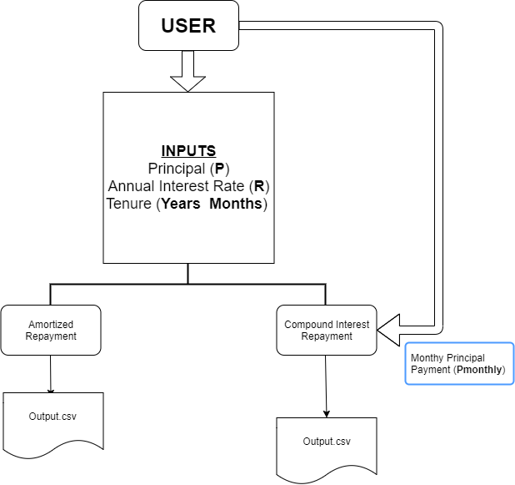

SWOT ANALYSIS:

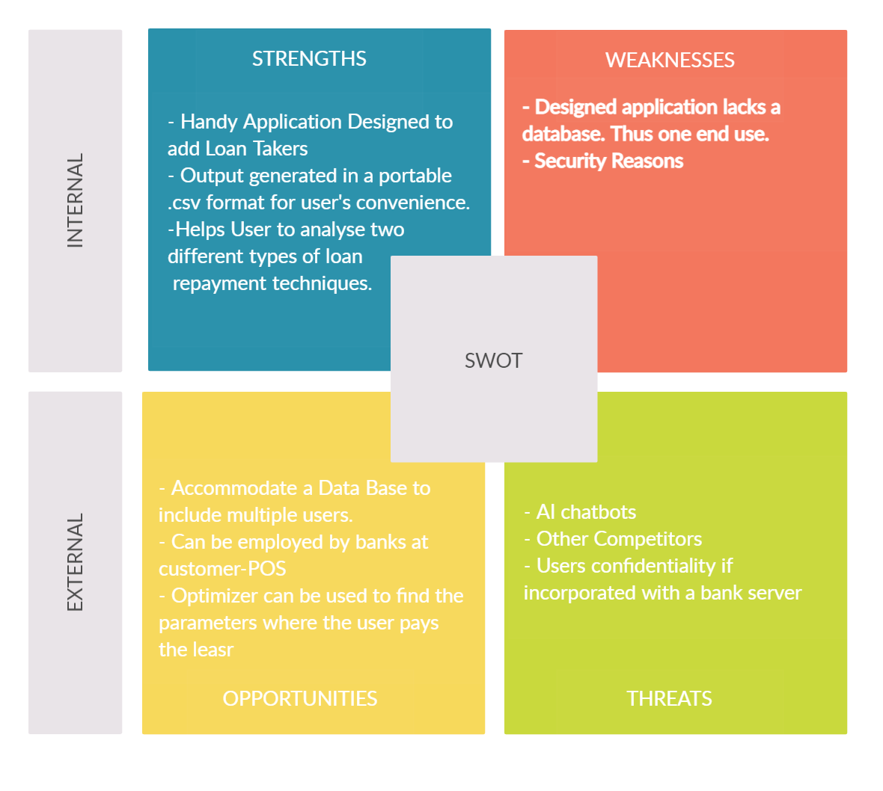

# 

4W’s and 1H:

**Who** - User's in search of affordable loans.

**What** - A simple calculations to calculate every month's loan installment irrespective of loan repayment methods.

**When** - Since the lenders and their offers are on a rise, loanee can be assured to compared all their offering using my application and take his decision.

**Where -** Basic computer application. Can be also integrated with a Mobile Application.

**How -** With Loan Calculator, the installment amount and interest can be analyzed easily on a monthly basis till loan is repaid.

**HIGH LEVEL REQUIREMENTS**:

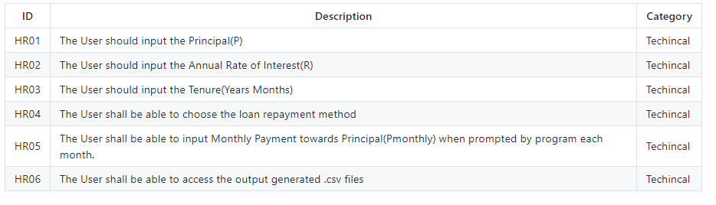

# LOW LEVEL REQUIREMNTS:

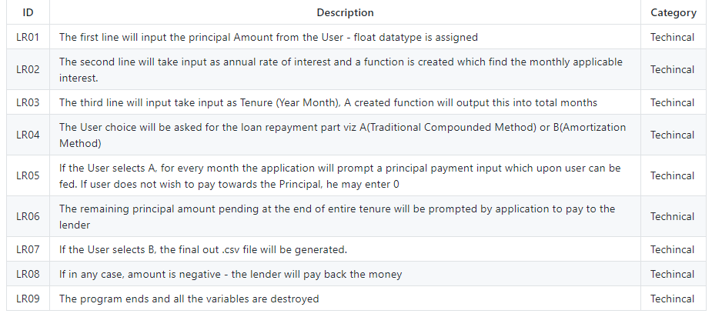

**PROGRAM FLOW DIAGRAM**:

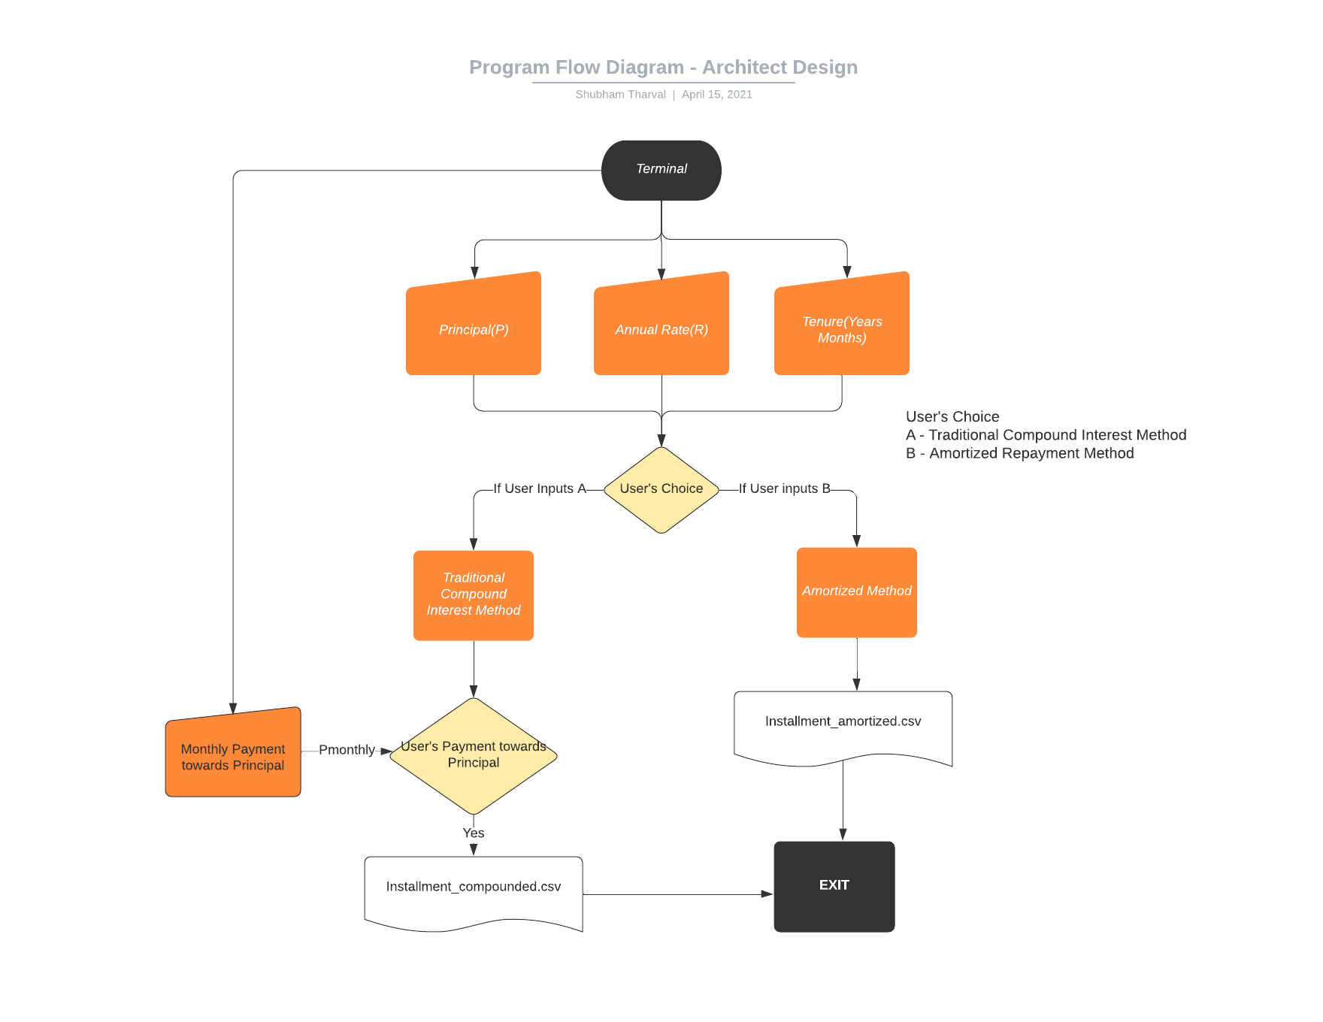

**PROGRAM FUNCTION DIAGRAM**:

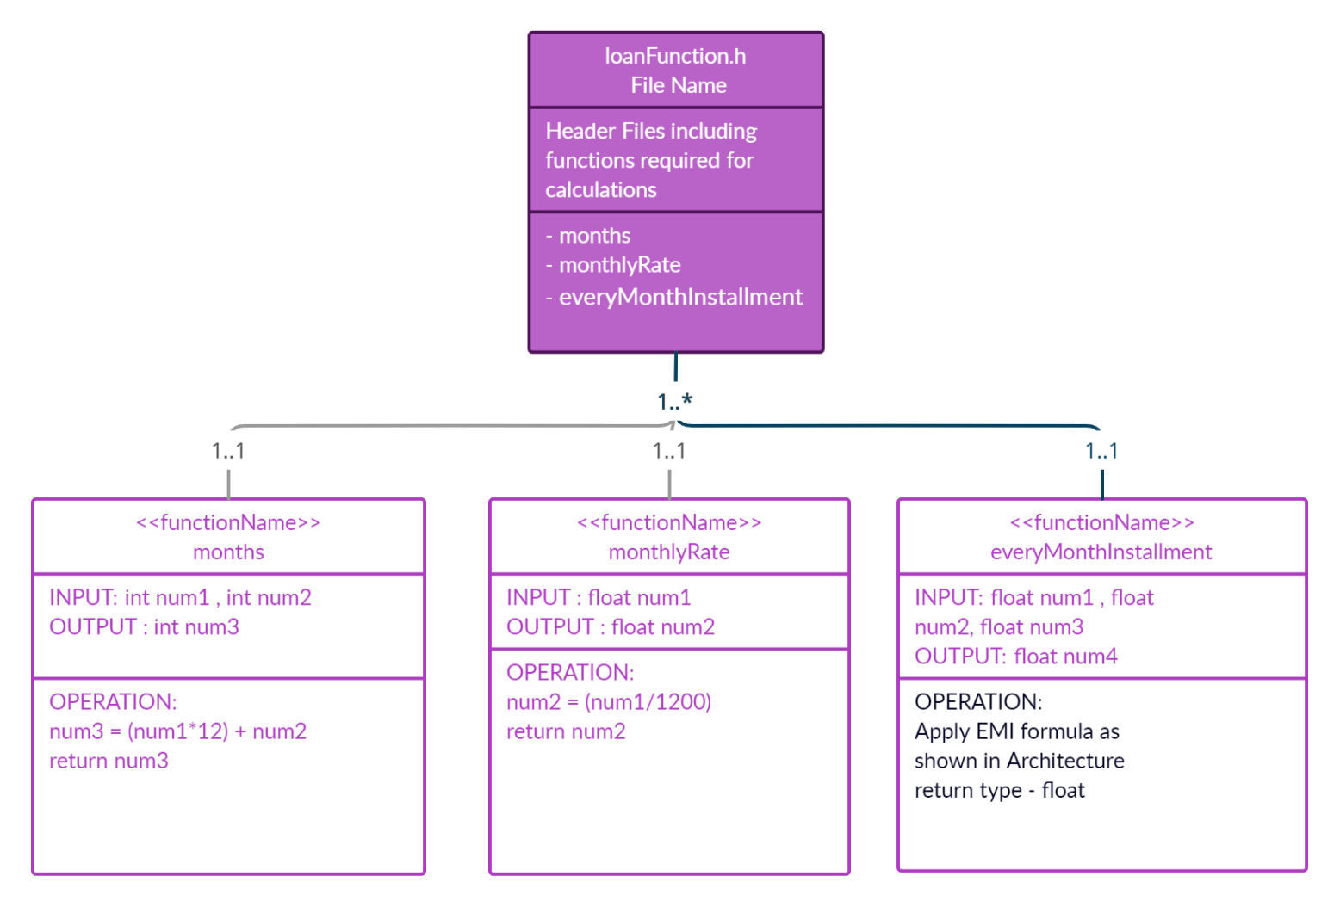

**USE CASE DIAGRAM**:

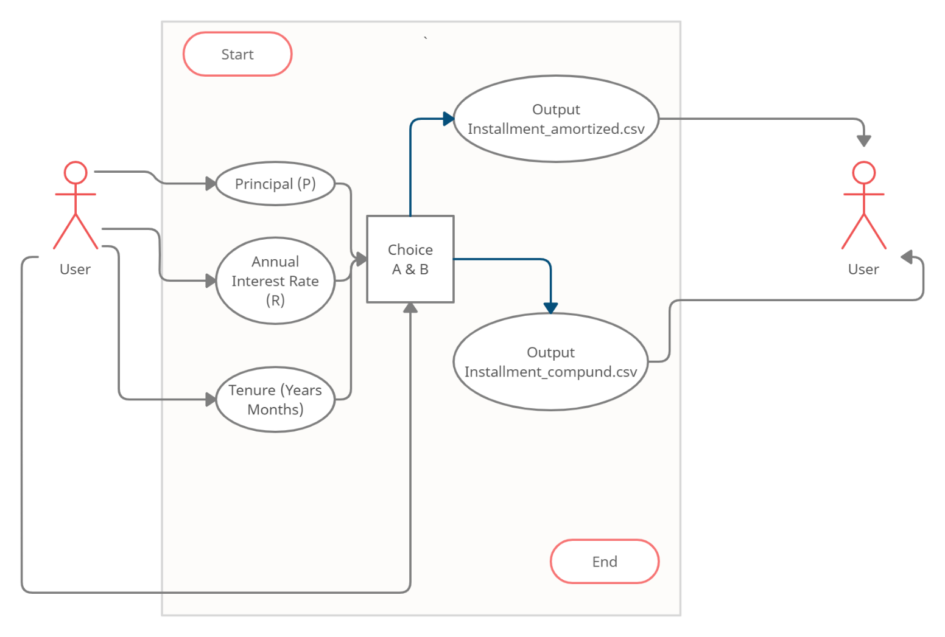

**TESTING PLAN AND OUTPUT**:

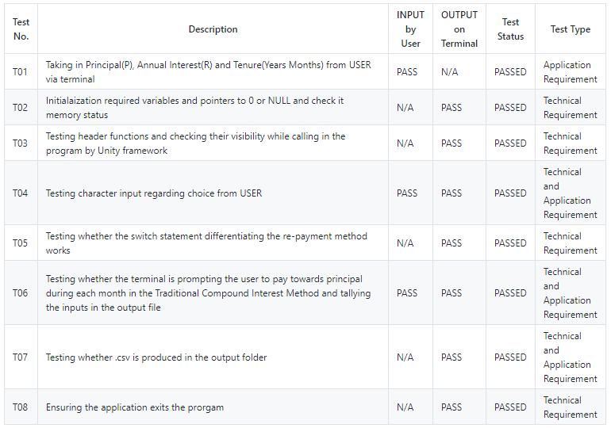

**IMPLEMENTATION FILE STRUCTURE**:

|  |  |
| --- | --- |
| File Name | Sub-Files |
| 1_Requirements | README.md |
| 2_Architecture | README.md |
| 3_Implementation | Unity, documentation, inc, output, src, test, Makefile, main.c |
| 4_TestPlanAndOutput | README.md |
| 5_Report | Project_Report_template.doc |
| 6_ImagesAndVideos | UML Diagrams |
| .gitignore | ***File*** |
| README.md | ***File*** |
| SECURITY.md | ***File*** |