

Functional Safety Concept Lane Assistance

**Document Version: [Version]**

**Version 1.0, Released on 2017-06-21**



# Document history

|  |  |  |  |
| --- | --- | --- | --- |
| Date | Version | Editor | Description |
| 5/24/2018 | V1 | Shamsher Singh Thind | Version-1 |
|  |  |  |  |
|  |  |  |  |

# Table of Contents

Document history

Table of Contents

Purpose of the Functional Safety Concept

Inputs to the Functional Safety Concept

Safety goals from the Hazard Analysis and Risk Assessment

Preliminary Architecture

Description of architecture elements

Functional Safety Concept

Functional Safety Analysis

Functional Safety Requirements

Refinement of the System Architecture

Allocation of Functional Safety Requirements to Architecture Elements

Warning and Degradation Concept

# Purpose of the Functional Safety Concept

The functional safety concept is to document the general functionality of the item without going into technical detail. This document also identifies safety requirements and then allocate those requirements to different parts of the item architecture. Functional safety requirements also have attributes that are specified in the functional safety concept. Further to prove that a system actually meets requirements, they have to be verified and validated.

# Inputs to the Functional Safety Concept

## Safety goals from the Hazard Analysis and Risk Assessment

|  |  |
| --- | --- |
| **ID** | **Safety Goal** |
| Safety_Goal_01 | The oscillating steering torque from the lane departure warning function shall be limited |
| Safety_Goal_02 | The lane keeping assistance function shall be time limited, and the additional steering torque shall end after a given time interval so that the driver cannot misuse the system for autonomous driving. |

## Preliminary Architecture

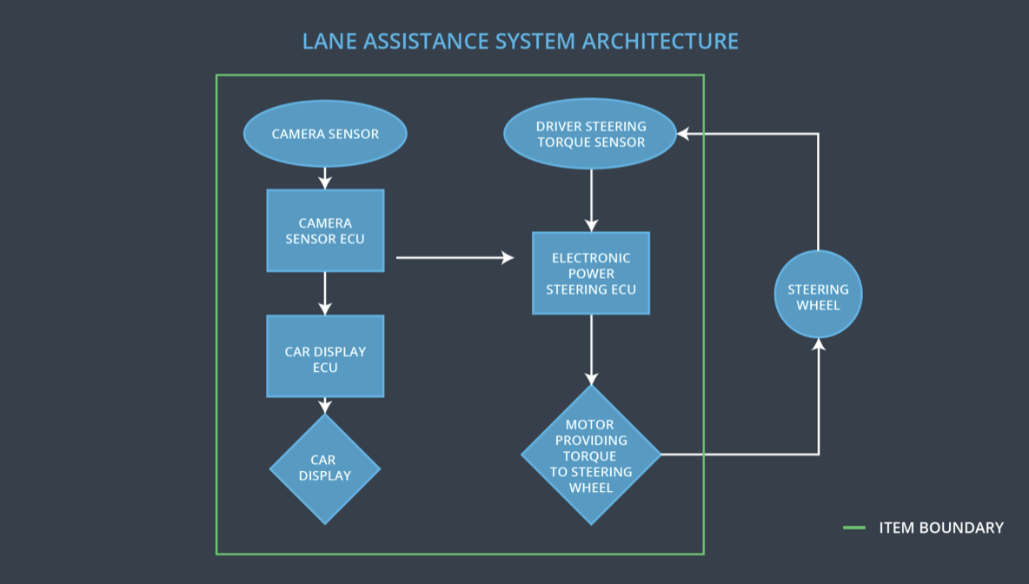

### Description of architecture elements

|  |  |
| --- | --- |
| **Element** | **Description** |
| Camera Sensor | It reads in images from the road and sends to camera sensor ECU |
| Camera Sensor ECU | Identifies when the vehicle has accidentally departed its lane, and sends the appropriate message to the car display ECU and electronic power steering ECU |
| Car Display | It displays the actual output generated by car display ECU |
| Car Display ECU | It generates output for LA on/off status, LA Active/inactive, LA malfunction warning |
| Driver Steering Torque Sensor | It reads the steering torque on the steering wheel |
| Electronic Power Steering ECU | It reads data from Steering Torque Sensor and Torque request generator and generates final torque signal to motor |
| Motor | It actuates the final torque provided by Electronic Power Steering ECU |

# Functional Safety Concept

The functional safety concept consists of:

* Functional safety analysis
* Functional safety requirements
* Functional safety architecture
* Warning and degradation concept

## Functional Safety Analysis

**[Instructions: Fill in the functional safety analysis table below.]**

|  |  |  |  |
| --- | --- | --- | --- |
| **Malfunction ID** | **Main Function of the Item Related to Safety Goal Violations** | **Guidewords (NO, WRONG, EARLY, LATE, MORE, LESS)** | **Resulting Malfunction** |
| Malfunction_01 | Lane Departure Warning (LDW) function shall apply an oscillating steering torque to provide the driver a haptic feedback | MORE | The lane departure warning function applies an oscillating torque with very high torque amplitude (above limit) |
| Malfunction_02 | Lane Departure Warning (LDW) function shall apply an oscillating steering torque to provide the driver a haptic feedback | MORE | The lane departure warning function applies an oscillating torque with very high torque frequency (above limit) |
| Malfunction_03 | Lane Keeping Assistance (LKA) function shall apply the steering torque when active in order to stay in ego lane | NO | The lane keeping assistance function is not limited in time duration which leads to misuse as an autonomous driving function. |

## Functional Safety Requirements

**[Instructions: Fill in the functional safety requirements for the lane departure warning ]**

Lane Departure Warning (LDW) Requirements:

|  |  |  |  |  |
| --- | --- | --- | --- | --- |
| **ID** | **Functional Safety Requirement** | **ASIL** | **Fault Tolerant Time Interval** | **Safe State** |
| Functional  Safety  Requirement  01-01 | The lane keeping item shall ensure that the lane departure oscillating torque amplitude is below Max_Torque_Amplitude | C | 50 ms | Set Vibration to zero when fault detected |
| Functional  Safety  Requirement  01-02 | The lane keeping item shall ensure that the lane departure oscillating torque frequency is below Max_Torque_Frequency | C | 50 ms | Set Vibration to zero when fault detected |

Lane Departure Warning (LDW) Verification and Validation Acceptance Criteria:

|  |  |  |
| --- | --- | --- |
| **ID** | **Validation Acceptance**  **Criteria and Method** | **Verification Acceptance**  **Criteria and Method** |
| Functional  Safety  Requirement  01-01 | validate how drivers react to different torque amplitudes | verify  that the torque amplitude crosses the limit, the lane assistance output is set to zero within the 50 ms fault tolerant time interval |
| Functional  Safety  Requirement  01-02 | validate how drivers react to different torque frequencies | verify  that the torque frequencies crosses the limit, the lane assistance output is set to zero within the 50 ms fault tolerant time interval |

**[Instructions: Fill in the functional safety requirements for the lane keeping assistance]**

Lane Keeping Assistance (LKA) Requirements:

|  |  |  |  |  |
| --- | --- | --- | --- | --- |
| **ID** | **Functional Safety Requirement** | **ASIL** | **Fault Tolerant Time Interval** | **Safe State** |
| Functional  Safety  Requirement  02-01 | The electronic power steering ECU shall ensure that the lane keeping assistance torque is applied for only Max_Duration | B | 500 ms | Reduce the torque by lane keeping system to zero when fault detected |

Lane Keeping Assistance (LKA) Verification and Validation Acceptance Criteria:

|  |  |  |
| --- | --- | --- |
| **ID** | **Validation Acceptance**  **Criteria and Method** | **Verification Acceptance**  **Criteria and Method** |
| Functional  Safety  Requirement  02-01 | Validate that the max_duration chosen really did dissuade drivers from taking their hands off the wheel | Verify that the system really does turn off if the lane keeping assistance every exceeded max_duration |

## Refinement of the System Architecture

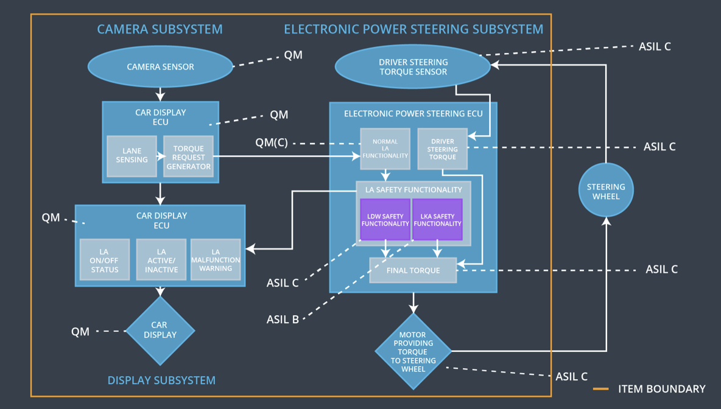

## Allocation of Functional Safety Requirements to Architecture Elements

|  |  |  |  |  |
| --- | --- | --- | --- | --- |
| **ID** | **Functional Safety Requirement** | **Electronic Power Steering ECU** | **Camera ECU** | **Car Display ECU** |
| Functional  Safety  Requirement  01-01 | The lane keeping item shall ensure that the lane departure oscillating torque amplitude is below Max_Torque_Amplitude | Responsible | Not responsible | Not responsible |
| Functional  Safety  Requirement  01-02 | The lane keeping item shall ensure that the lane departure oscillating torque frequency is below Max_Torque_Frequency | Responsible | Not responsible | Not responsible |
| Functional  Safety  Requirement  02-01 | The electronic power steering ECU shall ensure that the lane keeping assistance torque is applied for only Max_Duration | Responsible | Not responsible | Not responsible |

## Warning and Degradation Concept

|  |  |  |  |  |
| --- | --- | --- | --- | --- |
| **ID** | **Degradation Mode** | **Trigger for Degradation Mode** | **Safe State invoked?** | **Driver Warning** |
| WDC-01 | Lane Departure warning functionality is set to zero | Malfunction_01  Malfunction_02 | Yes | Malfunction warning on with Lane Departure warning indicator signal |
| WDC-02 | Lane keeping assistance functionality is set to zero | Malfunction_03 | Yes | Malfunction warning on with Lane keeping assistance indicator signal |