- In SSTL, we use Pare Studio Licenced Jar File to perform billing on monthly basis.
- Every month before 05th, the billing will be performed using Pare Studio and the billing report will be sent to the client CREST.
- To perform the billing, its requires JAVA 11.
- Install java 11 and setup the environment variables in your laptop.
- Once this setup is completed. Go to command prompt and check that java -version.
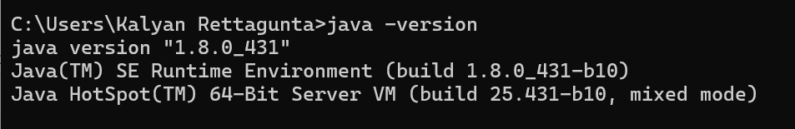
- Java 11 has installed successfully in your laptop.
- To run Pare Studio, it requires java 11.
- Now download the Pare Studio jar file.
- Create a Folder called Pare Studio, inside this folder place the Pare Studio Jar File.
- Execute the below command to run the Pare Studio from this folder path.
  - Java -jar PareStudio.jar
- The interface of Pare Studio looks like the below image.
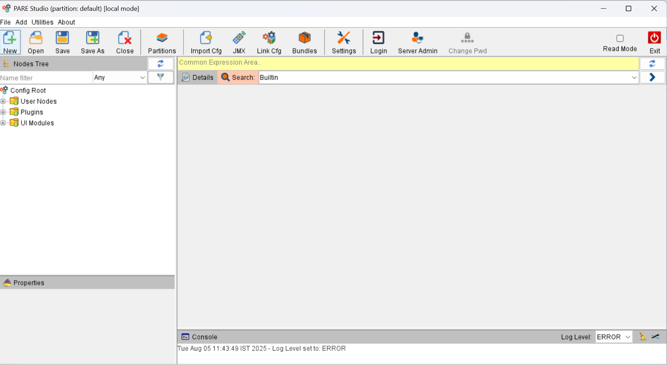
- Now click on Settings and navigate to Server Links menu.
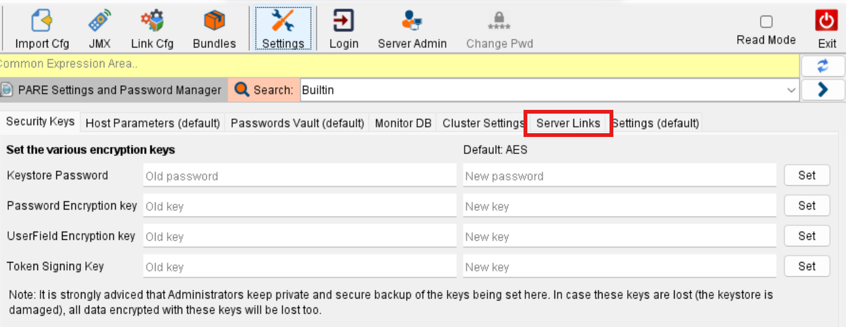
- Configure the login credentials. You can setup 2 login credentials both for Production Environment and UAT environment.
- Production Environment Credentials:
- Name: LMS_PROD
- Protocol: https
- Host: 103.239.138.80
- Port: 443
- Username: support@ssquarespenta.com
- Password: ABC37@?@#jnq69?
- UAT Environment Credentials:
- Name: LMS_UAT
- Protocol: https
- Host: 103.239.138.64
- Port: 443
- Username: support@ssquarespenta.com
- Password: ABC37@?@#jnq69?
- After setting up the login credentials, you can login into LMS_PROD user.
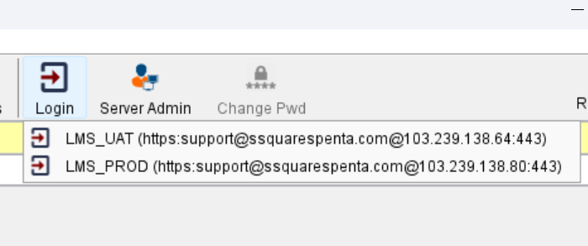
- Login to LMS_PROD user.
- NOTE: Before login to LMS_PROD, always select UI Models -> Pare Process Monitor module and then login into LMS_PROD user.
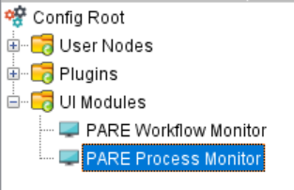
- In the process tree, select the component Invoice Service.
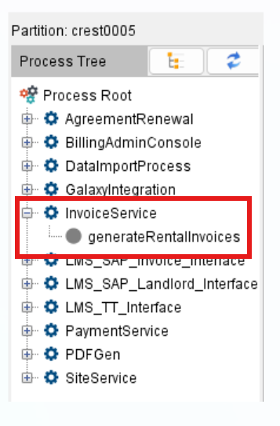
- Select generateRentalInvoices and click on Start.
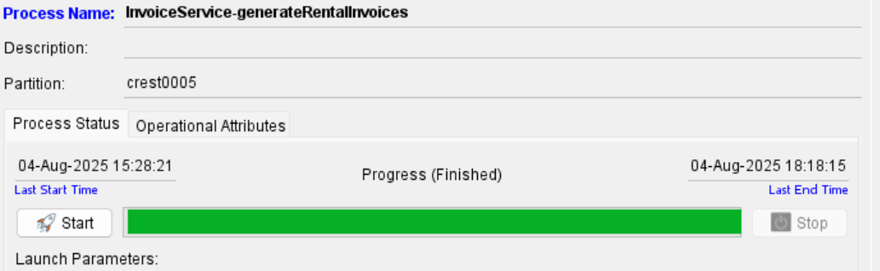
Once you start the process, the invoice will be created. It takes close to 3 Hours to 4 Hours to complete the billing process.
- NOTE: Every time you run the billing process the CREST_LMS_CUTOFF_DATE must be set in Pare Studio.
- To Setup CREST_LMS_CUTOFF_DATE, navigate to Server Admin which is present in the header section.
- Next navigate to Remote Params menu.
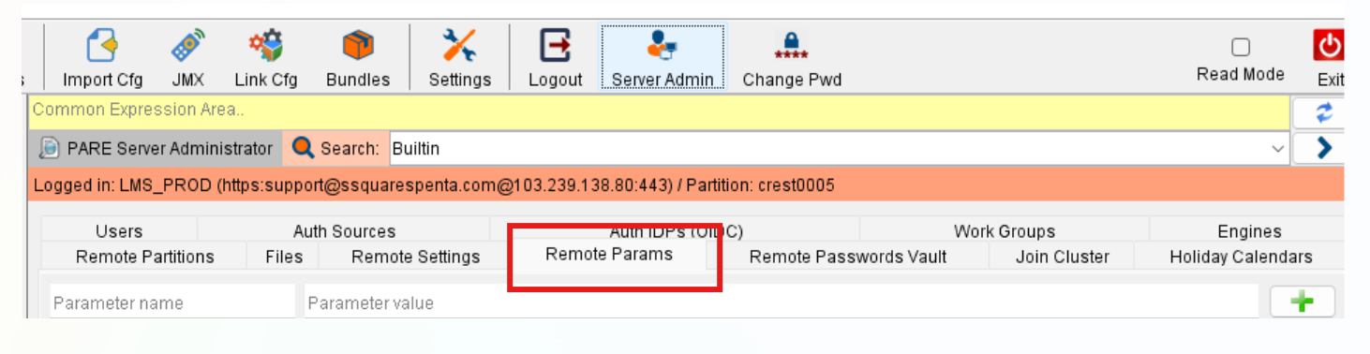
- Click on Remote Params menu, check for the parameter named CREST_LMS_CUTOFF_DATE
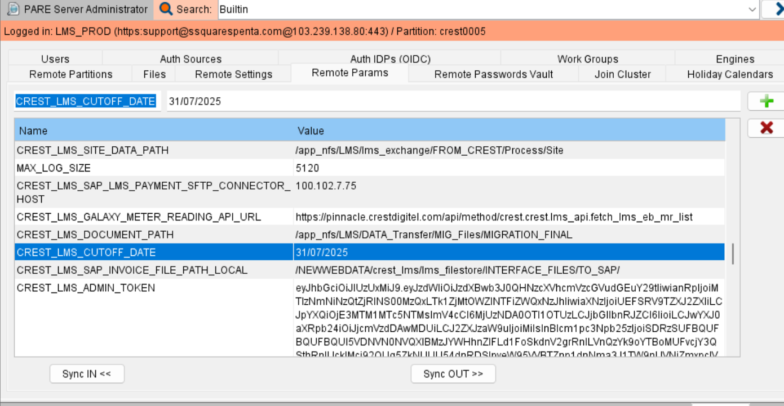
- Now edit the CREST_LMS_CUTOFF_DATE to the month ending date. The format of the date should be DD/MM/YYYY.
- For Example: If you want to do billing for the month of August 2025, the CREST_LMS_CUTOFF_DATE should be 31 JULY 2025.
- Do the necessary changes, click on the ‘+” icon.
- Final step is to click on sync IN which is present at the end of the window.
Validate the Invoices LMS Portal:
- Login to LMS Application and click on the Hamberger icon.
- Click on Reports. In the Report drop down menu, select “Invoice Rental Dump Report”.
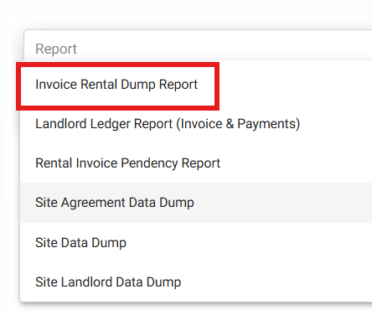
- Click on Invoice Rental Dump Report. In the browser settings, allow Popups Window.

