* **UI Module build and deployment instructions :**
* **How to build enterpriseassetmanager :**

1. Download apache-maven from the internet using following steps as provided in the images below.

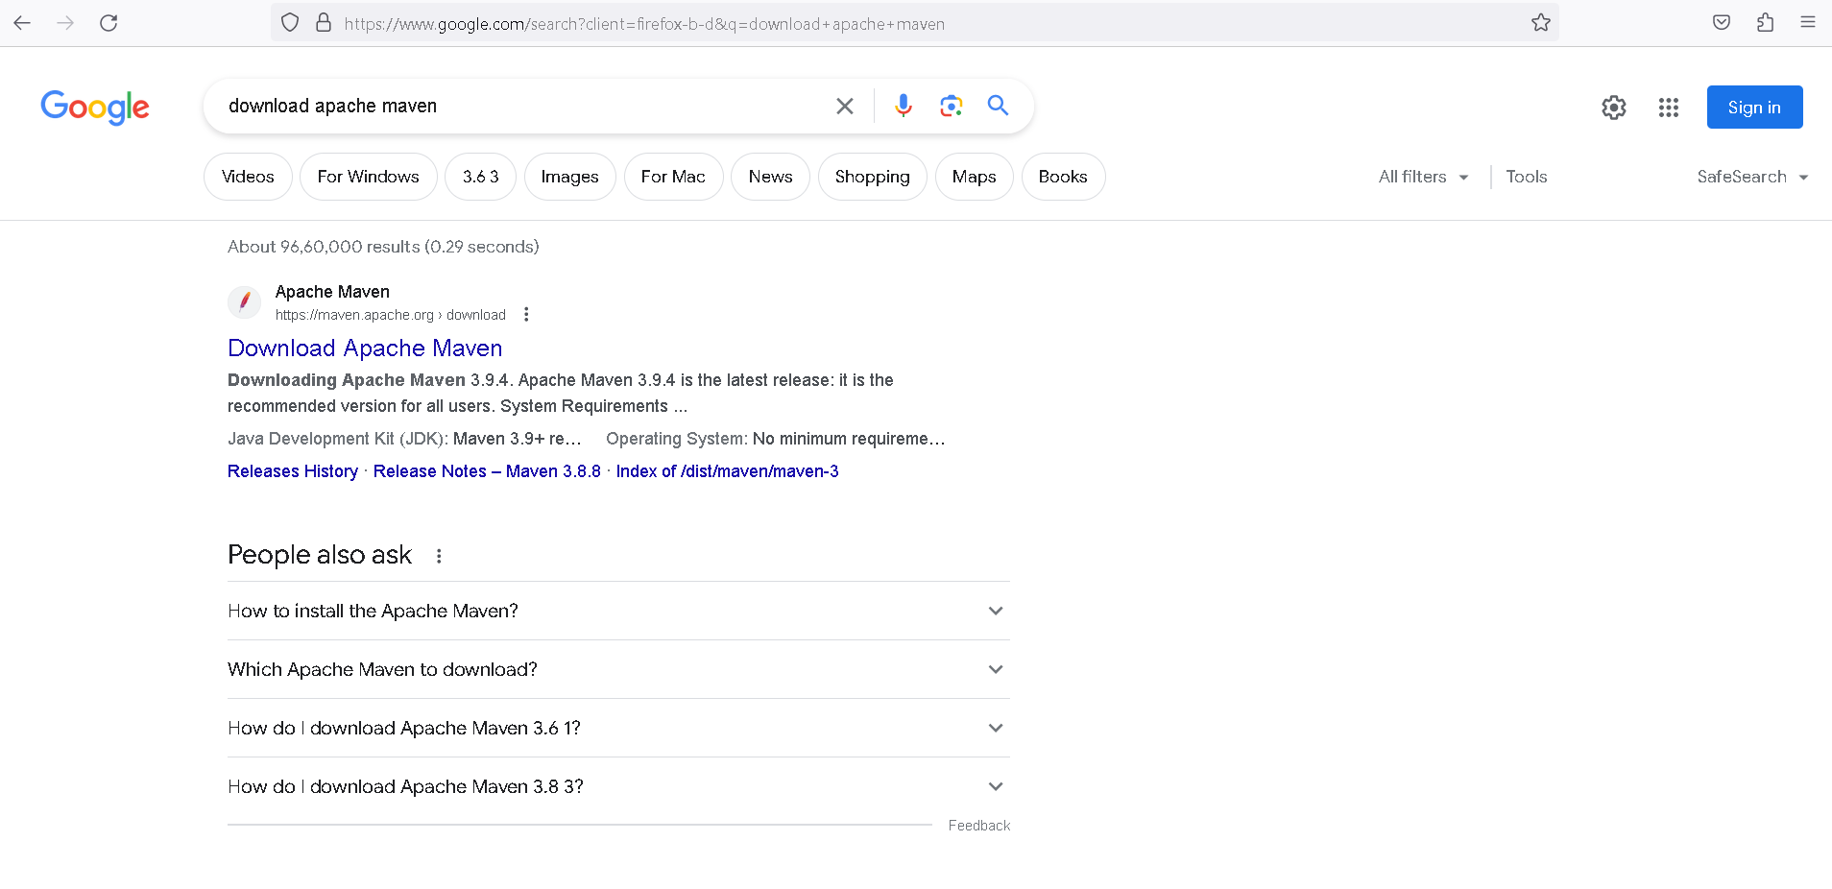

**Figure1 : Step 1 (Click the first link)**

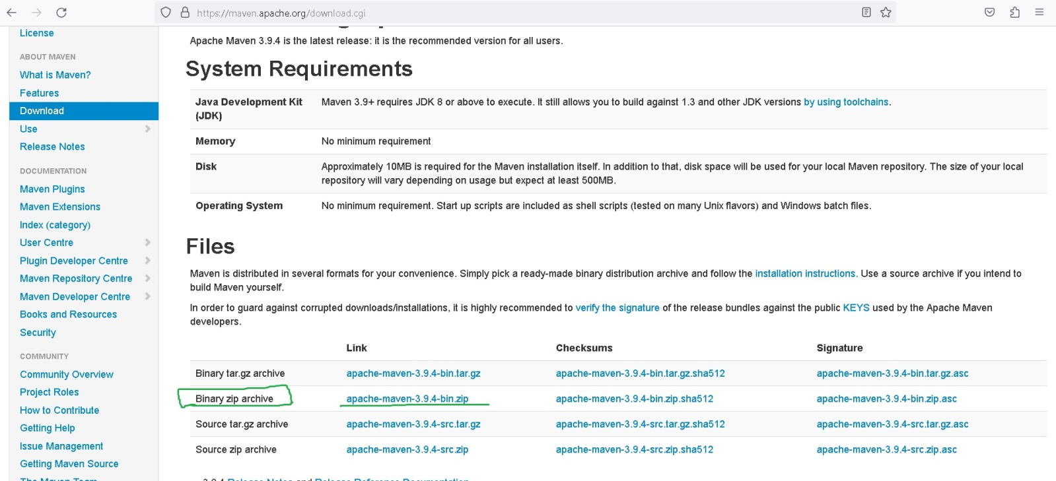

**Figure 2: Step 2 Download the second Link (marked with green )**

* Unzip the apache-maven folder and place it in the Drive eg: D:\apache-maven-3.9.4:
* Set the path within the environment variable as follows:
  + This Pc =>right click=>click properties=> then click Advanced system settings=> A popup will open known as “**system properties**” here click **“Environment Variables”=>** Within Environment Variable Popup Select variable Path and click on Edit => Within Edit Environment Variable Popup click New and add your maven path eg **D:\apache-maven-3.9.4\bin =>**click ok and save the changes

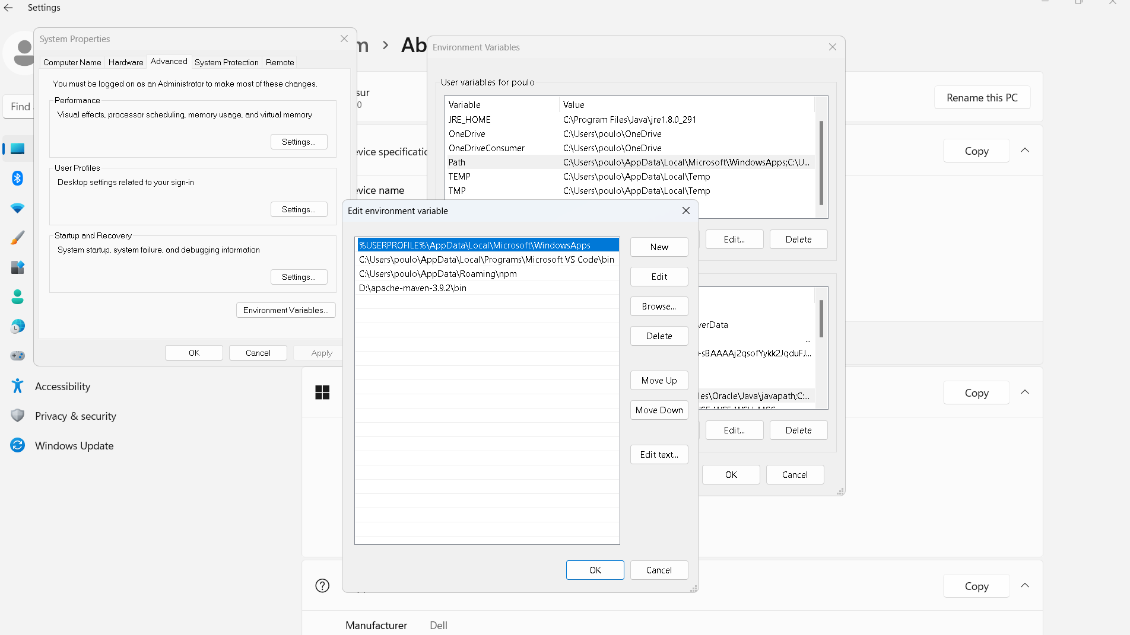

**Figure 3: Step 3 Setting up the apache-maven path**

2. Create a folder (keep the apache maven and the newly createdproject folder within the same drive for example D drive).

3. Copy src, frontend, pom.xml from particular Enterpriseassetmanger project file which is provided.

4. Open command prompt , go to the folder where src,frontend,pom.xml was pasted (for example D:\BUILD_DIRECTORY\siteassetinventory) & copy the path.

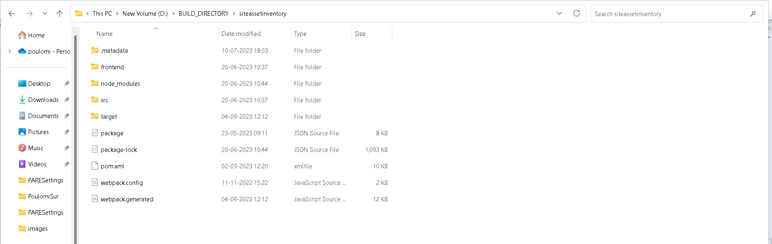

**Figure 4 : Step 4**

5. For building the application for **first time** run the command **“npm install”.(**Run this step to create nodemodules only for 1st time build, skip this step from second time build**)**

6. Then Run this command “**mvn clean package -Pproduction”**

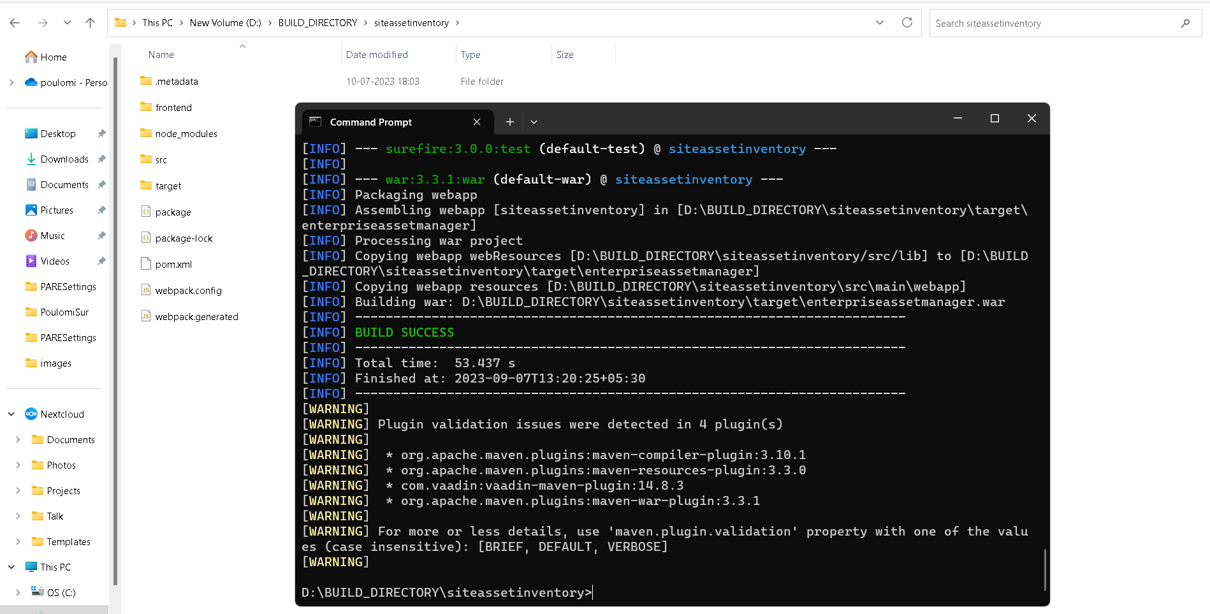

**Figure 5: Step 5**

7. Now get the “enterpriseassetmanager.war “ from “**target”** folder on build success and its ready to deploy.

* **How to build landlordselfservice:**

1. Open the command prompt.

2. Point to the location where the project code is for example D:\BUILD_DIRECTORY\ landlordselfservice

3. Run the command “**npm install**” .

4. Then run the command **“ng build --base-href=/landlordselfservice/”**

5.After build successwithin the project folder a “**dist”** folder will be generated. Take the folder created within the dist folder and zip it and its ready for deployment

**UI Deployement in Server :**

* Stop the server
* Delete the enteroriseassetmanager, workflow, Landlordselfservice folders
* Then put UI .zip and .war files are deployed in tomcats webapps folder

1. enterpriseassetmanager.war
2. Workflow.zip
3. Landlordselfservice.zip

* Unzip all the zip files by unzip *.zip command



**Figure 6: server**

* After unzip the zip files go to Landlordselfservice folder ,change the
* To change env.js
  1. Go inside each of signup, usermanagement, workflow, landlordselfservice.
  2. Change env.js
* Replace all http://localhost:8080/ with the actual server port or load balancer server port (if any) values

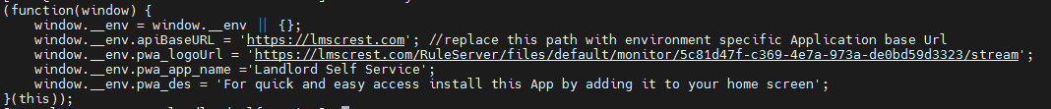

**Figure 7: envs.js**