

Version 1.1

17th March 2023

Landlord Self Service Portal

**User Manual**

# Disclaimer

User Guide

U11 Energy Billing Solution

for

EGSB

**7th Sep’2021**

Information in this document is subject to change without notice. The software described in this document is furnished under a license agreement or nondisclosure agreement. The software may be used for copying, only in accordance with the terms of those agreements. No part of this manual may be reproduced, stored in a retrieval system, or transmitted in any form or any means electronic or mechanical, including photocopying and recording for any purpose other than the purchaser’s personal use without the written permission of Eppix eSolution Limited.

All trademarks used herein are properties of their respective owners.

Table of Contents

Disclaimer 2

Document Release History 4

Circulation Details 5

List of Amendments 6

Glossary 7

1. Introduction 8

2. Overview 8

3. Prerequisite 8

4. Getting Started 8

4.1. Log In 8

4.2. Home Page and General Features 10

4.2.1. Menu Bar 10

4.2.2. Add to Homepage (Install like an App) 12

4.2.3. Change Password 14

4.2.4. Logout 15

5. My Profile 15

6. My Site Details 19

6.1. Details 20

6.2. Site History 21

6.3. Documents 22

6.4. Payments 23

7. Tickets 24

8. Documents 29

# Document Release History

|  |  |  |  |  |  |  |
| --- | --- | --- | --- | --- | --- | --- |
| **Sl#** | **Ver. No.** | **Release Date** | **Prepared By** | **Reviewed By** | **Approved By** | **Reasons for New Release** |
| 1 | 1.0 | 8-Jul-2022 | Mohana Adhikary | Devadyuti Sengupta, Abhra Chandra | Abhijit Guhathaurta | Initial Document |
| 2 | 1.1 | 17-Mar-2023 | Sumana Santra | Abhra Chandra | Rakesh Singh | Modified for Crest Digitel |

# Circulation Details

|  |  |  |
| --- | --- | --- |
| **Copy No.** | **Designation of Copy Holder** | **Location of the Copy** |
| 1 | Eppix Project Manager | Soft Copy in LMS SVN |
| 2 | SSTL Project Manager | Soft Copy via Email |

# List of Amendments

|  |  |  |  |  |  |  |
| --- | --- | --- | --- | --- | --- | --- |
| **Sl#** | **Section No. /Page No.** | **Description of the amendment** | **Raised by** | **Response** | **Updated By** | **Approved by** |
| 1 |  | Included changes for Crest Digitel | SSTL |  | UMT | SSTL |
|  |  |  |  |  |  |  |
|  |  |  |  |  |  |  |

# Glossary

| **Acronyms** | **Description** |
| --- | --- |
| LMS | Landlord Management System |
| TelCo | Telecom Operator |
| TowerCo | Tower Operator |

# Introduction

Welcome to the **Landlord Self Service Portal** User Guide. This user guide is designed to provide step by step guides for landlords who will use Landlord Self Service System time to time. This document is designed to be read by landlords and users of TowerCo. This same document can be referred by testers for functional testing of the system.

# Overview

Landlord Self Service Portal is a mobile friendly web application. Landlords can use it to manage their relationship with the TowerCo. Landlords can view their profile and contact information, view their invoices and payments, check sit details, request for information change, raise tickets for problems and monitor the status of the tickets.

# Prerequisite

The users of the system should have -

* Mobile Device
* Latest Chrome Browser (Version 100+) installed on the mobile
* Connectivity to the server running the Landlord Self Service application
* URL of the application
  + https://<server><:port>/landlordselfservice
* Thelandlord should be created in the Landlord Management System
* Landlord Credentials to log-in to the system

# Getting Started

This section includes login mechanism and general features of Landlord Self Service Portal.

## Log In

* Open latest Google Chrome browser from Mobile
* Go to the application URL
* A sign-in page will appear

(If you have previously signed successfully from this mobile and did not log out you may be taken directly to the home page instead of the sign-in page)

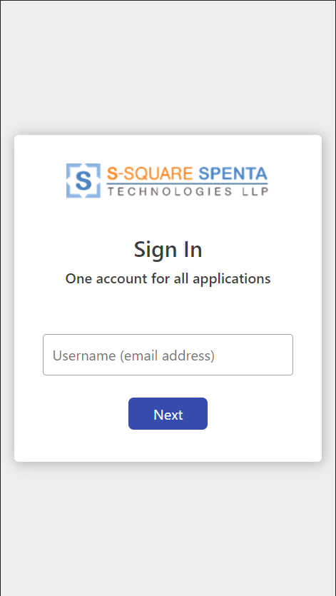

Figure - Sign in Page / Log in Page

* Enter user id (Vendor Code)
* Click on the next button.
* This will open the password page

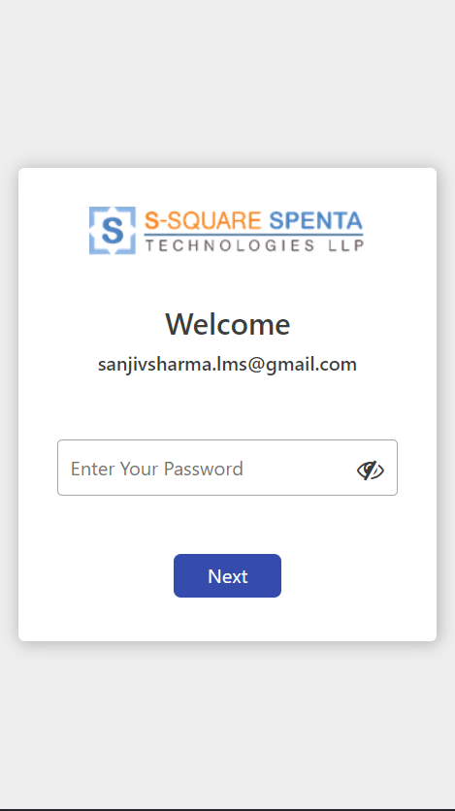

Figure - Sig-In Password Entry Page

* Provide password to login.
* Click on next
* In case of successful authentication user will be redirected to the home page of the application.

Note: *In case of first time login attempt by the landlord, instead of home page system will redirect to the change password page. Changing password after first login is mandatory.*

*Landlords will receive login credentials via welcome email.*

## Home Page and General Features

After successful login user is redirected to the home page of the application.

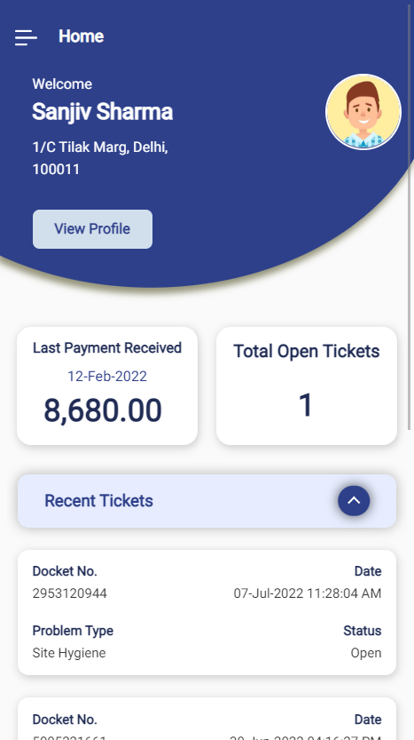

Figure - Landlord Self Service Portal - Home Page

* The home page shows a dashboard with a quick glance on the important information to the landlords
* It shows the logged in user name, address, last payment received and number of open tickets
* Recent tickets (Both open and closed) and payments are also listed

### Add to Homepage (Install like an App)

* Landlord Self Service portal can be installed as an application in the mobile device. Once installed user may click on the icon to open the application, thus not requiring typing the URL in browser any more.

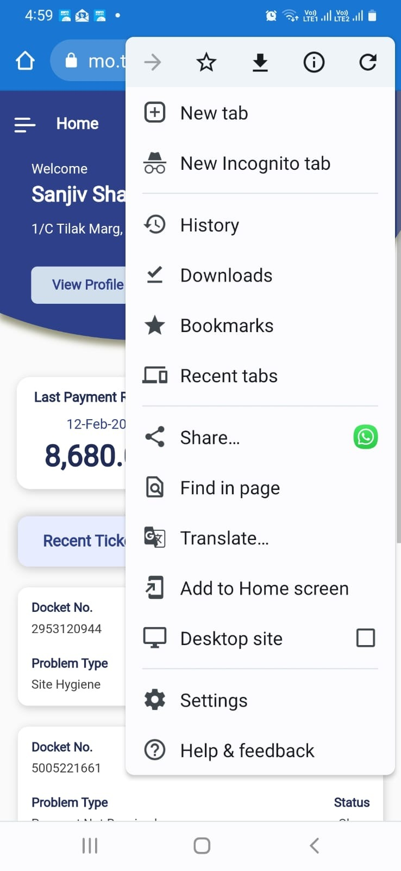

Figure - Add to Home Page menu

* Login to the Landlord Self Service portal and go to homepage.
* Click on the three dots on the top right corner of the browser.
* A menu bar will open. Click on the menu.
* This will open an installation dialog

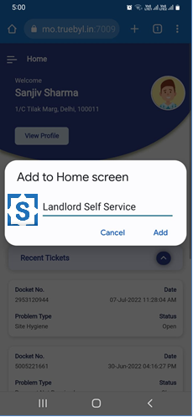

Figure - App Installation Dialog

* Click on Add. This will open a confirmation dialog

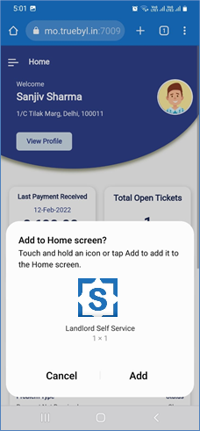

Figure - App Installation Confirmation Dialog

* Click on Add
* This will add the application to the home page of the mobile device
* Click on the icon to open the app directly

### Menu Bar

Menu bar can be accessed anytime by clicking on the following icon on the top left corner of the page.



Figure - Hamburger Menu Icon

Menu bar provides navigation to following components or views.

* **Home** – Navigates to home page.
* **My Profile** - Navigates to Landlord Profile information.
* **My Site Details** - Navigates to Site related information for the site selected.
* **Helpdesk** - Navigates to landlord’s Tickets view to view, raise and track tickets / incidents.
* **Documents** - Navigates to landlord’s documents view to view the uploaded documents.
* **Change Password** – To change user password
* **Logout** – To sign out of the application

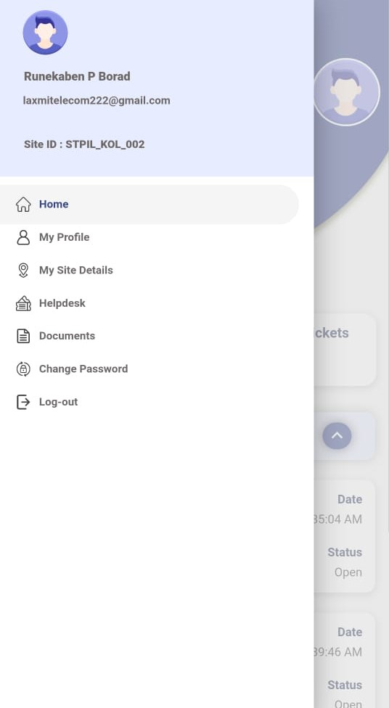

Figure - Menu Bar (Expanded)

### Change Password

* To change password go to the menu bar and click on change password menu
* This will open the Change Password screen
* Enter old password, and new password twice (to confirm)
* Click to change password

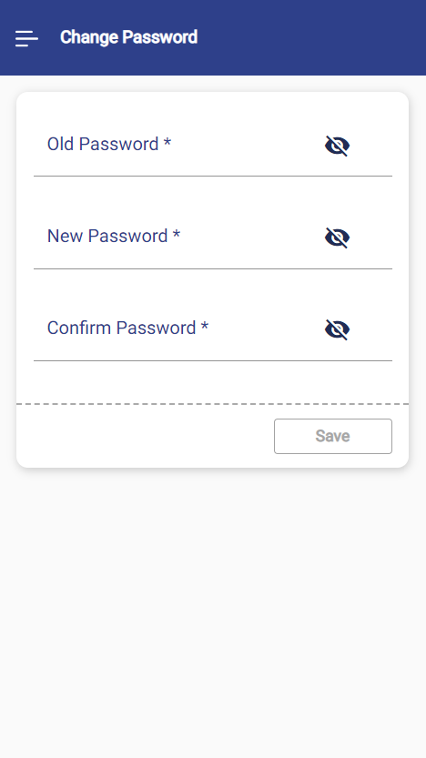

Figure - Change Password Utility

Note: *Password Policy allows Password size minimum 8 and maximum 20 characters with at least one uppercase character, one lowercase, one digit and one symbol.*

### Logout

Click on the  menu in the menu bar to log out from the application.

# My Profile

Users may view and update their profile information from the My Profile page.

* To go to My Profile
  + Either click on the  menu in the Menu Bar
  + Or click on the  button in the home page.

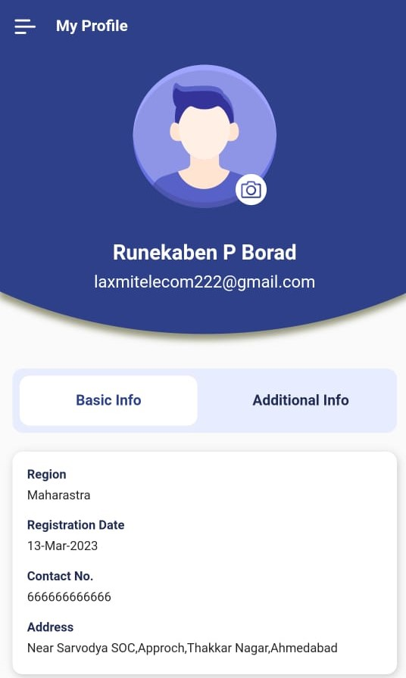

Figure – My Profile

* Users can view Basic and Additional Information about themselves here.
* To view Additional information click on the 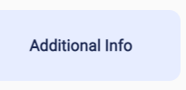 switch

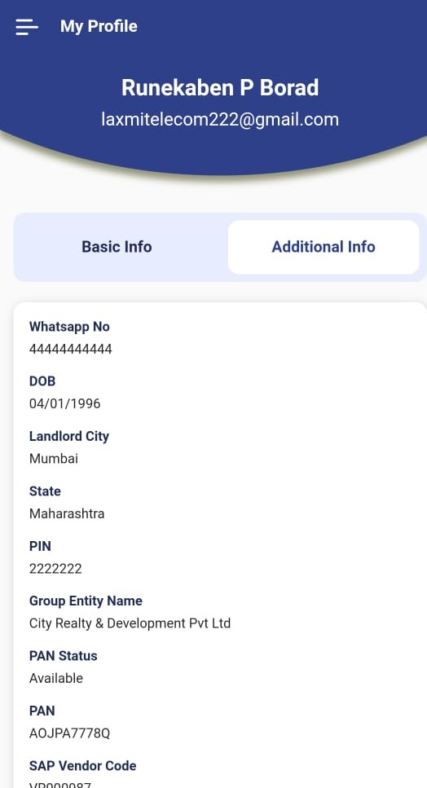

Figure - Additional Information

* To change the profile picture, click on the icon
  + - This will open the photo upload dialog

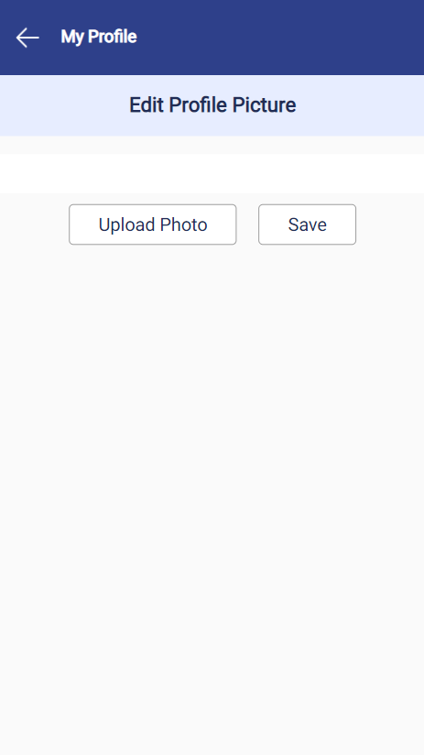

Figure - Edit Profile Picture

* + - Click on button to open the Camera or Gallery and take a picture or select an image
    - There is an option to crop the image by pinching it.

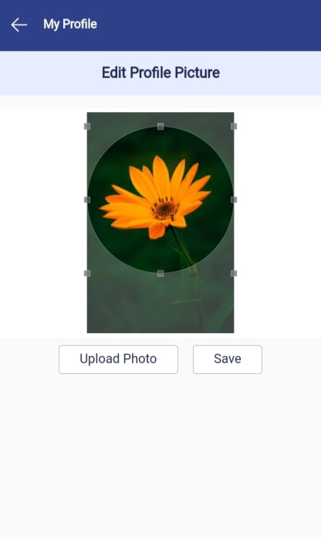

Figure - Crop Profile Picture

* + - Click on Save in the photo upload dialog to upload the picture and close it

# My Site Details

* The sites user is associated with as a landlord, are shown in the Site drop down in the menu drawer.
* The Site selected is shown in Site ID field
* User may change the site selected by selecting another site from the drop down

Note: *If landlord has multiple sites associated with him/her, then only the dropdown for site selection appears*.

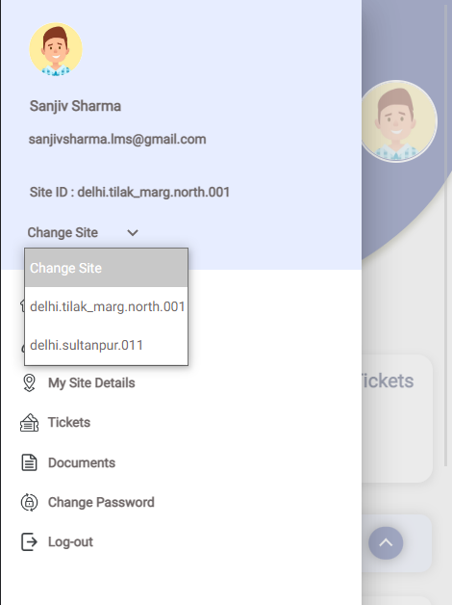

Figure - Site Change Option

* Users may view details of the selected site by clicking the  menu item.
* This will open the Site Details page

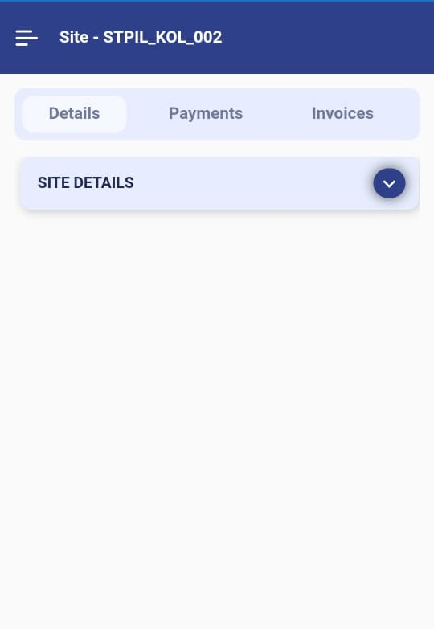

Figure - Site Details

* There are three tabbed views –
* Details
* Payments
* Invoices

## Details

* Shows Site Id, Site Name, Site Address, Circle under SITE DETAILS accordion.

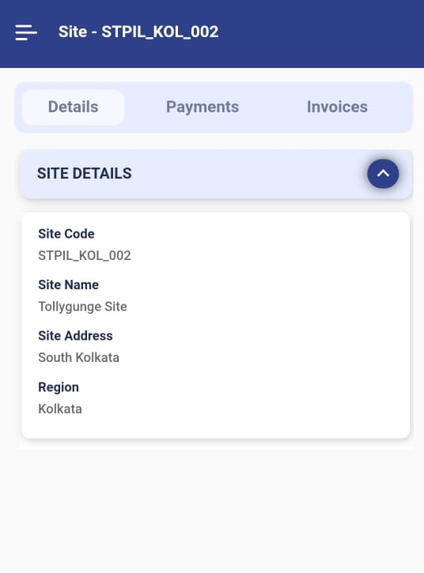

Figure - Site Details

## 6.2 Payments

* Shows the information of payments received by the landlord for that particular site
* Detailed breakup of payments can be viewed (if available) y clicking on the button

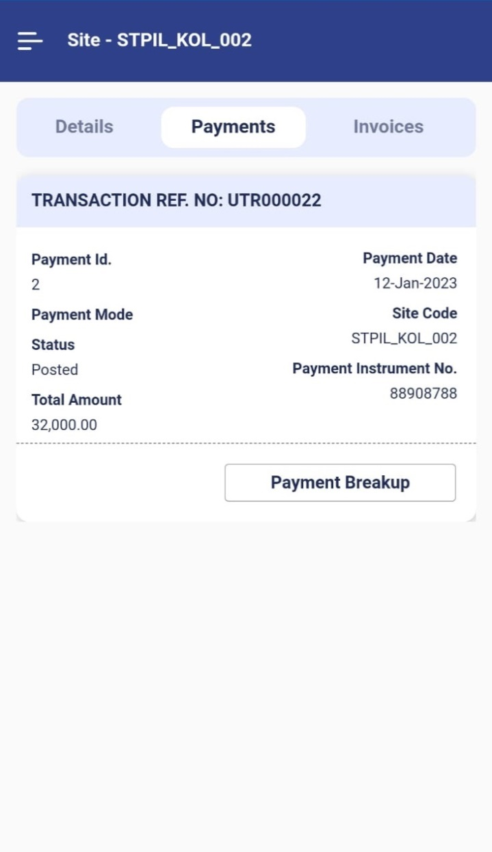

**Figure 20 – Payments for a Site**

# 6.3 Invoices

* Shows the information of invoice details for that particular site.
* Shows Invoice Id, Invoice No, Invoice Date, Invoice Start Date Invoice End Date, Invoice Type, and Invoice Amount under Invoices accordion.

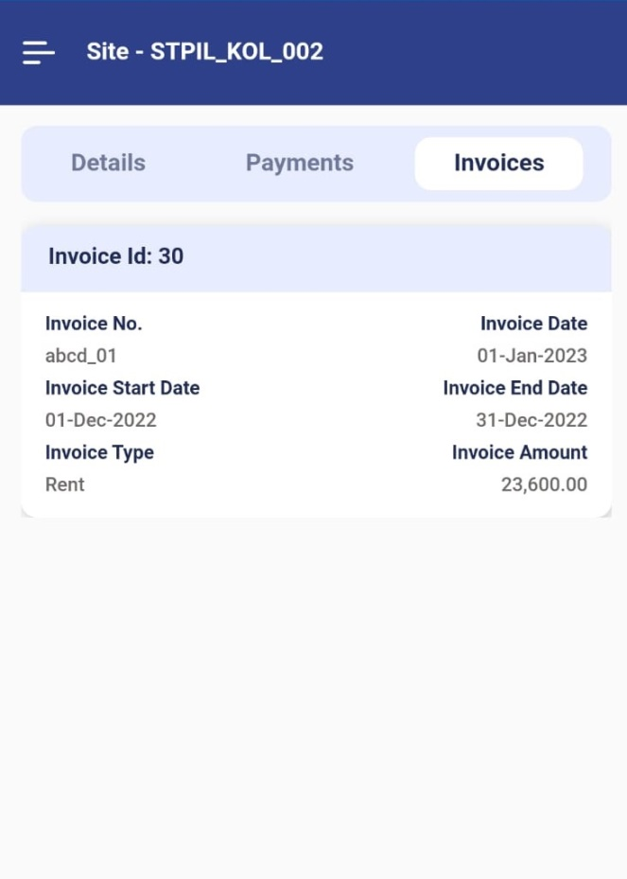

Figure – Invoices of a Site

# Help Desk

Landlords can raise Trouble Tickets to resolve issues or problems faced by them. It is called reporting an incident. The application allows to raise and view and track incidents for landlords.

* To view and manage the incidents click on menu. User will be taken to the landlord’s tickets page
* It shows the list of open or closed tickets or incidents raised by this landlord
* Following fields of the incident are shown in the card view –
  + **Docket#** - Identifier for the incident or ticket.
  + **Order Name** – Name or type of the incident
  + **Status** – Status of the incident. Open or Closed

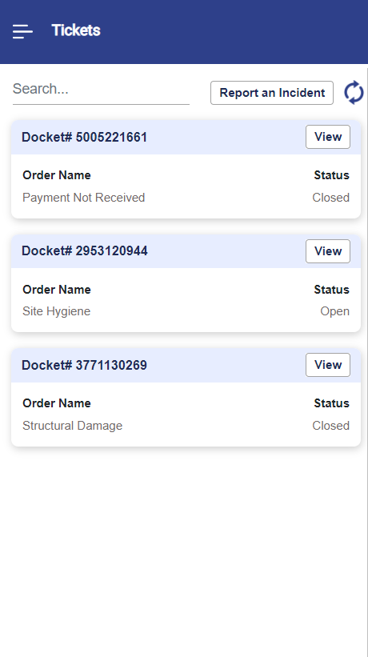

Figure - Landlord Tickets

* To filter the incident list –
  + Enter any text in the search bar. System will match the entered text with all the fields (Docket#, Name, Status) of the vendor list and filtered out the ones not matching.
* To refresh the incident list user may click on the  icon
* To view details of a ticket click on  button beside that ticket or incident.
* It will open the ticket / incident details dialog

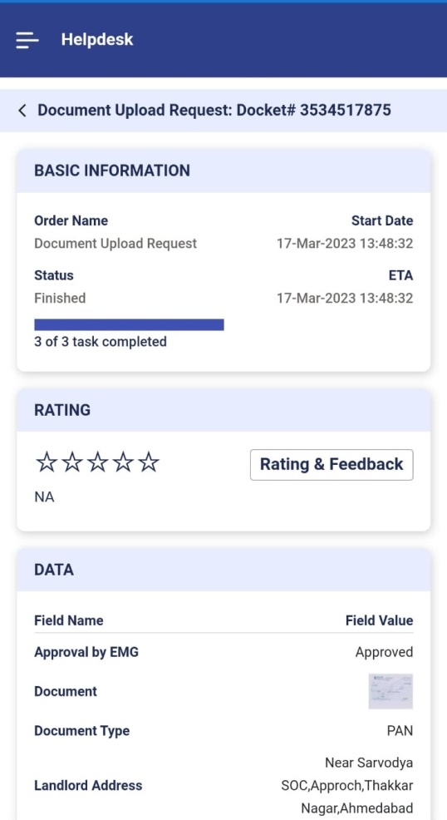

Figure - Ticket Details Dialog

* It shows the following information –
  + Order Name – Name of the Incident
  + Start Date – Date on which the ticket was raised
  + Status – State of the ticket. Either Open or Finished
  + ETA – Expected completion time.
  + Progress bar – Shows number of tasks completed out of total number of tasks in the ticket
  + In the lower section it shows the data of the instance which were supplied during ticket creation or task execution. The data fields are dynamic and change from ticket type to ticket type as per template configuration
  + It also shows the task details of the ticket with following details –
    - Task Name
    - Task Type – Either Manual or Automatic
    - Task State
      * To Start – Task is assigned but the engineer or technician or user has not accepted it yet
      * Started – Task is accepted by the engineer or technician or user
      * Finished – Task is closed by the engineer or technician or user
    - Assigned To - The engineer or technician or user, the task is assigned to.

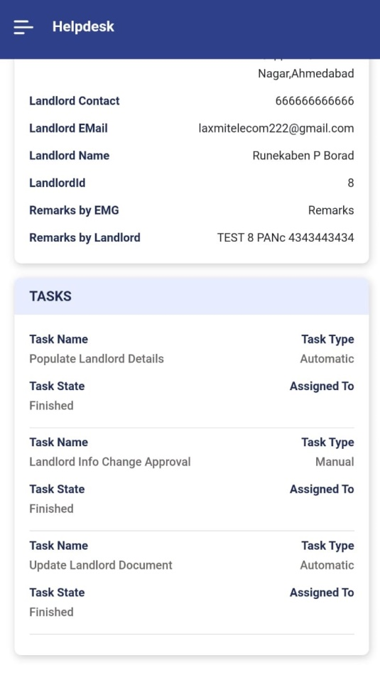

Figure - View of Tasks in a ticket

Note: *This view of the ticket is read only, as in it can not be modified by the user. As and when the tasks are worked upon by the engineer or technician or user the view of the ticket gets changed accordingly*

* There is an option to provide rating and feedback on the closed tickets.
  + Click on the button.
  + This will open the Rating & Feedback window.

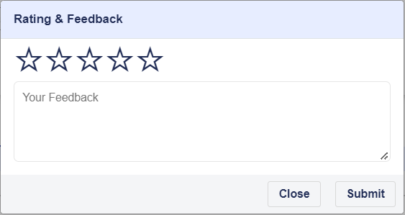

Figure - Ticket Rating & Review Dialog

* + Click on the stars to provide rating.
  + Enter feedback
  + Click on  button to save the rating and review.
  + This will show the rating and feedback on ticket details page.

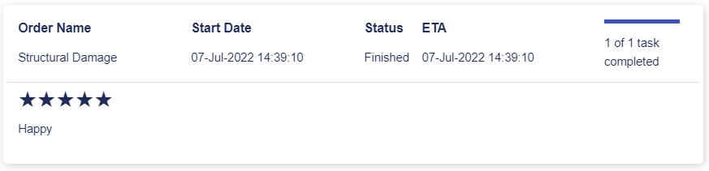

Figure - Ticket Rating & Review

Note: *Rating & review can be provided only on closed ticket and only once. If rating and review is already given for a closed ticket it can not be given again.*

* To report a new Incident or raise a new ticket –
  + Click on the button.
  + This will open the Report Incident dialog
  + Select the Incident Type to raise, from the drop down.
  + The list can be filtered by typing the search text in the search bar
  + Based on the selected incident type, launch parameters are loaded dynamically.
  + Enter values in the launch parameters as appropriate.
  + Some of the launch parameters may have value already populated and disabled. Ignore them.
  + Click on the save button to create the incident.

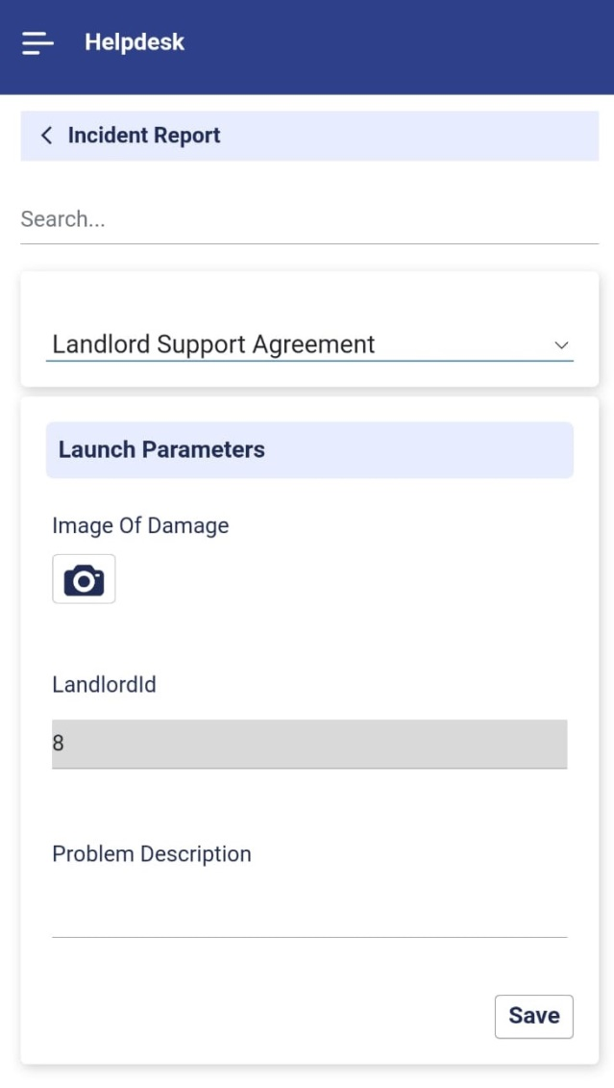

Figure - Report an Incident Dialog

* + Once the incident is successfully created a message appears with the docket number.

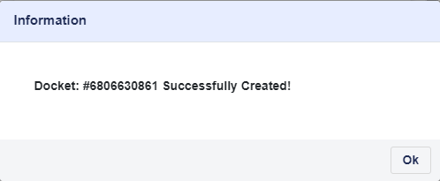

Figure - Incident Creation Message

* + The docket also appears in the ticket list with Open status
* System allows raising same types of ticket multiple times

# Documents

The application provides an option to upload, view and download documents at landlord level. Documents can be any document related to the landlord, for example identity card or address proof or agreements etc. There is no restriction on number of documents being added to the landlord.

To view and manage the landlord documents

* Click menu to view all the documents in card view.
* For each document “**Document Type**”, “**Name**” and “**Description**” is shown in card view.
* To view a content of the document click on the icon in the document card. This will open the document content.

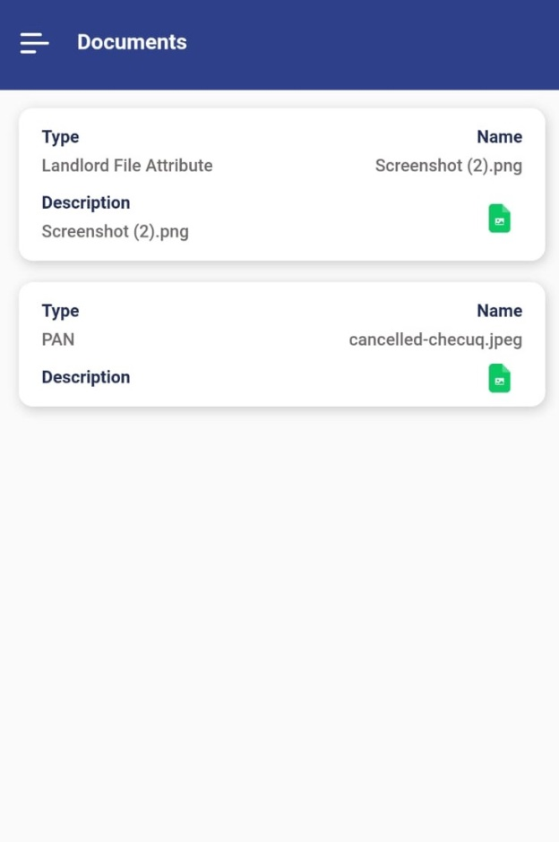

Figure - Landlord Documents

------------------------------------------------------------End of the User Manual--------------------------------------------------------------------