**SATS Web Portal API Performance Test Report**

Number of Thread(s): Number of User(s).

Ramp-up Period (in seconds): After how many seconds of interval, the user will send the request.

Loop Count: How many times the same request, sent by several users, will be repeated.

1. **Login**

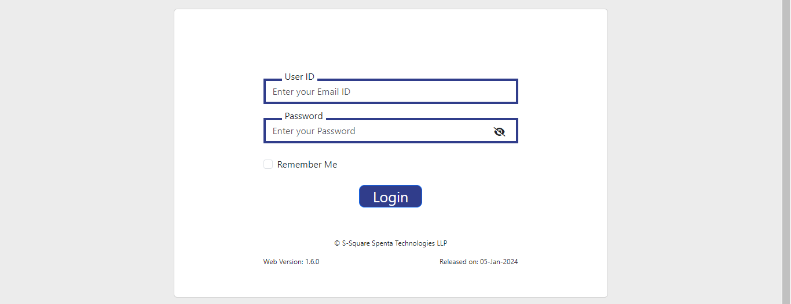

Scenario:

Number of Threads: 400.

Ramp-up Period (seconds): 1.

Loop Count: 3.

Thread Group:

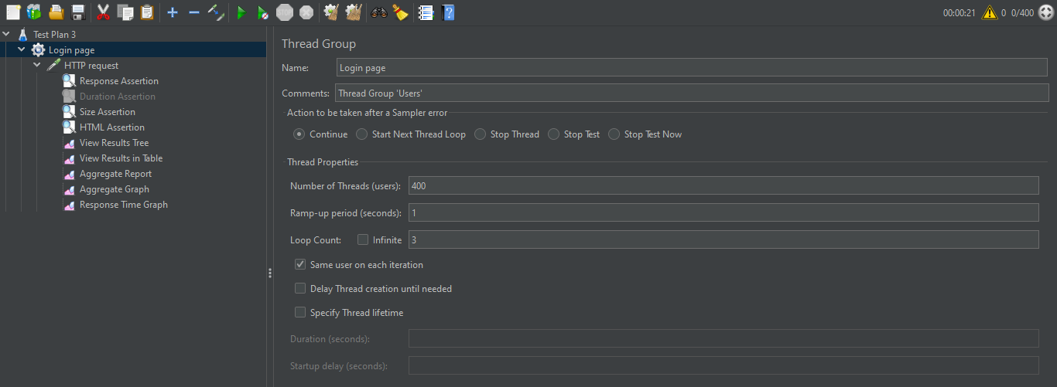

The Thread Group includes the thread properties, such as no. of threads, ramp-up period and loop count. It also has the HTTP request, the assertions and different sorts of listeners.

View Results in Table:

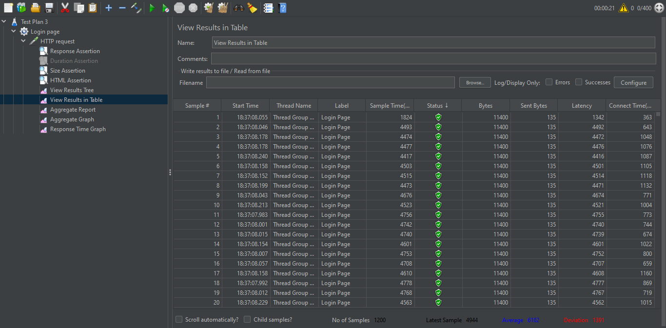

The table shows that all 1200 samples have green status, indicating they have passed successfully.

Aggregate Report:

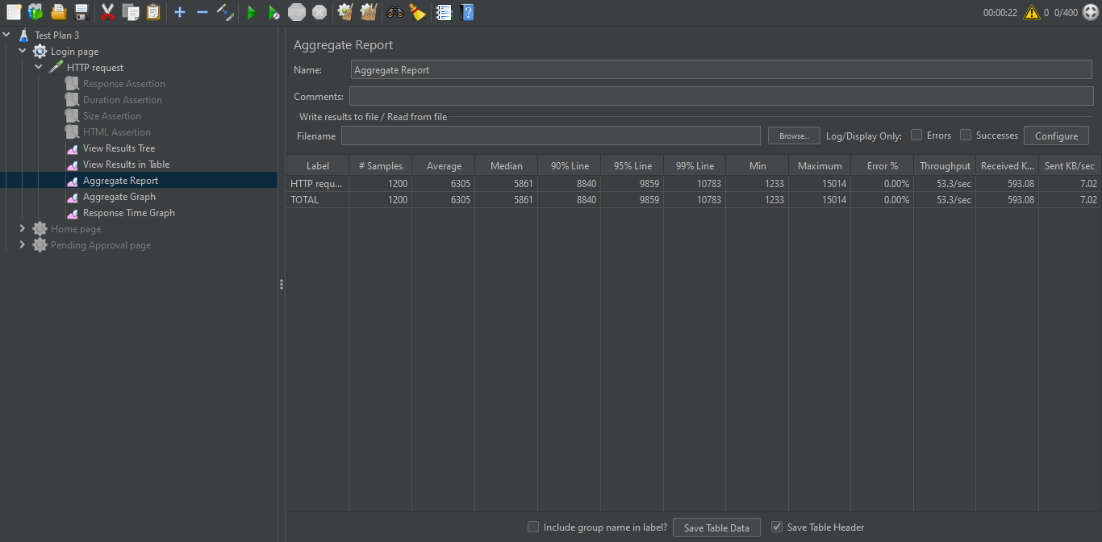

The Aggregate Report table shows No. of Samples = 1200, Error = 0%, Throughput = 53.3/sec.

Response Time Graph:

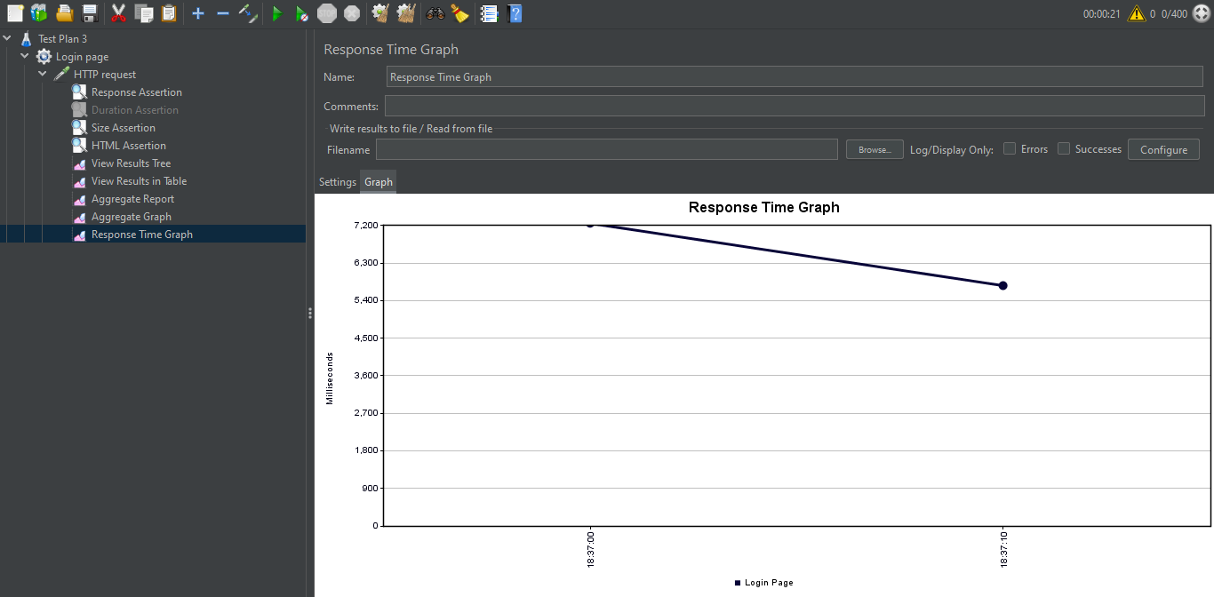

The Response Time Graph shows that the time of response decreases as more samples are processed.

1. **Home**

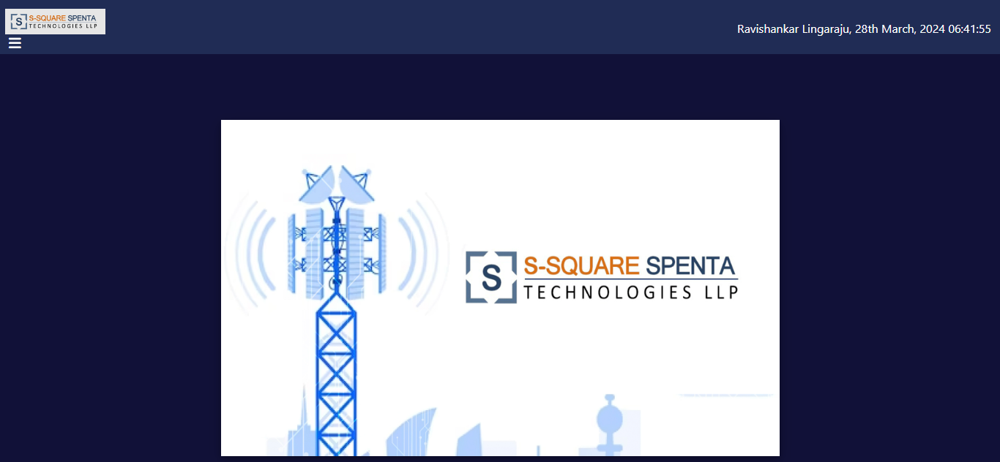

Scenario:

Number of Threads: 400.

Ramp-up Period (seconds): 1.

Loop Count: 3.

Thread Group:

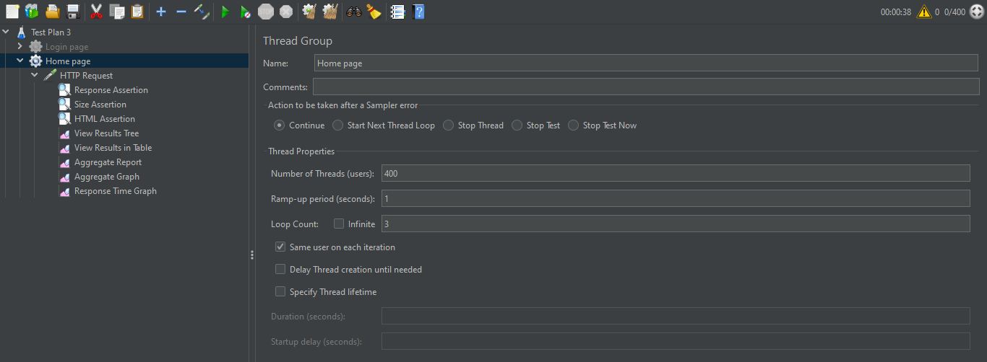

The Thread Group includes the thread properties, such as no. of threads, ramp-up period and loop count. It also has the HTTP request, the assertions and different sorts of listeners.

View Results in Table:

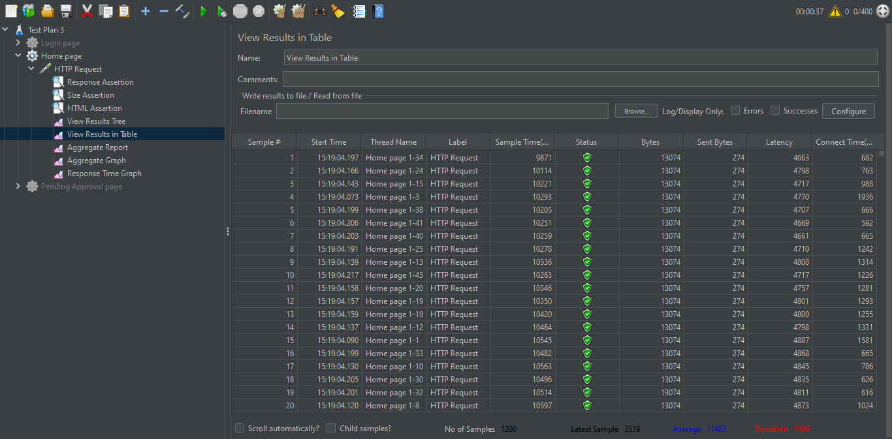

The table shows that all 1200 samples have green status, indicating they have passed successfully.

Aggregate Report:

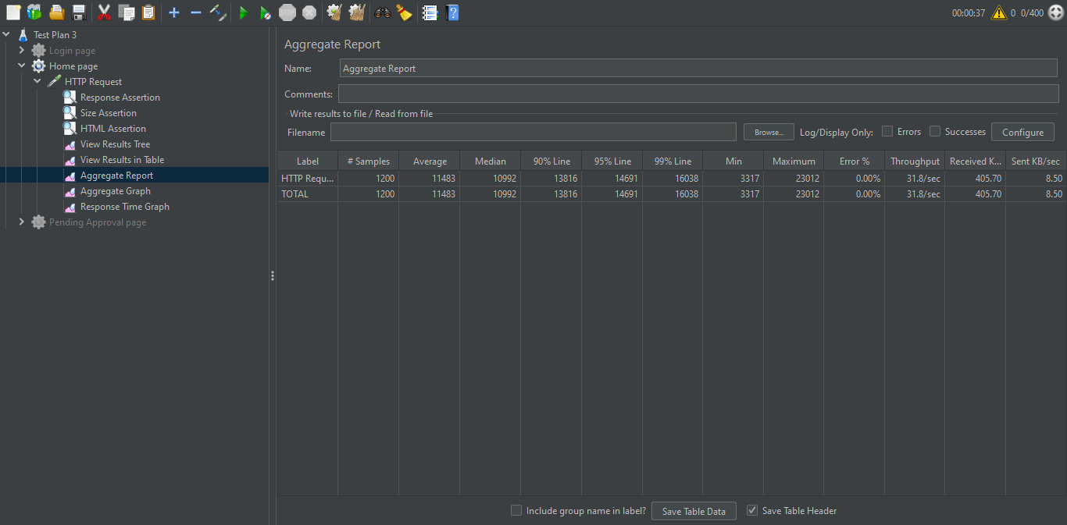

The Aggregate Report table shows No. of Samples = 1200, Error = 0%, Throughput = 31.8/sec.

Response Time Graph:

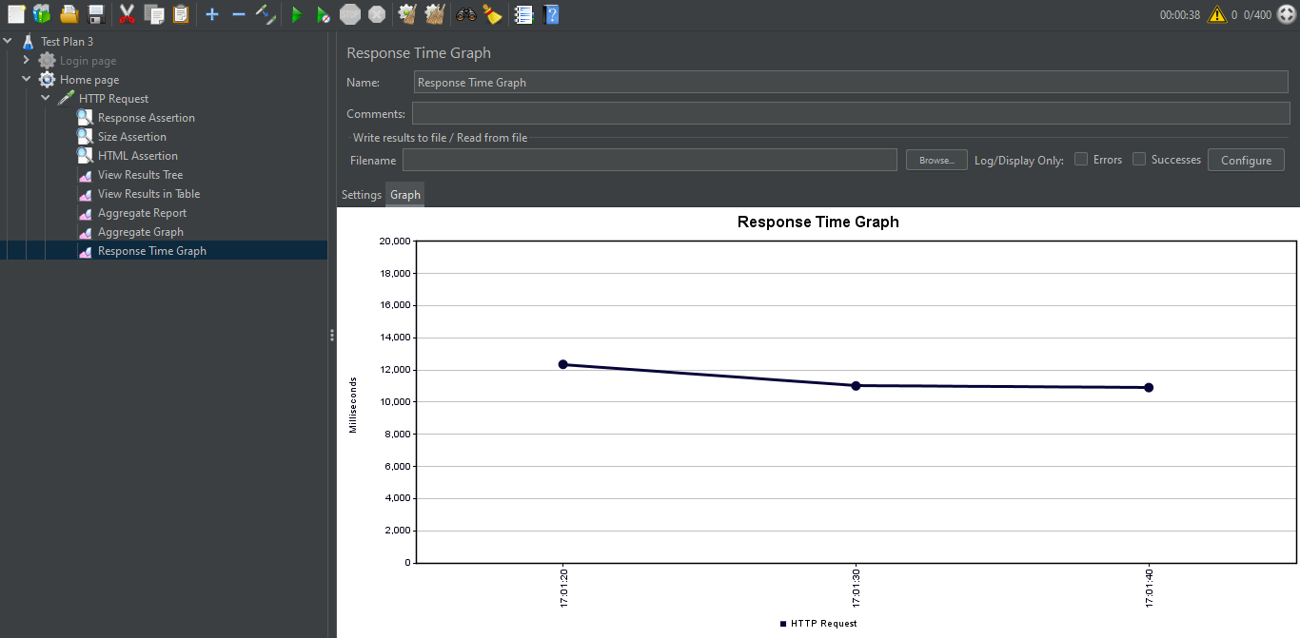

The Response Time Graph shows that the time of response decreases as more samples are processed. After a certain value (around 11000 ms), it becomes constant.

1. **Pending Approval**

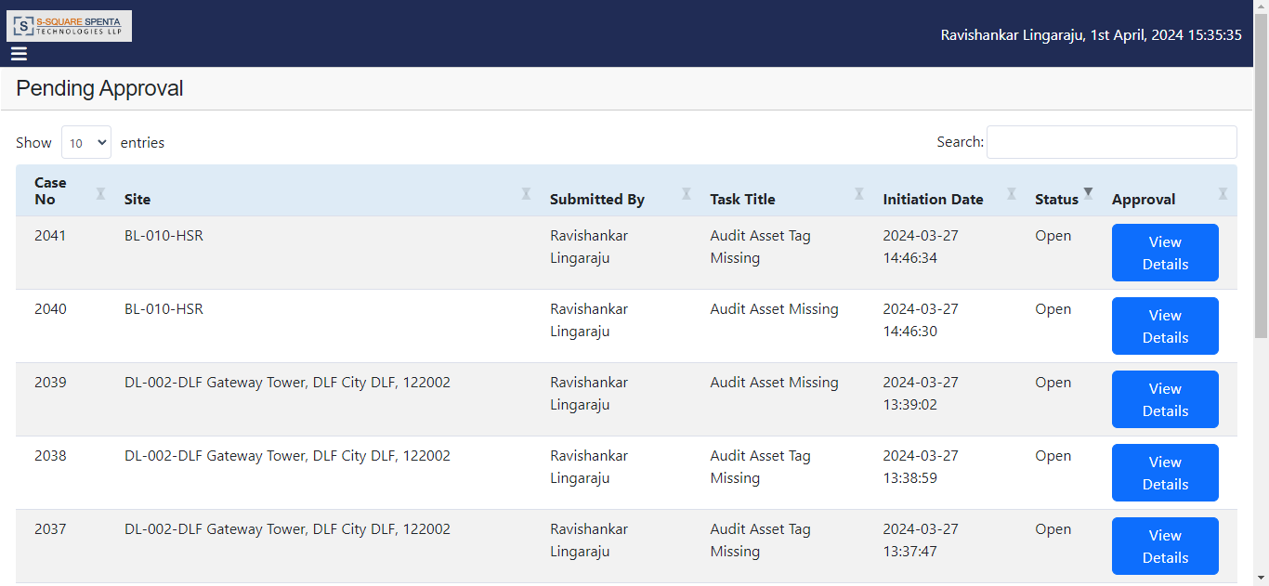

Scenario:

Number of Threads: 400.

Ramp-up Period (seconds): 1.

Loop Count: 3.

Thread Group:

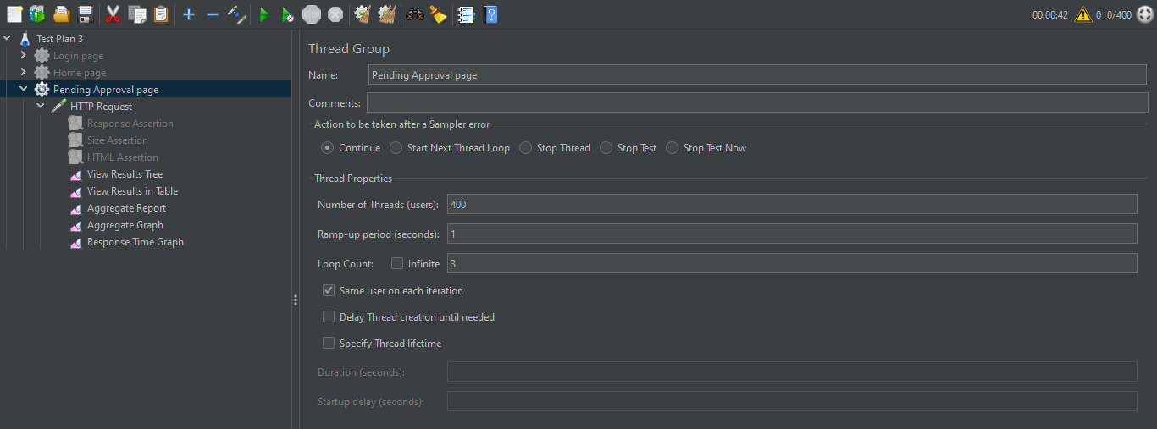

The Thread Group includes the thread properties, such as no. of threads, ramp-up period and loop count. It also has the HTTP request, the assertions and different sorts of listeners.

View Results in Table:

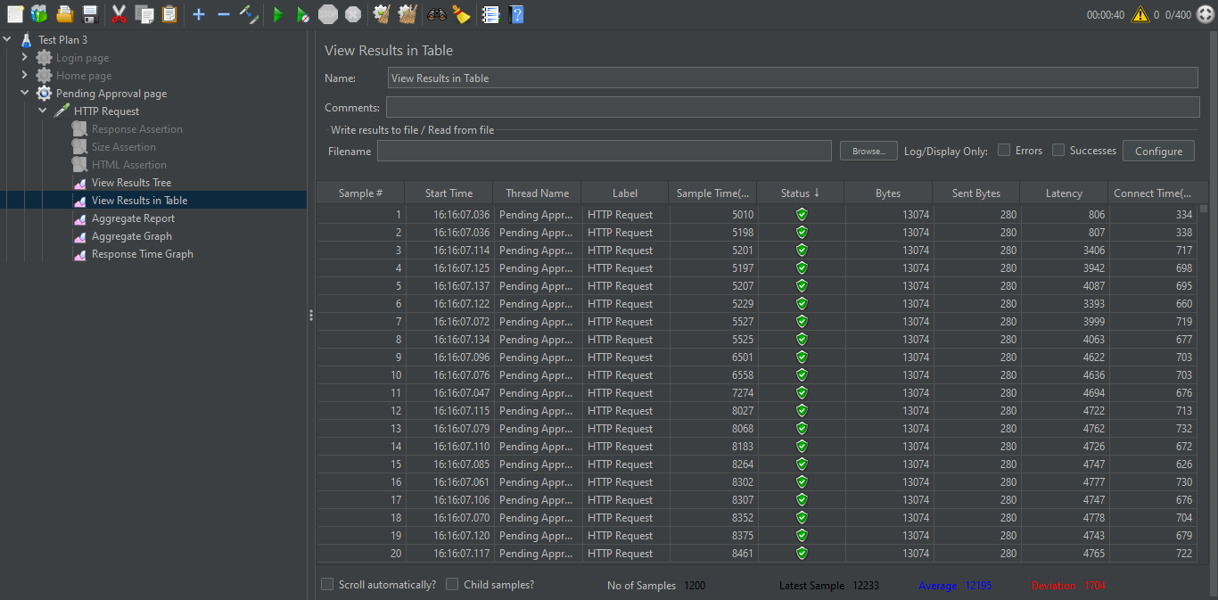

The table shows that all 1200 samples have green status, indicating they have passed successfully.

Aggregate Report:

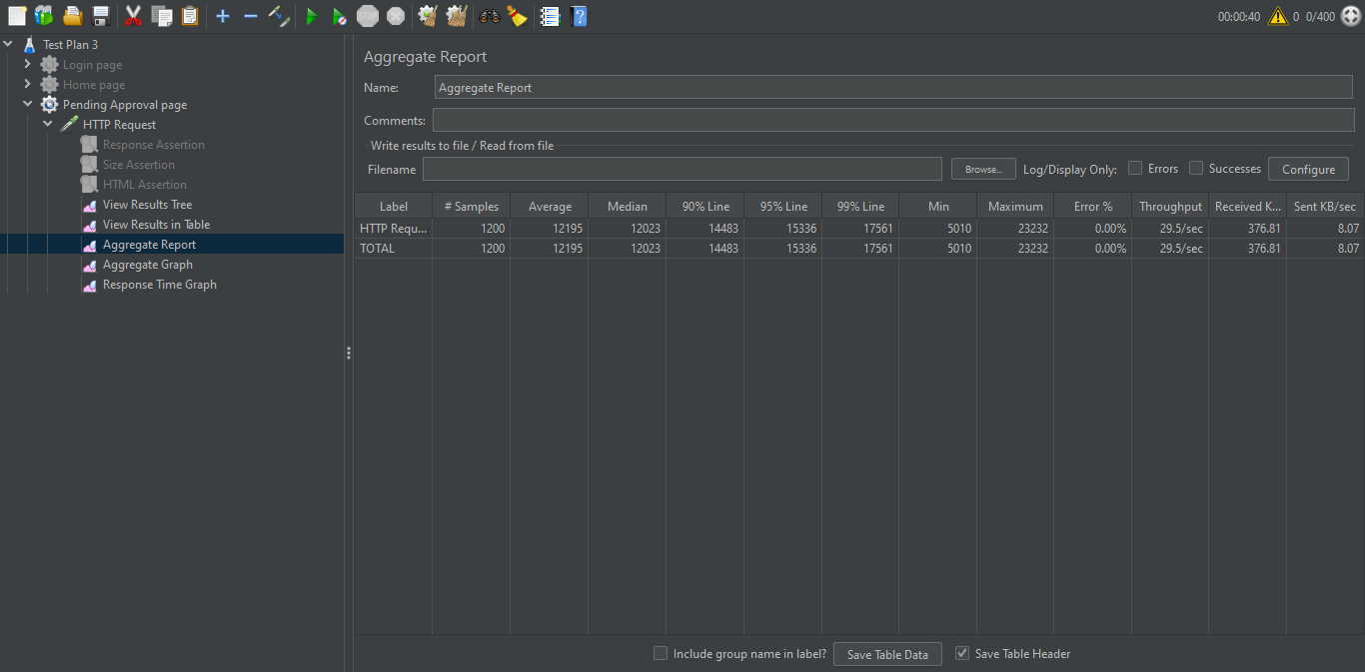

The Aggregate Report table shows No. of Samples = 1200, Error = 0%, Throughput = 29.5/sec.

Response Time Graph:

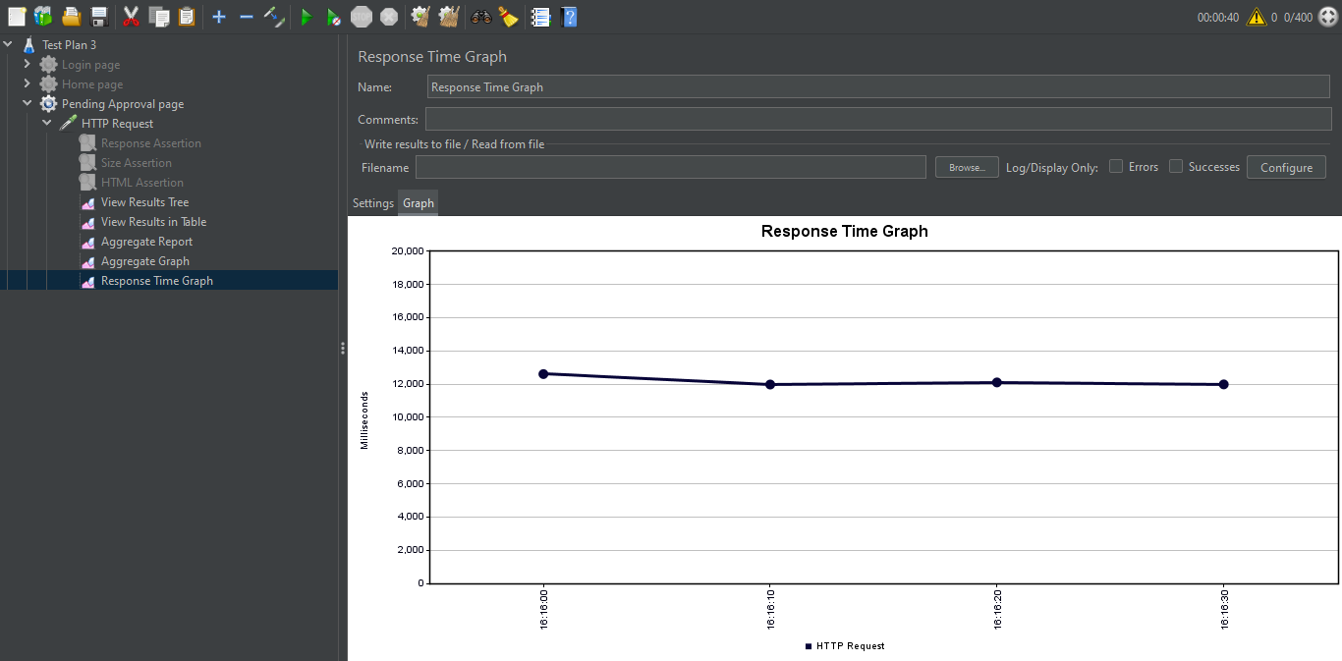

The Response Time Graph shows that the time of response decreases as more samples are processed. After a certain value (around 12000 ms), it becomes constant.

1. **Technician to Site Tagging Status**

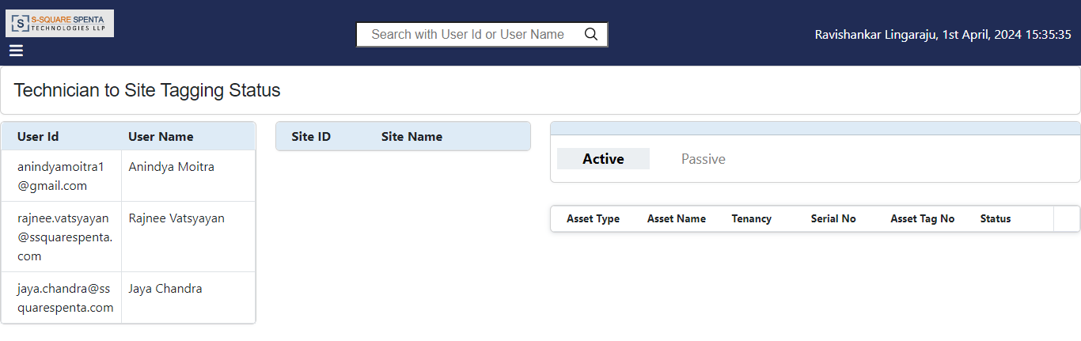

Scenario:

Number of Threads: 400.

Ramp-up Period (seconds): 1.

Loop Count: 3.

Thread Group:

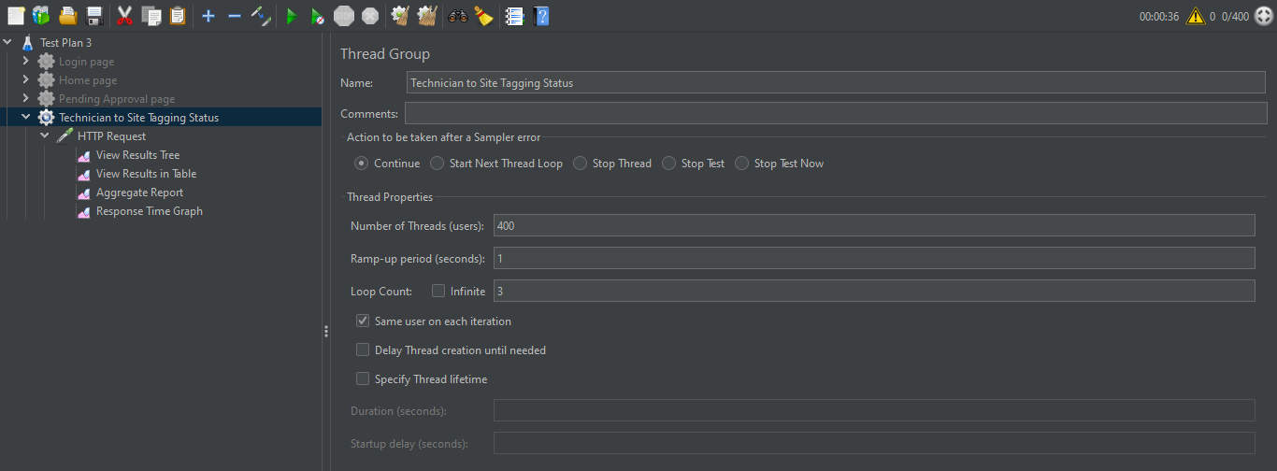

The Thread Group includes the thread properties, such as no. of threads, ramp-up period and loop count. It also has the HTTP request, the assertions and different sorts of listeners.

View Results in Table:

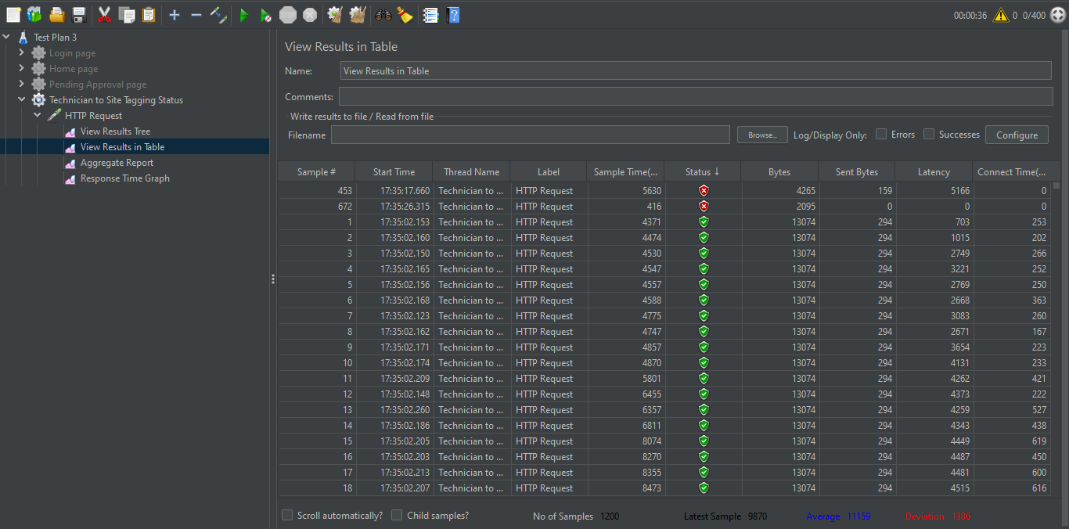

The table shows that 2 out of the 1200 samples have red status, indicating they failed, while the remaining 1198 have green status and passed successfully.

Aggregate Report:

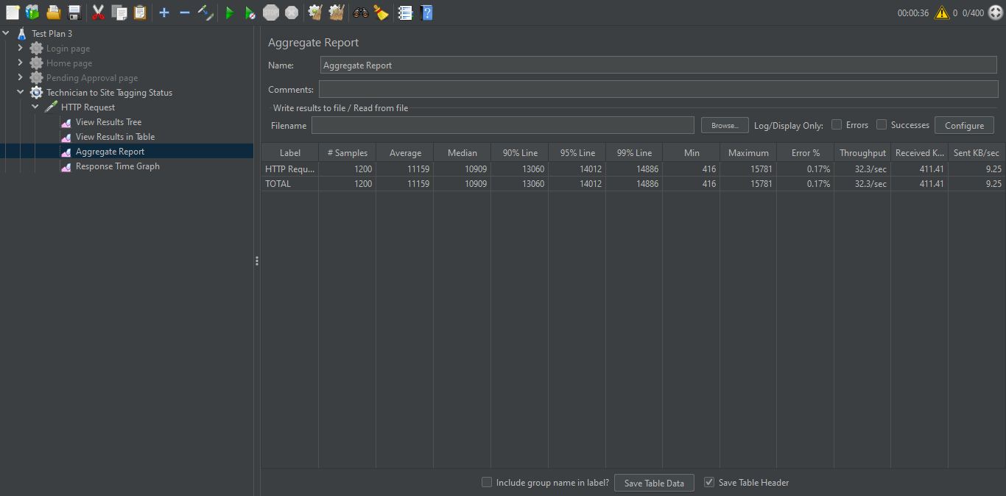

The Aggregate Report table shows No. of Samples = 1200, Error = 0.17%, Throughput = 32.3/sec.

Response Time Graph:

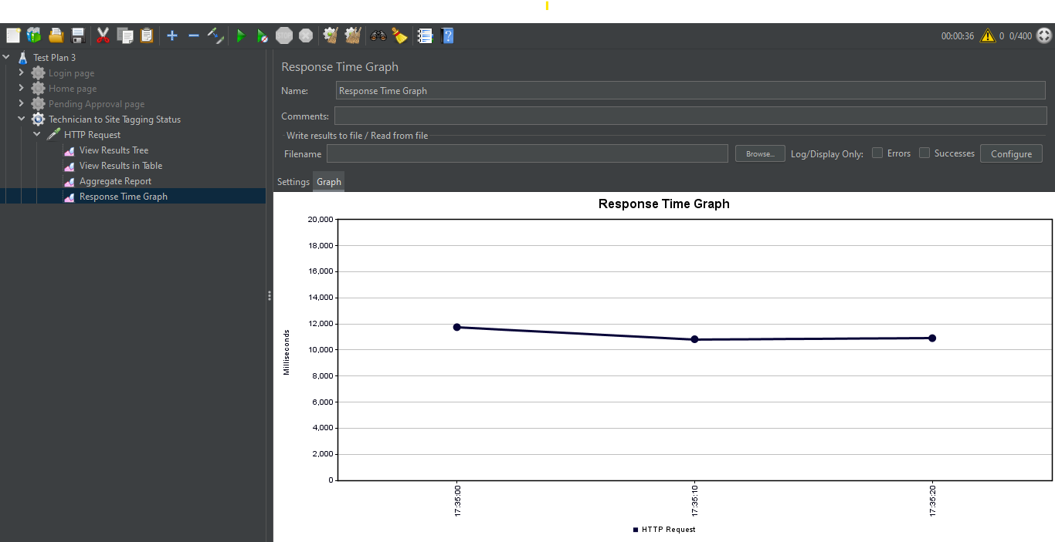

The Response Time Graph shows that the time of response decreases as more samples are processed. After a certain value (around 11000 ms), it becomes constant.

1. **Operator Site View**

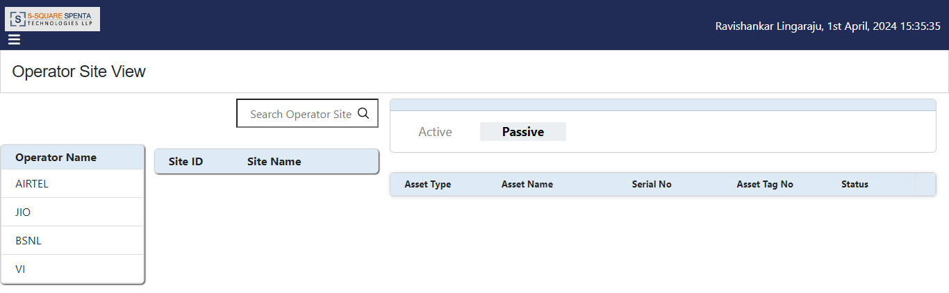

Scenario:

Number of Threads: 400.

Ramp-up Period (seconds): 1.

Loop Count: 3.

Thread Group:

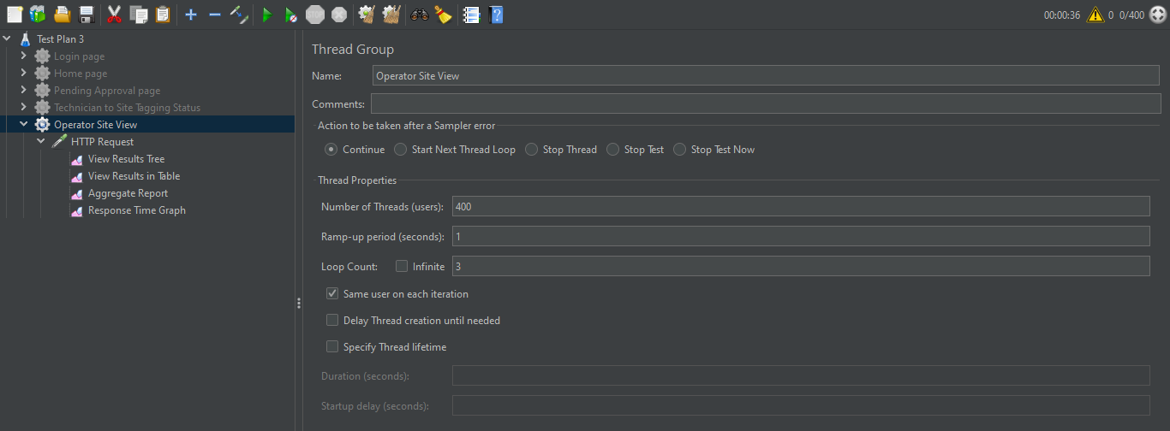

The Thread Group includes the thread properties, such as no. of threads, ramp-up period and loop count. It also has the HTTP request, the assertions and different sorts of listeners.

View Results in Table:

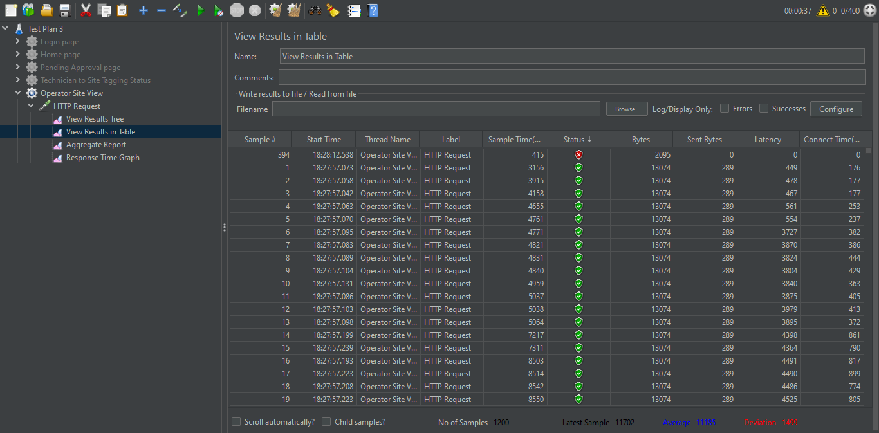

The table shows that 1 out of the 1200 samples have red status, indicating it failed, while the remaining 1199 have green status and passed successfully.

Aggregate Report:

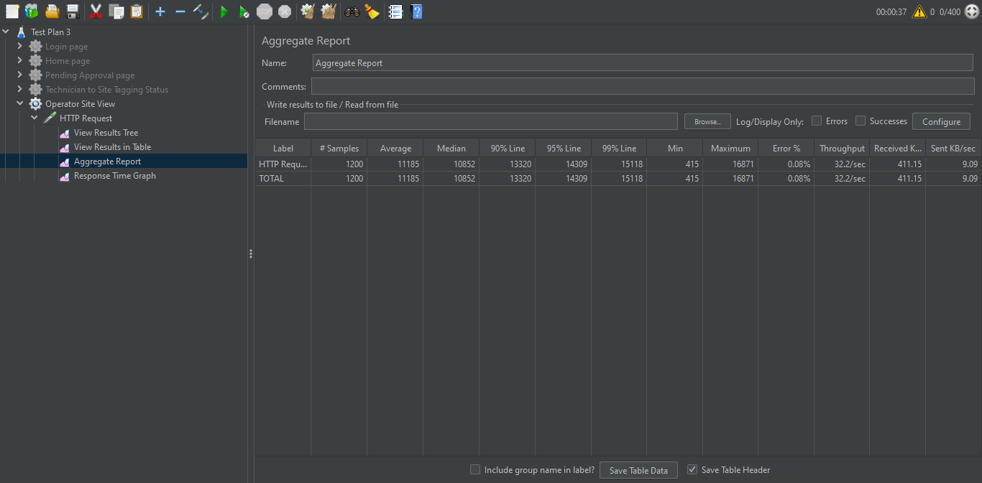

The Aggregate Report table shows No. of Samples = 1200, Error = 0.08%, Throughput = 32.2/sec.

Response Time Graph:

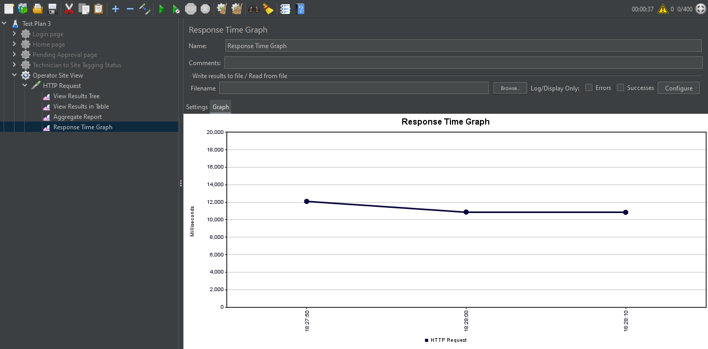

The Response Time Graph shows that the time of response decreases as more samples are processed. After a certain value (around 11000 ms), it becomes constant.

1. **Technician Supervisor Mapping**

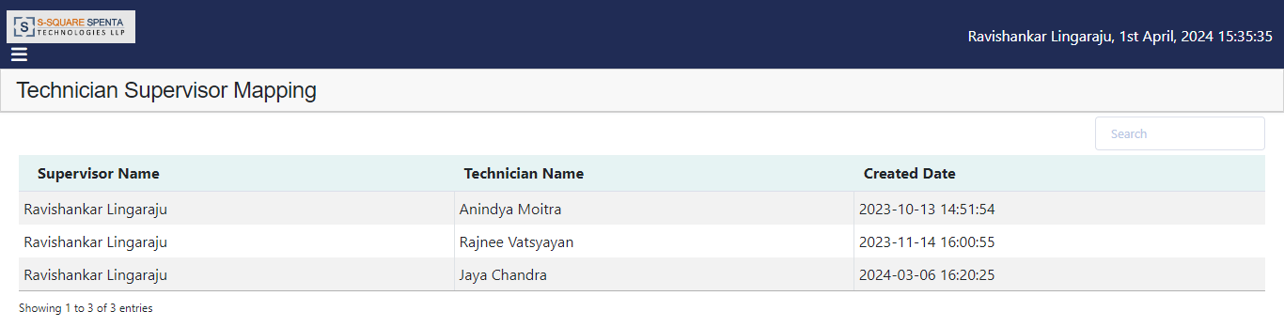

Scenario:

Number of Threads: 400.

Ramp-up Period (seconds): 1.

Loop Count: 3.

Thread Group:

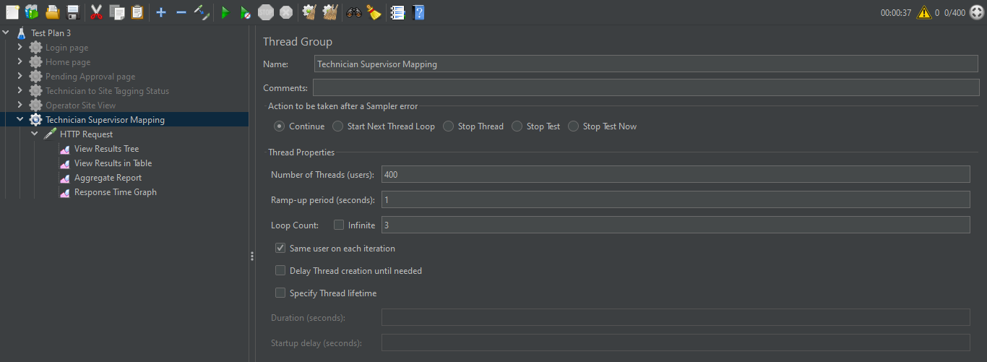

The Thread Group includes the thread properties, such as no. of threads, ramp-up period and loop count. It also has the HTTP request, the assertions and different sorts of listeners.

View Results in Table:

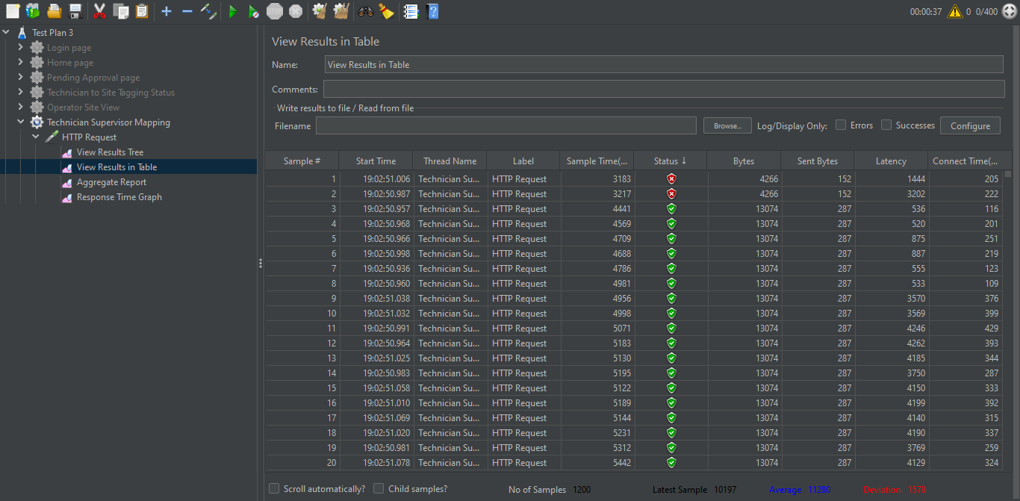

The table shows that 2 out of the 1200 samples have red status, indicating they failed, while the remaining 1198 have green status and passed successfully.

Aggregate Report:

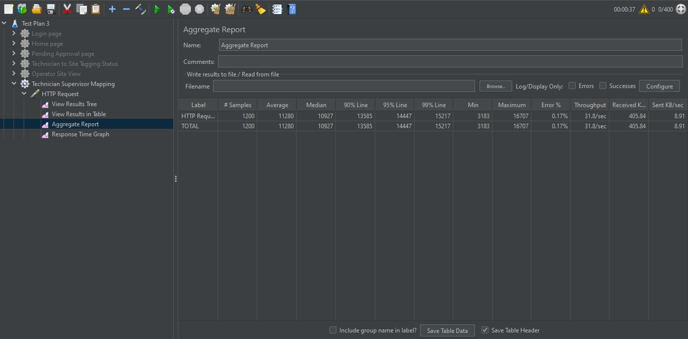

The Aggregate Report table shows No. of Samples = 1200, Error = 0.17%, Throughput = 31.8/sec.

Response Time Graph:

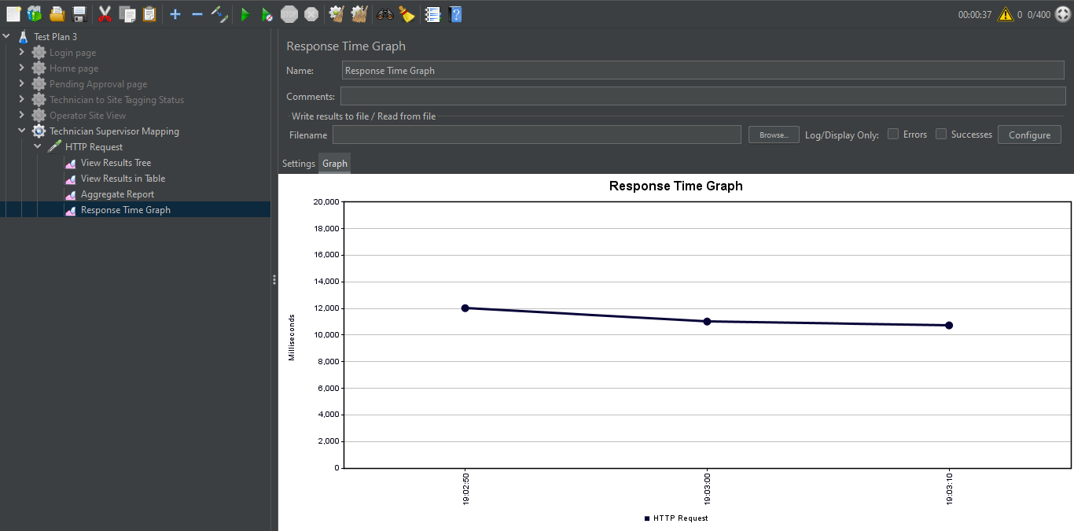

The Response Time Graph shows that the time of response decreases as more samples are processed. After a certain value (around 11000 ms), it becomes constant.

1. **Site Asset View**

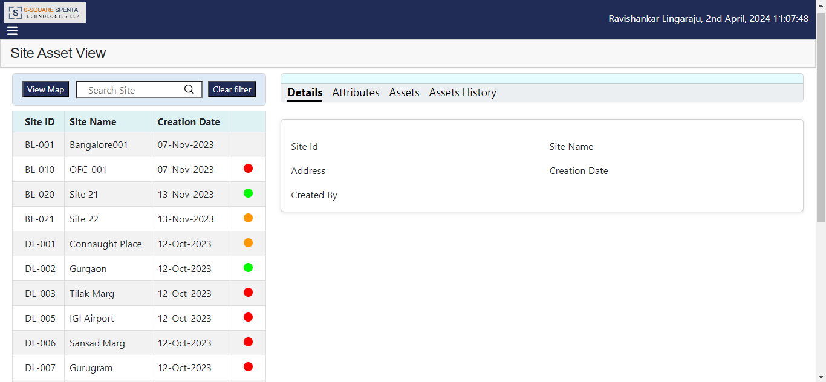

Scenario:

Number of Threads: 400.

Ramp-up Period (seconds): 1.

Loop Count: 3.

Thread Group:

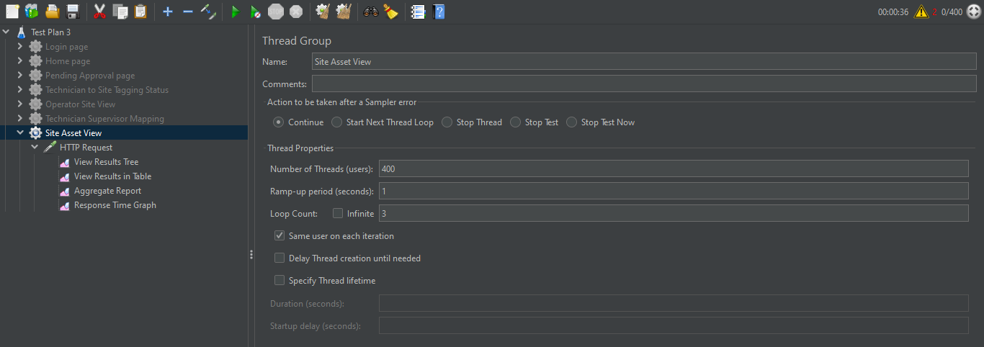

The Thread Group includes the thread properties, such as no. of threads, ramp-up period and loop count. It also has the HTTP request, the assertions and different sorts of listeners.

View Results in Table:

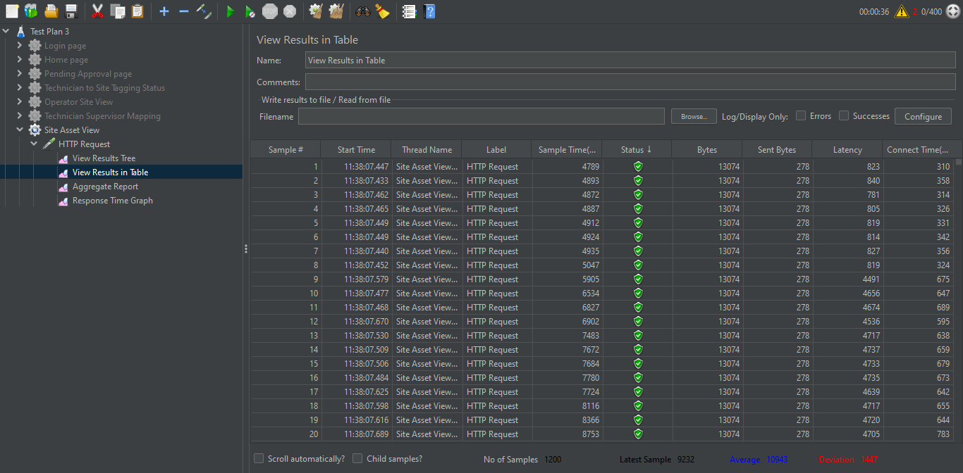

The table shows that all 1200 samples have green status, indicating they have passed successfully.

Aggregate Report:

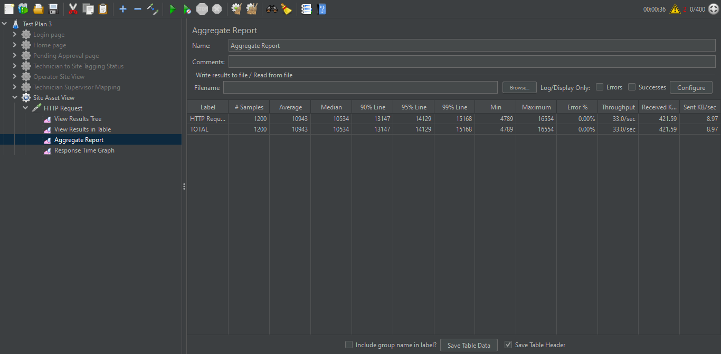

The Aggregate Report table shows No. of Samples = 1200, Error = 0%, Throughput = 33.0/sec.

Response Time Graph:

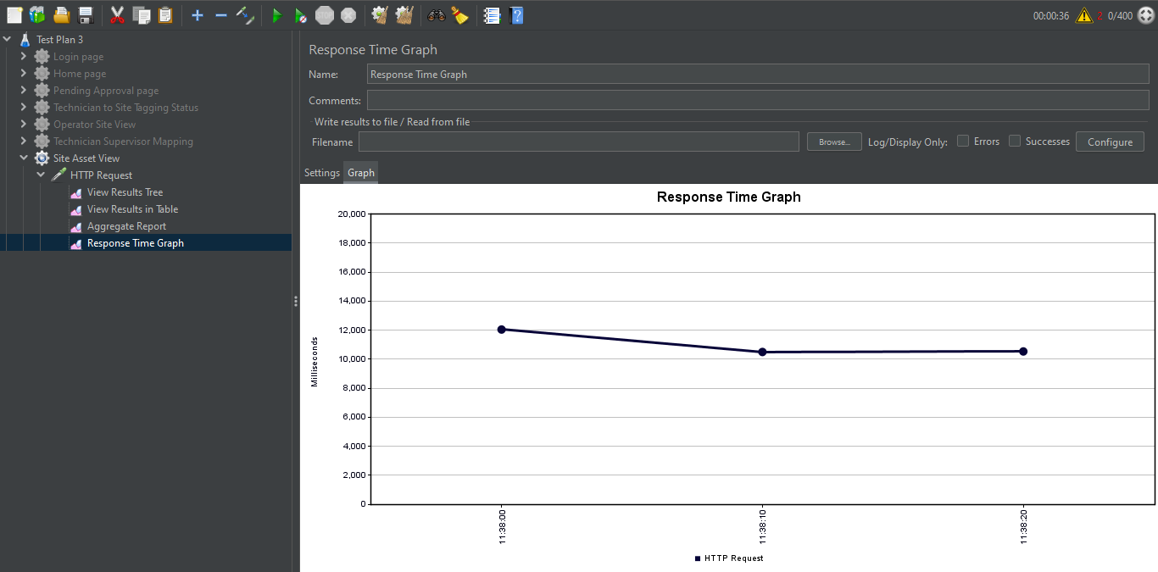

The Response Time Graph shows that the time of response decreases as more samples are processed. After a certain value (a bit over 10000 ms), it becomes constant.

1. **Asset History**

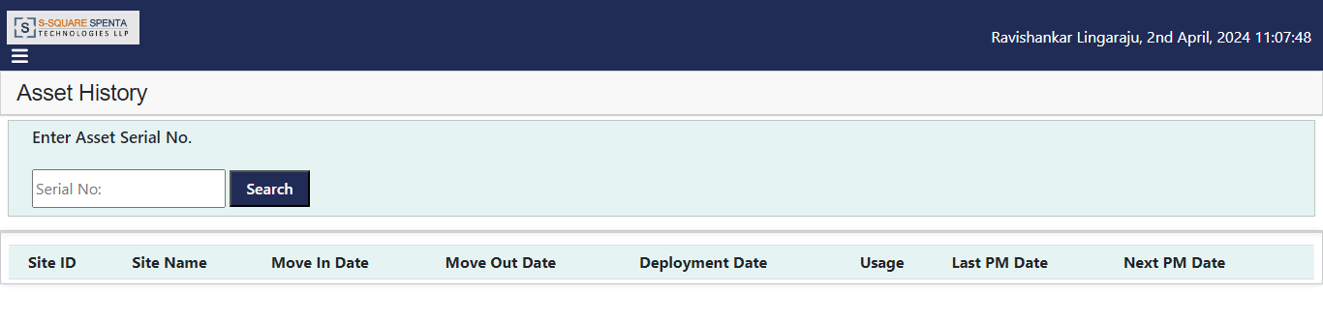

Scenario:

Number of Threads: 400.

Ramp-up Period (seconds): 1.

Loop Count: 3.

Thread Group:

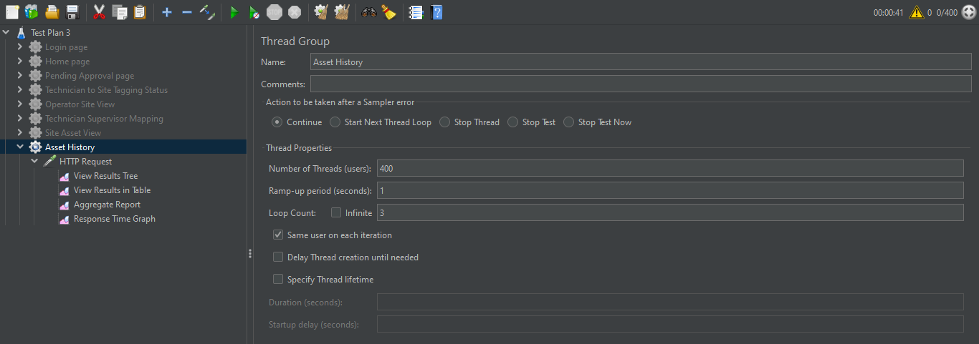

The Thread Group includes the thread properties, such as no. of threads, ramp-up period and loop count. It also has the HTTP request, the assertions and different sorts of listeners.

View Results in Table:

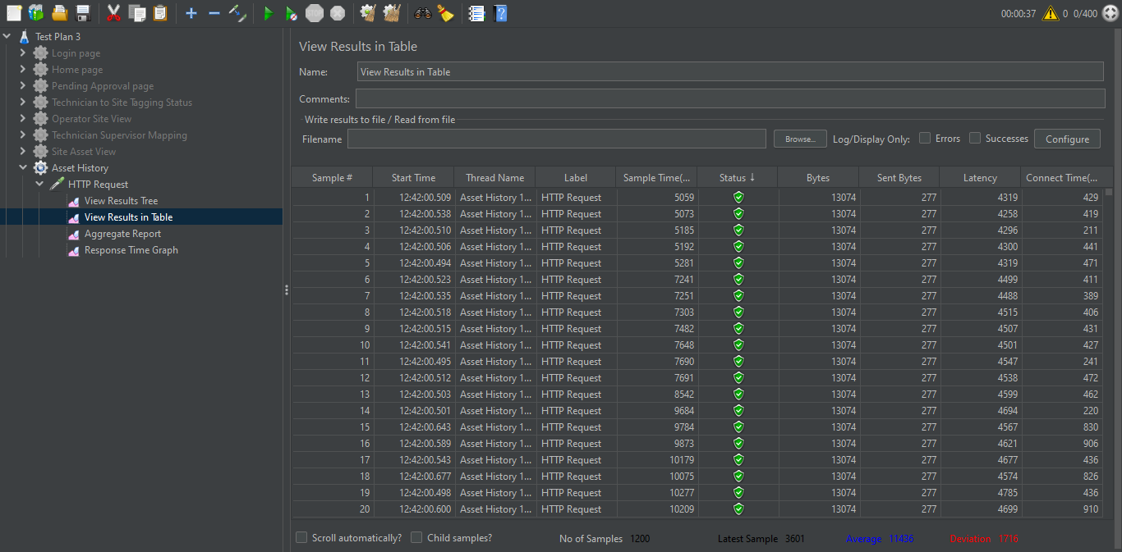

The table shows that all 1200 samples have green status, indicating they have passed successfully.

Aggregate Report:

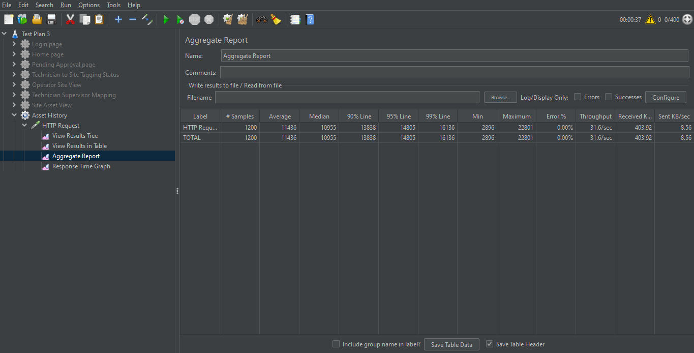

The Aggregate Report table shows No. of Samples = 1200, Error = 0%, Throughput = 31.6/sec.

Response Time Graph:

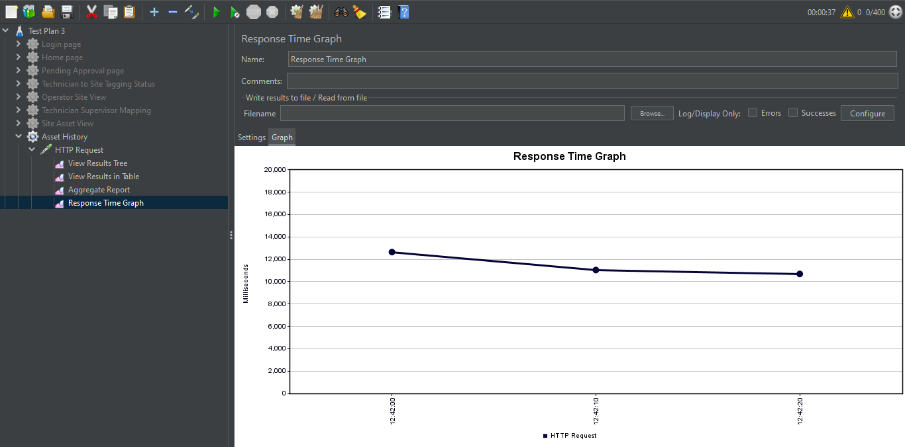

The Response Time Graph shows that the time of response decreases as more samples are processed. After a certain value (around 11000 ms), the rate of decrease becomes less and eventually the time of response becomes constant.

1. **Configuration Management**

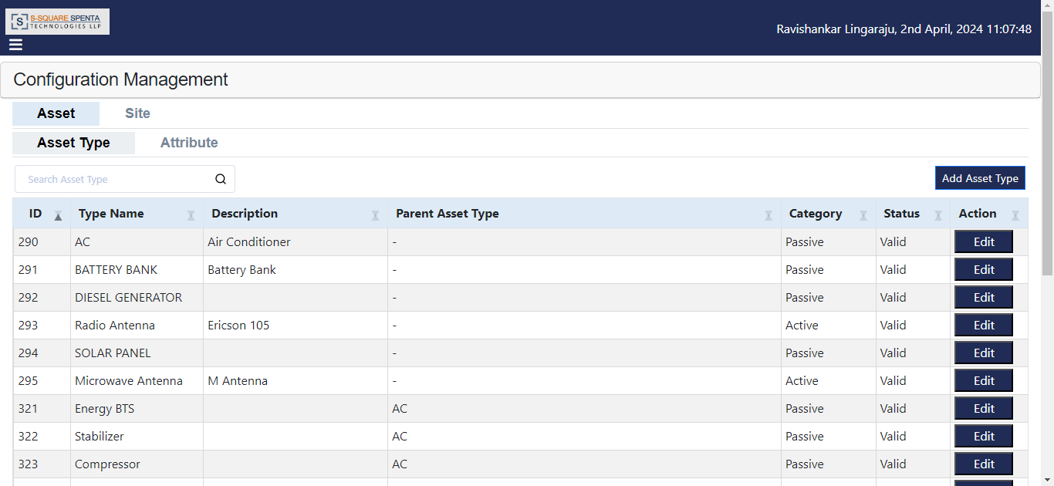

Scenario:

Number of Threads: 400.

Ramp-up Period (seconds): 1.

Loop Count: 3.

Thread Group:

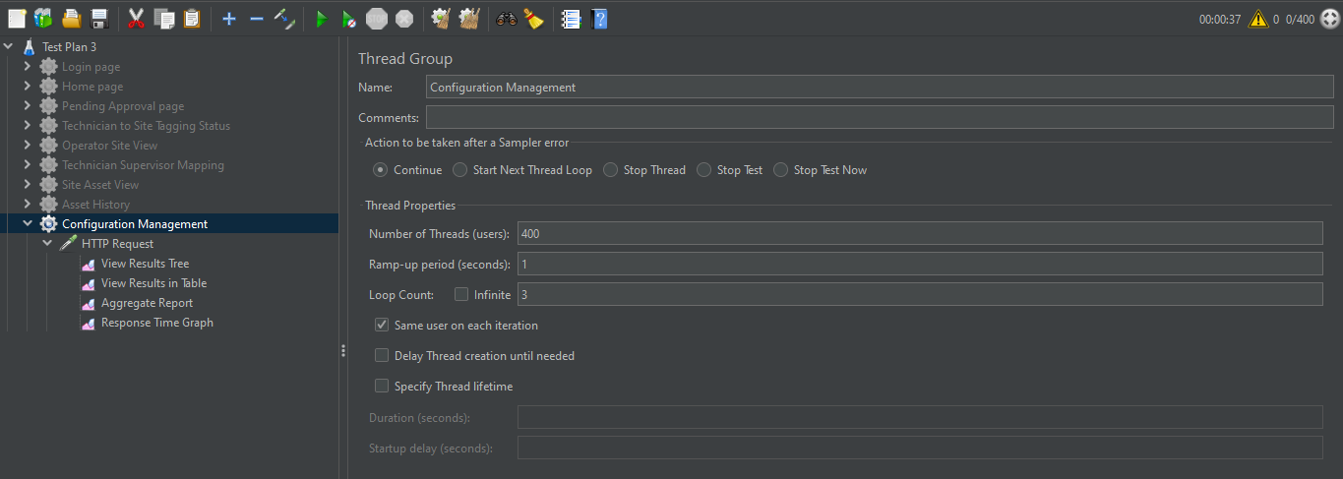

The Thread Group includes the thread properties, such as no. of threads, ramp-up period and loop count. It also has the HTTP request, the assertions and different sorts of listeners.

View Results in Table:

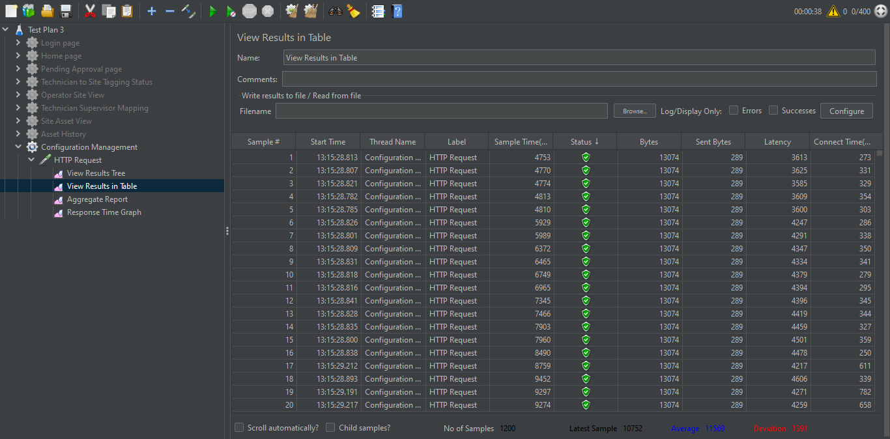

The table shows that all 1200 samples have green status, indicating they have passed successfully.

Aggregate Report:

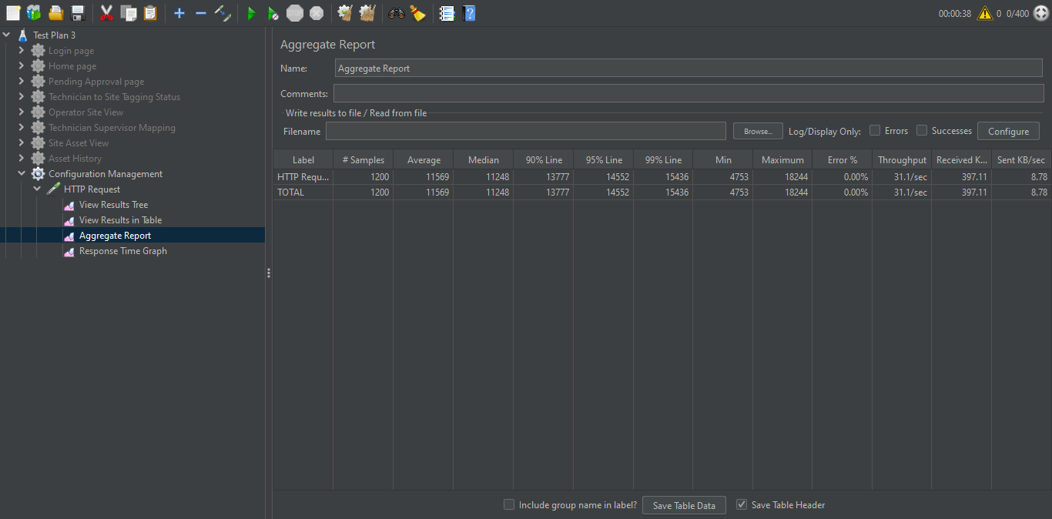

The Aggregate Report table shows No. of Samples = 1200, Error = 0%, Throughput = 31.1/sec.

Response Time Graph:

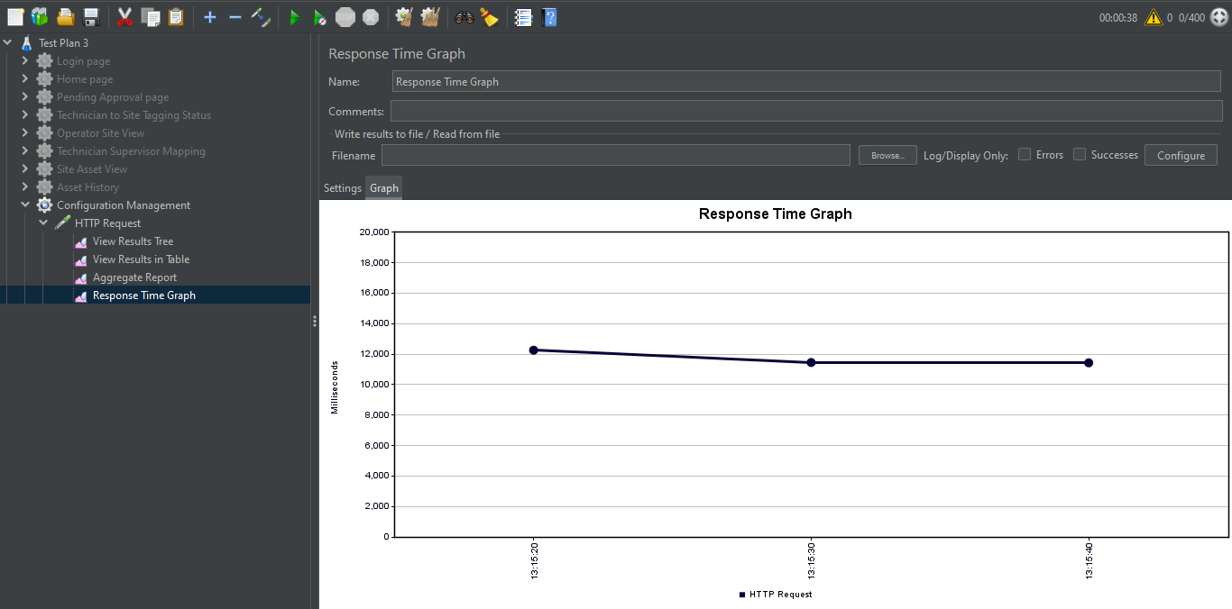

The Response Time Graph shows that the time of response decreases as more samples are processed. After a certain value (around 11500 ms), it becomes constant.

1. **Batch Process**

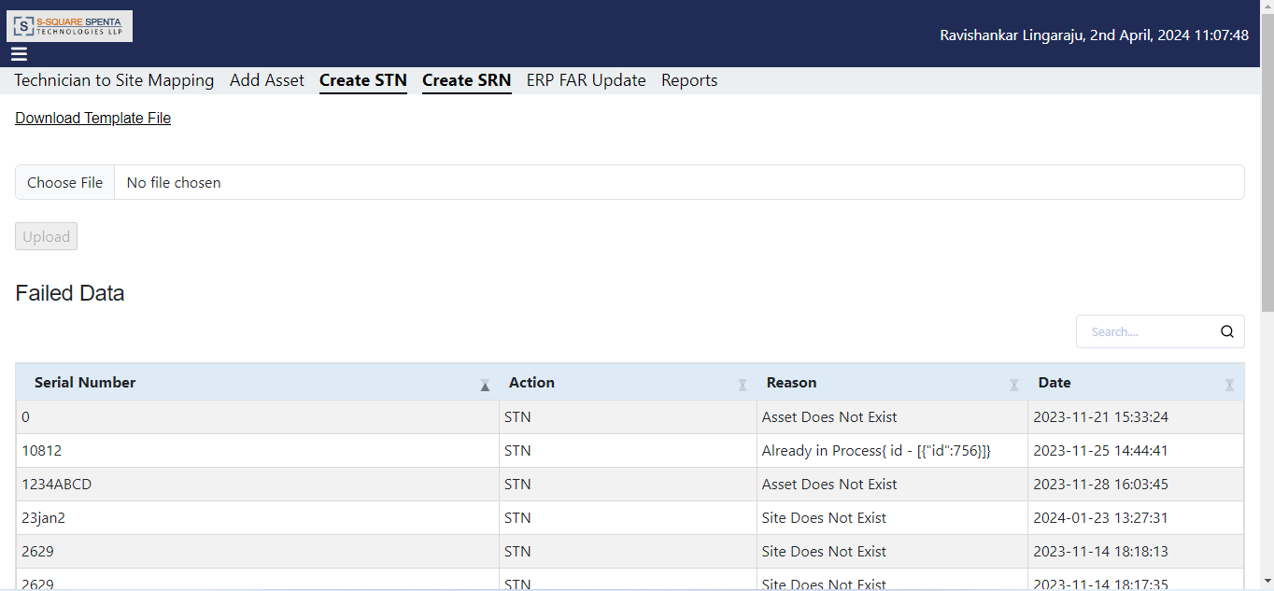

Scenario:

Number of Threads: 400.

Ramp-up Period (seconds): 1.

Loop Count: 3.

Thread Group:

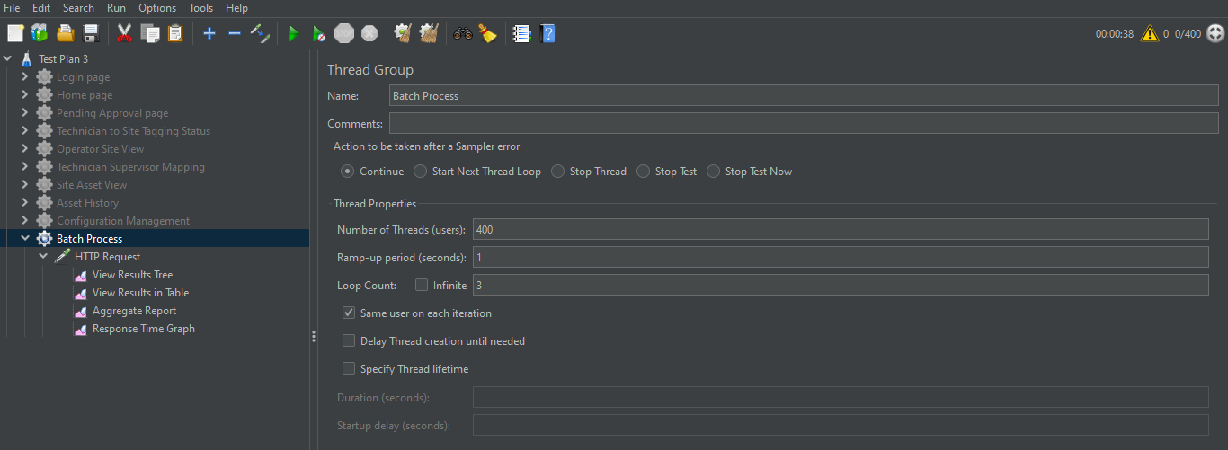

The Thread Group includes the thread properties, such as no. of threads, ramp-up period and loop count. It also has the HTTP request, the assertions and different sorts of listeners.

View Results in Table:

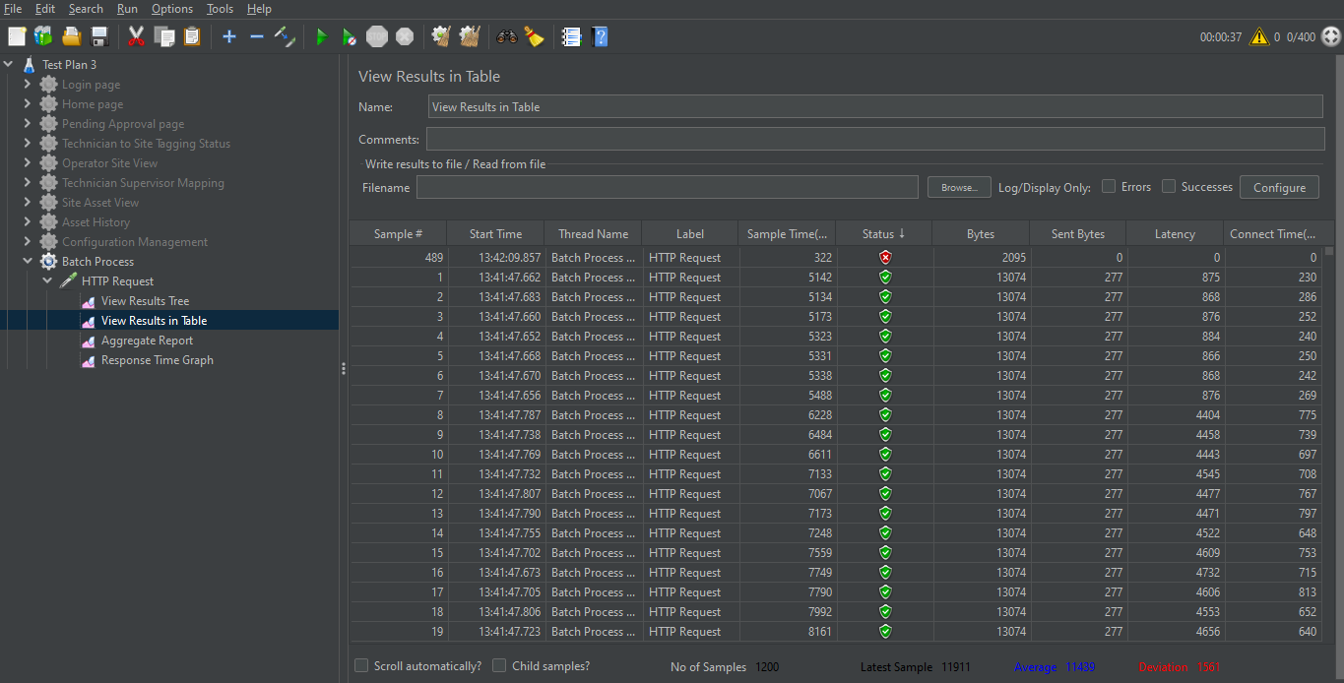

The table shows that 1 out of the 1200 samples have red status, indicating it failed, while the remaining 1199 have green status and passed successfully.

Aggregate Report:

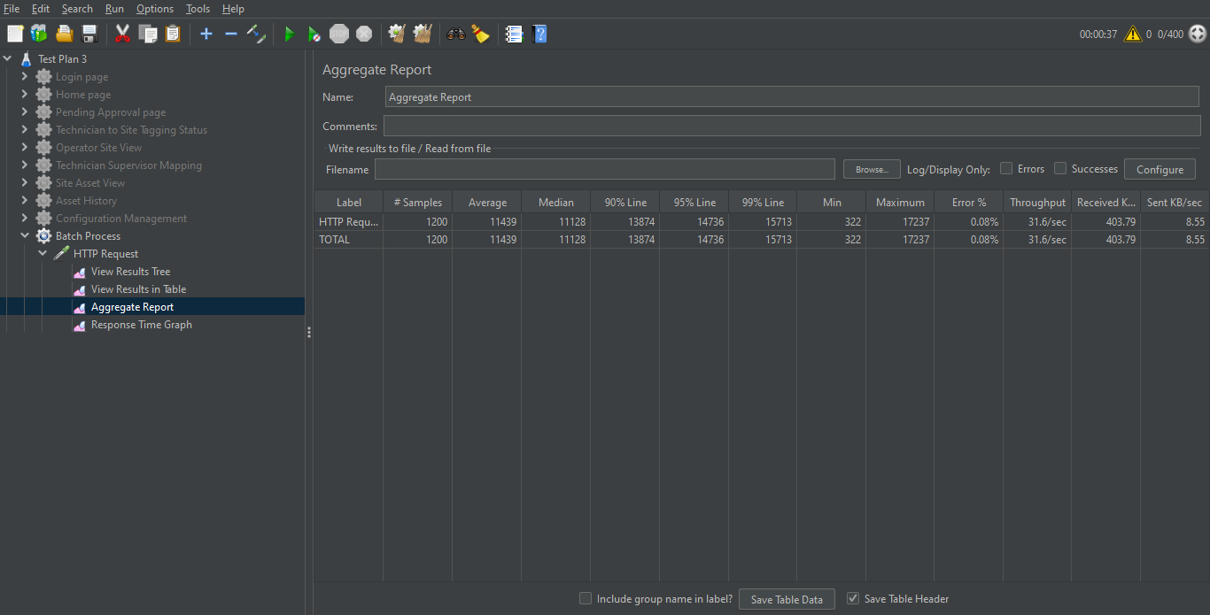

The Aggregate Report table shows No. of Samples = 1200, Error = 0.08%, Throughput = 31.6/sec.

Response Time Graph:

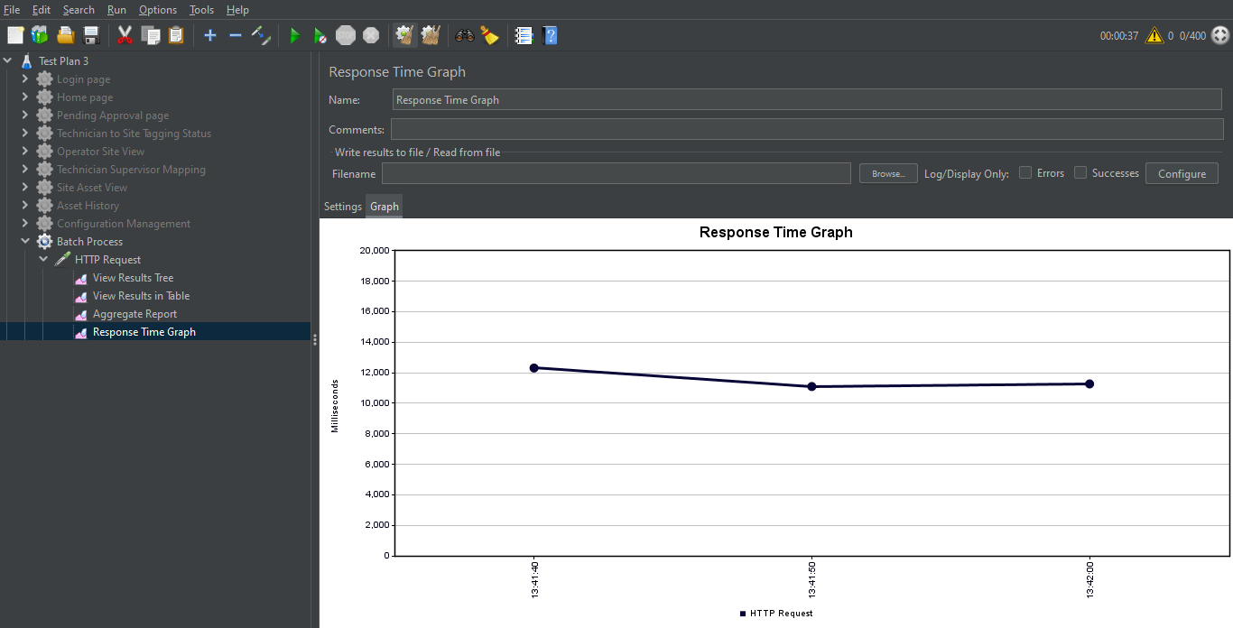

The Response Time Graph shows that the time of response decreases as more samples are processed. After a certain value (around 11000 ms), it increases slightly.

1. **Audit Trail**

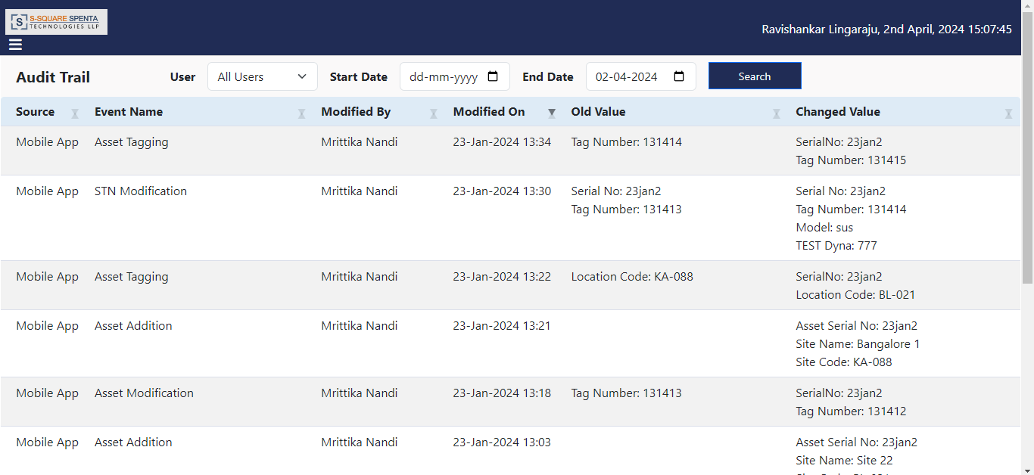

Scenario:

Number of Threads: 400.

Ramp-up Period (seconds): 1.

Loop Count: 3.

Thread Group:

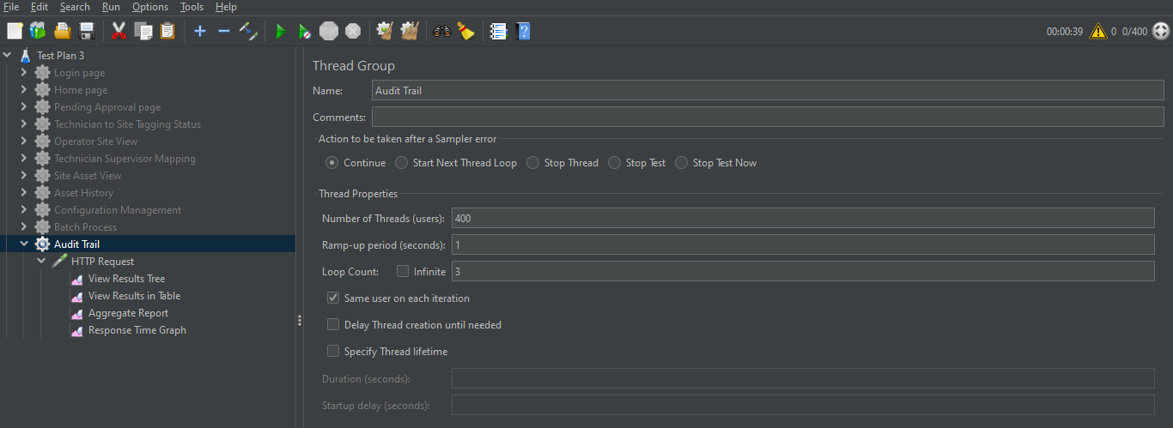

The Thread Group includes the thread properties, such as no. of threads, ramp-up period and loop count. It also has the HTTP request, the assertions and different sorts of listeners.

View Results in Table:

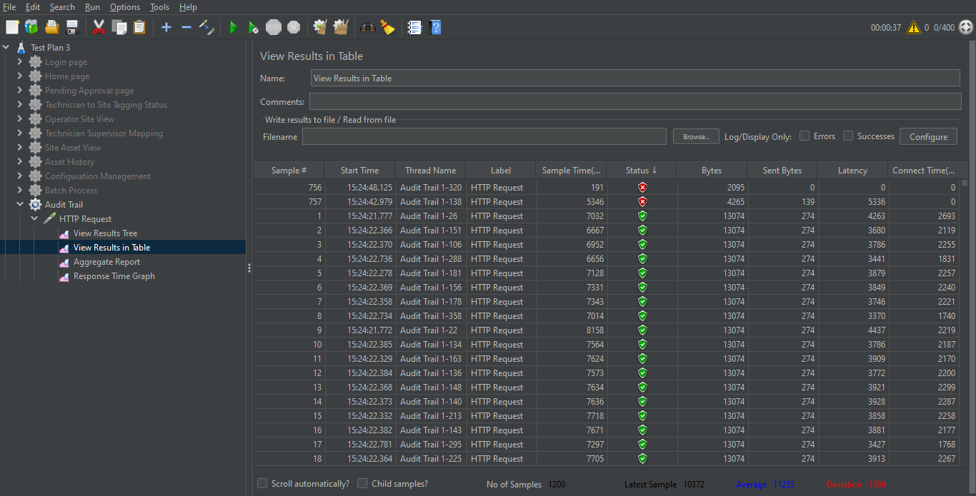

The table shows that 2 out of the 1200 samples have red status, indicating they failed, while the remaining 1198 have green status and passed successfully.

Aggregate Report:

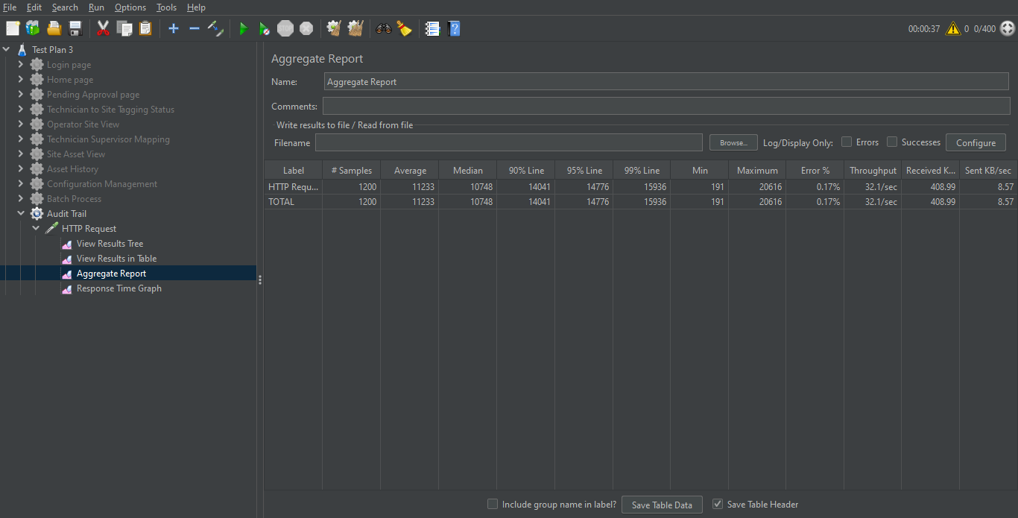

The Aggregate Report table shows No. of Samples = 1200, Error = 0.17%, Throughput = 32.1/sec.

Response Time Graph:

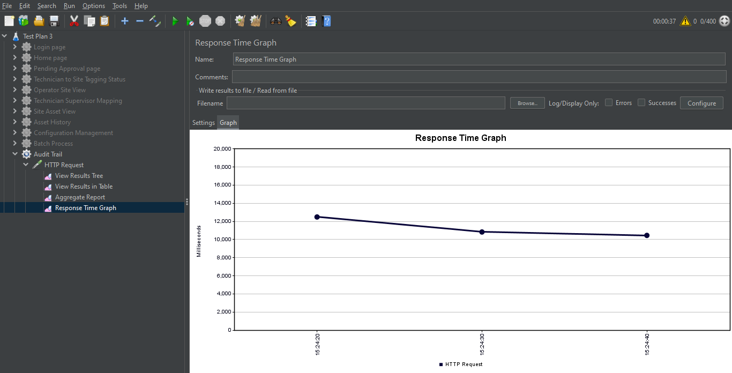

The Response Time Graph shows that the time of response decreases as more samples are processed. After a certain value (around 11000 ms), it decreases at a lesser rate.

1. **Report**

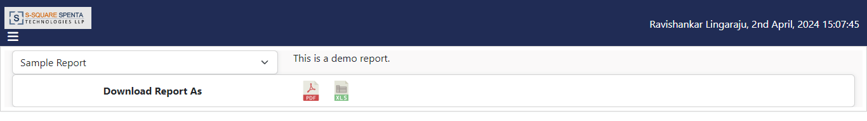

Scenario:

Number of Threads: 400.

Ramp-up Period (seconds): 1.

Loop Count: 3.

Thread Group:

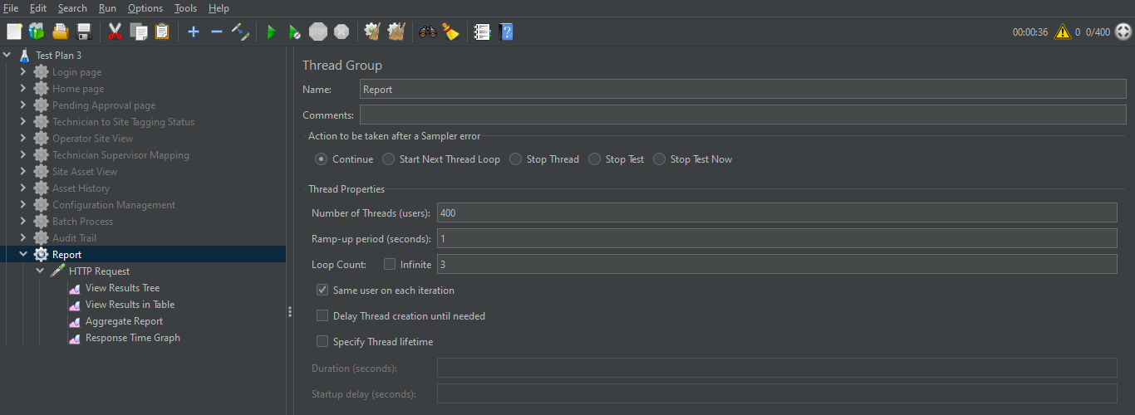

The Thread Group includes the thread properties, such as no. of threads, ramp-up period and loop count. It also has the HTTP request, the assertions and different sorts of listeners.

View Results in Table:

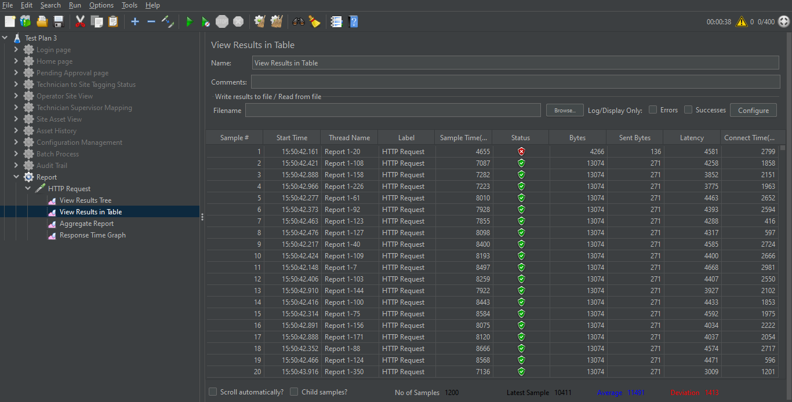

The table shows that 1 out of the 1200 samples have red status, indicating it failed, while the remaining 1199 have green status and passed successfully.

Aggregate Report:

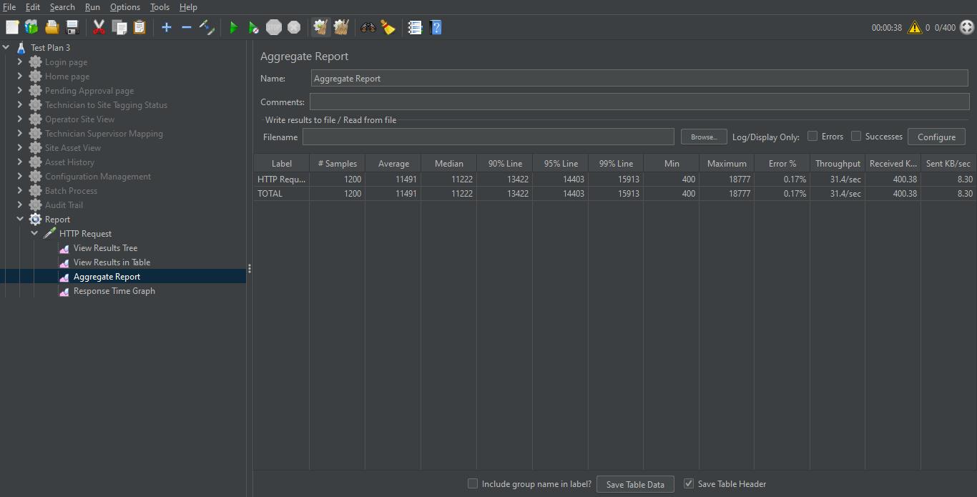

The Aggregate Report table shows No. of Samples = 1200, Error = 0.17%, Throughput = 31.4/sec.

Response Time Graph:

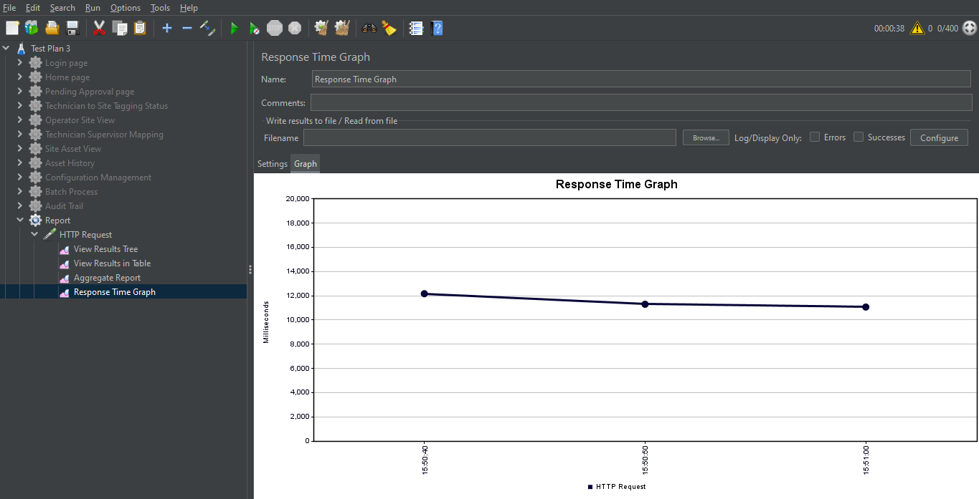

The Response Time Graph shows that the time of response decreases as more samples are processed. After a certain value (around 11500 ms), it decreases at a lesser rate.

**Test Summary**

| **Screen** | **No. of Threads (N)** | **Ramp-up Period (second)** | **Loop Count (C)** | **Total Samples (N*C)** | **Error Percentage** | **Throughput (per second)** | **Response Time Pattern** |
| --- | --- | --- | --- | --- | --- | --- | --- |
| Login | 400 | 1 | 3 | 1200 | 0.00 | 53.3 | Decreasing |
| Home | 400 | 1 | 3 | 1200 | 0.00 | 31.8 | Decreasing, then constant |
| Pending Approval | 400 | 1 | 3 | 1200 | 0.00 | 29.5 | Decreasing, then constant |
| Technician to Site Tagging Status | 400 | 1 | 3 | 1200 | 0.17 | 32.3 | Decreasing, then constant |
| Operator Site View | 400 | 1 | 3 | 1200 | 0.08 | 32.2 | Decreasing, then constant |
| Technician Supervisor Mapping | 400 | 1 | 3 | 1200 | 0.17 | 31.8 | Decreasing, then constant |
| Site Asset View | 400 | 1 | 3 | 1200 | 0.00 | 33.0 | Decreasing, then constant |
| Asset History | 400 | 1 | 3 | 1200 | 0.00 | 31.6 | Decreasing, then constant |
| Configuration Management | 400 | 1 | 3 | 1200 | 0.00 | 31.1 | Decreasing, then constant |
| Batch Process | 400 | 1 | 3 | 1200 | 0.08 | 31.6 | Decreasing, then increasing slightly |
| Audit Trail | 400 | 1 | 3 | 1200 | 0.17 | 32.1 | Decreasing, then decreasing at a lesser rate |
| Report | 400 | 1 | 3 | 1200 | 0.17 | 31.4 | Decreasing, then decreasing at a lesser rate |