

**Asset Tagging and Tracking System**

**User Manual Version 1.0**

April, 2024

The software described in this document is furnished under a non-disclosure agreement or a license agreement. The software maybe used for copying, only in accordance with the terms and conditions as per the agreement. Information in this document is subject to change without any notice.

**Table of Contents**

**1.** **Document Revision History 4**

**2.** **Acronyms & Glossary 5**

**3.** **Introduction 6**

**4.** **General Functions 7**

4.1 Login 7

4.2 Home Page 8

4.3 Distance Slider 9

4.4 Nearby Sites 9

4.5 My Sites 9

4.6 Search Any Site 10

4.7 Hamburger Menu 11

4.8 Site Selection 12

**5.** **Site Asset 13**

5.1 Site Home Page 13

5.2 Add Asset 15

5.3 View Asset Detail 21

5.4 Edit Asset Detail 22

5.5 Re-Tag Asset 23

5.6 Add Child Asset 26

**6.** **Task List 28**

6.1 STN (Add Asset) 28

6.2 SRN (Asset Deallocation) 30

**7.** **Site Audit 32**

**8.** **Site Gallery 36**

**9.** **Change Password 39**

**10.** **Logout 40**

# Document Revision History

# 

| **Sl. No.** | **Version No.** | **Description** | **Date of Release** |
| --- | --- | --- | --- |
| 1 | 1.0 | Mobile App for Asset Tagging and Tracking System | April, 2024 |
|  |  |  |  |
|  |  |  |  |

# Acronyms & Glossary

| **Abbreviation** | **Description** |
| --- | --- |
| SATS | SSTL Asset Tagging and Tracking System |
| STN | Site Transfer Note |
| SRN | Site Release Note |

# Introduction

This document provides operation steps for the SATS Mobile App users. This document provides operational information on how the technician user can do various operations in SATS Mobile App. This document is created based on the Mobile App developed and delivered to SSTL for asset tagging and tracking system.

Mobile App is for technician user to perform various activities like Add Assets to a site, Tag an asset, execute STN, SRN, and edit asset details. Also supervisor user will perform site asset audit, add photos and videos at site gallery using mobile app.

# General Functions

## Login

1. Install the SATS mobile app into mobile device. Start the SATS Mobile App. Allow all required permission like location access, camera access. The Login page of the app will be displayed on the screen.

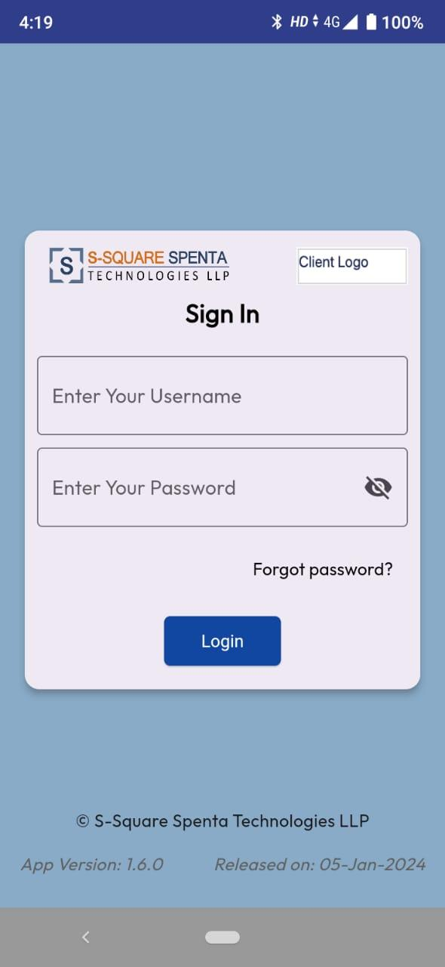

1. Make sure you have received you username and password from your supervisor or administrator.
2. Provide username (email id) and password and click Login button. User will be logged in into the app and home page of the app will be displayed.

## Home Page

1. Once user successfully login into mobile app, user will be landed in home page of the app.

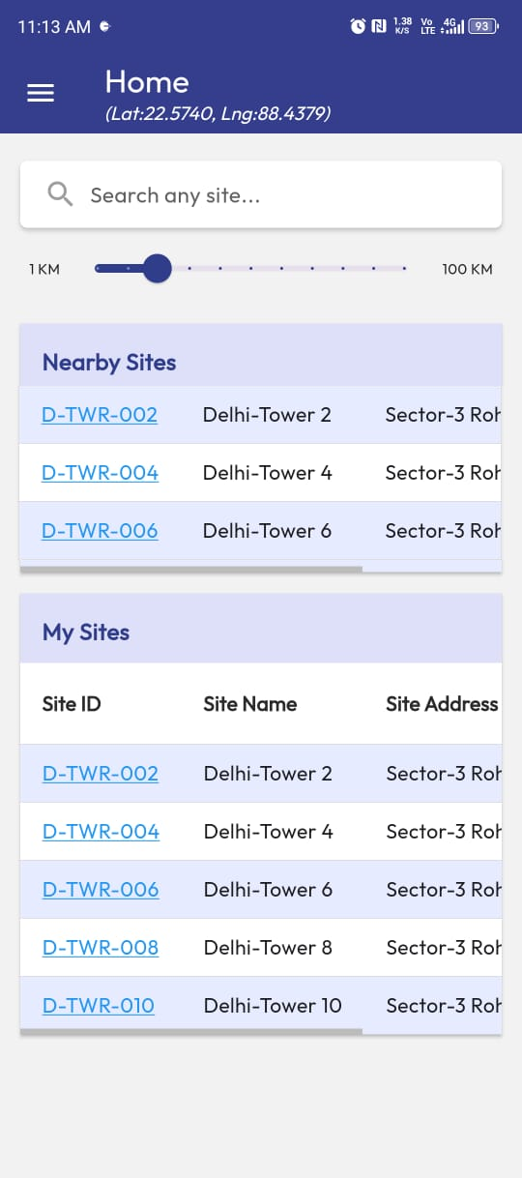

1. Home page will display latitude and longitude of the user location from where user login into system.
2. There will be a site search box, distance slider, nearby sites and my sites at the home page of the mobile app.

## Distance Slider

1. User can move the distance slider from home page to change the radius distance. The sites present within this radius (with respect to the present location) will be displayed at the Nearby Sites section of the home page.



## Nearby Sites

1. The sites present within the radius of set distance at distance slider (with respect to the present location) will be displayed at the Nearby Sites section of the home page.



## My Sites

1. My Sites section of home page will display all the sites which are assigned to the logged in user.



1. An assigned site (showing at my sites section) within the radius of set distance at distance slider will also appear at the nearby sites section of the user.

## Search Any Site

1. User can search any site using the site search box present at the home page of the app. Enter search string and click on the search icon beside the search box.

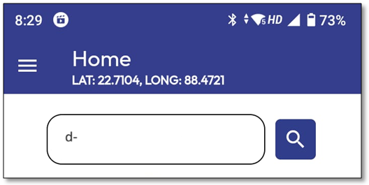

1. A popup screen will appear with all the sites which are matching search criteria.

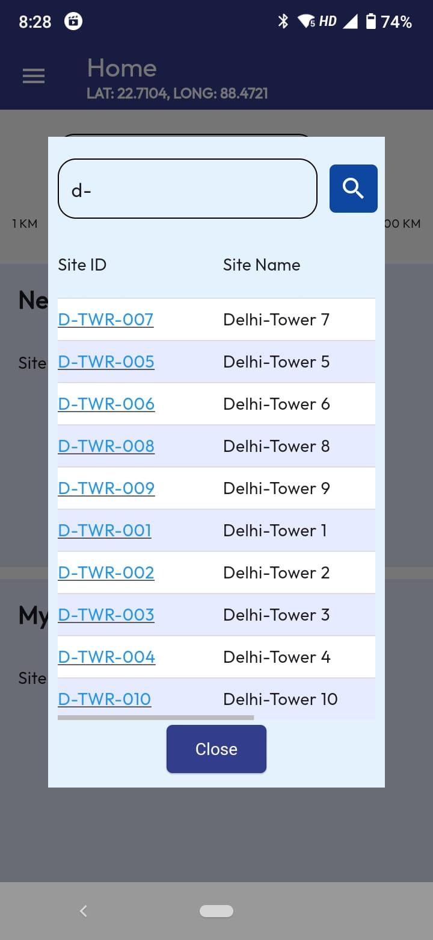

1. User can further change the search string and search again to narrow down the search result.

## Hamburger Menu

1. Click on the hamburger present at the top left corner of the app. User will see the menu list resent at the app.
2. Menu Items are:
   * Home
   * Task List
   * Site Audit
   * Site Gallery
   * Change Password
   * Logout

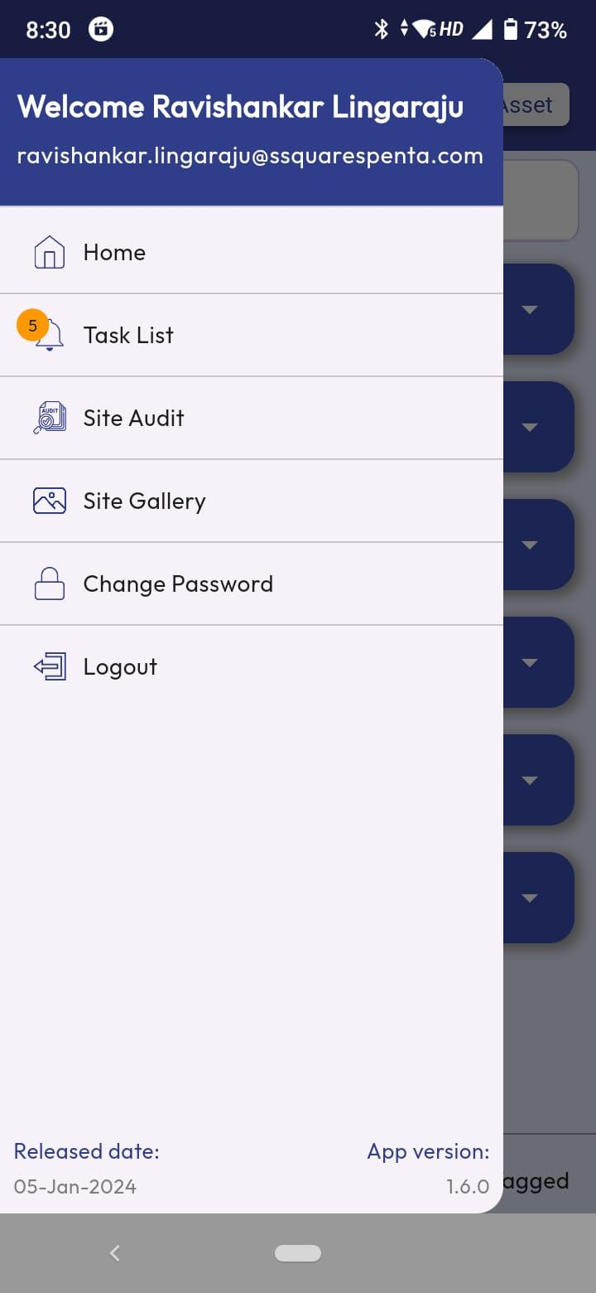

## Site Selection

1. From Home page, user can select a site from My Sites section or Nearby Sites or Search Popup screen.
2. Click on Site ID to select and enter into a site.
3. User will get an alert message if tries to enter into a site which is not assigned to him/her. Click on Submit button to proceed.

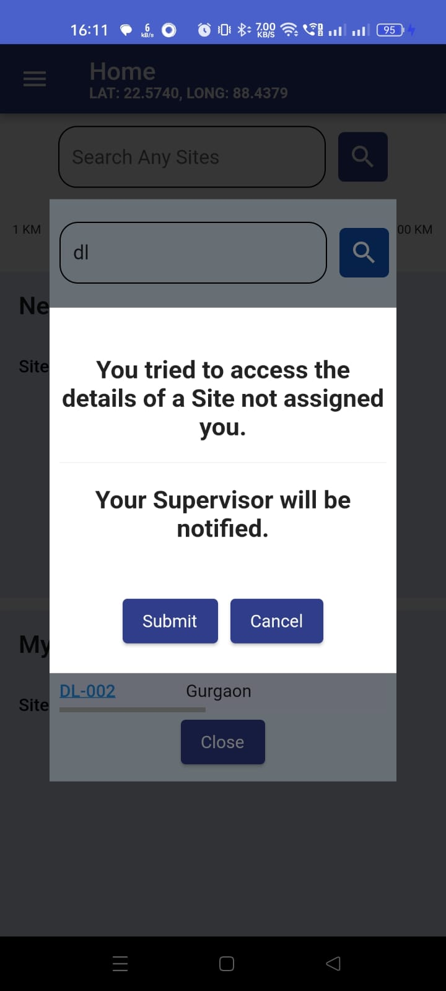

1. User will enter into the selected site where the site assets will be visible. Site Id and Address is displayed at the header area.

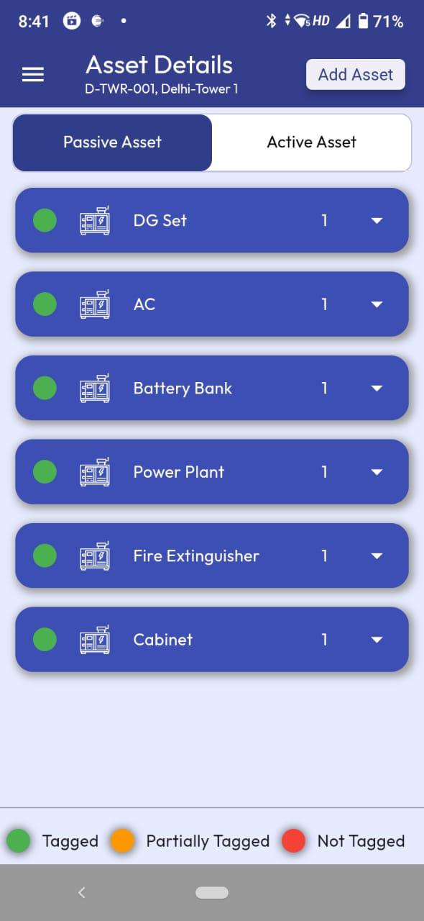

# Site Asset

## Site Home Page

1. Once user selects and enters into a site, user will be presented with the site home page where asset catalog of the site is present.

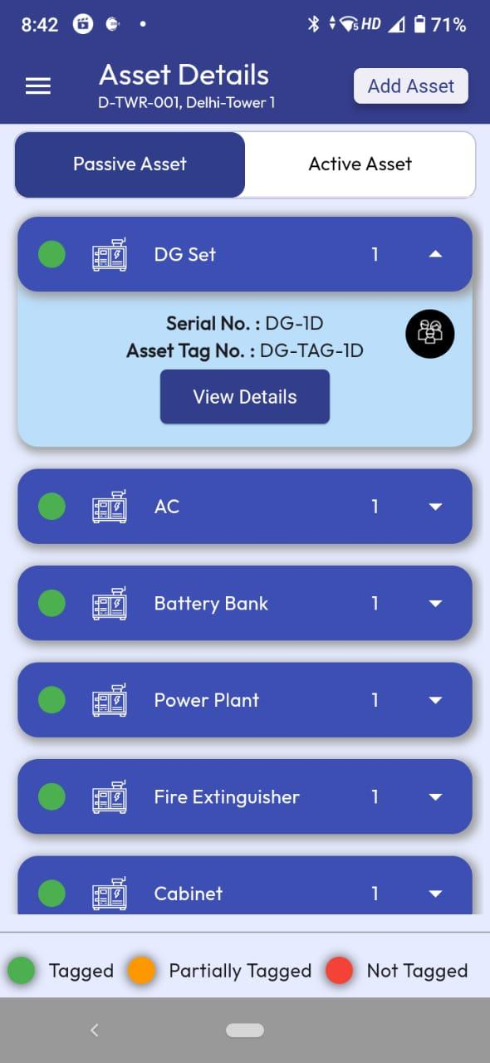

1. There is Add Asset button at the top right corner of the screen header to add new asset for the site.
2. User can toggle between Passive Asset and Active Asset to view the respective assets of the site.
3. User can see the Asset Type-wise grouping of all assets. The number beside the asset type indicates the number of that type of asset present.

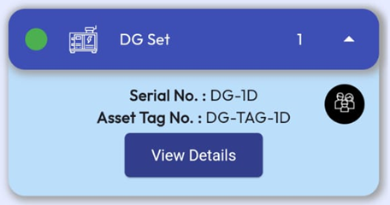

1. Clicking on the arrow beside the number for an asset type will show expanded view where all the assets of that type will be displayed. The Serial No. and Tag No. of asset will be shown. For Active Asset, Operator name is displayed.

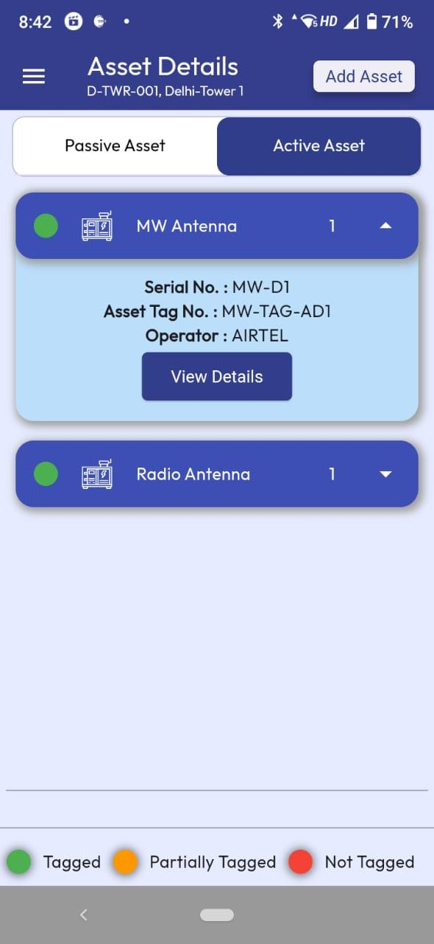

1. There will be a circular icon here if the asset has child asset.



1. Also there is View Details button to view the details of the asset.
2. The legends for colour code are mentioned at the bottom of the screen.



## Add Asset

1. Click on the Add Asset button present at the top right of the site home page. Add asset screen will appear.

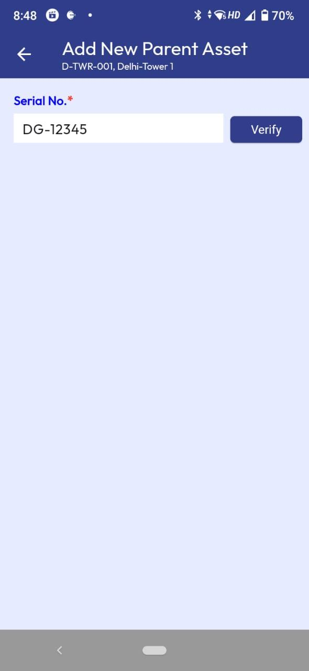

1. Enter asset serial no. and click verify. If the serial no. already exists in another site, a message will appear for confirmation for asset transfer from that site. Click Yes for confirmation.

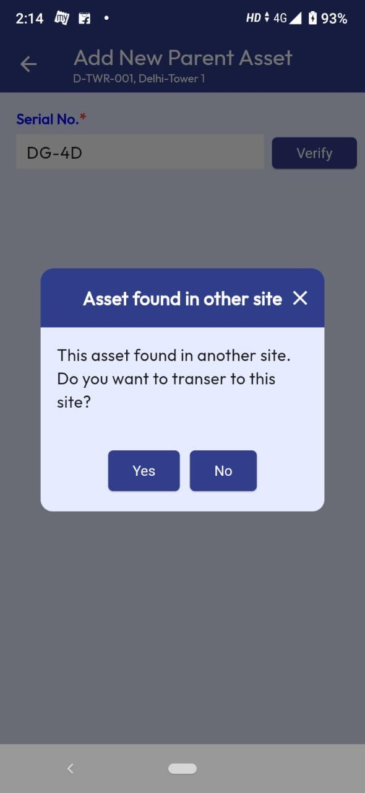

1. On confirmation, the existing asset data will populated in the screen in editable mode. Use may modify the asset data if required.

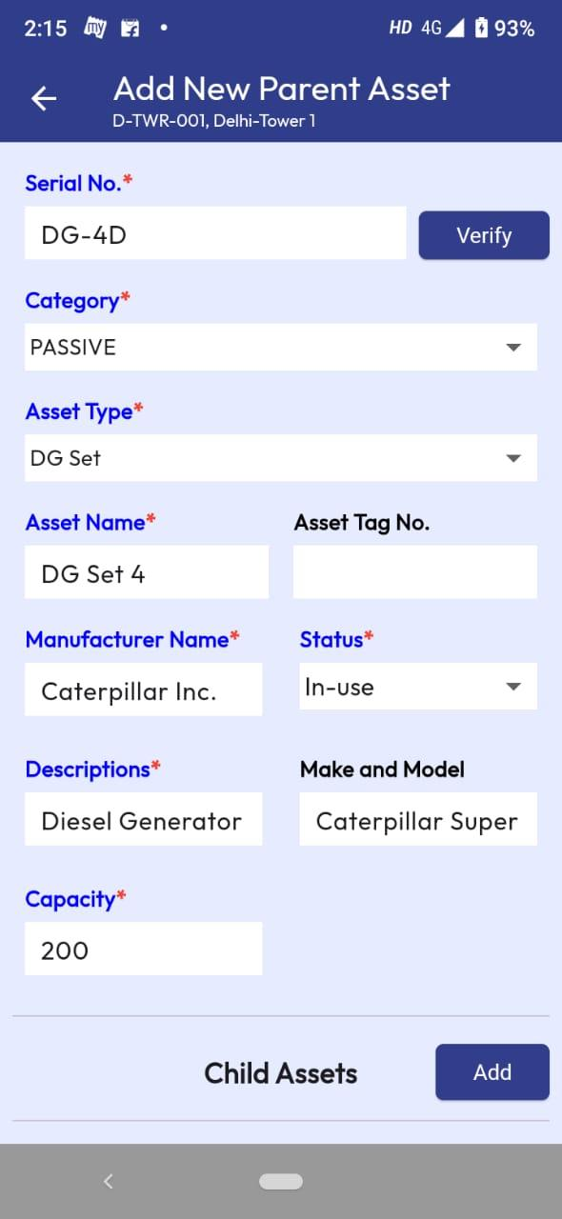

1. After modifying the required data, user needs to scan the tag (QR code) of the asset by clicking on the ‘tag’ button at the bottom of the page.

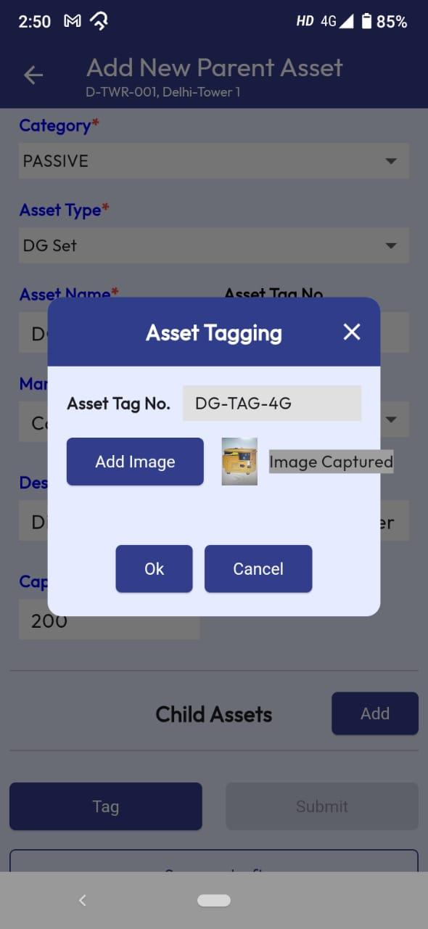

1. An information message will appear to check if the tag (QR code) is present and attached with the asset.

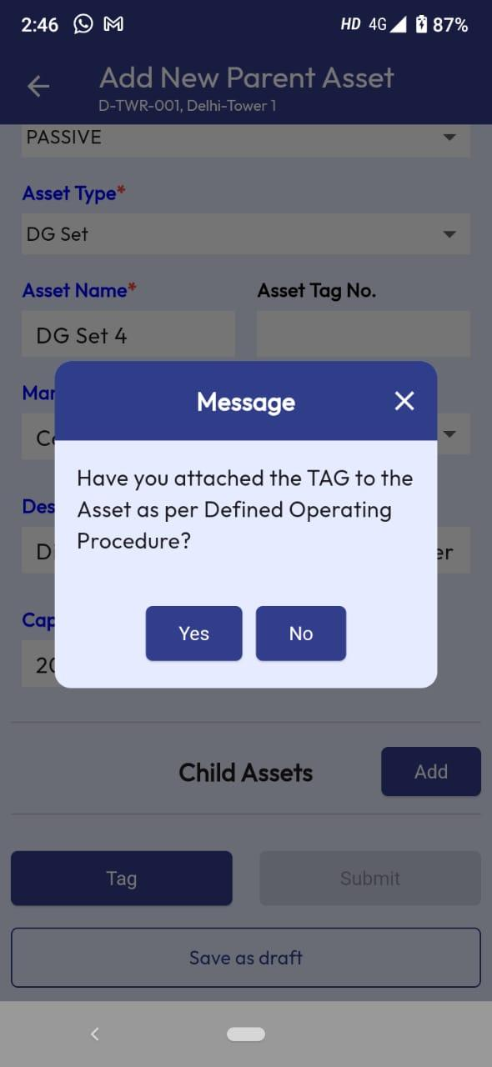

1. Click on Yes option will open the mobile scanner to scan the QR code. Scan the QR Code. The Tag value will appear.

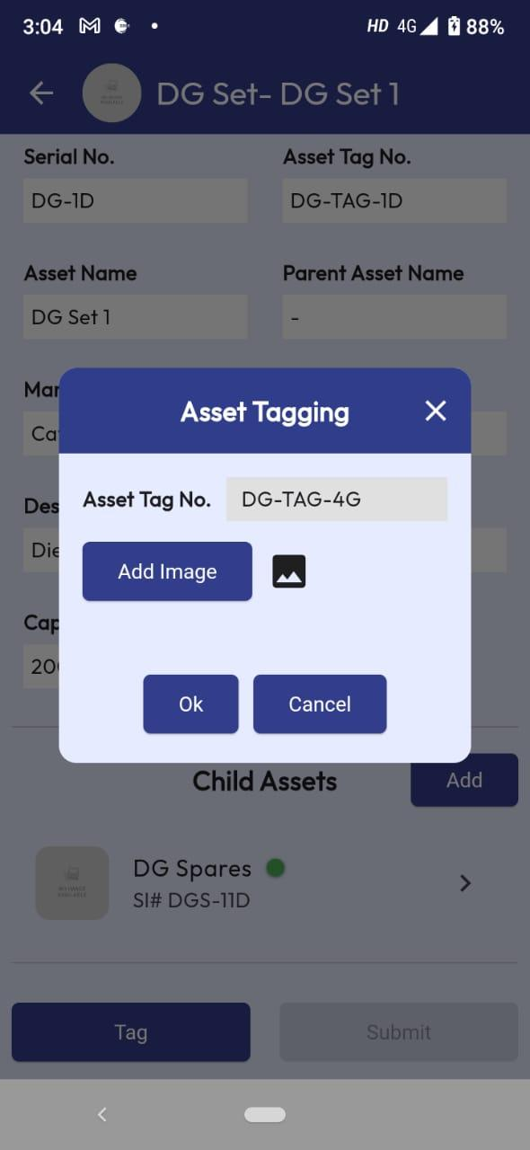

1. Click on Add Image to capture the image of the asset. Mobile camera will open. Capture the image of the asset. Click Ok after scanning the tag and capturing asset image.



1. The Submit button at the bottom of the screen gets enabled.

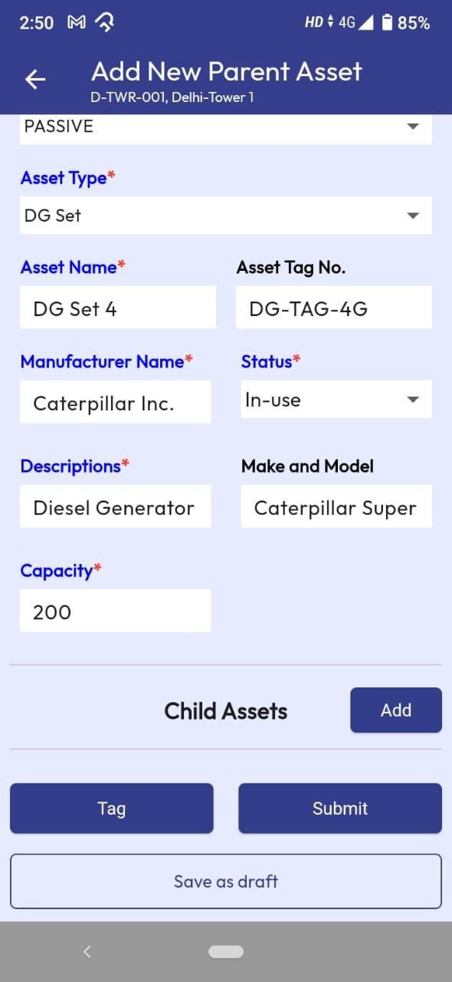

1. User may add child asset under this asset. To do that, click ‘Add’ button beside the ‘Child Assets’ label.

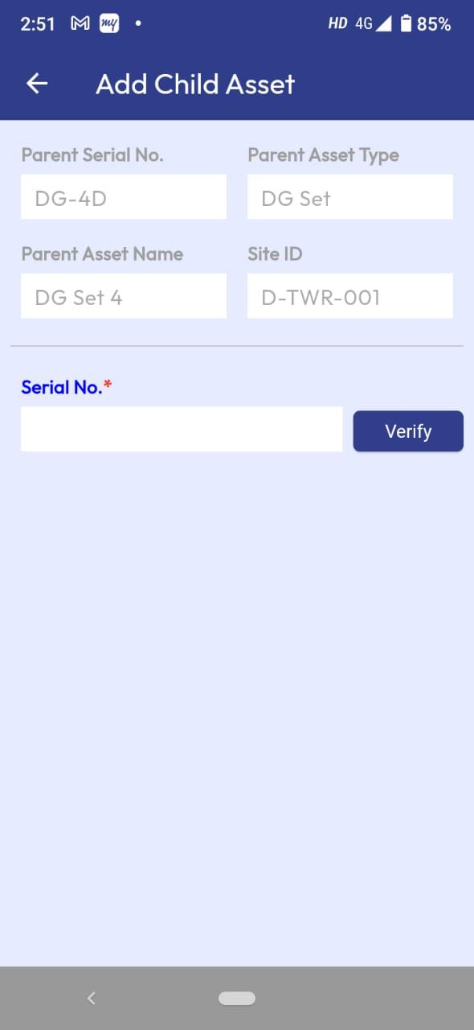

1. Enter serial number of the child asset and click Verify. Rest of the process is same as adding parent asset. User may add multiple children under the parent asset using same process. Adding grandchild asset under child asset follows same process.
2. User can add child or grandchild asset if respective Asset Types are configured under Parent Asset Type from Configuration Management>Asset Type of Web Portal.
3. After entering all asset data, user has option to save the data as draft so that user can work on it later. To save the data as draft, click ‘Save as draft’ option present at the bottom of the screen.



1. If user tries to exit without saving the draft data below message appears. Clicking on Yes will save the data as draft.

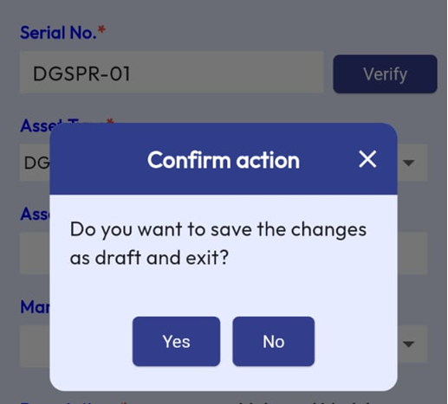

1. After saving data as draft and exit, if user opens add new asset screen for this site, the draft will be shown at the top of the add asset screen.

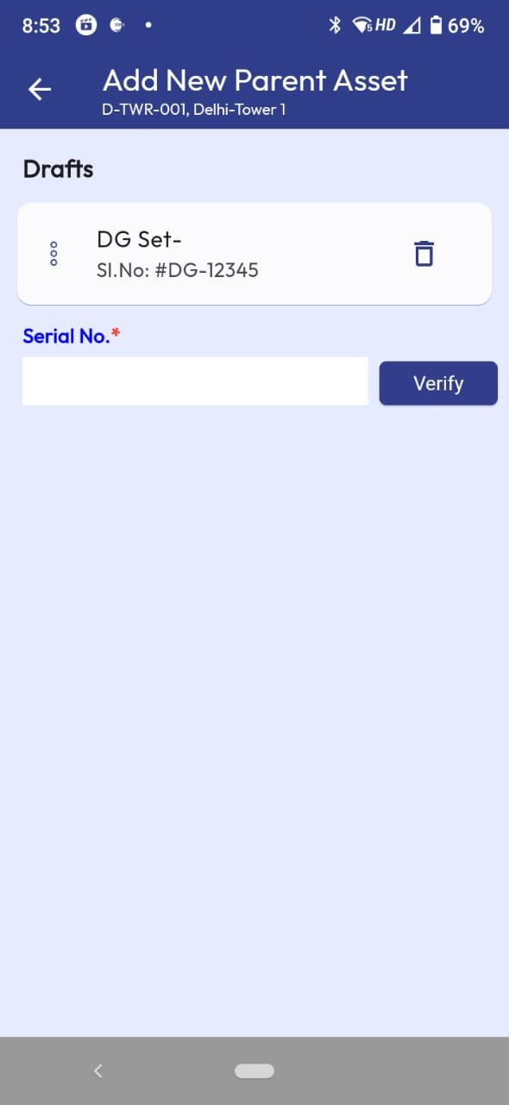

1. User has option to delete the draft. User can tap on the saved draft to open the add asset screen with previously entered data and continue to complete the transaction.
2. After entering all data click on the Submit button.



1. The Add Asset ticket will be created for approval by Supervisor. Supervisor will see the ticket at the ‘Pending Approval’ screen of web portal.
2. After approval by Supervisor, the Asset will be added in the site.

## View Asset Detail

1. From the site home page expand the asset type and click on ‘View Details’ button below the asset to view the details.



1. User will be able to see the details of the asset. Child assets are shown below the asset details. Tap on a child to view the details of the child asset.

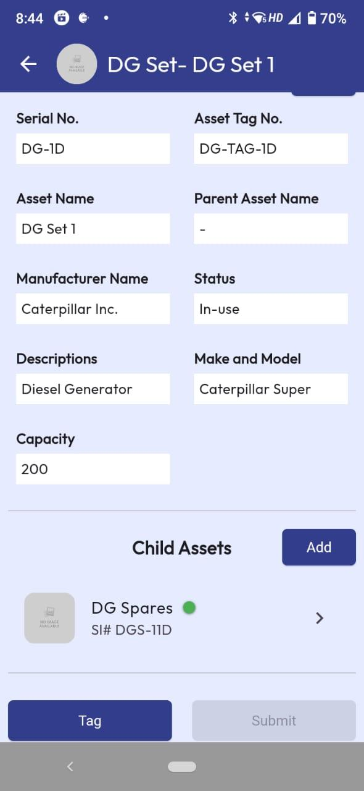

## Edit Asset Detail

1. From an asset detail screen, click on ‘Edit’ button.

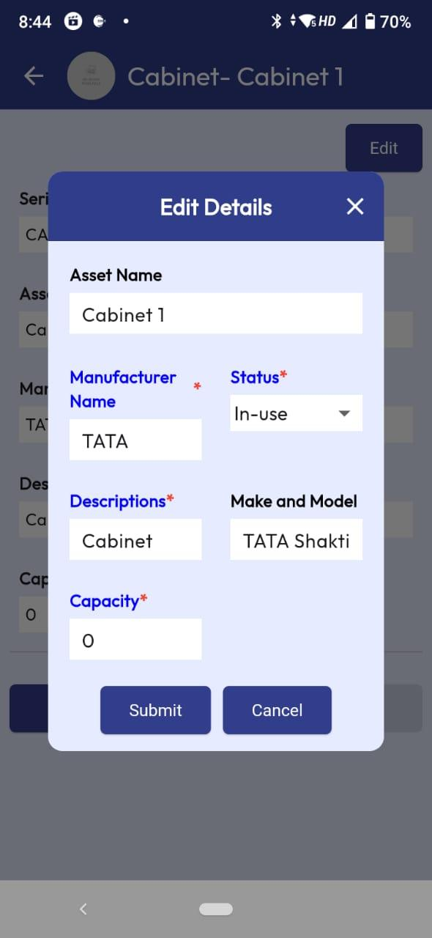

1. Modify the required data and click ‘Submit’ button below the screen.
2. The Edit Asset ticket will be created for approval by Supervisor. Supervisor will see the ticket at the ‘Pending Approval’ screen of web portal.
3. After approval by Supervisor, the data will be updated.

## Re-Tag Asset

1. From an asset detail screen, click on ‘Tag’ button present at the bottom of the screen.

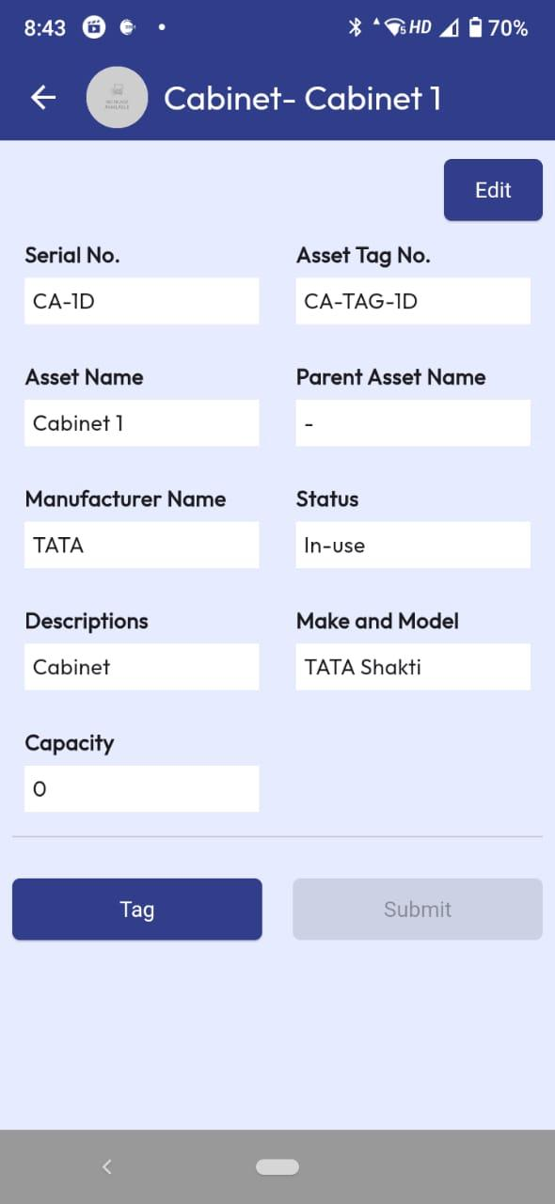

1. User gets information message to check if the tag (QR code) is present and attached with the asset.

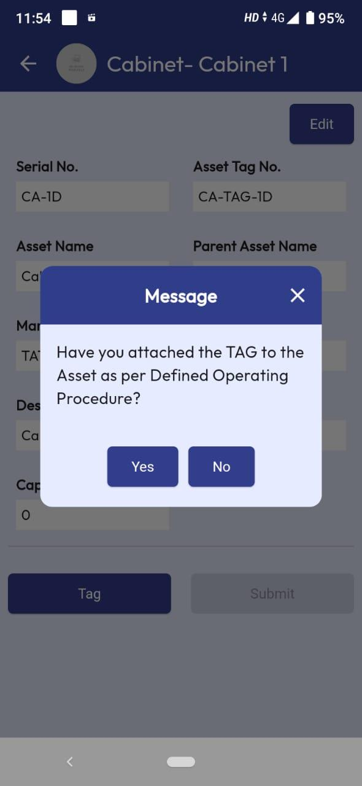

1. Click on Yes option will open the mobile scanner to scan the QR code. Scan the QR Code. The Tag value will appear.

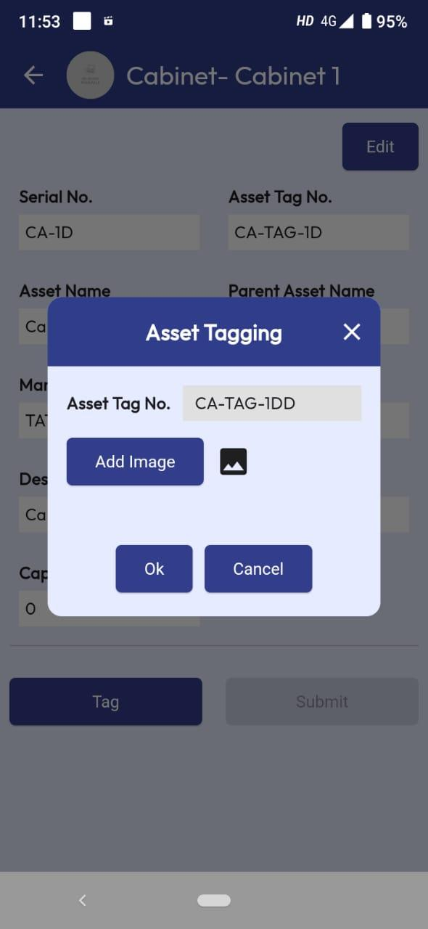

1. Click on Add Image to capture the image of the asset. Mobile camera will open. Capture the image of the asset.

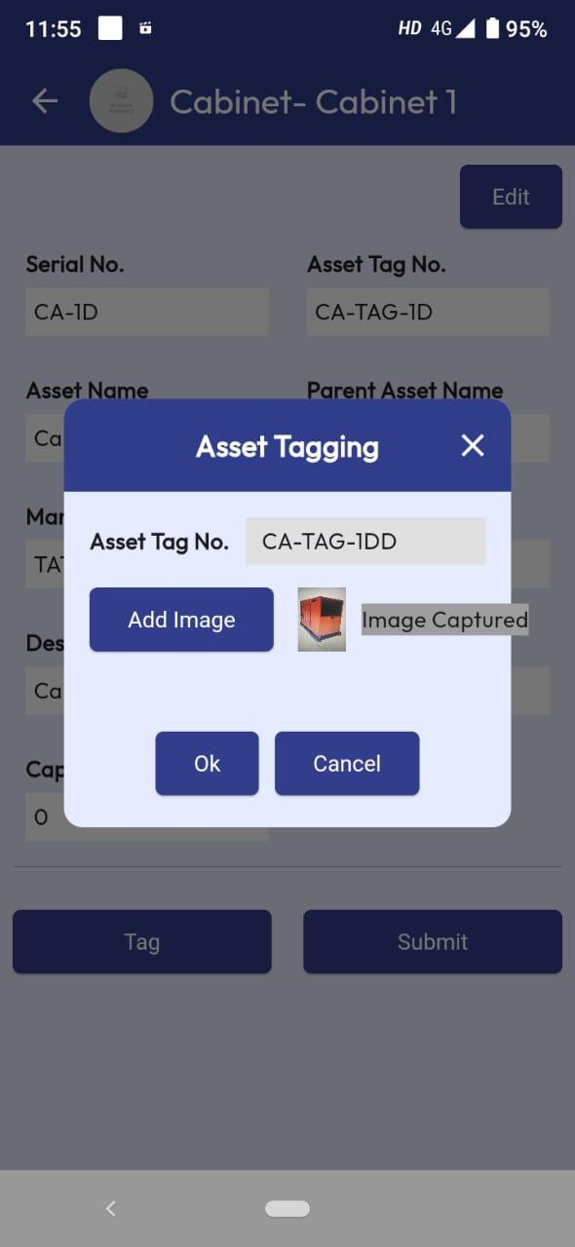

1. Click Ok after scanning the tag and capturing asset image. The Submit button beside Tag option gets enabled. Click on Submit option.

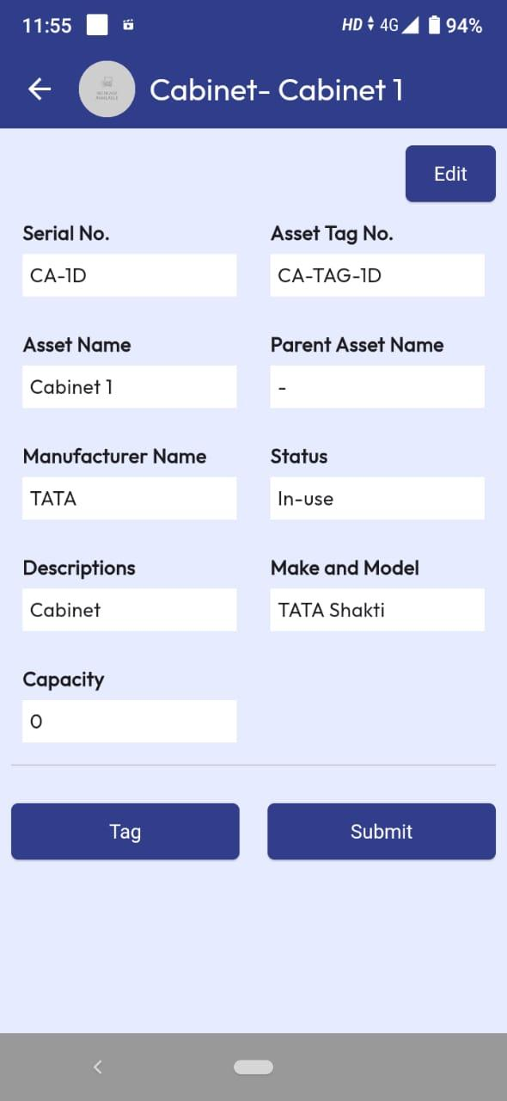

1. The Asset Tagging ticket will be created for approval by Supervisor. Supervisor will see the ticket at the ‘Pending Approval’ screen of web portal.
2. After approval by Supervisor, the Tag data will be updated.

## Add Child Asset

1. Go to a site and open the view details screen of parent asset where user wants to add a child asset. Click on the ‘Add’ button beside the label ‘Child Assets’.



1. User will get the Add Child Asset screen.



1. Enter serial number of the child asset and click Verify. Rest of the process is same as adding parent asset. User may add multiple children under the parent asset using same process. Adding grandchild asset under child asset follows same process.
2. User can add child or grandchild asset if respective Asset Types are configured under Parent Asset Type from Configuration Management>Asset Type of Web Portal.
3. After entering all data click on the Submit button.

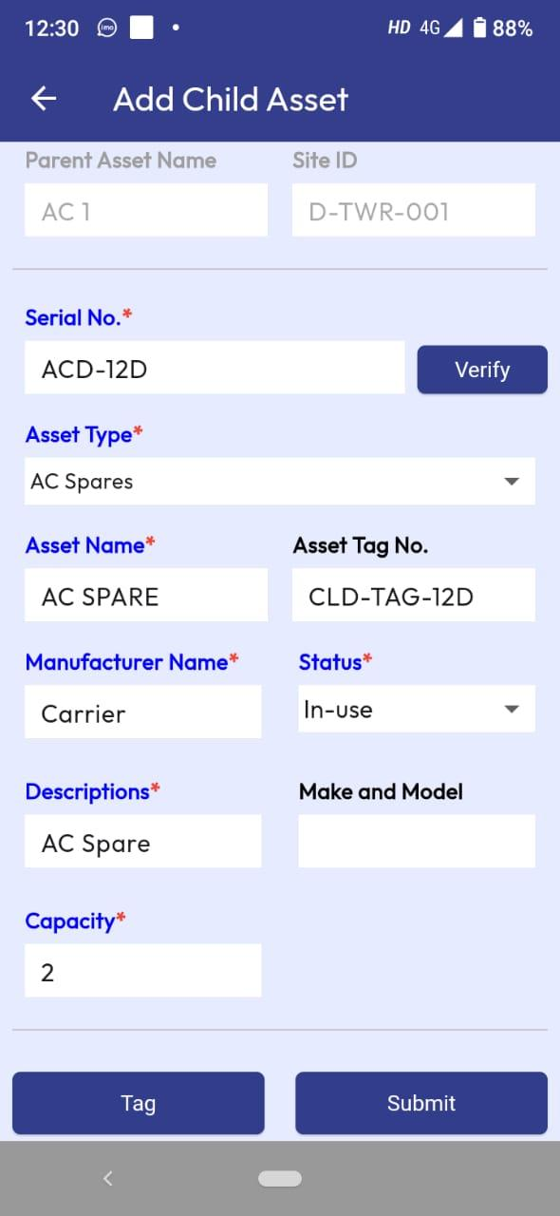

1. The Add Asset ticket will be created for approval by Supervisor. Supervisor will see the ticket at the ‘Pending Approval’ screen of web portal.
2. After approval by Supervisor, the Child Asset will be added in the site under the parent asset.

# Task List

## STN (Add Asset)

1. Login as technician. Go to a site and then click on the Task List from menu item of the site home page.



1. The pending tasks of the site will be displayed. From the site task list, tap on the STN task.

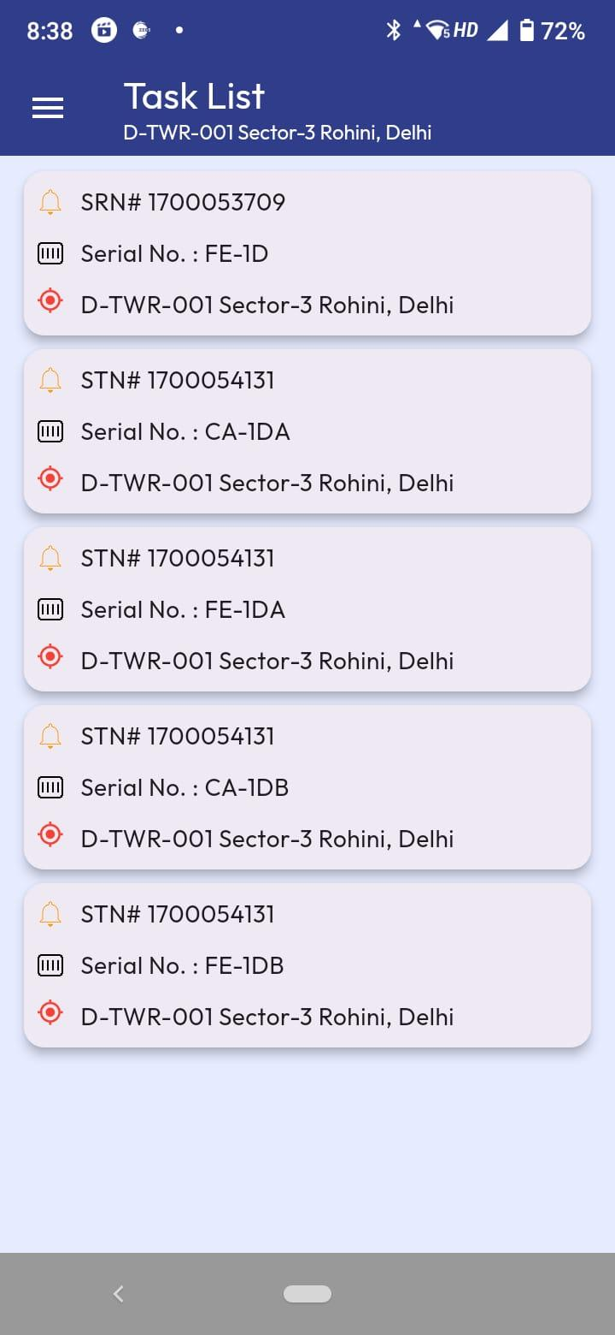

1. The STN details will be displayed.

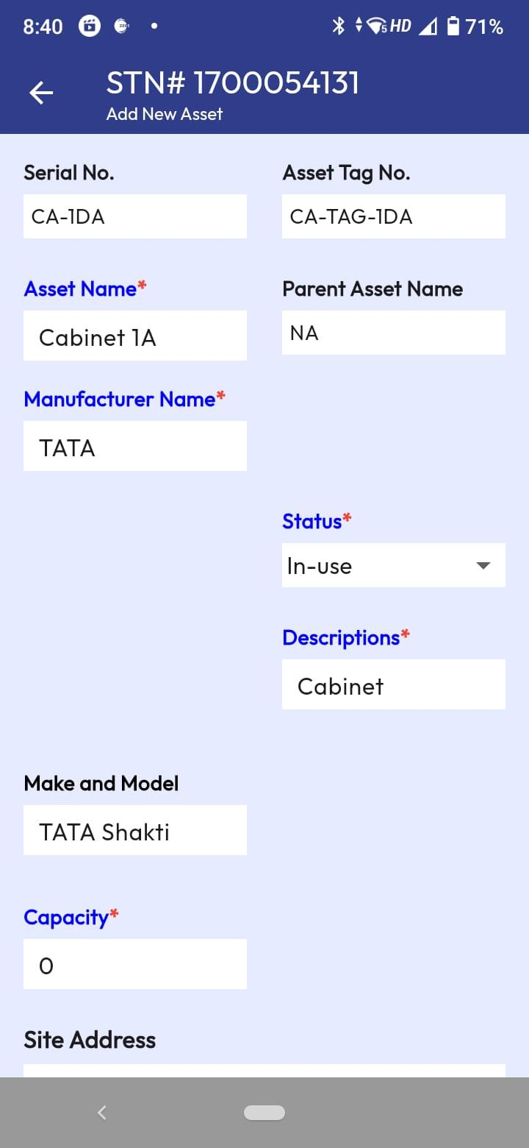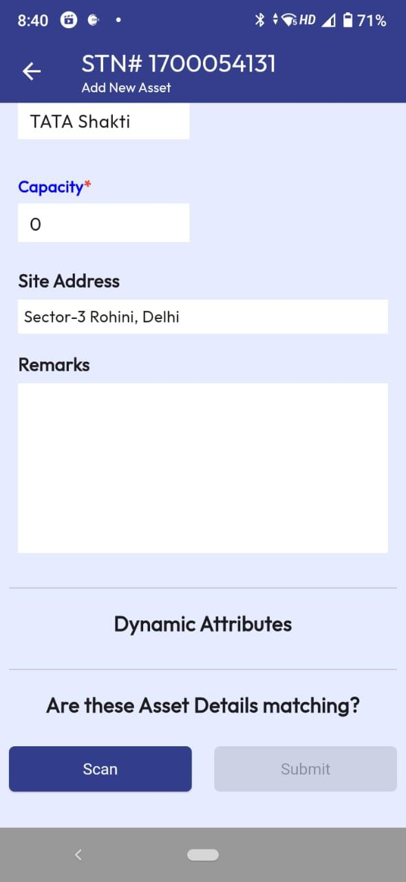

1. Verify the asset details; modify details so that the asset detail matched. Then click on the ‘Scan’ option present at the bottom of the screen.
2. Click Ok after scanning the tag and capturing asset image (same process like Re-Tag Asset).
3. The Submit button beside ‘Scan’ button gets enabled. Click on Submit option.
4. The STN ticket will be created for approval by Supervisor. Supervisor will see the ticket at the ‘Pending Approval’ screen of web portal.
5. After approval by Supervisor, the asset of STN will be added in the site.

## SRN (Asset Deallocation)

1. Login as technician. Go to a site and then click on the Task List from menu item of the site home page.



1. The pending tasks of the site will be displayed. From the site task list, tap on the SRN task.



1. The SRN details will be displayed.

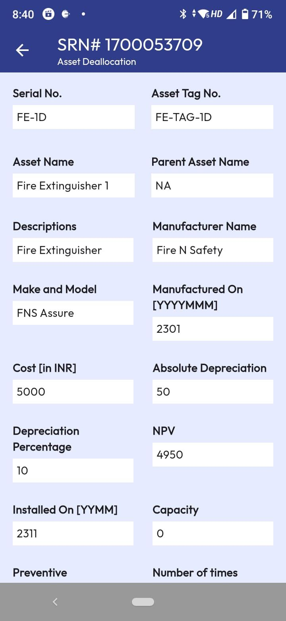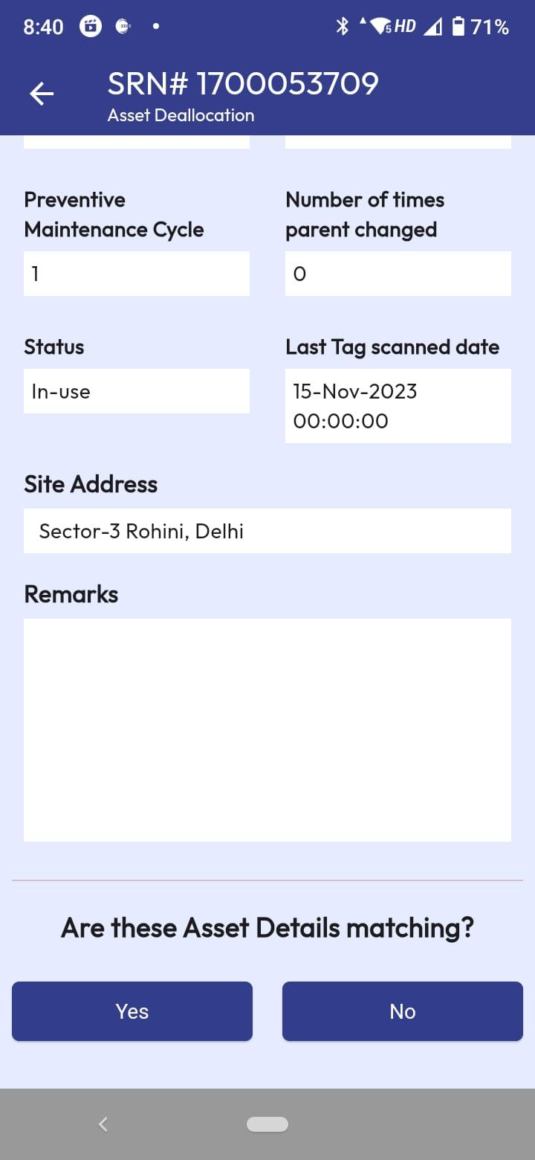

1. Verify the asset details. The details are not editable. If the details are not matching then user will put suitable remarks and clicks No option. An email notification will be sent to supervisor for data correction.
2. If the details are matching then click on the ‘Yes’ option.
3. The SRN ticket will be created for approval by Supervisor. Supervisor will see the ticket at the ‘Pending Approval’ screen of web portal.
4. After approval by Supervisor, the asset of SRN will be de-allocated from the site.

# Site Audit

1. Login as Supervisor. Go to a site and then click on the Site Audit option from menu item of the site home page.



1. The asset audit screen will open where all assets of the site will be shown with red colour code.

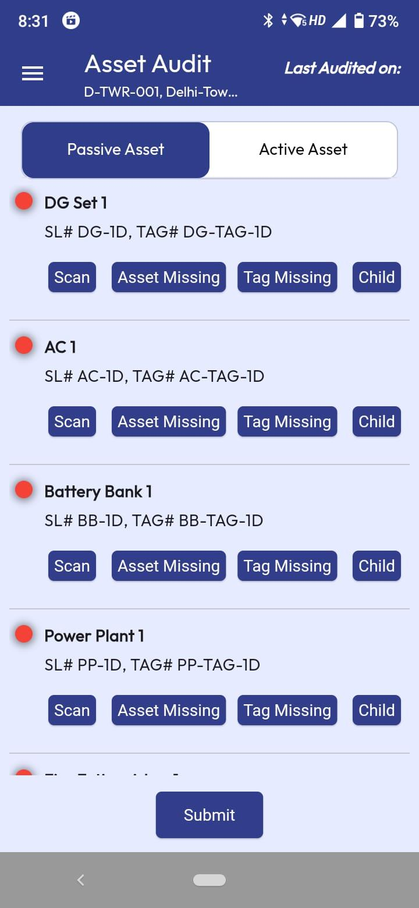

1. Click on the Scan button and scan the asset tag (QR code). If the tag is not matching, then user will get message. If tag matches, then asset details view for audit screen will open.

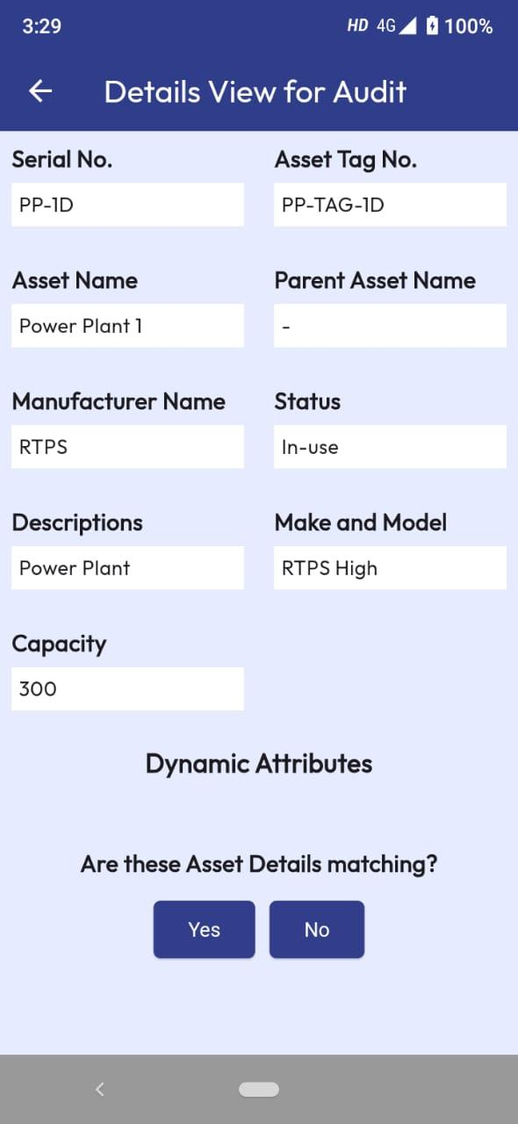

1. If asset details are not matching then click ‘No’ and an email notification will be sent to technicians of the site.
2. If asset details are matching then click ‘Yes’ and user will be back to Audit screen. The audited asset colour will change to green colour.
3. Similarly, user needs to audit all the assets of the site including child assets using scan option. Child option will be disabled if there is no child under parent.
4. If user could not find the asset at the site, then click on the ‘Asset Missing’ option.

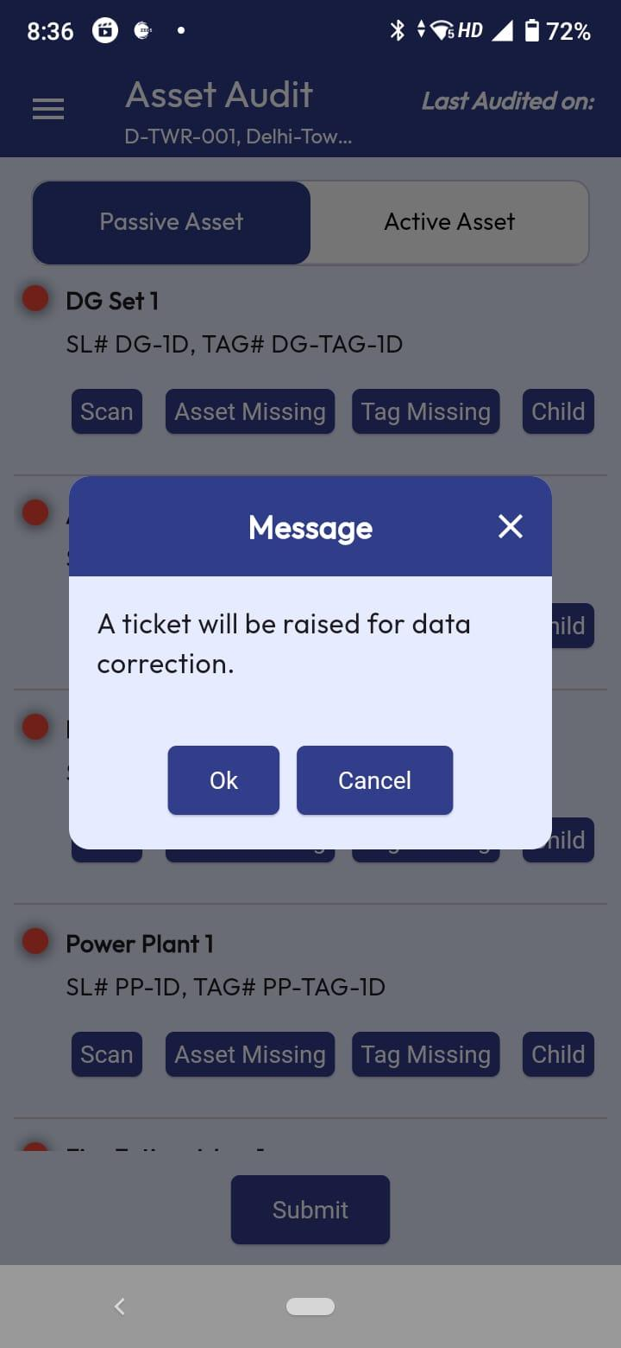

1. A message screen will appear, click ‘Ok’ from the screen. Audit Asset Missing ticket will be raised for supervisor to take further action. Supervisor will see the ticket at the ‘Pending Approval’ screen of web portal.
2. If user could not find the tag of an asset, then click on the ‘Tag Missing’ option.
3. 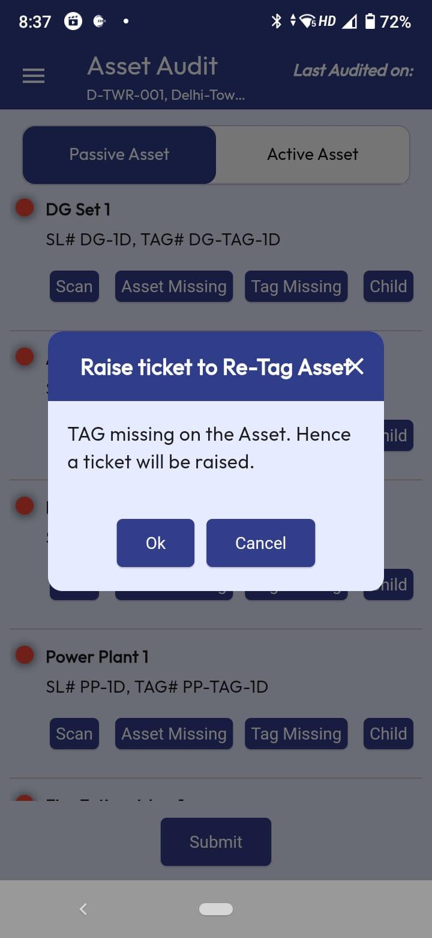
4. A message screen will appear, click ‘Ok’ from the screen. Audit Asset Tag Missing ticket will be raised for supervisor to take further action. Supervisor will see the ticket at the ‘Pending Approval’ screen of web portal.
5. After audit of all assets, the colour code changes to green.

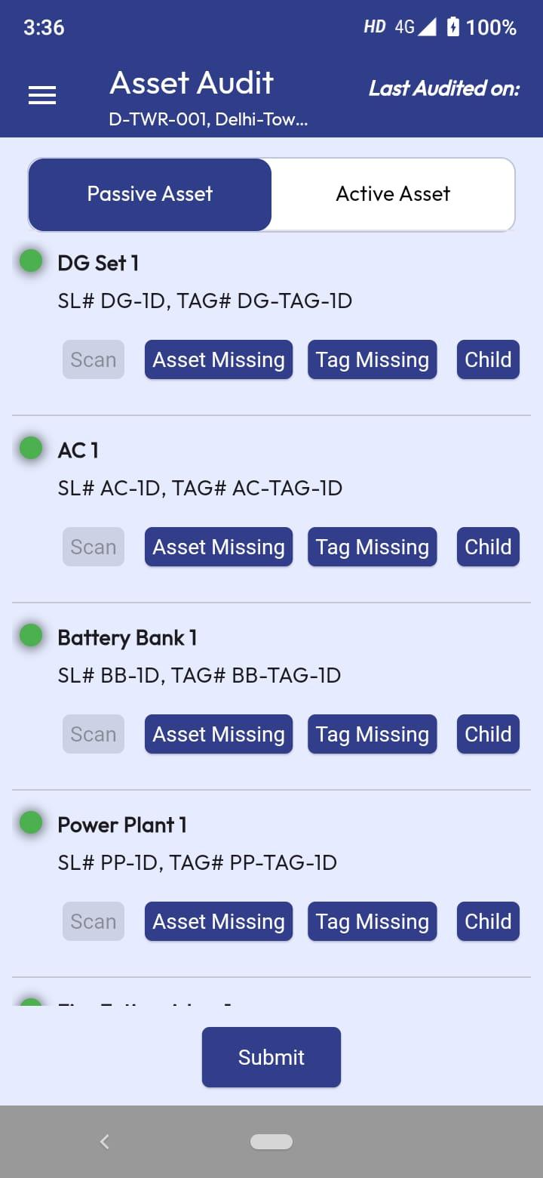

1. Click ‘Submit’ button to complete the audit process.

# Site Gallery

1. Login as Supervisor. Go to a site and then click on the Site Gallery option from menu item of the site home page.



1. The site gallery screen will open where photos and videos can be captured for the site. Click on the plus (+) button present at the bottom right corner of the screen.

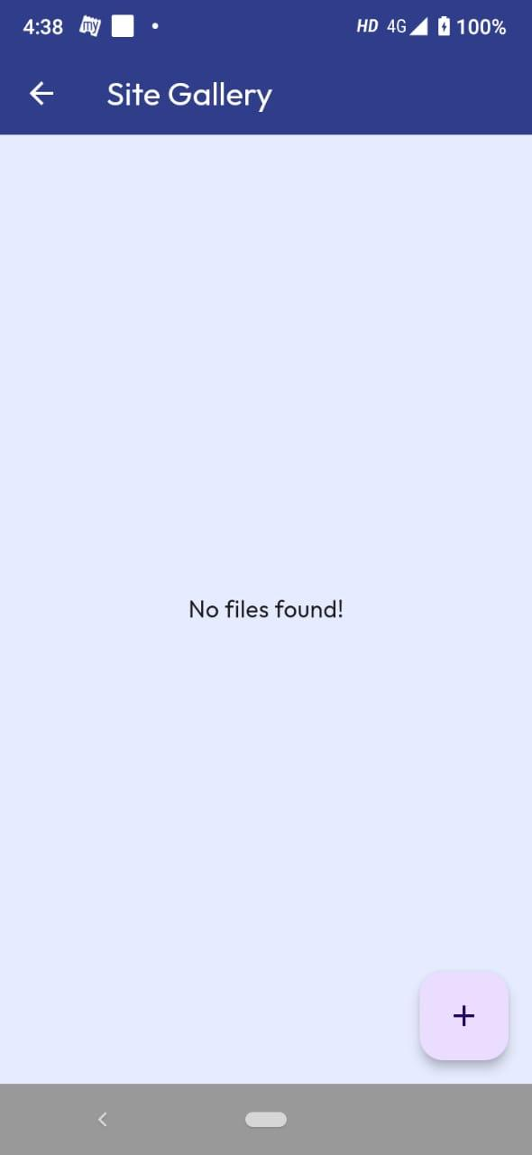

1. Upload photos/videos screen appears.

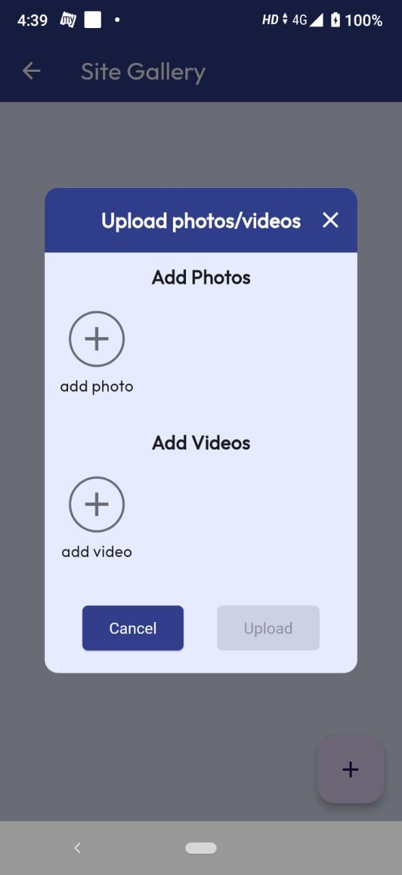

1. Click on the ‘add photo’ button to capture photo. Camera will open in photo mode. Capture the photo. User will get option to enter the description of the photo.

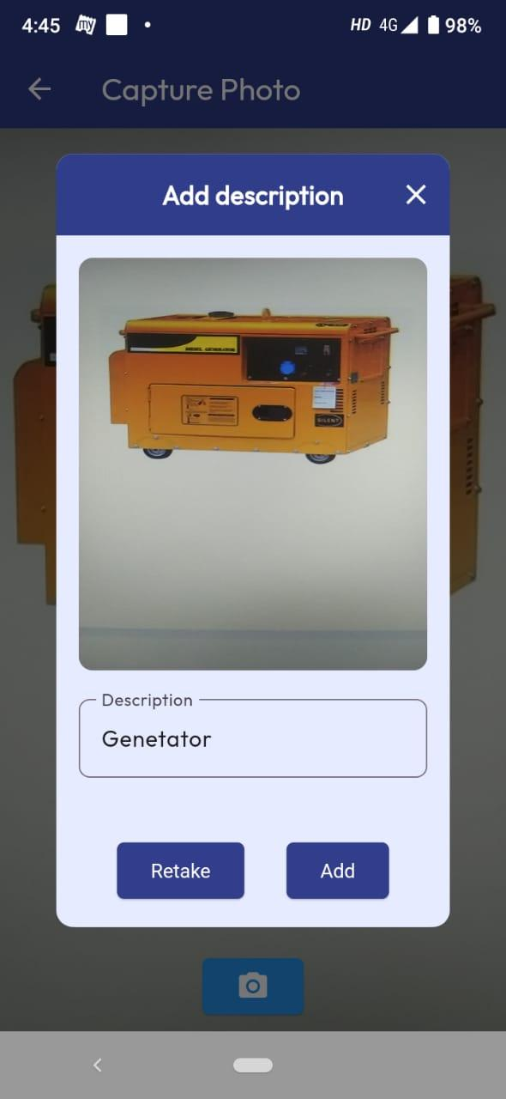

1. Enter photo description and click ‘Add’ button. Click ‘Retake’ button to capture the photo again.
2. Similarly, click on the ‘add video’ button to capture video. Camera will open in video mode. Capture the video. User will get option to enter the description of the video. Enter video description and click ‘Add’ button. Click ‘Retake’ button to capture the video again.

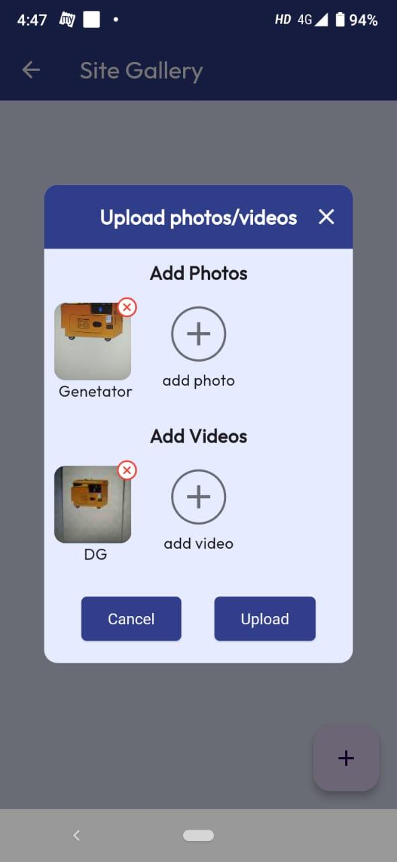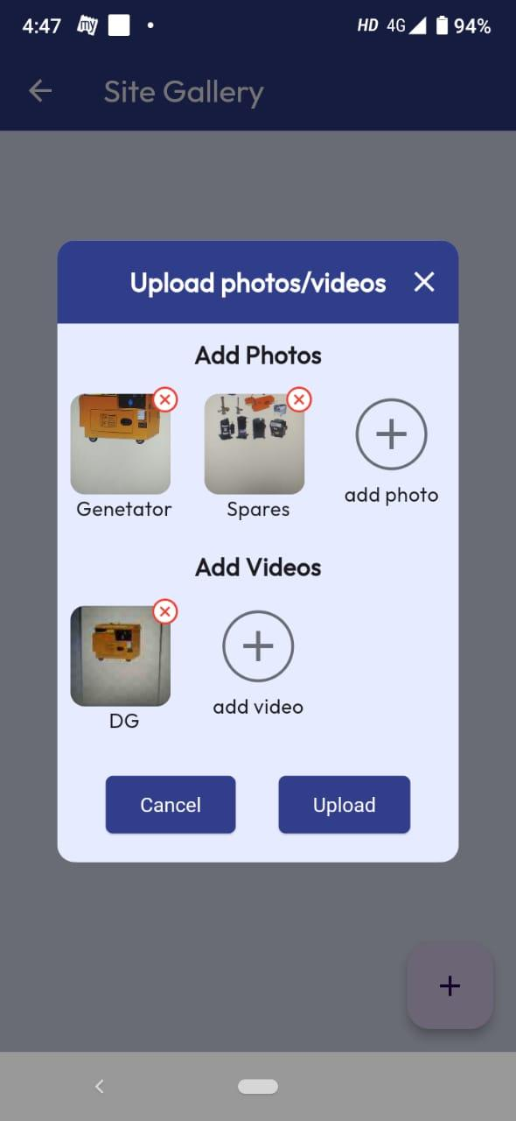

1. User can capture multiple photos and videos.
2. Click ‘Upload’ button to save the photos and videos for the site.

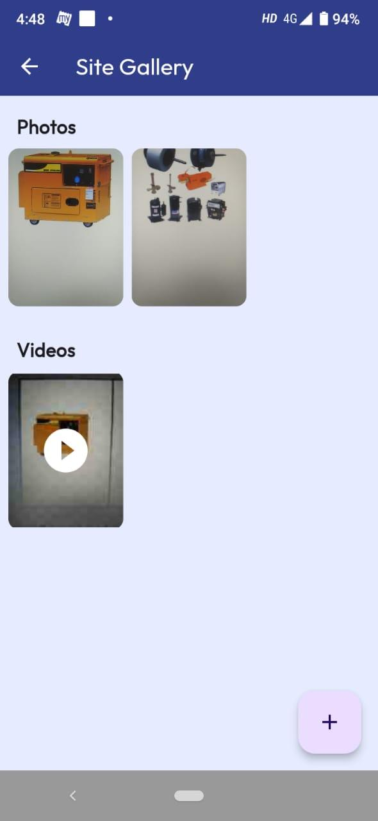

1. All photos and videos get uploaded at site gallery.

# Change Password

1. Click on the Change Password option from menu item of the app home page.

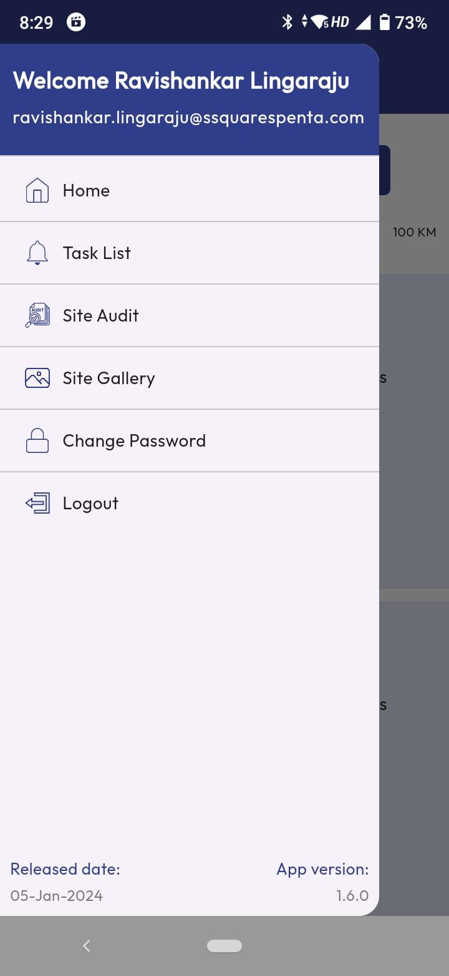

1. The change password screen appears. Enter the old password, new password and confirm password.

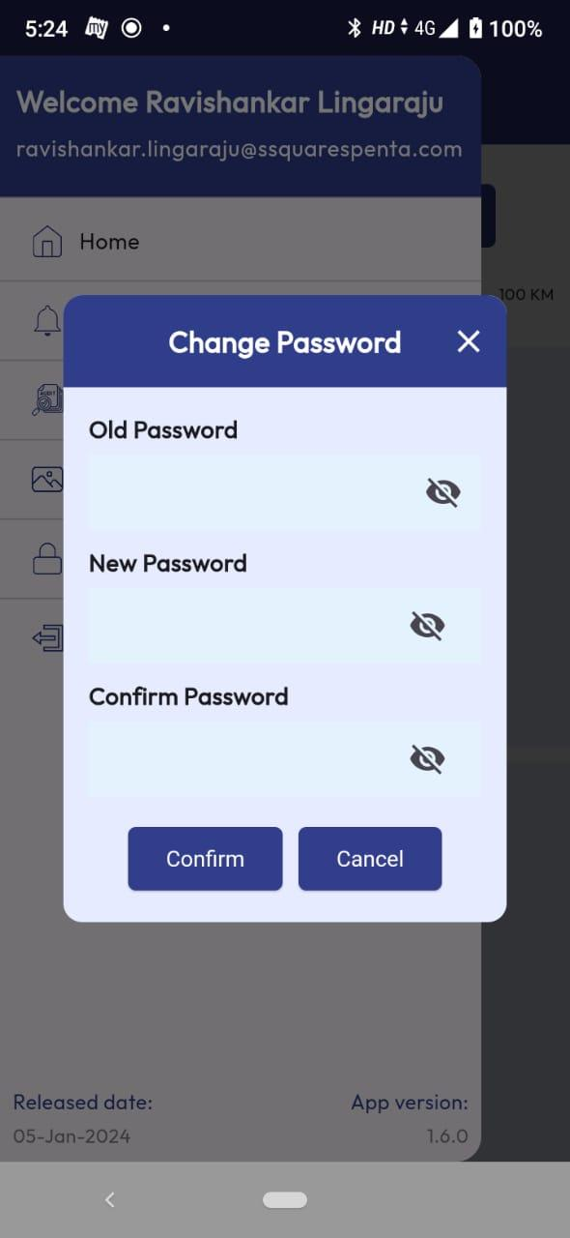

1. Click on Confirm option to change the password.

# Logout

1. Click on the Logout option from menu item of the app home page.



1. Use will be logged out from the app and login page will appear where user can login again using login credentials.

