User Manual

**User Management System**

SATS: User Management

**User Manual Version 1.0**

April, 2024

The software described in this document is furnished under a non-disclosure agreement or a license agreement. The software maybe used for copying, only in accordance with the terms and conditions as per the agreement. Information in this document is subject to change without any notice.

**Table of Contents**

1. Document Revision History 4

2. Acronyms & Glossary 5

3. Introduction 6

4. User On-boarding 7

4.1 User Landing Page 7

4.2 Existing User Login 7

4.3 Register New User 8

5. User Management 9

5.1 Activate User 9

5.2 Add User 10

5.3 Edit User 11

5.4 Search User 12

5.5 Suspend & Delete User 12

6. Module Management 13

7. Role Management 13

7.1 Add Role 13

7.2 Edit Role 14

7.3 Assign/De-assign Access to Role 14

8. User Role Mapping 15

9. Change Password 15

10. Password Policy 16

11. Logout 16

# Document Revision History

|  |  |  |  |
| --- | --- | --- | --- |
| **Sl. No.** | **Version No.** | **Description** | **Date of Release** |
| 1 | 1.0 | User Management System for Asset Tagging and Tracking System | April, 2024 |
|  |  |  |  |
|  |  |  |  |

# Acronyms & Glossary

|  |  |
| --- | --- |
| **Abbreviation** | **Description** |
| SATS | SSTL Asset Tagging and Tracking System |
|  |  |

# Introduction

This document provides operation steps for the User Management System users. This document provides operational information on how the user can do various operations in user management system. This document is created based on the user management software developed and delivered to SSTL for asset tagging and tracking system.

The User Management system or module is a standalone application which is a centralize repository of all users and provides the capabilities to validate and authenticate users across products. This module will to define and manage users, roles and modules. It will maintain user lifecycle management including onboarding, suspension, reactivation, password change and password reset and forgot password. It provides role based access control mechanism.

It provides a web portal (web based application) to configure and manage the system users. An administrator user will have access to the portal to configure the system and add more users.

It will publish integration interfaces for all future SSTL platform applications to integrate and validate users and eliminate the need of managing user’s module product wise.

# User On-boarding

## User Landing Page

1. Open the provided login link (e.g. <http://115.113.197.12/usermanagement/public/>) for user management module.
2. User will be directed to the below landing page where user can click on either ‘Log in’ option or in ‘Register’ option.

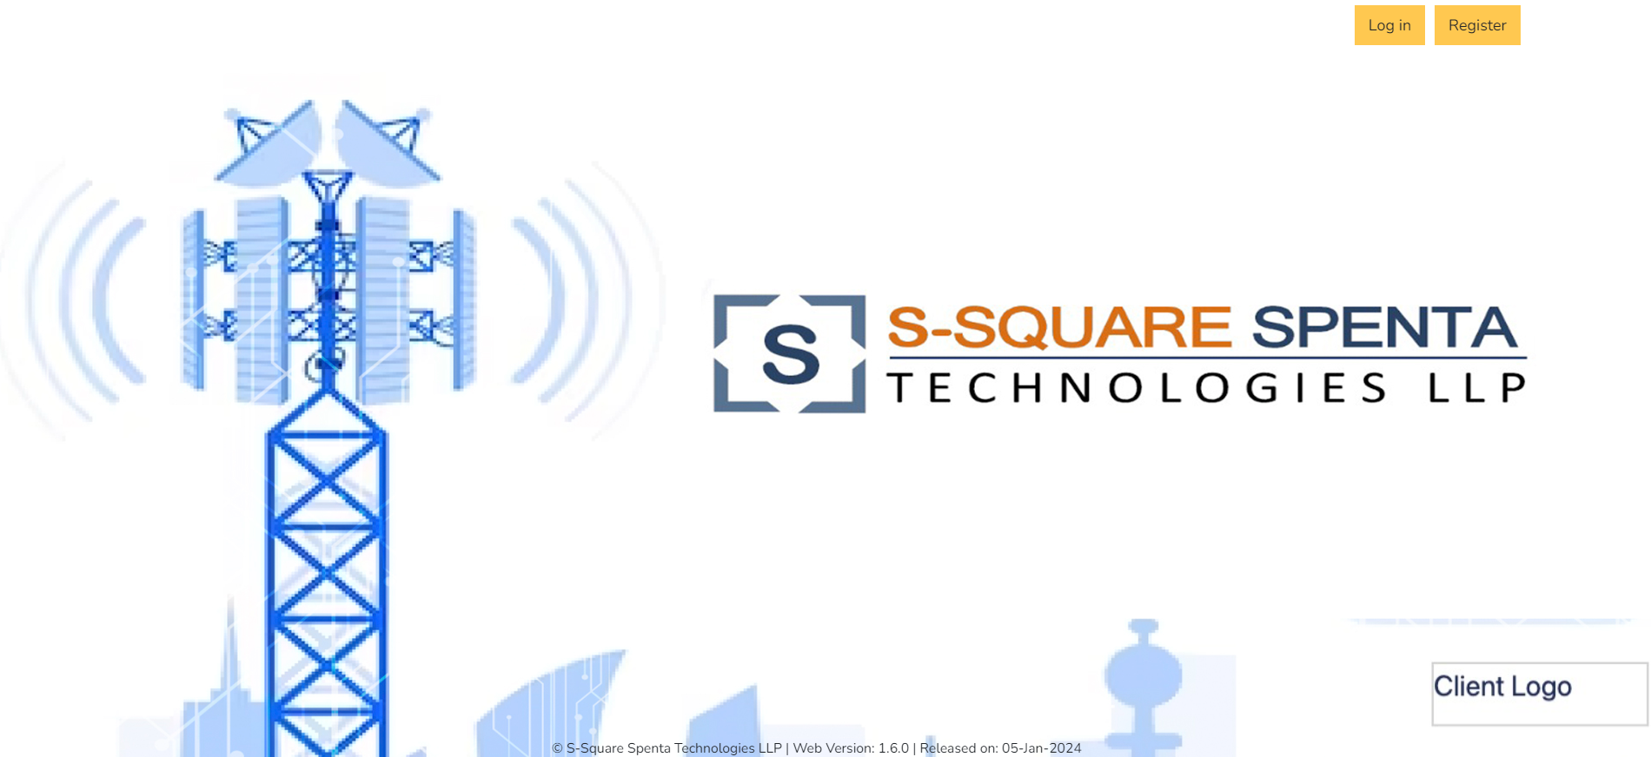

## Existing User Login

1. Existing user clicks on the ‘Log in’ option at the landing page.
2. User will be redirected to the login page where user will enter login id (email address) and password and clicks login option.

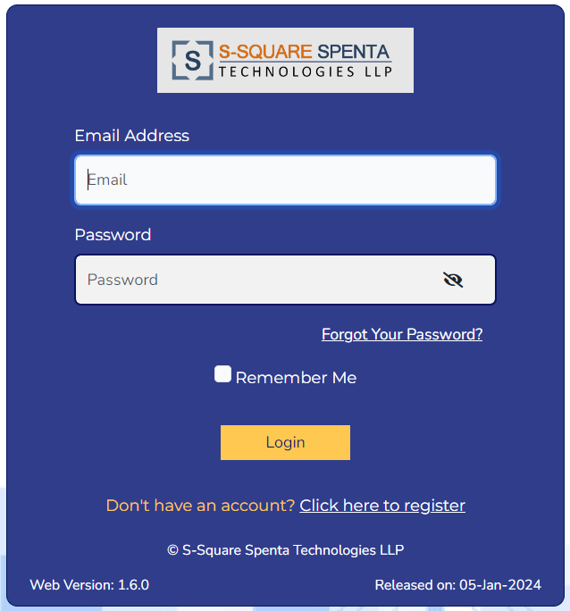

1. After successful login, user will be redirected to the dashboard of the user management module.

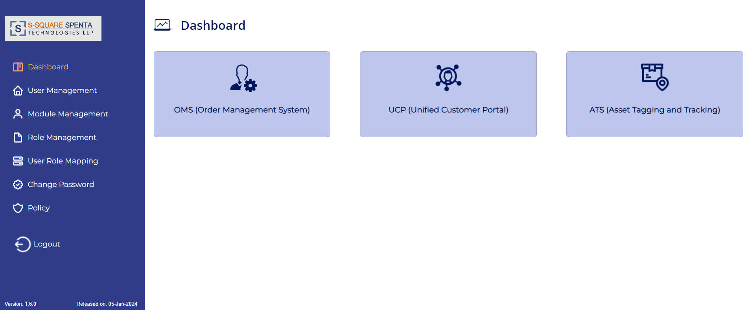

## Register New User

1. New user clicks on the ‘Register’ option at the landing page.
2. User will be redirected to the registration page where user needs to enter all information for user registration request.

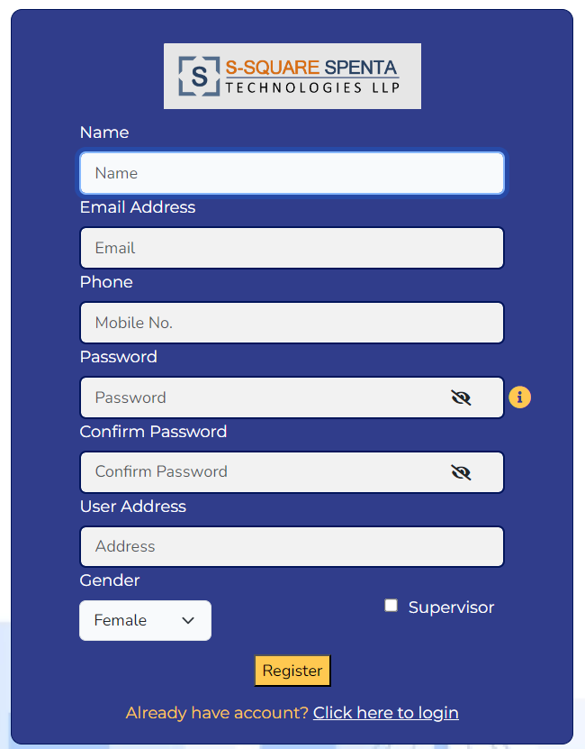

1. Name- Enter Name of the user.
2. Email Address- Enter email address of the user. This will be the login id of the user.
3. Phone- Enter mobile number of the user.
4. Password- Enter password for the user. The password should fulfill the password required set in the system. Move cursor over the ‘i’ button will display the password policy.

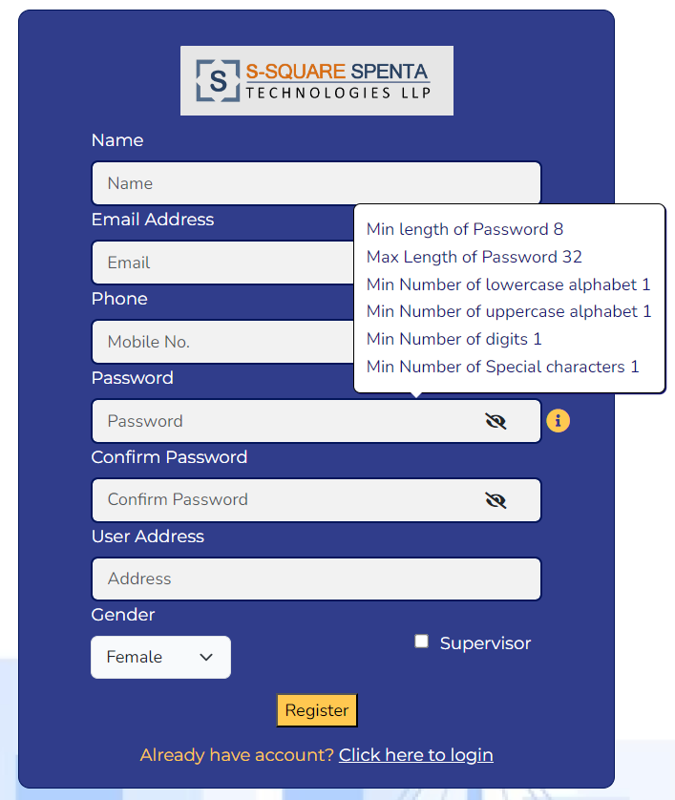

1. Confirm Password- Enter the password again. This should be same as the password entered above.
2. User Address- Enter user address.
3. Gender- Select the gender of the user from drop-down.
4. Supervisor- User may or may not click this check box. If the user is supervisor, then click on this check box.
5. Click on the ‘Register’ option. User will get message as ‘You are registered successfully’. User will be created in ‘Pending’ state and an email will be send to ‘Administrator’ user for activation of the newly registered user.

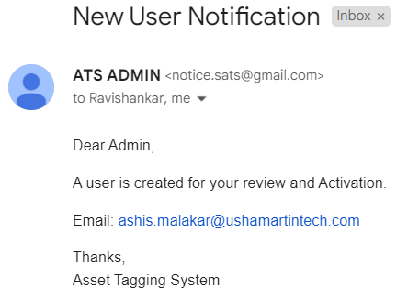

# User Management

## Activate User

1. Login to user management with administrator user. Click on the User Management from left menu. User will be presented with list of users present in the system.

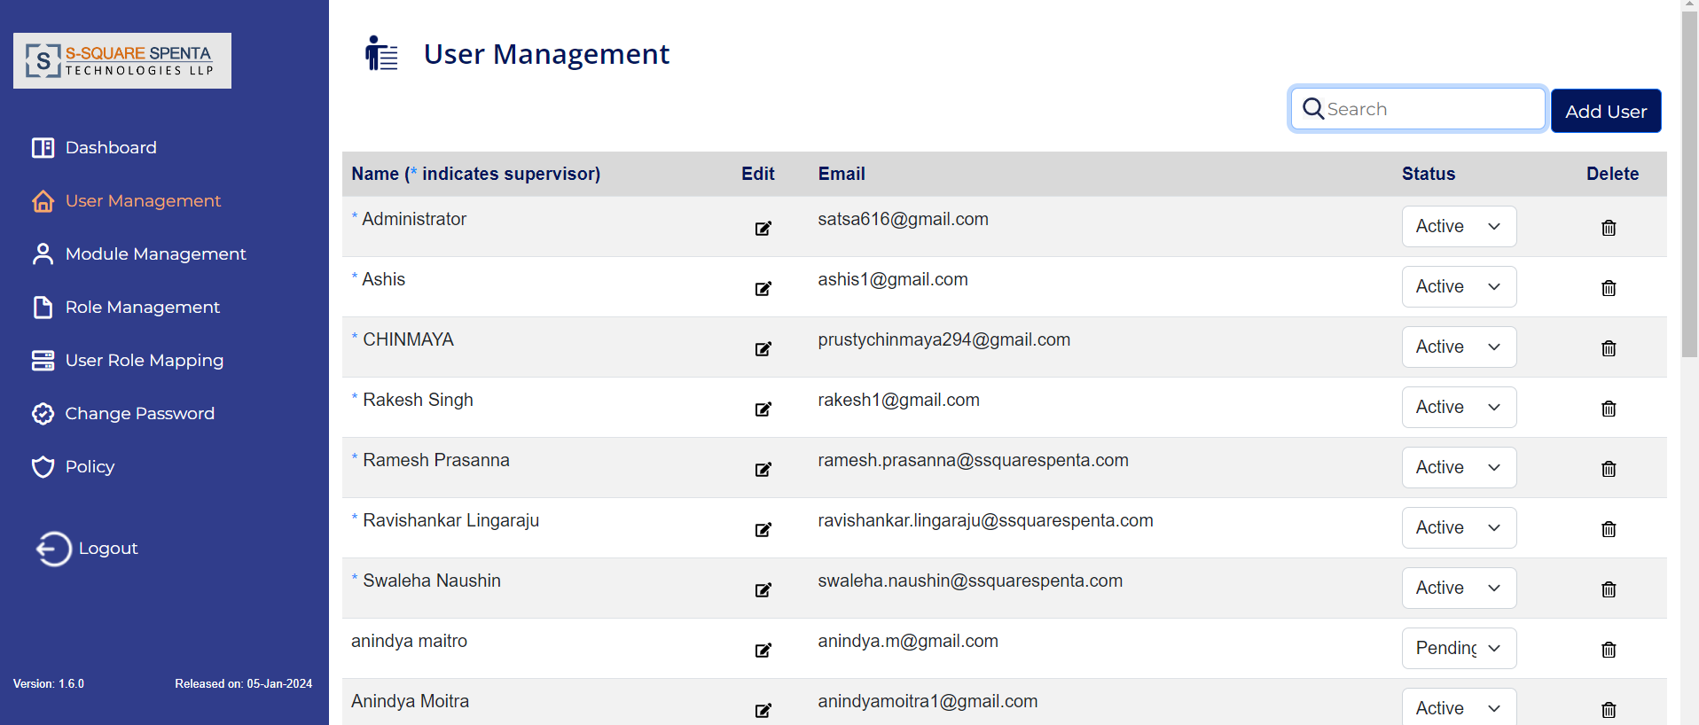

1. Find the user with ‘Status’ as pending and modify the status as ‘Active’ to activated the user.

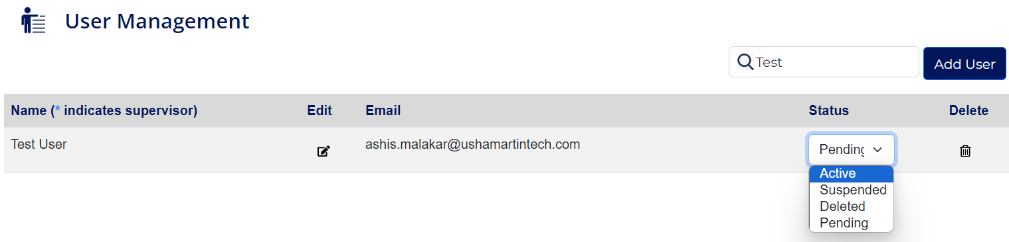

1. User will be activated and an email will be send to the user with login credential.

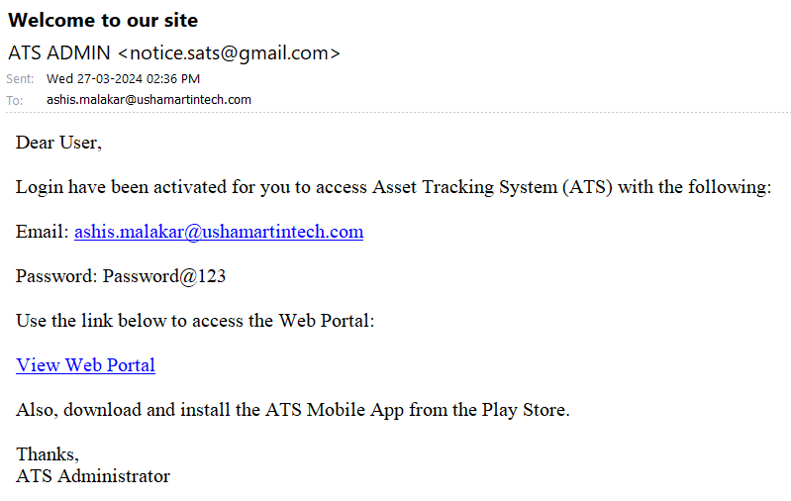

## Add User

1. Click on the Add User button from right hand side panel of user management.

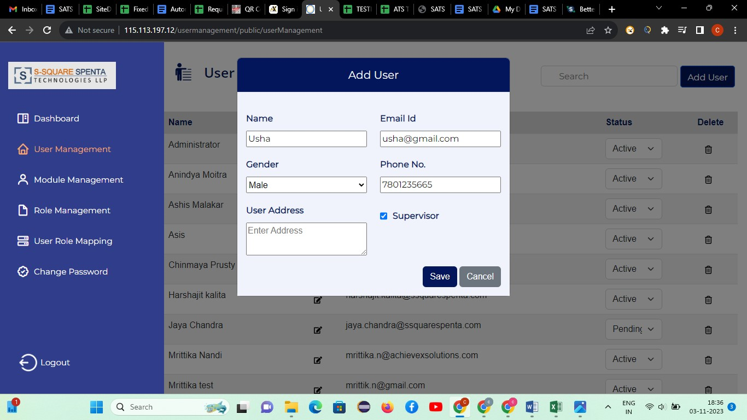

1. In the Add New User page provide the necessary data and click on save button to add a new User.

|  |  |
| --- | --- |
| **Field** | **Data to be entered** |
| Name | The name of the user. |
| Email | Please provide an Email ID of the user |
| Gender | Provide a gender of the user |
| Phone No. | Please provide a valid phone number of the user. |
| User Address | Provide an address of the user |
| Supervisor | Select the checkbox if the user is to be made supervisor |

1. After successfully adding, the success message will be displayed and the particular user will be displayed in the user list.
2. Status of the user will be displayed as ‘Pending’.
3. Administrator can select Active, Suspended, Deleted, Pending options from the dropdown as the Status.
4. If the Suspended, Deleted, Pending options are selected, the user would not be able to login to web or mobile app.
5. If the Active option is selected, the user will receive an email notification with the login credential.

## Edit User

1. Click on the Edit button () from the Editcolumn of a user.
2. In the Edit User page modify the necessary data and click on the Update button to edit the user.

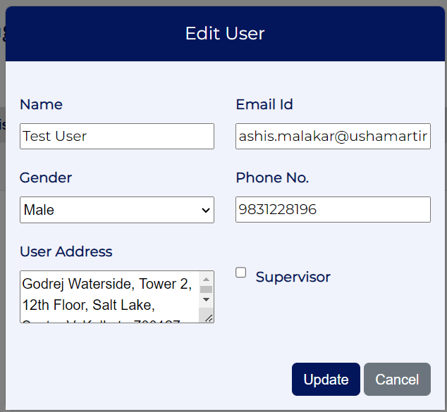

1. After successful editing, the success message will be displayed and the updated user details will be displayed in the user list.

## Search User

User can search any User using either Name or Email id from user list.

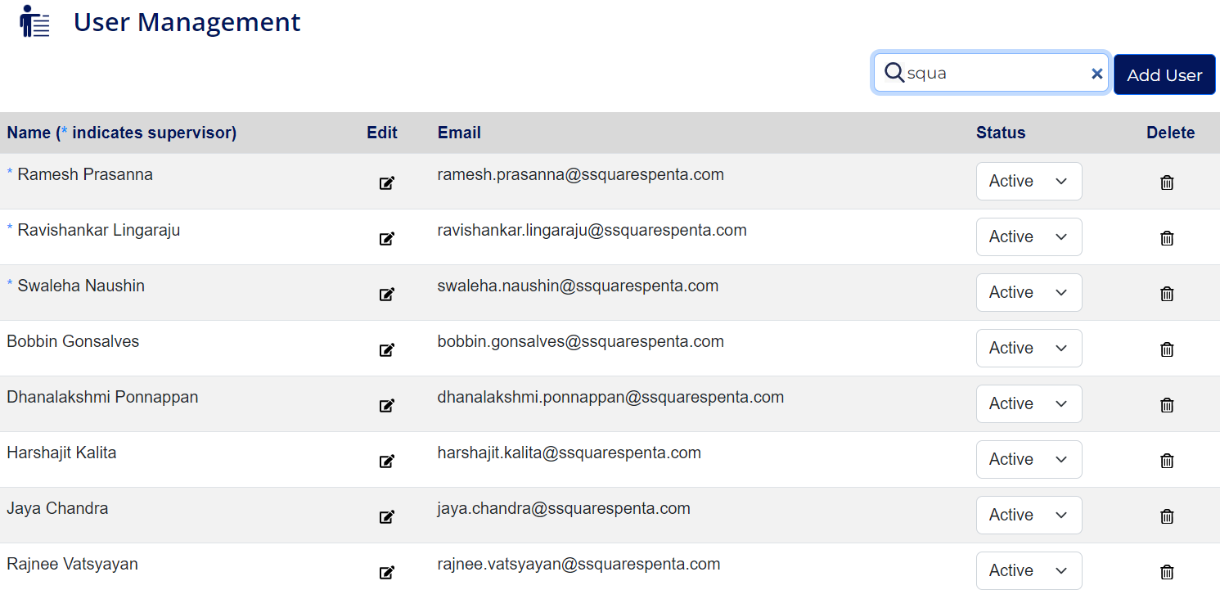

## Suspend & Delete User

1. Administrator user can suspend any User by changing the status of the user to ‘Suspended’.
2. Change the ‘Suspended‘ status to ‘Active’ to re-activate the user.

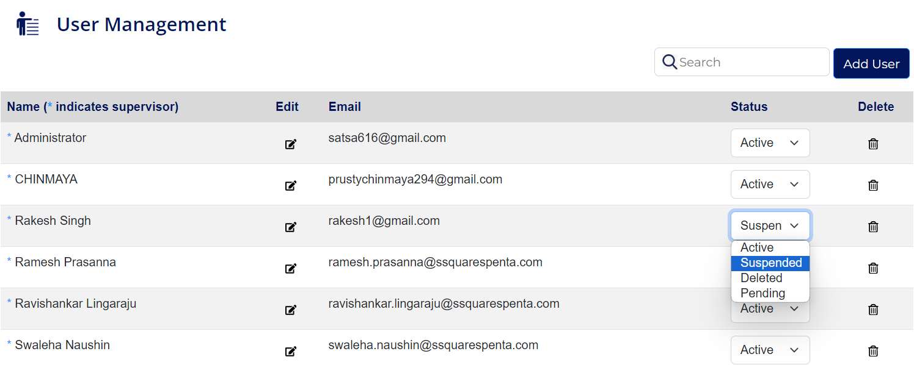

1. Administrator can delete any User using the Delete () button.
2. A Confirm Deletion pop up box will appear with the message “Are you sure you want to delete this user?”

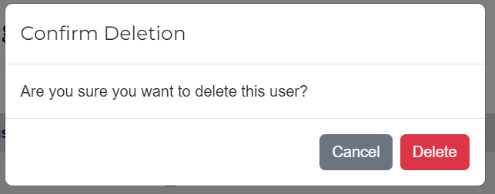

1. Click on Delete button to delete user or click on Cancel button to cancel.

# Module Management

1. This is a view only screen.
2. Click on the ‘Module Management’ from left menu. The module name will be displayed at the right side.
3. Clicking on a particular Module Name will display its corresponding Functions which are available for that particular module.
4. User also can search a function for a particular module.

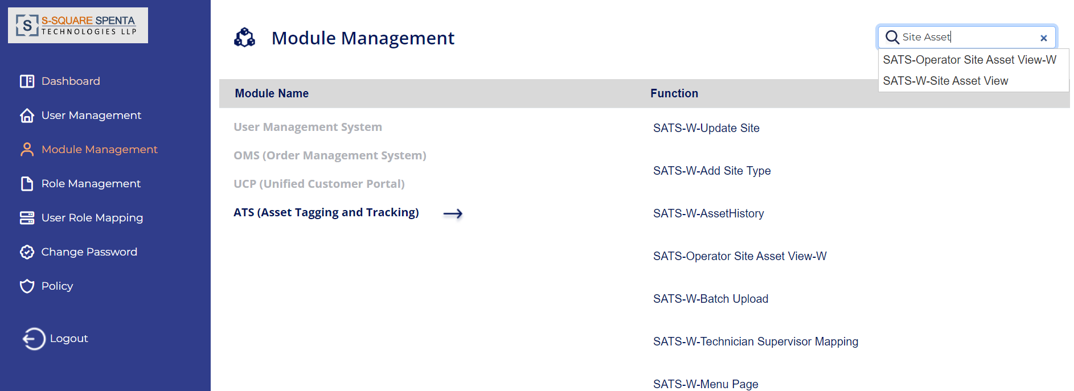

# Role Management

## Add Role

1. Click Role management from the left menu.
2. Click on the Add Role button from right hand side panel.
3. In the Add Role popup screen provide the necessary data i.e. role name, descriptipn and click on Save button to add a new Role.

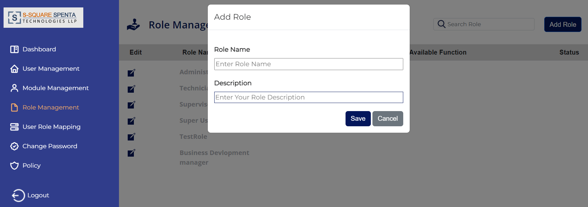

1. After successfully adding, the success message will be displayed and the particular role will be displayed in the list.

## Edit Role

1. Click on the Edit button from the **Edit** column of the role.
2. In the Edit Role screen modify the necessary data and click on the save button to edit the role.

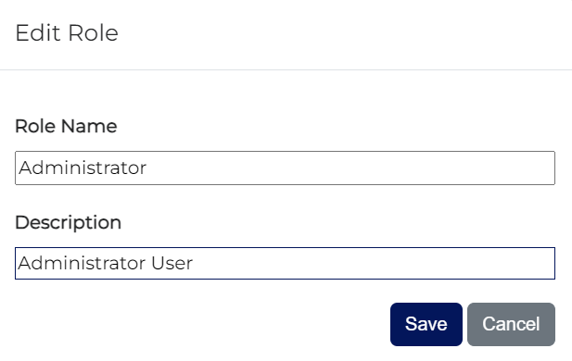

1. After successfully editing, the success message will be displayed and the particular role details will be displayed in the table with updated details.

## Assign/De-assign Access to Role

1. Click on the created role from the list. User will be able to see the available module list.
2. Click on a Module name whose function access is required. User can see the available function list.
3. User can see the all Functions with its corresponding status which is either active or inactive for that particular role.
4. Click on the status (enable/disable) option to make a Function active or inactive for that role.

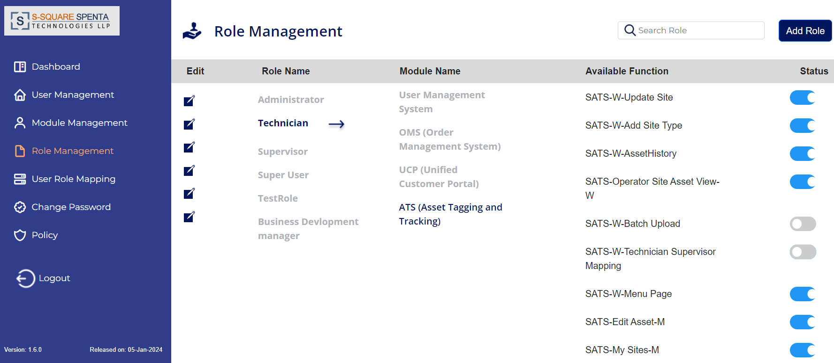

# User Role Mapping

1. Click on the User Role Mapping option from left menu. The entire user list will be displayed at the right side screen.
2. Click on a user name from the list and the list of Roles will be displayed along with the status of the role for that particular user.
3. User can click on the enable/disable button to make a Role active or inactive for that user.

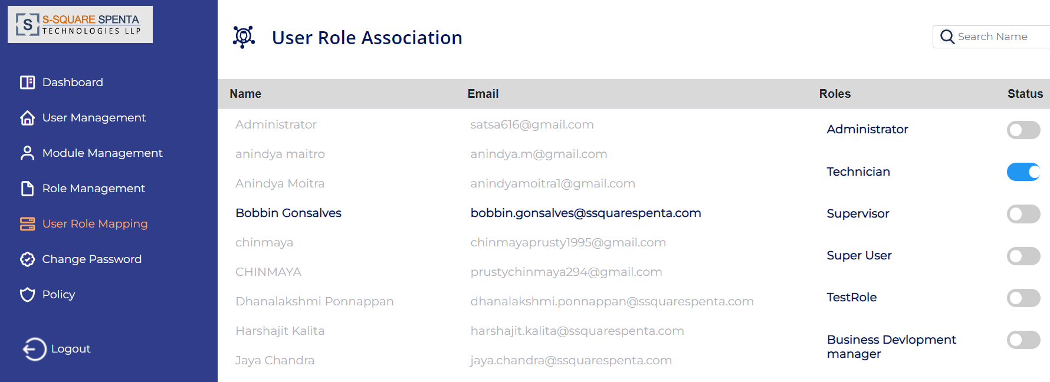

# Change Password

1. Click on the Change Password option from left menu. Change Password screen will appear at the right side.
2. To change the password, enter old password, new password and confirm new password and click on change password button.
3. User will get the successful message of password change.

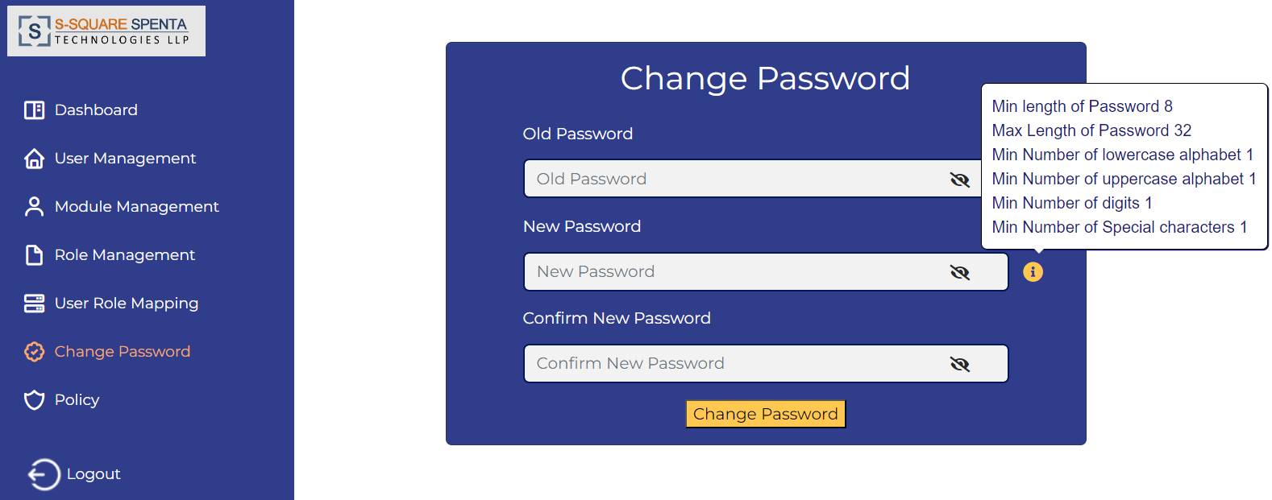

# Password Policy

1. Click on the Policy option from left menu. Password Policy screen will appear at the right side.
2. User can view all the applicable policies present in the system.
3. User can enable or disable a specific policy by clicking on the status option.
4. User can also set the value of enabled policies by changing the value field of the policy.

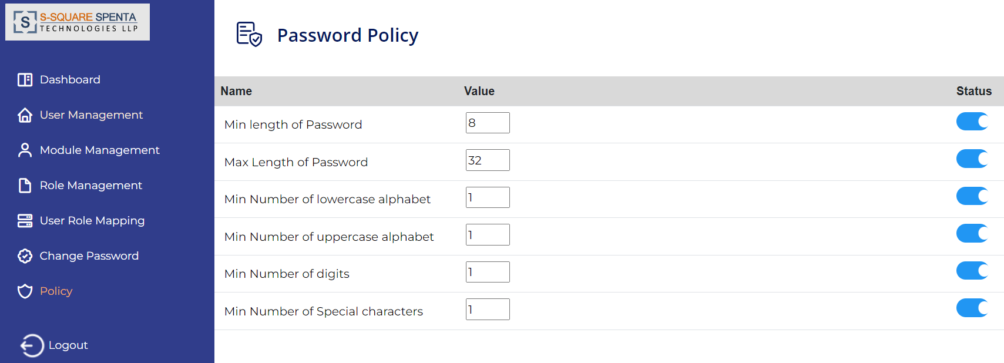

# Logout

1. Click on the Logout option from left menu. User will be logged out from the system and redirected to the landing page.

