



# Disclaimer

Information in this document is subject to change without notice. The software described in this document is furnished under a license agreement or nondisclosure agreement. The software may be used for copying, only in accordance with the terms of those agreements. No part of this document may be reproduced, stored in a retrieval system, or transmitted in any form or any means electronic or mechanical, including photocopying and recording for any purpose other than the purchaser’s personal use without the written permission of Eppix eSolution Limited.

All trademarks used herein are properties of their respective owners.

Table of Contents

Disclaimer 2

Document Release History 6

Circulation Details 7

List of Amendments 8

1. Introduction 9

2. Scope of the System 9

3. Solution Overview 9

4. System Actors or Stake holders 10

5. Dependencies and Change Impacts (Not considered in Phase I) 10

6. Functional Specifications 11

6.1. System Entities 13

6.2. Web Portal - Configuration Management 13

6.2.1. [FR-1] Asset Type Configuration 13

6.2.2. [FR-2] Dynamic Asset Attribute Configuration 15

6.2.3. [FR-3] Location Type Configuration 16

6.2.4. [FR-4] Dynamic Location Attribute Configuration 17

6.2.5. [FR-6] Reason and Sub-reason Configuration 18

6.2.6. [FR-7] Technician and Supervisor Mapping 19

6.3. Web Portal - Asset Management 20

Asset Attributes (Fixed) 20

Asset Attributes (Dynamic) 21

6.3.1. [FR-8] Asset List View & Map View 21

6.3.2. [FR-9] Asset Search on List & Map 22

6.3.3. [FR-10] Asset Modification 22

6.3.4. [FR-11] Child Asset View 23

6.3.5. [FR-12] Asset Movement & View History 23

6.3.6. [FR-13] Asset Tag History View 23

6.4. Web Portal - Location Management 24

Location Attributes (Fixed) 24

Location Attributes (Dynamic) 24

Technician - Location Mapping 25

6.4.1. [FR-14] Location List View & Map View 25

6.4.2. [FR-15] Location Search on List & Map 26

6.4.3. [FR-18] Location Modification 26

6.4.4. [FR-19] Location wise Active Asset View 27

6.4.5. [FR-20] Location wise Passive Asset View 27

6.4.6. [FR-21] Deactivate Location 27

6.4.7. [FR-22] Launch Asset Audit & View Audit History 27

6.4.8. [FR-23] Technician Association 28

6.5. Mobile App - General Feature 28

6.5.1. [FR-24] Login & Site Selection 29

Location wise Asset Catalog 30

Operations on Assets 33

6.6. Asset Related Processes 34

6.6.1. [FR-25] Tag 34

6.6.2. [FR-26] STN 35

6.6.3. [FR-27] SRN 35

6.6.4. [FR-28] Asset Audit 36

6.6.5. [FR-29] Technician Task List 36

7. Batch Processes 37

7.1. [FR-30]Fully Tagged Site Identification Batch Process 37

7.2. [FR-31]Not Found Asset Batch Process 37

7.3. [FR-32]Additional Item Asset Batch Process 38

7.4. [FR-33]Inventory FAR Mismatch Batch Process 38

7.5. [FR-34]STN and SRN Task Creation Batch Process 38

7.6. [FR-35]STN Task Closure Batch Process 38

7.7. [FR-36]SRN Task Closure Batch Process 39

7.8. [FR-37]Asset Audit Batch Process 39

7.9. [FR-38]ERP FAR Update Batch Process 39

8. System Configurations 40

9. Other System Requirements/ Non-Functional Requirements 40

9.1. Audit Trail (Not considered in Phase I) 40

10. Reporting Requirements (Not considered in Phase I) 41

11. Integration Requirements (Not considered in Phase I) 41

12. Data Migration Requirements 42

13. Assumptions 42

14. Open Items 42

15. Out of Scope 42

# Document Release History

| Sl# | Ver. No. | Release Date | Prepared By | Reviewed By | Approved By | Reasons for New Release |
| --- | --- | --- | --- | --- | --- | --- |
| 1 | 1.0 | 29-Mar-2023 | Saheb Biswas | Abhra Chandra | Abhijit Guhathakurta | Initial Document |
| 2 | 1.1 | 30-Mar-2023 | Saheb Biswas | Abhra Chandra | Abhijit Guhathakurta | Changes for updating FR numbers and reporting section |
| 3 | 1.2 | 12-Apr-2023 | Saheb Biswas | Abhra Chandra | Abhijit Guhathakurta | Changes for marking Phase I items and Removal of non-required FRs |

# Circulation Details

| Copy No. | Designation of Copy Holder | Location of the Copy |
| --- | --- | --- |
| 1 | Eppix Project Manager | Soft Copy in SVN |
| 2 | SSTL Project Manager | Soft Copy via Email |

# List of Amendments

| Sl# | Ver. # | Section No. /Page No. | Description of the amendment | Raised by | Response | Updated By | Approved by |
| --- | --- | --- | --- | --- | --- | --- | --- |
| 1 | 1.1 | Section 6 & 7 | FR numbers are updated to keep them sequential | UMT | UMT | UMT | SSTL |
| 2 | 1.1 | Section 10 | Elaborated reporting section | UMT | UMT | UMT | SSTL |
| 3 | 1.2 | All | Marking Phase I items.  Removal of non-required FRs.  Assumption for User authentication not applicability in phase 1. | SSTL | UMT | UMT | SSTL |

# Introduction

This document provides requirement specification for the Asset Tagging and Tracking system to be built under SSTL platform of products or modules. This document provides detailed information on how the ATS will function and how it will be integrated with other products/modules. This document is created based on the high-level requirements discussed with SSTL and provides traceability on the functional specifications back to the business requirements.

# Scope of the System

The proposed Asset Tagging and Tracking system (to be referred as ATS) is an application integrated into SSTL product platform. Purpose of the system is to maintain updated tower catalog by integrating with FAR (Fixed Asset Register) and enabling technicians to tag and scan assets in a guided process oriented mechanism and in the process keeping FAR updated and sync with real life data. The scope of the system is –

* To define and manage different type of active and passive assets
* To define and manage different type of locations (i.e. warehouses, sites etc.)
* Capabilities to integrate with FAR (for Passive assets), Asset Inventory (for Active assets) and Billing to keep data in sync in all the systems based on the reality on the ground.
* Capabilities to maintain parent-child hierarchy of assets, i.e., battery bank and battery cell.
* To support asset involved processes like Asset Tagging and Addition, STN, SRN and Asset Audit
* To support workflow ticket based approval processes for asset change requests

# Solution Overview

The ATS product or module will consists of a few integrated software components connected seamlessly.

* A native mobile app (Android and iOS) for technicians and supervisors for asset tracking, tagging, ticket management and all other field work
* One desktop friendly web application for system administrators to configure the system as well as view different reports. It will also allow to manage locations and assets.

# System Actors or Stake holders

Following are the identified stakeholder groups / users in the system

| User/Role | Example | Frequency of Use | Security/Access, Features Used | Additional Notes |
| --- | --- | --- | --- | --- |
| Administrator |  | Frequent | System Configuration, Asset Type and Location Management |  |
| Technician | Persons who manage sites and towers | Most Frequent | Asset related process features, i.e. tagging, scanning etc. |  |
| Supervisor | Supervisors of technicians | Most Frequent | All Technician features plus Tickets handling and approval | Supervisor are also technicians with additional privileges |
| Corporate |  | Frequent | Monitor assets and locations, approvals and tickets, Execute & View Reports etc. |  |

# Dependencies and Change Impacts (Not considered in Phase I)

ATS module will have dependencies on -

* User management module of SSTL platform for user authentication and role based feature access/restriction –
  + ATS needs to publish list of functionalities on which access privileges can be configured into User management module.
  + Roles need to be created in User management module for Technician, & Supervisor using those access privileges.
* Workflow and Ticketing module of SSTL platform for approval process – New workflows need to be created in this module as per ATS requirement
* Reports Module of SSTL platform for report execution and view – New reports to be created and deployed in this module as per ATS requirement.

As this is a new module, hence there is no change impact on itself.

# Functional Specifications

Following are the features of the ATS module. Each of the functionalities of the module is identified by a unique FS# which provides traceability across documents for the said functionality.

| SL# | Module | Functional Area / Process | Detailed Functionalities / Use Cases | FS # | Phase# | Remarks |
| --- | --- | --- | --- | --- | --- | --- |
| 1 | ATS Web Portal | Configuration Management | Asset Type Configuration | FR-1 | TBD | DB & API in Phase I |
| 2 | Dynamic Asset Attribute Configuration | FR-2 | TBD | DB & API in Phase I |
| 3 | Location Type Configuration | FR-3 | TBD | DB & API in Phase I |
| 4 | Dynamic Location Attribute Configuration | FR-4 | TBD | DB & API in Phase I |
|  |  |  |  |  |
| 6 | Reason and Sub-reason Configuration | FR-6 | TBD |  |
| 7 | Technician and Supervisor Mapping | FR-7 | TBD |  |
| 8 | Asset Management | Asset List View & Map View | FR-8 | List View in Phase 1 | DB & API in Phase I |
| 9 | Asset Search on List & Map | FR-9 | Search from List View in Phase 1 |  |
| 10 | Asset Modification | FR-10 | TBD |  |
| 11 | Child Asset View | FR-11 | TBD |  |
| 12 | Asset Movement & View History | FR-12 | TBD |  |
| 13 | Asset Tag History View | FR-13 | TBD |  |
| 14 | Location Management | Location List View & Map View | FR-14 | List View in Phase 1 | DB & API in Phase I |
| 15 | Location Search on List & Map | FR-15 | Search from List in Phase 1 |  |
|  |  |  |  |  |
|  |  |  |  |  |
| 18 | Location Modification | FR-18 | TBD |  |
| 19 | Location wise Active Asset View | FR-19 | Phase I |  |
| 20 | Location wise Passive Asset View | FR-20 | Phase I |  |
| 21 | Deactivate Location | FR-21 | TBD |  |
| 22 | Launch Asset Audit & View Audit History | FR-22 | TBD |  |
| 23 | Technician Association | FR-23 | TBD | DB & API in Phase I |
| 24 | ATS Mobile App | General Feature | Login & Site Selection | FR-24 | Phase I |  |
| 25 | Asset Related Processes | Tag | FR-25 | Phase I |  |
| 26 | STN | FR-26 | Phase I |  |
| 27 | SRN | FR-27 | Phase I |  |
| 28 | Asset Audit | FR-28 | Phase I |  |
| 29 | Technician Task List | FR-29 | Phase I |  |
| 30 | Batch Processes |  | Fully Tagged Site Identification Batch Process | FR-30 | Phase I |  |
| 31 | Not Found Asset Batch Process | FR-31 | Phase I |  |
| 32 | Additional Item Asset Batch Process | FR-32 | Phase I |  |
| 33 | Inventory FAR Mismatch Batch Process | FR-33 | Phase I |  |
| 34 | STN and SRN Task Creation Batch Process | FR-34 | Phase I |  |
| 35 | STN Task Closure Batch Process | FR-35 | Phase I |  |
| 36 | SRN Task Closure Batch Process | FR-36 | Phase I |  |
| 37 | Asset Audit Batch Process | FR-37 | Phase I |  |
| 38 | ERP FAR Update Batch Process | FR-38 | Phase I |  |

# System Entities

Following are the main system entities for this ATS module.

* **Assets** – Assets are the equipment or devices or any physical tangible item involved in the scope of tower / site management
  + **Active Assets –** Assets or equipment owned by Telecom Operators (OpCo). These are mainly equipment for telecommunication. Active assets are installed and maintained by OpCos.
  + **Passive Assets –** Assets or equipment owned by the TowerCo. These are equipment installed at site and provide support for the Active Assets. These are mainly power sources, backup power, air conditioning or cooling devices etc.
* **Locations** – Locations are the physical places on earth where an asset can be placed or retrieved from. Examples of locations are Sites, Warehouses, Repair centers, vendor locations, offices etc. Assets have many to one relationship with locations, i.e. one location can have multiple assets but one asset will be placed in one location in any particular time. All locations are identified by unique geo coordinates (latitude/longitude).

# Web Portal - Configuration Management

ATS product will allow all configuration management to be done from the web portal.

# [FR-1] Asset Type Configuration

ATS will allow configuring asset types dynamically for both Active and Passive assets. Asset types are broad categories of assets, i.e. Diesel Generator, Air Conditioner etc. Each asset type entity will have following attributes –

* Unique ID
* Type Code or Name
* Type Description
* Parent Asset Type Id (if any)
* Category (Active or Passive Assets)
* Status (Active/Inactive)

There will be a tabular list view with filtration option for all configured asset types. There will be option to add new asset types and edit existing one. There will not be any delete option.

Only the description can be modified during edit. Making an asset type inactive will not allow adding/tagging assets of that type in ATS.

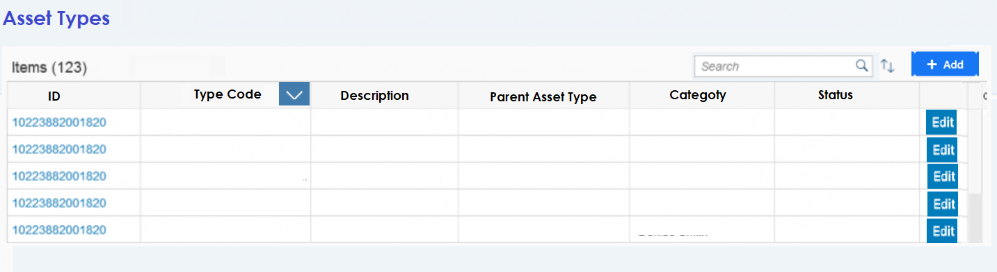

**Figure 1 - List View**

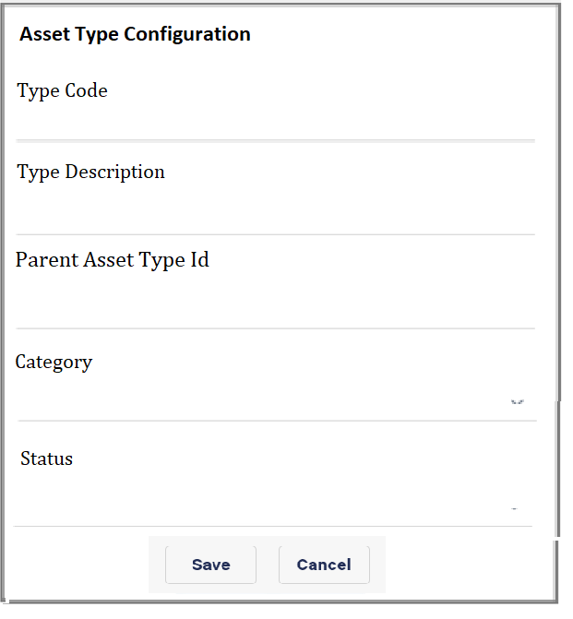

**Figure 2 - Addition dialog**

**Parent Child Relationship**

Parent child relationship can be established between two types of individual assets. For example Diesel Generator and Alternator can be two separate asset types and Alternator may have Diesel Generator set at it’s parent. In the similar way another type of equipment, for example ‘magnetic coil’ can have alternator as it’s parent, thus making Diesel Generator it’s grandparent. This relationship may continue to any number of level required.

Defining child asset type for an asset makes child asset view and tagging enabled and mandatory for that type of asset.

# [FR-2] Dynamic Asset Attribute Configuration

Each type of asset will have some fixed data fields defined in the system; those are common to all assets irrespective of the type.

System should allow configuring asset type specific data fields as asset type attributes. Each asset type attribute will have following attributes –

* Unique Id
* Unique Attribute Name or Code
* Attribute Description
* Data Type (Numeric, Alphanumeric, Free-flow, Choice, Date)
* Mandatory Flag
* Default Value

These attributes appear dynamically in the asset creation or modification form as per the asset type selected.

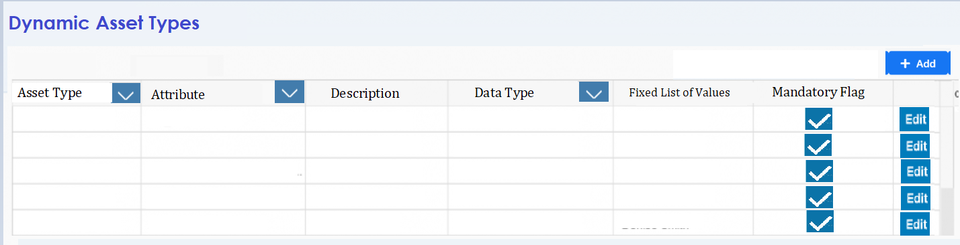

**Figure 3 - List View**

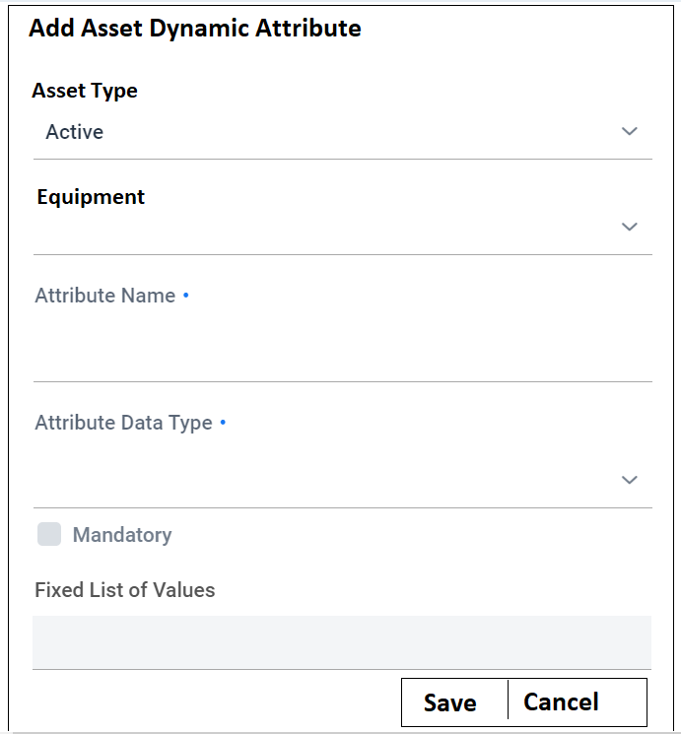

**Figure 4 - Add Dialog**

# [FR-3] Location Type Configuration

ATS will allow configuring any location type with the following attributes.

* Unique Id
* Location Type (Warehouses, Sites, Repair centers, vendor locations, offices etc.)
* Name
* Status

There will be a tabular list view with filtration option for all configured location types. There will be option to add and edit. There will not be any delete option.

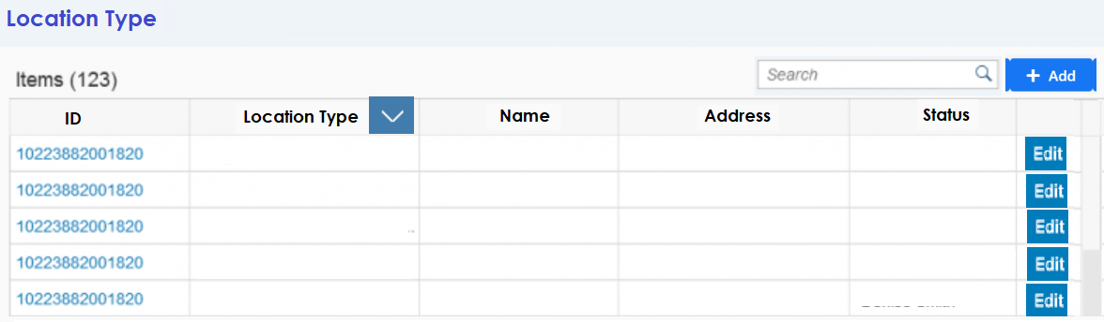

**Figure 5 - Location Type List**

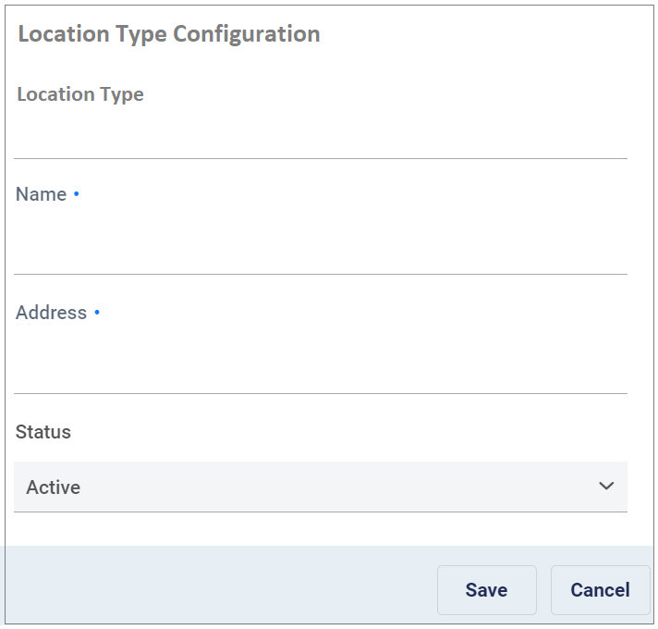

**Figure 6 - Location Type Addition Popup**

By default two location types (Site and Warehouse) will be pre-configured in the system.

# [FR-4] Dynamic Location Attribute Configuration

ATS will allow configuring Location type specific data fields as Location attributes. Each Location attribute will have following data fields –

* Unique Id
* Location Type – For which type of location this attribute is applicable
* Attribute Name – Name of the attribute
* Description
* Data Type (Numeric, Alphanumeric, Free-flow, Choice, Date)
* Mandatory Flag
* Default Value

There will be a tabular list view with filtration option for all configured location attributes. There will be option to add and edit. There will not be any delete option.

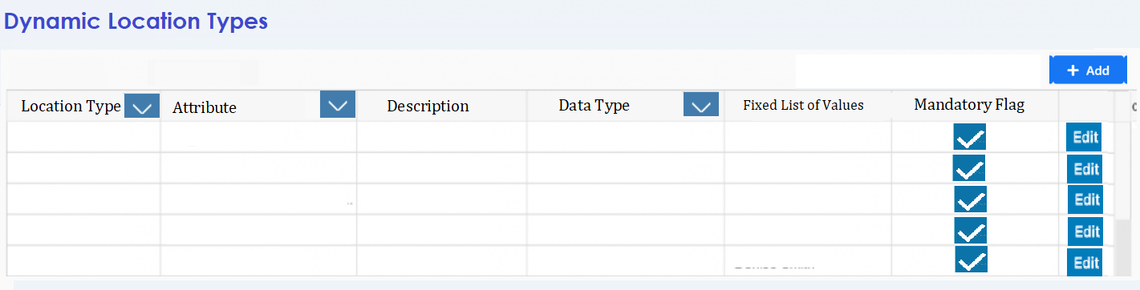

**Figure 7 - List View**

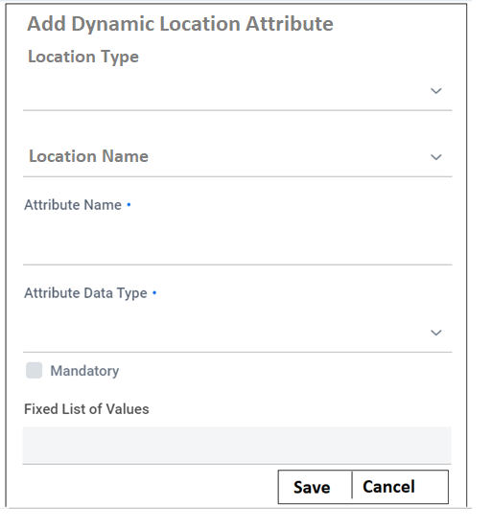

**Figure 8 - Addition Dialog**

These attributes appear dynamically in the Location creation or modification form as per the Location type selected.

# [FR-6] Reason and Sub-reason Configuration

ATS will have two master data records for Reason and Sub-reason. The sub-reasons will be dependent on reasons. So when someone selects a reason the dependent sub-reasons will be auto populated. This reason and sub-reasons will be used to capture RCA or Sub RCA for equipment data modifications.

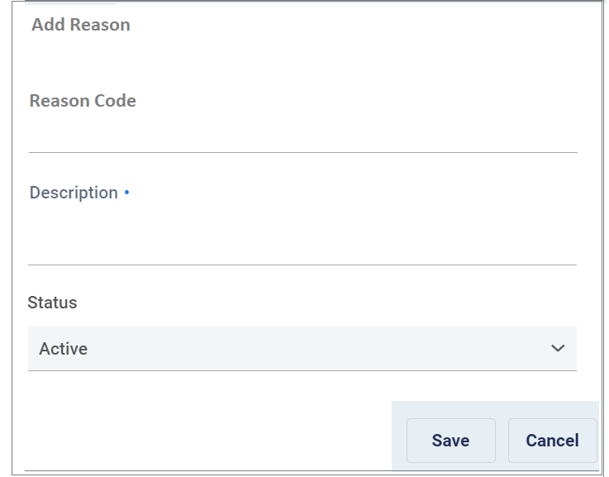

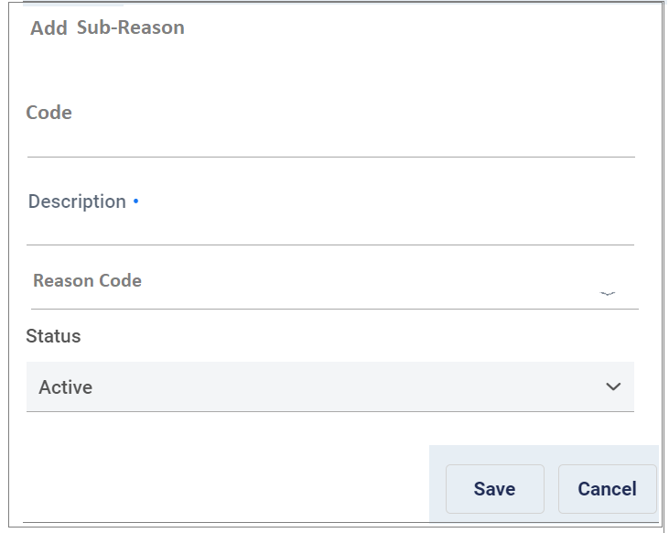

There will be a tabular list views with filtration option for all configured reasons and sub reasons. There will be option to add and update.

# [FR-7] Technician and Supervisor Mapping

Though all users and roles are maintained in user management module, ATS will maintain the relationship between technician users and supervisor users, as this mapping is specific to ATS and violates the genericity of the user management module.

A GUI will be provided where all the users having access to ATS module will be listed in a tabular list view. Option will be there to select one supervisor against each of the users. One user can be supervisor of multiple users. One user who is a supervisor for another user can have a third user as his/her supervisor. In this way it will be possible to establish a multi-level hierarchy. Circular reference in hierarchy will not be allowed.

This technician and supervisor mapping will be used for approval and reporting any deviation from SOP on part of the technician.

# Web Portal - Asset Management

Following is a high level description of the asset component as well as operations that could be performed on.

### Asset Attributes (Fixed)

All assets will have a common set of data fields or attributes irrespective of their types. They are –

* Unique Asset Id – ATS will maintain a unique id for each asset in ATS DB.
* Asset Type– Type of the asset (Dropdown List as configured)
* Manufacturer Serial No
* Asset Name
* Description
* Asset Tag Number – The current tag associated with the asset.
* Parent Asset Unique Asset Id – Asset Id of the parent asset, in case of child asset.
* Location Id – Id of the location where the asset currently is.
* Status of the Asset – Current status of the asset as per status definition.
* Last Modification Date – When the asset was modified last.
* Last Tag Scan Date – When tag was scanned last.

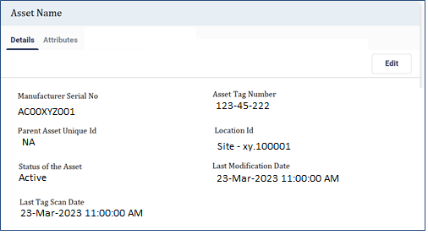

Asset wise photos need to be stored and maintained.

### Asset Attributes (Dynamic)

Other than the fixed attributes any additional data capture requirements for any type of assets will be handled via dynamic attribute configuration for that type of asset. Asset type wise attributes can be configured which will be shown in asset details screen for viewing and modification. Basic validation logic based on the data type configured will be implemented for these dynamic attributes. No additional logic will be implemented on them.

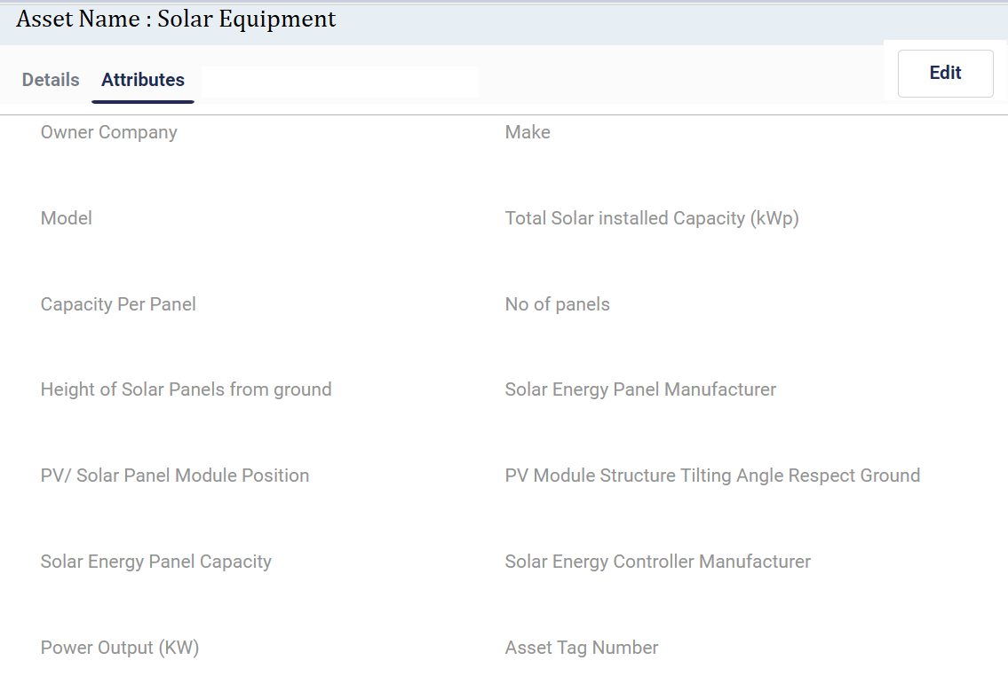

# [FR-8] Asset List View & Map View

Assets from ATS DB can be seen list-wise or can be viewed on a map based on the location of asset. Following key attributes of the assets will be listed in a tabular view on the left section of the screen. The user will select a specific asset to view the detail of the asset.

* Asset Type
* Serial Number
* Creation Date

ATS will provide the following asset data in the right section of the screen when the user selects any asset from the table listed above. This section allows users to edit any asset's details.

* Asset Details – To view and modify Fixed attributes
* Attributes - To view and modify Dynamic Attributes
* Child Assets – Lists of child assets under this asset in case it is a parent asset
* Movement History – To view date wise location history of asset.
* Tag History – To view date wise tagging history of the asset.

Images of assets taken during various processes will be visible as image carousal with date and time.

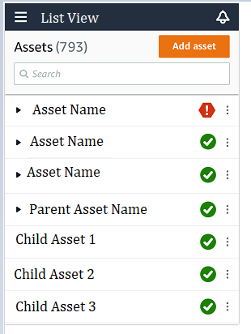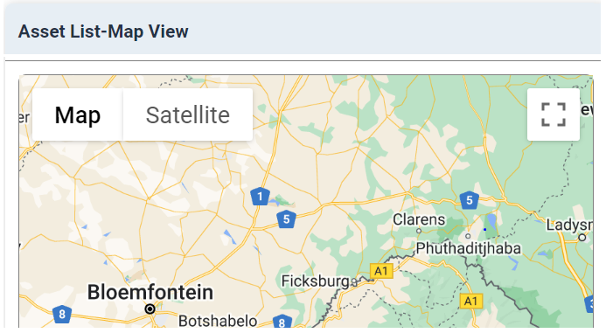

# [FR-9] Asset Search on List & Map

ATS will enable users to search any asset based on fixed and dynamic attributes values. User will be able to also mention any attribute name with value in search box to search any particular asset more precisely like below –





Additionally users may search with latitude and longitude (geo coordinates). All assets in and around (a configurable distance for the searched lat/long) that geo coordinate will be shown in the map.

Moreover, users may apply a distance based radius filter with different unit of distance (meters and KMs) in the map display to draw a circle on the map and point out which assets lay inside that radius and which are not.

# [FR-10] Asset Modification

ATS will allow editing following fixed attributes of the assets and all dynamic attributes.

* Manufacturer Serial No
* Asset Name
* Description
* Asset Tag Number

Uploading of pictures or images for the asset will also be possible.

Any modification of asset details will log events which can be viewed via Audit Trail.

# [FR-11] Child Asset View

For equipment, which belongs to an asset type which is configured as parent asset in the system, the child asset details will be visible for that equipment in a list view. All the child assets will be listed in the GUI and users may traverse to each child asset and view its details. The child asset details will open in a new tab. Both parent and child assets will have same GUI view and operations available on them.

# [FR-12] Asset Movement & View History

As and when assets are scanned in different locations throughout the asset lifecycle the locations will be maintained against the dates of the assets. This information will be used to show location wise history of the asset. This will be view only information. Following data will be shown

* Date time stamp
* Location Type
* Location Code
* Location Address
* Tech/User (who scanned the asset)

# [FR-13] Asset Tag History View

As and when assets are tagged (or retagged) throughout the asset lifecycle the previous tag numbers will be maintained against the dates of the assets. This information will be used to show date wise tagging history of the asset. This will be view only information. Following data will be shown -

* Date time stamp
* Asset Tag Number
* Tech/User (who tagged the asset)

# Web Portal - Location Management

Following is a high level description of the location component as well as operations that could be performed on.

### Location Attributes (Fixed)

All locations will have a common set of data fields or attributes irrespective of their types. They are –

* Unique Location Id – ATS will maintain a unique ID for each location.
* Location Type – Type of Location
* Name or Code – Location code or name to logically identify a location.
* Address – Address of the location
* Description
* Status of the Location – Active location or inactive
* Creation Date
* Region – Dropdown of regions
* Latitude
* Longitude
* Last Modification Date

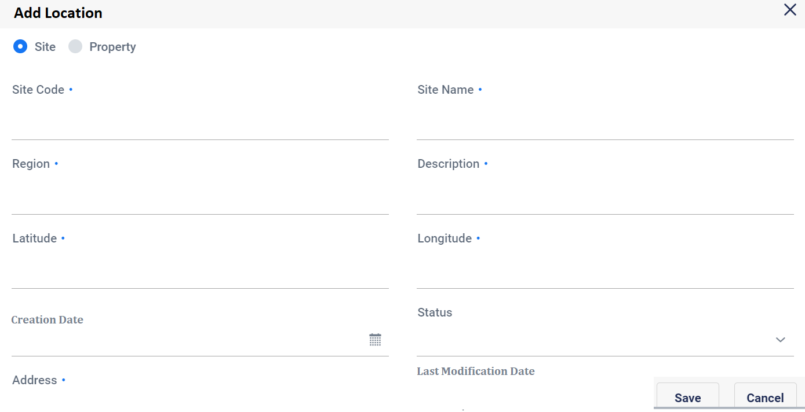

Location wise photos need to be stored and maintained.

### Location Attributes (Dynamic)

Other than the fixed attributes any additional data capture requirements for any type of locations will be handled via dynamic attribute configuration for that type of location. Location type wise attributes can be configured which will be shown in location details screen for viewing and modification. Basic validation logic based on the data type configured will be implemented for these dynamic attributes. No additional logic will be implemented on them.

### Technician - Location Mapping

Each location will have one or more technicians and supervisors mapped with it. The technician(s) / supervisors(s) mapped with the sites will be able to select and work on the sites via Mobile App.

# [FR-14] Location List View & Map View

Locations from ATS DB can be seen list-wise or can be viewed on a map based on the geocode of the location. Following key attributes of the locations will be listed in a tabular view on the left section of the screen. The user will select a specific location to view the detail.

* Location Type
* Location Code or Name
* Region
* Creation date
* Color Code - To identify tagging status of the location
  + Green – All assets are tagged
  + Orange – Number of assets tagged is more than number of assets not tagged
  + Red – Number of assets tagged is less than number of assets tagged

ATS will provide the following locations data tabs in the right section of the screen when the user selects any location from the table listed above. This section allows users to edit any location’s details.

* Location Details – To view and modify location Fixed attributes
* Location Attributes - To view and modify location dynamic attributes
* Active Assets – To view the active assets in this location as per ATS DB
* Passive Assets – To view the passive assets in this location as per ATS DB

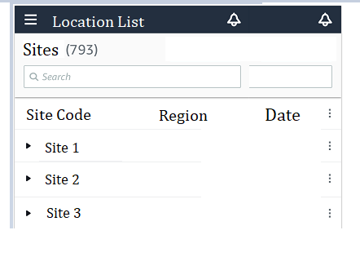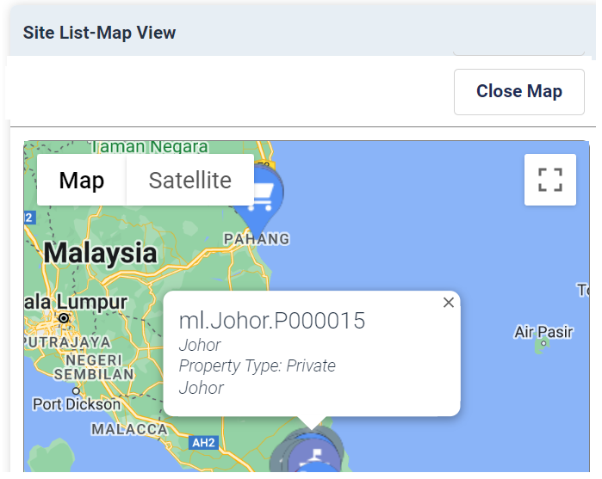

# [FR-15] Location Search on List & Map

ATS will enable users to search any location based on fixed and dynamic attributes values. User will be able to also mention any attribute name with value in search box to search any particular location more precisely.

Additionally users may search with latitude and longitude (geo coordinates). All locations in and around (a configurable distance from the searched lat/long) that geo coordinate will be shown in the map.

Moreover, users may apply a distance based radius filter with different unit of distance (meters and KMs) in the map display to draw a circle on the map and point out which locations lay inside that radius and which are not.

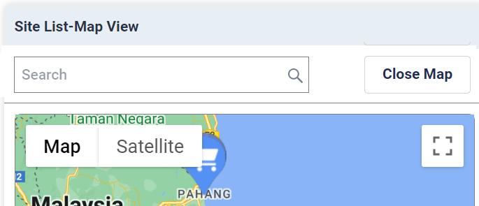

# [FR-18] Location Modification

ATS will allow editing following fixed attributes of the locations and all dynamic attributes.

* Address – Address of the location
* Description
* Status of the Location – Active location or inactive
* Region – Dropdown of regions
* Latitude
* Longitude

Uploading of pictures or images for the location will also be possible.

Any modification of location details will log events which can be viewed via Audit Trail.

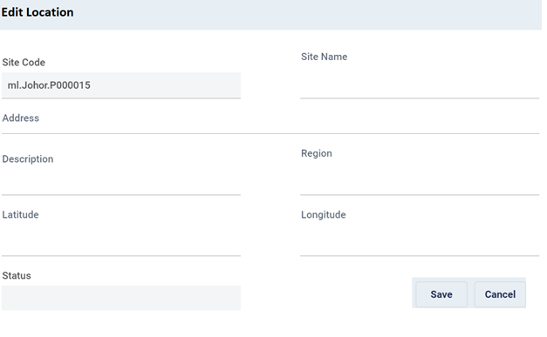

# [FR-19] Location wise Active Asset View

ATS will maintain location wise active assets. The information will be initially loaded into ATS DB from the available site asset inventory system via integration with that system. When the user selects a location all active assets for that location are retrieved and shown in tabular list view. It will be possible to traverse to the asset view for a particular asset from this screen.

# [FR-20] Location wise Passive Asset View

ATS will maintain location wise passive assets. The information will be initially loaded into ATS DB from the available FAR system via integration with that system. When the user selects a location all passive assets for that location are retrieved and shown in tabular list view. It will be possible to traverse to the asset view for a particular asset from this screen.

# [FR-21] Deactivate Location

ATS will allow changing the status of a location from view location screen. Location status can be changed from Active to Inactive or vice versa. Once a location is made inactive, technicians will not be able select that location for login to mobile app and work on it. There will be no restrictions of web portal for inactive locations.

# [FR-22] Launch Asset Audit & View Audit History

ATS will allow launching asset audit for a site location from view location screen. Once launched a task will be created and assigned to the supervisor of the technician assigned to that site. All the previous asset audit incidents for that location should be visible date wise in a tabbed view. It should be also possible to view the report for a particular asset audit incident.

# [FR-23] Technician Association

ATS will allow associating and managing technicians with locations. One or more technicians can be associated with a site. A list view of site wise technicians will be maintained. Option to add technicians will be provided. Already associated technician can also be removed from the location. This will make the location inaccessible from the mobile app for that technician.

Supervisors who need access to this location also need to be added to that location as technicians.

Initially, location wise technician data will be uploaded in ATS from O&M system via interface integration. A periodic sync process will be maintained to update the location wise technician data via the same integration interface.

# Mobile App - General Feature

ATS mobile app will be available in both iOS and Android stores for download and install. It will be a native app.

On starting the app it will ask for location and camera access which needs to be provided. Otherwise the app shall not start and shutdown. This should be a onetime approval (unless the access privilege manually removed. In that case the app will ask again for permissions). On startup, the app will also check if the location service is on, if not it will try to switch it on. If there is any problem in switching on location service, then the app should not start. Only when the location service is accessible the login prompt for the technician will appear.

In case the technician had previously logged in and the authentication is not yet expired, then the login screen will be skipped and tech will be taken directly to the site selection screen.

# [FR-24] Login & Site Selection

The Technician will login into ATS app with user credentials.

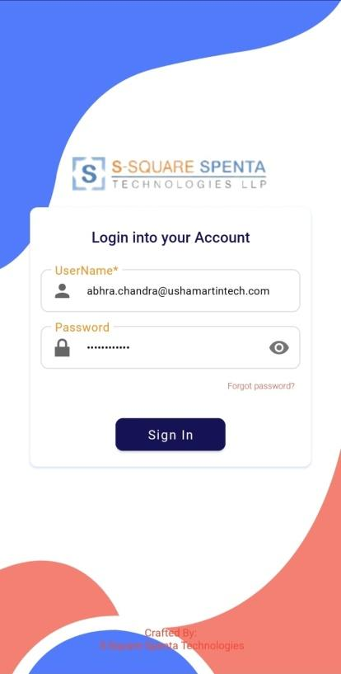

After successful authentication, the app will list all the nearby locations (within a configured distance of X meters) based on the device’s geo location and the locations which are associated with the technician. Location Type, Location Code, Location Name and address will be shown in individual cards. All type of locations (Warehouse, Site etc.) will be shown. Additionally, the locations associated with the technician but not in nearby locations will also be shown in a different color coding. There will be a quick filter option (by typing the site name).

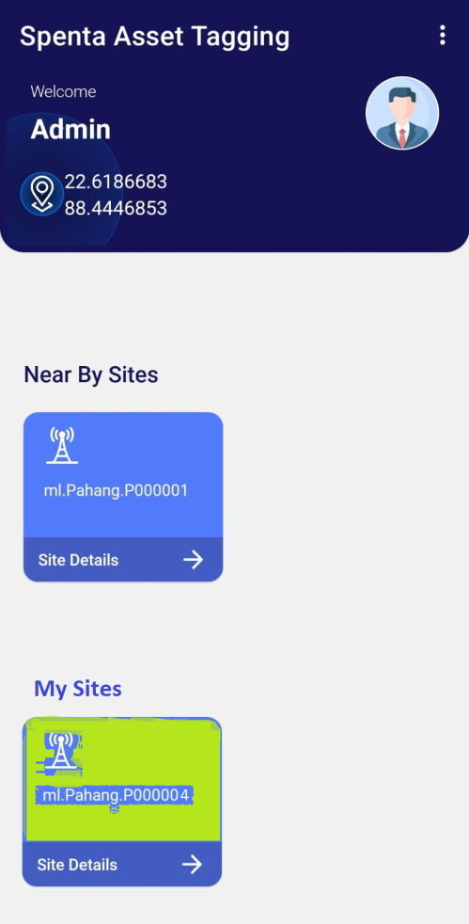

Technician needs to select one location card to enter the app and work on that location. If the technician chooses a location, which is outside of the geo location, an email will be sent to the technician supervisor.

## Location wise Asset Catalog

After log-in and site selection the app lands in the location wise asset catalog view. Following location details are shown in the screen.

* Location Type
* Location Code
* Location Name
* Address
* Color Code – To identify tagging status of the location
  + Green – All assets are tagged
  + Orange – Number of assets tagged is more than number of assets not tagged
  + Red – Number of assets tagged is less than number of assets tagged

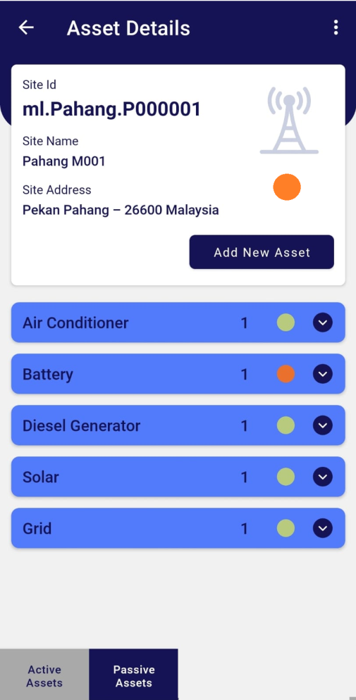

Both active and passive assets in that location are listed in the GUI in separate tabbed view. The location wise asset data is retrieved and shown from ATS DB.

Note: *Initially ATS DB will be loaded with active asset data from Site Inventory system and passive asset data from FAR.*

Assets are shown by grouping asset types. The group level header shows the asset type name and number of assets in that group. Also a color coding is present at the group level to identify the tagging status of that group.

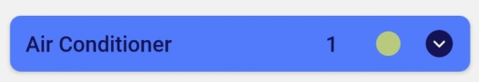

On selecting a group, the view is extended and the individual assets under that group are shown. Following details of each asset are shown in card like view –

* Asset Id (as maintained by ATS)
* Asset Type
* Manufacturer Serial No
* Tag No (if available)
* Color Code – To identify tagging status of the asset
  + Red – self not tagged
  + Orange – Self tagged but one or multiple child assets not tagged
  + Green – Self and all child assets tagged

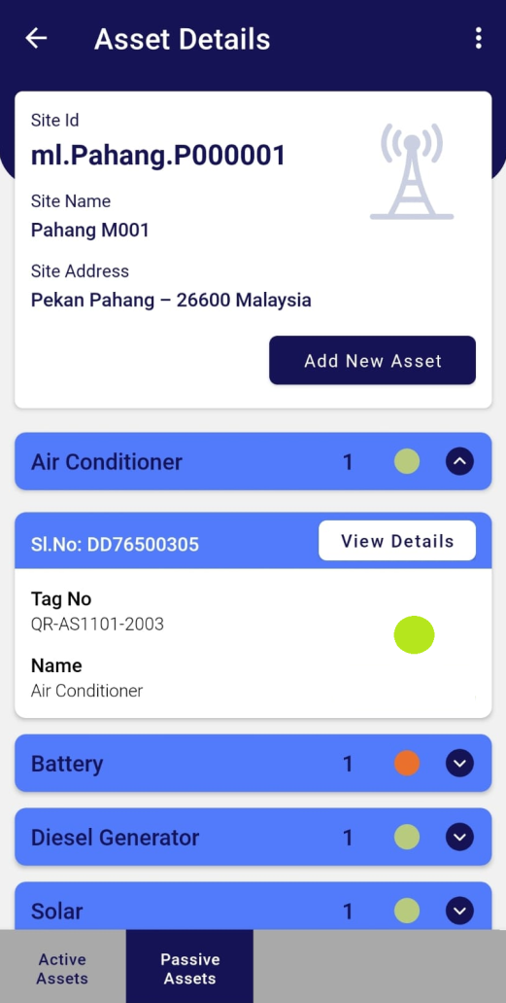

There will be option to view details of a selected asset. All the fixed and dynamic attributes are shown for that asset in non-editable form.

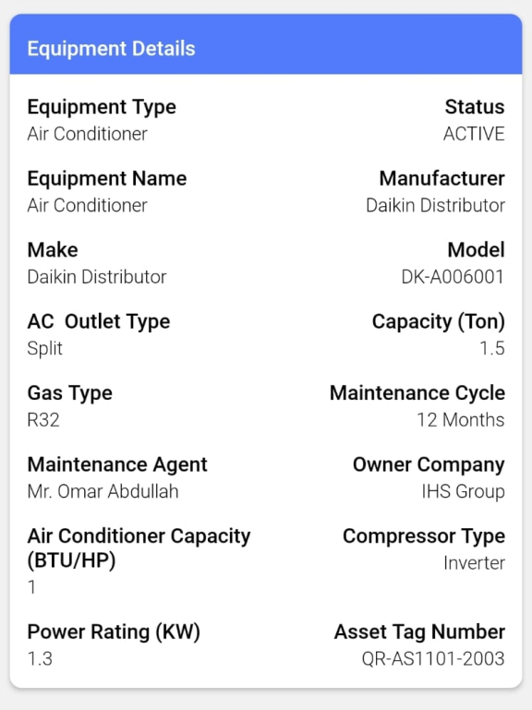

The photos of the assets are also shown in image carousal. Option will be there to take picture and upload against the asset.

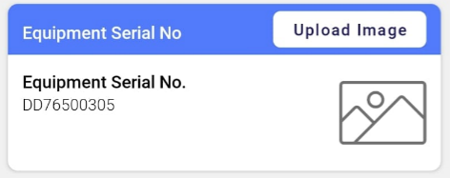

Additionally child assets with their tagging status can also be viewed. It will be possible to navigate to child asset details view. The details view of the child asset will be similar to that of the parent asset.

## Operations on Assets

There will be following operational options on the asset details view of the each asset.

* **Tag** - In case the asset is not tagged then this option will be visible in form of a button which will mark initiation of the tagging process in ATS.
* **STN** – In case the current location is of type Site and asset is of passive category then this option will be visible in form of a button which will mark initiation of the STN process in ATS.
* **SRN** - In case the current location is of type Site and asset is of passive category then this option will be visible in form of a button which will mark initiation of the tagging process in ATS.
* **Report Not Found** – For all assets this operation will be available in form of a button.

An option to “**Tag Additional Item**” will be provided at the location level. This option will be available in both Site and Warehouse locations.

Another option to “**Asset Audit**” will be provided at the location level. This option will be available in Site locations where asset audit has been launched for supervisors only.

Additionally these options can be restricted based on the technician’s role based privilege. No other operations on assets will be possible via this app.

# Asset Related Processes

# [FR-25] Tag

Technician will log into ATS and go via site selection process. Once the technician reaches the location wise asset catalogue view the tagging process can be started.

Technician will select a red color coded asset from the asset catalog or child asset view of a parent asset. If the asset is not physically present in the site, technician will be able to mark it as “Not Found”. Please check Section 7.2 Inventory FAR Mismatch Batch Process.

Otherwise technician will go to the asset details view. There the option to tag will appear in form of a button.

Technician will launch the tagging process by clicking that button. A new screen will appear. Technician needs to enter the manufacturer serial no. of the asset manually. ATS will search for with the serial no. in ATS DB. In case it is not found then the asset is marked as a candidate for Inventory – FAR mismatch which needs to be reconciled via asset capitalization (out of scope of ATS). Please check Section 7.4 Inventory FAR Mismatch Batch Process.

If found then ATS checks if the asset was previously tagged. In case it was previously tagged ATS asks for confirmation on retagging. On confirmation a QR code scanner is launched. In case the asset was never tagged the QR code scanner opens directly. Technician needs to scan the QR Code. The tag value is shown in the screen. ATS checks if the tag is associated with any other asset. In that case it throws error and again opens the scanner. Otherwise the camera app is opened so that technician can take picture of the tagged asset.

Once the picture is taken and accepted, ATS will check if the type of the asset is defined as parent asset for any other asset type. If yes, then tagging process for the child starts in the same way of entering manufacturer serial no. and continuing from there. In this way all the child assets need to be tagged and photographed. Once all the child assets are tagged and photographed ATS allows saving the tagging data along with the images in ATS DB.

To save the parent asset tagging information the technician must tag all the child assets and data is saved at one go. No partial data commit will be done.

# [FR-26] STN

When STN is generated in ERP the notification comes to ATS (via ATS – ERP integration interface) and ATS generates task for the respective technician. Technician can view the task in the mobile app and is aware of incoming equipment. When equipment is received at any site then technician will check if the asset received has already been tagged or not. If it is tagged then tech will scan the QR code to identify the equipment.

There will be an option in the mobile app at location view for performing STN in form of a button. Clicking it will open a QR Code scanner. Tech will scan the tag. If the tag value is found in the system ATS will show the asset details view for the scanned asset, otherwise throw an error. Once an asset is scanned at any location then the current location of that asset is updated to that site location.

If the asset received does not have visible tag on it, then technician will be able to enter Manufacturer serial number and search the asset and view details. Also the tagging option will be given which will be mandatory if the asset is not previously tagged.

Once the technician action is complete, the backend batch process for STN correlates the data collected and STN data to close the STN. Please check Section 7.6 STN Task Closure Batch Process.

# [FR-27] SRN

When SRN is generated in ERP the notification comes to ATS (via ATS – ERP integration interface) and ATS generates task for the respective technician. Technician can view the task in the mobile app and is aware of outgoing equipment. Technician needs to initiate the process of equipment return. There will be an option in the equipment details view in form of a button. Clicking it will open QR Code scanner. The technician needs to scan the tags of the equipment to be returned including any child equipment. Once the action is complete data is saved in ATS DB.

Once the data is saved in ATS DB, the backend batch process for SRN correlates the data collected and SRN data to close the SRN. Please check Section 7.7 SRN Task Closure Batch Process.

# [FR-28] Asset Audit

When an asset audit for a site location is launched, a task is assigned to the site supervisor. When the site supervisor logs in ATS and selects that site an option for auditing asset is presented to him in the asset catalogue view screen. Clicking the “Asset Audit” button opens a view similar to tower catalog containing all the assets present in that site. Only difference is all the assets are color coded as RED irrespective of their tagging status.

The supervisor needs to select red colored equipment one by one and it will present a QR code scanning option. If the scanned tag matches with the selected asset tag (as per ATS DB) then the color coding of that selected asset is changed to Green (or orange for parent asset which has yet to be audited children). The supervisor needs to select all the red color assets and turn them into green including child assets. There will be option to mark any asset as “not found” or “tag not visible” which will change the color code to grey for that asset. Once finished, the supervisor can submit the repot. If there is any red or orange item, then ATS will not allow submitting the report.

Once the report is submitted, the backend batch process for Asset Audit correlates the data collected and closes the task. Please check Section 7.8 Asset Audit Batch Process.

# [FR-29] Technician Task List

A read only task list view will be provided in the mobile app for technicians. It should be accessible from the site selection screen (after login). All STNs and SRNs and Asset Audit tasks assigned to the technician via backend batch processes will be appearing in this list. Technician can view the task list and select task to view the detail of the task (Site details and Asset details associated with the task).

There will be no actionable item on the tasks. These tasks will be view only.

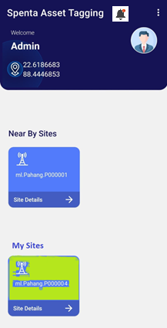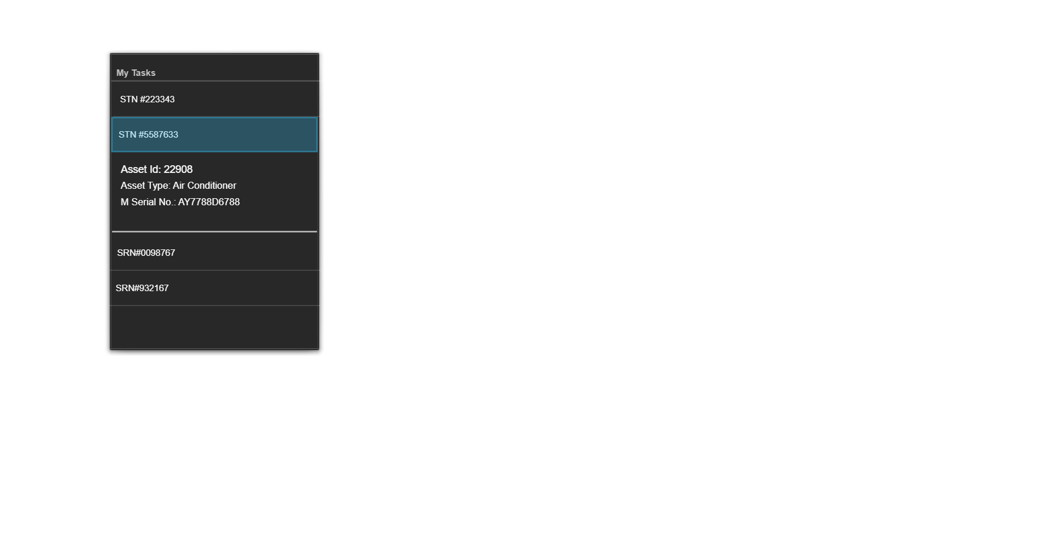

# Batch Processes

Following batch processes will be provided. These processes run automatically and periodically in back end and monitor the asset information coming into ATS DB and generate task list or action items based on them.

## [FR-30]Fully Tagged Site Identification Batch Process

This batch process identifies sites which have all the assets tagged but not yet declared as Green site or waiting for approval. It prepares a list of those sites and pushes to a queue of such sites pending for approval. This queue is displayed in the web portal as a report view. Users can approve or reject the request. If approved the site status is changed to Green. If rejected the site status remains same.

## [FR-31]Not Found Asset Batch Process

This batch process identifies assets which are reported as not found. These are candidates for probable mismatch between reality and FAR data. It also check of the asset is reported as additional item in any other location. It prepares a list of this type of assets and pushes into a queue of such assets requiring attention. This queue is displayed in the web portal as a report view. Users can approve or reject the data. Also user can generate report from the data. Users can take further actions like correction of master config or send the material to site based on approved list (Both of these actions are out of scope of the ATS). If rejected the asset remains in the ATS DB as associated with the location and removed from this queue. The onus again goes to the technician who must find it and tag it.

## [FR-32]Additional Item Asset Batch Process

This batch process identifies assets which are reported as additional items. These are candidates for probable mismatch between reality and FAR data. It also check of the asset is reported as not found in any other location. It prepares a list of this type of assets and pushes into a queue of such assets requiring attention. This queue is displayed in the web portal as a report view. Users can approve or reject the data. Also user can generate report from the data. Users can take further actions like correction of master config or take the material back from site based on approved list (Both of these actions are out of scope of the ATS). In case it is approved the asset is made part of the site configuration and the additional item tag is removed and sent for FAR update. If rejected the asset is removed from the ATS DB and association with the location is also removed.

## [FR-33]Inventory FAR Mismatch Batch Process

This batch process identifies assets which were not found on Manufacturer Serial No based search during asset tagging process. These are candidates for probable mismatch between Inventory and FAR data. Most probably the capitalization process is due for these assets. It prepares a list of this type of assets and pushes into a queue of such assets requiring attention. This queue is displayed in the web portal as a report view. Users can approve or reject the data. Also user can generate report from the data. Users can take further actions like asset capitalization (out of scope of the ATS). If rejected the asset is removed from the ATS DB and association with the location is also removed.

## [FR-34]STN and SRN Task Creation Batch Process

The ATS - ERP integration interface will receive all STNs and SRNs generated from ERP and that information will be dumped in ATS DB. This batch process will run on those STN and SRNs received from ERP and create tasks for the corresponding technicians. For STNs – Accept Material task will be created. For SRNs – Release Material task will be created. These tasks will be pushed to respective technicians task list/bin. These lists will be visible from ATS mobile app.

## [FR-35]STN Task Closure Batch Process

This batch process identifies assets which have open STNs against them and which are scanned or tagged at any site location. It prepares a list of those assets and push to a queue of such assets. This queue is displayed in the web portal as a report view. Users can approve or reject the data. Also user can generate report from the data. Once approved the STN task gets closed in ATS and removed from the technician’s bin and the asset is associated with the site location and sent for FAR update. If rejected the STN is not closed and remains in the technician’s bin. The onus is on technician to receive and scan the correct equipment.

## [FR-36]SRN Task Closure Batch Process

This batch process identifies assets which have open SRNs against them and which are scanned or tagged at any site location. It prepares a list of those assets and push to a queue of such assets. This queue is displayed in the web portal as a report view. Users can approve or reject the data. Also user can generate report from the data. Once approved the STN task gets closed in ATS and removed from the technician’s bin and the asset is removed from the site location and sent for FAR update. If rejected the STN is not closed and remains in the technician’s bin. The onus is on technician to rescan the correct equipment.

## [FR-37]Asset Audit Batch Process

This batch process identifies asset audit reports submitted for which there is open Asset Audit task against them. It automatically closes the task. Then it checks if there is any missing equipment reported in audit or if there is any “tag not visible” reported. It prepares a list of these equipment and push to a queue. This queue is displayed in the web portal as a report view. Users can view the assets reported as not found or tag not visible. User can approve or reject the data. Also user can generate report from the data.

In case the tag not visible record is approved then the current tag information is removed from the equipment, so that the equipment become a red color coded in ATS app and the technician can re-tag the asset. For the asset not found case it needs to be investigated by the user and corrective action needs to be taken, i.e. like correction of master config or send the material to site based (not in ATS scope).

## [FR-38]ERP FAR Update Batch Process

This batch process identifies assets which have been approved for following scenarios –

* modifications or
* STNs or
* SRNs or
* additional items found on site or
* asset lost cases

It prepares a list of such assets and push to a queue for ERP FAR update. The ATS - ERP FAR integration interface picks up data from this queue and process them to update ERP FAR.

# System Configurations

* **Asset Configuration** - Following system level configuration will be provided for asset management
  + Dynamic asset type configuration (both of Active and Passive types)
  + Dynamic asset attribute configuration for each type of assets
  + Dynamic parent – child relationship configuration between asset types supporting one to many relationships between parent and children.
* **Location Configuration** - Following system level configuration will be provided for location management
  + Dynamic Location Type configuration (Warehouse, Sites, Repair Centers) both physical
  + Dynamic attributes for each type of locations
  + Location wise asset status configuration (Active, Inactive, Available, Sent for Repair etc.)

# Other System Requirements/ Non-Functional Requirements

* Availability of APIs for all user operations
* Availability of detailed log files for all operations
* Search, filtration, sort and Pagination on all tabular views and lists
* System should never allow to upload images from gallery where technicians are supposed to take live picture of the asset
* There should be traversable links on all reference to the main entities of the system (Assets and Locations). For example if in a GUI view assets details is being shown and it is showing location of that asset, then that location should be navigable, meaning clicking on the location will take the user to the location view GUI.
* System should support easy steps for White labeling of the product. Company logo and UI color scheme.

# Audit Trail (Not considered in Phase I)

System will capture all types of events which can show who did, what activity happened and when. The administrator will examine all types of change logs to get a complete picture of normal and abnormal events on the ATS system.

* + - The following fields will be captured for each event performed by a User

| **Field Name** | **Details** |
| --- | --- |
| Event id | UUID |
| Event Name | What action performed |
| Modified By | Who performed |
| Modified On | When performed |
| Reason Code | Event Code |
| Reason/ Sub-reason Description | Event details if any |
| Attribute Name Value Pair | A list of attribute name value pairs for attributes which were changed |

# Reporting Requirements (Not considered in Phase I)

The following reports will be available in ATS web portal. Users will be able to view them based on privilege. The data reports will be in screen. Appropriate search & filtration conditions will be available. There will be options to take appropriate actions approve/reject/provide comment on the data retrieved. Also it will be possible to download the data in excel or PDF format as report.

* List of Fully tagged Sites for Approval
* List of assets presents in Site physically but not as per FAR
* List of assets NOT present in Site physically but present as per FAR
* List of assets NOT present in ATS but scanned (Inventory /FAR mismatch)
* List of assets for STN approval
* List of assets for SRN approval
* List of assets for asset audit approval

# Integration Requirements (Not considered in Phase I)

* To be integrated with User management module of SSTL product platform for user authentication and user roles and privileges
* To be integrated with Workflow and Ticketing module of SSTL product platform for ticket generation and execution
* Email gateway integration
* Location service for geo location
* Google Location API will be used and it may require additional cost based on usage pattern
* Should be able to support file based integration with ERP FAR, Active Asset Inventory and Billing system integration (downstream). Actual integrations implementation will be scoped during project implementation phase. Following are broad level integration to be supported
  + O&M System – For loading of site locations & corresponding technician mapping
  + ERP FAR – Loading of one time ATS data
  + Site Asset Inventory – Loading of active assets
  + Billing – Push active assets data

# Data Migration Requirements

One time data migration activity will be performed from telecom operator ERP/site inventory system to ATS system. This is required to map the technician’s data with various sites. Actual data migration requirements will be scoped during project implementation phase.

# Assumptions

* QR Code will contain one line of alphanumeric characters to be used as tag value.
* ATS will support both Active and Passive assets
* For ATS implementation ERP in the software landscape of the TowerCo is a pre-requisite
* There will be no option to retag an asset if tag information is available in ATS DB.
* STN and SRN is not applicable on active assets
* Tagging is applicable on both active and passive assets
* All images / pictures of UI screens given in this document are for reference only. The actual UI/UX design may vary.
* As user management integration is not considered in Phase I, there will be no authentication feature in the ATS mobile app in Phase I. Dummy login screen will be provided. Any combination of user and password will be accepted and there will not be any access control mechanism in Phase I.

# Open Items

* May one STN or SRN involve multiple equipment? Or each equipment will have it’s own SRN / STN?

# Out of Scope

* SMS Gateway integration is out of scope and will be scoped during project implementation.
* QR Code Tag generation and printing is not considered
* Asset Tracking via RFID is not considered