

Spenta Asset Tagging & Tracking System (SATS)

**Version 1.0**

18th Jul 2023

# Disclaimer

Information in this document is subject to change without notice. The software described in this document is furnished under a license agreement or nondisclosure agreement. The software may be used for copying, only in accordance with the terms of those agreements. No part of this document may be reproduced, stored in a retrieval system, or transmitted in any form or any means electronic or mechanical, including photocopying and recording for any purpose other than the purchaser’s personal use without the written permission of Eppix eSolution Limited.

All trademarks used herein are properties of their respective owners.

Table of Contents

Disclaimer 2

Document Release History 6

Circulation Details 7

Reference Documents 7

List of Amendments 8

Glossary 9

1. Introduction 10

2. Scope of the System 10

3. Solution Overview 10

4. System Actors or Stake holders 10

5. Dependencies and Change Impacts 11

5.1. System Entities 11

6. Web Portal 12

6.1. Web Portal - Configuration Management 12

6.1.1. Asset Type Configuration 12

6.1.2 Technician and Supervisor Mapping 13

6.3.1 Login 14

6.3.2 Forgot password 14

6.3.3 Technician to Site Tagging Status 15

6.3.3 Operator Site View 16

6.3.4 Site Asset View 17

6.3.5 Asset History 18

6.4.1 Dynamic Asset Attribute Configuration 19

6.4.2 Location Type Configuration 21

6.4.3 Dynamic Location Attribute Configuration 21

6.4.4 Reason and Sub-reason Configuration 23

6.5 Change Password 25

7.1 Mobile App - General Feature 25

7.1.1 Login & Site Selection 26

7.2 Site wise Asset Catalog 28

7.3 Operations on Assets 32

7.4 Asset Related Processes 33

7.4.1 [FR-25] Tag 33

7.4.2 [FR-26] STN 33

7.4.3 [FR-27] SRN 34

7.4.4 [FR-28] Asset Audit 35

7.4.5 [FR-29] Technician Task List 36

7.3. Approval Process 37

8 Batch Processes 39

8.1 [FR-30] ERP FAR Update Batch Process 39

8.2 [FR-31] STN and SRN Task Creation Batch Process 39

8.3 [FR-32] STN and SRN Task Closure Batch Process 39

8.4 [FR-33] Additional Item Asset Batch Process 40

8.5 [FR-34] Inventory FAR Mismatch Batch Process 40

8.6 [FR-37] Asset Audit Batch Process 40

9 System Configurations 40

10 Other System Requirements/ Non-Functional Requirements 40

10.1 Audit Trail 41

10.2 Server Sizing 41

10.3 Technology Stack 41

10.4 Performance Parameter: Response Time 42

10.5 System Security 42

11 Integration Requirements 42

12 Data Migration Requirements 42

13 Assumptions 43

14 Open Items 43

15 Out of Scope 43

# Document Release History

| Sl# | Ver. No. | Release Date | Prepared By | Reviewed By | Approved By | Reasons for New Release |
| --- | --- | --- | --- | --- | --- | --- |
| 1 | 1.0 | 18-Jul-2023 | UMT | UMT | SSTL | Initial High level design document |
| 2 | 2.0 | 15-Sep-2023 | UMT | UMT |  | Technical specs added in sections 10.2 to 10.5 |

# Circulation Details

| Copy No. | Designation of Copy Holder | Location of the Copy |
| --- | --- | --- |
| 1 | Eppix Management | Soft Copy in SVN |
| 2 | SSTL Management | Soft Copy via Email |

# Reference Documents

| Serial# | Document Name | Provided By |
| --- | --- | --- |
| 1 |  |  |
|  |  |  |

# List of Amendments

| Sl# | Ver. # | Section No. /Page No. | Description of the amendment | Raised by | Response | Updated By | Approved by |
| --- | --- | --- | --- | --- | --- | --- | --- |
| 1 |  |  |  |  |  |  |  |
|  |  |  |  |  |  |  |  |

# Glossary

| **Acronym** | **Detail** |
| --- | --- |
| SATS | Spenta Asset Tagging and Tracking System |
| GBT | Ground Based Tower |
| RTT | Roof Top Tower |
| RTP | Roof Top Pole |
| IBS | In-Building Solution |
| WFE | Workflow Orchestration Engine |
| PM | Process Maker |
| RFAI | Ready For Active Installation |
| OpCo | Operator Company / Customer |
| TowerCo | Tower Company |
| HLD | High Level Design |
| FAR | Fixed Asset Register |
| SCM | Supply Chain Management |
| O&M | Operation & Maintenance |
|  |  |

# Introduction

This High-Level Design document details out the various features mutually agreed with SSTL and as per the agreed screen designs. This document will be referred for development and for all future purposes.

# Scope of the System

The proposed Asset Tagging and Tracking system (to be referred as SATS) is an application integrated into SSTL product platform. Purpose of the system is to maintain updated tower asset catalog by integrating with FAR (Fixed Asset Register) and enabling technicians to tag and scan assets in a guided process oriented mechanism and in the process keeping FAR updated and sync with real time data. The scope of the system is:

* To define and manage different type of active and passive assets
* To define and manage different type of locations (i.e. warehouses, sites etc.)
* Capabilities to integrate with FAR (for Passive assets), Asset Inventory (for Active assets) to keep data in sync with all the systems based on the reality on the ground.
* Capabilities to maintain parent-child hierarchy of assets, i.e., battery bank and battery cell.
* To support asset involved processes like Asset Tagging and Addition, STN, SRN and Asset Audit
* To support workflow (Process Maker community version) ticket-based approval processes for asset change requests

# Solution Overview

SATS will be delivered consisting of below integrated software components connected seamlessly:

* A desktop web application/portal for system administrators to configure the system such as site and asset types along with their respective attributes and datatypes. It would have the option to view Active and Passive assets: Site-wise, Operator-wise & Technician-wise. It would also support different reports to be mutually agreed upon and defined later.
* A flutter mobile app (Android and iOS) for technicians and supervisors for carrying out various field activities for site’s assets required for asset tracking & tagging purposes.
* All sorts of approval processes will be supported through Process Maker as has been detailed out in relevant subsection.

# System Actors or Stake holders

Following are the identified stakeholder groups / users in the system:

| User/Role | Example | Frequency of Use | Security/Access, Features Used | Additional Notes |
| --- | --- | --- | --- | --- |
| Administrator |  | Frequent | System Configuration, Asset Type and Location Management |  |
| Technician | Persons who manage sites and towers | Most Frequent | Asset related process features, i.e. tagging, scanning etc. |  |
| Supervisor | Supervisors of technicians | Most Frequent | All Technician features plus Tickets handling and approval | Supervisor are also technicians with additional privileges |
| Corporate |  | Frequent | Monitor assets and locations, approvals and tickets, Execute & View Reports etc. |  |

# Dependencies and Change Impacts

SATS module will have dependencies on:

* User Management module of SSTL platform for user authentication and role-based feature access/restriction –
  + SATS needs to publish the list of functionalities on which access privileges can be configured into User Management module.
  + Roles need to be created in User Management module for Technician & Supervisor using those access privileges.
* Process Maker module (Workflow Engine) for all sorts of approval workflows.
* Reports Module of SSTL platform for all sorts of data reporting requirement based out of data stored in SATS.

# System Entities

Following are the main system entities for this SATS module.

* **Assets** – Assets are the equipment or devices or any physical tangible item involved in the scope of tower / site management
  + **Active Assets –** Assets or equipment owned by Telecom Operators (OpCo). These are mainly equipment for telecommunication. Active assets are installed and maintained by OpCos.
  + **Passive Assets –** Assets or equipment owned by the TowerCo. These are equipment installed at site and provide support for the Active Assets. These are mainly power sources, backup power, air conditioning or cooling devices etc.
* **Locations** – Locations are the physical places on earth where an asset can be placed or retrieved from. Examples of locations are Sites, Warehouses, Repair centers, vendor locations, offices etc. Assets have many to one relationship with locations, i.e. one location can have multiple assets but one asset will be placed in one location in any particular time. All locations are identified by unique geo coordinates (latitude/longitude).

# Web Portal

SATS web portal will have only display data with filters for the active and passive assets based on location/supervisors/operators. A suppervisor can only see the data of the site’s data he has access.

# Web Portal - Configuration Management

SATS product will allow all configuration management to be done from the web portal.

# Asset Type Configuration

SATS will allow configuring asset types dynamically for both Active and Passive assets.

There will be a tabular list view with filtration option for all configured asset types. There will be option to add new asset types and edit existing one. There will not be any delete option.

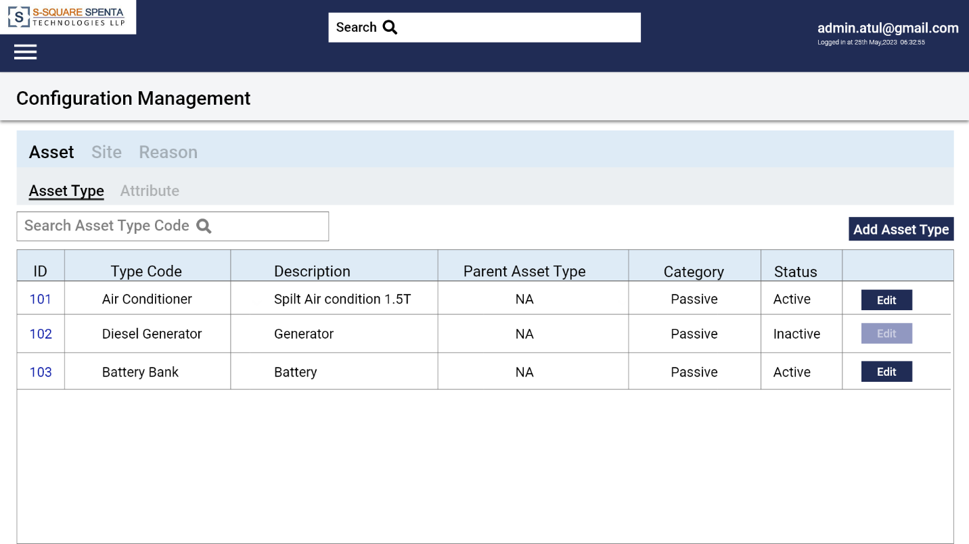

**Figure 1 – Asset Type List View**

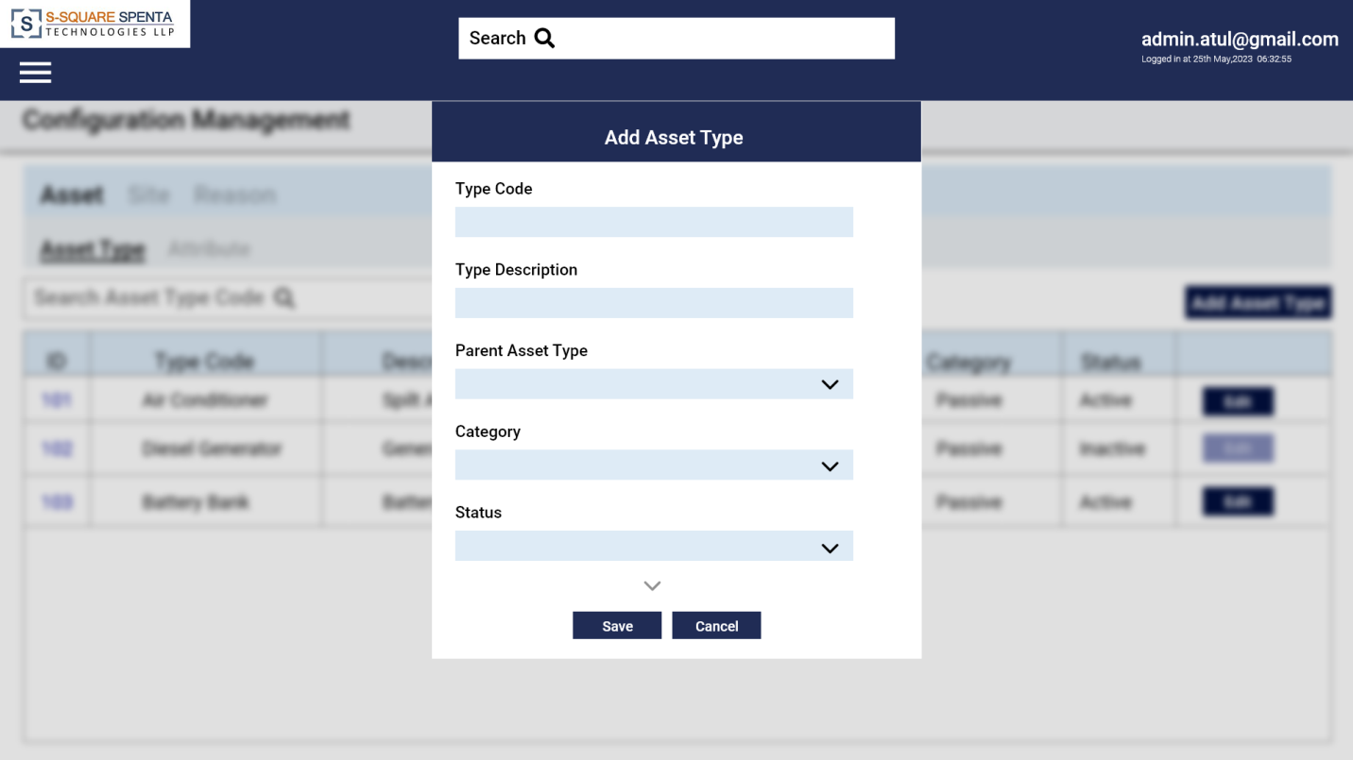

**Figure 2 – Add Asset Type**

**Parent Child Relationship**

Parent child relationship can be established between two types of individual assets. For example Diesel Generator and Alternator can be two separate asset types and Alternator may have Diesel Generator set as it’s parent. The parent child relationship is for one level only.

Defining child asset type for an asset makes child asset view and tagging enabled and mandatory for that type of asset.

# 6.1.2 Technician and Supervisor Mapping

Though all users and roles are maintained in user management module, SATS will maintain the relationship between technician users and supervisor users, as this mapping is specific to SATS.

A GUI will be provided where all the users having access to SATS module will be listed in a tabular list view. Option will be there to select one supervisor against each of the users. One user can be supervisor of multiple users.

This technician and supervisor mapping will be used for approval process and listing of data in web portal.

# Login

Only supervisiors/Administrator can login to the web portal using userid and password. The userid will be the email id of the user. The technicians have no access to the web portal. The SSTL logo and client logo with copyright text will appear in the login screen.

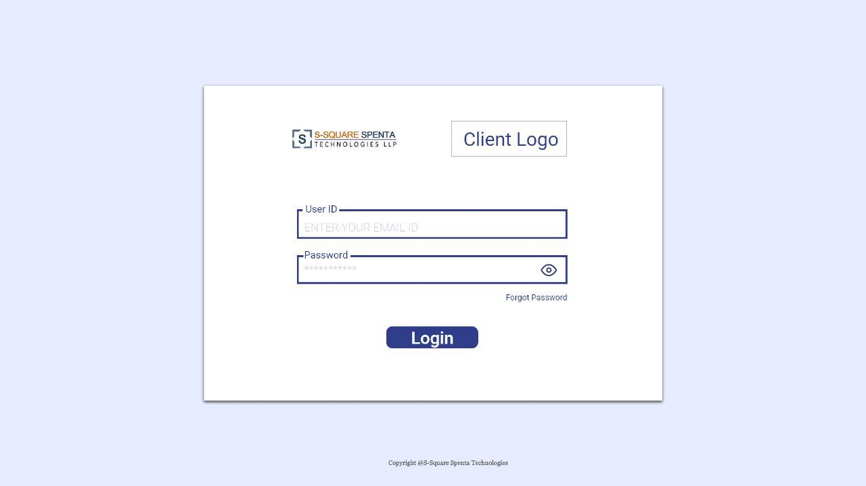

**Figure 3 –Login screen**

# Forgot password

SATS will allow the user to reset password in case the user forget his/her password. All fields except User Id and get OTP will be disabled. On clicking the Get OTP button the user will get the OTP on his email which is the User Id for that user and the verify OTP button with OTP input box will be enabled. After entering the OTP and clicking the Verify OTP button the OTP will be verified and new password and confirm password input box will be activated. After entering the new password and confirm password on clicking the submit button it will match the new Password and confirm password. If its matches password will be updated.

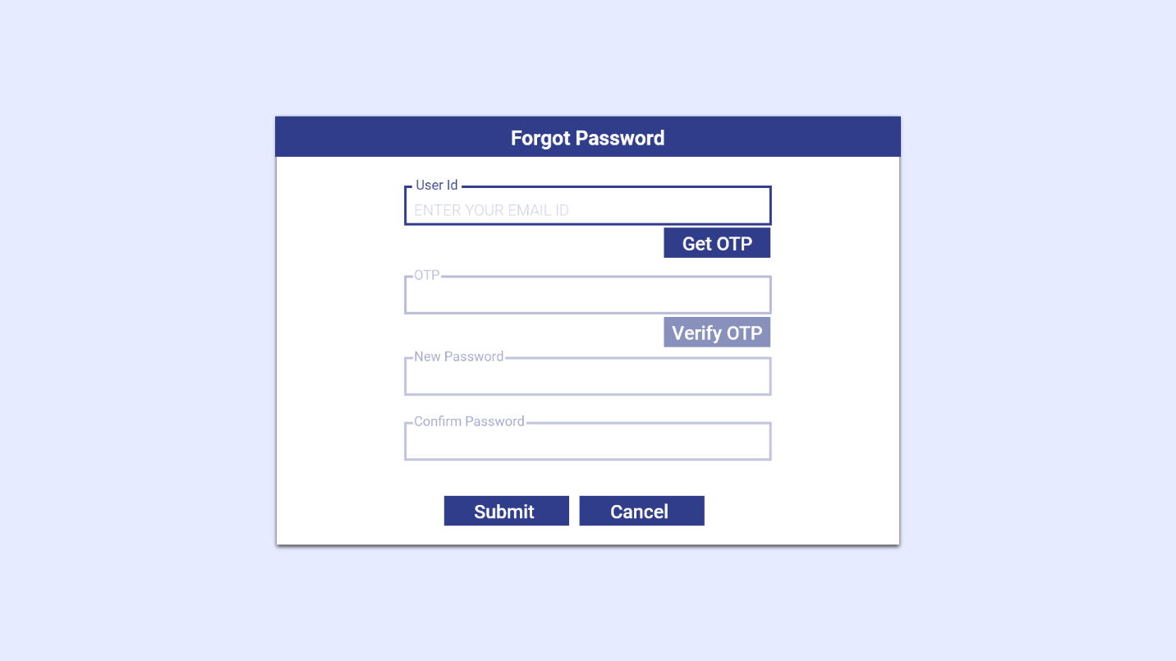

**Figure 4–Forgot password screen**

# 6.3.3 Technician to Site Tagging Status

SATS will allow the Supervisor to see the list of technicians assigned to him. On clicking any user id it will show the list of sites assigned to that technician with color code of tagging (Red/Green/Amber). Clicking on any site will show the listing of all active and passive assets in two different tabs. All the assets will contain the color codes of tagging (Red/Green/Amber)

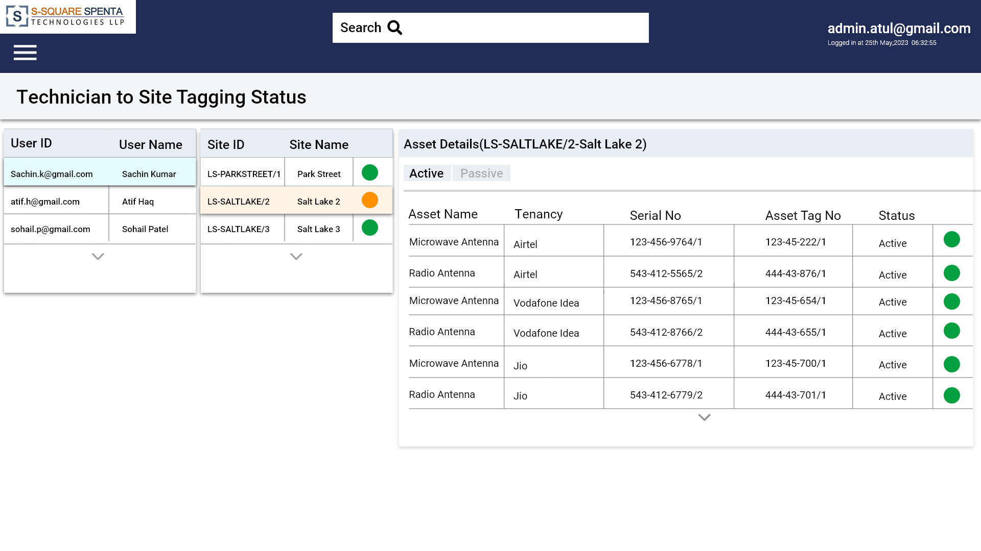

**Figure 5– Technician to Site Tagging Status screen**

# 6.3.3 Operator Site View

SATS will allow the supervisor to see the list of operators. Clicking on the operator list of sites will be displayed with site id and site name. Clicking on any site will list all the active assets with tagging status on that site installed by that operator and all passive assets.

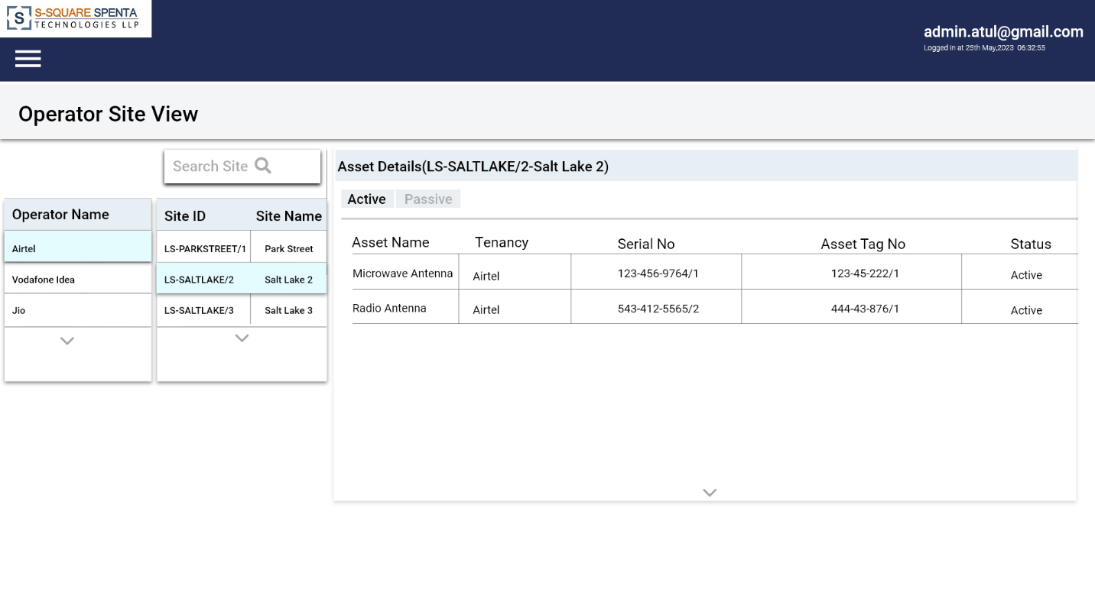

**Figure 10 – Operator Site View screen**

# 6.3.4 Site Asset View

SATS will allow the supervisor will able to list all sites with Site ID, Site name, Region, filters can be applied to Site ID, Site name, Region fields. Tagging status using color code will also displayed. Clicking on any site displays the details in three tabs (Details, Attributes, Assets). The details tab will display the location details. The attribute tab will show all the dynamic attributes for that location and the asset tab will display the active and passive assets in two tabs. There will be a map view so that filters can be added.

#### 

**Figure 11 – Site Asset View screen**

# 6.3.5 Asset History

SATS will allow the supervisor to search an asset with serial number and able to view the history of the asset present in the sites with Move in date and Move out Date.

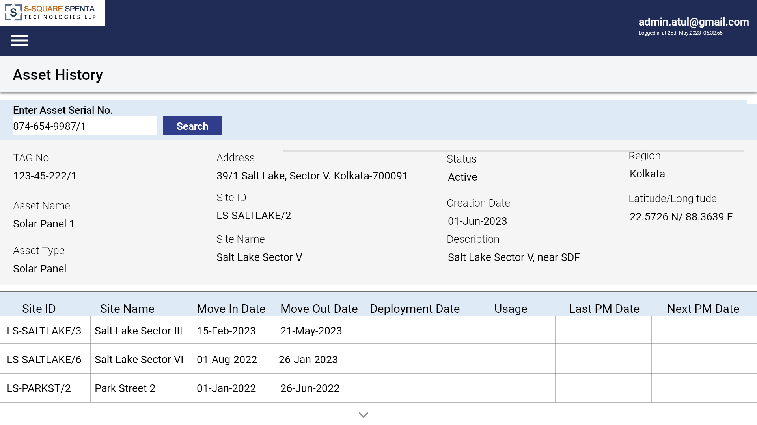**Figure 12 – Asset History screen**

**6.4 Configuration Management**

SATS will allow all configuration management to be done from the web portal by administrator.

# 6.4.1 Dynamic Asset Attribute Configuration

Each type of asset will have some fixed data fields defined in the system; those are common to all assets irrespective of the type.

System should allow configuring asset type specific data fields as asset type attributes. Each asset type attribute will have following attributes –

* Unique Id
* Unique Attribute Name or Code
* Attribute Description
* Data Type (Numeric, Alphanumeric, Free-flow, Fist List of values, Date)
* Mandatory Flag
* Default Value
* Status

These attributes appear dynamically in the asset creation or modification form as per the asset type selected.

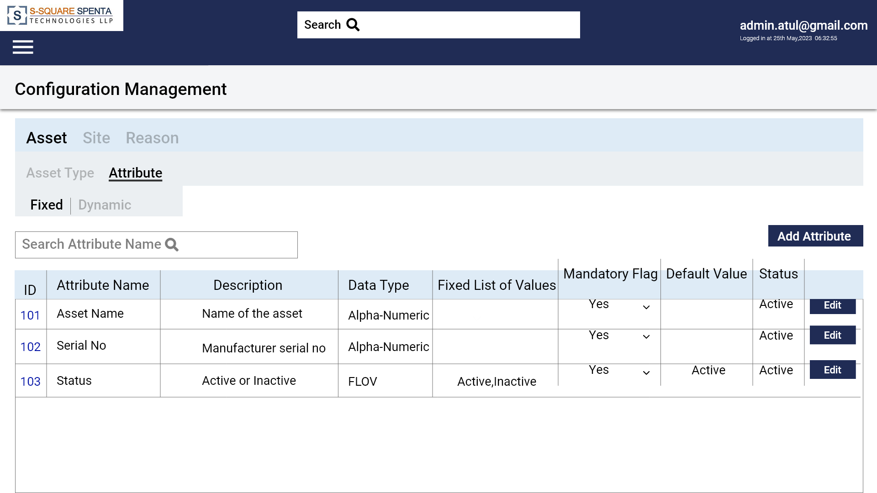

**Figure 13 – Fixed attribute List View**

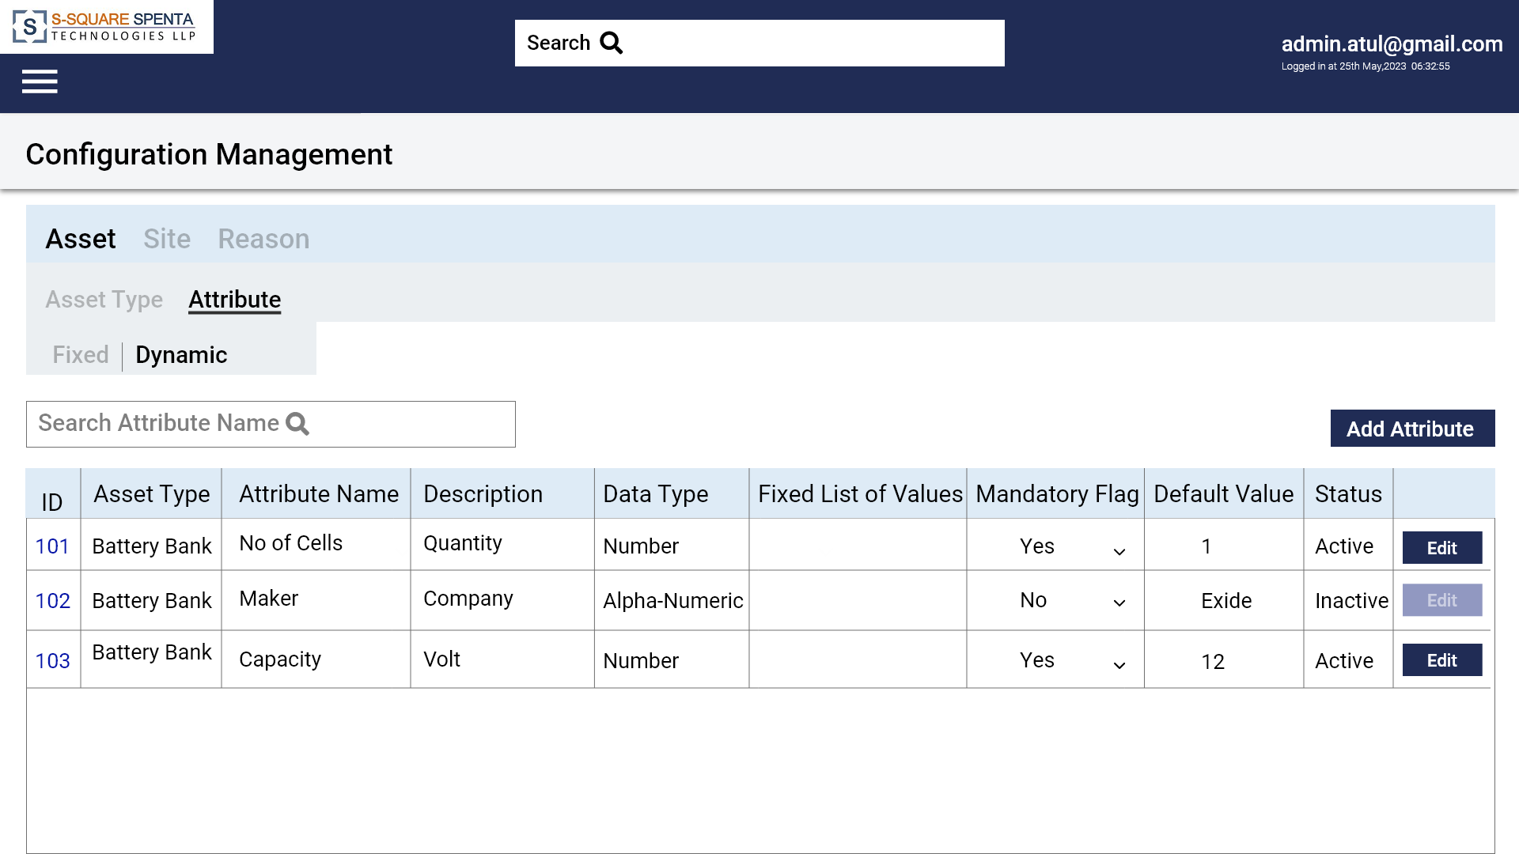

**Figure 14 – Dynamic attribute List View**

# Location Type Configuration

SATS will allow configuring any location type with the following attributes.

* Unique Id
* Location Type (Warehouses, Sites, Repair centers, vendor locations, offices etc.)
* Name
* Status

There will be a tabular list view with filtration option for all configured location types. There will be option to add and edit. There will not be any delete option.

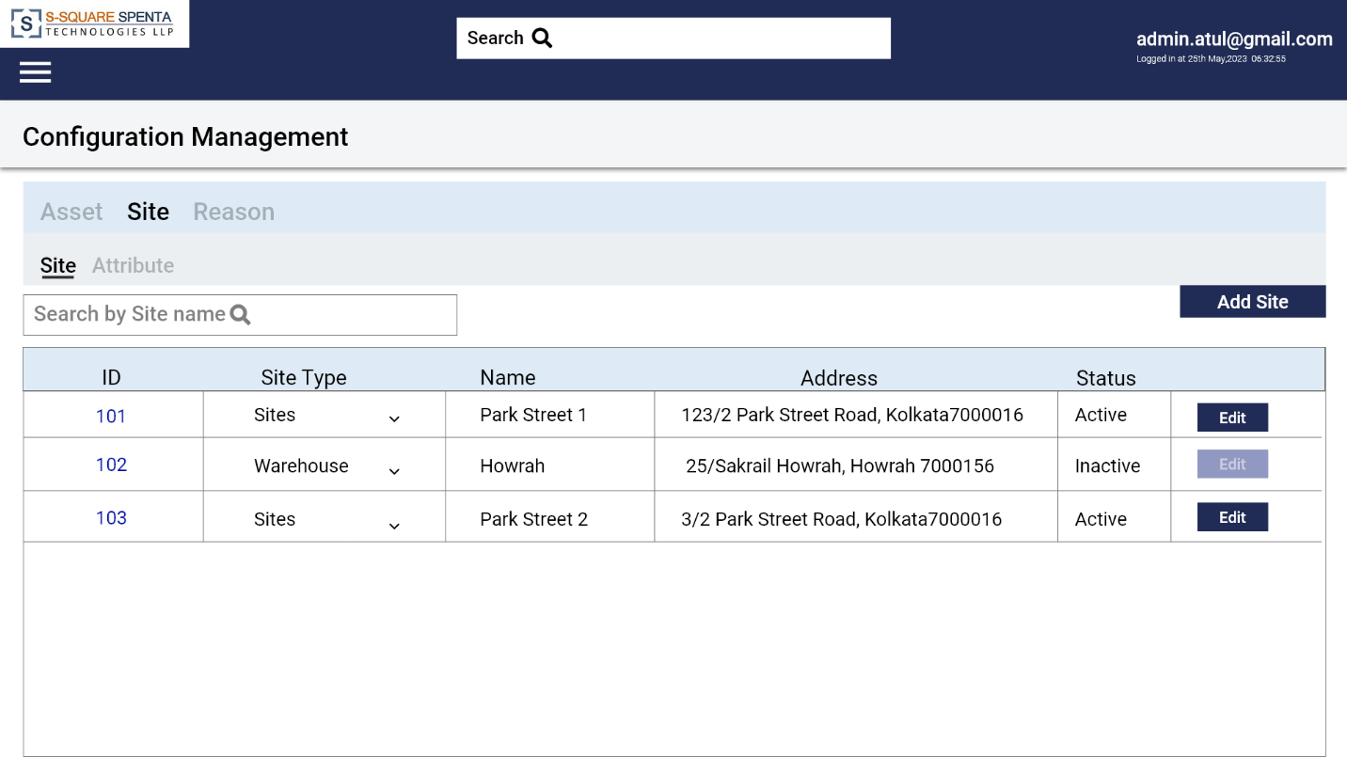

**Figure 15 – Location type List View**

By default two location types (Site and Warehouse) will be pre-configured in the system.

# Dynamic Location Attribute Configuration

SATS will allow configuring Location type specific data fields as Location attributes. Each Location attribute will have following data fields –

* Unique Id
* Location Type – For which type of location this attribute is applicable
* Attribute Name – Name of the attribute
* Description
* Data Type (Numeric, Alphanumeric, Free-flow, Choice, Date)
* Mandatory Flag
* Default Value

There will be a tabular list view with filtration option for all configured location attributes. There will be option to add and edit. There will not be any delete option.

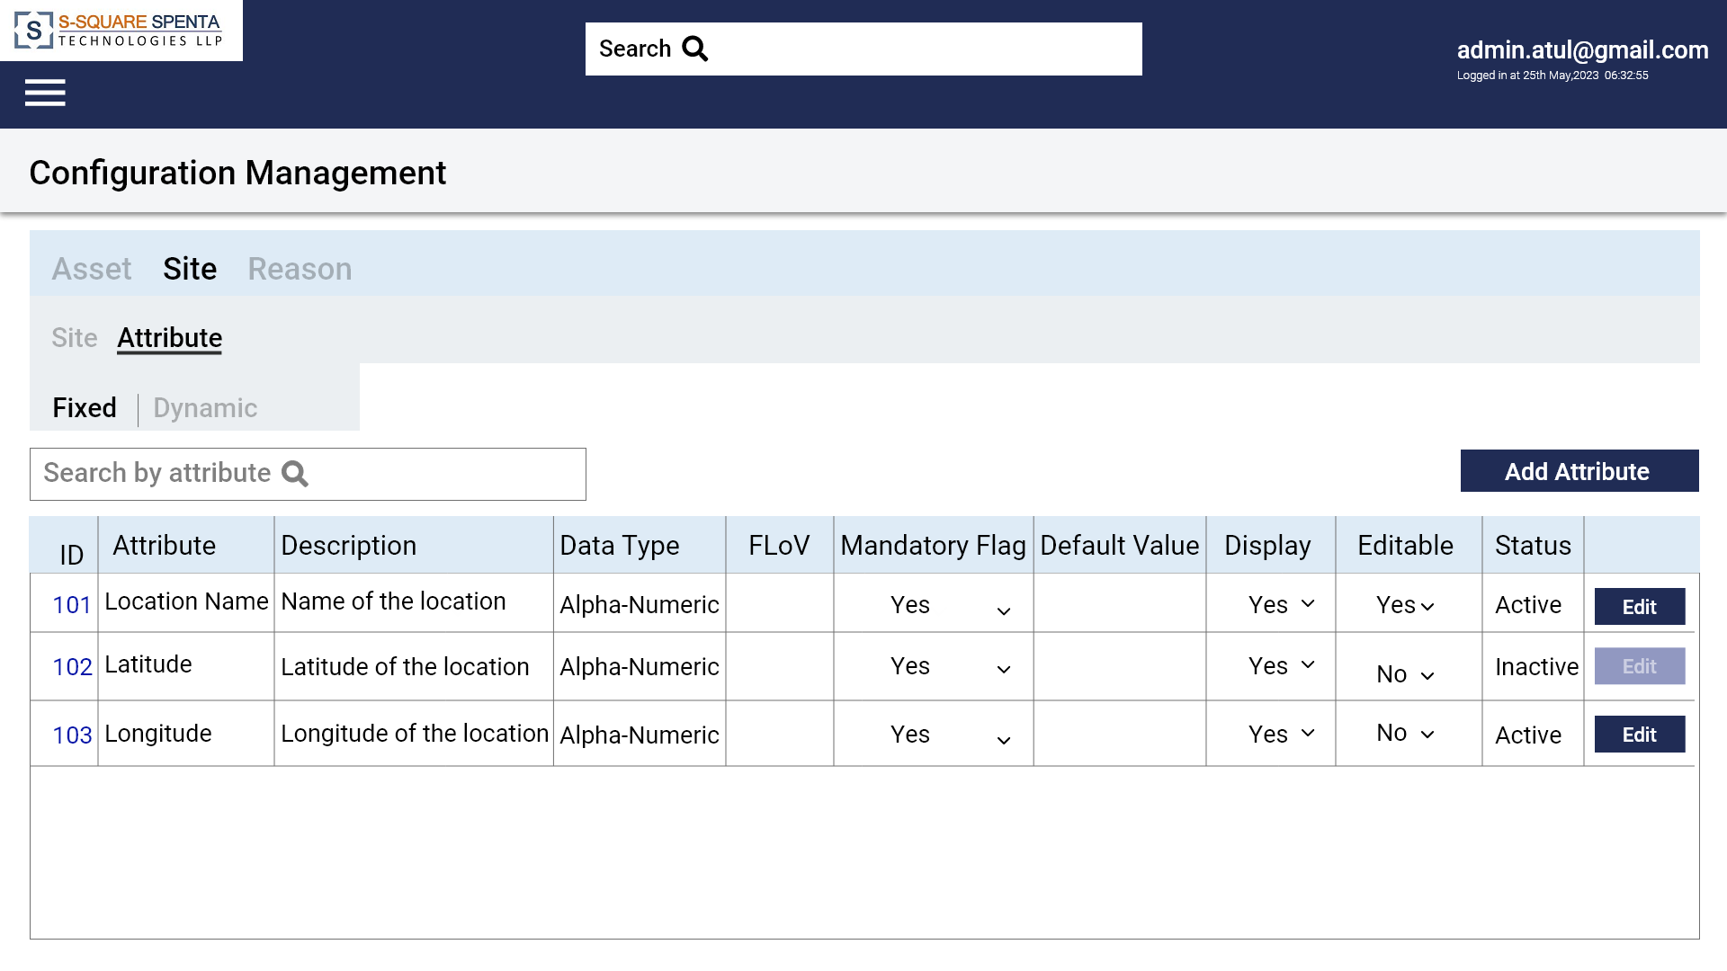

**Figure 16–Fixed attribute (Location) List View**

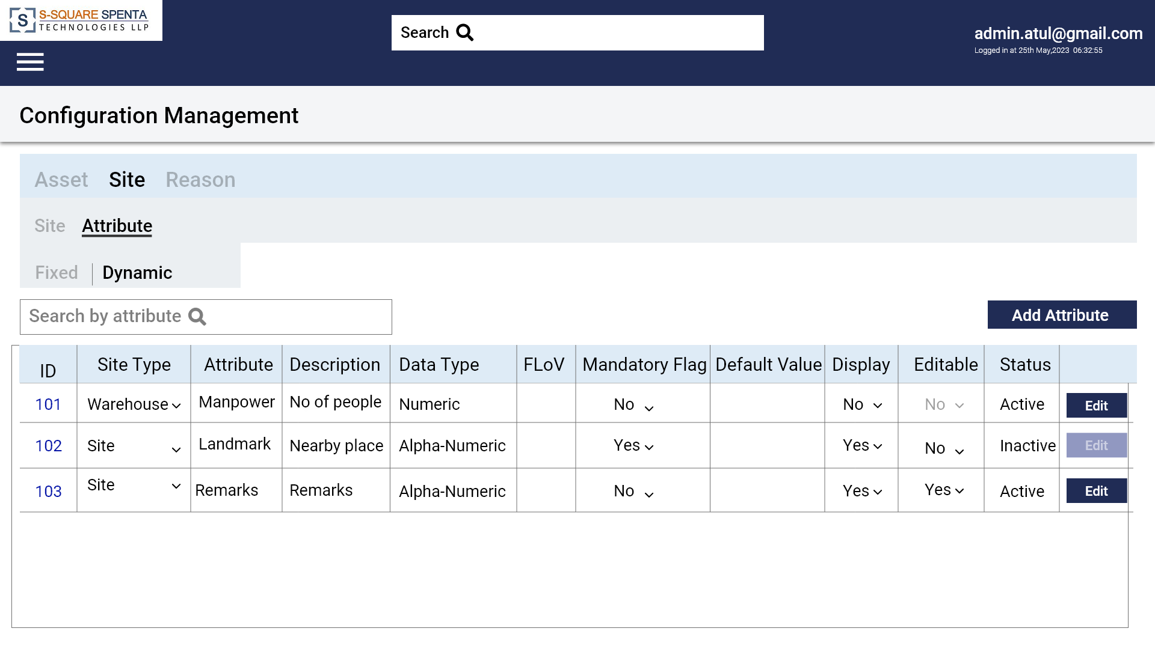

**Figure 17–Dynamic attribute (Location) List View**

These attributes appear dynamically in the Location creation or modification form as per the Location type selected.

# 6.4.4 Reason and Sub-reason Configuration

SATS will have two master data records for Reason and Sub-reason. The sub-reasons will be dependent on reasons. So when someone selects a reason the dependent sub-reasons will be auto populated. This reason and sub-reasons will be used to capture RCA or Sub RCA for equipment data modifications.

There will be a tabular list views with filtration option for all configured reasons and sub reasons. There will be option to add and update.

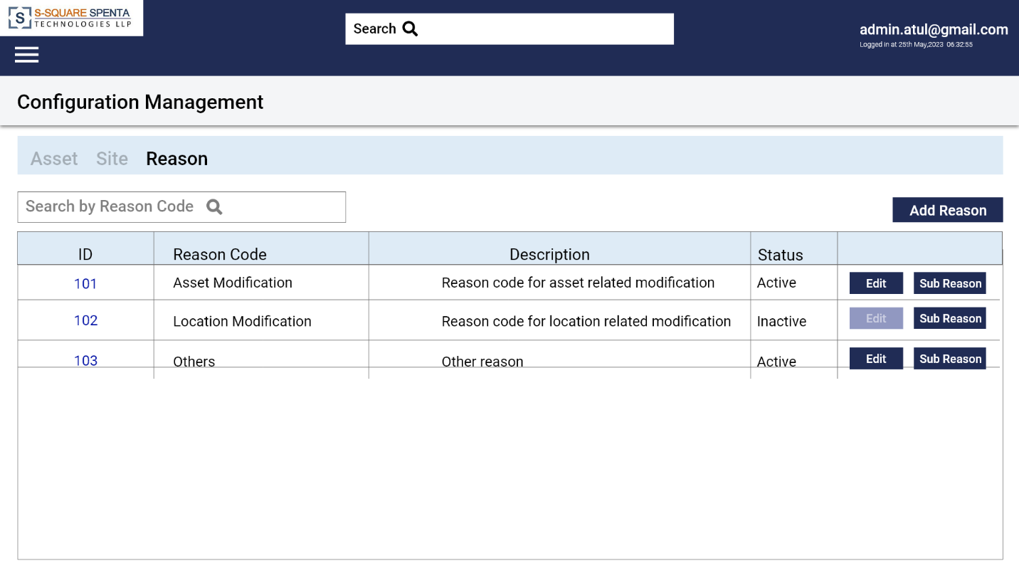

**Figure 18–Reason List View**

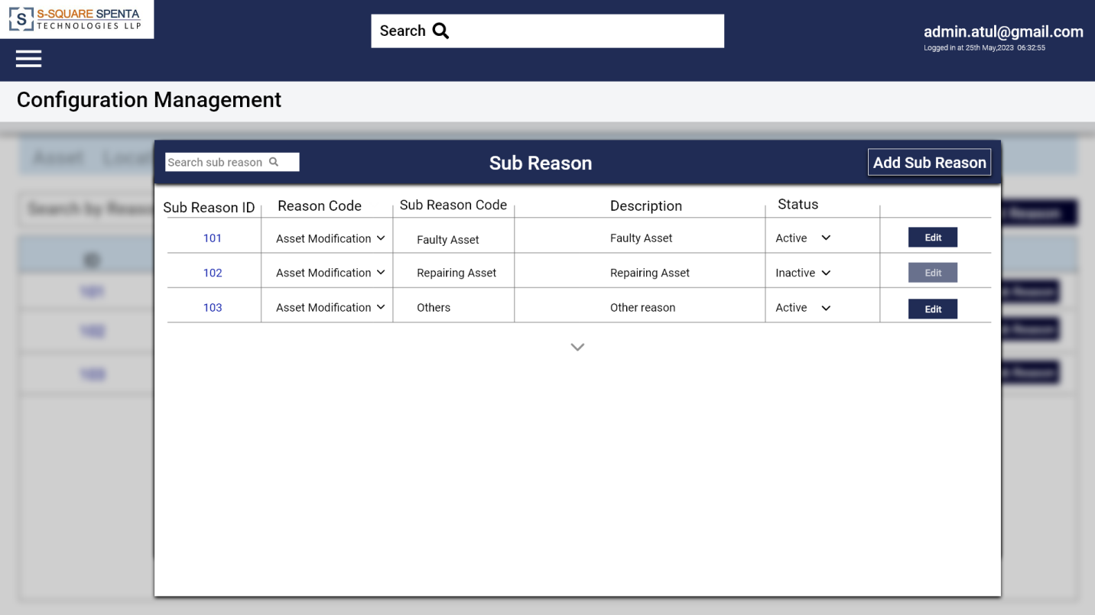

**Figure 19–Sub Reason List View**

# 6.5 Change Password

SATS will allow the users to change password.

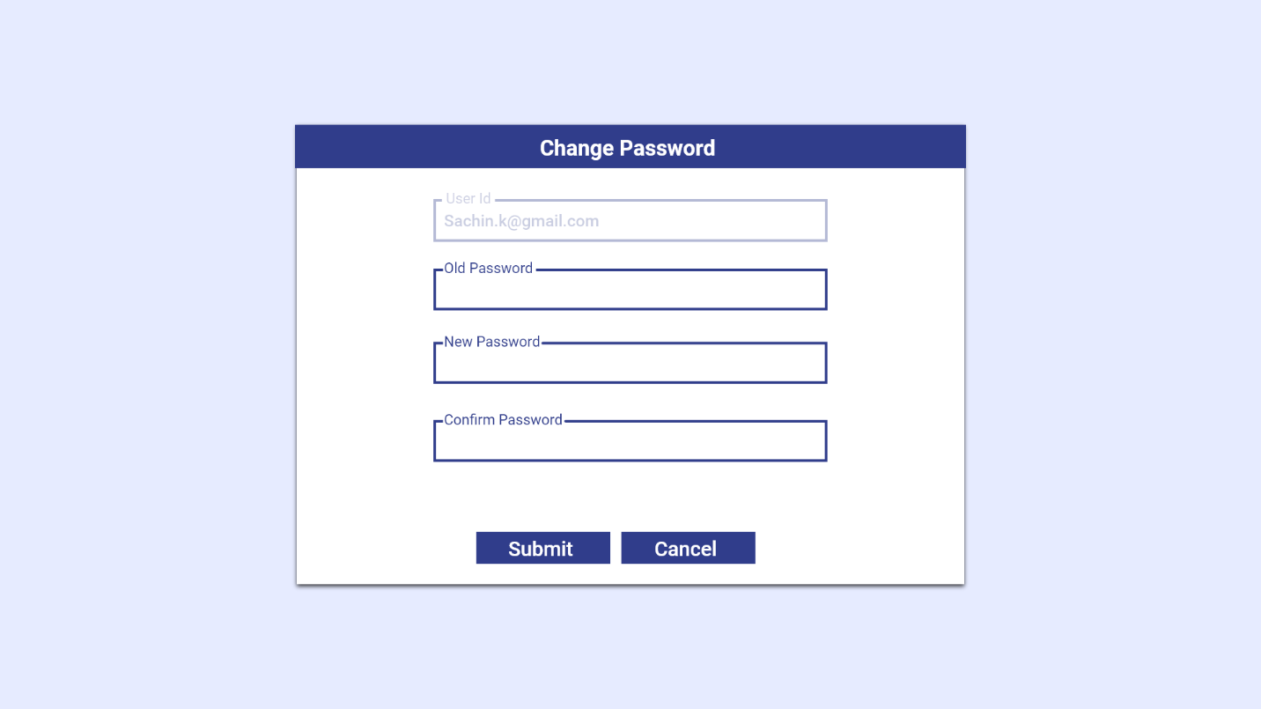

**Figure 20–Change Password**

# Mobile App - General Feature

SATS mobile app will be deployed in both iOS and Android stores for download and install. It will be a flutter app.

On starting the app it will ask for location and camera access which needs to be provided. Otherwise the app shall not start and shutdown. This should be a onetime approval (unless the access privilege manually removed. In that case the app will ask again for permissions). On startup, the app will also check if the location service is on, if not it will try to switch it on. If there is any problem in switching on location service, then the app should not start. Only when the location service is accessible the login prompt for the technician will appear.

In case the technician had previously logged in and the authentication is not yet expired, then the login screen will be skipped and tech will be taken directly to the site selection screen.

# Login & Site Selection

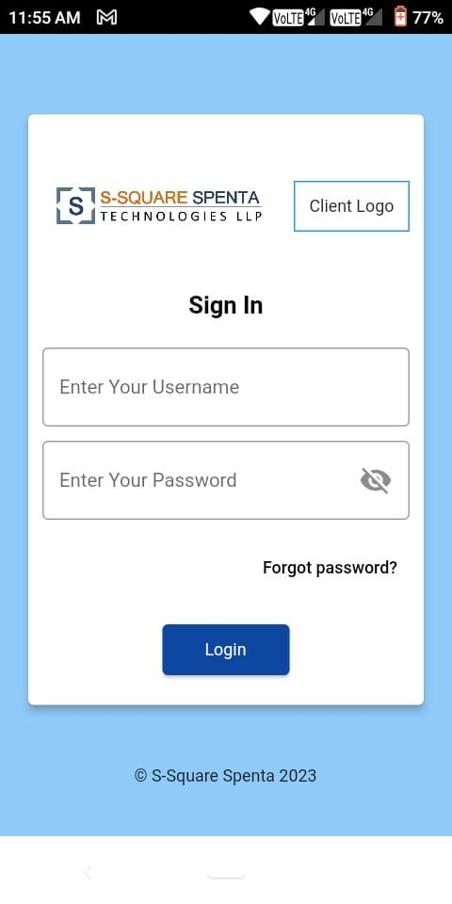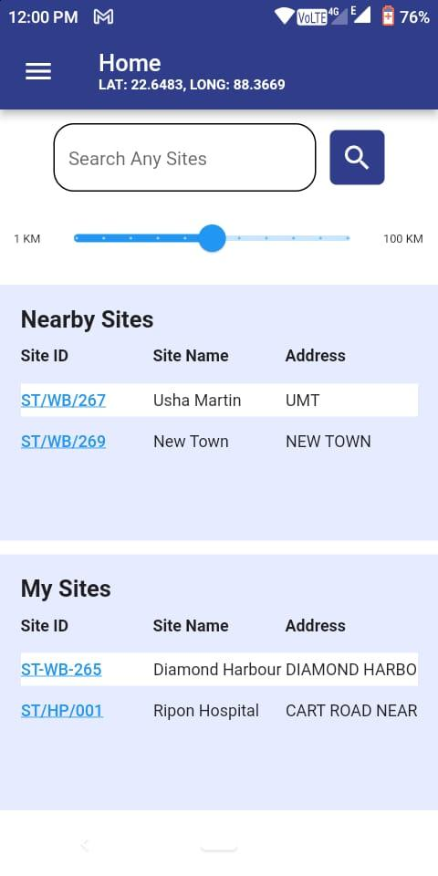

**Figure 21–Login Screen Figure 22–Home Screen**

Technician/supervisor will login into SATS app with user credentials.

After successful authentication, the app will list all the nearby sites (within a distance of X kilometers can be changed from the slider) based on the device’s geo location and the sites which are associated with the technician. Site Id, Site Name and Address will be shown in the list. All type of locations (Warehouse, Site etc.) will be shown. Additionally, the sites associated with the technician will be shown in my sites. There will be a quick filter option. Typing any text and clicking on the search it will search for the text in Site ID, Site name and Address fields.

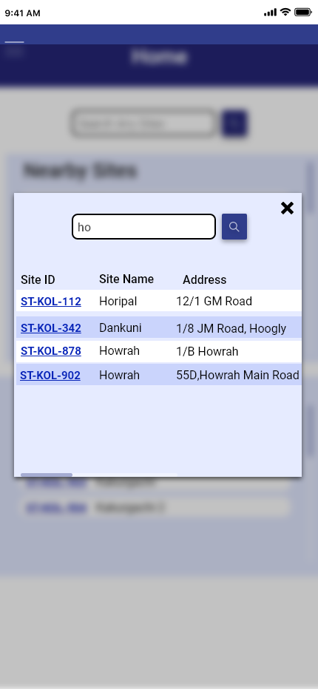

**Figure 23– Search location**

Technician needs to select one site to enter to the site and work. If the technician chooses a site, which is not associated with him, an email will be sent to the technician’s supervisor.

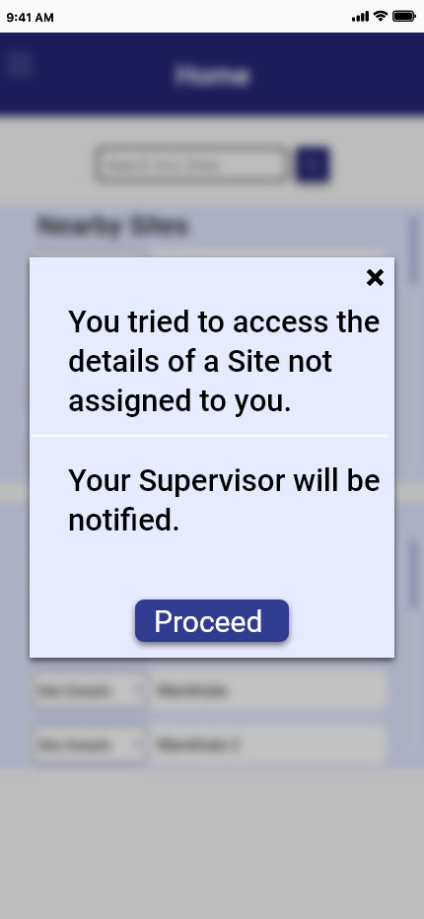

**Figure 24–Alert message for non-assigned site**

## 7.2 Site wise Asset Catalog

After log-in and site selection the app lands in the site wise asset catalog view. Following site details are shown in the screen.

* Address
* List Assets
* Color Code – To identify tagging status of the location
  + Green – All assets are tagged
  + Amber – Number of assets tagged is more than number of assets not tagged
  + Red – Number of assets tagged is less than number of assets tagged

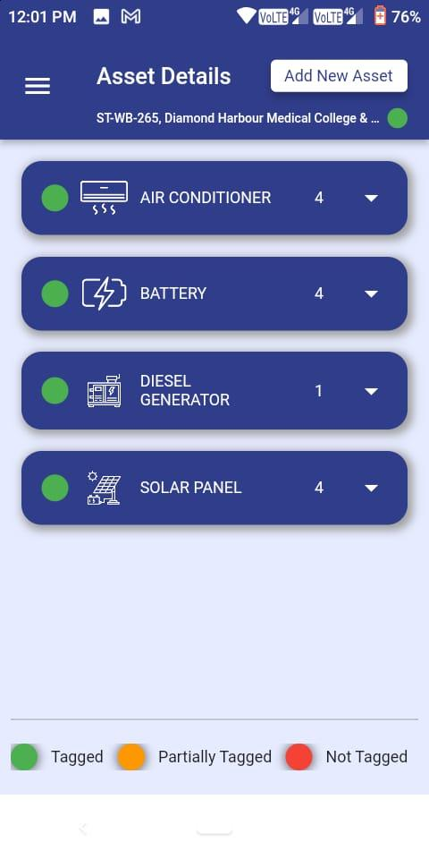

**Figure 25– Asset listing for a site**

Both active and passive assets in that site are listed in the GUI. The site-wise asset data is retrieved and shown from SATS DB.

Note: *Initially SATS DB will be loaded with active asset data from Site Inventory system and passive asset data from FAR.*

Assets are shown by grouping asset types. The group level header shows the asset type name and number of assets in that group. Also a color coding is present at the group level to identify the tagging status of that group.

On selecting a group, the view is extended and the individual assets under that group are shown. Following details of each asset are shown in card like view –

* Asset Id (as maintained by SATS)
* Asset Type
* Manufacturer Serial No
* Tag No (if available)
* Color Code – To identify tagging status of the asset
* Red – self not tagged
* Amber – Self tagged but one or multiple child assets not tagged
* Green – Self and all child assets tagged

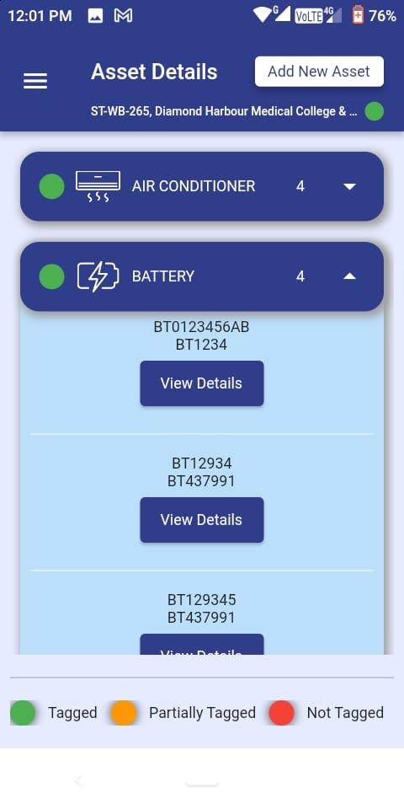

**Figure 26– Asset listing for an asset category**

There will be option to view details of a selected asset. All the fixed and dynamic attributes are shown for that asset in non-editable form. Clicking on the edit button will open a popup with details in edit mode.

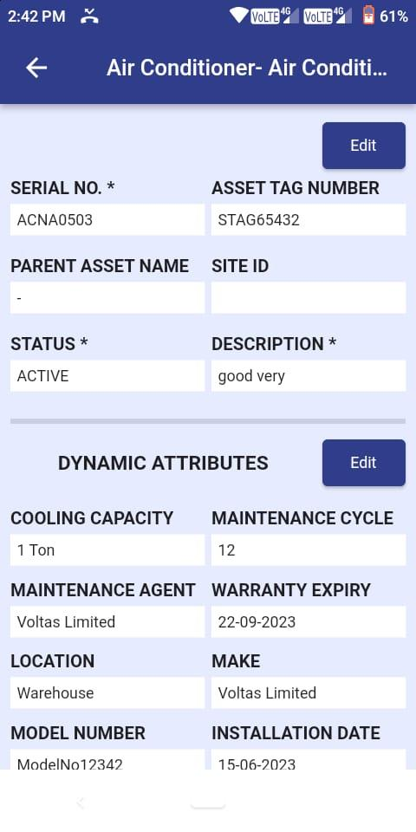

**Figure 27– Asset details**

Option will be there to take picture and upload against the asset.

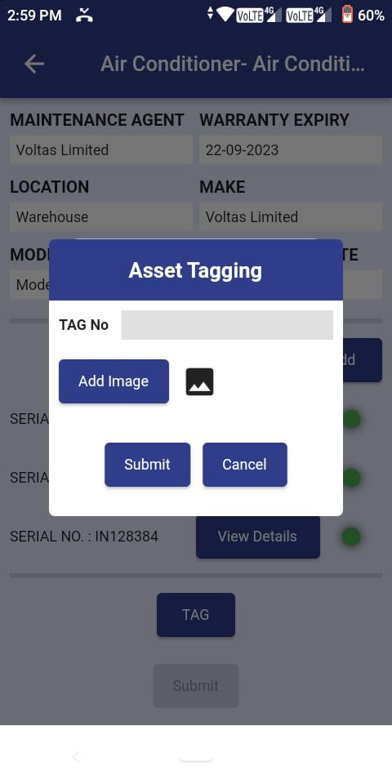

**Figure 28– Asset Tagging screen**

Additionally child assets with their tagging status can also be viewed. It will be possible to navigate to child asset details view. The details view of the child asset will be similar to that of the parent asset.

## 7.3 Operations on Assets

There will be following operational options on the asset details view of the each asset.

* **Tag** - In case the asset is not tagged then the technician will click the tag button which will initiate the tagging process in SATS.
* **STN** –After entering into a site if the technician clicks the menu of task list he can get the STN requests on clicking on the link will mark initiation of the STN process in SATS.
* **SRN** - After entering into a site if the technician clicks the menu of task list he can get the SRN requests on clicking on the link will mark initiation of the SRN process in SATS.

“**Asset Audit**” will be provided at the location level. This option will be available to supervisors only. Supervisor can lunch audit in any site after clicking on the menu after selecting any site.

# Asset Related Processes

# [FR-25] Tag

Technician will log into SATS and go via site selection process. Once the technician reaches the location asset catalogue view the tagging process can be started.

Technician will select a red color coded asset from the asset catalog or child asset view of a parent asset. Technician will go to the asset details view. There the option to tag will appear in the form of a button.

Technician needs to scan the QR Code. The tag value is shown in the screen. SATS checks if the tag is associated with any other asset. In that case it throws error and again opens the scanner. Otherwise the camera app is opened so that technician can take picture of the tagged asset.

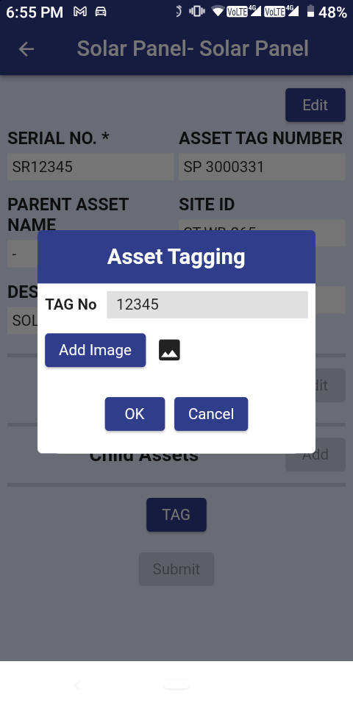

Once the picture is taken and accepted, SATS will check if the type of the asset is defined as parent asset for any other asset type. If yes, then tagging process for the child starts in the same way of entering manufacturer serial no. and continuing from there. In this way all the child assets need to be tagged and photographed. Once all the child assets are tagged and photographed SATS allows saving the tagging data along with the images in SATS DB.

To save the parent asset tagging information the technician must tag all the child assets and data is saved at one go. No partial data commit will be done.

# [FR-26] STN

When STN is generated in ERP the notification comes to SATS (via ERP-FAR) and SATS generates task for the respective sites. Technician can view the task as tasklist item in the mobile app after entering into the site and is aware of incoming equipment. When equipment is received at any site then technician will check if the asset received has already been tagged or not. If it is tagged then tech will scan the QR code to identify the equipment.

If the tag value is found in the system SATS will show the asset details view for the scanned asset, otherwise throw an error. Once an asset is scanned at any location then the current location of that asset is updated to that site location.

If the asset received does not have visible tag on it, then technician will be able to enter Manufacturer serial number and search the asset and view details. Also the tagging option will be given which will be mandatory if the asset is not previously tagged.

Once the technician action is complete, the backend batch process for STN correlates the data collected and STN data to close the STN. Please check STN Task Closure Batch Process.

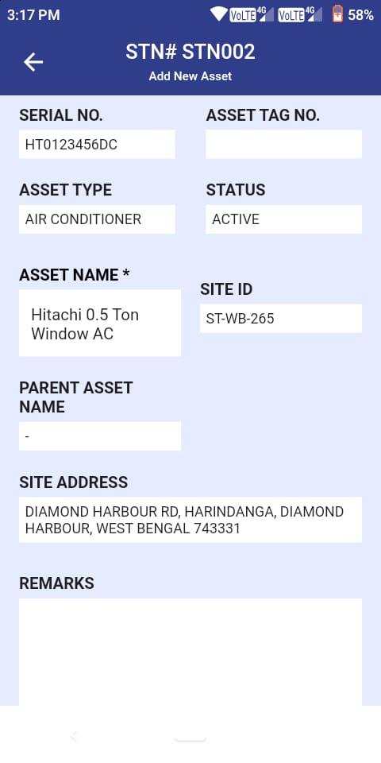

**Figure – STN screen**

# [FR-27] SRN

When SRN is generated in ERP the notification comes to SATS (via ERP-FAR) and SATS generates task for the respective technician. Technician can view the task in the mobile app and is aware of outgoing equipment. Technician needs to initiate the process of equipment return. There will be an option in the equipment details view in form of a button. Clicking it will open QR Code scanner. The technician needs to scan the tags of the equipment to be returned including any child equipment. Once the action is complete data is saved in ATS DB.

Once the data is saved in ATS DB, the backend batch process for SRN correlates the data collected and SRN data to close the SRN.

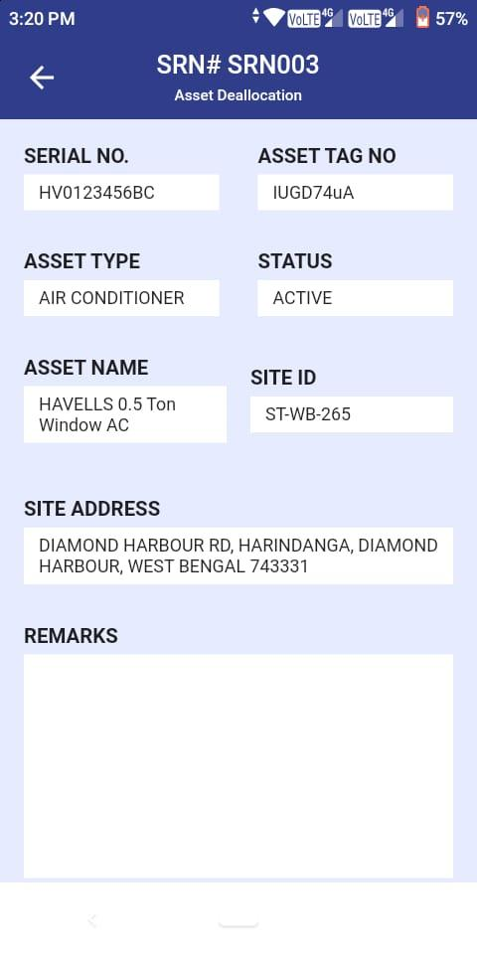

**Figure – SRN screen**

# [FR-28] Asset Audit

When the site supervisor logs in ATS and selects that site an option for auditing asset is presented to him in the hamburger menu. Clicking the “Asset Audit” button opens catalog containing all the assets present in that site. Only difference is all the assets are color coded as RED irrespective of their tagging status.

The supervisor needs to select red colored equipment one by one and it will present a QR code scanning option. If the scanned tag matches with the selected asset tag (as per SATS DB) then the color coding of that selected asset is changed to Green (or amber for parent asset which has yet to be audited children). The supervisor needs to select all the red color assets and turn them into green including child assets. There will be option to mark any asset as “Asset missing” or “TAG Missing” which will change the color code to grey for that asset. Once finished, the supervisor can submit the report. If there is any red or amber item, then ATS will not allow submitting the report.

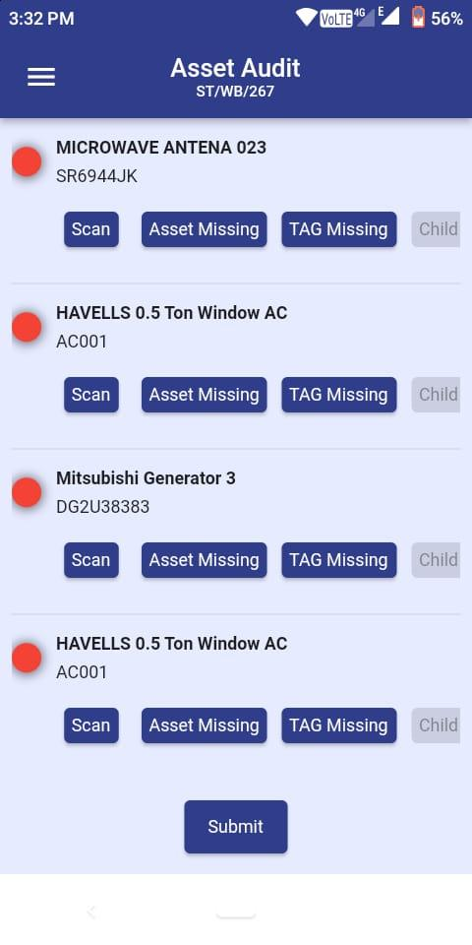

**Figure – Asset Audit screen**

Once the report is submitted, the backend batch process for Asset Audit correlates the data collected and closes the task.

# [FR-29] Technician Task List

A task list view will be provided in the mobile app for technicians. It should be accessible from the site selection screen (after login). All STNs and SRNs tasks assigned to the technician via backend batch processes will be appearing in this list. Technician can view the task list and select task to view the detail of the task (Site details and Asset details associated with the task).

There will be no actionable item on the tasks. These tasks will be view only.

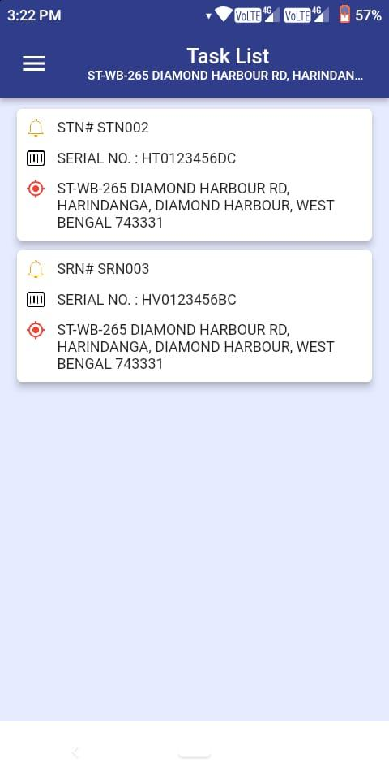

**Figure – Task list screen**

# 7.3. Approval Process

All changes done by mobile app will go for approval process. The approval process will be done from Process Maker community version. When any changes done for an asset one ticket will be generated in process maker using Process Maker’s API. Clicking on the pending approval link in web portal will open the Process Maker with auto login for the current user. Details of the changes will be show from SATS’s API and supervisor can approve or reject the task. There will be option for comment and image upload.

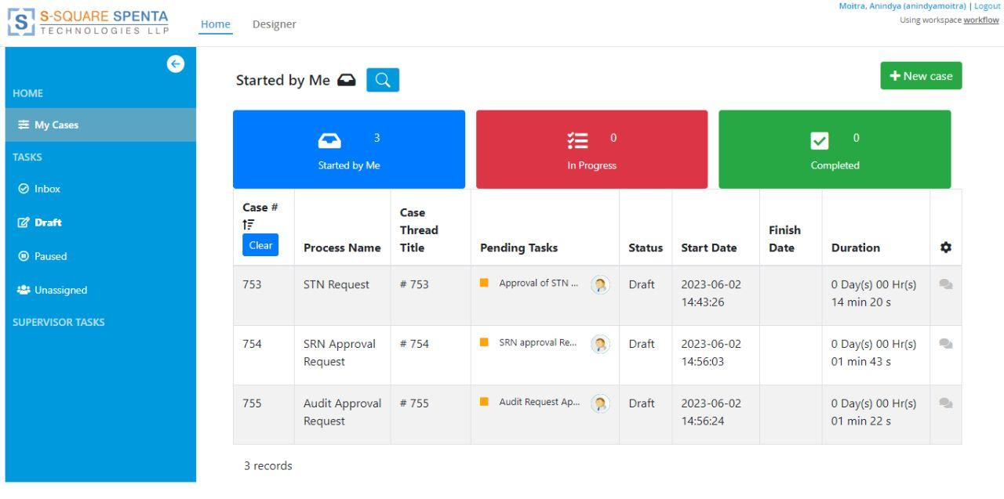

**Figure – Process Maker screen**

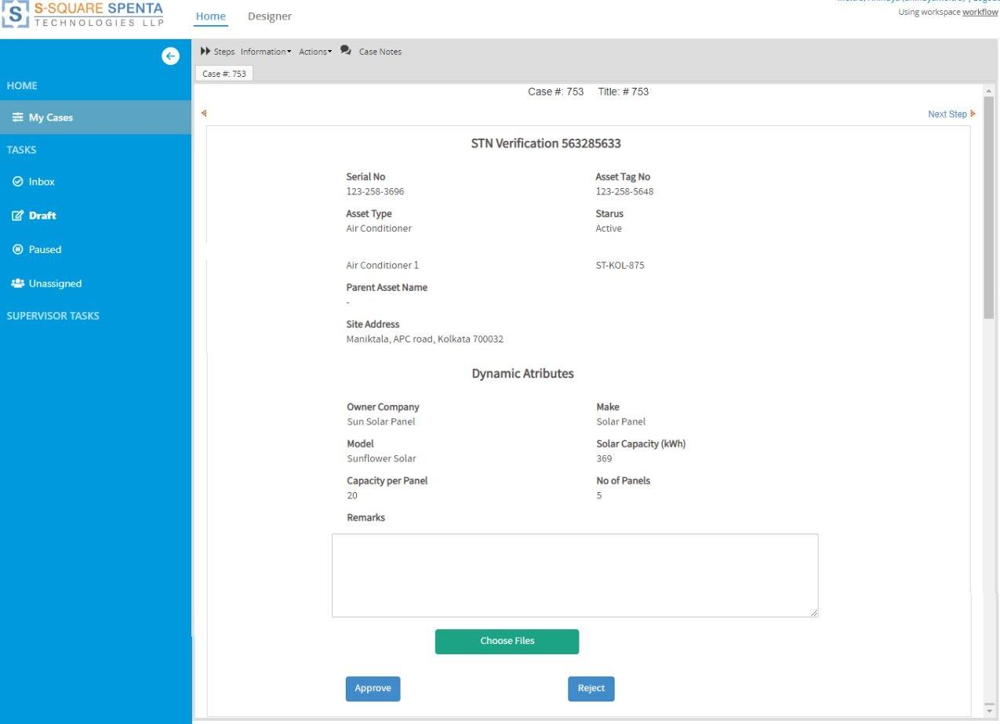

**Figure – Process Maker verification screen**

# Batch Processes

All batch processes will be automatic which will process the input files at predefined location(s) from other systems (like FAR/ERP) and generate output files at predefined location(s) for other systems.

## [FR-30] ERP FAR Update Batch Process

This Batch Process is for Incremental Data synching in SATS Database (File Based Integration).

## [FR-31] STN and SRN Task Creation Batch Process

STN Task Submission from Mobile App for approval using PM and PM ticket creation. From Process Maker (PM), STN ticket submission to update SATS. Then SATS to update FAR (file- based integration).

## [FR-32] STN and SRN Task Closure Batch Process

From Process Maker (PM), STN/SRN ticket submission to update SATS. Then SATS to update FAR (file based integration).

## [FR-33] Additional Item Asset Batch Process

From PM, Asset Addition ticket submission to update SATS. Then SATS to update FAR (file-based integration).

## [FR-34] Inventory FAR Mismatch Batch Process

From PM, Asset Modification ticket submission to update SATS. Then SATS to update FAR (file-based integration).

## [FR-37] Asset Audit Batch Process

* + - From PM, Audit Completion ticket submission to close audit task.
    - From PM, Asset Missing (from Asset Audit) ticket submission to update SATS.
    - Then SATS to update FAR (file-based integration).

# System Configurations

* **Asset Configuration** - Following system level configuration will be provided for asset management
  + Dynamic asset type configuration (both of Active and Passive types)
  + Dynamic asset attribute configuration for each type of assets
  + Dynamic parent – child relationship configuration between asset types supporting one to many relationships between parent and children.
* **Location Configuration** - Following system level configuration will be provided for location management
  + Dynamic Location Type configuration (Warehouse, Sites, Repair Centers) both physical
  + Dynamic attributes for each type of locations
  + Location wise asset status configuration (Active, Inactive, Available, Sent for Repair etc.)

# Other System Requirements/ Non-Functional Requirements

* Availability of APIs for all user operations
* Availability of detailed log files for all operations
* Search, filtration and pagination on all tabular views and lists as agreed during design finalization.
* System should never allow to upload images from gallery where technicians are supposed to take live picture of the assets.
* System should support easy steps for White labeling of the product, Company logo and UI color scheme.

# Audit Trail

System should capture all types of events which can show who did, what activity happened and when. The administrator will examine all types of change logs to get a complete picture of normal and abnormal events on the ATS system.

The following fields will be captured for each event performed by a User:

| **Field Name** | **Details** |
| --- | --- |
| Event id | Unique Event ID |
| Event Name | What action performed |
| Modified By | Who performed |
| Modified On | When performed |
| Reason Code | Event Code |
| Reason/ Sub-reason Description | Event details as required |
| Attribute Name Value Pair | A list of attribute name value pairs of attributes which were changed. |

# Server Sizing

This is minimum configuration to run application with no failover:

| **Type** | **Configuration** |
| --- | --- |
| Application Server | 4 Core, 8GB RAM, 128GB SSD |
| Database Server | 4 Core, 4GB RAM, 128GB SSD |
| Server OS | Linux (any Debian or Redhat based distro) |
| Android OS version | Minimum Android version supported is 8 |

**In case of AWS, RDS will be preferred.**

**DB administration is responsibility of customer.**

# Technology Stack

| **Particulars** | **Specifications** |
| --- | --- |
| Software | Open source technologies (Apache 2.x, PHP) |
| Database Management System | PostgreSQL |
| Front end | HTML5, CSS, jQuery, Bootstrap5 |
| Mobile App | Flutter |

# Performance Parameter: Response Time

1. Average response time for every request would be less than 3 seconds

# System Security

* The system supports 256-bit encryption
* Role based access privilege
* Custom password policy
* Audit log on all / selected actions in transactions
* IP Binding - End user can be restricted to file and database access from a given IP only.
* User log-in IP address tracking facility (client IP address will be embedded in the passport token)
* System supports SSL and TLS 1.3. TLS 1.3 Certificate should be provided by Customer
* System supports HTTPS (web server)

# Integration Requirements

Integration requirements for SATS:

* To be integrated with User management module of SSTL product platform for user authentication and user roles and privileges
* To be integrated with Process Maker based Workflow Engine for approval workflow.
* Email gateway integration
* Location service for geo location.
* Google Location API will be used and it may require additional cost based on usage pattern.
* Should be able to support file based integration with ERP FAR, Active Asset Inventory and Billing system integration (downstream). Actual integrations implementation will be scoped during project implementation phase. Following are broad level integration to be supported
  + O&M System – For loading of site locations & corresponding technician mapping
  + ERP FAR – Loading of one time SATS data
  + Site Asset Inventory – Loading of active assets
  + Billing – Push active assets data

# Data Migration Requirements

One time data migration activity will be performed from TowerCo, Telecom Operator ERP/site inventory system to ATS system. Also, technician site mapping data needs to be migrated.

However, Actual data migration requirements will be scoped during project implementation phase.

# Assumptions

* QR Code will contain one line of alphanumeric characters to be used as tag value.
* SATS will support both Active and Passive assets
* For SATS implementation ERP in the software landscape of the TowerCo is a pre-requisite. However, all integration will be file-based.
* There will be no option to retag an asset if tag information is available in SATS DB.
* STN and SRN will only be applicable for Passive Assets. These are not applicable on active assets.
* Tagging is applicable on both active and passive assets.
* One STN action will only be for one asset and the same is true for SRN.
* Reporting requirements will be mutually agreed and scoped during customer project implementation scope and hence not being considered.

# Open Items

# Out of Scope

Following item are out of scope and hence will not be considered:

* SMS Gateway integration
* QR Code Tag generation and printing
* Asset Tracking via RFID