Efficient Retrieval of Information From Hierarchical REST Requests

Seth Stoudenmier
Computer Science Dept.
College of Charleston
Charleston, SC, USA
stoudenmiersh@g.cofc.edu
Aspen Olmsted
Computer Science Dept.
College of Charleston
Charleston, SC, USA
olmsteda@cofc.edu

Abstract—REST Requests are utilized by developers across many fields to access data that companies make public that they would not normally have access to. Typically, efficiency is not a concern when making a REST Request to some server since only a handful are performed at one time. With the increasing popularity of gaming more and more web services have emerged that aim to present the data taken from these APIs. API Keys, and other methods of authorization used, are associated with an account that has a maximum number of requests that are allowed per a specific unit of time. The problem is that these databases are relational and result in multiple REST Requests to traverse the hierarchical structure and retrieve the needed information, leading to a long runtime before the application is loaded. As a result, many of these web services have downtime at specific intervals, such as the release of a new patch, so that all necessary information can be retrieved, stored on a local server, and then presented to users. This paper presents a solution to increasing the efficiency of retrieving data from a REST API such that a web service that presents this information may minimize its downtime.
Keywords-REST; API

Introduction
The gaming industry is continuously growing as time progresses, resulting in a rapid increase of web services aimed at improving the experience and community surrounding these games. To implement these web services developers must make use of APIs made available by different companies throughout the industry. In some cases, only a handful of REST requests are made at a time to the API which causes no conflict. On the other hand, sometimes a large amount of data is desired and this results in many subsequent REST requests which would surpass the maximum allowed in a specified unit of time. The solution to this problem is to pull back all data that would be needed for a specific web service and store it on a local server. This still leaves one concern, which is the amount of time that it takes to pull back copious quantities of data. A proposed solution to this problem is the use of multiple API keys on a rotating basis allowing for the downtime in-between calls to be minimal.
Of course, this solution does have its restraints and limitations. In this paper, I will talk about a simple implementation that uses multiple API keys to retrieve information from a hierarchical database. Additionally, I will discuss some future work for this project that will result in an increase in efficiency.

Related Work
Background research into the topic of efficient REST Requests did not result in any articles that try to solve a similar problem as what this paper aims to do. However, many papers were found that were used and will be used to improve the presented solution.
Heiland et al. [1] talk about the process of deciding what type of authorization the API for their application, Science Gateway Platform, should utilize. In doing so they discuss briefly some of the other applications that utilize API keys and other authorization techniques. While API keys are not the most secure method of authentication, they are the most user friendly and are used widely across multiple applications. The solution presented in this paper focuses primarily on API keys since they are so widely used, but it can be adapted to other forms of authorization.
Li and Halfond [2] discuss HTTP request in relation to power consumption on android. They state that network usage is to blame for majority of battery usage since HTTP requests have multiple steps within them resulting in a large amount of processing per request. Their solution to this problem involves the capturing of sequential requests so that they may be sent as a single request to a proxy that handles the rest. Li and Halfond’s paper resulted in the realization that for enormous quantities of data these HTTP requests would be run on a local server instead of client side, resulting in the scope of the problem for this paper being altered to address the exponential growth of time that is needed for hierarchical databases.
Schreier [3] addresses the issue of how to model RESTful applications. She talks of how the behavioral model “…offers the possibility to describe the behavior with state machines.” A similar idea can be used in the mapping of REST requests of an API to create a hierarchy. The run time to traverse all branches can be estimated if a rough idea of the number of nodes at each level are known. From here it can be easily seen how utilizing multiple API keys can reduce the runtime by half, minus the necessary overhead.

.

Motivating Example
The motivation for this idea comes from the gaming industry. The industry is growing rapidly and the number of developers with it. Many of these developers utilize some sort of an API that companies in the industry make public. From these APIs, many different web services have been developed to present statistics, raw information, and much more to the community who share a similar interest. The game that was used for proof of concept in this paper is League of Legends by Riot Games [4]. They have an outward facing API that provides a multitude of information, however, like any other API there is a maximum to the number of REST requests that may be made per some unit of time. Some web services that utilize this API are required to have down time that surpasses twenty-four hours so that they can pull all necessary data to a local server when a new patch is released. The solution proposed in this paper hopes to minimize this down time for the previously mentioned web services and for developers that would like to test different combinations of data.

Implementation
The implementation used for the paper is a simple proof of concept. Fig. 1 shows the top portion of a function that is used to handle the pulling and relating of data from the API. The key component of the solution can be found in the segments “interval = ((maxTime * 60.0) / maxRequests) / keyCount” and “[requestCount % keyCount].” First is the interval between REST requests. This is determined by the number of API keys and the request limitations that an API has. Between each request the sleep function is called so that the threshold is not reached, which would result in an API key being blacklisted and no longer able to be used. Next is the index into the list that contains the API keys. A count of the requests made is maintained so that through modular division the solution can cycle over the keys one at a time. Paired with the interval, this maximizes the number of requests that are allowed per key. A summary of the hierarchy that the data was retrieved from can be found in Fig. 2. The result of each run was a JSON pairing each Account ID to its corresponding Match IDs and Match Info.

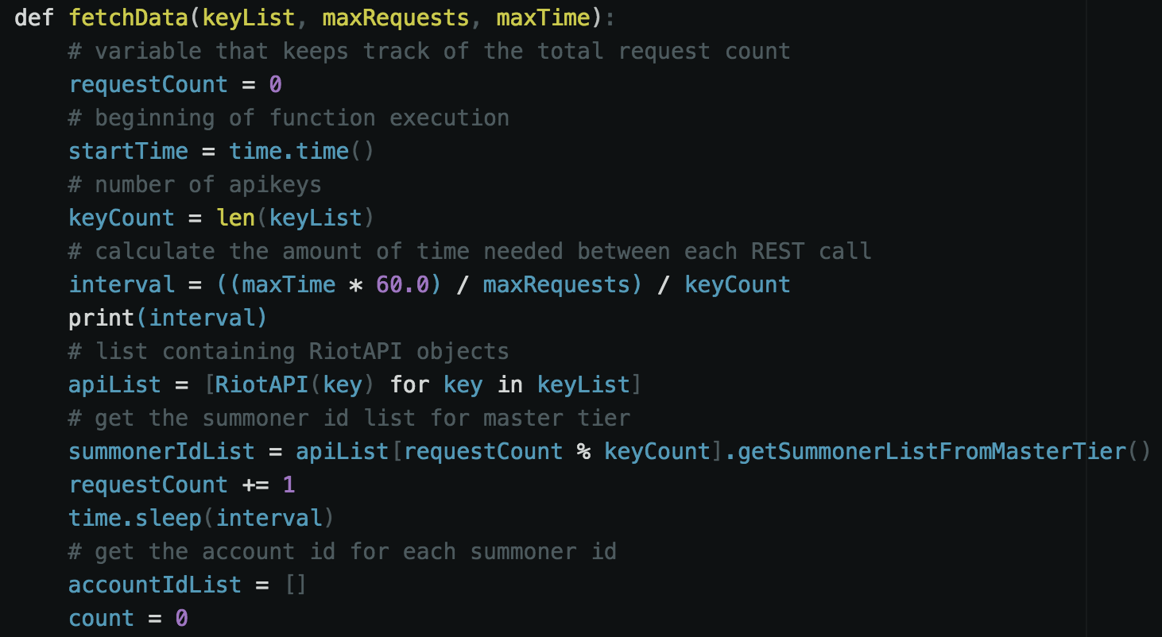
- Small portion of implementation for proof of concept
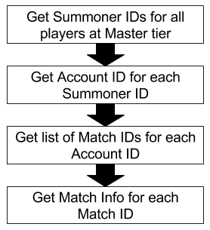
- Example hierarchy of REST requests

Results
The results for the solution were as predicted. The addition of a second API key decreased the amount of time necessary to retrieve the same information by 33%. When used in a small sample size, such as the data presented in Fig. 3, the difference is only a matter of minutes. However, this difference becomes significant as the number of requests increase. For the testing of the implementation a range of 1 to 20 players’ data was pulled out of hundreds of players, possibly thousands depending on the dataset.
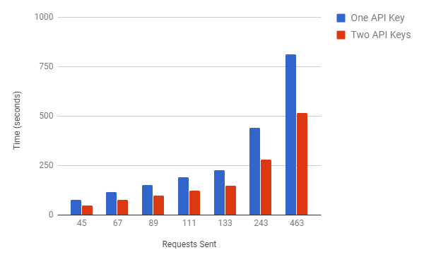
- Results showing number of requests against the time in seconds

Future Work
To improve on this proof of concept two key areas will be considered: security and modularity. Security is a major concern for this solution since it handles API keys that are unique to each user. For this solution to be used multiple people would have to be willing to offer their unique key. A possible solution to this would be to implement public-key cryptography. This would allow people in these gaming communities to safely support their favorite web services. Next is the goal to make this solution more modular since currently it is nothing more than a theory that has been proven. Implementing a way for developers to utilize this with any API seamlessly would allow for efficient data retrieval and collaboration between communities. Of course, this concept of shared keys can be applied to any web service with an API that requires a substantial number of REST requests to retrieve all necessary data.

References
- R. Heiland et al. “Authentication and Authorization Considerations for a Multi-tenant Service,” in Proc. SCREAM, 2015, pp. 29-35.
- D. Li and W. G. J. Halfond. “Optimizing Energy of HTTP Requests in Android Applications,” in Proc. DeMobile, 2015, pp. 25-28.
- S. Schreier. “Modeling RESTful applications,” in Proc. WS-REST, 2011, pp. 15-21.
- Riot Games. 2017. League of Legends. Retrieved from http://na.leagueoflegends.com/en/

