Clayton Early Learning
Denver, CO

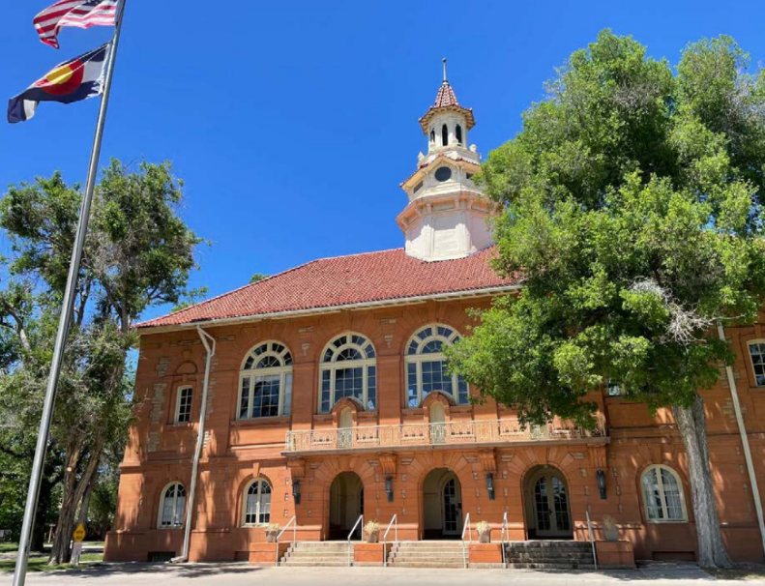
Project Details
Description: Master Planning & Clinic Development
Owner: Clayton Early Learning
Design Team: Livable Cities (master planning)
RTA Architects (health clinic)
General Contractor: TBD
Budget: Phase 1 ~$12MM, Future Projects TBD
Completion: Anticipated 2027

Project Description
Clayton Early Learning is a historically-designated education and service providing campus on MLK Blvd in Denver. SII recently completed managing a master planning exercise to provide Clayton with a roadmap for the long-term renovation and development of the historic 19 -acre campus. Phase 1 of the master plan is the renovation of one of the original dormitories into a health clinic in partnership with Denver Health. That project is currently in design and commencement of construction is anticipated in Q4 2026.
Project-Specific Scope
SII is engaged to provide full-service project management services, including the following project-specific scope elements:

- Close coordination with the Denver historic community, as well as City of Denver planning department and City Council
- Detailed master planning including high-level and detailed analysis of overall site conditions, user group and tenant planning, and historic considerations
- Management of capital stack, which includes funds with restrictions by the clinic partner
- Separation of consultant management scope between Clayton and clinic partner including oversight of project roles & responsibilities
- Detailed, extensive coordination of entitlements and enabling development activities including zoning, historic, environmental analysis, survey, utilities & existing infrastructure, and organizational structure

