

Milestone

Bacchus Winery

Kyle Marlia-Conner  
Steve Stylin  
Ean Masoner  
Cuitlahuac Hernandez  
Mirajo Tesora

| Database Development and Use | 12/15/2024

In the context of a case study involving a Bacchus Wine production and distribution business, it is essential to generate reports that can aid in making informed business decisions. This document outlines three specific reports that can be created using Python and a graphical user interface (GUI). Each report will include a description, the corresponding Python script to generate the report, and a screenshot of the report output.

*Report 1: Sales Performance Report: sales_perforamce.py***Description:**  
The Sales Performance Report provides insights into the sales data, including the quantity sold and the total sales amount for each wine type. This report is crucial for understanding which wines perform well and which may need marketing efforts or adjustments in production.

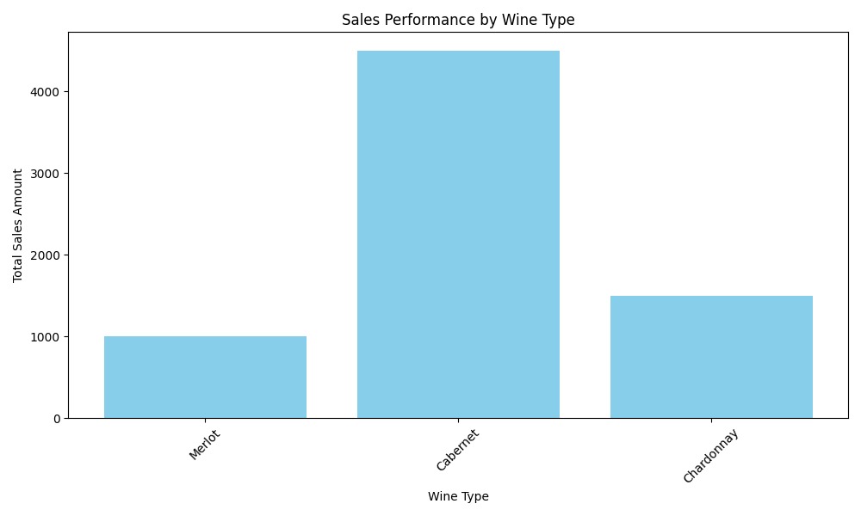

*Report 2: Inventory Status Report: Inventory_status.py***Description:**  
The Inventory Status Report displays the current inventory levels of raw materials and finished products. This report is vital for ensuring that the production process is not hindered by a lack of materials and for helping in planning future purchases.

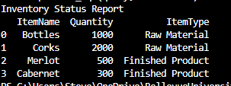

*Report 3: Employee Work Hours Report: Work_Hour.py***Description:**  
The Employee Work Hours Report summarizes each employee's total work hours. This report is essential for evaluating employee productivity and ensuring compliance with labor regulations.

