December 18, 2024

steve stylin

Bellevue University

Advanced Python

Module 12: Revise of module 9.2

After careful consideration, I have chosen to focus on revising module 9.2, which involves working with Application Programming Interfaces (APIs). This will allow me to deepen my understanding of API interactions, improve the quality of my code, and enhance the overall functionality of my project. Through this revision process, I aim to address any shortcomings and ensure that I meet the assignment criteria more effectively.

API (Application Programming Interface): A set of rules that allows different software entities to communicate with each other. In this case, we are using the Open Notify API to access data about astronauts.

HTTP Requests: This is the method used to request data from a server. The script utilizes the GET method to retrieve information.

JSON (JavaScript Object Notation): A lightweight data interchange format that is easy for humans to read and write. The API response is in JSON format, which we will parse in our script.

*Explanation of the Code*

This line imports the requests library, which is essential for making HTTP requests in Python; we define the URL of the Open Notify API endpoint that provides information about astronauts. A GET request is sent to the specified API URL, and the response is stored.

We check if the response's status code is 200, indicating a successful connection. If not, it prints an error message with the status code.

This section outputs the raw response from the API in JSON format.

The response is converted from JSON format into a Python dictionary. The script then prints the number of astronauts currently in space and iterates through the list of astronauts to display their names and the spacecraft they are on.

[Fireball Data API](https://ssd-api.jpl.nasa.gov/doc/fireball.html)

We will now connect to a simple API provided by NASA that retrieves data about fireballs. We will test the connection, print the raw response, format the response similarly to a tutorial program, and finally present the data in a well-structured table format.

api_url = <https://ssd-api.jpl.nasa.gov/fireball.api?limit=20> (return the most recent 20 records)

We test the connection and return the output without formatting.

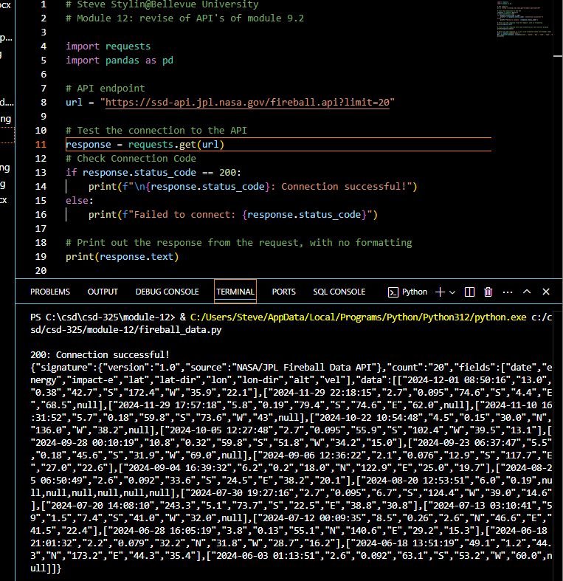

Print out the response with the same formatting as the tutorial program.

Now, let's print the data in a nice, more readable format.

This code serves as a comprehensive guide that effectively illustrates the process of connecting to an API. It not only demonstrates how to manage the response in a structured manner but also presents the retrieved data in a variety of formats. This makes it an invaluable resource for anyone who aspires to work with APIs in Python, as it highlights key techniques and best practices for seamless integration.