***AWT (Abstract Window Toolkit):***

Introduced in 1995 as part of Java 1.0, AWT was the first GUI toolkit for Java. It provided a set of lightweight components but relied on the underlying operating system for rendering, which could lead to platform-specific behaviors. AWT components are heavyweight, meaning they consume more resources and are less flexible compared to later libraries.

***Swing:***

Released with Java 1.2 in 1998, Swing extended AWT by providing a richer set of lightweight components that are drawn by Java runtime. Swing components can be more easily customized and are more consistent across platforms. It introduced the Model-View-Controller (MVC) architecture, allowing for better separation of concerns in design. Swing remained a widely used toolkit for many years, famous for its pluggable look-and-feel capabilities.

***JavaFX:***

Launched in 2008, JavaFX was designed as a modern alternative to Swing, targeting rich internet applications (RIAs). It offers advanced features like hardware-accelerated graphics, CSS styling, and FXML for defining user interfaces, enabling a more web-like approach to desktop applications. JavaFX has been integrated into JDK since Java 8 and is marketed as the future of Java desktop applications.

|  |  |  |
| --- | --- | --- |
|  | **Benefits** | **Drawbacks** |
| **AWT** | Simple to use, lightweight for basic application | Limited component sets and heavyweight components lead to resource inefficiency and inconsistent look and feel across platforms. |
| **Swing** | Rich component set, customizable look and feel, lightweight components, support for MVC architecture, and extensive documentation. | More complex architecture is perceived as outdated and less suitable for modern UI design paradigms. |
| **JavaFX** | Modern UI capabilities, rich graphics features (animations, CSS styling), FXML for UI design, improved performance with hardware acceleration, and better suited for mobile and web applications. | It is a smaller community than Swing, has a steeper learning curve for those familiar with Swing, and is less mature than Swing in certain areas. |

**Compatibility with Different Java Versions**

***AWT and Swing:*** Both are part of the Java Standard Edition and have been fully compatible with all Java versions since Java 1.0 and 1.2, respectively. However, updates and improvements are infrequent as they have become somewhat stagnant in terms of new features.

***JavaFX***: Initially available as an external library, it has been integrated into the JDK since Java 8 (Java SE 8). Starting from Java 11, JavaFX is no longer included in the JDK by default, meaning developers must include it as a separate module. It has seen ongoing updates, helping it remain relevant.

***Code Comparison***

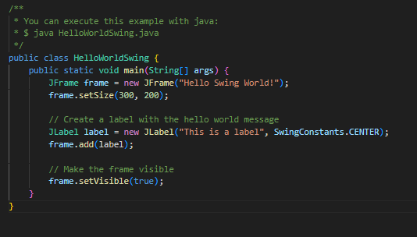

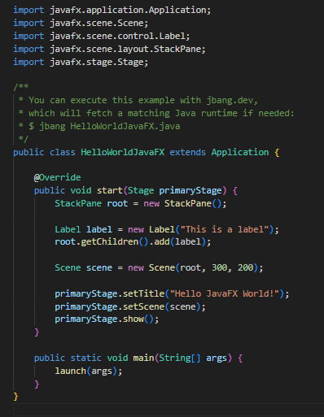

***Suitability for Various Development Scenarios***

**AWT:** Best for lightweight applications or when backward compatibility with ancient Java versions is necessary. It is not recommended for modern applications due to limitations.

**Swing:** Suitable for applications that require a robust, mature toolkit with many established libraries and practices in place. It can be a good choice for desktop applications but is starting to show its age as UI design trends evolve.

**JavaFX** is ideal for modern desktop applications, especially those needing responsive interfaces, animations, and styling. It is suitable for applications looking to integrate desktop and web technologies. Given its future direction, it is the best choice for new projects.

In conclusion:

Each toolkit has its strengths and weaknesses, making it suitable for different scenarios. Swing and AWT are well-suited to legacy applications, while JavaFX provides more modern capabilities that reflect current trends in application design and user experience. As Java continues to evolve, developers should consider the specific requirements of their projects when choosing between these GUI frameworks.