Heap Data Structures: Implementation, Analysis, and Applications

Sanjay Subedi
University of the Cumberlands
Algorithm and Data Structures (MSCS-532-B01)
Professor Michael Solomon
November 8, 2026

Heap Data Structures: Implementation, Analysis, and Applications
This report compares Heapsort with Quicksort and Merge Sort, then uses a binary max-heap to schedule tasks. The sorting measurements come from the submitted benchmark CSV. The scheduling results come from running the simulation on the two workloads described below.
1. Heapsort
1.1 Implementation
The heap is represented as a list; parent of i-th index is (i-1)//2, its children are 2i+1 and 2i+2. heapsort first constructs the max-heap bottom-up and then iterates extracting elements one by one - it swaps the root and the last heap element, decreases the size of the heap and sifts the new root. max_heapify procedure is implemented iteratively to make sure that the additional space used is O (1) and to avoid recursion overhead. There is an optional key function allowing sorting of any objects. Correctness is based on the loop invariant: before each extraction heap prefix is a valid max-heap, while the suffix contains the largest elements already sorted.

1.2 Complexity analysis
A sift from height h costs O(h). Bottom-up construction starts with the last parent. At most ⌈n/2^(h+1)⌉ nodes have height h, so summing the work over heights gives O(n), since the series Σ h/2ʰ converges. Removing maxima costs at most the sum of O(log m) for heap sizes m from 2 to n. Consequently, O(n log n) bounds every input.
Case | Time
Worst | Θ(n log n)
Average | Θ(n log n)
Best (distinct keys) | Θ(n log n)

For distinct keys, the worst case and the average over random permutations both take Θ(n log n). Even the best ordering requires Θ(n log n) moves for classical Heapsort (Schaffer & Sedgewick, 1993). Equal keys change the tight best case for this implementation. On an all-equal list, the strict comparisons end every sift at its first level, so the build and extraction loops together take Θ(n). Iterative sifting uses O(1) auxiliary space assuming constant-cost key evaluation and comparison. The swaps can reorder equal keys, so the sort is unstable.

1.3 Experimental comparison
For each distribution and size (1,000, 5,000, 10,000, and 50,000), the benchmark timed each algorithm on copies of the same input and checked the output against Python’s sorted result. It recorded the fastest of three trials. The table gives seconds at 50,000 elements.
Input | Heapsort | Quicksort | Merge sort
Random | 0.180 | 0.0705 | 0.095
Sorted | 0.149 | 0.062 | 0.068
Reverse-sorted | 0.142 | 0.063 | 0.067
10 distinct values | 0.133 | 2.692 | 0.073

Figure 1. Running time versus n.
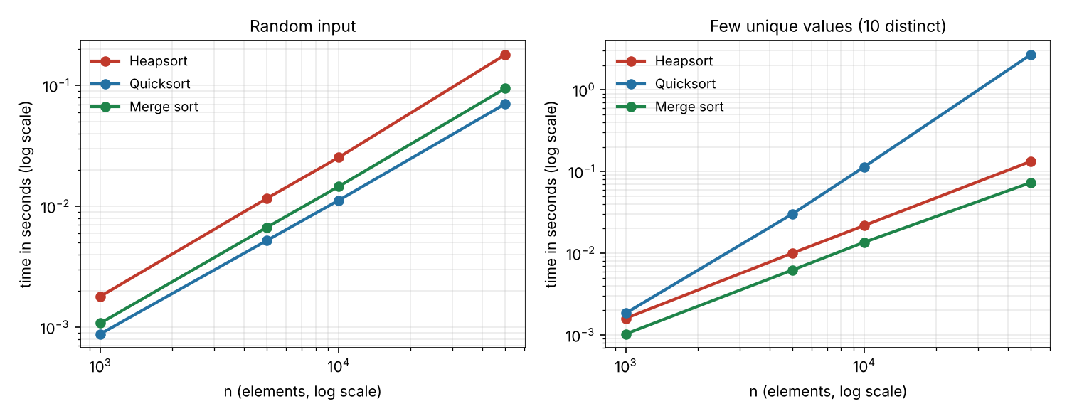
On random data, Heapsort grew from 0.01164 seconds at 5,000 elements to approximately 0.180 seconds at 50,000, a factor of 15.5. The n log n model predicts a factor of about 12.7. Timing includes Python comparison, indexing, and function-call costs, whose individual effects were not measured. At 50,000 random elements, Heapsort took about 2.6 times as long as Quicksort and 1.9 times as long as Merge Sort. On inputs with only ten distinct values, two-way Lomuto Quicksort repeatedly left equal keys on one side. It took 2.692 seconds, versus 0.133 for Heapsort. Random pivot selection helps with ordered distinct input but cannot distribute identical values across this partition.
2. Priority queue
2.1 Design
A Python list stores the complete binary tree without per-node pointers. Its parent and child indices take constant time to compute, and its height for n ≥ 1 is ⌊log₂ n⌋. Higher numbers denote more urgent tasks, so a max-heap places the next task at the root. Each task stores its ID, priority, arrival, deadline, burst time, and remaining work. Earlier arrivals win ties, followed by the smaller ID. A dictionary maps IDs to array positions. Each swap updates both affected entries.
Policy | Avg wait | Max wait | High-prio wait | Low-prio wait
Priority | 6.52 | 89 | 0.17 | 18.00
Priority + aging | 6.20 | 58 | 0.17 | 14.21
FIFO | 5.32 | 22 | 4.67 | 5.40

2.2 Operation costs
Insert appends a leaf and sifts up. Extract-max replaces the root with the last task and sifts down. Increase-key and decrease-key locate the task by ID and sift up or down, respectively. Each sift crosses at most one tree height, giving O(log n) heap work. This assumes expected O(1) dictionary access and amortized list growth. Peek and is_empty take O(1). The heap and position map together use O(n) storage.

2.3 Scheduler results
At each tick, the highest-priority ready task executes for one time unit. An unfinished task returns to the queue. At each aging interval, every task still in the queue gains one priority point. On the six-task workload, priority scheduling met all six deadlines with mean wait 4.83 time units. FIFO met three deadlines with mean wait 7.17. On the 200-task workload (seed 1), priority scheduling met 179 deadlines, aging met 174, and FIFO met 182. Aging lowered the maximum wait from 89 to 58 while urgent tasks still waited only 0.17 units on average. FIFO gave the shortest overall mean wait, but urgent tasks waited 4.67 units. The scheduler uses deadlines to evaluate completion, not to select the next task.
2.4 Testing
All 14 tests passed. They cover sorting edge cases, task ordering, tie breaking, error handling, and a randomized sequence of 2,000 queue operations checked against a reference model.
3. Conclusion
Heapsort offers an O(n log n) upper bound and constant auxiliary space. The timing results show why input distribution also matters when selecting a sort. For scheduling, a max-heap gives urgent tasks quick access to the processor. Aging reduced the longest wait on the larger workload, while FIFO met the most deadlines on that same workload.

References
Schaffer, R., & Sedgewick, R. (1993). The analysis of Heapsort. Journal of Algorithms, 15(1), 76–100. https://sedgewick.io/wp-content/themes/sedgewick/papers/1993Heapsort.pdf

