CHAPTER 4. RACE PERFORMANCE ANALYSIS

4.1 Race Overview
The Austrian Grand Prix provides a useful environment for comparing the race performance of George Russell and Andrea Kimi Antonelli over a complete Grand Prix distance. Unlike qualifying, where performance can be assessed primarily through individual lap execution, race performance develops through the interaction of pace, tyre condition, fuel mass, traffic, pit-stop timing, track position and driver consistency.
For this reason, the finishing order alone does not provide sufficient information to explain the performance relationship between the two drivers. The analysis must instead consider how their relative performance evolved throughout different phases of the race.
This chapter therefore begins by establishing the strategic and positional context of the event before progressing towards representative race pace, stint behaviour, sector performance and race pace analysis. These complementary methods are used to determine not only which driver produced stronger performance at different stages, but also how consistently that performance was delivered.
The objective is not to identify a single universally faster driver. Instead, the analysis aims to establish the principal race-level performance characteristics that can subsequently be investigated using detailed telemetry.

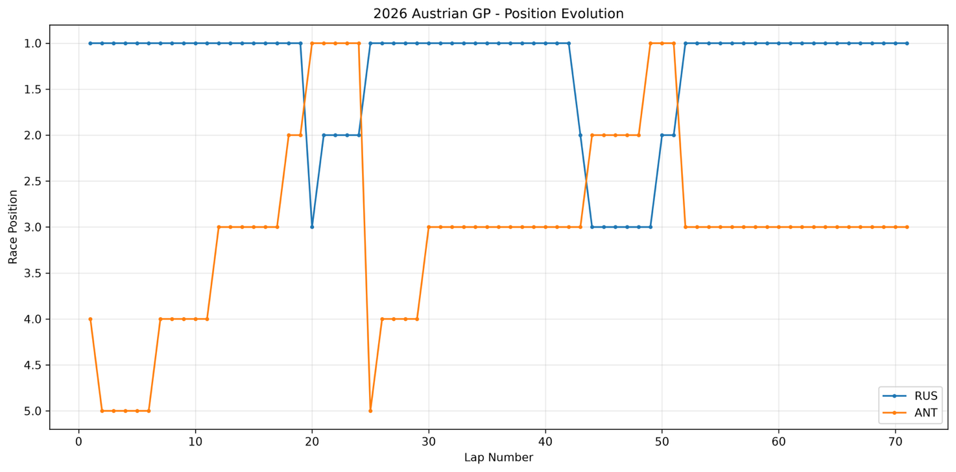
4.1.1 Position Evolution

Figure 4.1 – Position Evolution
Figure 4.1 illustrates the race-position evolution of Russell and Antonelli throughout the Austrian Grand Prix.
Russell remained at or close to the front of the race for the majority of the event. The principal changes visible in his position trace occur around the pit-stop phases, after which his track position was recovered as the pit sequence developed.
Antonelli began the race further down the order and improved his position during the opening phase. His trace also contains substantial position changes around the pit-stop windows before stabilising later in the race.
The figure demonstrates an important limitation of analysing race performance through position alone. Temporary changes in position do not necessarily correspond directly to changes in underlying pace, because pit-stop sequencing can substantially alter track position without representing an on-track performance loss.
Position evolution is therefore used primarily to establish race context. The subsequent analyses investigate representative lap times and stint behaviour in order to distinguish strategic position changes from underlying pace differences.

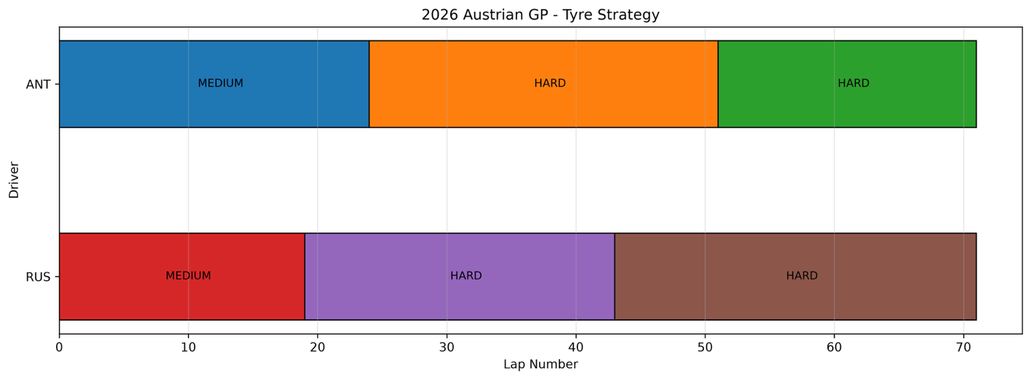
4.1.2 Tyre Strategy
Figure 4.2 – Tyre Strategy
Figure 4.2 presents the tyre-compound sequences used by Russell and Antonelli throughout the race.
Both drivers followed the same broad Medium–Hard–Hard compound sequence. This creates a useful basis for comparison because the overall strategic structure was similar, while the timing of the individual stops differed.
Russell completed his first tyre change earlier than Antonelli, producing an offset between the two drivers during the transition from the Medium to the first Hard stint. A similar offset developed during the second pit-stop sequence.
Consequently, the two cars did not operate on tyres of identical age at every point in the race. This is important when interpreting direct lap-time differences. A faster lap at a particular stage cannot automatically be attributed to driver performance because differences in tyre age, fuel load and race circumstances may also contribute.
The tyre-strategy analysis therefore establishes the operating context required for the subsequent stint comparison. Although the drivers used the same compound sequence, their tyre histories were not identical.

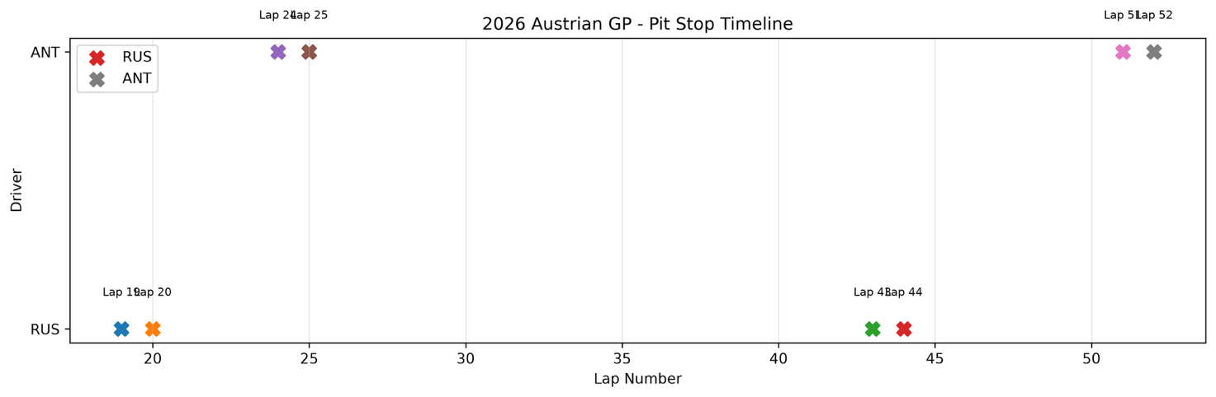
4.1.3 Pit Stop Timeline
Figure 4.3 – Pit Stop Timeline
Figure 4.3 summarises the timing of the pit-stop sequences completed by both drivers.
Russell completed his first stop around Lap 19, while Antonelli remained on the opening stint until approximately Lap 24. The second sequence was separated by a larger interval, with Russell stopping around Lap 43 and Antonelli around Lap 52.
These offsets created different tyre-age profiles throughout the race. Russell began both Hard-tyre stints earlier, while Antonelli remained on the preceding tyre set for longer before receiving a newer tyre later in the corresponding race phase.
This difference is particularly relevant to the final stint. Antonelli’s later stop meant that his final Hard tyres were newer during the closing laps, while Russell completed a longer final stint.
No additional pit-stop sequence is visible that would fundamentally change the strategic comparison. However, pit-stop timing should not be treated as an independent explanation of the final performance difference. Instead, it forms part of the context in which the lap-time and stint results must be interpreted.

4.2 Overall Race Pace
Race pace provides a more informative measure of sustained performance than isolated lap times. However, raw race laps contain several observations that are not representative of normal competitive performance, including pit-entry and pit-exit laps and other substantial outliers.
Representative laps were therefore selected according to the filtering methodology described previously. The resulting dataset is used to examine lap-time evolution, moving-average trends and statistical pace distributions.
Across the representative sample, the drivers demonstrated extremely similar overall race pace. Antonelli recorded a representative mean of approximately 71.83 s, compared with approximately 71.87 s for Russell.
The difference in mean representative pace is therefore only around 0.04 s per lap, indicating that the principal distinction between the drivers cannot be described simply as a large difference in underlying race speed.

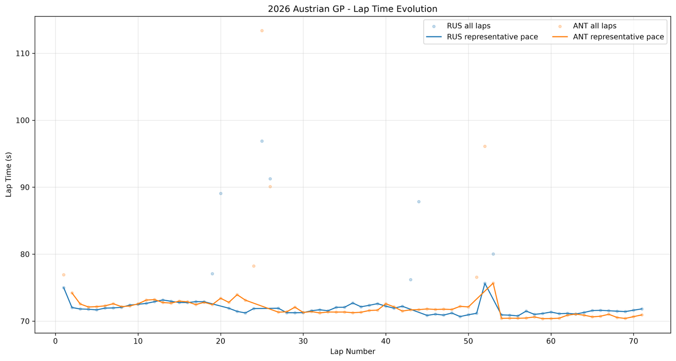
4.2.1 Lap Time Evolution
Figure 4.4 – Lap Time Evolution
Figure 4.4 illustrates the lap-time evolution of both drivers across the race, including the filtered representative pace traces.
The raw lap-time data contains several substantial increases associated with non-representative race events such as pit-stop phases. These laps should not be interpreted as direct indicators of competitive pace.
Once these effects are reduced through representative-lap filtering, both drivers display broadly comparable performance throughout the event. Their relative advantage changes across the race rather than remaining constant.
Russell demonstrates several extended phases of stable representative performance, particularly during the earlier and middle sections of the race. Antonelli shows greater variation across the complete representative sample but also produces increasingly competitive performance during later phases.
The figure therefore does not support the interpretation that either driver maintained a substantial underlying pace advantage throughout the complete race. Instead, the performance relationship changes according to race phase.
This observation motivates the use of moving average and stint analysis, which provide clearer information regarding how small lap-time differences developed over longer periods.

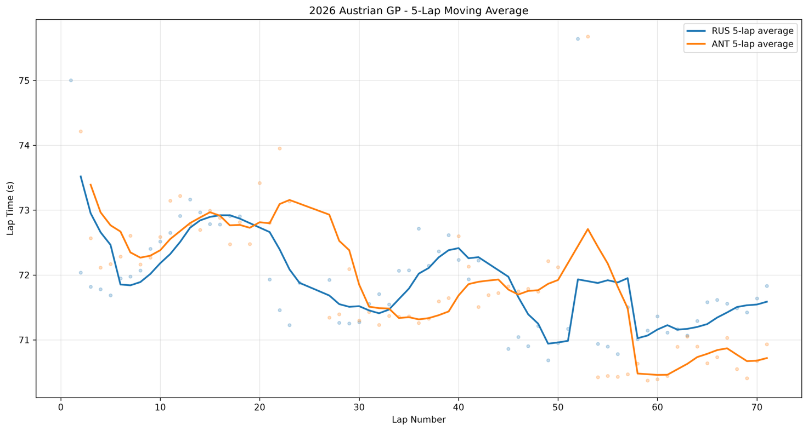
4.2.2 Five-Lap Moving Average
Figure 4.5 – Five-Lap Moving Average
A five-lap moving average was applied to reduce the influence of short-term lap-time fluctuations and reveal the underlying pace evolution more clearly.
Figure 4.5 demonstrates that the relative performance of the two drivers changed repeatedly throughout the race.
During sections of the opening phase, Russell maintained the stronger moving-average pace. The relationship became closer during the middle part of the event, with periods in which Antonelli matched or exceeded Russell’s representative performance.
The most visible change occurs during the final phase. Following Antonelli’s later second stop, his moving-average lap time decreases substantially and remains below Russell’s for much of the closing sequence.
This late-race improvement should not automatically be attributed to a single cause. Antonelli was operating with a different tyre-age profile, while fuel mass, traffic and other race conditions were also evolving.
Nevertheless, the moving-average analysis demonstrates that the performance relationship was dynamic. Russell held stronger phases earlier in the race, whereas Antonelli produced a sustained period of stronger representative pace during the closing stages.

4.2.3 Pace Distribution
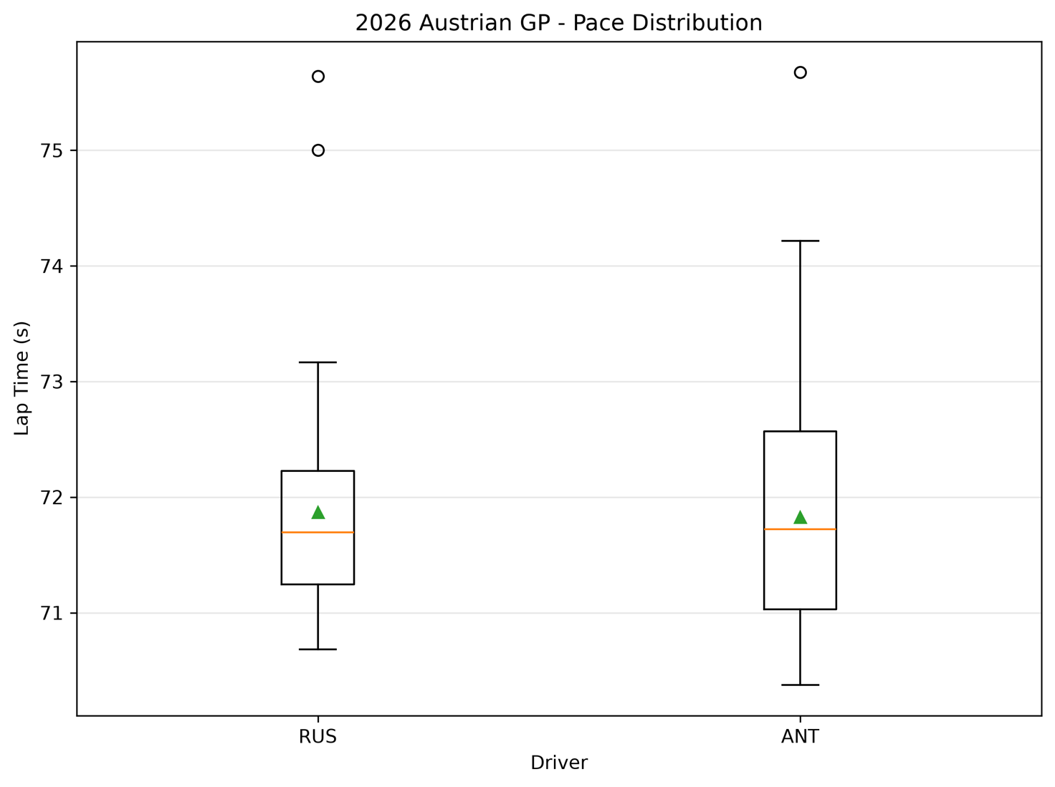
Figure 4.6 – Pace Distribution
The representative pace distribution provides information not only about typical lap time, but also about the variability with which that pace was produced.
The median representative lap times were extremely close:
- Russell: approximately 71.696 s
- Antonelli: approximately 71.723 s
The representative means were similarly close:
- Russell: approximately 71.87 s
- Antonelli: approximately 71.83 s
These values reinforce the conclusion that the underlying representative race pace of the two drivers was comparable.
A clearer difference appears in the spread of the distributions. Russell recorded a representative-lap standard deviation of approximately 0.89 s, compared with approximately 1.06 s for Antonelli.
Russell’s representative pace was therefore distributed within a narrower range, indicating lower lap-to-lap variability within the analysed sample. Antonelli’s distribution was wider, while also containing competitive laps at the faster end of the range.
The principal race-level distinction is therefore not simply one of average speed.
Instead, the distribution indicates two different performance characteristics:
Russell — lower variability and stronger repeatability
Antonelli — marginally stronger representative mean pace but greater variability
This distinction becomes important later when translating the analysis into driver-development objectives.

4.3 Stint Analysis
Overall race statistics can conceal substantial changes in relative performance between different tyre and fuel conditions. The race was therefore separated into individual stints to investigate how each driver’s representative pace evolved throughout the event.
Both drivers completed three principal stints:
Stint 1 — Medium
Stint 2 — Hard
Stint 3 — Hard
Mean pace, median pace, variability and observed lap-time trends were examined independently for each stint.

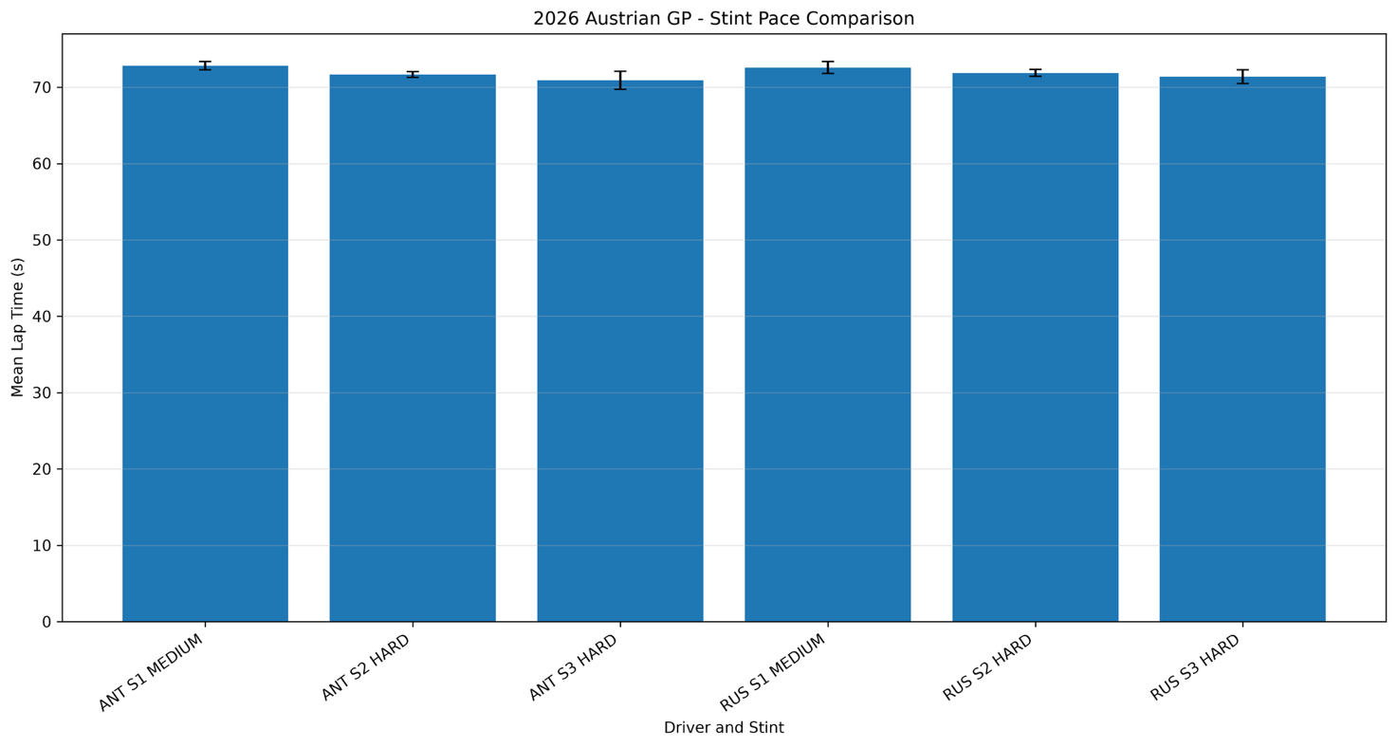
4.3.1 Stint Pace Comparison
Figure 4.7 – Stint Pace Comparison
The opening medium stint produced the clearest early advantage for Russell.
Representative mean pace was approximately:
Russell: 72.57 s
Antonelli: 72.81 s
Russell was therefore approximately 0.24 s per representative lap faster on average during this phase.
The performance relationship changed during the first Hard stint.
Representative mean pace was approximately:
Russell: 71.87 s
Antonelli: 71.66 s
Antonelli therefore produced the stronger mean representative pace during this phase.
The final Hard stint produced a further shift:
Russell: approximately 71.38 s
Antonelli: approximately 70.90 s
Antonelli recorded the faster mean pace within the respective final-stint samples.
These figures should not be interpreted as direct compound-performance comparisons because the stints occurred at different stages of the race and were not equal in length. Fuel load, tyre age and race circumstances differed between the drivers.
Nevertheless, the stint results demonstrate clearly that the relative performance advantage changed throughout the race. Russell was stronger in the opening medium phase, while Antonelli produced stronger representative averages during the later Hard-tyre phases.
This prevents the race from being characterised accurately through a single average lap-time comparison.

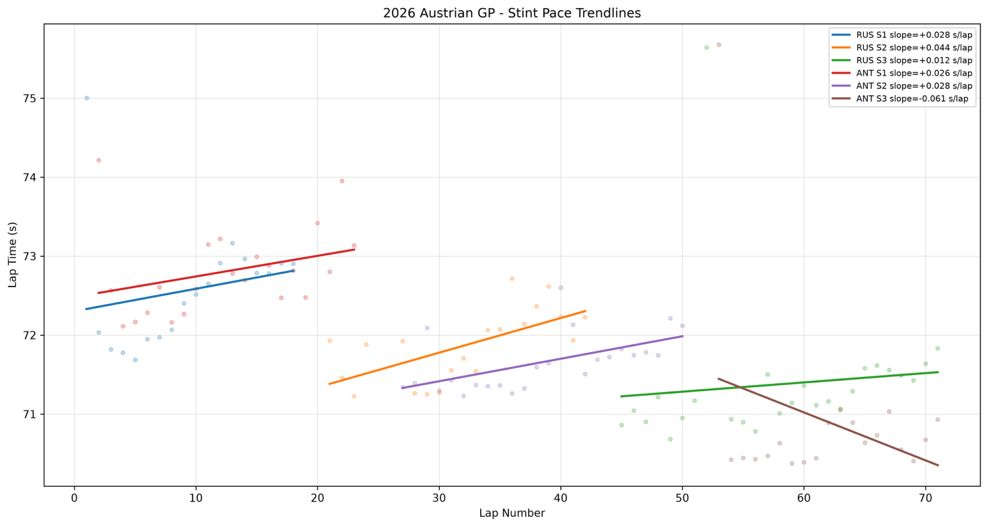
4.3.2 Stint Pace Trend Analysis
Figure 4.8 – Stint Pace Trendlines
Linear trendlines were applied to the representative laps within each stint to examine observed pace evolution.
Russell produced approximate slopes of:
- Stint 1: +0.028 s/lap
- Stint 2: +0.044 s/lap
- Stint 3: +0.012 s/lap
Antonelli produced:
- Stint 1: +0.026 s/lap
- Stint 2: +0.028 s/lap
- Stint 3: −0.061 s/lap
The opening-stint slopes are similar, indicating comparable observed pace evolution during the Medium-tyre phase.
During Stint 2, Russell’s lap-time trend increased more rapidly than Antonelli’s. Antonelli therefore maintained a more stable observed pace trend within this particular Hard-tyre sample.
The most distinctive result occurs during Antonelli’s final stint, where the calculated slope is negative. His representative lap times therefore became progressively faster across the analysed sample.
This must not be interpreted as negative physical tyre degradation. Observed lap-time evolution is influenced simultaneously by tyre condition, decreasing fuel mass, traffic, track evolution and driver pace. The trendline measures the net change in observed lap time rather than tyre degradation in isolation.
The correct interpretation is therefore that Antonelli produced an improving observed pace trend during the final stint, while Russell’s final-stint representative pace remained comparatively stable.

Engineering Interpretation
The stint analysis demonstrates that neither driver maintained a constant advantage across all operating conditions.
Russell produced stronger representative performance during the opening medium stint, while Antonelli became comparatively stronger during later phases.
This changing relationship suggests that driver performance should be evaluated in combination with tyre age, fuel state and race progression rather than using a single race-wide metric.
Confidence Level: Medium
Supporting Evidence:
- representative stint lap times;
- stint mean and median pace;
- linear pace trends.
Unavailable or Uncontrolled Information:
- tyre temperature;
- tyre pressure;
- physical tyre wear;
- fuel-corrected lap time;
- traffic effect;
- detailed vehicle balance.

4.4 Sector Performance Analysis

4.4.1 Sector Time Comparison
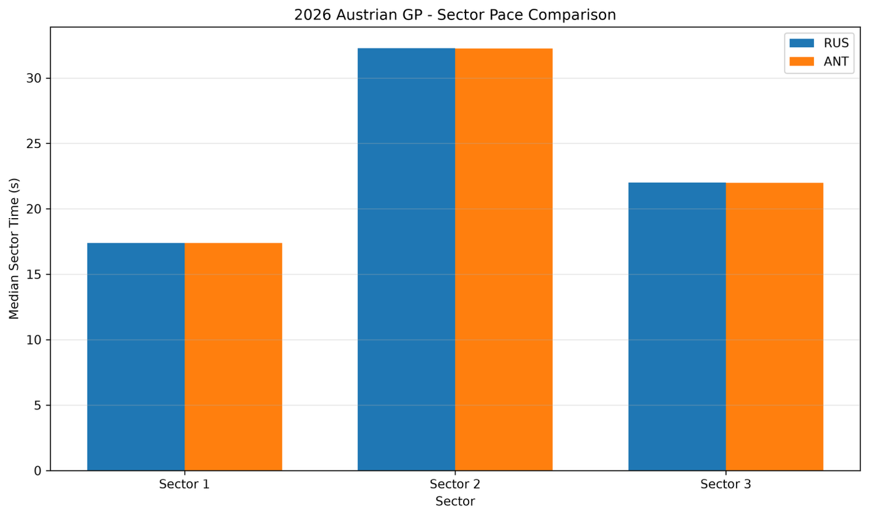
Figure 4.9 – Sector Pace Comparison
Sector analysis provides a first level of spatial localisation by determining whether the overall performance difference is concentrated within a particular part of the circuit.
The representative median sector times were:
Sector | Russell | Antonelli | ANT − RUS | Advantage
Sector 1 | 17.384 s | 17.388 s | +0.004 s | Russell
Sector 2 | 32.278 s | 32.249 s | −0.029 s | Antonelli
Sector 3 | 22.014 s | 21.999 s | −0.015 s | Antonelli
The sector differences are extremely small.
Sector 1 is effectively equal within the representative comparison. Antonelli holds a small median advantage in Sector 2 and a further small advantage in Sector 3.
However, none of the three sectors independently accounts for a substantial overall performance difference.
The sector results therefore support two conclusions.
First, the drivers operated at a broadly comparable level across the complete circuit.
Second, sector timing alone does not provide sufficient resolution to identify the mechanisms responsible for the smaller differences. A sector can contain several corners, braking zones and acceleration phases in which gains and losses partially cancel.
For this reason, the later telemetry investigation divides the circuit into individual corner regions and examines speed and driver-input traces in greater detail.

4.5 Integrated Race-Level Engineering Discussion
The combined race-level results demonstrate that the performance relationship between Russell and Antonelli was more complex than the finishing order or an isolated lap-time comparison would suggest.
Russell demonstrated the stronger opening-stint representative pace and the narrower overall pace distribution. His representative-lap standard deviation of approximately 0.89 s, compared with approximately 1.06 s for Antonelli, indicates greater repeatability within the analysed race sample.
Antonelli, however, recorded a marginally faster representative mean pace across the race and became particularly competitive during the later phases. His second and third stint representative means were faster than Russell’s corresponding values.
The sector analysis further demonstrates that the broad circuit-level difference was small. No single official sector provides a sufficient explanation for the overall performance relationship.
The evidence therefore suggests that the drivers produced similar overall performance through different race-level characteristics.
Within the analysed representative sample, Russell’s clearest statistical characteristic was lower lap-time variability, while Antonelli recorded a marginally lower mean lap time but greater variability.
This distinction is more useful from a performance-engineering perspective than simply assigning one driver the label of “faster.”
However, race-level analysis remains primarily descriptive. It can establish when performance differences developed and how large they became but cannot independently determine the precise driver-input mechanisms responsible.
That requires the detailed telemetry analysis presented later in the report.

4.6 Chapter Summary
This chapter investigated the race-level performance of George Russell and Andrea Kimi Antonelli during the 2026 Austrian Grand Prix using position evolution, tyre strategy, pit-stop timing, representative lap times, pace distributions, stint analysis, sector timing.
The analysis demonstrates that the drivers possessed closely matched representative race pace but delivered that performance differently.
Antonelli recorded a marginally faster representative mean pace of approximately 71.83 s, compared with approximately 71.87 s for Russell. Russell, however, demonstrated lower representative-lap variability, with a standard deviation of approximately 0.89 s compared with approximately 1.06 s for Antonelli.
The stint analysis revealed that the relative advantage changed throughout the race. Russell produced the stronger representative mean during the opening medium stint, while Antonelli recorded stronger representative averages during the later Hard-tyre phases.
The race-phase and stint analyses further demonstrated the dynamic nature of the comparison. Russell produced the stronger representative performance during the opening medium stint, whereas Antonelli became comparatively stronger during the later Hard-tyre phases. The five-lap moving-average analysis supports this transition, showing that the relative performance advantage changed repeatedly rather than remaining fixed throughout the race.
Sector timing showed only very small differences between the drivers and therefore did not identify one broad circuit section as the dominant source of the performance difference.
The central race-level conclusion is therefore that the difference between Russell and Antonelli is better described as a difference in performance delivery than as a simple difference in absolute speed.
Russell demonstrated lower variability within the representative sample, while Antonelli recorded a marginally lower representative mean and particularly competitive performance during later race phases.
However, the race-level analysis establishes primarily what happened and when. It cannot independently determine the detailed driver-input mechanisms responsible for those differences.
The following chapters therefore progress from race-level performance towards corner-level telemetry, where speed, braking, throttle application, gear selection are used to investigate how the observed performance differences were generated.

CHAPTER 5. PERFORMANCE DISCUSSION
5.1 Overall Race Performance
The analysis of the 2026 Austrian Grand Prix reveals a close but contrasting performance profile between George Russell and Kimi Antonelli. While their overall representative race pace was similar, the manner in which this performance was produced differed throughout the race.
For the detailed comparison, representative clean laps were selected to reduce the influence of traffic, pit activity and other race-specific disturbances. The selected representative lap was 70.374 s for Antonelli and 70.683 s for Russell, giving Antonelli a 0.309 s advantage within this specific lap comparison. These values should not be interpreted independently as a measure of overall race pace, as individual laps remain influenced by fuel load, tyre condition and race circumstances.
The representative mean pace provides a more appropriate indication of sustained performance. Antonelli recorded approximately 71.83 s, compared with approximately 71.87 s for Russell, demonstrating that the difference in their overall representative race pace was extremely small. Antonelli therefore held a slight advantage in mean representative pace despite Russell showing competitive performance across several phases of the race.
The sector analysis reinforces this observation. Median sector times were almost identical between the two drivers. Russell recorded approximately 17.384 s, 32.278 s and 22.014 s across Sectors 1, 2 and 3 respectively, while Antonelli recorded approximately 17.388 s, 32.249 s and 21.999 s.
The differences are therefore measured in only hundredths of a second. Sector-level analysis does not identify one broad section of the circuit as being solely responsible for the performance difference. Instead, the result appears to develop through the accumulation of smaller differences across multiple parts of the lap and throughout changing race conditions.
This sector-level comparison provides an initial localisation of performance differences. A more detailed corner-by-corner telemetry investigation is therefore required to determine precisely where and how these smaller differences were generated.

5.2 Tyre Management and Stint Behaviour
The stint analysis provides a clearer indication of how the performance relationship evolved throughout the race.
Both drivers began the race on the medium compound before completing two subsequent stints on the hard compound. This provides a useful comparison because the drivers operated under broadly similar tyre strategies.
During the first stint, Antonelli recorded a mean lap time of approximately 72.81 s, compared with approximately 72.57 s for Russell. Russell therefore demonstrated the stronger average pace during this initial medium-tyre phase.
The situation changed during the second stint. Antonelli’s mean pace improved to approximately 71.66 s, while Russell recorded approximately 71.87 s. Antonelli therefore gained an advantage during the first hard-tyre stint.
The final stint produced the clearest contrast. Antonelli recorded an average of approximately 70.90 s, compared with approximately 71.38 s for Russell.
However, average stint pace should not be interpreted independently of stint position, fuel load and tyre age. Later stints naturally occur with a lighter car, meaning direct comparison between Stint 1 and Stint 3 does not represent tyre performance alone.
The degradation trendlines provide additional information. Russell’s observed stint pace slopes were:
- S1: +0.028 s/lap
- S2: +0.044 s/lap
- S3: +0.012 s/lap
Antonelli produced:
- S1: +0.026 s/lap
- S2: +0.028 s/lap
- S3: −0.061 s/lap
The negative trend in Antonelli’s final stint is particularly interesting. Rather than becoming progressively slower, his observed lap times improved. This should not automatically be interpreted as negative physical tyre degradation. Fuel burn, changing traffic conditions and increasing driver pace can outweigh the effect of tyre degradation within the observed lap-time data.
Consequently, the final stint indicates that Antonelli was able to extract increasingly competitive pace late in the race, but the available data does not allow this improvement to be attributed exclusively to tyre management.

5.3 Repeatability and Accessible Pace
Russell recorded a representative-lap standard deviation of approximately 0.89 s, compared with approximately 1.06 s for Antonelli. This indicates that Russell’s representative lap times were distributed within a narrower range in the analysed sample.
Antonelli nevertheless recorded a marginally lower representative mean and produced the faster of the two selected representative laps later used for telemetry analysis. This demonstrates that locally faster performance was present within the analysed sample but does not establish a higher absolute performance ceiling.
From a performance-engineering perspective, the objective is therefore not simply to maximise the fastest observed lap. Competitive performance requires strong pace to be accessed repeatedly and converted effectively within the constraints of the race.

5.4 Race-Phase Evolution
The relative performance relationship between Russell and Antonelli was not constant throughout the race. Instead, the stint and moving-average analyses indicate that the balance changed between the opening, middle and closing phases.
Russell recorded the stronger representative mean during the opening medium stint, with approximately 72.57 s compared with Antonelli’s 72.81 s. During the first Hard-tyre sample, the relationship reversed, with Antonelli recording approximately 71.66 s compared with Russell’s 71.87 s. Antonelli also recorded the lower representative mean during the respective final Hard-tyre samples.
The five-lap moving-average analysis supports this changing relationship, showing stronger phases for Russell earlier in the race and increasingly competitive representative pace from Antonelli later in the event.
However, these phases were not produced under controlled, identical operating conditions. Differences in tyre age, fuel mass, traffic, pit-stop timing and track position prevent the observed changes from being attributed to a single mechanism.
The engineering significance of the result is therefore not that one driver became inherently faster than the other. Rather, the analysis identifies when the relative performance relationship changed, allowing the subsequent telemetry investigation to target specific phases and performance characteristics.

5.5 Engineering Interpretation
The race-level analysis indicates that the performance relationship between Russell and Antonelli cannot be represented adequately by a single lap-time metric. Instead, the available evidence identifies differences in performance delivery across changing race conditions.
Russell achieved the stronger overall competitive outcome and demonstrated lower lap-to-lap variability within the representative sample. His stronger opening-stint representative pace further indicates that competitive performance was accessible during the early Medium-tyre phase. Antonelli, meanwhile, recorded a marginally lower race-wide representative mean and lower representative means during the later Hard-tyre samples. These observations describe different phases of the race rather than establishing a single performance hierarchy between the drivers.
From an engineering perspective, the most important result is therefore the change in relative performance across race phases. The comparison suggests that the conditions under which each driver produced stronger representative performance were not identical. However, because tyre age, fuel load, traffic, track position and other race-dependent variables changed simultaneously, the race-level data cannot determine whether these differences originated primarily from driver execution, vehicle behaviour or operating conditions.
The sector analysis provides a further constraint on interpretation. The small median differences across all three sectors indicate that the performance relationship was not dominated by one broad section of the circuit. Local gains and losses may instead occur within individual braking, cornering and acceleration phases and partially cancel when aggregated into complete sector times.
The engineering task is therefore not to conclude that one driver should reproduce the other’s overall driving approach. Instead, the race-level results should be used to identify where higher-resolution investigation is required.
Three questions emerge from the analysis:
- Where within the lap are the measurable performance differences generated?
- Which observable driver-input or speed characteristics accompany those differences?
- Which findings represent repeatable performance characteristics rather than isolated selected-lap effects?
These questions define the transition from race-performance description to performance diagnosis. Chapter 6 therefore investigates selected representative laps at corner level, using speed, throttle, binary brake state, gear selection and cumulative time delta to localise the observed differences while maintaining a clear distinction between directly observed evidence and engineering interpretation.

5.6 Limitations of the Race-Level Analysis
The results presented in Chapters 4 and 5 are based on publicly available race timing data and should therefore be interpreted within the limitations of the available dataset. Although representative-lap filtering reduces the influence of pit-entry, pit-exit and major non-representative laps, it does not create fully controlled like-for-like comparisons between the two drivers.
Russell and Antonelli completed representative laps under different combinations of fuel load, tyre age, tyre condition, traffic, track position and changing circuit conditions. DRS availability and other race-dependent factors may also influence individual lap times. Consequently, differences in representative mean pace, stint behaviour or lap-time variability cannot be attributed exclusively to driver execution.
The stint trendlines require particular caution. A positive or negative lap-time slope represents the net observed evolution of pace within the analysed stint and should not be interpreted as a direct measurement of physical tyre degradation. Decreasing fuel mass, changing traffic conditions, track evolution and tyre behaviour may all contribute simultaneously to the observed trend.
The available public data also limits causal interpretation at vehicle level. Detailed information such as tyre temperatures and pressures, aerodynamic balance, vehicle setup, energy-management strategy and other internal vehicle-state parameters is unavailable. The analysis can therefore identify performance patterns and generate engineering hypotheses but cannot independently establish the complete physical cause of those patterns.
Chapter 6 reduces some of this uncertainty by examining selected-lap telemetry at higher spatial resolution. However, telemetry analysis does not remove the limitations entirely. In particular, the absence of continuous brake-pressure data, steering-angle information and detailed tyre-state measurements restricts the extent to which differences in braking technique, vehicle rotation or tyre behaviour can be determined directly.
For this reason, the conclusions of the race-level analysis are treated according to a distinction between observable evidence and engineering interpretation. Directly measured timing differences are reported as findings, while explanations of their underlying mechanisms are treated as hypotheses requiring further telemetry analysis or controlled validation.

5.7 Transition to Corner-Level Telemetry Analysis
The race-level analysis establishes that Russell and Antonelli produced closely matched representative pace but differed in how that performance was distributed across the race. Russell achieved the stronger overall competitive outcome and showed lower variability within the filtered representative sample, while Antonelli recorded lower representative mean lap times during particular later race phases.
Sector analysis provides an initial indication of where these differences may have occurred, but its resolution is insufficient for detailed performance diagnosis. Each sector contains multiple braking, cornering and acceleration phases, meaning that local gains and losses can partially cancel before appearing in the final sector time.
The next stage of the investigation therefore moves from race-level performance to corner-level telemetry.
Chapter 6 compares selected representative laps from Russell and Antonelli using speed, throttle, binary brake state, gear selection and cumulative lap-time delta. The circuit is then divided into selected corner windows to determine where the lap-time difference develops and whether individual gains occur primarily during entry, minimum-speed or exit phases.
This progression changes the central engineering question from:
What performance differences were observed during the race?
to:
Where were those differences generated, and what does the available telemetry indicate about how they developed?
The objective is not to infer a definitive driving mechanism from every difference. Instead, the telemetry analysis is used to localise performance opportunities, distinguish observation from hypothesis, and identify the most valuable areas for subsequent engineering investigation and driver-development testing.
This provides the link between the race-level findings of Chapters 4 and 5 and the detailed performance diagnosis developed in Chapter 6.

CHAPTER 6. CORNER-LEVEL TELEMETRY AND PERFORMANCE DIAGNOSIS

6.1 Objective of the Telemetry Investigation
The race-level analysis demonstrated that George Russell and Kimi Antonelli produced broadly comparable overall performance during the 2026 Austrian Grand Prix but delivered that performance in different ways. Russell achieved the stronger overall competitive outcome by winning the race and demonstrated lower lap-to-lap variability within the filtered representative sample. Antonelli, meanwhile, recorded a marginally lower representative mean lap time and lower representative lap times during later race phases. These race-level metrics do not establish superior overall performance for Antonelli, but they identify specific performance characteristics that warrant more detailed investigation.
Race-level statistics, however, primarily describe what happened. They do not independently explain how the lap time was generated.
The purpose of this chapter is therefore to move from statistical comparison to driver-performance diagnosis using representative-lap telemetry.
The investigation combines speed, throttle position, brake state, gear selection and cumulative time delta. Emphasis is placed on identifying where lap-time differences develop within individual corners and whether those differences can be associated with observable changes in vehicle speed or driver input.
The analysis follows the general sequence:
Approach → Braking → Entry → Minimum Speed → Throttle Transition → Exit
This structure is important because an individual corner-time difference can result from several different mechanisms. A driver may gain through braking, speed retention, a shorter transition to acceleration, or stronger exit performance.
Consequently, the objective is not simply to determine which driver was faster at each corner, but to establish where the performance difference developed, how it was sustained, and whether it represents a reproducible driver-development opportunity.

6.2 Representative Lap Selection
The telemetry comparison uses one selected representative lap from each driver.
Driver | Selected Representative Lap
George Russell | 70.683 s
Kimi Antonelli | 70.374 s
Difference | 0.309 s
The selected laps are used as diagnostic case studies rather than evidence of the drivers’ maximum performance capability.
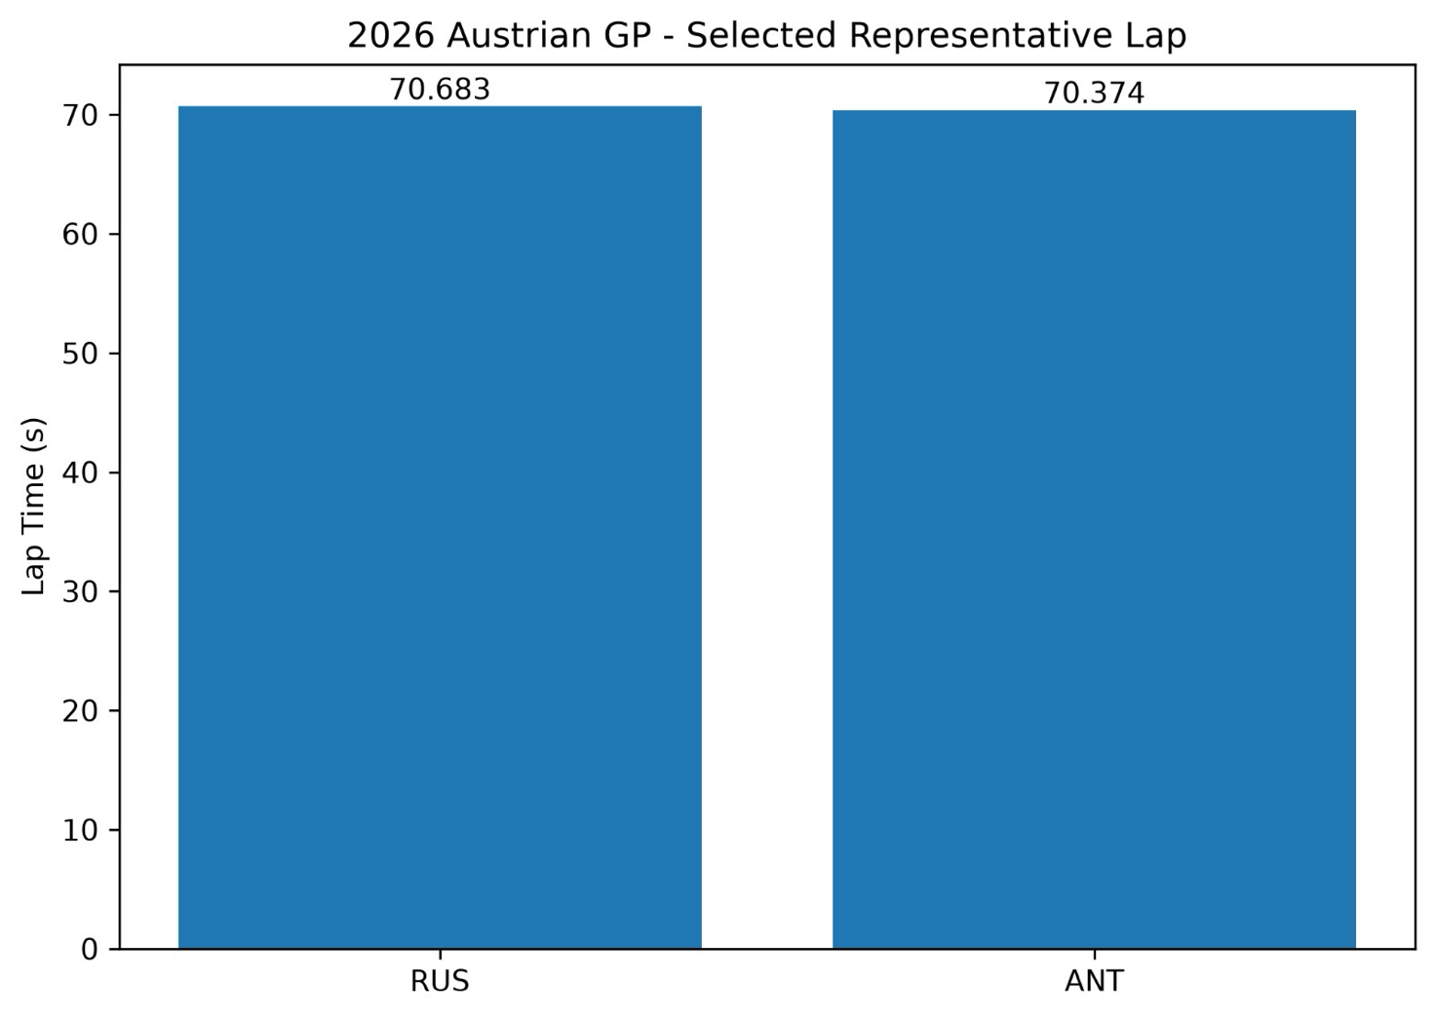
Figure 6.1 – Selected Representative Lap Comparison
These values should not be interpreted as the drivers’ absolute fastest laps or as a complete representation of race pace. Instead, they provide a controlled basis for investigating how two representative performances were constructed.
The complete speed traces show that the drivers followed broadly similar performance patterns around the lap. Major braking events, acceleration zones and gear-selection behaviour occur in comparable locations.
The 0.309 s difference therefore does not appear to result from a fundamentally different approach to the lap. Instead, the advantage develops through multiple smaller differences distributed around the circuit.
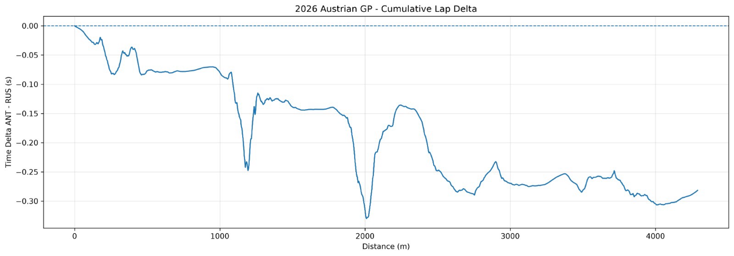
This is reinforced by the cumulative representative-lap delta.

Figure 6.2 – Cumulative Representative Lap Delta
Using the convention:
$$Δt = t_{\left\{ANT\right\}}-t_{\left\{RUS\right\}}$$
negative values indicate an Antonelli advantage.
The cumulative trace finishes close to the observed −0.309 s representative-lap difference, while also showing that the rate at which the advantage develops changes substantially around the circuit.
This makes corner-level localisation necessary.

6.3 Corner-Level Performance Distribution
The selected corner analysis produced the following differences:
Corner | ANT − RUS | Advantage
T1 | −0.067 s | Antonelli
T3 | −0.042 s | Antonelli
T4 | +0.013 s | Russell
T6 | −0.145 s | Antonelli
T7 | +0.009 s | Russell
T9 | −0.025 s | Antonelli
T10 | −0.047 s | Antonelli
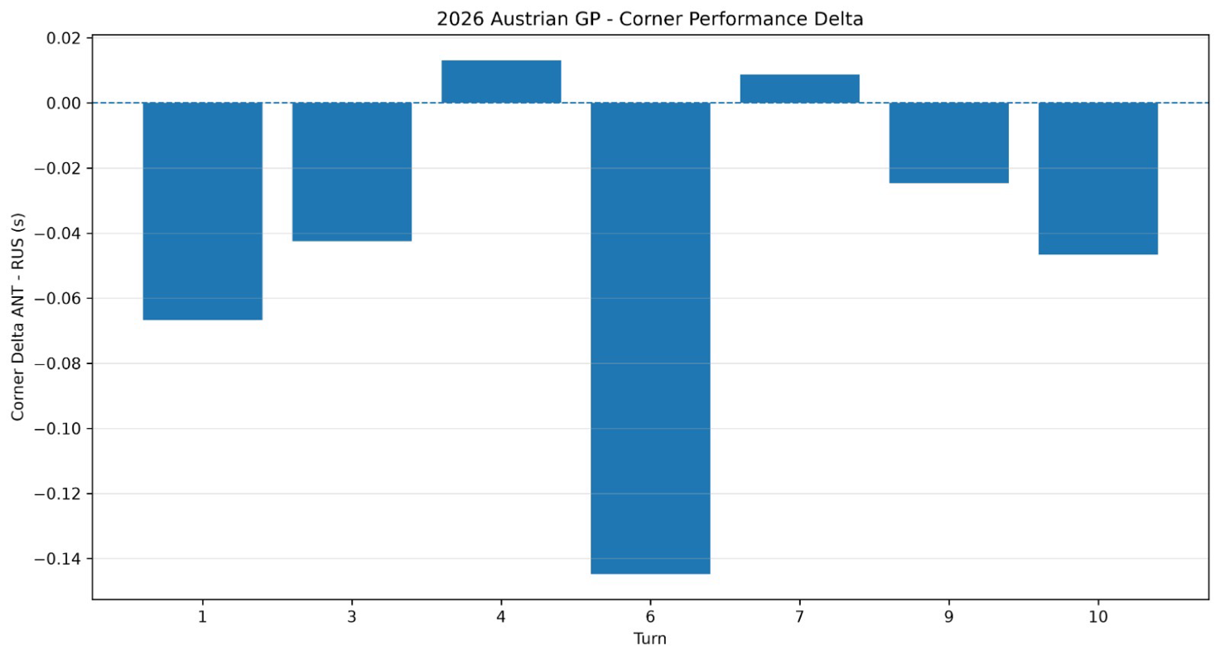
Figure 6.3 – Corner Performance Delta
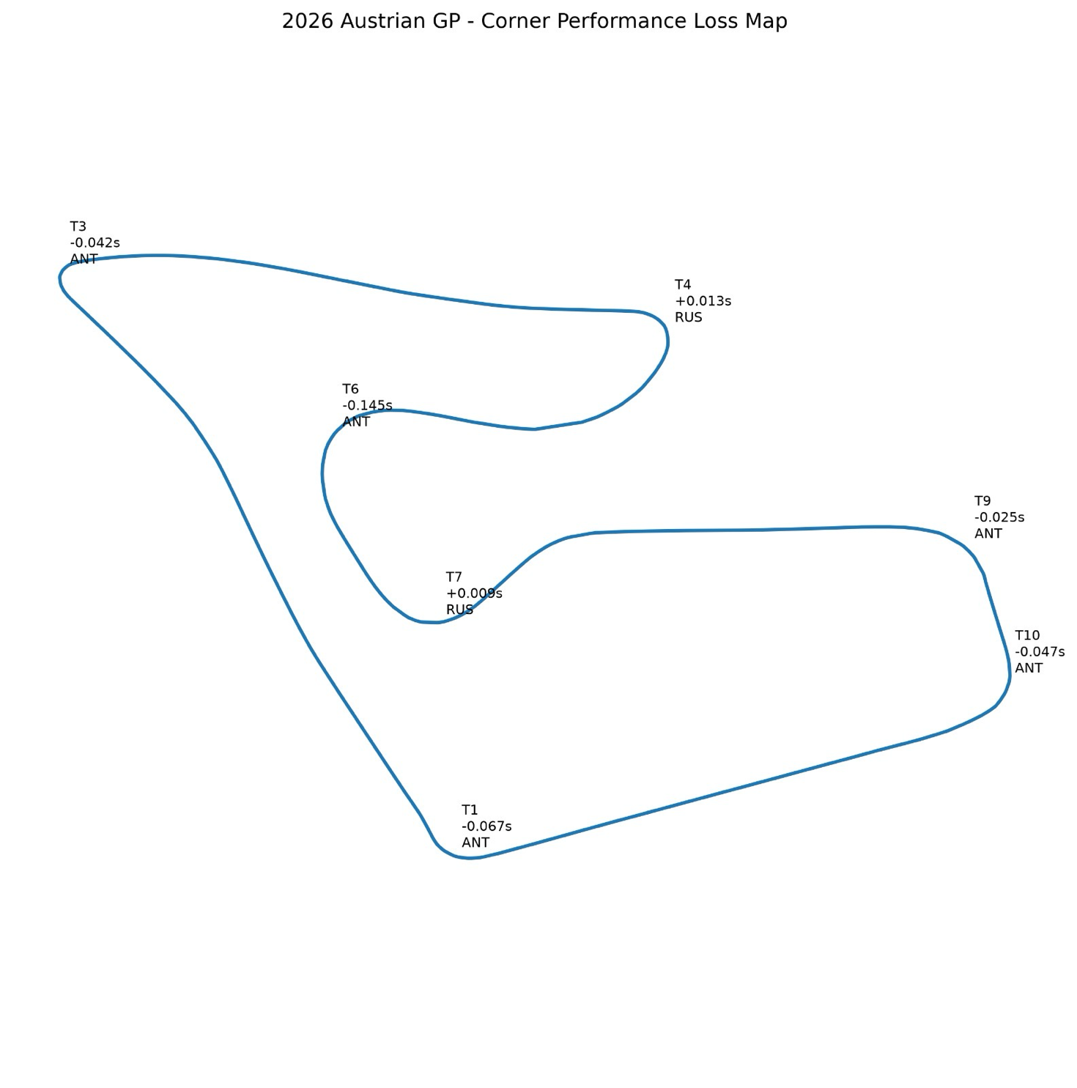
Figure 6.4 – Corner Performance Loss Map
The results immediately demonstrate that Antonelli’s representative-lap advantage was not uniformly distributed.
Antonelli gained at T1, T3, T6, T9 and T10, whereas Russell produced smaller advantages at T4 and T7.
The largest individual differentiator was Turn 6, where Antonelli gained approximately 0.145 s within the defined analysis window.
This represents almost half of the complete 0.309 s representative-lap difference and therefore makes T6 the highest-priority diagnostic target.
However, the remaining corners provide an important warning against assuming that one driving characteristic explains every Antonelli advantage. Different corners display different relationships between entry speed, minimum speed and resulting time delta.

6.4 Braking and Driver-Input Interpretation
The brake telemetry shows broadly similar brake-application architecture between the drivers.
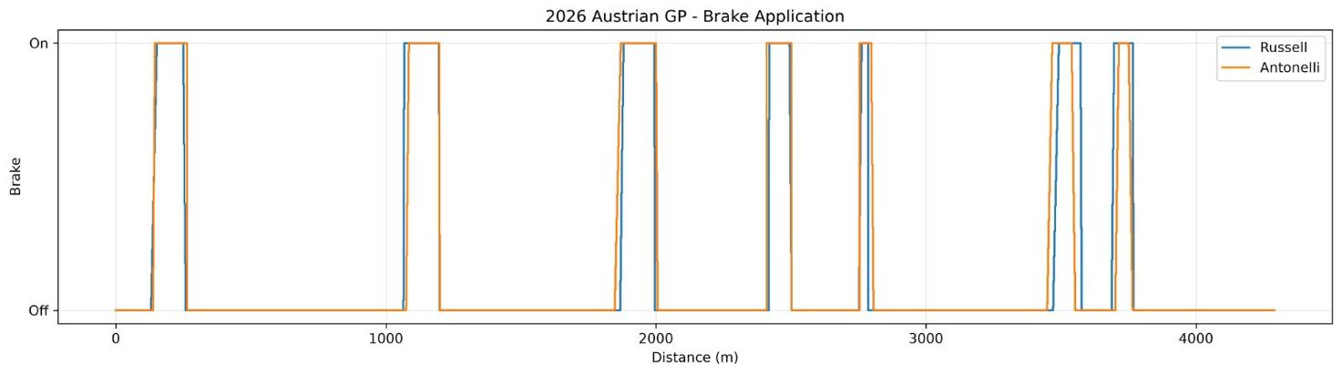
Figure 6.5 – Brake Application
However, the public FastF1 Brake channel does not provide detailed brake-pressure information. It therefore cannot establish whether one driver applied greater pressure, released the brake more progressively, or used a different trail-braking profile.
For this reason, statements such as:
“Driver A braked harder” cannot be established reliably from the available brake trace.
The previously derived longitudinal-acceleration channel also contains large instantaneous spikes produced by numerical differentiation of sampled speed data. These values should not be interpreted as physical vehicle acceleration or direct braking force.
The derived acceleration trace may provide qualitative information about the timing and shape of speed-change events, but it is not used as primary quantitative evidence in the driver diagnosis.
The more defensible analysis therefore combines:
brake state + speed trace + minimum speed + throttle transition + cumulative time delta.
This provides a stronger basis for determining the performance consequence of a braking event without claiming information that the public telemetry does not contain.

6.5 Minimum Speed Is Not a Universal Performance Indicator
One of the clearest findings from the corner analysis is that higher minimum speed does not automatically correspond to the faster corner.
For example, at Turn 3:
Metric | Russell | Antonelli
Minimum speed | 69.0 km/h | 64.4 km/h
Despite Russell recording a minimum speed approximately 4.6 km/h higher, Antonelli was approximately 0.042 s faster across the defined T3 analysis window.
Antonelli’s minimum speed was approximately 4.6 km/h lower, yet he still gained approximately 0.042 s within the defined corner window.
This is important because it prevents an overly simple interpretation of the telemetry.
Antonelli’s advantage at T3 cannot be explained by greater minimum-speed retention alone.
The result demonstrates that corner performance must be evaluated as a complete sequence. A driver can accept a lower minimum speed if the preceding or subsequent phases compensate sufficiently through entry, rotation or acceleration.
The public telemetry does not contain steering angle or detailed vehicle-balance information, so the precise mechanism at T3 cannot be isolated with high confidence.
Nevertheless, the result provides an important engineering principle for the remainder of the analysis:
Higher minimum speed should only be considered beneficial when it produces a measurable time advantage across the complete corner sequence.

6.6 Turn 6 – Primary Performance Differentiator
Turn 6 provides the strongest opportunity for detailed diagnosis because it produced the largest selected corner-time difference.
Antonelli gained approximately 0.145s relative to Russell within the defined T6 analysis window.
Unlike T3, the T6 speed data supports a relationship between greater speed retention and the resulting time advantage.
The minimum speeds were:
T6 Metric | Russell | Antonelli | Difference
Minimum speed | 161.08 km/h | 163.00 km/h | +1.92 km/h ANT
Minimum-speed location | 2552 m | 2550 m | 2 m earlier ANT
Antonelli therefore carried approximately 1.9 km/h more minimum speed through the analysed T6 sequence.
However, the most significant result appears when the cumulative time delta is decomposed through the corner.
At the beginning of the defined T6 window, the cumulative ANT − RUS delta was approximately:
-0.142s
Around the minimum-speed region it had increased to approximately:
-0.261s
and by the end of the defined window, it reached approximately:
-0.287s
Therefore, within T6:
$$Δt_{\left\{Entry→Min\right\}} ≈-0.118s$$
while:
$$Δt_{\left\{Min→Exit\right\}} ≈-0.027s$$
The total change is approximately:
-0.145s
which agrees with the independently calculated T6 corner delta.
Approximately 82% of the measured T6 advantage therefore develops before the minimum-speed region, with the remaining 18% developing afterwards.
This is one of the most important findings of the telemetry investigation.
It indicates that Antonelli’s T6 advantage cannot primarily be described as an exit-only gain. The majority of the difference is already established during the approach-to-minimum-speed phase.

6.6.1 Turn 6 Throttle Transition
Although the majority of the T6 advantage develops before minimum speed, Antonelli also demonstrates a measurable difference during the transition back to acceleration.
Following minimum speed:
T6 Throttle Metric | Russell | Antonelli | ANT Difference
Distance to 50% throttle | 30 m | 24 m | 6 m earlier
Distance to 90% throttle | 70 m | 64 m | 6 m earlier
Brake release → 50% throttle | 86 m | 74 m | 12 m shorter
Antonelli therefore reached both 50% and 90% throttle approximately 6 m sooner relative to his minimum-speed location.
The measured brake-release-to-50%-throttle transition was also approximately 12 m shorter.
Approximately 100 m beyond the defined T6 corner centre, Antonelli was travelling around:
182.96 km/h
compared with:
180.19 km/h
for Russell, an advantage of approximately:
+2.77 km/h
The combination of the time-delta and throttle data therefore produces a more nuanced interpretation.
Antonelli does not gain the majority of the T6 time simply because he reaches throttle earlier. Most of the difference has already developed before minimum speed.
Instead, the earlier throttle transition appears to preserve and reinforce an advantage generated earlier in the corner.
The T6 performance mechanism can therefore be summarised as:
The observable T6 pattern can therefore be summarised as: an advantage developing predominantly during the entry-to-mid-corner phase, accompanied by higher minimum speed, a shorter transition to significant throttle, and a downstream speed advantage.
This interpretation is considerably stronger than identifying either braking point or throttle application independently.

6.6.2 Turn 6 Engineering Diagnosis
The available evidence supports the following diagnosis:

What the data demonstrates
Antonelli gains approximately 0.145 s through the T6 analysis window.
Approximately 0.118 s of that gain develops before the minimum-speed region.
Antonelli carries approximately 1.9 km/h greater minimum speed.
He reaches 50% and 90% throttle approximately 6 m sooner after minimum speed.
His brake-release-to-50%-throttle transition is approximately 12 m shorter.
A downstream speed advantage remains after the corner.

What the data suggests
The primary performance differentiator is in the entry-to-mid-corner phase, rather than being purely an acceleration or exit effect.
Antonelli then converts that initial advantage effectively into the subsequent acceleration phase.

What the data cannot establish
The public telemetry cannot determine whether the difference was produced by:
- steering input,
- brake-pressure modulation,
- trail-braking technique,
- tyre condition or temperature,
- aerodynamic balance,
- differential behaviour,
- or another vehicle-state difference.
The correct conclusion is therefore not that Russell simply needed to brake later or apply throttle earlier.
Instead, T6 represents a candidate for targeted investigation of entry-to-mid-corner speed retention and subsequent throttle transition.
Confidence in location of performance difference: High
Confidence in observable speed/throttle pattern: High
Confidence in underlying physical cause: Low Medium

6.7 Turn 6–7 Sequence Interaction
Turn 7 provides an important constraint on any T6 development recommendation.
Antonelli gains approximately:
0.145s
at T6, while Russell subsequently holds an approximately:
0.009s
advantage at T7.
Russell’s T7 advantage is small relative to the preceding T6 loss, meaning that the combined sequence still strongly favours Antonelli.
Nevertheless, the reversal demonstrates why T6 should not be optimised independently.
Changes intended to increase Russell’s T6 minimum speed or reduce his transition to throttle could alter vehicle positioning and preparation for T7.
Therefore, the development objective should not be:
maximise Turn 6 performance independently.
Instead, it should be:
recover part of the T6 deficit while preserving Russell’s existing competitiveness through T7.
This is particularly important in connected corner sequences, where the fastest isolated corner technique does not necessarily produce the fastest combined section.

6.8 Final-Sector Performance: Turns 9 and 10
Antonelli also produced advantages at both selected final-sector corners:
- T9: approximately 0.025 s
- T10: approximately 0.047 s
This produces a combined selected-corner advantage of approximately:
0.072s
across T9 and T10.
Turn 10 provides another notable speed-retention example.
Minimum speeds were approximately:
T10 | Minimum Speed
Russell | 161.10 km/h
Antonelli | 164.13 km/h
Antonelli therefore carried approximately:
+3.03 km\h
more minimum speed.
The throttle data also indicates that Antonelli reached 90% throttle approximately 10 m sooner after the minimum-speed point in the analysed sequence.
Unlike T3, the direction of these differences is consistent with the corner-time result: Antonelli combines a higher minimum speed with a faster transition towards high throttle and gains approximately 0.047 s.
The presence of a similar pattern at both T6 and T10 is noteworthy.
It does not prove that a single driving characteristic explains both corners, but it identifies a potentially repeatable performance feature worthy of further investigation.

6.9 Different Corners, Different Performance Mechanisms
The comparison between T3, T6 and T10 provides one of the strongest overall conclusions from the telemetry analysis.
At T6 and T10, Antonelli’s advantage is associated with higher minimum speed and a comparatively rapid transition towards high throttle.
At T3, however, Antonelli gains time despite recording a substantially lower minimum speed.
Therefore, the analysis does not support a universal statement such as:
Antonelli is faster because he always carries more corner speed.
Instead, the evidence suggests that Antonelli is capable of generating performance through different corner-specific mechanisms.
This finding also demonstrates why driver coaching based on a single global metric can be misleading.
A development recommendation should be constructed around the performance mechanism of the individual corner rather than attempting to impose one technique across the complete lap.

6.10 Best-versus-Typical Performance
Teammate comparison identifies relative strengths, but it does not independently establish whether a driver’s strongest performance is repeatable.
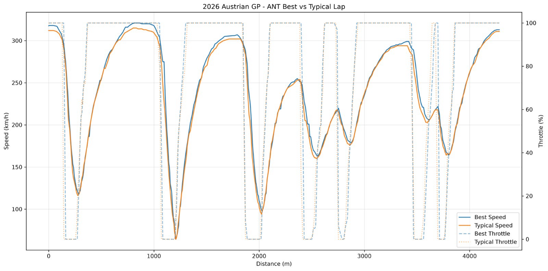
For this reason, each driver is also compared against his own typical representative performance.

Figure 6.6 – Antonelli Representative Best vs Typical Lap
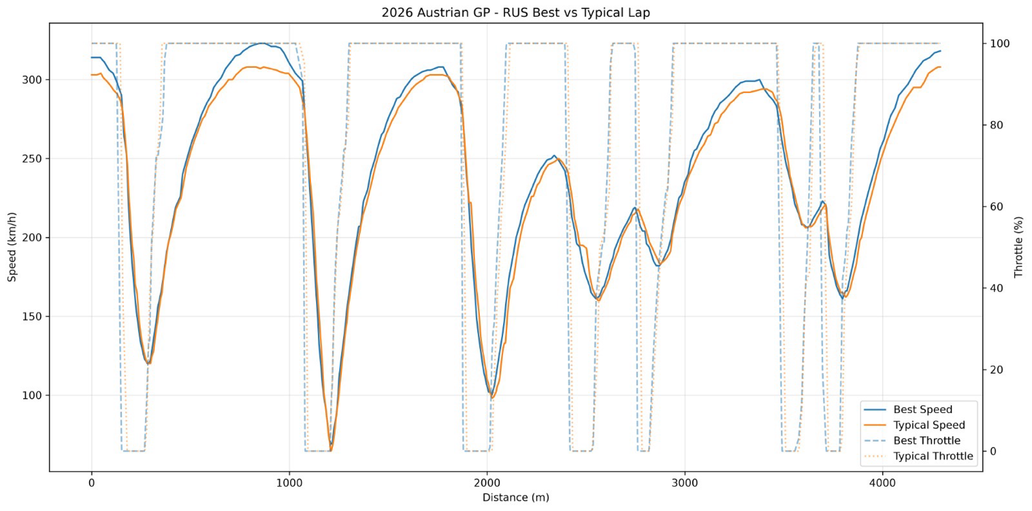
Figure 6.7 – Russell Representative Best vs Typical Lap
The best-versus-typical overlays show that the difference between a driver’s stronger and more typical performance is not uniformly distributed around the circuit.
This supports the race-level finding that repeatability should be evaluated alongside absolute pace.
The purpose of the self-comparison is therefore different from the teammate compiranno:
Driver vs Teammate → Where is relative performance being gained or lost?
Driver vs Self → Where does the driver’s own execution change?
This distinction is particularly relevant to Antonelli because the race-level analysis found a representative-lap standard deviation of approximately 1.06 s, compared with approximately 0.89 s for Russell.
Antonelli therefore demonstrated slightly stronger representative mean pace but greater lap-to-lap variability.
A future development analysis should investigate whether the same corner sequences repeatedly account for the difference between Antonelli’s stronger and more typical laps.

6.11 Theoretical Selected-Corner Performance Envelope

The corner-level analysis demonstrates that the selected representative-lap difference was distributed unevenly around the circuit. Antonelli recorded lower corner-window times at T1, T3, T6, T9 and T10, while Russell recorded lower times at T4 and T7.
Across the selected corners, the magnitudes of Antonelli’s local advantages total approximately 0.326 s, while Russell’s advantages at T4 and T7 total approximately 0.022 s. These values provide a useful representation of where local performance differences were concentrated within the selected-lap comparison.
However, the individual corner differences should not be combined to construct a predicted or achievable “perfect lap”. Corner performance is not independent: a change in braking, line, minimum speed or exit behaviour at one corner may influence the following straight or subsequent corner. This is particularly relevant for linked sequences such as T6–T7.
The resulting Theoretical Selected-Corner Performance Envelope should therefore be interpreted as an exploratory diagnostic tool rather than a lap-time prediction. Its purpose is to identify where locally stronger performance was observed and to distinguish high-value investigation areas from corners in which the drivers were already closely matched.
Within this framework, T6 represents the largest individual performance differentiator, while the combined T9–T10 sequence provides a secondary area of interest. T3 also remains important because Antonelli achieved a lower corner-window time despite recording a lower minimum speed, demonstrating that different corners may produce lap-time gains through different observable performance patterns.
The envelope therefore provides a prioritisation framework for further investigation without assuming that all identified local advantages can be reproduced simultaneously.

6.12 Driver Performance Diagnosis
The telemetry results indicate that the selected representative-lap difference cannot be explained by a single universal driving characteristic. Instead, the difference is composed of several localised gains and losses with different observable patterns.
For Russell, the race-level analysis established lower lap-to-lap variability within the representative sample, while the selected-lap telemetry identifies several specific areas in which time was lost relative to Antonelli. The most significant is T6, where approximately 0.145 s of the selected-corner difference was recorded in Antonelli’s favour. Approximately 82% of this difference developed before the minimum-speed point within the defined analysis window.
Antonelli also recorded approximately 1.9 km/h higher minimum speed at T6, reached 50% and 90% throttle approximately 6 m earlier after minimum speed, and retained approximately 2.8 km/h more speed around 100 m downstream of the corner centre. These observations identify T6 as the clearest local performance differentiator in Russell’s selected lap. They do not, however, establish the underlying physical cause of the difference.
Russell recorded smaller local advantages at T4 and T7. The T7 result is particularly relevant because it immediately follows T6, demonstrating that the largest T6 difference should not be considered independently from the performance of the wider T6–T7 sequence.
For Antonelli, the selected representative lap demonstrates locally stronger performance at T1, T3, T6, T9 and T10. However, these advantages do not follow a single consistent mechanism. At T6 and T10, Antonelli combined higher minimum speed with favourable subsequent throttle and speed behaviour. At T3, by contrast, Antonelli completed the defined corner window approximately 0.042 s faster despite recording approximately 4.6 km/h lower minimum speed than Russell.
This counterexample is important because it prevents a general conclusion that Antonelli’s selected-lap advantage resulted simply from carrying greater minimum speed. The telemetry instead indicates that performance must be evaluated across the complete corner sequence.
When combined with the race-level results, the two drivers therefore present different diagnostic characteristics. Russell’s representative race sample showed lower variability, while Antonelli’s selected lap contained several significant local advantages. These findings identify areas for engineering investigation without establishing that either observed characteristic represents a universal driver tendency.
6.13 Engineering Confidence Framework
Because the analysis is based on publicly available telemetry rather than full team-level vehicle data, the conclusions can be separated according to the strength of the available evidence.

High Confidence — Directly Observed
The following findings are directly supported by the analysed timing and telemetry data:
- The selected representative laps were 70.683 s for Russell and 70.374 s for Antonelli, producing a difference of 0.309 s.
- T6 was the largest selected-corner differentiator, with approximately 0.145 s in Antonelli’s favour.
- Approximately 0.118 s, or 82%, of the measured T6 difference developed before the minimum-speed point within the defined analysis window.
- Antonelli’s T6 minimum speed was approximately 1.9 km/h higher.
- Antonelli reached both 50% and 90% throttle approximately 6 m earlier after minimum speed.
- The distance from brake release to 50% throttle was approximately 12 m shorter for Antonelli.
- Antonelli retained approximately 2.8 km/h greater speed around 100 m downstream of the T6 corner centre.
- Antonelli recorded selected-corner advantages at T1, T3, T6, T9 and T10, while Russell recorded advantages at T4 and T7.
- Russell displayed lower lap-time variability within the race-level representative sample.

Medium Confidence — Engineering Interpretation
The available evidence supports, but does not independently prove, the following interpretations:
- The principal T6 differentiation occurred during the entry-to-mid-corner phase, rather than being generated exclusively during corner exit.
- Antonelli’s shorter transition to significant throttle appears to have helped preserve or extend an advantage that was already developing before minimum speed.
- T6 represents the highest-value local area for further investigation within Russell’s selected representative lap.
- The similar observable pattern at T6 and T10 warrants further investigation but is insufficient to establish a general driving characteristic.
- T6 should be assessed together with T7 because changes intended to recover performance in one corner may influence the following corner.

Low Confidence / Not Directly Observable
The available public telemetry does not provide sufficient evidence to determine:
- continuous brake-pressure modulation;
- trail-braking behaviour;
- steering-angle or steering-rate differences;
- precise vehicle rotation mechanisms;
- tyre temperature, pressure or detailed tyre condition;
- aerodynamic balance;
- differential behaviour;
- detailed setup effects;
- or driver perception and confidence.
These factors may contribute to the observed performance differences, but attributing the measured deltas directly to them would exceed the resolution of the available dataset.
The confidence framework therefore separates what the telemetry demonstrates, what it reasonably suggests, and what remains unobservable. This distinction is essential when translating the analysis into engineering recommendations.

6.14 Chapter Summary
The corner-level telemetry analysis demonstrates that the 0.309 s selected representative-lap difference between Antonelli and Russell was not distributed uniformly around the circuit. Instead, the difference resulted from several localised gains and losses with different observable characteristics.
T6 was the largest selected-corner differentiator, with approximately 0.145 s recorded in Antonelli’s favour. Approximately 0.118 s, or 82%, of this difference developed before the minimum-speed point within the defined corner window. Antonelli also recorded approximately 1.9 km/h higher minimum speed, reached significant throttle over a shorter distance and retained approximately 2.8 km/h greater speed around 100 m downstream of the corner centre.
However, the analysis also demonstrates why no single performance metric should be applied universally. At T3, Russell recorded approximately 4.6 km/h higher minimum speed, yet Antonelli completed the defined corner window approximately 0.042 s faster. Minimum speed alone is therefore insufficient to explain the observed corner-performance differences.
The selected-corner analysis further identified smaller Antonelli advantages at T1, T9 and T10, while Russell recorded local advantages at T4 and T7. The T6–T7 sequence also demonstrates the importance of considering interactions between consecutive corners rather than optimising each corner independently.
Overall, the telemetry evidence indicates that the selected-lap difference resulted from corner-specific performance patterns rather than one universal driver behaviour. T6 represents the clearest local area for further investigation, while T3 and the T9–T10 sequence demonstrate that different corners require different diagnostic approaches.
These results should be interpreted alongside the race-level findings rather than as a ranking of overall driver performance. Russell won the Grand Prix and demonstrated lower variability within the representative race sample, while Antonelli’s selected representative lap provides useful examples of locally faster performance in several corner windows. The two analyses therefore answer different engineering questions: race-level analysis describes performance delivery across the event, while telemetry analysis identifies where measurable local differences developed.
The findings of this chapter provide the evidence base for Chapter 7, where the identified performance differences are translated into controlled engineering hypotheses, driver-feedback targets and validation procedures.

CHAPTER 7.ENGINEERING RECOMMENDATIONS AND DRIVER DEVELOPMENT

7.1 Engineering Approach
The purpose of this chapter is to translate the performance differences identified in Chapter 6 into testable engineering hypotheses and controlled driver-development experiments. The recommendations are not presented as definitive corrections to driver technique. Public telemetry identifies where measurable differences occurred but does not provide sufficient information to determine every underlying physical or behavioural cause.
The development approach therefore follows four principles:
- Preserve demonstrated strengths before targeting weaknesses.
- Translate observed differences into testable hypotheses rather than fixed conclusions.
- Evaluate changes using representative performance and repeatability, rather than isolated fastest laps.
- Accept a change only when the measured benefit exceeds any associated loss elsewhere in the lap or in performance consistency.
For Russell, the principal objective is to investigate whether selected local performance opportunities can be recovered without compromising the lower variability demonstrated across the representative race sample.
For Antonelli, the objective is different. The selected-lap analysis already demonstrates locally strong performance at several corners; the engineering question is whether these performance characteristics can be reproduced consistently across a wider range of laps and operating conditions.
The recommendations developed below therefore represent controlled experiments, with each intervention requiring telemetry-based validation before being accepted.

7.2 George Russell — Development Direction
Russell’s representative race sample showed lower lap-to-lap variability than Antonelli’s, while the selected-lap telemetry identified several local areas in which performance was available relative to the teammate reference.
The largest selected-corner difference occurred at T6, where approximately 0.145 s was recorded in Antonelli’s favour. Smaller opportunities were identified at T1, T3, T9 and T10, while Russell retained local advantages at T4 and T7.
The development objective should therefore not be to alter Russell’s driving approach globally. Instead, the analysis supports a targeted performance-release strategy, in which the highest-value local opportunities are investigated while monitoring whether Russell’s existing repeatability is preserved.
T6 should receive the highest priority because it represents the largest measured selected-corner difference. The T9–T10 sequence provides a secondary investigation area, particularly because T10 leads onto the following straight and may therefore have downstream performance consequences.
Russell’s existing advantages at T4 and T7 should be treated as reference constraints. A change that improves another corner but removes an existing advantage may not produce a net lap-time benefit.

7.3 Russell — Turn 6 Development Experiment
The T6 analysis provides the clearest opportunity for a controlled development experiment. Antonelli gained approximately 0.145 s within the selected corner window, with approximately 82% of the difference developing before the minimum-speed point. Antonelli also recorded approximately 1.9 km/h higher minimum speed and a shorter transition to significant throttle.
These observations do not demonstrate that Russell should simply enter the corner faster or delay braking. Instead, they provide measurable reference values that can be used to investigate whether a different T6 operating window produces a net performance benefit.
A three-stage test is proposed.
Run A – Baseline
Russell should first reproduce his normal T6 execution across multiple representative laps. The following metrics should be recorded:
- T6 corner-window time;
- minimum speed;
- cumulative delta at corner entry, minimum speed and exit;
- distance from minimum speed to 50% and 90% throttle;
- T6 exit speed;
- T7 corner time;
- combined T6–T7 sequence time.
This establishes the repeatability and natural variation of the baseline before any intervention is introduced.
Run B – Conservative Performance Target
A conservative experiment can then investigate whether approximately 1–2 km/h additional minimum speed can be retained through T6 while maintaining acceptable entry stability, throttle transition and T7 performance.
The 1–2 km/h value is not presented as a predicted optimum. It is deliberately smaller than the approximately 1.9 km/h selected-lap difference and is used as a controlled test target.
The intervention should be accepted only if the additional speed produces a repeatable reduction in T6 or combined T6–T7 time.
Run C – Sequence-Level Performance Test
If Run B produces a measurable benefit, a more aggressive test can investigate the complete T6–T7 sequence.
The objective is not necessarily to maximise T6 performance independently. A small deterioration at T7 may be acceptable if the T6 gain produces a larger combined improvement.
For example, a 0.050 s T6 gain accompanied by a 0.010 s T7 loss would still produce a net 0.040 s sequence improvement.
The primary optimisation metric should therefore be the combined T6–T7 delta rather than isolated T6 corner time.

7.4 Russell – Performance Boundary Investigation

Russell’s lower representative-lap variability raises a further engineering question: whether his selected-lap performance reflects an operating window that prioritises repeatability over access to more aggressive local performance.
The available telemetry cannot establish this directly. However, it can be investigated through controlled short-run testing.
Following the conservative T6 experiment, Russell could complete a limited number of laps with progressively more aggressive performance targets at T6 and, separately, the T9–T10 sequence. The purpose would be to identify the point at which additional mean performance begins to produce an unacceptable increase in variability or a loss elsewhere in the sequence.
The test should therefore examine the relationship between performance gain and repeatability cost, rather than simply identifying the fastest individual lap.
If a more aggressive operating window produces repeatable gains without materially increasing lap-time or corner-time variance, the change may represent accessible performance. If the gain appears only on isolated laps or produces significant downstream losses, the existing operating window should be retained.
This approach treats Russell’s repeatability as an engineering asset rather than a limitation while still investigating whether additional local performance can be accessed.

7.5 George Russell — T9 and T10
The selected-lap analysis identified a combined Antonelli advantage of approximately 0.072 s across T9 and T10, comprising approximately 0.025 s at T9 and 0.047 s at T10.
This represents a smaller opportunity than T6 but remains relevant because T10 leads onto the subsequent straight. The investigation should therefore consider not only the isolated T10 corner time but also the speed retained after corner exit.
Rather than attempting to reproduce Antonelli’s telemetry trace directly, his selected-lap performance should be used as a reference envelope demonstrating that lower corner-window time was achieved under the analysed conditions.
The principal validation metrics should include T9 time, T10 time, combined T9–T10 time, minimum speed, throttle transition and downstream speed.
Any intervention should be accepted only if the combined sequence and subsequent acceleration phase improve without introducing an unacceptable increase in variability.

7.6 Antonelli – Development Direction
Antonelli requires a different development approach. His selected representative lap contained the largest local advantages at several analysed corners, particularly T6, while his representative race sample exhibited greater lap-to-lap variability than Russell’s.
The engineering priority should therefore not be to modify the strongest observed corner patterns simply because overall variability was higher. Instead, the first objective should be to determine whether the locally strong performance identified in the selected lap is reproduced consistently across a wider sample.
T6 is particularly important. If the higher minimum speed, shorter throttle transition and associated corner-time advantage appear repeatedly across Antonelli’s representative laps, the pattern should be preserved as an existing strength.
If the same performance characteristics appear only intermittently, the engineering task becomes identifying which observable conditions distinguish the successful executions from the typical or slower examples.
The objective is therefore performance consolidation rather than immediate performance expansion.

7.7 Antonelli — Repeatability Programme
Antonelli should complete repeated target-lap runs in which the objective is not to produce the fastest possible lap, but to reproduce the corner characteristics observed in the stronger selected representative lap.
T1, T3, T6 and T10 provide suitable initial investigation areas because each contributed measurable selected-corner advantages.
For each corner, the analysis should compare:
- corner-window time;
- minimum speed;
- throttle-transition distance;
- exit speed;
- cumulative corner delta;
- standard deviation across repeated executions.
The key question is whether the performance pattern observed in the selected lap represents a repeatable operating window or an isolated high-performance execution.
If T6, for example, repeatedly produces similar corner time, minimum speed and throttle-transition characteristics, no corrective intervention is required. If the pattern disappears on slower laps, best-versus-typical telemetry should be used to identify where the execution begins to diverge.
The target is therefore not lower variance at any cost. It is to increase the frequency with which demonstrated high-performance corner execution is reproduced.

7.8 Antonelli — High-Fuel and Opening-Stint Investigation
The race-level analysis identified another important development question.
The race data do not establish that this difference was caused by Antonelli’s driving.
During the opening medium stint, Russell’s representative mean was approximately 72.57 s compared with approximately 72.81 s for Antonelli, giving Russell an advantage of roughly 0.24 s per representative lap in that phase.
The relationship changed later in the race, when Antonelli demonstrated stronger representative pace.
I would therefore include a dedicated high-fuel simulation in Antonelli’s development programme.
Rather than immediately attributing the opening-stint deficit to driving technique, the test should investigate several possible contributors:
- high-fuel vehicle behaviour,
- tyre preparation,
- early-stint balance,
- traffic sensitivity,
- and driver adaptation to the heavier car.
The key engineering question becomes:
- Why was Antonelli’s stronger later-race representative performance not similarly observed during the opening phase?
If the same corner-performance differences appear repeatedly during high-fuel simulation, driver adaptation becomes a stronger candidate.
If they disappear when traffic and race context are removed, the original race deficit should not be attributed primarily to driver execution.

7.9 Using Antonelli as an Internal Performance Reference
One of the more valuable opportunities in a two-car team is that the faster driver does not need to be treated as a universal template.
Antonelli’s selected T6 performance, for example, can be used as an internal performance reference without requiring Russell to reproduce the same inputs.
The engineering target is the outcome: Comparable or improved sequence time
Not: Identical driver inputs
Russell may achieve comparable performance through a different braking, rotation or acceleration profile.
Likewise, Russell’s stronger repeatability can be used as an internal benchmark for Antonelli without forcing Antonelli to abandon the characteristics responsible for his higher selected-lap performance.
This creates a two-way development process:
Russell → repeatability benchmark
Antonelli → local performance benchmark
The ideal outcome is therefore not convergence toward one driving style, but the transfer of useful performance characteristics while preserving individual strengths.
The teammate comparison should therefore be used as a two-way engineering reference rather than a hierarchy: Russell provides evidence of lower race-level variability, while Antonelli provides examples of locally faster selected-corner execution.

7.10 Proposed Engineering Run Plan
I would convert the recommendations into the following test programme:
Run | Driver | Test | Primary metric | Risk
A | RUS | Baseline | T6–T7 sequence time | Low
B | RUS | +1–2 km/h T6 minimum-speed target | T6 delta + exit | Medium
C | RUS | Aggressive T6–T7 optimisation | Combined sequence delta | High
D | RUS | T9–T10 performance release | T9+T10 + downstream speed | Medium
E | ANT | Repeated target laps | Corner/lap variability | Low
F | ANT | Best-vs-typical reproduction | Repeatability of strong technique | Low
G | ANT | High-fuel simulation | Opening-stint representative pace | Medium
H | Both | Cross-driver reference run | Lap gain without variance penalty | Medium

For every intervention I would compare not only the fastest lap but:
Mean Pace
Median Pace
$$σ_{\left\{Lap Time\right\}}$$
Target Corner Delta
and, where appropriate,
Combined Corner Sequence Delta.
A change would only be accepted if the performance improvement remained sufficiently repeatable.

7.11 Acceptance and Rejection Criteria

A proposed change would be classified as:
Accept — repeatable lap or sequence improvement with no meaningful deterioration elsewhere.
Conditional Accept — performance improvement is present but accompanied by a small increase in variability or a secondary corner loss requiring further optimisation.
Reject — isolated peak improvement with no improvement in representative performance, excessive variability, or a downstream loss greater than the original gain.
Therefore, a modification producing a 0.050 s T6 improvement, but a 0.060 s T7 loss would be rejected despite the apparent improvement at T6.
Similarly, an Antonelli intervention that reduces variability but removes a substantial portion of his existing pace advantage should not automatically be considered successful.

7.12 Final Engineering Assessment
The analysis developed in this chapter supports two different but complementary development directions for Russell and Antonelli.
For Russell, the priority is targeted performance extraction rather than a global change in driving approach. His lower variability within the representative race sample should be treated as an existing performance asset. The selected-lap telemetry nevertheless identifies specific local opportunities, with T6 representing the highest-priority investigation area and the T9–T10 sequence providing a secondary target.
The objective is therefore to determine whether additional local performance can be accessed without materially compromising repeatability or creating downstream losses. Any T6 intervention should be evaluated using the combined T6–T7 sequence rather than T6 in isolation.
For Antonelli, the priority is performance consolidation. His selected representative lap demonstrates locally faster execution at several analysed corners, particularly T6, but his representative race sample exhibited greater lap-to-lap variability. The engineering question is therefore not simply how to generate a faster individual lap, but whether the demonstrated local performance characteristics can be reproduced more frequently.
The opening medium stint also remains an important investigation area for Antonelli. Russell recorded an approximately 0.24 s/lap lower representative mean during this phase, but the race data do not establish a single cause for the difference. High-fuel testing should therefore be used to determine whether the change in relative performance is associated with driver execution, tyre behaviour, traffic, vehicle balance or other operating conditions.
The teammate comparison should consequently be used as a two-way engineering reference rather than a performance hierarchy. Russell provides a useful reference for lower race-level variability, while Antonelli provides examples of locally faster selected-corner execution.
The central engineering principle is therefore:
Preserve demonstrated strengths, investigate measurable opportunities, and validate every proposed change against both performance gain and repeatability cost.
No recommendation should be accepted solely because it produces a faster isolated lap or reproduces another driver’s telemetry trace. A development intervention should only be retained when it generates a measurable and repeatable net performance benefit under controlled testing.

7.13 Translating Analysis into Driver Feedback
Performance analysis becomes useful to the driver only when the engineering findings can be translated into clear, measurable and testable objectives.
Generic instructions such as “brake later,” “carry more speed,” or “be more consistent” provide limited engineering value because they do not define the performance mechanism being investigated or establish how success will be measured.
Driver feedback should instead follow the same evidence-based process used throughout this report:
Observation → Engineering Hypothesis → Driver Target → Controlled Run → Telemetry Comparison → Accept / Modify / Reject
The objective is not to instruct the driver to reproduce the teammate’s inputs. Teammate telemetry is used as evidence that a different performance outcome occurred under the analysed conditions. The driver’s task is then to investigate whether a similar or alternative performance gain can be accessed within their own operating window.

7.13.1 Russell – Turn 6 Feedback
The selected-lap analysis identifies T6 as Russell’s largest local performance opportunity, with approximately 0.145 s recorded in Antonelli’s favour. Approximately 82% of this difference developed before the minimum-speed point, while Antonelli also recorded approximately 1.9 km/h higher minimum speed.
The feedback should therefore be framed as an experiment rather than a correction:
“T6 is our largest measured opportunity on this comparison. Most of the difference is developing before minimum speed. On the next run, let’s test whether you can retain approximately 1–2 km/h more minimum speed while keeping the car within a comfortable operating window. Don’t force the throttle pickup or copy the reference trace. We’ll evaluate the complete T6–T7 sequence afterwards and keep the change only if it produces a repeatable net gain.”
This instruction provides a measurable target without assuming that the observed difference was caused by later braking, different brake pressure, steering input or any other variable unavailable in the public telemetry.
The first comparison after the run should examine:
- T6 corner-window time;
- minimum speed;
- cumulative delta before and after minimum speed;
- throttle-transition distance;
- T6 exit speed;
- T7 corner time;
- combined T6–T7 performance.
If T6 improves but T7 deteriorates by a greater amount, the intervention should be rejected.

7.13.2 Russell – T6–T7 Performance Boundary
If the conservative T6 experiment produces a repeatable improvement, the next stage should investigate whether a more aggressive operating window provides additional net performance.
The driver feedback can progress to:
“The first change produced a measurable gain. On this run, explore slightly more performance through T6, but treat T6 and T7 as one sequence. A small T7 loss is acceptable if the combined sequence becomes faster. We are looking for the performance boundary, not the fastest isolated T6.”
The purpose is to determine the relationship between additional corner performance and its associated repeatability or downstream cost.
For example, a 0.050 s T6 improvement accompanied by a 0.010 s T7 loss would still represent a 0.040 s net sequence gain. Conversely, an aggressive T6 execution that produces a larger T7 loss or substantially greater variability should not be retained.
This approach prevents an isolated corner improvement from being incorrectly interpreted as a lap-time improvement.

7.13.3 Russell – T9–T10 Feedback
The selected-lap analysis identifies a combined Antonelli advantage of approximately 0.072 s across T9 and T10, with the larger component occurring at T10.
Because T10 leads onto the subsequent straight, the feedback should consider the complete sequence and downstream speed rather than minimum speed alone:
“The second opportunity is the T9–T10 sequence, particularly T10. Let’s test whether we can reduce the combined sequence time while protecting the exit. Don’t target minimum speed by itself; we’ll compare the complete corner delta, throttle transition and downstream speed.”
The primary validation metrics should therefore be combined T9–T10 time and subsequent speed development. Any improvement in isolated corner time that compromises the following acceleration phase should be treated cautiously.

7.13.4 Antonelli – Repeatability Feedback
Antonelli’s development objective requires a different feedback structure. The selected representative lap already demonstrates strong local performance at several corners, particularly T6. The immediate objective should therefore be to determine whether these characteristics can be reproduced rather than attempting to increase the selected-lap performance further.
The feedback can be framed as:
“We already have a strong reference at T6. The target for this run isn’t to beat it; it’s to reproduce it. Use the same approach you consider natural and aim to repeat the corner across several laps. We’ll compare the corner time, minimum speed, throttle transition and exit speed across the run.”
The engineering target is not simply lower variability. It is to increase the frequency with which demonstrated high-performance execution is reproduced.
If Antonelli repeatedly produces similar T6 characteristics, the corner should be treated as an established strength rather than an area requiring intervention.
If the performance appears only intermittently, telemetry from the stronger and typical executions should be compared to determine where the traces begin to diverge.

7.13.5 Antonelli – Opening-Stint / High-Fuel Feedback
The race-level analysis identified an approximately 0.24 s/lap representative mean disadvantage for Antonelli during the opening medium stint. However, the available race data cannot determine whether this difference originated from driver execution, tyre behaviour, traffic, vehicle balance or another race-dependent factor.
The feedback should therefore avoid assuming a driver deficiency:
“The opening high-fuel phase is the area we want to understand. We’re not targeting a specific technique yet. Run your normal reference approach and we’ll compare how the corner and lap characteristics develop as fuel reduces. The objective is to identify where the performance difference appears before changing anything.”
A controlled high-fuel simulation should compare repeated laps across the run, with particular attention to whether the performance difference is concentrated in specific corners, braking phases or acceleration zones.
Only after a repeatable pattern has been identified should a specific driver or setup intervention be proposed.

7.13.6 Example Debrief Sheet
Driver | Priority | Evidence | Driver Target | Validation
RUS | T6 | ~0.145 s selected-corner deficit | Test +1–2 km/h minimum-speed retention | T6–T7 combined delta
RUS | T9–T10 | ~0.072 s combined deficit | Improve sequence/exit performance | T9–T10 time + downstream effect
ANT | Repeatability | Higher representative-lap variability | Reproduce strong-lap execution | Multi-lap variance
ANT | Opening stint | ~0.24 s/lap representative mean deficit to RUS | High-fuel controlled run | High-fuel pace + telemetry
Both | Cross-driver learning | Different individual strengths | Use teammate as reference, not template | Pace gain without unacceptable variance
The debrief sheet deliberately separates evidence from intervention. Each driver receives a target derived from an observed performance difference, but the proposed response remains a hypothesis until validated through repeated telemetry comparison. This prevents teammate data from being converted directly into prescriptive driving instructions and maintains the distinction between measured performance, engineering interpretation and driver development.

CHAPTER 8. CONCLUSION AND FUTURE WORK

8.1 Conclusion
This study investigated the race performance of George Russell and Andrea Kimi Antonelli during the 2026 Austrian Grand Prix using publicly available FastF1 timing and telemetry data. The objective was not simply to compare lap times, but to examine how the two drivers generated and delivered performance throughout the race, identify where measurable differences occurred, and translate those findings into engineering and driver-development decisions.
The race result provides the primary performance context: Russell won the Grand Prix and therefore achieved the stronger overall race outcome. The subsequent analysis does not contradict this result. Instead, it investigates the performance characteristics that existed within the race and explains why individual pace metrics should not be interpreted independently from race context.
Within the filtered representative-lap sample, Antonelli recorded a marginally lower mean lap time of approximately 71.83 s, compared with approximately 71.87 s for Russell. However, the difference was only approximately 0.04 s per representative lap, and the samples were produced under different combinations of tyre age, fuel load, traffic and track position. Consequently, this result should not be interpreted as evidence that Antonelli delivered the stronger overall race performance.
A more substantial distinction appeared in repeatability. Russell recorded a representative-lap standard deviation of approximately 0.89 s, compared with approximately 1.06 s for Antonelli. Within the analysed sample, Russell therefore delivered his representative pace within a narrower performance range. This characteristic is particularly relevant when considered alongside the race result: Russell combined competitive pace with stronger repeatability and ultimately converted his performance into the race-winning outcome.
The race-phase analysis also demonstrated that the relative pace relationship was not constant. Russell produced the stronger representative performance during the opening medium stint, averaging approximately 72.57 s compared with Antonelli’s 72.81 s. Antonelli subsequently recorded lower representative mean lap times during the later Hard-tyre phases. These changes identify different performance phases within the race but cannot independently establish their causes because the drivers were not operating under identical conditions.
The selected representative-lap telemetry provided a separate, controlled investigation of driver execution. Antonelli’s selected representative lap of 70.374 s was 0.309 s faster than Russell’s selected lap of 70.683 s. These laps were selected for telemetry comparison and should not be interpreted as the drivers’ absolute fastest laps or as a ranking of their overall race performance.
The corner-level analysis showed how this selected-lap difference was distributed around the circuit. Using the convention
$$Δt=t_{\left\{ANT\right\}}-t_{\left\{RUS\right\}},$$
- Antonelli held selected-corner advantages at T1, T3, T6, T9 and T10, while Russell held smaller advantages at T4 and T7. The largest identified difference occurred at T6, where Antonelli gained approximately 0.145 s across the defined corner window. Further decomposition indicated that approximately 82% of this difference had already developed before the minimum-speed point, shifting the investigation towards the entry-to-mid-corner phase rather than attributing the advantage primarily to corner exit rather than simply attributing the advantage to greater minimum speed.
This finding illustrates one of the central conclusions of the study. A faster corner, lower representative mean or faster selected lap cannot independently define the stronger race performance. Minimum speed, braking behaviour, throttle application, repeatability, tyre condition, race phase and strategic context all contribute to the final outcome.
The comparison should therefore be interpreted at two different levels. At the race level, Russell achieved the superior outcome and demonstrated greater repeatability within the analysed representative sample. At the local telemetry level, Antonelli demonstrated specific phases and corner sequences in which faster performance was accessible, providing useful references for identifying potential development opportunities.
The principal conclusion of this study is therefore not that Antonelli was faster than Russell despite Russell winning the race. Rather, it is that race outcome and local performance metrics answer different engineering questions. Russell’s victory represents the complete competitive outcome, while the representative and telemetry analyses reveal where performance was gained, lost, repeated or potentially available within that race.
This distinction forms the basis for the driver-development recommendations presented in the preceding chapter: the purpose of performance engineering is not merely to identify the faster trace, but to determine which characteristics contribute to successful race execution and which local performance opportunities can be investigated without compromising the strengths that already exist.

8.2 Driver-Specific Conclusions
The analysis identifies different development priorities for Russell and Antonelli rather than a single performance hierarchy.
For Russell, the clearest race-level characteristic was lower lap-time variability within the representative sample. This indicates that his representative performance was delivered within a narrower range across the analysed race. The selected-lap telemetry nevertheless identified specific local opportunities, particularly at T6 and across the T9–T10 sequence.
Russell’s development objective should therefore focus on determining whether additional local performance can be accessed while preserving the repeatability already demonstrated within the race sample. This does not require a fundamental change in driving approach; instead, it supports targeted investigation of the highest-value local differences.
For Antonelli, the selected representative lap provides evidence of locally faster execution at several analysed corners, particularly T6, while the race-level representative sample showed greater lap-to-lap variability. The primary development question is therefore whether these demonstrated local performance characteristics can be reproduced more frequently across different laps and operating conditions.
His relatively weaker representative performance during the opening medium stint also identifies high-fuel running as an important area for further investigation. However, the available race data cannot determine whether this difference originated from driver execution, tyre behaviour, vehicle state or race context.
The resulting development objectives can therefore be summarised as:
Russell: Preserve Repeatability + Investigate Targeted Local Performance
Antonelli: Preserve Demonstrated Local Performance + Improve Reproducibility
These objectives deliberately avoid attempting to make the two drivers converge towards an identical driving style.

8.3 Engineering Significance
One of the most important outcomes of this investigation was the transition from descriptive analysis to engineering decision-making.
The initial question of who was faster? was progressively replaced by more useful questions:
Where was the performance difference generated?
Was it repeatable?
Which differences were sufficiently supported by the available telemetry?
Which observations remained hypotheses?
What intervention could be tested?
How would that intervention be accepted or rejected?
This produced the following engineering workflow:
$$Race Performance →Performance Difference→Corner Localisation→Telemetry Diagnosis→Engineering Hypothesis → Driver Feedback→Controlled Validation$$
The proposed driver-development programme therefore does not assume that Antonelli’s faster execution should simply be copied by Russell, or that Russell’s greater repeatability should be imposed directly on Antonelli.
Instead, each driver’s strongest characteristics become an internal performance reference for the other.
This approach is particularly relevant in motorsport engineering, where the objective is not to identify a theoretically universal driving style, but to maximise the performance available from the interaction between driver, vehicle and operating conditions.

8.4 Limitations
Several limitations must be considered when interpreting the results.
The analysis was conducted using publicly available FastF1 data rather than complete team telemetry. Consequently, several parameters that would normally contribute to a professional performance investigation were unavailable.
In particular, detailed brake-pressure information was not available. The public brake channel primarily indicates application state and therefore cannot reliably determine braking force, pressure modulation or detailed trail-braking behaviour.
Similarly, the analysis could not directly account for parameters including tyre surface and carcass temperature, tyre pressure, aerodynamic balance, steering input, differential settings, detailed energy deployment, vehicle setup or driver perception.
Race telemetry was also influenced by external factors such as fuel load, traffic, dirty air, tyre condition, DRS availability, race position and changing track conditions. Although representative laps and filtering were used to reduce these effects, they cannot be removed completely.
The findings should therefore be interpreted as evidence-supported performance observations and engineering hypotheses derived from public data, rather than as a substitute for the complete telemetry, vehicle-state information and driver feedback available within a Formula One team.

8.5 Future Work
The next stage of the investigation should focus on testing whether the performance characteristics identified in this report remain stable across larger datasets and different operating conditions.
A first extension would be to perform corner-level repeatability analysis across all representative clean laps rather than relying primarily on selected-lap corner comparisons. This would allow the race-level variability difference between Russell and Antonelli to be localised around the circuit and determine whether Antonelli’s additional variability originates from the same corners in which he demonstrates his strongest selected-lap performance.
A second extension would compare the drivers under different fuel and tyre conditions. In particular, Antonelli’s relatively weaker opening stint suggests that high-fuel performance deserves dedicated investigation. Comparing equivalent early-, middle- and late-stint telemetry could help distinguish driver adaptation from tyre, traffic and vehicle-state effects.
A further extension would be to construct matched-condition lap pairs, comparing laps with similar tyre age, stint phase and traffic state. This would reduce the influence of operating-condition differences and provide a stronger basis for attributing observed performance differences to driver execution
The analysis could also be expanded across multiple circuits. Austria represents only one circuit configuration and one race weekend. Repeating the methodology at circuits with different braking demands, corner speeds and aerodynamic requirements would establish whether the identified characteristics are driver tendencies or event-specific behaviour.
A multi-event analysis could therefore investigate whether:
- Russell’s stronger repeatability persists across different circuit types;
- whether Antonelli repeatedly demonstrates locally faster selected-corner execution across different events;
- the same corner phases generate relative performance differences;
- and the proposed development priorities remain valid across different vehicle operating conditions.
Where higher-resolution data becomes available, future analysis should incorporate steering angle, brake pressure, lateral acceleration, tyre information and more detailed vehicle-state parameters. These would allow the current performance hypotheses to be investigated at a deeper vehicle-dynamics level.
Finally, the proposed driver-development experiments from Chapter 7 could be implemented in a simulator or controlled testing environment. This would complete the engineering cycle by moving from retrospective analysis to experimental validation.

8.6 Final Statement
The principal conclusion of this study is not that one driver was categorically faster than the other, but that meaningful performance differences can exist at multiple levels of the same race.
Russell achieved the stronger overall competitive outcome by winning the Grand Prix and demonstrated lower variability within the analysed representative race sample. Antonelli’s selected representative lap, meanwhile, provided examples of locally faster execution at several corner windows. These findings describe different aspects of performance and should not be reduced to a single driver ranking.
The engineering value of telemetry analysis lies in identifying where measurable performance differences develop, determining which conclusions are supported by the available evidence, and converting those observations into testable development hypotheses.
A teammate’s faster trace should therefore be treated as a reference rather than a template. The objective is not to copy an individual input pattern, but to determine whether the underlying performance opportunity can be accessed repeatably without compromising existing strengths elsewhere in the lap.
Ultimately, performance engineering transforms observation into experimentation:
identify the difference, localise it, test the hypothesis, measure the response, and retain only the changes that produce repeatable net performance.

