Aerodynamic Nomenclature

X = C_{x}QS Axial force
Y = C_{y}QS Side force
Z = C_{z}QS Normal force

L = C_{l} QSl Rolling moment
M = C_{m} QSl Pitching moment
N = C_{n} QSl Yawing moment

Q=dynamic pressure
S=Wing Surface area

 | Roll Axis x_{b} | Pitch Axis y_{b} | Yaw Axis z_{b}
Angular rates | P | q | r
Velocity components | U | v | w
Aerodynamic forces components | X | Y | Z
Aerodynamic moment components | L | M | N
Moment of inertia about each axis | I_{x} | I_{y} | I_{z}
Product of inertia | I_{yz} | I_{xz} | I_{xy}

Angle of attack and Sideslip Angle

The angle of attack and sideslip can be defined in terms of the velocity components as illustrated in Figure 1.3. The equations for and 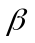 follow:

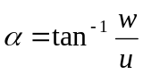
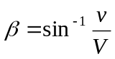
Where 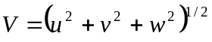

If the angle of attack and sideslip are small, that is, < 15º then
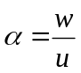
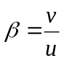
Where and are in radians.
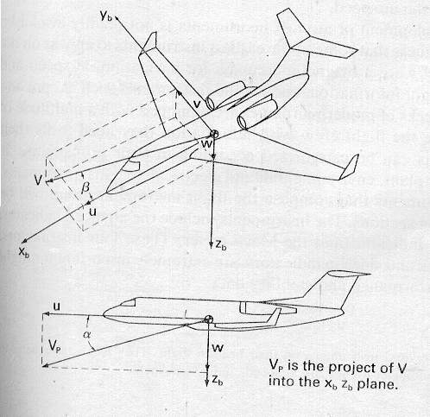

Aerodynamic force and moment representation
The term 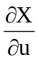 called the stability derivative is evaluated at the reference flight condition.

The contribution of the change in the velocity u to change 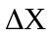 in he X force is just 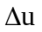
We can also express in terms of the stability Coefficient 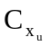, as follows:
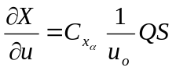
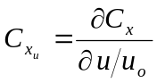
Note that the stability derivative has dimensions, whereas the stability coefficient is defined so that it is non-dimensional.
Control and motion

Control Surface | Elevator | Aileron | Rudder
Angular Motion | Pitch | Roll | Yaw
Axis | Lateral | Longitudinal | Vertical

