Lab1 – Group 3 (Sukhbat Amartugs, Nomin Nergui, Myo Min Tun)



|  |  |
| --- | --- |
| User Action | System Response |
| 1. User types in PIN into main screen | 1. System checks validity of PIN and presents options to user on another screen |
| 1. Choose option “Withdraw money” | 2. Goes to account type screen. |
| 1. Choose account type | 3. Goes to Withdrawal screen. |
| 1. Enter withdraw amount and click on accept | 4. System checks if it is available then cash out the money and update the balance. Then ask if user wants to do another action. |

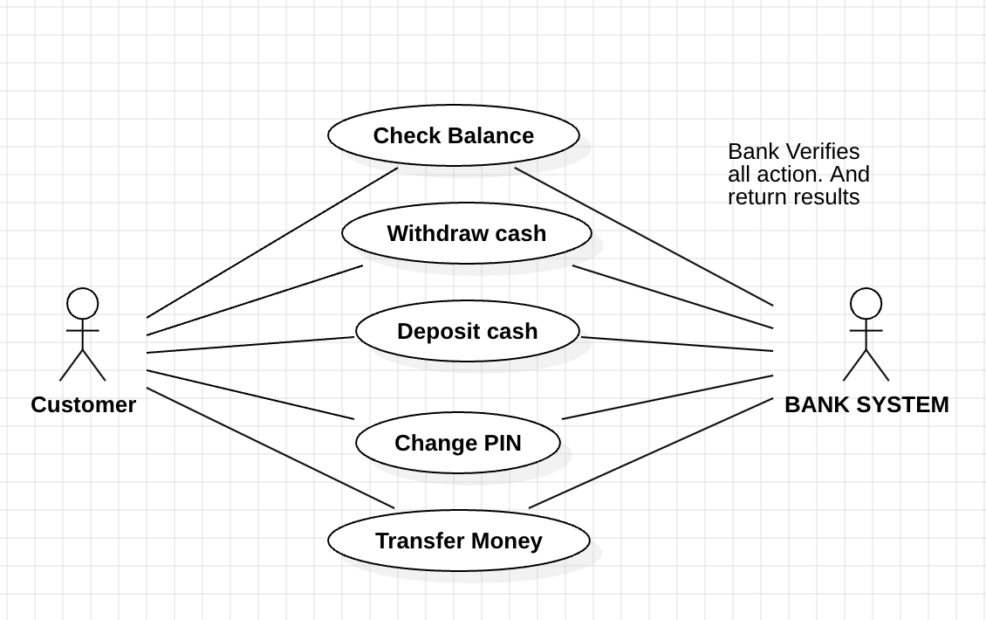

3.

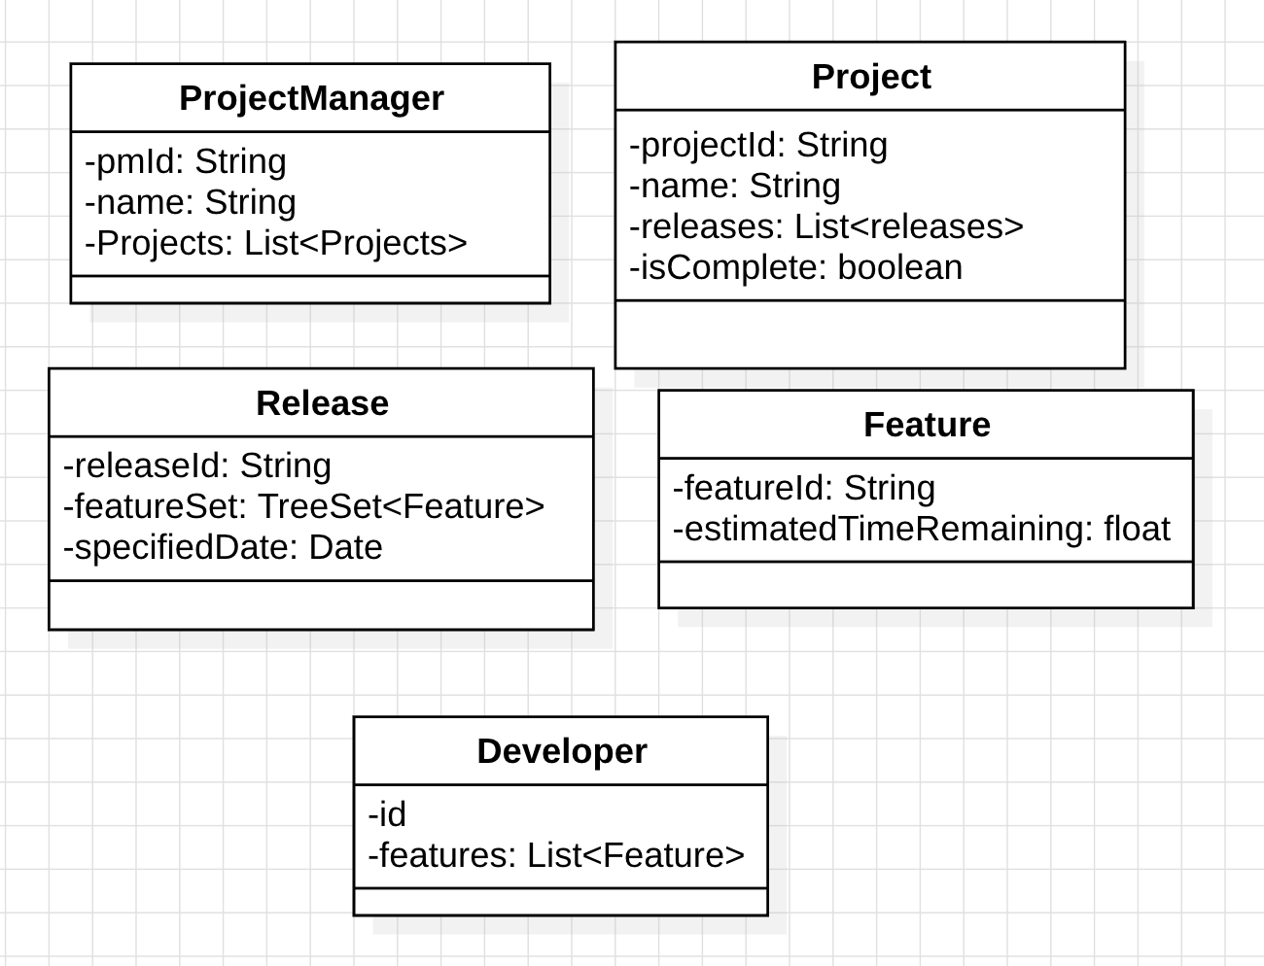

4.

