IOT BASED OCR AND DATA PROCESSOR

Name of Student - Suhrid Srivastava (13102162)
- Priyank Lalpuria(13102167)

Name of Supervisor -Dr. Shamim Akhter



Submitted in Partial fulfilment of the Degree of
Bachelor of Technology

DEPARTMENT OF ELECTRONICS AND COMMUNICATION ENGINEERING

JAYPEE INSTITUTEOF INFORMATION TECHNOLOGY, NOIDA

CONTENTS

TABLE OF CONTENTS

CERTIFICATE……………………………………………………………………………. IIIACKNOWLEDMENT…………………………………………………………………….. IV SUMMARY……………………………………………………………………………….. V

Chapter1 Introduction…………………………………………………………………… 1

1.1 Purpose……………………………………………………………………… 1

1.2 Existing System……………………………………………………………... 1

1.3 Drawback of Existing System………………………………………………. 2

1.4 Proposed System…………………………………………………………...... 2

1.5 Benefit of Proposed System…………………………………………………. 2

1.6 Architecture of Proposed System…………………………………………..... 3

1.7 Components…………………………………………………………………. 3

1.8 Application…………………………………………………………………. 4

Chapter2 Background…………………………………………………………………… 5

2.1 Raspberry Pi………………………………………………………………… 5

2.1.1 Location of different components on raspberry Pi ……………….... 5

2.1.2A brief description of some components on the Pi………………….. 5

2.2 Python ……………………………………………………………………….6

2.3 OpenCV…………………………………………………………………….. 6

2.4 IOT… ……………………………………………………………………….7

2.5 Speech Synthesis..………………………………………………………….. 7

2.5.1Concatenation Synthesis… ………………………………………… 8

2.5.1.1Diaphone Synthesis………………………………………… 8

I
Chapter 3 Working…………………………………………………………………….. 9

3.1 System Description………………………………………………………….9

3.1.1 Connection of Camera with Pi……….…………………………........ 9

3.1.2 OCR…………….………………………………………………….... 9

3.1.2.1 Four Point Transform…..…………………………………… 9

3.1.2.2 Image Segmentation………………………………………… 10

3.1.3 Text to Speech….………………………………………………….... 12

Chapter 4 Working Model 14

Chapter 5 Conclusions 18

Chapter 6 Future Work 19

APPENDIX 20

RESUME 21

II
CERTIFICATE

This is to certify that the work titled “IOT BASED OCR AND DATA PROCESSOR” submitted by “SUHRID SRIVASTAVA & PRIYANK LALPURIA” in partial fulfilment for the award of degree of B.Tech of Jaypee Institute of Information Technology, Noida has been carried out under my supervision. This work has not been submitted partially or wholly to any other University or Institute for the award of this or any other degree or diploma.

Signature of Supervisor…………………………. Name of Supervisor Dr. Shamim Akhter Designation Asst. Professor (Sr.)
Date 08-05-2017

III

ACKNOWLEDGEMENT

We sincerely thank our project guide Dr. Shamim Akhter JIIT, Noida for the constant inspiration, motivation and direction he provided us in the project and without whom, this project would not have been possible.

We also use this opportunity to express our gratitude towards the Electronics and Communication Department, JIIT Noida, for providing us an excellent environment and facilities in order to prepare and present the report of the project.

We express our gratitude to Prof. S.C. Saxena, Vice Chancellor, JIIT Noida, and Prof. R.C. Jain, Head of Electronics and Communication Department, JIIT Noida for providing conductive atmosphere for this project.

We would also like to thank all those who are concerned directly or indirectly and helped us in continuous progress of the project.

Signature of theStudent ………………………

Name of Student Suhrid Srivastava

Signature of theStudent ……………………...

Name of student Priyank Lalpuria

Date 08-05-2017

IV

SUMMARY

The project titled, “IOT BASED OCR AND DATA PROCESSOR”, is a tool to scan text documents, extract text data from it and save it in a machine-understandable format.Additionally, the text extracted can be vocally read out to the user using the text-to-speech module. The project would have application in the field of data entry, wherein the present scenario, a human computer operator reads the data from a form and types out the information into the computer. The system we have designed will help to save both the precious time, and the cost of hiring a person for such a job, and help in making the world a better place.

............................................. ……..……………….. Signature of Student Signature of Supervisor Name: Suhrid Srivastava &Priyank Lalpuria Name: Dr.Shamim Akhter Date: 08-05-2017 Date: 08-05-2017

V
CHAPTER1
INTRODUCTION

In today’s world, there is growing demand forextracting data from images of printed or handwritten paper documents, and convert it into digital format. One way to do it is to type out each and every such document by hand, which would consume a large amount of time, and also the cost of hiring a computer operator to do the job. A simpler way to do this is to build a software system which could do the same automated. Such a system would save both time and money. This process of converting images of text documents into digital machine editable form is calledCHARACTER RECOGNITION SYSTEM. ^{[1], [2]}.
The conversion of paper documents into electronic format is an on-going task in many of the organizations particularly in Research and Development (R&D) area, in large business enterprises, in government institutions, so on. Many organizations have taken up the task of conversion of paper documents into electronic format. Storing the data in digital text format also saves of tons of memory as compared to storing images of the paper documents in the computer memory. It is one of the upcoming fields and is likely to be one of the driving forces of the mobile revolution which is just begun.
Also, there is an upcoming demand to generate intelligence from the data acquired through the OCR^{[3]} system, and make it available for further processing. This is where the proposed system will come in handy.
1.1 Purpose
The primary objective is to speed up the process of character recognition in document processing. The system would be capable of processinga huge number of documents quickly and hence saves the time.The Optical Character Recognition (OCR) system will help to perform Document Analysis. Document processing of electronic document formats converted from paper formats is more effective and efficient.
1.2Existing System
In the running world there is a growing demand for the users to convert the printed documents into electronic documents for maintaining the security of their data. Hence the basic OCR system was invented to convert the data available on papers into thecomputerprocessableform so that the documents can be edited and reused.

1.3DRAWBACK of Existing System
The main drawbackof the early OCR systems is that they only return the text data which they read. The text available is in raw form and no intelligence is generated from the data.

1.4Proposed System
The system we are proposing is of a grid based OCR System, and extract the meaningful data placed in different portions of the grid to easy out the process of transferring both handwritten and printed data to the machine understandable form. Additionally, the data extracted would be uploaded to a server and be available to use at place via the internet.

1.5BENEFIT of Proposed System
The benefit of proposed system that overcomes the drawback of the existing system is that it supports multiple functionalities such as reading out the data out to the user using text-to-speech methodology. The data extracted would be uploaded to a server and be available to use at place via the internet.

1.6ARCHITECTURE OF THE PROPOSED SYSTEM
Our system has the following main components:
- Scanner
- OCR Software
- Output Interface
- Text to Speech Software and Speaker
- Uploading data to online server
Document
Illuminator
Detector
Document Analysis
Character Recognition
Contextual Processing
Scanner
OCR Hard-Ware or Soft-Ware
Document image
Output Interface
Recognition Results
To application user

1.7 COMPONENTS
Following is the list of the components to be used during the course of the project.
- Hardware Requirement
- For Mobile Phone
- Mobile Phone with Camera (Min. 2MP).
It will be used as a substitute for scanner during the initial development phase.
- For Hardware Product
- Scanner
- Raspberry Pi
- Computer Monitor with HDMI Port
- Speakers

- Software Requirement
- Python IDLE
- OpenCV Library (To implement Image Processing Algorithms)
- Putty (to communicate with Raspberry Pi)

1.8 APPLICATIONS
- The task comprises of extraction of data from a form and automatically feed it in the database.
Tentative Users:
- Railways
- Airline Industry
- Educational Institution
- Post and Telegraph Department
- Banking and Financial Institution
- Expense Tracker
- ID-Proof Verification

CHAPTER2

BACKGROUND

2.1 RASPBERRY PI ^{[4]}
A Raspberry Pi is a single board SoC computer that has built-in CPU, graphics, USB controller, memory etc. An important feature of the Raspberry Pi is that it has ready to use GPIO (General Purpose Input Output) ports, which makes it easy to interface real world sensors that send analogue and digital values.
The Raspberry Pi supports a large number of Linux based and Windows based operating systems. We have used Raspian OS in our project which is a Linux based operating system.
2.1.1 LOCATION OF DIFFERENT COMPONENTS ON RASPBERRY PI:
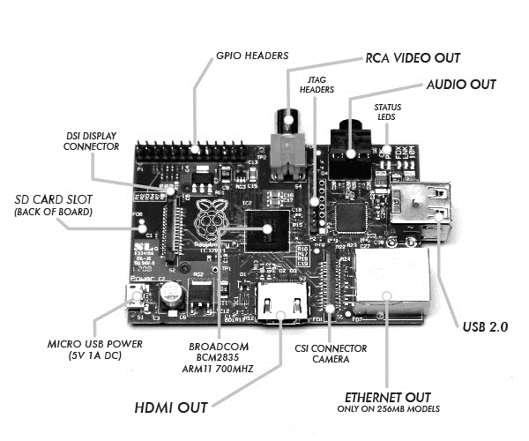
2.1.2 A BRIEF DESCRIPTION OF SOME COMPONENTS ON THE PI
- SD Card
The Raspberry Pi hasno on-board storage option. The operating system is loaded on an SD card which is inserted into the SD card slot on the Raspberry Pi. The operating system can be loaded on the card using a card reader from a different computer.

- Wi-Fi Receiver
The Raspberry Pi 3 has a built-in Wi-Fi available on the board. In the last iteration of our project we upgraded the version of Raspberry Pi that we had been using from Raspberry Pi 2 to Raspberry Pi 3, which has a built-in wifi receiver available on the board. This helped us in cutting the cost of the project by removing the USB Wi-Fi receiver that we had been using so far. The wifi also came in handy while transferring images from our mobile phone to the Raspberry Pi for further use.
- USB 2.0
There are four ready to use USB ports available on the Raspberry Pi. We used the USB port to connect our Webcam which we were using as a scanner.

2.2 PYTHON ^{[5]}
Python is a widely used high-level, general-purpose programming language. Python emphasizes on codereadability, and its syntaxes allow programmers to express their logic in relatively lesser lines of code than standard programming languages.This helped us by providing a clean easy-to-read code which further aided the process of debugging.
An important feature of Python is that it has built-in installer for newer packages and modules. The ‘pip installer’ and the ‘easy_install’ module available in the ‘Scripts’ folder of the Python directory were used to install the various modules (like OpenCV, Text-to-Speech etc) on the Raspberry Pi. This feature helped in saving a lot of time which would otherwise have been spent on the searching for the binaries over the internet and installing them using the Linux terminal. Instead, we are able to setup the modules using just a couple of lines of code.

2.3 OpenCV ^{[6]}
OpenCV (Open Source Computer Vision Library) is an open source computer vision software library. OpenCV was created to help facilitate the development of image processing and machine learning system by providing an easy to use API for development of complex computer vision systems.
The library has more than a thousand optimized algorithms, which provide both classic and state-of-the-art computer vision tools which we could use to build an advanced system without the hassle of writing the code for each and every standard algorithm ourselves. Algorithms are available for face recognition, identifying objects, tracking moving objects, finding similar images from an image database, follow eye movements, etc. It is available in most of the high level programming languages like C++, Python, Java and MATLAB.
Here we are using OpenCV to learn implement our Optical Character Recognition System, and also in the pre-processing stage to make the image ready to be fed into the OCR.

2.4 IOT ^{[7]}
The Internet of things is the internetworking of physical devices, vehicles, buildings, and other items—embedded with electronics, software, and network connectivity that enable these objects to collect and exchange data. Each thing is uniquely identifiable through its embedded computing system but is able to interoperate within the existing Internet infrastructure.
Here, we have embedded the features of IoT into our product to allow the syncing of the data generated by different OCR devices into a common online server.

2.5 SPEECH SYNTHESIS ^{[8]}
Speech Synthesis is the construction of human speech, for which the computer system used is called a speech computer or speech synthesizer. Synthesized speech is being created by concatenating pieces of recorded speech that are stored in a database.
A text-to-speech system has two parts: a front-end and a back-end. The front-end does two major tasks. First, it converts raw text containing symbols like numbers and abbreviations into the corresponding of written-out words. The process is called text normalization. Then the front-end assigns phonetic transcriptions to each and every word, which divides and marks the text into units, like phrases, clauses, and sentences. This process is known as text-to-phoneme conversion. The back-end is often referred to as the synthesizer which converts the symbolic language representation into sound.

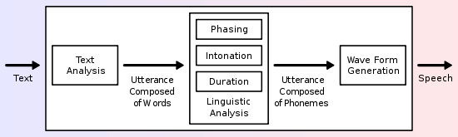

2.5.1 CONCATENATION SYNTHESIS
Concatenative synthesis is based on the stringing together of segments inrecorded speech. In general, concatenative synthesis produces the best natural-sounding synthesized speech. Diaphone Synthesis is most often used.

2.5.1.1 Diphone Synthesis
Diphone synthesis uses a nominal speech database containing all the diphones (sound-to-sound transitions) occurring in a language. The number of diphones depends on the language: for e.g., Spanish has only 800 diphones while German is about 2500. During the process, the prosody of the sentence is superimposed on itusing digital signal processing techniques.

CHAPTER3

WORKING

  - SYSTEM DESCRIPTION:
3.1.1 CONNECTING CAMERA TO RASPBERRY PI

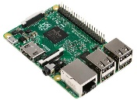
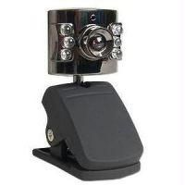
A camera was connected to the Raspberry Pi to take a picture of the document to be scanned.
Python Imaging Library

Following is the code to take a picture using a camera and Raspberry Pi:
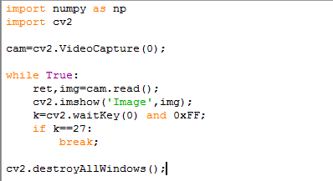

    - OCR (OPTICAL CHARACTER RECOGNITION)
We implemented a non-neural network based OCR System. Following is a block diagram of the OCR System designed:
3.1.2.1 Four Point Transform
It is done to extract the Region of Interest, i.e. the actual document to be scanned from the entire image and straighten the same to make it ready for further processing.
Following are steps to find the region of interest and apply four point transform:
  - Step 1: Detect edges.
  - Step 2: Use the edges in the image to find the contour (outline) representing the piece of paper being scanned.
  - Step 3: Apply a perspective transform to obtain the top-down view of the document.
3.1.2.2 Image Segmentation
Image segmentation is the process of partitioning a digital image into multiple segments (sets of pixels, also known as super-pixels). The goal of segmentation is to simplify and/or change the representation of an image into something that is more meaningful and easier to analyze.

Here, each character is separated into a separate segment.
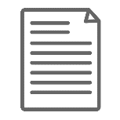
Boxes and Noise Removed
4 Point
Transform
Thresholding
Image

Corrected Image
Raw Image
Segmentation

Select a Segment & Perform 2-D Correlation on each with elements in database
N, A, M, E

Yes
If
Distance > Threshold Distance

Add Space “ ” to string

No
Add Char to string being created

    - TEXT TO SPEECH
Normalisation
Text
Speaker
+
Script

Voice Reference Database

Segmentation

Voice Database
Syntactic Analysis
+
Prosody

Unit Selection

Sound

- In order to reproduce the natural sound of each language, a narrator records a series of texts (poetry, political news, sports results, stock exchange updates, etc.) which contain every possible sound in the chosen language.
- These recordings are then sliced and organized into an acoustic database.
- During database creation, all recorded speech is segmented into some or all of the following: diphones, syllables, morphemes, words, phrases, and sentences.
- To reproduce words from a text, the TTS system begins by carrying out a sophisticated linguistic analysis that transposes written text into phonetic text.
- A grammatical and syntactic analysis then enables the system to define how to pronounce each word in order to reconstruct the sense. We call this the prosody: it gives the rhythm and intonation of a sentence.
- Finally, the system produces information associating the phonetic writing with the tone and required length of the pronunciation. The chain of analysis ends here and sound is generated by selecting the best units stocked in the acoustic database.

CHAPTER 4
WORKING MODEL

- Original Image taken from mobile phone Camera or Scanner

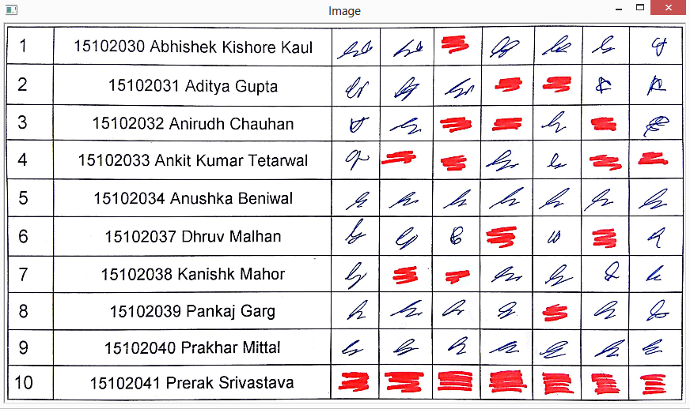

- Grayscale Image

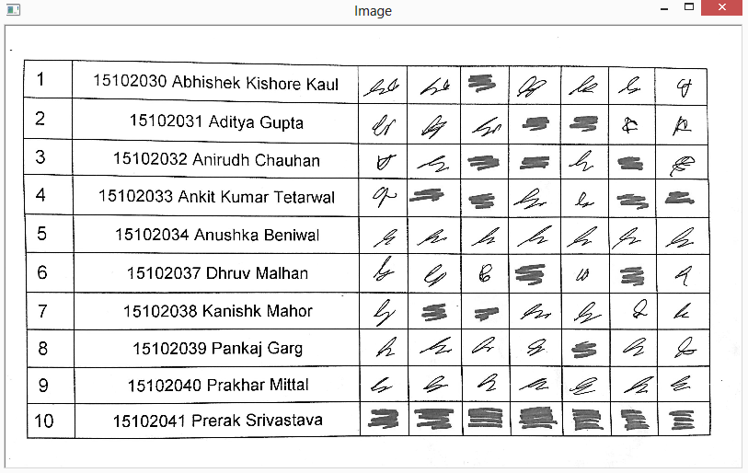
- Largest contour of Image

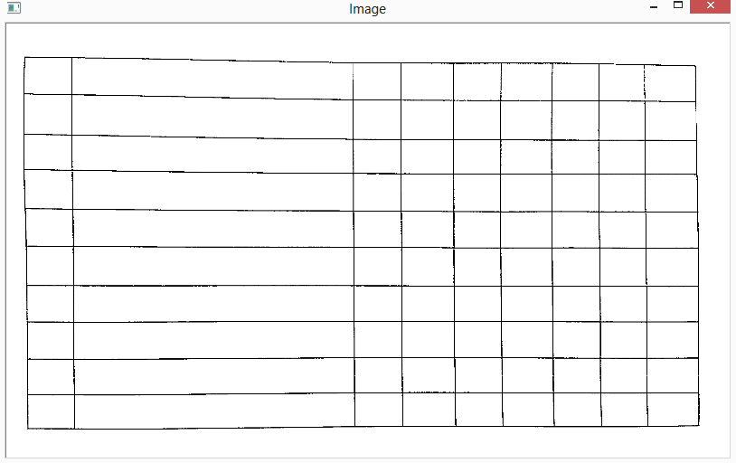

- Dilated Largest Contour

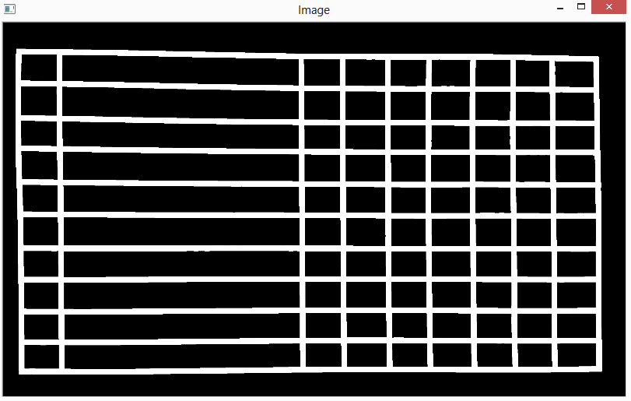

- Warped Image

- Traversing each cell

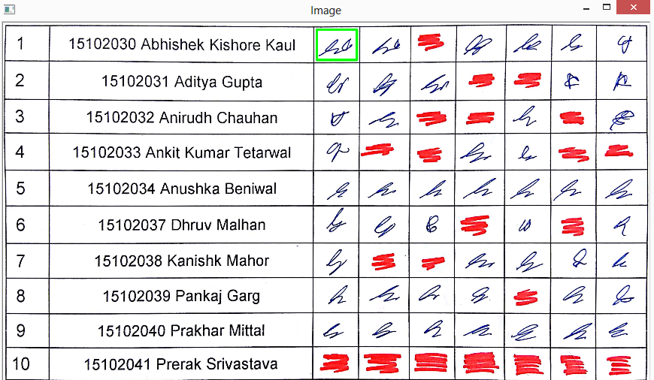
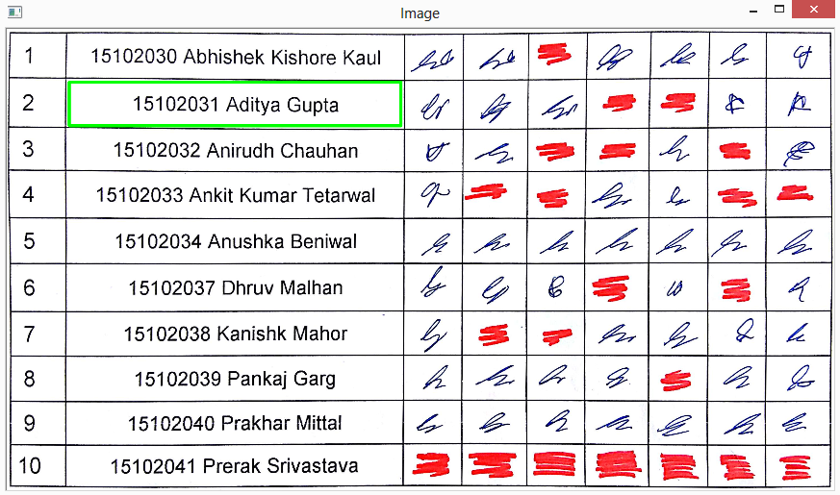

- Fiinal Result
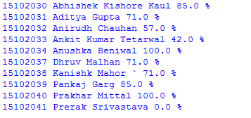

CHAPTER 5
CONCLUSION

The project is in semi-complete stage at the time of production of this report.
- The Optical Character recognition software and the Text-to-Speech conversion software has been implemented without a neural network and checked on a small number of test cases. Improvements and further work are required to improve the accuracy of the same.
- The feature of uploading the document to the web and making them available to be viewed in a tabulated database has been successfully completed.

CHAPTER 6
FUTURE WORK

- The algorithm developed in this project can later be implemented in an Android Application.
- The OCR can be extended to recognize hand-written data.
- The system can be adapted to build the following:
  - Automated ticketing machine
  - ID Proof Verification Device
  - Expense Tracker
  - Automated Form Reading

APPENDIX

[1] en.wikipedia.org/wiki/Optical_character_recognition
[2] Shalin A. Chopra , Amit A. Ghadge ,Onkar A. Padwal , Karan S. Punjabi , Prof. Gandhali S. Gurjar, “Optical CharacterRecognition”, International Journal of Advanced Research in Computer and Communication Engineering Vol. 3, Issue 1, January 2014.
[3] AyatullahFarukMollah ,NabamitaMajumder ,SubhadipBasu ,MitaNasipuri , “Design of an Optical Character Recognition System for Camera based Handheld Devices” , IJCSI International Journal of Computer Science Issues, Vol. 8, Issue 4, No 1, July 2011.
[4] https://www.raspberrypi.org/
[5] https://en.wikipedia.org/wiki/Python_(programming_language)
[6] http://opencv.org/about.html
[7] https://en.wikipedia.org/wiki/Internet_of_things
[8] https://en.wikipedia.org/wiki/Speech_synthesis
[9] Jacob A. Benfield, William J. Szlemko, “Internet-Based Data Collection: Promises and Realities”, Journal of Research Practise Volume 2, Issue 2, Article D1, 2006.
[10] “Digital Image Processing”, 3rd Edition by Rafael C. Gonzalez, Richard E. Woods.

101, Aashirwaad Aangaan, PRIYANK LALPURIA plalpuria@gmail.com
Indra Vihar, Kota, Rajasthan. + 91-7838097163

CAREER OBJECTIVE

To be a part of an organization where I can fully utilize my skills and make a significant contribution to the success of the employer and at the same time my individual growth.

EDUCATIONAL QUALIFICATION
 | Degree | Discipline | Institute | Year | CGPA / Percentage
 | Bachelors of | Electronics & | Jaypee Institute of Information | 2017 | 8.2/10
 | Technology (B.Tech) | Communication | Technology, Sector 62, Noida | (Expected) | (As of 7th Semester)
 | Senior Secondary | CBSE | Modern Senior Secondary School, Kota | 2012 | 79.40 %
 | High School | CBSE | Modern Senior Secondary School, Kota | 2010 | 8.8/10

INDUSTRIAL EXPERIENCE
Bharat Electronics Limited, Ghaziabad, India [June ’16 - July ’16]
- Had a training on basics knowledge involved in radar communication, quality control and workspace organisation methods (5S Methodology).In addition to it, built a basic project report on radar communication.
TECHNICAL & INDUSTRY SKILLS

- Programming languages: Basic C/Java, Embedded C, MySQL.
- Areas of Interest: Embedded Systems, Robotics, Project Management.
                - Software Packages: MATLAB, Cadence OrCAD, Arduino IDE, Atmel Studio, T-Spice, L-Edit, Proteus, AdobePhotoshop, AdobeIllustrator.
- Hardware Skills: Arduino Development Board, Atmega 328, Atmega 8, PCB Fabrication & Soldering.
ACHIEVEMENTS & HONORS

- Second Prize in Plethora, a Project Exhibition Event duringTROIKA-2015, the Technical fest of Delhi Technical University.
- Second Prize in Robocon, an Autonomous Robotics Event duringESYA-2014, the Technical fest of IIIT-Delhi.
- First Prize in Robo-Hustle, a Manual Robotics Event during COLOSSUS-2014, the Technical Fest of Amity School of Engineering & Technology.
- Second Prize in Project Exhibition, duringCyber Srishti-2017, the Annual technical fest ofJIIT,Noida.
- Second Prize in Chakravyuh, an On-Spot Microcontroller Coding Challenge Event duringImpression-2017, the Annual fest ofJIIT,Noida.
- Certificate of Participation in Apexo-WildCard Event during TECHFEST-2013, the Technical fest of IIT-Bombay.
- First Prize for Best Junior Jaycee Event (2009) in lieu oforganising Trade Fair for Students at Kota by JCI India.
- Third Prize inUCMAS State Competition (2005), Rajasthan.
- Certificate of Participation and Passing of International Standard of Abacus Computation (2005) Proficiency Examination by UCMAS, Malaysia.
KEY PROJECTS UNDERTAKEN

SELF TRANSAFORMING ROBOT

- The Aim of the project is to make a robot which transforms itself into various shapes such that it overcomes the obstacle in front of it .The robot deals with four obstacles:
T1. Slope of maximum 45 degrees T2. Passage of fixed height T3. Staircase T4. Irregular surface
The versatility of the robot can serve as a bench mark for building large scale automated machines for military and space research.

SEPOY: AN AUTOMATIC TURRENT PROTOTYPE

- The Aim of the project was to fire a laser (prototype of a Gun) to any intruder in territory at Borders. The system features an automated laser gun and a camera. It uses variousimage processing algorithmsto detect and track any intrusion in the territory. The turret is then turned in the appropriate direction to aim at the intruder and a laser is fired thereafter.

SPREADSHEET SCANNER

- The project aims to build a system that reads the text from a document picture (.jpg/.png) , interpret and uploads the data in the appropriate table in the online database.
HEALTH MONITORING SYSTEM

- An app that measures the heart rate using a smartphone camera. The measured data is stored in the database to provide a more insightful understanding of the person's heart rate patterns.
Developing using: Android, MATLAB Signal Processing Toolbox
And many more …….
EXTRA CURRICULAR ACTIVITIES

- Head Student Coordinator of μCR, Micro-Controller based Robotics Hub for session 2015-16.
- Manager at Cyber Srishti-2016, an Annual Technical Festival of JIIT, Noida.
- Head Student Coordinator at ICSA-2017 (International Conference on Peaceful and Prosperous South Asia Opportunities and Challenges) at JIIT, Noida.
- Organizer of Event SPACEPUNK, an Autonomous Robotics Event at IMPRESSIONS-2016, Annual Festival of JIIT, Noida.
- Volunteer at International Conference on Signal Processing & Communication (ICSC-2015), IEEE at JIIT, Noida.
- Volunteer at International Conference of Contemporary Computing (IC3-2015) at JIIT, Noida.
- Participated in Jaypee Youth Parliament as a Member of Opposition in LokShabha at Jaypee Youth Parliament, 2013.
- Directorat JCI Kota Achiever for session 2010-11.
- Junior Jaycee President at JCI Kota Dynamic for session 2009-10.
- Independent Coursework: Graduate- UCMAS, Malaysia.

PERSONEL PROFILE

Name : Priyank Lalpuria
Father’s Name : CA Pawan Kumar Lalpuria
Date of Birth : 30-06-1994
Gender : Male
Nationality : Indian
Languages Known : English, Hindi.
Hobbies : Listening Music, Playing Chess or Cricket.

DECLARATION

I hereby declare that the information and facts stated above are true and correct to the best of my knowledge and belief.

Place: Noida (Priyank Lalpuria)

D-19 VivekanandPuri | SUHRID SRIVASTAVA | suhrid.srivastava@gmail.com
Lucknow, Uttar Pradesh. |  | + 91-9810672924

CAREER OBJECTIVE
To be an innovator and make successful contribution in the field of technology by delivering the best in class technical skills and fostering innovation practices.

EDUCATIONAL QUALIFICATION

Degree | Discipline | Institute | Year | Marks (%)
Bachelor of Technology | Electronics & Communication | Jaypee Institute of Information Technology | 2017 (Expected) | CGPA 6.6 (As of 7th Semester)
Intermediate | ISC | La Martiniere College, Lucknow | 2012 | 91.75%
High School | ICSE | La Martiniere College, Lucknow | 2010 | 95.4%

INDUSTRIAL EXPERIENCE
- Electro-med, Lucknow, India: Product Development Intern June ’15 - July ’15
Under the supervision of MrPushkar Srivastava, I developed various software programs in Embedded C for microcontroller AT89S52. I also designed the PCBs and the other hardware for the same. The key projects undertaken were:
1. Line frequency monitor accurate to 2 decimal places.
2. Day countdown system.
The products designed by me are now in commercial production.

TECHNICAL &INDUSTRY SKILLS
- Programming languages: Basic C / Java, Python, Embedded C, Assembly.
- Areas of Interest: Embedded Systems, Robotics, Drones.
- Software Packages: Arduino IDE, Eagle, Adobe Photoshop, MATLAB, Cadence ORCAD, TSPICE.
- Hardware Skills: Arduino Development Board, ATMEGA328, AT89S52, PCB Fabrication & Soldering.

KEY PROJECTS UNDERTAKEN
- HEART RATE MEASURING SYSTEM
The aim of the project was to design a system capable of computing the heart rate of a person using video from a Smartphone camera. It was achieved by a implementing a series of digital filters to remove the ambient noise and examining the frequency response of the signal.
- SELF-TRANSFORMING ROBOT
A robot capable of transforming itself into various shapes to travel on the following types of terrain:
i. Slope of maximum 45 degrees | ii. Passage of a fixed height
iii. Block of a fixed height | iv. Irregular surface
Received a Letter of Appreciation from Prof R C Jain, Head of Department, ECE, JIIT-Noida.
- GRID SOLVING ROBOT
A versatile line following robot capable was made.
v1: Simple line following robot.
v2: Solve a maze using the Left Hand Wall Algorithm
It also had the capability to pick objects from target node autonomously.

ACHIEVEMENTS
- First Prize in Robocon, an Autonomous Robotics inter-college event at IIIT Delhi.
- First Prize in Grenadizer, a Manual Robotics inter-college event at JIIT, Noida.
- First Prize in Robo Hustle, a Manual Robotics event at Amity School of Engineering and Technology.
- Second Prize in Plethora, an inter-college Project exhibition contest at Delhi Technical University.
- Finalists in Canyon Rush, a Manual Robotics Event at IIT Kharagpur.

EXTRA CURRICULAR ACTIVITIES
- Head Student Coordinator of µCR, Micro-Controller based Robotics Hub. (Aug’15 to Present)
- Joint Secretary of IEEE Student Branch STB-01711. (Aug’15 to Present)
- Senior Prefect at La Martiniere College. (Aug’10 to March ’12)
- Sub Editor of College Magazine, ‘The Martiniere Post’. (April ’11 to March ‘12)

