Agile Group Project

**By**

**Lovepreet**

**Sahil**

**Gurpreet**

**Sukhpreet**

Contents

Introduction 3

Project Members 4

Gantt Chart 4

Agile Methodology 5

Pages and Mock-ups 6

Home Page 6

News Page 7

Testing 8

Conclusion and future Work 8

# Introduction

The main aim of this project is the design of an agile / scrum mobile application. We have created an application for finding the **New Zealand National News** using RestSharp API. RestSharp is an all-around HTTP client library open source that deals with DotNet technologies of all kinds. This makes it possible to build scalable software by leveraging shared APIs and quickly gaining access to data without the pressure of handling raw HTTP requests. RestSharp blends many benefits with a smooth, simple interface that makes it one of the hottest REST apps today.

REST providers are an ever more popular model for network construction because of their accessibility and their intrinsic agnostic approach to the platform. Many of the major REST service providers, including Google, Instagram, Facebook, etc. REST makes stateless, cacheable, and easy to use HTTP client-server architecture.

To view government-related news from Herald, we used REST API, where xml feed is used as data. To view the data, the xml must be deserialised. Deserialization is used to convert data bytes like XML or binary information into object type. Serialisation is the process by which an object is converted into a form that can be transported easily.

For example, You can serialise an object and move it through the Internet using HTTP between a client and a server. On the other hand, deserialization reconstructs the stream object. XML serialisation results in strictly specified public property classes and fields that are translated for storage or transport to serial format (in this case, XML). For deserialize XML, you need a class for label the XML document that you would like to read.

In this NZ National News, We access the RSS feed from the NZ herald website: <http://www.nzherald.co.nz/rss/> and use the <http://rss.nzherald.co.nz/rss/xml/nzhrsscid_0000000001.xml> feed for National News.

In this app there are two main screens one is design screen which highlights the various news related with rugby, when user click or select a news the article page displays the whole news article.

# Project Members

In order to increase the effectiveness of the application, five team members are participating in a different role that is given in the below table:

|  |  |
| --- | --- |
| Name of team Member | Role |
| Gurpreet | Team Leader |
| Sahil | Front End Developer |
| Sukhpreet | Web Designer |
| Sahil | Back End Developer (API) |
| Lovepreet | Application Tester |

# Gantt Chart

|  |  |  |  |  |  |  |  |  |  |  |  |  |  |  |  |
| --- | --- | --- | --- | --- | --- | --- | --- | --- | --- | --- | --- | --- | --- | --- | --- |
| **Stages** | **Activities** | **Duration**  **Week1-2** | | | | **Duration**  **Week-2-3** | | | | | **Duration**  **Week-3-4** | | | | |
| Project Planning | Research |  |  |  |  |  |  |  |  |  |  |  |  |  |  |
| Start of Meeting |  |  |  |  |  |  |  |  |  |  |  |  |  |  |
| Project Proposal and documentation |  |  |  |  |  |  |  |  |  |  |  |  |  |  |
| Project Execution | Application Design |  |  |  |  |  |  |  |  |  |  |  |  |  |  |
| UI Design |  |  |  |  |  |  |  |  |  |  |  |  |  |  |
| coding |  |  |  |  |  |  |  |  |  |  |  |  |  |  |
| Testing |  |  |  |  |  |  |  |  |  |  |  |  |  |  |
| Final | Documentation and Report |  |  |  |  |  |  |  |  |  |  |  |  |  |  |

# Agile Methodology

The Agile approach is used as an alternative to traditional methods in this project. This strategic approach is highly effective and pragmatic and tackles the changing needs of the technology.

In this project, our group used the agile / scrum approach. At the beginning, the team members define and fulfil all criteria. The team then decided to implement the special feature of the Rugby News application in order to meet the needs of users.

Many improvements have been made to make this programme more user-friendly. After all enhancements have been made, the app is available for the use of users.

# Pages and Mock-ups

## Home Page

This is the main page of the application. On this page there are various bulletins related to **New Zealand National News** User can select any news of their choice and click on that news in order to read the news in more detail.

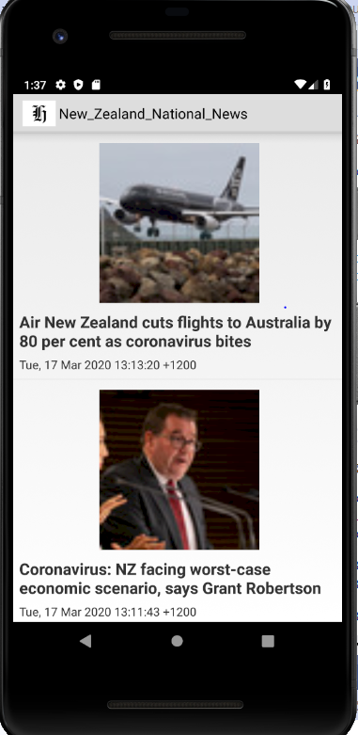

## News Page

With the help of this page user can read the whole news in detail. When your click on the news in the home/design page, it will lead to the news page.

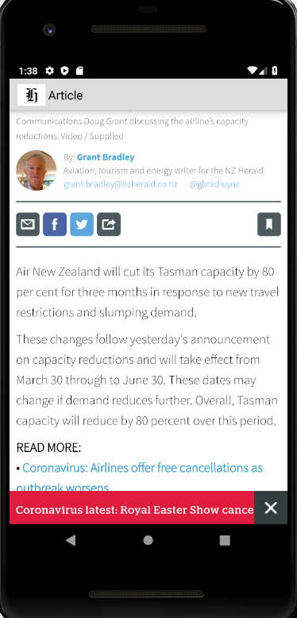

# Testing

Because of the limited time available, we have just carried out the project usability check which can be found at [usability test.xlsx](usability%20test.xlsx)

# Conclusion and future Work

Briefly, this project is based on an agile scrum strategy in which the IT community developed the Android application NZ National News. Because of the short time, we just create a small application. Nonetheless, this framework can be further enhanced, and additional features can be introduced, such as categories different types of news and delivering all news in one application.