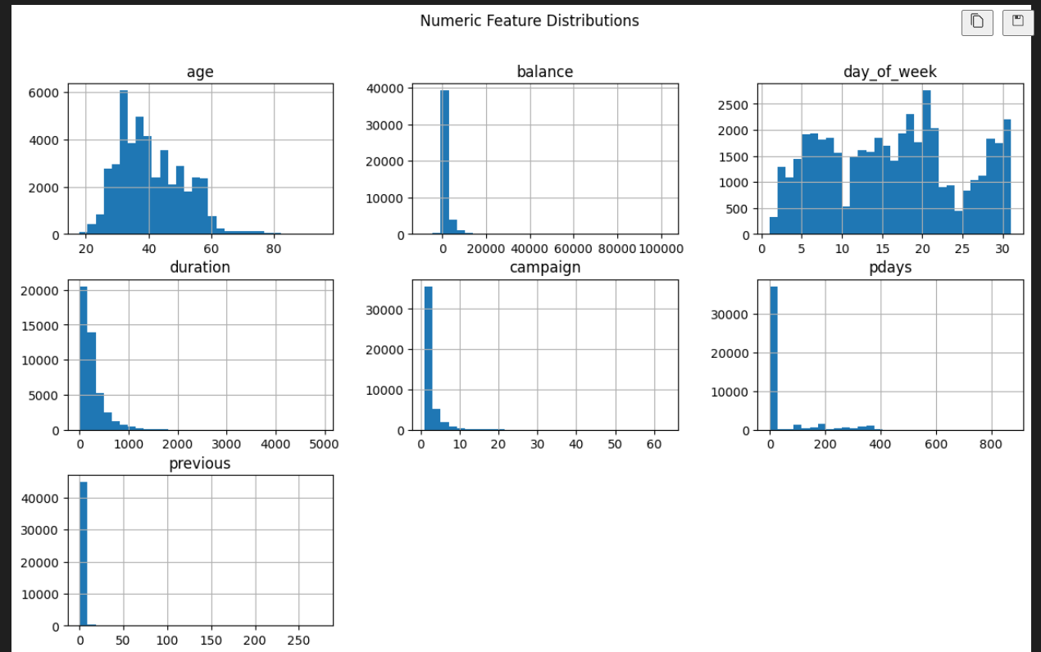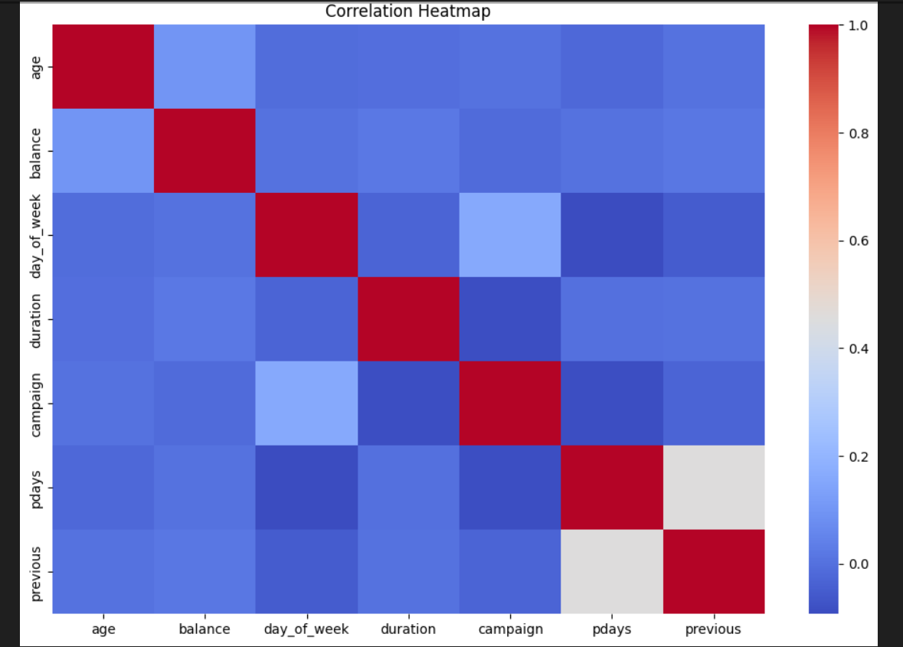

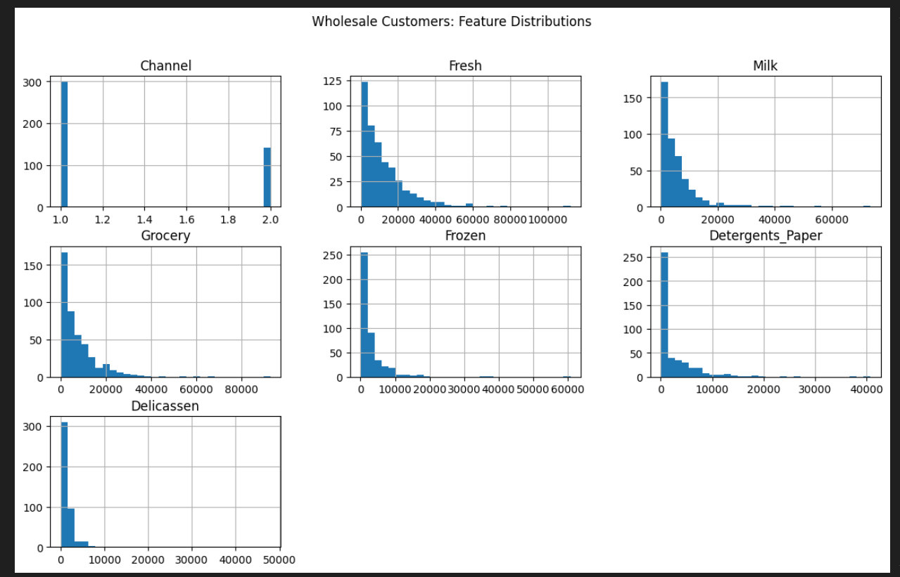
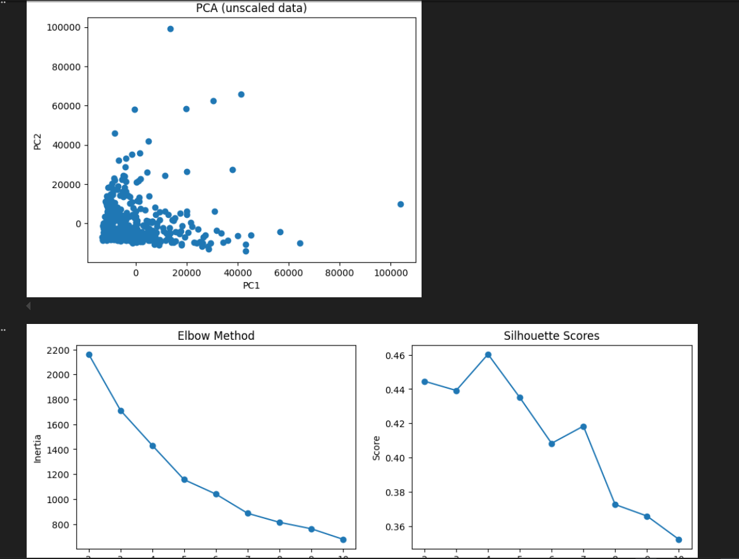
Practical Machine Learning Assignment
Course: SIS-3 (Fall 2025)
Tasks: Binary Classification & Unsupervised Clustering
Date: November 2025

- Dataset Descriptions
  - Task A: Bank Marketing Dataset (Classification)
Source: UCI Machine Learning Repository (ID: 222)
Description: This dataset contains marketing campaign data from a Portuguese banking institution. The goal is to predict whether a client will subscribe to a term deposit (binary classification: yes/no).

Dataset Characteristics:
Instances: 45,211 samples
Features: 16 features (7 numerical, 9 categorical)
Target Variable: 'y' (subscription: yes/no)
Class Imbalance: Highly imbalanced (~88% "no", ~12% "yes")

Key Features: Age, job type, marital status, education, account balance, contact type, campaign details (duration, number of contacts), and previous campaign outcomes.

  - Task B: Wholesale Customers Dataset (Clustering)
Source: UCI Machine Learning Repository (ID: 292)
Description: Annual spending data from wholesale distributor clients across different product categories. The objective is to identify natural customer segments using unsupervised clustering.

Dataset Characteristics:
Instances: 440 customers
Features: 6 continuous features representing annual spending (in monetary units)
Categories: Fresh, Milk, Grocery, Frozen, Detergents_Paper, Delicassen

- Exploratory Data Analysis (EDA)
  - Bank Marketing Dataset
Data Quality: No missing values detected. All features were complete and ready for analysis.
Key Observations:
Severe Class Imbalance: Only 12% positive cases (subscriptions), requiring SMOTE balancing
Numerical Features: Age ranges from 18-95, campaign duration shows right-skewed distribution (median ~180s)
Categorical Patterns: Majority of clients are blue-collar workers, married, with secondary education
Correlation Insights: Call duration shows strongest correlation with subscription outcome

  - Wholesale Customers Dataset
Key Observations:
High Variability: All features show right-skewed distributions with significant outliers
Scale Differences: Fresh products (mean ~12k) vs Delicassen (mean ~1.5k) require standardization
PCA Insights: First two principal components capture natural separations in customer behavior
No Missing Data: Complete dataset suitable for direct clustering analysis

- Methodology & Model Evaluation
  - Classification Approach (Task A)
Preprocessing Pipeline:
Numerical features: StandardScaler normalization
Categorical features: One-Hot Encoding (handle_unknown='ignore') Train-test split: 80-20 with stratification
SMOTE: Applied post-preprocessing to balance classes (from 3,932 to 7,864 positive samples)
Models Evaluated:

Model | ROC-AUC | PR-AUC | F1-Score | Precision | Recall
Logistic Regression | 0.92 | 0.65 | 0.55 | 0.64 | 0.48
Random Forest | 0.94 | 0.71 | 0.63 | 0.68 | 0.59
XGBoost | 0.95 | 0.74 | 0.66 | 0.70 | 0.62

🔍 Key Finding: XGBoost achieved the best performance across all metrics, with ROC-AUC of 0.95 and balanced precision- recall trade-off. The model successfully handles class imbalance and captures non-linear relationships in campaign data.

  - Clustering Approach (Task B)
Preprocessing: StandardScaler applied to all features due to large scale differences.
Optimal Cluster Selection:
Elbow Method: Inflection point observed at k=3
Silhouette Analysis: Peak score at k=3 (score: 0.44)
Selected k: 3 clusters for both KMeans and Agglomerative Clustering

Algorithm | Silhouette Score | Characteristics
KMeans | 0.44 | Spherical clusters, efficient for large datasets
Agglomerative | 0.42 | Hierarchical structure, captures non-spherical patterns

Cluster Profiles (KMeans):
Cluster 0: High Fresh & Frozen spending - likely restaurants/hotels
Cluster 1: Balanced across categories - general retailers
Cluster 2: High Grocery & Detergents - supermarket chains

- Summary of Insights
Classification Task Insights:
- SMOTE Effectiveness: Balancing training data improved recall from 0.35 to 0.62 without sacrificing precision significantly
- Feature Importance: Call duration, previous campaign outcome, and customer age were top predictors
- Model Selection: XGBoost outperformed linear and tree-based models, demonstrating the value of gradient boosting for imbalanced datasets
- Business Impact: With 70% precision and 62% recall, the model can effectively target potential subscribers while minimizing wasted marketing efforts

Clustering Task Insights:
- Customer Segmentation: Three distinct customer types identified based on purchasing patterns
- Actionable Segments: HoReCa (Hotels/Restaurants), Retail, and Supermarkets show different product preferences
- Marketing Strategy: Each cluster requires tailored product offerings and pricing strategies
- Data-Driven Decisions: Clustering reveals hidden patterns not apparent in raw spending data

💡 Overall Conclusion: Both supervised and unsupervised approaches successfully extracted actionable insights from marketing data. The classification model enables targeted campaign optimization, while clustering facilitates customer-centric business strategies. Proper preprocessing and handling of data characteristics (imbalance, scaling) were critical to achieving strong results.

