Methodological Figure
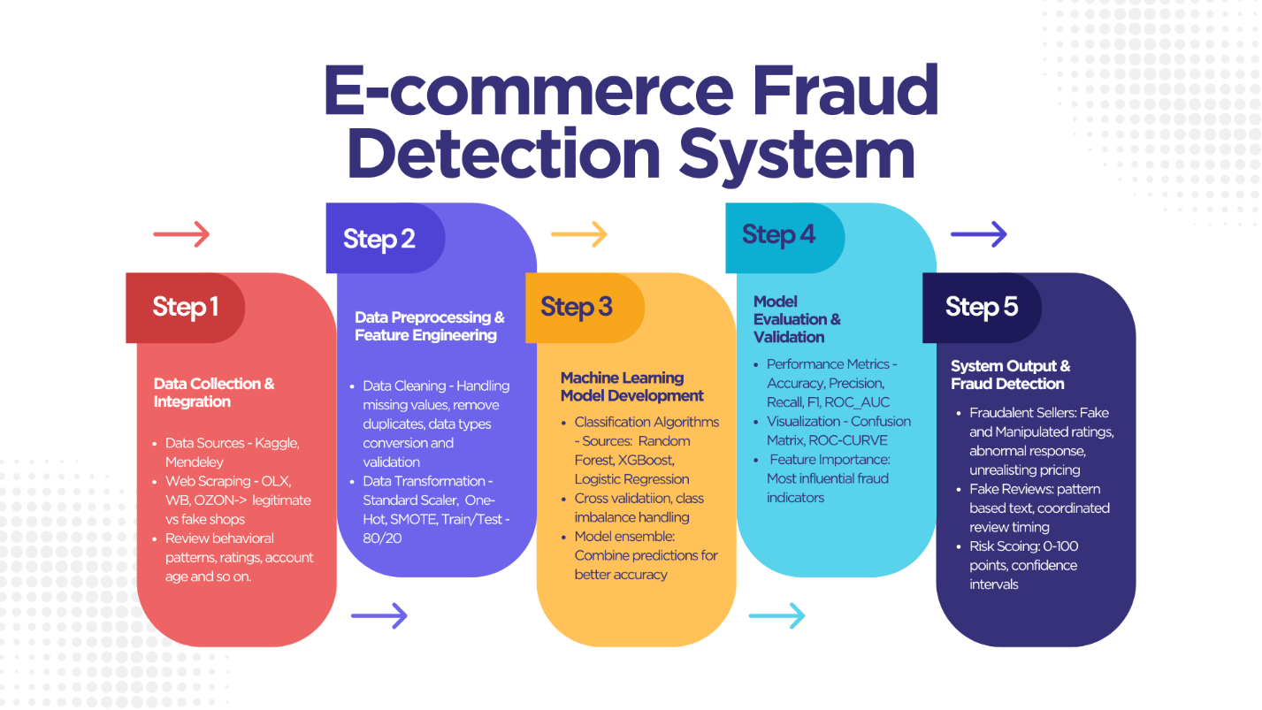
Entity Relationship Diagram
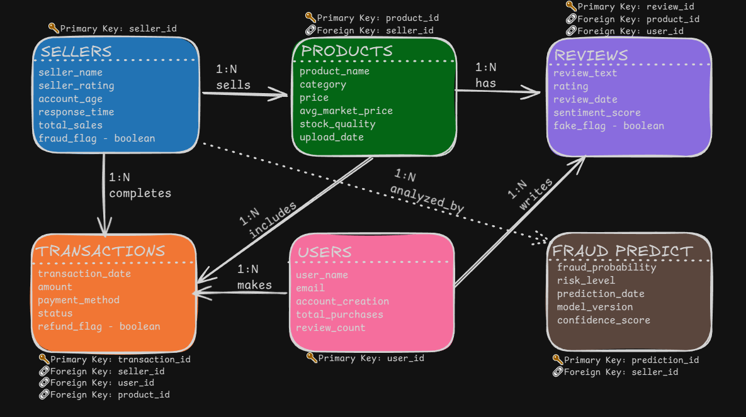
🔑 Primary Key (Unique identifier) | 🔗 Foreign Key (reference to another table)
1:N : One-to-Many Relationship
Solid lines: Direct data relationships | Dashed lines: Prediction relationships
Each entity stores specific attributes for comprehensive fraud detection and analysis across the e-commerce platform

