Class: CMSC203 CRN 25800

Program: Assignment 3 Design

Instructor: Grigoriy Grinberg

Summary of Description: Allows users to encrypt and decrypt inputted strings via the the Caesar and Bellaso Cipher.

 Due Date: 10/05/2020

 Integrity Pledge: I pledge that I have completed the programming assignment independently.

 I have not copied the code from a student or any source.

Student: Sereen Sultana

Assignment 03: Cryptography-Pseudocode

1. Create the method stringInBounds:
   1. Create the variable boolean boundary that returns false as default.
   2. Enter a FOR loop when the index, beginning at 0, is less than the length of the string input.
   3. Boolean boundary returns true when the character at the index is higher than or equal to the LOWER_BOUND and is lower than or equal to the UPPER_BOUND.
   4. Return the variable boundary.
2. Create the method encryptCaesar:
   1. Create an integer variable to measure the length of the text wanting to encrypt.
   2. Create a FOR loop that loops for each letter within the text that needs to be encrypted.
      1. Create a variable that holds the character of the text wanting to be translated, and add the key.
      2. If the variable is now above the UPPER_BOUND, subtract it from the range.
   3. Return the encrypted text.
3. Create the method encryptBellaso:
   1. Create a string for the encrypted text.
   2. Create an integer to measure the length of the Bellaso encrypted key.
   3. Enter the text that needs to be encrypted into a FOR LOOP that measures the length of the string and enters each character into the loop and encrypts it.
   4. WHILE the encrypted character is less than the lower bound, add the encrypted character to the range.
   5. Return the encrypted text.
4. Create the method decryptCaesar:
   1. Create an integer variable to measure the length of the text wanting to decrypt.
   2. Create a FOR loop that loops for each letter within the text that needs to be decrypted.
      1. Create a variable that holds the character of the text wanting to be translated, and subtract the key.
      2. If the variable is now below the LOWER_BOUND, add it to the range.
   3. Return the decrypted text.
5. Create the method decryptBellaso:
   1. Create a string for the decrypted text.
   2. Create an integer to measure the length of the Bellaso encrypted key.
   3. Enter the text that needs to be decrypted into a FOR LOOP that measures the length of the string and enters each character into the loop and decrypts it.
   4. WHILE the decrypted character is less than the lower bound, add the decrypted character to the range.
   5. Return the decrypted text.

Test Table

|  |  |  |  |  |  |  |  |
| --- | --- | --- | --- | --- | --- | --- | --- |
| Case # | Input Text | Input Key | Encrypted (method1) | Encrypted (method2) | Decrypt (method1) | Decrypt (method2) | Pass: Yes or No |
| 1 | Testing | Caesar Cipher | Whvwlqj |  | Testing |  | Yes |
| 2 | Can you read a & or must I type out and? | Caesar Cipher | Fdq brx uhdg d ) ru pxvw L wbsh rxw dqgB |  | Can you read a & or must I type out and? |  | Yes |
| 3 | TESTING THIS | Bellaso Cipher |  | G8FG<A:SG;<F |  | TESTING THIS | Yes |
| 4 | DECODE &&&& | Bellaso Cipher |  | 786B78SYYYY |  | 786B78SYYYY | Yes |

Screenshots

Case 1

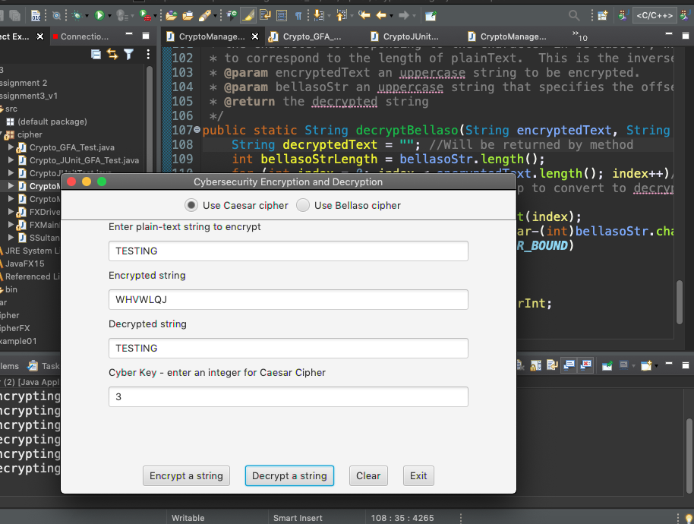

Case 2

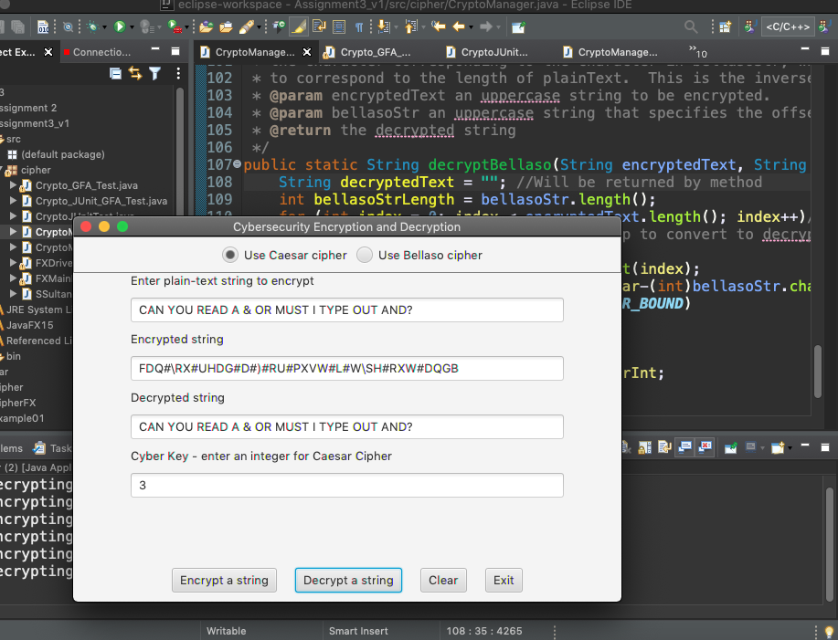

Case 3

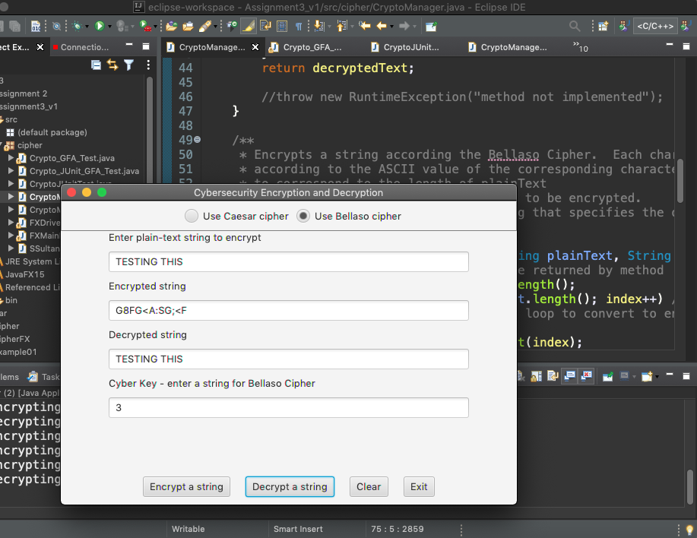

Case 4

