Assignment #3
Responsive Web Design
Sultan Sekerkhanov • IT-2512

Task 1. Media queries by hand
For Task 1 I created the “Players to watch” section without Bootstrap layout classes. I used CSS Grid and mobile-first media queries. On a phone there is one card in a row, on a tablet there are two cards, and on a laptop there are three cards. At the laptop breakpoint the cards also change from a horizontal layout to a centered vertical layout.
Breakpoints used: 600px and 992px. The base style is for mobile, so the page starts with one column and wider screens add columns.
375px viewport preview:
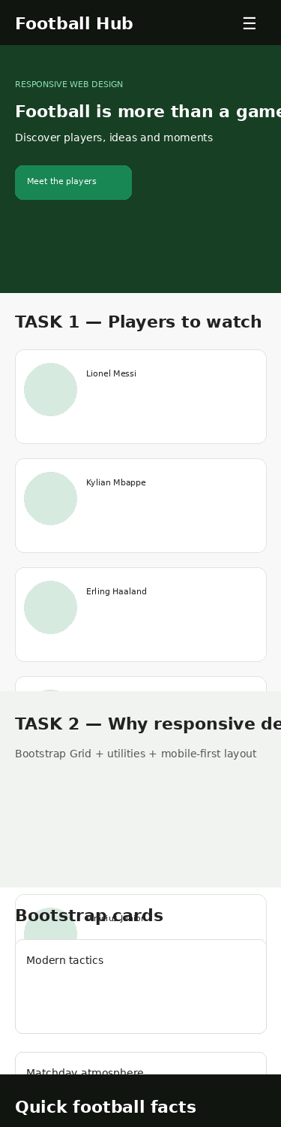
768px viewport preview:
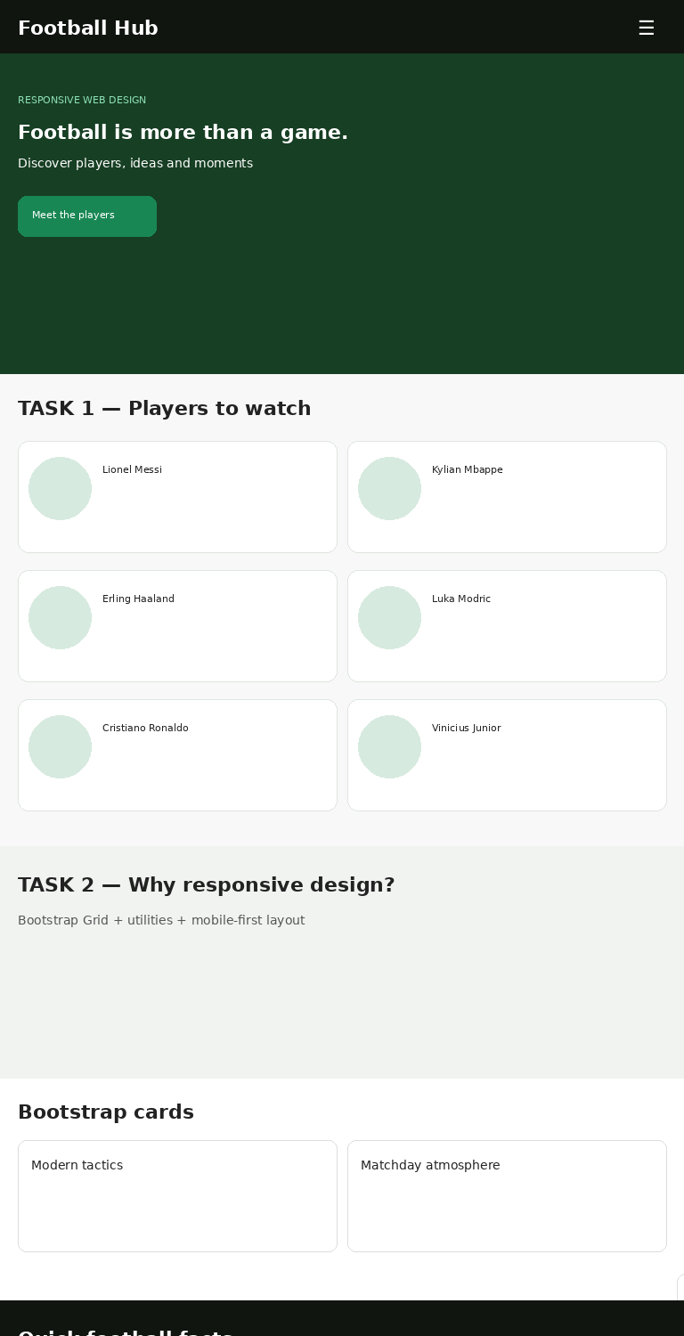
1280px viewport preview:
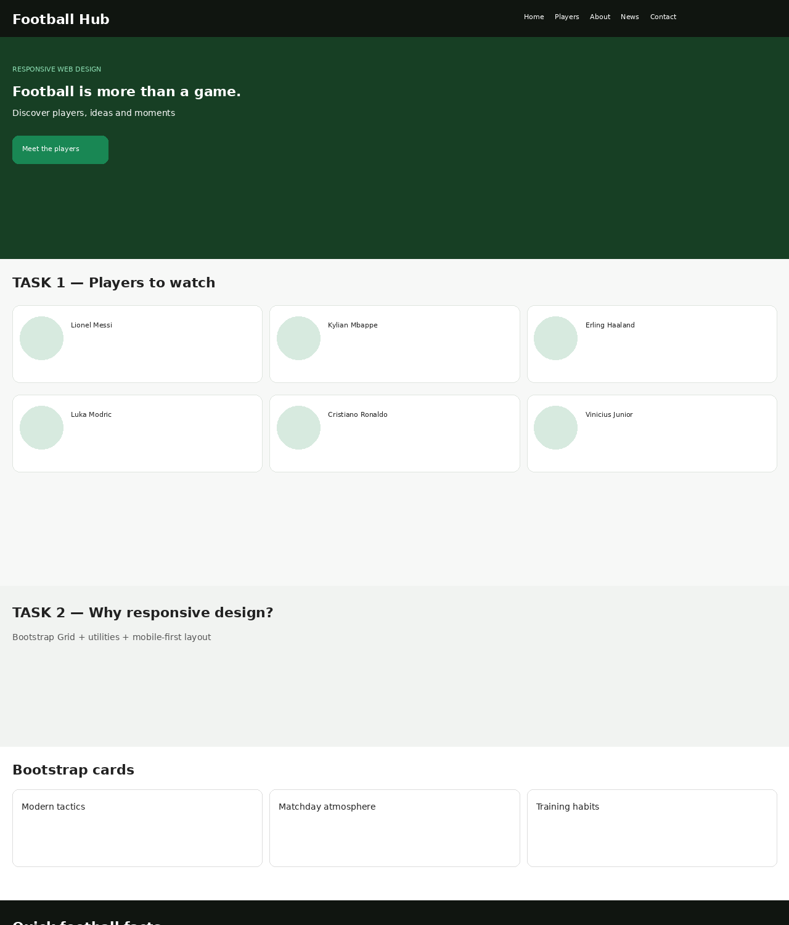

Task 2. Bootstrap grid and components
The other sections use Bootstrap 5.3. I used container, row, col-* and order-* classes, responsive utility classes and a collapsing navbar. The news section has Bootstrap cards with 1 column on phones, 2 on tablets and 3 on larger screens. The page also contains an accordion and a modal. The hero and About sections use order classes so the important text appears first on small screens.
A small note is hidden on large screens and shown on smaller screens with d-lg-none. The Bootstrap JavaScript bundle is included before the closing body tag so the navbar, accordion and modal work.

Task 3. Comparison
Point | My CSS / Media Queries | Bootstrap Grid
Amount of code | More custom CSS is needed for the player cards and breakpoints. | Less layout CSS because Bootstrap provides grid classes and utilities.
Control over design | More direct control over card layout, spacing and the change from horizontal to vertical cards. | Fast and consistent, but some design choices follow Bootstrap defaults.
Speed of work | Takes more time because the breakpoints and layout rules are written manually. | Faster for common responsive layouts because container/row/col classes are ready.
Example from this page | Players section uses .players-grid with 1 / 2 / 3 columns. | News cards use col-12 col-md-6 col-xl-4.
I would choose custom media queries when I need detailed control over one special section. I would choose Bootstrap when I need to build a responsive layout quickly and want ready-made components such as a navbar, cards, accordion or modal.

Conclusion
In this assignment I learned how to make a page responsive in two different ways. I practiced mobile-first CSS media queries and Bootstrap breakpoints, columns, ordering and utilities. I also learned that Bootstrap is faster for common layouts, while custom CSS gives more control over a special design.

GitHub repository
[PASTE YOUR GITHUB REPOSITORY URL HERE]
The source files are in the GitHub repository. The repository should contain index.html, style.css, assets/, README.md and this report file.

Defense notes
- Task 1 uses only my own CSS Grid and @media (min-width: ...).
- 600px changes the player grid from 1 to 2 columns; 992px changes it to 3 columns and changes card alignment.
- Task 2 uses Bootstrap container, row, col-*, order-*, d-none/d-lg-none and utility classes.
- The navbar collapses on small screens using Bootstrap JavaScript.
- The cards use col-12 col-md-6 col-xl-4, so they become 1 / 2 / 3 columns.
- The modal and accordion are Bootstrap components.
- Bootstrap CSS is loaded first and style.css is loaded after it so my CSS can override Bootstrap when needed.

