**Calculating Simple LTV for Shutterfly customers & Select Top X customers**

**Coding language :** Python

To execute the job you have to start with ltvcalc.py which will call all required method



ltvcalc.py will run from command line and it will take two parameters

1) Data file ( event.txt) - Its a json file with customer information

**Sample data :**

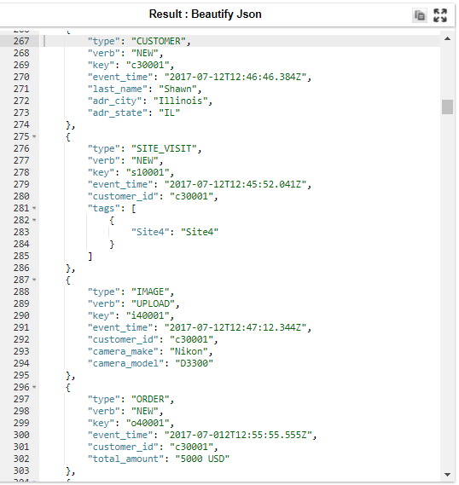

2) Number of customer ( 7) : Needs to provide number of customer you want to select from data set

**Error Handling:**

1. Executable code has been written in try except block so that we can get right error.

Divide by zero is handled while calculating the number of visits.

2. Add some validation for divided by zero also add some validation on number of argument.

**Test case:**

1. Execute with bad data:

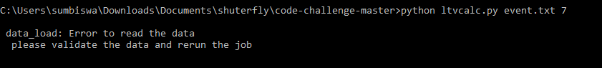

1. Execute with less number of parameter :



1. Positive test case :

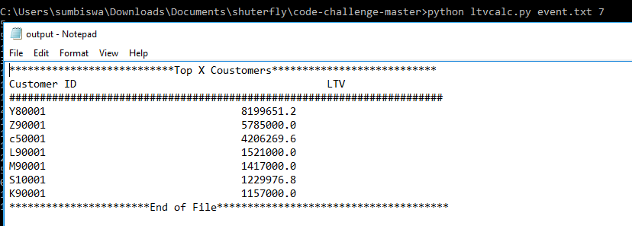

**Performance:**

For Small to medium set of data dictionaries should give the good performance. For

large set of data we may need to think about parallel execution like map reduce job.

**Improvement**:

If we want to run this code in production environment we need to improve the code by by handling few more exceptions for data issue and IO error.Though I have written the code in try except block however I have not written any error handling method to read bad data and IO error.

**Reference :**

<https://blog.kissmetrics.com/how-to-calculate-lifetime-value>