The Type System represents the different types of values supported by the language. The Type System checks the validity of the supplied values, before they are stored or manipulated by the program. This ensures that the code behaves as expected. The Type System further allows for richer code hinting and automated documentation too.

TypeScript provides data types as a part of its optional Type System. The data type classification is as given below −

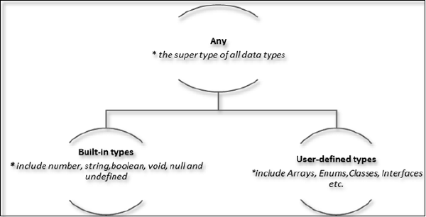

**The Any type**

The **any** data type is the super type of all types in TypeScript. It denotes a dynamic type. Using the **any** type is equivalent to opting out of type checking for a variable.

**Built-in types**

The following table illustrates all the built-in types in TypeScript −

|  |  |  |
| --- | --- | --- |
| **Data type** | **Keyword** | **Description** |
| Number | number | Double precision 64-bit floating point values. It can be used to represent both, integers and fractions. |
| String | string | Represents a sequence of Unicode characters |
| Boolean | boolean | Represents logical values, true and false |
| Void | void | Used on function return types to represent non-returning functions |
| Null | null | Represents an intentional absence of an object value. |
| Undefined | undefined | Denotes value given to all uninitialized variables |