Decision-making structures require that the programmer specifies one or more conditions to be evaluated or tested by the program, along with a statement or statements to be executed if the condition is determined to be true, and optionally, other statements to be executed if the condition is determined to be false.

Shown below is the general form of a typical decision-making structure found in most of the programming languages −

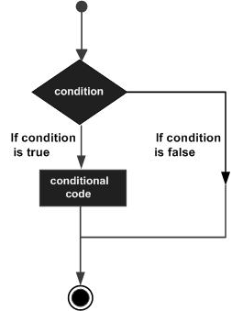

A decision-making construct evaluates a condition before the instructions are executed. Decision-making constructs in TypeScript are classified as follows −

|  |  |
| --- | --- |
| **S.No.** | **Statement & Description** |
| 1. | [if statement](https://www.tutorialspoint.com/typescript/typescript_if_statement.htm)  An ‘if’ statement consists of a Boolean expression followed by one or more statements. |
| 2. | [if...else statement](https://www.tutorialspoint.com/typescript/typescript_if_else_statement.htm)  An ‘if’ statement can be followed by an optional ‘else’ statement, which executes when the Boolean expression is false. |
| 3. | [else…if and nested if statements](https://www.tutorialspoint.com/typescript/typescript_nested_if_statements.htm)  You can use one ‘if’ or ‘else if’ statement inside another ‘if’ or ‘else if’ statement(s). |
| 4. | [switch statement](https://www.tutorialspoint.com/typescript/typescript_switch_statement.htm)  A ‘switch’ statement allows a variable to be tested against a list of values |