Problem Statement – Online Banking

Online banking, also known as internet banking, it is an electronic payment system that enables customers of a bank or other financial institution to conduct a range of financial transactions through the financial institution's website. The online banking system will typically connect to or be part of the core banking system operated by a bank and contrasts with branch banking which was the traditional way customers accessed banking services.

Now a day’s internet has made life simple and Internet banking is the need of the hour.

Internet banking (e-banking) is a remote service, where access to account information and any transactions is granted at any time from any computer with an Internet connection.

Thus, online becomes more and more common for customers, and banks are motivated to propose a new and convenient way to use their services.

The website developed would provide its user all the facilities with simplicity and security giving the customers the satisfaction. The user would be able to log in and perform all the features like fund transfer, keeping the track of all the e-transaction and services such as balance enquiry, e-statements and change password.

The major modules are –

1. Login and Register
2. User Profile------>
3. Account Summary
4. Account Statement
5. User Profile
6. Change Password
7. Fund transfer----->
8. Interbank transfer
9. Intra Bank Transfer
10. Quick Transfer

**Module 1: Registration and Login**

Existing Customer will opt for login and new user will opt for new user for new registration.

Home Products Digital Banking Apply for Account Services

**Login**

**New User**

Registration Page

photo

Customer Name

Gender

MobNo

Email

Signature

DOB

City

Address

State

Submit

Pan Card

nch

Back

Country

Branch

Aadhar Card

Payment/Fund Transfer

1. Interbank transfer Transfer within same bank by adding beneficiary
2. Intra Bank Transfer Transfer within different banks.

1.IMPS 2.RTGS 3.NEFT

3. Quick Transfer Required Fields for instant transfer

Beneficiary name, Beneficiary Accno,Payment Option(within/outside),purpose, amount

**Login**

(**CARE:**Username and password are case sensitive.)

Username

New User Registration

Password

Forgot Password

**Reset**

**Login**

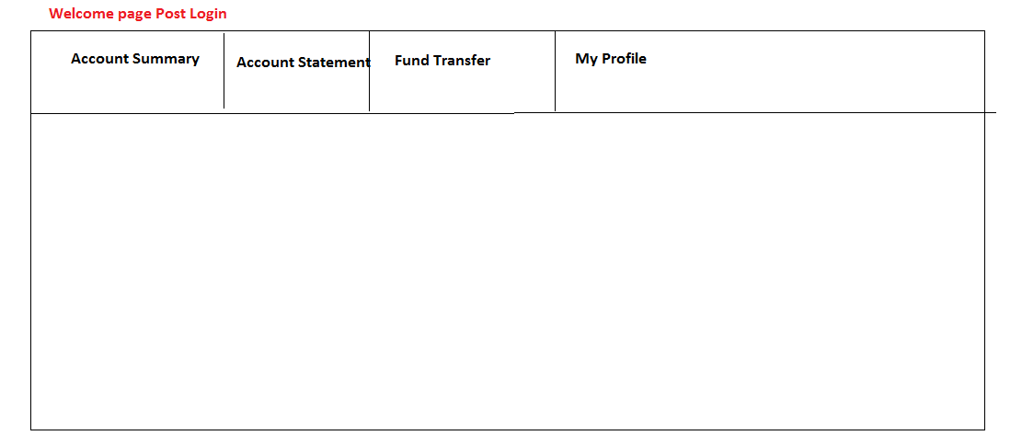

**Account Summary**

**Transactions**

**Available Balance**

**Branch**

**Account No. / Nick Name**

**Account Statement**

**Select options for the statement period**

1. By month 2. By date 3.By 6 Months

End Date

Start Date

**My Profile:**

|  |  |  |
| --- | --- | --- |
| **My Profile** | **E-SERVICES** | **Fund Transfer** |

Profile details:



Profile details:

**FUND TRANSFER**

FUND TRANSFER

BACK

NEXT

Select Payee:

Pay Mode:

Amount:

Payee Acc. Type:

SAME ACCOUNT

BACK

NEXT

IFSC Code:

Account Type:

Payee Name:

Account number:

Confirm Acc. No:

ADD PAYEE

OTHER ACCOUNT