Crime Management System Project

**Software Design Specification**

Name: - Nitish Surana

Register Number: - 16BCE0526

Course Code: - CSE3001

Course Name: - Software Engineering

Slot: - L57+L58

Topic: - Software Design Specification (SDS)

Faculty: - Swathi J.N

Preface

This document presents the Software Design Specification for the Crime Management Software. The major sections of the document address the system decomposition by module along with system architecture and data entity. The system dependencies are also described.

Section 2, Decomposition Description, gives a view of the whole system design including the control model, data decomposition methodology as well as the system structuring model followed.

Section 3, Dependency Description, gives a view on the dependent and independent modules in the project. It also talks about the control scheme that is followed while making this document.

Section 4, UML Diagrams, gives a view of the functionalities and requirements on a diagrammatic level. This section contains Use Case Diagram, Sequence Diagram, Collaboration Diagram and Activity Diagram.

Section 5, Interface Description, goes into detail about the user interface for each module of the Crime Management System. It represents the kind of the interface the user will be interacting with while using the software.

Table of Contents

1 Introduction 4

1.1 Purpose 4

1.2 Scope 4

1.3 Definitions, Acronyms, and Abbreviations 4

1.4 References 4

2 Decomposition Description 5

2.1 Module Decomposition 5

2.2 Repository Model Decomposition 5

2.3 Data Decompositions 5

3 Dependency Description 7

3.1 Inter-module Dependencies 7

3.1.1 Independent Modules 7

3.1.2 Dependent Modules 7

3.2 Inter-process Dependencies 7

3.3 Control Scheme 7

4. UML Diagrams 8

4.1 Use Case Diagram 8

4.2 Sequence Diagram 9

4.3 Collaboration Diagram 13

4.4 Activity Diagram 17

4.5 Class Diagram 21

5. Interface Description 22

5.1 Homepage 22

5.2 Law Module 23

5.3 Criminal Module 25

5.4 Image Recognition Module 27

# 1 Introduction

## Purpose

The main purpose of the Software Design Specification is to describe the specific design of the Crime Management System Software. The design specification includes an overview of the design along with software module decomposition.

This document provides a detailed description of each software module’s design. For each module, all the possible leading user interfaces are shown as well as a structured class diagram is shown to explain the internal structure of the system database.

## Scope

It is within the scope of the Software Design Specification to describe the specific system design of the Crime Management System Project. This would include a class diagram, sequence diagram, collaboration diagram, activity diagram as well as the user interfaces. Any specific detail that is needed about the standards or technology used to design the software are within the scope of this document.

It is outside the scope of this document to describe in any detail at all how certain followed standards or technologies work and operate at workplaces.

## Definitions, Acronyms, and Abbreviations

Table of Definitions, Acronyms, and Abbreviations

|  |  |
| --- | --- |
| Definition, Acronym, or Abbreviation | Description |
| SDS | Software Design Specification. |

## References

Table of References

|  |  |
| --- | --- |
| References | Description |
| Software Design Specification | The basic Software Design Specification was referenced and understood from Google. |

# Decomposition Description

## 2.1 Module Decomposition

The Crime Management System is mainly divided into 3 major modules:

* Law Module: This module is one of the major modules in the entire project. It has the information regarding every law that are being accepted throughout the country. It has details mainly comprising of law name, code as well as its definition that can be used by users for understanding the significance of the particular. It provides a complete analysis of the law that can be used by the users.
* Criminal Module: This module contains the entire details of the criminal that are present all over the country. It contains the name of the criminal along with their image as well as the location of the jail that are they are present or where the criminal is penalized. It also provides the details of when they would be released if no further unfortunate events occur.
* Image Recognition: This module has the user enter an image through which they want to check the details of the criminal. If the image is already stored in the database, the details of the criminal is displayed but if the image is not present in the database then if the user is the database administrator he can update the database.

## 2.2 Repository Model Decomposition

The Crime Management System will follow the ideology Repository Model for the System Structuring. The reason for choosing this model is as the entities in the database of the Crime Management System share data among themselves for proper functioning, the use of this model is very essential as each sub-system can exchange data. Since there is a large of amount present in the database, the use of Repository Model increases the efficiency.

## 2.3 Data Decompositions

The following are the three major data components, the Law database, the Criminal database and the Image Recognition database.

The law database consists of these attributes:

* Code: Code of the Law.
* Name: Name of the Law.
* Definition: Basic definition of the law.
* Release Date: The date on which this law become applicable.
* Occupation: The occupation for which this law is most susceptible to.
* Procedure: The basic procedure that is followed for the execution of the law.
* Punishment: The punishment for breaking the law.

The criminal Database consists of these attributes:

* Name: Name of Criminal.
* Image: Image of the Criminal.
* Age: Age of the Criminal.
* Law Broken: The law which the criminal broke.
* Location: The location where is criminal is captured and present.
* Date of Entry: Date on which the criminal entered the jail or was fined.
* Expected Date of Release: Date on which the criminal is expected to be released.

The Image Recognition database consists of these attributes:

* Image: The image that will be uploaded by the user and will be checked.
* Check: The result of the search.

The pictorial representation of the Repository Model that will be used in this project is shown below:

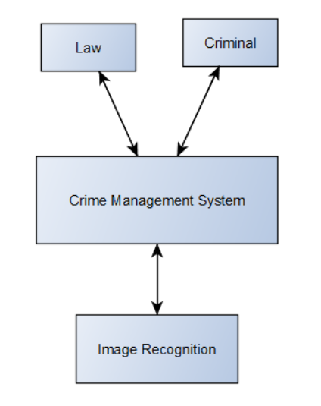

# Dependency Description

## Inter-module Dependencies

## Independent Modules

The following modules are independent and do not rely on any other modules to initiate them or to provide data.

* Law Module

## Dependent Modules

The following Modules are dependent on one another for their functioning.

* Criminal Module: This module depends upon the Law Module. Since it has the list of the criminals that broke the laws that are present in the Database, they are dependent on the Law module for their Functioning. Many criminals can break on particular law and Many laws can be broken by one single criminal. So, they share n: n cardinality.
* Image Recognition Module: This module depends on the Criminal Database for their functioning. This module is used to identify the details of the criminal through the image that is provided by the user. Many photos can be used to represent one criminal but many criminals cannot have one photo. Hence, they share n:1 relationship.

## 3.2 Inter-process Dependencies

Upon the option that is taken from the user, the modules will depend on each other for functioning. The Criminal Module depends on the law module for the details regarding the law. The Image Recognition Module is dependent on the Criminal Module which will help the user get the information regarding the criminal.

## 3.3 Control Scheme

The control Scheme that will be implemented for this project is the Broadcast Model Control Scheme. The reason for choosing this control scheme is because this control Scheme mainly works on the property of any sub-system which can be available for the performing the task given by the user successfully will be used for implementing the task. Hence, for our project this control Scheme fits perfectly as its direct input output database-oriented project and the sub-systems performing the event doesn’t know when the event will be handled.

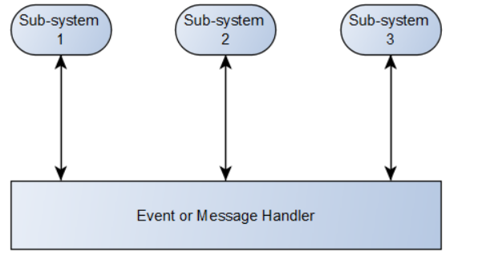

# 4. UML Diagrams

## 4.1 Use Case Diagram

A simple use – case depicting the working of the system is shown below:

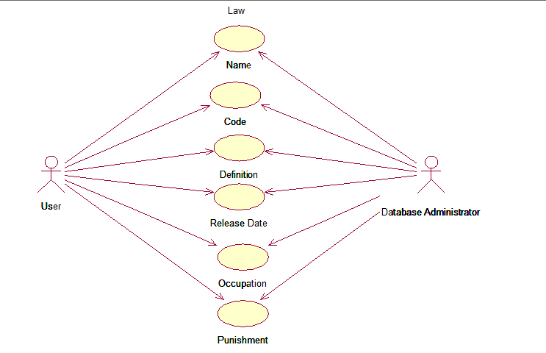

## 4.2 Sequence Diagram

The sequence Diagram for the User giving the input of the wrong law Code in the interface is shown below:

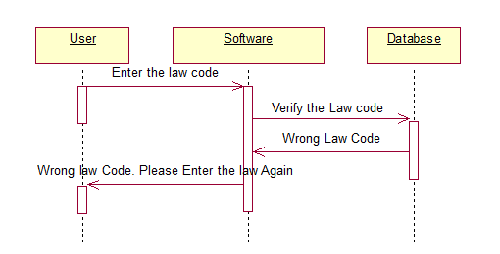

The sequence Diagram for the User giving the input of the valid law Code in the interface is shown below:

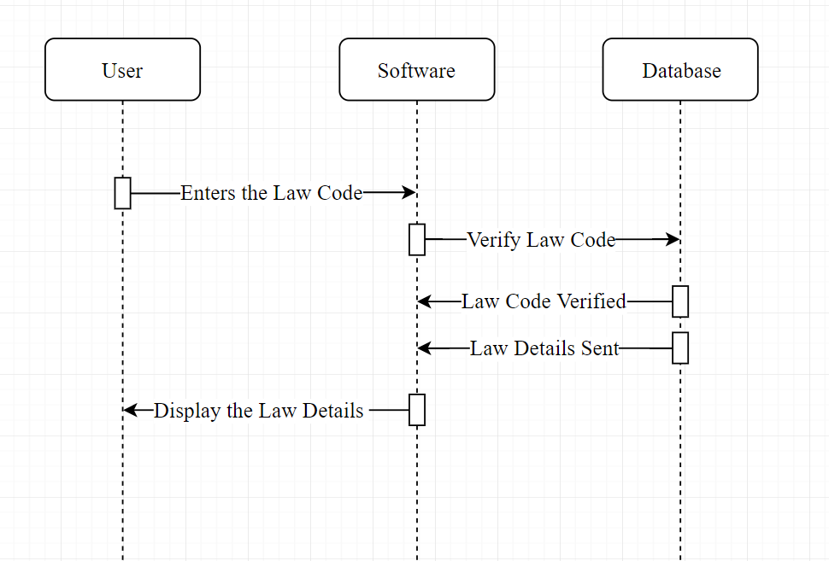

The sequence Diagram for the User giving the wrong input for the Occupation in the interface is shown below:

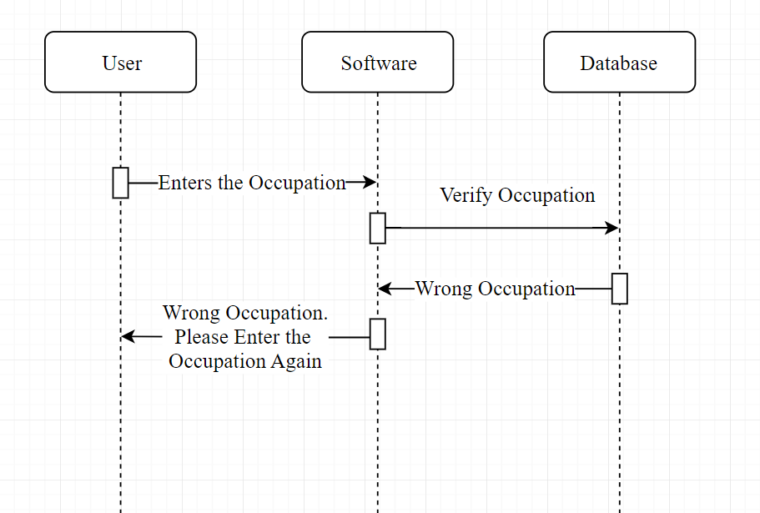

The sequence Diagram for the User giving the valid input for the Occupation in the interface is shown below:

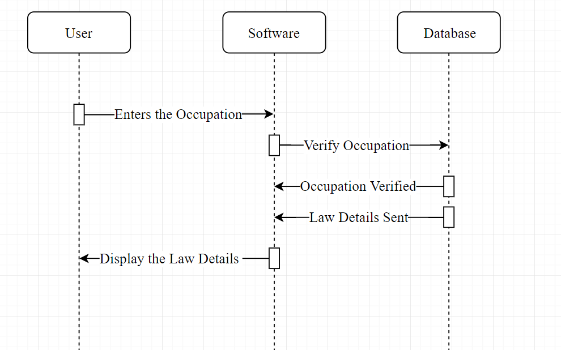

The sequence Diagram for the User giving the wrong input for the Criminal Name in the interface is shown below:

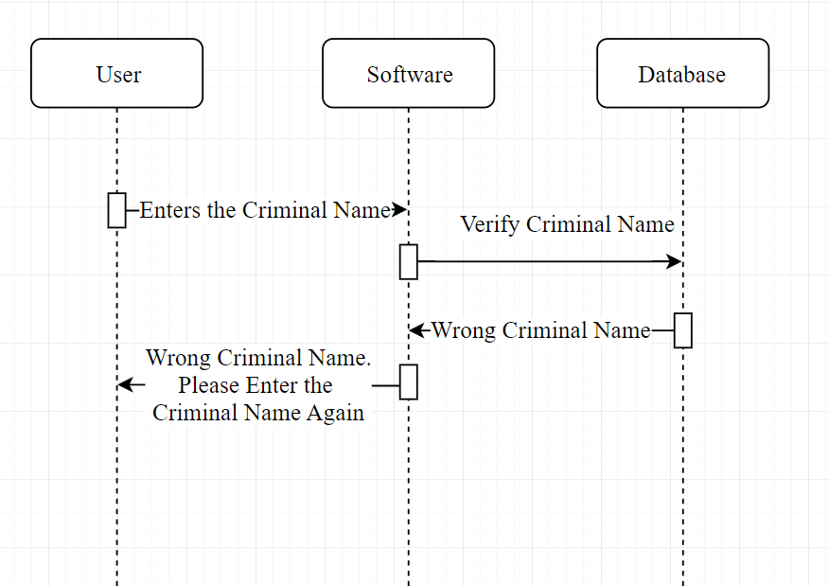

The sequence Diagram for the User giving the valid input for the Criminal Name in the interface is shown below:

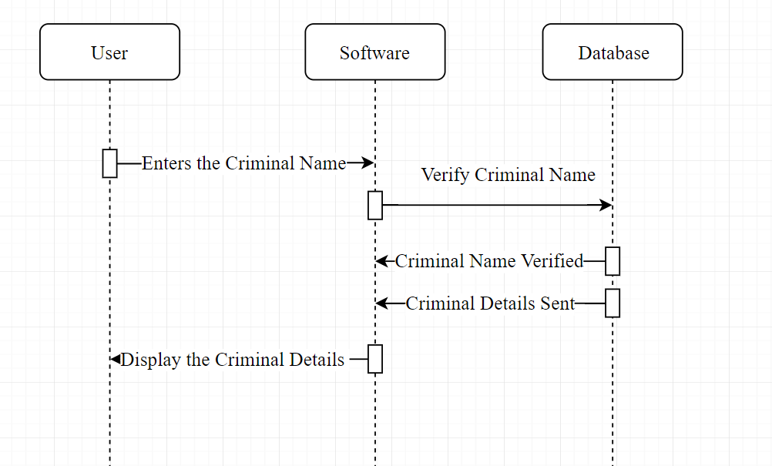

The sequence Diagram for the User giving the wrong input for the Criminal Picture in the interface is shown below:

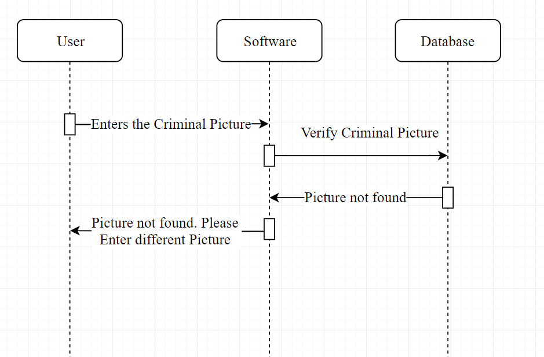

The sequence Diagram for the User giving the right input for the Criminal Picture in the interface is shown below:

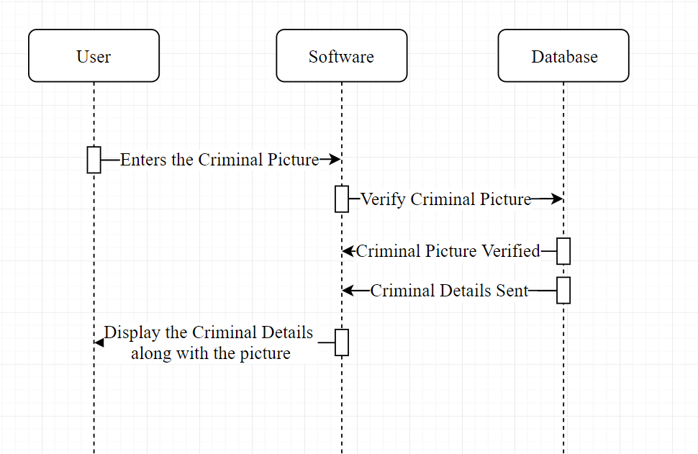

## 4.3 Collaboration Diagram

The Collaboration Diagram for the User giving the wrong input for the Law Code in the interface is shown below:

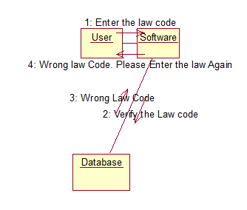

The Collaboration Diagram for the User giving the right input for the Law Code in the interface is shown below:

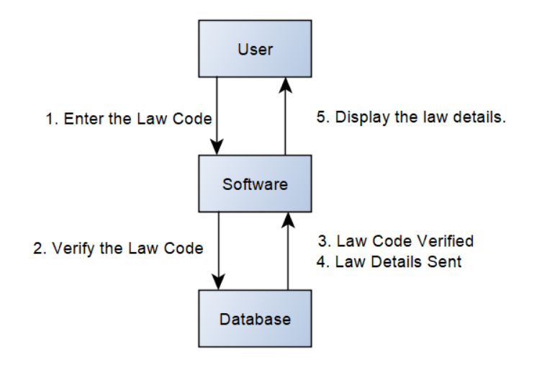

The Collaboration Diagram for the User giving the wrong input for the Occupation in the interface is shown below:

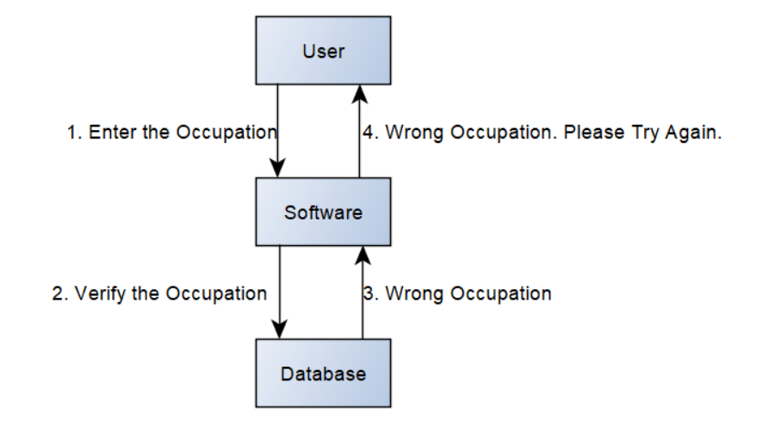

The Collaboration Diagram for the User giving the right input for the Occupation in the interface is shown below:

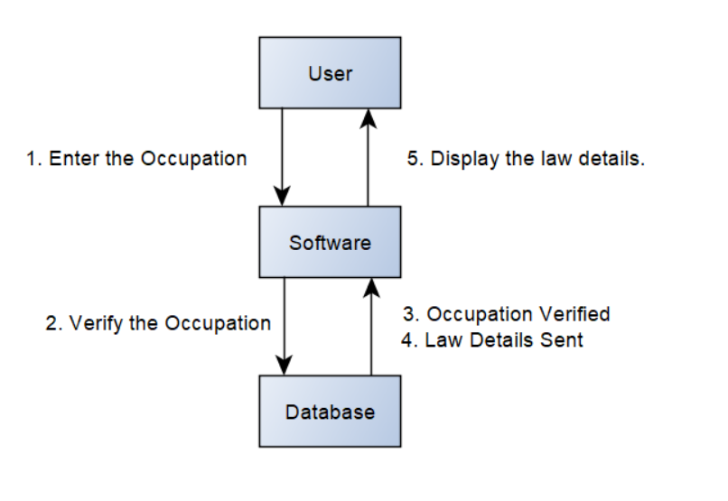

The Collaboration Diagram for the User giving the wrong input for the Criminal Name in the interface is shown below:

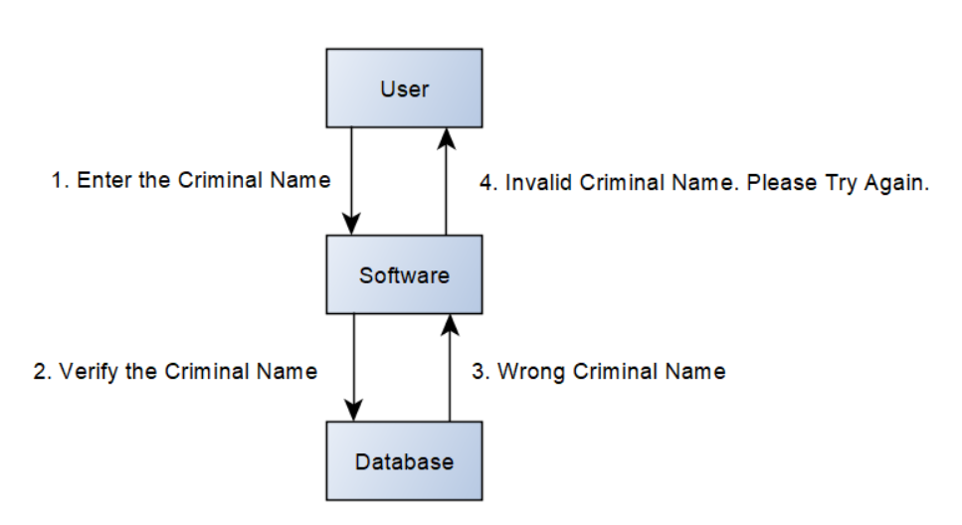

The Collaboration Diagram for the User giving the right input for the Criminal Name in the interface is shown below:

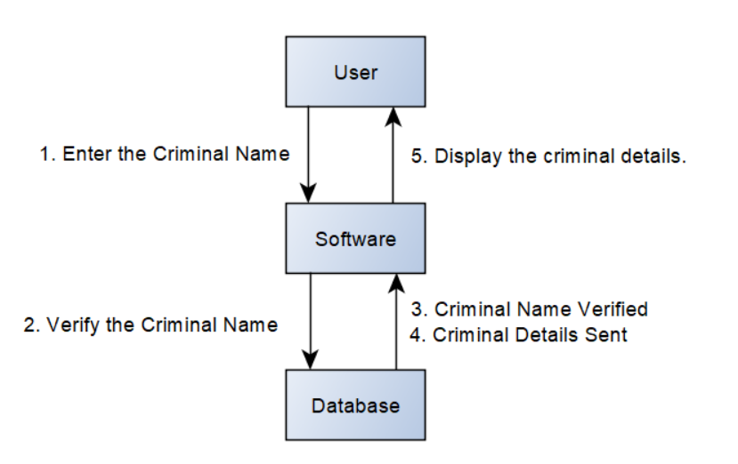

The Collaboration Diagram for the User giving the wrong input for the Criminal Picture in the interface is shown below:

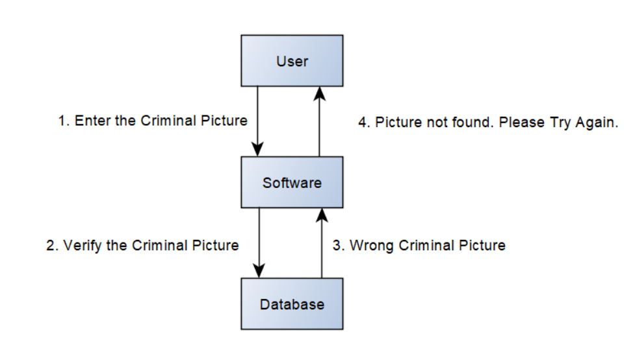

The Collaboration Diagram for the User giving the right input for the Criminal Picture in the interface is shown below:

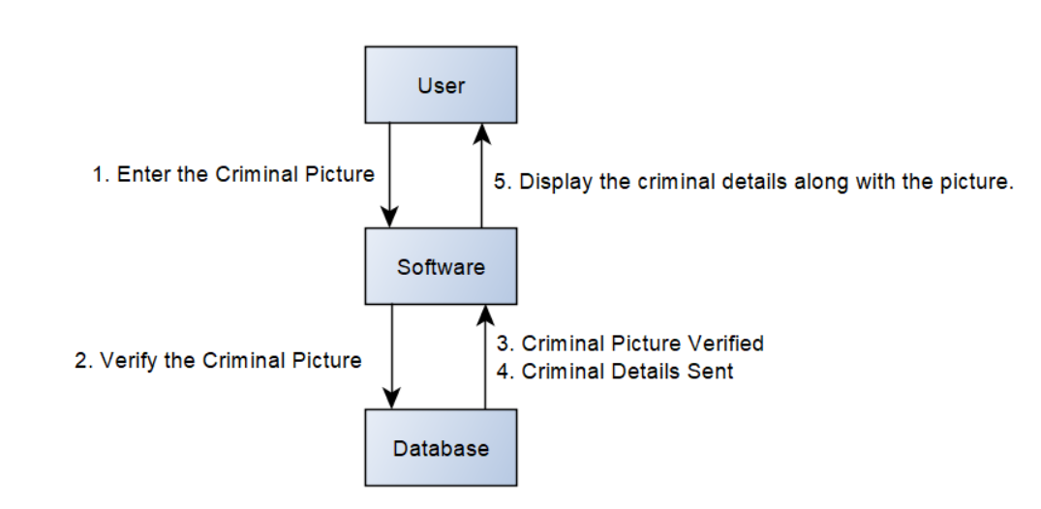

## 4.4 Activity Diagram

The Activity Diagram of the User input for the Law code in the interface is shown below:

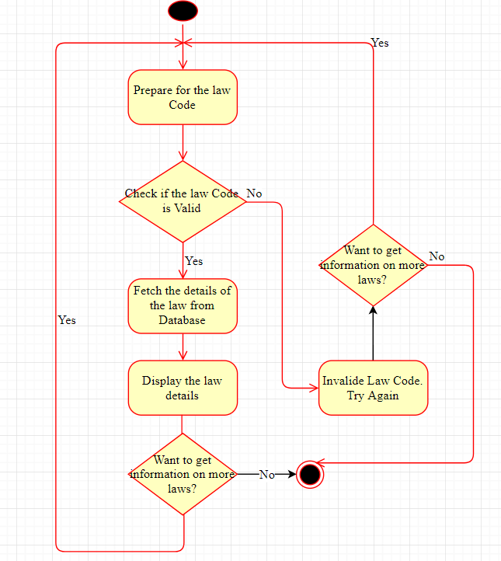

The Activity Diagram of the User input for the Occupation in the interface is shown below:

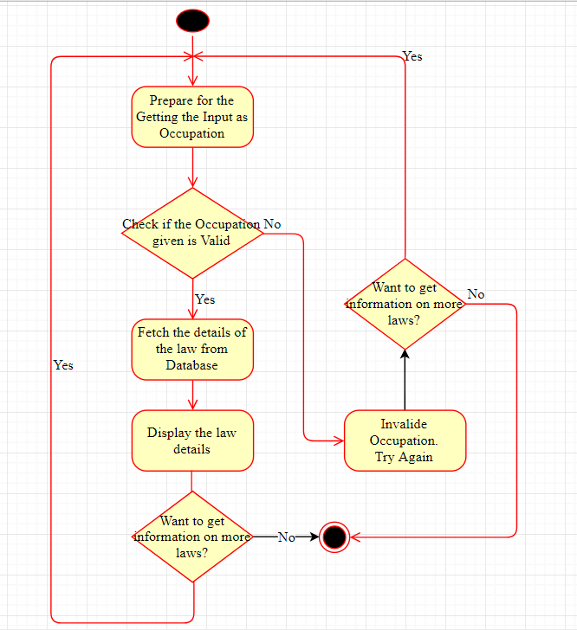

The Activity Diagram of the User input for the Criminal Name in the interface is shown below:

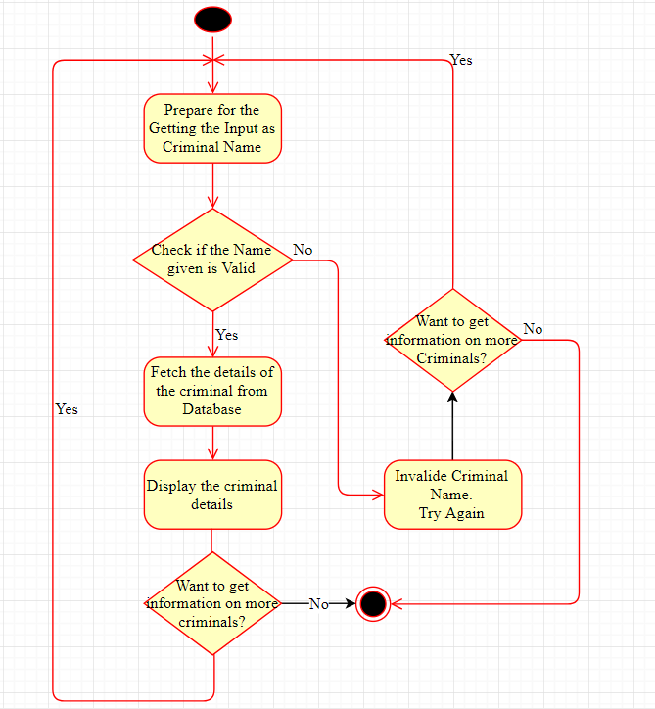

The Activity Diagram of the User input for the Criminal Picture in the interface is shown below:

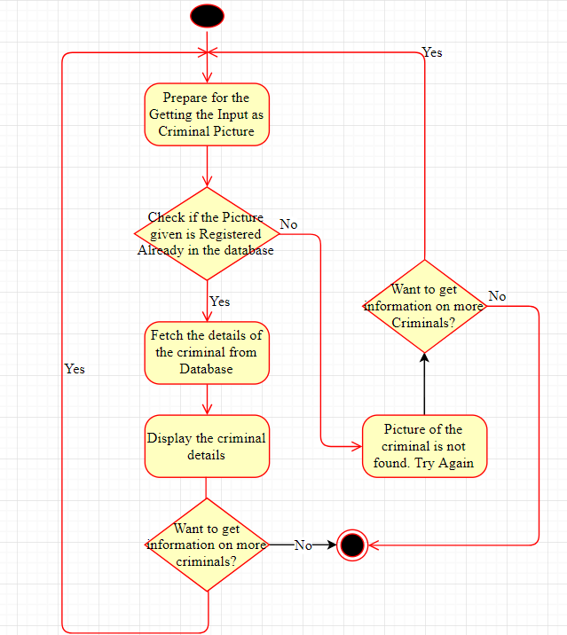

## 4.5 Class Diagram

The class Diagram is shown below:

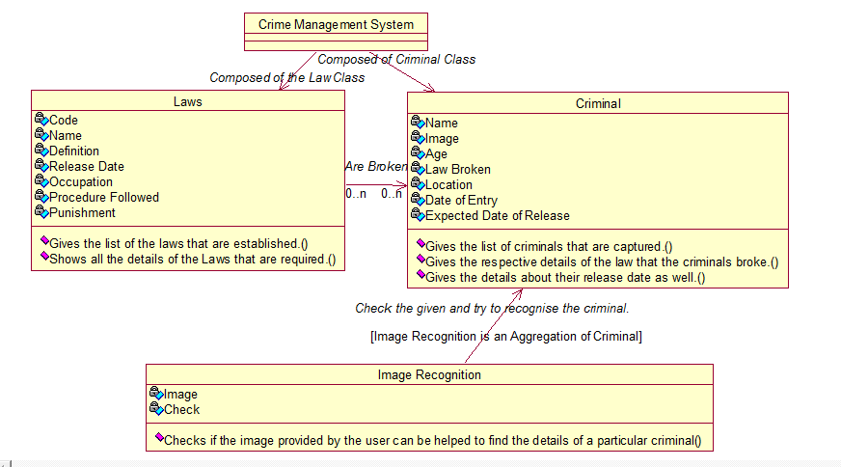

# 5. Interface Description

## 5.1 Homepage

The homepage of the software will give the user to choose between the options following options and will look like this:

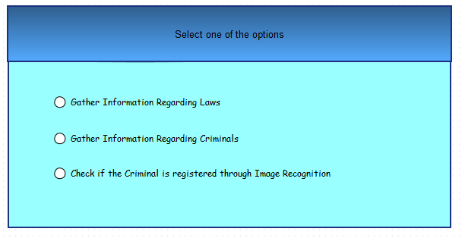

## 5.2 Law Module

When gather information regarding Laws is selected, the following interface will look like this:

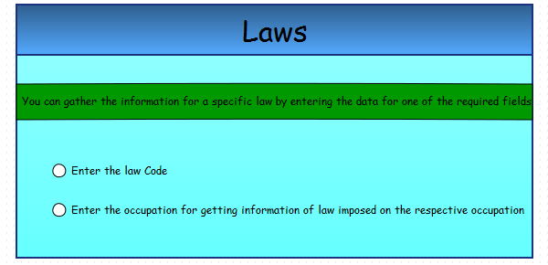

Upon this the user has two options:

* The user can select to search the law based on the law code.
* The user can select to search the law based on occupation.

When the user decides to search the law based on law code the following interface is selected:

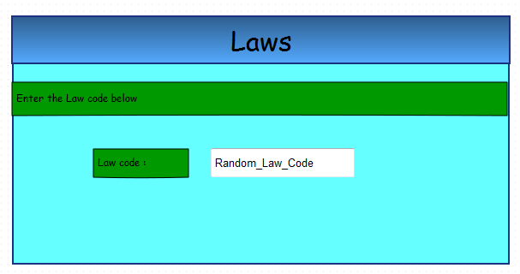

Else if , the user decides to search the law based on occupation the following interface is displayed:

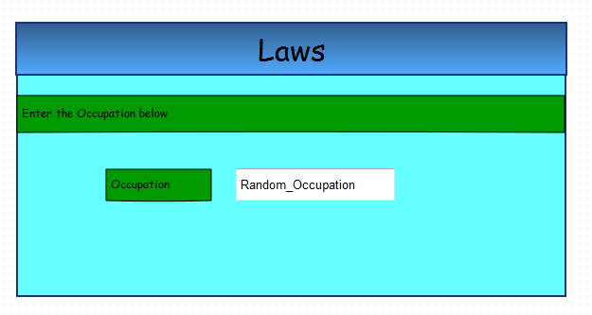

If the user then further enters a valid law code or occupation the following interface is shown which represents the details of the specific law:

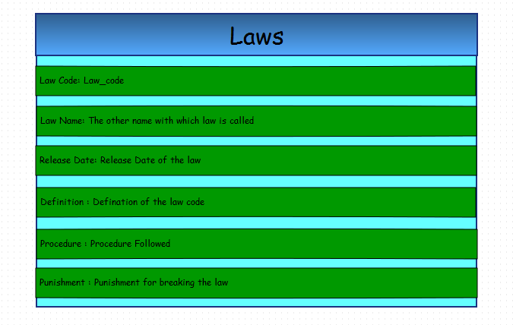

## 5.3 Criminal Module

When the user decides to gather the information regarding a particular criminal, the following interface is shown:

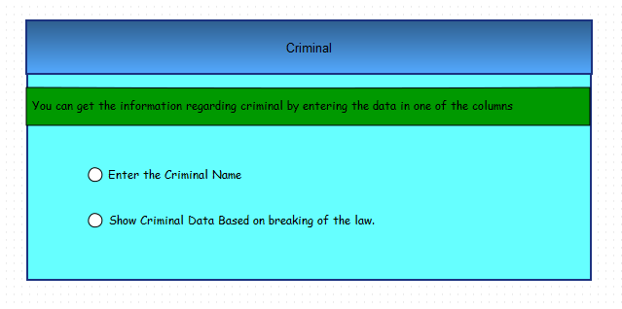

Upon this the user has two options:

* The user can select to search the information regarding based on his name.
* The user can select to search the information regarding a criminal based on the law they broke.

When the user decides to search the criminal based on the name the following interface is shown:

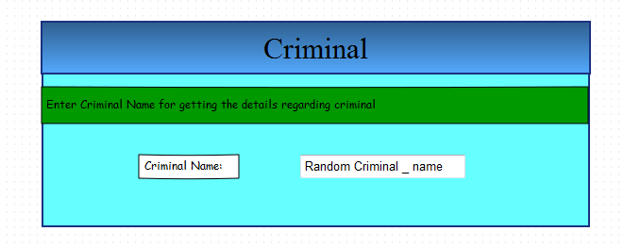

When the user decides to search the criminal based on law they broke the following interface is shown:

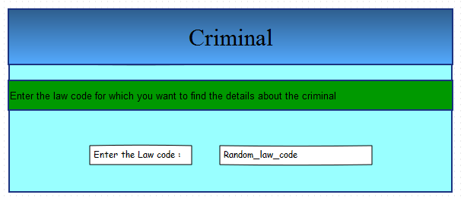

After entering valid criminal name or law code, the main screen the contains the details about the criminal is shown. The interface for that screen is shown below:

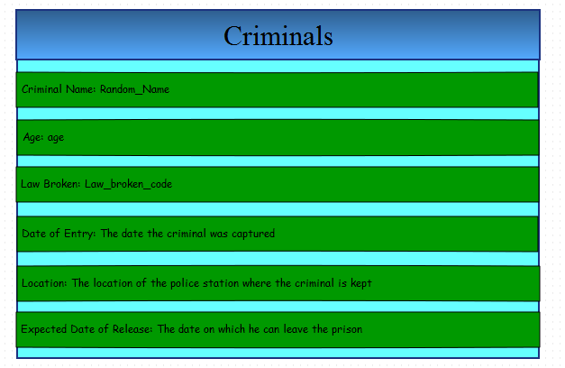

## 5.4 Image Recognition Module

When the user decides to identify the criminal based on the input picture they would be providing. The following interface is shown:

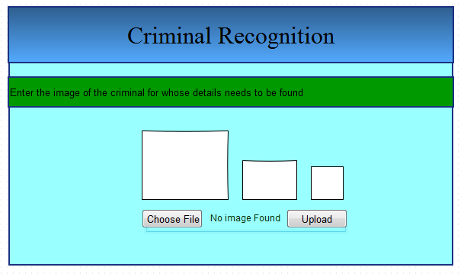

After the image being chosen and uploaded, the system will check the entire database for the picture uploaded and this is the interface that is shown to the user.

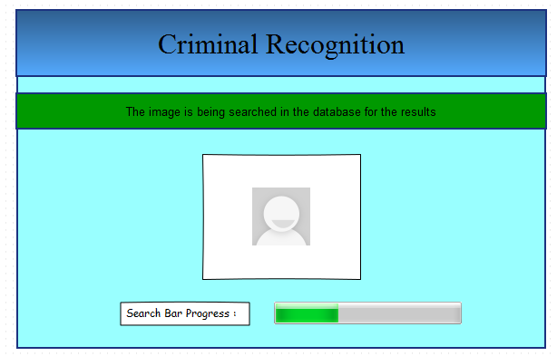

If the results of searching was a Success, then this interface is shown to the user: 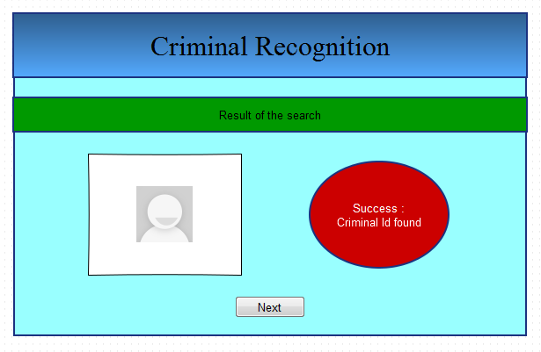

After the success screen being displayed, the next screen will show the respective criminal detail. The respective interface is shown below:



If the results of searching is a failure, the following interface will be shown:

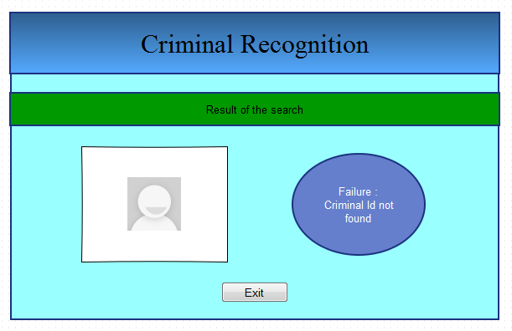

Clicking exit button at the bottom of the interface will lead the user to the home screen as shown below:

