Crime Management System Project

Software Requirements Specification

Name: - Nitish Surana

Register Number: - 16BCE0526

Course Code: - CSE3001

Course Name: - Software Engineering

Slot: - L57+L58

Topic: - Software Requirements Specification (SRS)

Faculty: - Swathi J.N

Preface

This document represents the Software Requirements Specification(SRS) for the Crime Management System. The document starts with the Introduction section that describes the purpose of the document and then describe how the entire scope of the project.

The next following section has an Overall Description of the requirements that are need for the project along with its functionalities. It includes all the constraints that the project is working on as well as the assumptions made while making the project. The project dependencies are also listed in this section.

The next section is the Specific Requirements section which comes next and is the most important section in this document as it goes into detail about each specific requirement that is needed for this project. A description, use case with sequence of events, and any related requirements is given for each requirement is mentioned in this section.

It also tells about the Performance Requirements that will be met during the execution of Crime Management System. This generally includes Design Constraints and the ER diagrams. Lastly, various System Attributes are discussed which includesReliability, Speed, Security, Robustness and Ease of Access.

Table of Contents

1 Introduction 1

1.1 Purpose 1

1.2 Scope 1

1.3 Definitions, Acronyms, and Abbreviations 1

1.4 References 1

2 Overall Description 2

2.1 Product Perspective 2

2.2 Product Functions 3

2.3 Constraints 3

2.4 User Characteristics 4

2.5 Entity Relationships 5

2.6 Data Dictionary 6

2.7 State Transitions 7

2.8 Assumptions 9

3 Specific Requirements 10

3.1 System Features 10

3.1.1 Showing the laws and the required Information regarding them 10

3.1.2 Accessing Criminal Database 11

3.1.3 Identification of Criminal Using Facial Recognition 12

3.2 Performance Requirements 13

3.3 Design Constraints 13

3.4 Software System Attributes 14

3.4.1 Reliability 14

3.4.2 Security 14

3.4.3 Speed 14

3.4.4 Robustness 15

3.4.5 Ease of Use 15

# 1 Introduction

## Purpose

The main aim of the Software Requirements Specification is to describe the specific Requirements that are needed while implementing the Crime Management project. These requirements are included any constraints or assumptions upon which it is working on.

It also includes any project dependencies that are needed to be aware of before implementing the project and hence are explicitly expressed.

## Scope

It is within the scope of the Software Requirements Specification(SRS) to describe the specific system requirements for the Crime Management System project. This would include performance requirements, system constraints, and project assumptions.

All the functionalities that are going to be implemented in the project have been described along with all the constraints that are needed. Any specific details regarding standards that are used to define requirements are also thoroughly mentioned.

## Definitions, Acronyms, and Abbreviations

Table of Definitions, Acronyms, and Abbreviations

|  |  |
| --- | --- |
| Definition, Acronym, or Abbreviation | Description |
| SRS | Software Requirements Specification. |

## References

Table of References

|  |  |
| --- | --- |
| References | Description |
| Software Requirement Specification | The basic Software Requirement Specification was referenced and understood from Google. |

# Overall Description

## 2.1 Product Perspective

Crime Management system is a new software system that will be introduced in the market. It will provide many functionalities that can be used by people for understanding the laws present in the country. It can be used by people to become well aware of the laws that are present in the country to safeguard them.

Along with representing the laws that are present in the country, it will also show list of people who have abandoned/broken these laws are have been punished and penalized. It will show where these criminals are present in the country and details regarding the crime along with the police station area name.

With these functions that will be implemented in this project, the awareness of various laws will be widespread and this will help to reduce the crime rate in the country. This will give the common people more ideas about the laws present in the country and measures to safeguard them.

The following figures represent the use case diagrams of the Crime Management System software.

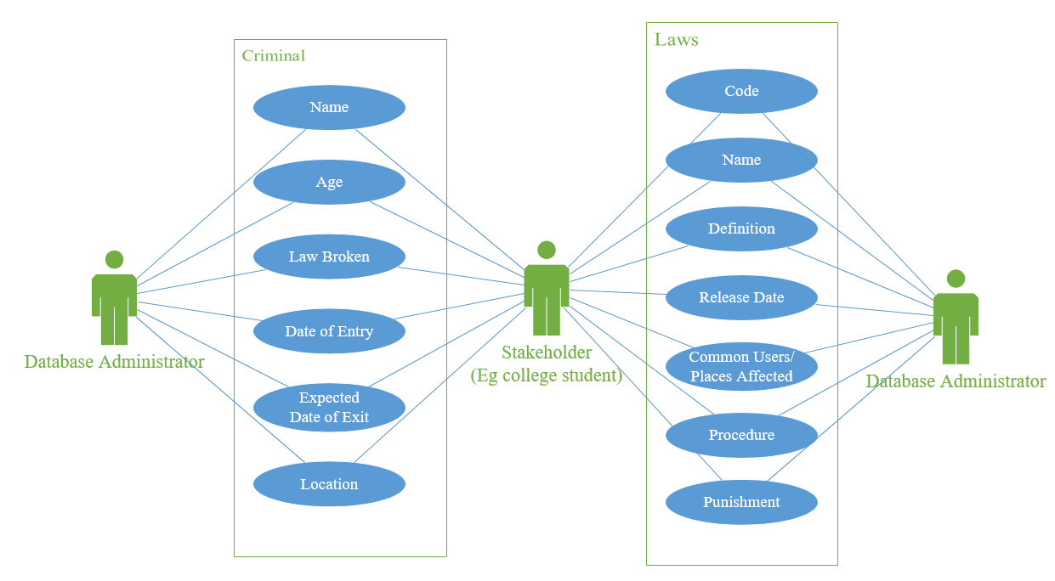

## 2.2 Product Functions

The following table elaborates the functionalities that will be made available to the consumers who will be using this project.

|  |  |  |
| --- | --- | --- |
| ID | Origin | Functionality |
| 1. | Laws | * It will show all the respective law code that are approved. * It will show who are the end users that might be affected by that law. * It will also show how these laws are followed. * It will show the penalty/punishment for not following them. |
| 2. | Criminal Database | * It will also provide the list of criminals that have broken these laws. * Along with the list of the criminal, their respective locations will also be shown. * It will also show the date of their entry and exit of the prison too. * It will also show the date when the penalty of these criminals will be removed. |
| 3. | Criminal Recognition | * It will take the image of the criminal as the input and check if the image is already present in the criminal database. * If it is already present in the database, it will display the outputs regarding the criminal. * If it’s not present in the database, the database administrator can update the database with the new criminal’s face. |

## 2.3 Constraints

The following table shows the basic constraints that are needed upon which this software system can be implemented upon.

|  |  |  |
| --- | --- | --- |
| ID | Origin | Reason |
| 1. | A qualified technician | Since the data present in this system is in database format, to operate the database a qualified technician is required. |
| 2. | An Active Internet Connection | The software system will need an active internet connection as if any changes is made in the main database it should be shown. |
| 3. | A good display device | A good display device is needed for showing all the functionalities that this project can support. |
| 4. | Real time server updating platform | The administrator should be able to update the laws that are changed/modified over a short period of time and hence the users should only be able to access the proper content. |

## 

## 2.4 User Characteristics

The following table identifies and describes the different kind of places where this software system might be helpful. Different kinds of users can use this software in any of the listed places according to their own benefit. The below scenarios represent the results of using this software system when needed.

|  |  |  |
| --- | --- | --- |
| ID | User | Description |
| 1. | Police Department | * To follow the proper procedure of penalty/punishment for the person who is found guilty of the crime. * Keeping the list of the criminals present at the respective police stations. |
| 2. | Cyber administrator | * To promote the importance of cyber laws and maintain a secure internet services. * To ensure that online harassment/cyber bullying doesn’t take place. * If it occurs, the victim can use this software to follow the steps that are required to report this to upper authorities that can take action on the oppressor. |
| 3. | Officers Present at airport | * To follow the correct procedure for the evaluation of the objects that are used by passengers while travel. * To avoid the un-authorized entry of people. * If any unwanted event occurs that might include breaking of the law, this software system can provide the correct procedure. |
| 4. | Colleges | * To ensure no harassment. * To ensure the safety of kids as well as teachers. * To provide a non-harmful environment for study basis. |
| 5. | Judges at various courts | * To keep the database that involves the list of the laws be kept up to date. |
| 6. | Artists | * To avoid stealing of data. * To avoid copyright of data. * To ensure data should not be leaked before the release date decided by the artist. |
| 7. | Jobs/Workplaces | * To ensure that the employee working in the particular job restrains from sharingdata with other person working for different company. (Affidavit). * To ensure proper working of junior employees under the senior employees and vice versa without involving any kind of harassment/ corruption. |
| 8. | Tourist Places | * To preserve the historic monuments from taking unwanted damage. * To preserve the historical decency present in the country. |

If any unwanted event occurs in any of the above listed places that might include breaking of the law, this software system can provide the correct procedure for execution of such crime.

## 2.5 Entity Relationships

Figure 1 shows the entity relationships for the Law database and Criminal Database.

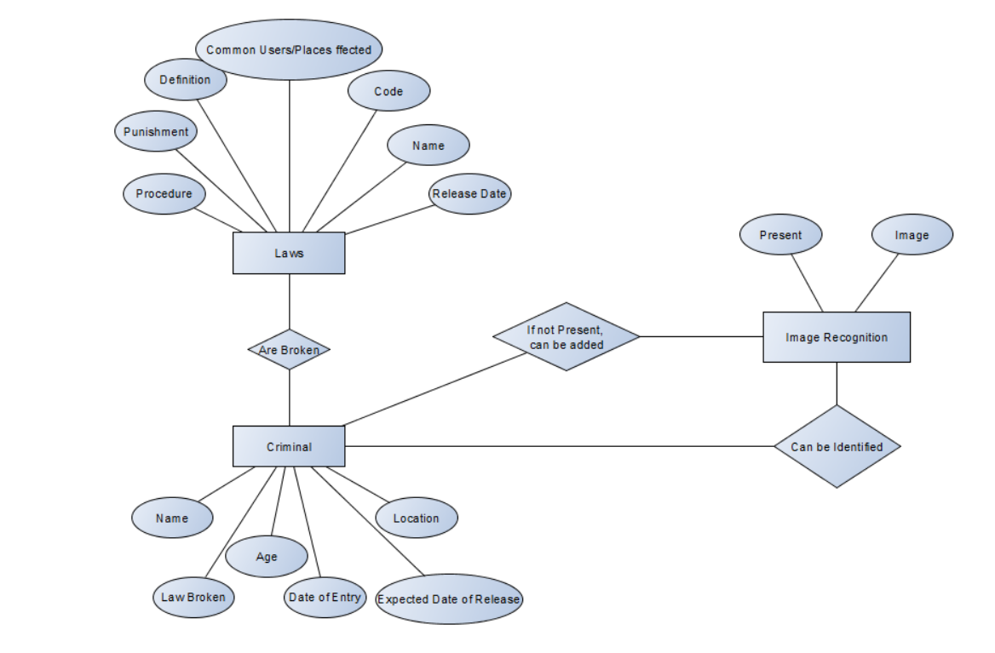

## 2.6 Data Dictionary

The follow tables in this section make up the data dictionary for the Crime Management project. Using the Use Case Diagrams, the following Data Dictionary elements were defined.

1. Laws
2. Criminals

|  |  |
| --- | --- |
| Data Dictionary Attribute | Detail |
| Name | Laws |
| Aliases | None |
| Where Used / How Used | It is used to display the laws and the regulations that are followed in the country. |
| Description | It explains the laws that are followed in the country along with their respective code as registered.  It also shows the most favorable places/users that are affected by the respective laws.  It gives the procedure that is followed for the particular law.  It also displays the penalty / punished that is given for breaking the respective law. |
| Supplementary Information | It will display the following laws when a technician decides to use the following software system. |

|  |  |
| --- | --- |
| Data Dictionary Attribute | Detail |
| Name | Criminal |
| Aliases | None |
| Where Used / How Used | It is used to display the details of the criminals in the country along with their respective locations. |
| Description | It will show the personal information such as name, age of the criminal.  It will also show the reason for which they have been penalized or punished for.  It will also show the date on which they have entered the prison and the expected date for their release if nothing unusual happens. |
| Supplementary Information | This information can be accessed by anyone who has knowledge of the database according to their own cause. |

|  |  |
| --- | --- |
| Data Dictionary Attribute | Detail |
| Name | Image |
| Aliases | None |
| Where Used / How Used | It is used to get the input of the criminal as image and displays the information about the criminal if present. |
| Description | It will check the input image given by the user is an image of the criminal that is already present in the database.  If it is already present in the database it will just display the information of the criminal that is present already.  If the name of the criminal is not present then it will update the database and ask the user for more details regarding the new criminal. |
| Supplementary Information | The checking phase can be done by any technician, but the updating of the database can only be done by the database administrator. |

## 2.7 State Transitions

The following figures show the state transition diagrams for the various functionalities that are provided by the software system.

A) Gets the information about a specific law.

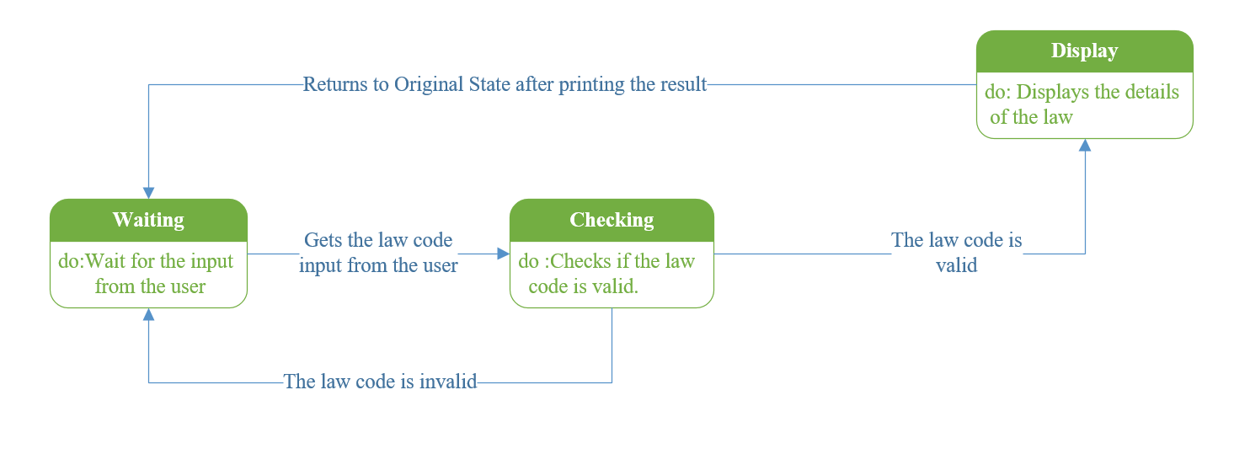

B) Gets the penalty about a specific law given the occupation of the user.

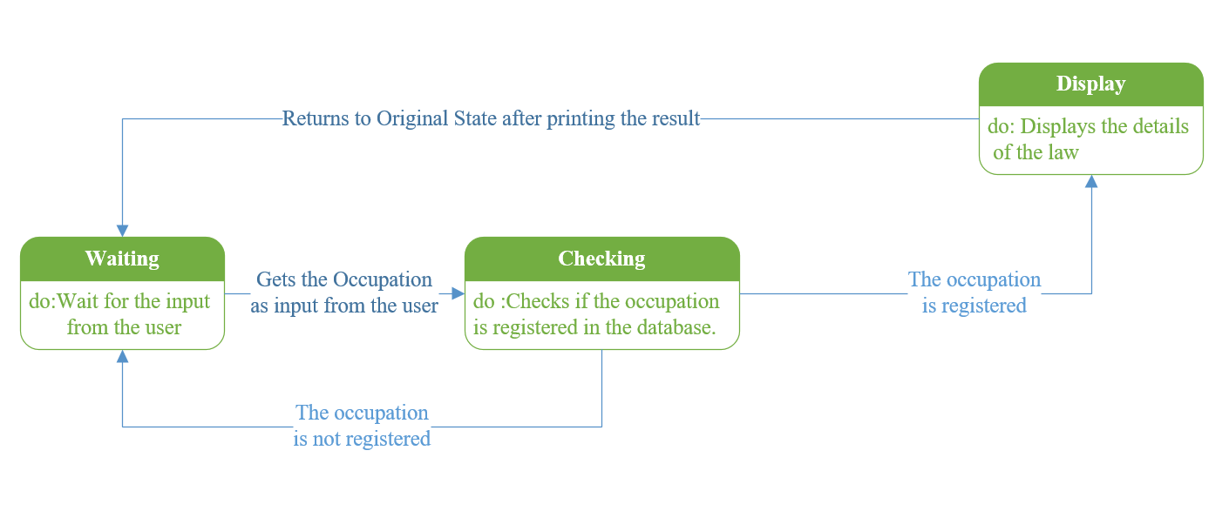

C) Gets the information about a specific criminal.

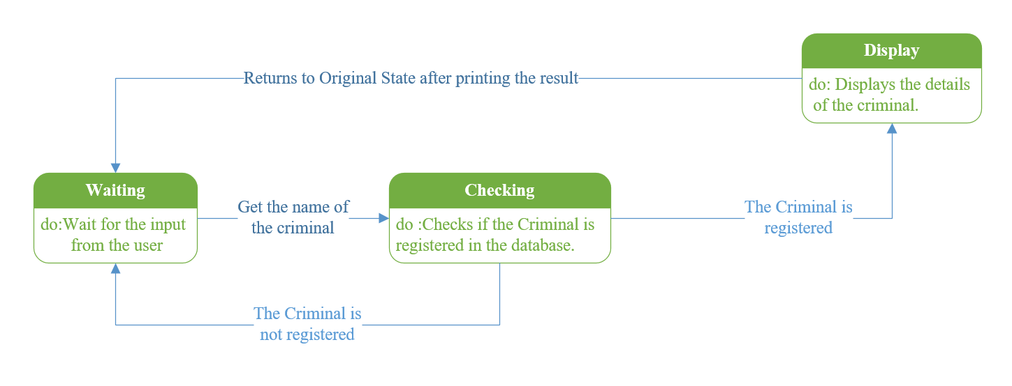

D) Checks if the criminal is present in the database through image recognition.

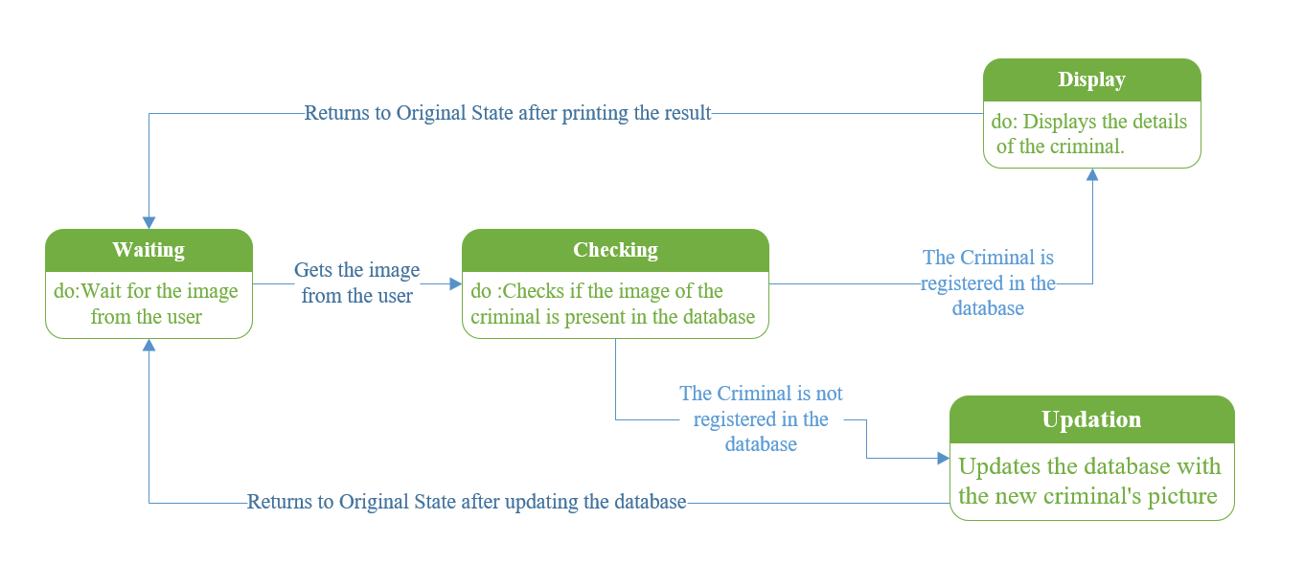

## 2.8 Assumptions

The following table lists the assumptions made by the requirements that define Crime Management System software.

|  |  |
| --- | --- |
| Assumption | Description |
| The output of the database is platform independent. | The output of the database functions is assumed to be platform independent and can be displayed on any output device. |

# Specific Requirements

## System Features

### 3.1.1 Showing the laws and the required Information regarding them

#### 3.1.1.1 Introduction

The crime management System shall allow the user to access any laws that has been passed by various courts present in the country. The user can see the code under which the law has been saved along with its definition. The Crime Management System will also show which are the main particulars users/places that come under that specific law.

#### 3.1.1.2 Functional Requirements

Purpose: Show the detailed information about all the laws that are followed in the country.

Input: The code of the law which the user wants the details about. The user can also ask for the laws that come under specific places/ specific kind of occupation.

Processing: Searches if the input is valid. If its valid then the required details about the law is given.

Output: The details of the laws that are followed in the country according to the user’s request.

#### 3.1.1.3 Stimulus Response

A) Gets the information about a specific law.

|  |  |
| --- | --- |
| User actions | System Actions |
| (1) Decides and enter the code of the law which the user wants to get detail about. |  |
|  | (2) Searches if the code of the law is valid. |
|  | (3) If it is valid, displays the output details according to user’s request |

B) Gets the penalty about a specific law given the occupation of the user.

|  |  |
| --- | --- |
| User actions | System Actions |
| (1) Enter the occupation of the user for which the law details need to be found. |  |
|  | (2) Searches if the occupation is defined. |
|  | (3) If it is valid, displays the penalty with the respective law defined. |

### 3.1.2 Accessing Criminal Database

#### 3.1.2.1 Introduction

The criminal database has all the information regarding the criminals that are present in the country along with their personal information like name,age etc. It also shows the reason why they are penalized or are in jail/prison along with their date of entry and exit.

#### 3.1.2.2 Functional Requirements

Purpose: Getting the detailed information of the criminals that are present and the details of the law also that they broke.

Input: Criminal name.

Processing: Searches if the input is valid. If its valid then the required details about the criminal is given.

Output: The required details about the criminal is given out as the output.

#### 3.1.2.3 Stimulus Response

Gets the information about a specific criminal.

|  |  |
| --- | --- |
| User actions | System Actions |
| (1) Decides and enter the name of the criminal whose details are to be found. |  |
|  | (2) Searches if the name of the criminal is valid. |
|  | (3) If it is valid, displays the output details according to user’s request. |

### 3.1.3 Identification of Criminal Using Facial Recognition

#### 3.1.2.1 Introduction

The image of the Criminal will be taken as the input and the output of this block will give the details of the criminal. It will give detailed information of the criminal from the criminal database. This functionality is very usual in getting the whereabouts of the criminal. If the criminal is already registered in the database, it will show the details otherwise it will add a new record to the database.

#### 3.1.2.2 Functional Requirements

Purpose: Getting the detailed information of the criminals that through image recognition.

Input: Criminal image.

Processing: Compares the input image and checks if the image is already present. If it’s already present in the database, it displays the results or else it will add new a record accordingly.

Output: The required details about the criminal are given out if the criminal is mentioned in the database or else the new data is added on to the database.

#### 3.1.2.3 Stimulus Response

Takes the image is as the input from the user.

|  |  |
| --- | --- |
| User actions | System Actions |
| (1) Enters the image of the criminal. |  |
|  | (2) Searches if the image is present in the current database. |
|  | (3) If it is present, it will show the details of the criminal. |
|  | (4) If it is not present, it will update the database with the new picture gathered. |

## 3.2 Performance Requirements

The following tables list the performance requirements of the Crime Management software.

Table of Performance Requirements

|  |  |
| --- | --- |
| Performance Requirement | Description |
| Database Storage Capacity | The storage of the data that is being done is not bound to any lower limit and provides more than enough space for the storage of data. |
| Software Runtime errors | The Crime Management Software will handle Runtime Errors consistently and as gracefully as possible. |

## 3.3 Design Constraints

The main database of the Crime Management software system will be mainly written on SQL Plus software so it may have design Constraints when compared to other languages that can be used for making the database.

|  |  |
| --- | --- |
| Design Constraint | Description |
| Bulk Input | SQL Plus doesn’t accept the Bulk input methodology that is followed in MySQL. So, the data cannot be put all at once in the server. |
| Tables | SQL Plus follows the database design that involves the usage of tables as entities to represent the attributes. This is not followed in NoSQL. |
| MySQL coding | The code written in SQL Plus maybe different when compared to other languages that can be used to design the database and hence the ambiguity might arise when the user tries to use more than one programming language. |

## 3.4 Software System Attributes

### 3.4.1 Reliability

Since the Crime Management System is a database orientated project, the loss of data occurring is very rare.Code running in SQL Server must deal with more stringent reliability guidelines than other server environments. This is due to SQL Server’s steady operation at the edge of resource consumption. OutOfMemoryException and ThreadAbortException exceptions are not uncommon in the SQL Server environment. These guidelines are focused l reliability feature of this Software Management System.

### 3.4.2 Security

Since only the database administrator can make changes to the database that is present on the system, unauthorized access of data is not possible. The administrator shall use its own unique username and password to log into the system and make changes as he wishes and no other person has been given the privilege of making changes in the system. Hence the system is secure.

### 3.4.3 Speed

The access of data in the database will be done at high speed and the data will be displayed on the screen of users. The number of transactions that can be performed on the database system per second is high and hence high speed.

### 3.4.4 Robustness

If there is any error that occurs while performing a transaction, the entire changes that are made in the transactions are rolled back and hence the data is not lost. The user just has to repeat the same steps from the beginning to get the same result from before. Hence this Software system is quite Robust in nature.

### 3.4.5 Ease of Use

A normal technician with around few hours of understanding the database can use this software system. It has numerous help frames that are embedded in the software itself to provide the user better access to the database and rectify the errors respectively.