PRIME FACTOR:
package weeklyassign;
public class Weeklyassign4_primefactor {
public static void main(String[] args)
{
int num=100;
if(num==91)
System.out.println("Neither prime nor composite");
else if(num==2)
System.out.println("prime");
else if(num%2==0)
System.out.println("Not prime");
Else {
boolean flag=true;
for(int fact=3; fact<=Math.sqrt(num);fact=fact+2) {
if(num%fact==0){
flag=false;
System.out.println("Not prime");
break;}}
if(flag==true)
System.out.println("Prime");
} } }

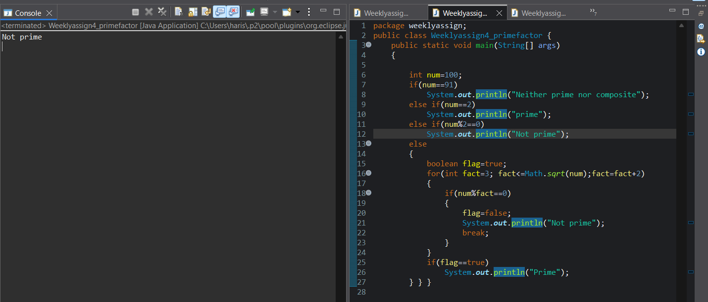

FIBONACCI SERIES:

package weeklyassign;
public class Weeklyassign4_fibonacci {
public static void main(String[] args) {
int n = 10;
int a = 0, b = 1;
for (int i = 1; i <= n; i++) {
if (a > 100) {
break;
}
System.out.print(a + " ");
int next = a + b;
a = b;
b = next;
} } }
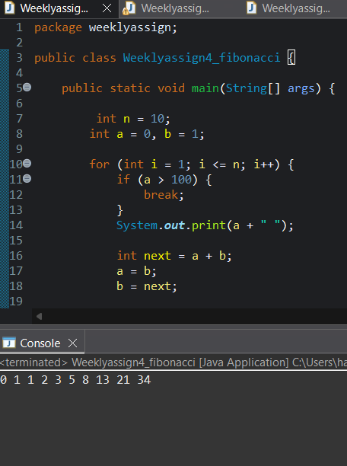
Digital_Transformation_logic
package weeklyassign;
public class Weeklyassign4_digittransformationlogic {
public static void main(String[] args) {
int n = 12345;
int position = 1;
int result = 0;
int place = 1;
while (n > 0) {
int digit = n % 10;
int newDigit;
if (position % 2 == 1 && digit <= 4) {
newDigit = digit * 2;
} else if (position % 2 == 0) {
newDigit = 1;
} else {
newDigit = digit; }
result = result + (newDigit * place);
place *= 10;
position++;
n /= 10 }
System.out.println("Output: " + result);
}
}
