Problem Statement:
A student scored 87.6 marks in an exam (stored in a float). Perform the following operations:
Convert the float marks into:
double
int
Print all three values.
Convert the final integer value into a character using ASCII and print it.

Expected Learning:
Float â†’ Double (Upcasting)
Double â†’ Int (Downcasting)
Int â†’ Char (ASCII conversion)

Sample Output:
Float value: 87.6
Double value: 87.6
Integer value: 87
Character value: W
CODE:
package day2;

public class weeklyassignment3 {
public static void main(String[] arg)
{
//PROGRAM 1
//original value
float score=87.6F;
//Upcasting
double value1=score;
//Downcasting
int value2=(int)value1;
//ASCII
char value3=(char)value2;
System.out.println("Float Value=" +score);
System.out.println("Double value=" +value1);
System.out.println("Integer value=" +value2);
System.out.println("Char value=" +value3);
}
OUTPUT
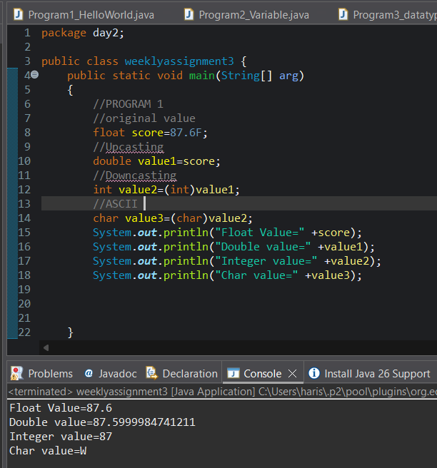

Problem Statement:
Write a Java program that:
Takes a character input from the user (e.g., 'A').
Finds and prints its ASCII value.
Adds 5 to the ASCII value.
Converts the new value back to a character and prints it.
Expected Learning:
Char â†’ Int conversion (ASCII)
Arithmetic operations on ASCII values
Int â†’ Char typecasting
Sample Input:
Enter character: A
Sample Output:
ASCII value: 65
New ASCII value: 70
New character: F
CODE
package day2;
import java.util.Scanner;
public class weeklyassignment3 {
public static void main(String[] arg) {
//PROGRAM2
Scanner scanner = new Scanner(System.in);
System.out.print("Enter a character: ");
char character = scanner.next().charAt(0);
int asciiValue = (int) character;
System.out.println("The ASCII value of '" + character + "' is: " + asciiValue);
scanner.close();
}
}

OUTPUT:
